# ACKNOWLEDGMENT

We are very thankful to our supervisor, who supervised and approved our project and helped us at every step of our project. Without his guidance, motivation and endless support it would have been impossible to remain sustainable in the convoluted situations.

# ABSTRACT

Water wastage in society and also some industries is very common issue now days. As human life becomes easier in recent years due to the advancement of technology and this project is also related to automation and control. The main concern of this project was to monitor the level of water through sensor. The sensor fetches the level information in the batteery and send to controller. The controller generates level value and switching the solenoid valve ON/OFF according to user defines levels. The Solenoid valve is connected with the water tank. It is completely automated with the help of a micro controller**.** The user define levels the controller decode it and show us whether the battery is empty, half and full of wate. It is very useful project in case of area facing electricity problem. Due to the automation of this project it helps the user to get rid of switching ON/OFF the solenoid wall manually and it also leads to reduce the wastage of water.

# TABLE OF CONTENTS

ACKNOWLEDGMENT 1

ABSTRACT 2

TABLE OF CONTENTS 3

LIST OF ACRONYMS 5

Chapter 1 6

INTRODUCTION 6

1.1 Overview 6

1.2 Problem statement 6

1.3 Specifications of proposed solution 7

1.4 Purpose of the project 7

1.5 Applications of the project 7

1.5.1 Society Application 7

1.5.2 Daily life Application 8

1.6 Project Plan 8

Chapter 2 9

LITERATURE REVIEW 9

2.1 Related component and technology 9

2.1.1 Sonar Sensors 9

2.1.2 Microcontrollers 10

2.2 Related Projects 10

2.2.1 Related project 1: 10

2.2.2 Related project 2 11

2.3 Related Studies 13

2.3.1 Water level indicator through transistor 13

2.3.2 Water level indicator with alarm 13

2.4 Their Limitations and Bottlenecks 14

2.5 Summary 14

Chapter 3 15

PROJECT DESIGN AND IMPLEMENTATION 15

3.1 Design of the Project Hardware/ Software 15

3.1.1 Level Sensor module 15

3.1.2 Arduino 16

3.2 Details about software/ algorithms 17

3.2.1 Arduino 17

3.3 Details of final working prototype 17

3.4 Summary 18

Chapter 4 19

TOOLS AND TECHNIQUES 19

4.1 Hardware used with technical specifications 19

**4.1.1** **Ultrasonic module HC-SR04** 19

**4.1.2** **Arduino** 22

**4.1.3 Solenoid velve** 25

**4.1.3** **Battery** 29

**4.1.4** **7812 IC** 36

**4.1.5** **SPDT Relay** 37

**4.1.6** **2N2222 Transistor** 37

4.2 Software(s), simulation tool(s) used 39

4.2.1 Arduino development environment 39

4.3 Testing Procedures 39

4.3.1 Ultrasonic module HC-SR04 39

4.3.2 Arduino uno 40

4.4 Summary 40

# LIST OF ACRONYMS

DOD Depth of Discharge

SLI Starting, Lighting and Ignition

PIC Programmable Interface Controller

C C language

RTU Remote Terminal Unit

CTU Control Terminal Unit

PC Personal Computer

LED Light Emitting Diode

UPS Uninterruptible Power Supplies

VCC Voltage Source

GND Ground

CM Centimeter

TTL Transistor Transistor Logic

USB Universal Serial Bus

# 

# Chapter 1

# INTRODUCTION

As human life becomes easier in recent year due to the advancement of technology every one try to make the things easy and automatic this project is also relate to automation and control. As we know that scarcity of resources is major issue in these days so we are going to do this project to save electricity and water over flow. Water wastage is major issue in big cities. This is a common problem facing by every house and factory. Due to busy life it is common that when the water level in the battery is increased or decrease it can demage the battery. So in order to increase the efficiency of the battery we the tank usually overflows without notice. One has to keep constantly monitor the battery through ultrasonic sensors. Sometimes this also can happen that the battery demage because of absence of water in the battery. Due to this problem monitoring of water or liquid is required. Which take the level information through sensor and automatically starts and stops the solenoid valve according to user define levels.

## Overview

This project is introduced for water monitoring system in battery through ultrasonic sensors. This will provide complete control to solenoid valve that is providing water to the battery. The main purpose of this project is to control the level of water in the battery, lesser the human effort and save the time. This system also helps in saving the electrical energy by automatic switching of solenoid valve. The level information of battery is collected by sensor and gives that level information to micro controller. The controller on off the solenoid valve.

## Problem statement

Measuring water level is an essential task for industry, government and residence perspective. Wastage of Liquid (water) in residence is not an efficient use of water resources. Wastage of liquid, time, and human power in industry is not acceptable. From the last few years several systems are designed to overcome this problem. But the limitation of those systems doesn’t solve this problem efficiently. The project overcome the human effort because sometime person don’t know the level of battery and it is not always convenient for him to check the level in battery all the time, in that case this project can help him which will run the solenoid valve according to user’s conditions.

## Specifications of proposed solution

First ultrasonic sensor fetches the level information of tank. This information is given to micro controller that converts this information into 4 bits. Micro controller reads this data and according to the user defined level turn on the solenoid valve if the level is not less then the defined level the solenoid valve will not be turn on.

## Purpose of the project

Past few years there are many projects implemented related to this project but those are failed due to their limitations. Limitations in those projects are, the systems are totally manual a person will regularly check the battery level. Our main aim is to develop a system which saves Liquid being wasted and overflowed. This problem is with so many areas covering residential and industrial, that water is being overflowed and no one noticed it. By implementation of our project, there is no need to humans to monitor the battery level, the controller will automatically monitor it.

## Applications of the project

It is very useful project in case of area facing electricity problem. It will help a lot due to its automatic on/off operation..

### Society Application

The water level monitoring for societies offers a solution for pumping of the water to overhead tanks in building it avoids.

* Overflow of overheads tanks
* Electricity saving
* Automatic switching which results in water saving

### Daily life Application

This project has number of practical users in daily life

* No need to go towards battery
* Can be used to measure underground storage of water
* Water level monitoring works to maintain a constant water level
* It can also be used to calculate incoming and outgoing water in large reservation.

## Project Plan

We divided our project within the group in different small task so that each group member can work on it and learn everything and can teach to other group members what he learnt. By this process every member was assigned a task to do and then this task was assessed by all group members.

# Chapter 2

# LITERATURE REVIEW

Before this project there are a lot of technique and method to control water flow and level. The problems that enforce us to use these techniques were:

1. Water scarcity.

2. Water overflow.

3. Wastage of electricity.

4. Wastage of water.

There were some method to monitor the water level in tank but they were using complex circuitry and having low efficiency or compatibility. This project used same idea but increase efficiency and compatibility through using wireless link.

## Related component and technology

The related technology and component that we can use in our project as well are:

### Sonar Sensors

Sonar sensor is also known as ultrasonic sensors it sends sound waves and receives this sound wave when it reflects back so it is also called transducer. They send high frequency sound wave send then start to calculate the time until the sound is received back to sensors. With the help of this calculating time sensor evaluate the distance from the object. The basic process is that sensor take command from the controller and transmit an echo sound when this sound is strike with an object (water or other solid things) it reflect back to the sensor and sensor receive it during this process controller calculate the time of sending and receiving to evaluate the distance from the object with the help of this formula.

S=V*T/2

S= Distance from the object.

V= Velocity of sound wave.

T= Time period between the wave transmit and receive.

### Microcontrollers

In know days microcontroller is using in every electronic technology because it acts as brain. A Micro controller controls all the system very efficiently according to program. It input and processes it then gives command as an output.

#### PIC Microcontroller

Programmable Interface Controllers (PIC) is microcontrollers in which we program our logic in a C language. This language is user friendly and easily understands by every human. They are used to make a lot of projects from simple category to high security purpose. They are very much user friendly

#### Arduino Microcontroller

Now a day’s arduino is use because it makes engineer life easy and having good efficiency and compatible for all type of project which use controller in other word you can say that it is an open source and give user friendly platform to code our logics of programming to make a lot of projects. The language of audino is very easily having built in command for different tasks and its language is very much close to human language.

In market there are different types of audino Microcontroller boards are present. Some of them are following.

* **Arduino Ethernet.**
* **Arduino Mega 2560.**
* **Arduino Leonardo.**
* **Arduino Uno.**
* **Arduino Due.**
* **Arduino Mega ADK.**

## Related Projects

### Related project 1:

Wireless water level monitoring system is more efficient because it was used in automation, data acquisition and control system. Wireless unit transmits water level signal from remote reservoir to a central monitoring station. Central monitoring station has desktop pc with suitable level which was descried through software as per real time. This unit plays important role in society water supply scheme and regional authorities.

At the top of tank remote terminal unit (RTU) is installed which indicates the level of water in three way, such as 0% (empty), 50% (half full), 100% (full) and contact free sensors are used to sense the water level. Suitable sensors for this project are rugged in construction and Sensor sense the water level and send signal trough RTU (remote terminal unit) to control monitoring unit. This unit is operated on main power supply so that it can easily inform the central monitoring system about the water level change even when the power supply is cutoff.

PC at central monitoring station receives the data from RTU through wireless network. The unit has been powered with main supply with precautions against surge and provided voltage variation. PC has storage to save the data so that receiver data can be shown on a special prepared famed of software. If user need any type of information about the water level so he can collect it from PC.

### Related project 2

This technology is also use for water level monitoring. The first part of design is using sensor to sense the water level and send output to microcontroller through inventor. Microcontroller is act as main control system which controls all process in the system automatically hence reduces size of design and control complexity. When the input from the sensor is change so the output from the microcontroller decides the water pump is ON or OFF on the current status of water in tank. The figure of the whole circuit diagram is shown in Fig. 2.1.

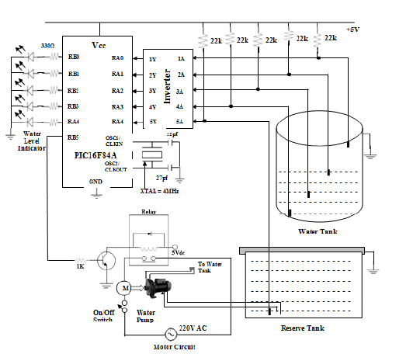

Figure‑2.1 water level indicator using PIC16F84A [4]

In the microcontroller RA4 pin is used to detect the water in the ground or reserve tank. If there is no water in the reserve tank it send command to switch OFF the system result pin RA0, RA1, RA2 and RA3 is inverted and does not change until the water is present. Crystal Oscillator is connected with pin 15 and 16 and with two capacitor 22pF and 27pF which further connect it to the ground. This combination act as external clock to executes the instruction of the system.

* If pins RA0, RA1, RA2 and RA3 get zero so all LEDs is OFF that mean water tank is empty and reserve tank is also empty.
* If all pins remain zero and LED 1 is ON and other LEDs are OFF which mean water tank is empty and water exist in reserve thank so we can ON motor.
* If RA0 get 1 (5V) and other pins are zero (0V) so LED 1 and 2 is ON remain are OFF this indicate us tank is ¼ full.
* If RA0 and RA1 get 1 (5V) and other pins are zero (0V) so LED 1, 2, and 3 is ON and remain LED is OFF this indicate us tank is half full.
* If first three pins get 1 (5V) and all LEDs in ON than this mean tank is ¾ full.
* If all pins get 1 (5V) and all LEDs in ON than this mean tank is complete full.

## Related Studies

As we know that there is limited resource like water and electricity etc. So people are doing research to save the resources and use it efficiently and avoid wasting them. For this purpose we read many research papers and projects to make our project more compatible and cost effective. There are following project we research on.

### Water level indicator through transistor

Water level indicator is use to indicate the levels of tank trough LEDs. This project is using 5 transistors and each transistor is connected with corresponding LED and electrode probes that is fixed step by step from bottom to top of the tank. One probe is fixed at the bottom of tank having 6V AC supply. As we know that water is good conductor so when water is raising each transistor gets electrical connection of 6V AC to ON the corresponding LED and indicates the water level.

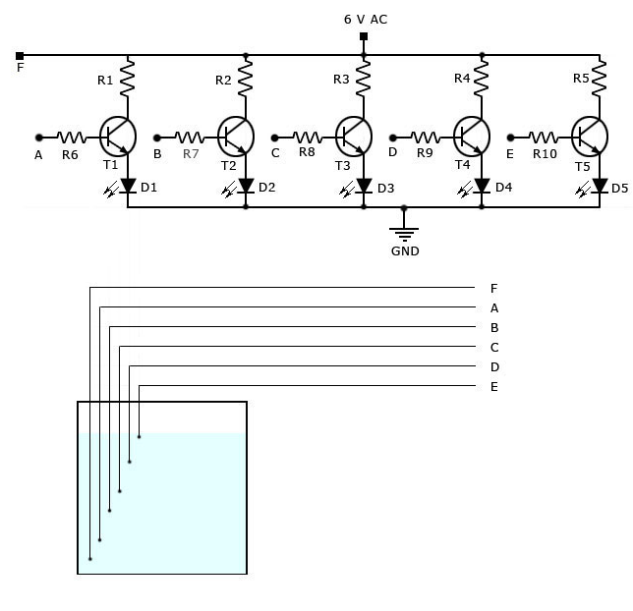

water level indicator using Transistors

### Water level indicator with alarm

This project is using the same phenomena as in water level indicator through transistor It also indicates the levels of water through using transistor and their corresponding LEDs. The things which change in it is using buzzer for alarm purpose. This buzzer is connected with bottom level LEDs now when the tank become empty it starts alarming.

## Their Limitations and Bottlenecks

The following related project and studies are discussing above have some limitation and accuracy or efficiency problems.

* All the projects are having low efficiency and less compatibility because user need time to go overhead tank and check the level.
* The entire projects are not automatically ON the water pump when the tank is empty.
* All the project using wiring system and having low life time component and need maintenances after some time so this makes these project expensive.
* Theses project are not doing complete monitoring of reserve tank.
* These projects are useless when the power supply cutoff.

## Summary

This chapter gives reader a complete view about the literature, related technologies, related project and studies. This chapter clears the sense of reader why we are going to do this project by telling him about the problems that was faced in daily life. It also gives over view of different project related to this project and their limitation. It also gives brief discussion about the related technology and component and their purpose that we are going to use in our project.

# Chapter 3

# PROJECT DESIGN AND IMPLEMENTATION

## Design of the Project Hardware/ Software

Ultrasonic Sensors

Battery

Solenoid Valve

Relay Driver Circuit

Controller

Container

Figure shows the complete block diagram of this project. The ultrasonic sensor in the battery measure the distance between water level give that data to Microcontroller. Microcontroller creates a 4 bit digital data with respect to the distance measure by ultrasonic sensor (I.e. 0000 for the end level, 1000 for half level and 1111 for full level of liquid) Details about hardware

### Level Sensor module

In this project we use ultrasonic sensor. Like dolphins and bats do, this sensor uses ultrasonic sound to measure distance. The pitch of the sound is very high that humans cannot hear. In our case we measure the distance between water level and the top of the tank. This ultrasonic sensor has 2 parts transducer and receiver. The transducer sends an ultrasonic sound that has frequency of 40 KHz. The receiver listen this sound.

The speed of sound is 340 meters per second that is 29.41 microseconds per centimeter. To measure the distance we use the formula

Distance = (Time x speed of sound) / 2

The 2 in the formula is because of the sound travel from transducer and after reflection come back to the receiver so it travels back and forth.

This sensor can measure distance up to 450 cm. The accuracy of this sensor is 2mm and it has focus of 15 degrees.

VCC of the sensor is connected to the 5 volts and GND is connected with ground. The trig pin is connected to the digital output of microcontroller and the Echo pin is connected with the digital input of microcontroller. A high pulse of at least 10 microseconds is give to Trig pin and then wait for high pulse receives at Echo pin. The distance travelled by ultrasonic sound is corresponds to the amount of time Echo pin is stay high.

### Arduino

There are two type of Arduino used in this project. One is Arduino uno and the other is Arduino Mega. Arduino uno is used with both transmitters while Arduino Mega is used with receivers. In receiver part we need more digital pins that’s why we used Arduino Mega. The controller used in Arduino uno is ATmega328 having 14 digital input/output pins. The controller used in Arduino mega is ATmega1280 having 54 digital input/output pins. To operate Arduino 5 volts DC is required.

Ultrasonic sensor is connected with the digital pins of Arduino. The sensor fetches the distance (Level) information and give to the controller. In controller we run an algorithm that converts that distance (Level) information in bits (Digital Level). I.e. 0000 for the end tank level, 1000 for half tank level and 1111 for full tank level of liquid.

Arduino mega is connected with receiver that receives level information of both tanks. The receivers are connected at the digital input pins of Arduino mega. In this controller we run an algorithm that read the received level information and turn on or off the motor according to users defined levels. Motor is connected at digital output pins of Arduino through Relay.

## Details about software/ algorithms

### Arduino

Arduino compiler is used in this project to code the Arduino. First of all input and output ports are initialized. Then send a high pulse and start a counter until it is received at echo. The counter gives us the value of distance by using formula.

## Details of final working prototype

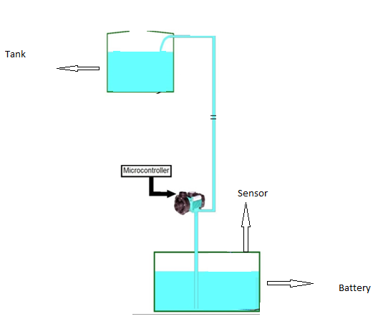

Figure‑3.2 final working prototype diagram

The details of final working protocol are shown in Figure 3.2. Sensor gets the level information of tank and pass to the micro controller. Micro controller makes a 4 bit code from this level information at pass to the wireless transmitter. The transmitter modulate the data on 433MHz at transmit it. At the other side receiver receive this signal and demodulate it, give the 4 bit data to micro controller. These types of arrangements are also done on sump. The level information of sump is also received by micro controller. On the basis of this data the micro controller starts the pump according to user defined levels. Micro controller sends high to relay. When relay receive high signal from micro controller it starts motor that is operating on 220 V AC. The level information of both tank and sump is also received by receivers that are connected with LCD through micro controller. The LCD shows the current levels to the user.

## Summary

In this chapter we highlight the hardware and software techniques which are used in this project. Ultrasonic sensor fetches the level information and gives it to the micro controller. Micro controllers process this data and make 4 bit code of it. This 4 bit code is passing to the transmitter that transmits it on modulating frequency. The receiver receives both information of tan and sump, demodulate it and pass to the micro controller. The micro controller checks the levels with to user defined levels and starts or stop the pump accordingly.

# Chapter 4

# TOOLS AND TECHNIQUES

Multiple hardware and software tools and techniques are used in this project. High Quality hardware is used to inshore quality. The main parts of this project are shown in Figure 4.1.

## Hardware used with technical specifications

### **Ultrasonic module HC-SR04**

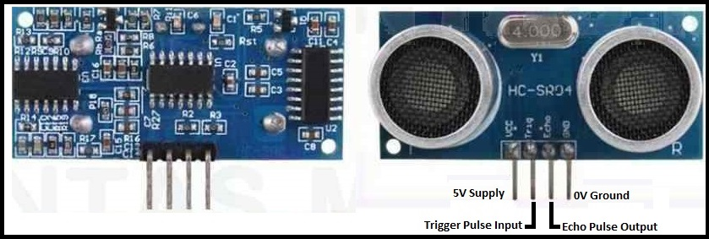

Figure‑4.2 Diagram of Ultrasonic Sensor

The [HC-SR04](http://cytron.com.my/p-sn-hc-sr04) ultrasonic sensor uses sonar to determine distance to an object like bats or dolphins do. It offers excellent non-contact range detection with high accuracy and stable readings in an easy-to-use package. From 2cm to 400 cm or 1” to 13 feet. It operation is not affected by sunlight or black material like Sharp rangefinders are (although acoustically soft materials like cloth can be difficult to detect). It comes complete with ultrasonic transmitter and receiver module.

The basic working of this module is

* Using at least 10us high signal at trigger
* The module sends eight (8) 40 KHz sound signals and detect whether there is a pulse signal back.
* If the signal is back then

Distance = (high level time x velocity of sound (340 m/s)) / 2

Module Pins

* 5V Supply
* Trigger Pulse Input
* Echo Pulse Output
* 0V Ground

#### Module Electric Parameters

|  |  |
| --- | --- |
| Operating Voltage | 5 Volts DC |
| Operating Current | 15 mA |
| Operating Frequency | 40 KHz |
| Max Range | 4 m |
| Min Range | 2 cm |
| Angle | 15 degree |
| Trigger input signal | 10 us TTL pulse |
| Echo output signal | Input TTL lever signal and the range in  proportion |
| Dimension | 45 x 20 x 15 mm |

Table‑4.1 Parameter of Ultrasonic sensor

#### Working

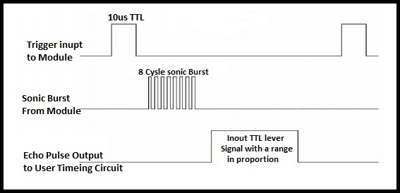

Figure‑4.3 Working of Ultrasonic Sensor

10 uS pulse is supply to the trigger input to start the ranging. The module will send eight cycle of ultrasound at frequency of 40 KHz and receive its echo. The range is the time between sending trigger and receive echo.

**SPECIFICATION AND LIMITATIONS**

|  |  |  |  |  |
| --- | --- | --- | --- | --- |
| **Parameter** | **Min** | **Typ.** | **Max** | **Unit** |
| Operating Voltage | 4.50 | 5.0 | 5.5 | V |
| Quiescent Current | 1.5 | 2 | 2.5 | mA |
| Working Current | 10 | 15 | 20 | mA |
| Ultrasonic Frequency | **-** | 40 | **-** | kHz |

**OPERATION**

The timing diagram of [HC-SR04](http://cytron.com.my/p-sn-hc-sr04) is shown. To start measurement, Trig of SR04 must receive a pulse of high (5V) for at least 10us, this will initiate the sensor will transmit out 8 cycle of ultrasonic burst at 40kHz and wait for the reflected ultrasonic burst. When the sensor detected ultrasonic from receiver, it will set the Echo pin to high (5V) and delay for a period (width) which proportion to distance. To obtain the distance, measure the width (Ton) of Echo pin.

Time = Width of Echo pulse, in uS (micro second)

Distance in centimeters = Time / 58

Distance in inches = Time / 148

Or you can utilize the speed of sound, which is 340m/s

### **Arduino**

"Uno" means one in Italian and is named to mark the upcoming release of Arduino 1.0. The Uno and version 1.0 will be the reference versions of Arduino, moving forward. The Uno is the latest in a series of USB Arduino boards, and the reference model for the Arduino platform;

Arduino uno is ATMEGA328 based microcontroller board. Consists of

* 14 digital I/P or O/P pins
* 6 analog I/P pins
* 16 MHz resonator
* USB connection

The power pins are as follows:

* **VIN**. The input voltage to the Arduino board when it's using an external power source (as opposed to 5 volts from the USB connection or other regulated power source). You can supply voltage through this pin, or, if supplying voltage via the power jack, access it through this pin.
* **5V.** The regulated power supply used to power the microcontroller and other components on the board. This can come either from VIN via an on-board regulator, or be supplied by USB or another regulated 5V supply.
* **3V3**. A 3.3 volt supply generated by the on-board regulator. Maximum current draw is 50 mA.
* GND. Ground pins.
* **Serial**: 0 (RX) and 1 (TX). Used to receive (RX) and transmit (TX) TTL serial data.These pins are connected to the corresponding pins of the ATmega8U2 USB-to-TTL Serial chip.
* **External Interrupts**: 2 and 3. These pins can be configured to trigger an interrupt on a low value, a rising or falling edge, or a change in value. See the [attachInterrupt()](http://arduino.cc/en/Reference/AttachInterrupt) function for details.
* **PWM**: 3, 5, 6, 9, 10, and 11. Provide 8-bit PWM output with the [analogWrite()](http://arduino.cc/en/Reference/AnalogWrite) function.
* **SPI**: 10 (SS), 11 (MOSI), 12 (MISO), 13 (SCK). These pins support SPI communication, which, although provided by the underlying hardware, is not currently included in the Arduino language.
* **LED**: 13. There is a built-in LED connected to digital pin 13. When the pin is HIGH value, the LED is on, when the pin is LOW, it's off.

#### **Technical specifications**

|  |  |
| --- | --- |
| Microcontroller | ATMEGA328 |
| Operating Voltage | 5V |
| Input Voltage (recommended) | 7-12V |
| Input Voltage (limits) | 6-20V |
| Digital I/O Pins | 14 |
| Analog Input Pins | 6 |
| DC Current per I/O Pin | 40 mA |
| DC Current for 3.3V Pin | 50 mA |
| Flash Memory | 32 KB |
| SRAM | 2 KB |
| EEPROM | 1 KB |
| Clock Speed | 16 MHz |
| Length | 68.6 mm |
| Width | 53.4 mm |
| Weight | 25 g |

Table‑4.2 Technical parameter of arduino

Two ways can be used to power up the arduino uno that is USB connection or external power supply. The arduino select the power source automatically. The arduino board can operate on 6 - 20 volts. However recommended range is 7-12 volts.

#### **Communication:-**

Arduino uno can be communicates with computer, other Arduino or other microcontroller. ATmega328 provides serial communication USB communication with computer. Arduino uses standard USB drivers.

Dimensions

* 2.7 inches Length and 2.1 inches width
* Four screw holes on board
* Distance between pins in 0.16 inch.

#### **Programming**

The Arduino Uno can be programmed with the Arduino software ([download](http://arduino.cc/en/Main/Software)). Select "Arduino Uno from the **Tools > Board** menu (according to the microcontroller on your board). For details, see the [reference](http://arduino.cc/en/Reference/HomePage) and [tutorials](http://arduino.cc/en/Tutorial/HomePage).

The ATmega328 on the Arduino Uno comes preburned with a [bootloader](http://arduino.cc/en/Tutorial/Bootloader) that allows you to upload new code to it without the use of an external hardware programmer. It communicates using the original STK500 protocol ([reference](http://www.atmel.com/dyn/resources/prod_documents/doc2525.pdf), [C header files](http://www.atmel.com/dyn/resources/prod_documents/avr061.zip)).

You can also bypass the bootloader and program the microcontroller through the ICSP (In-Circuit Serial Programming) header using [Arduino ISP](http://arduino.cc/en/Main/ArduinoISP) or similar; see [these instructions](http://arduino.cc/en/Hacking/Programmer) for details.

The ATmega16U2 (or 8U2 in the rev1 and rev2 boards) firmware source code is available . The ATmega16U2/8U2 is loaded with a DFU bootloader, which can be activated by:

On Rev1 boards: connecting the solder jumper on the back of the board (near the map of Italy) and then resetting the 8U2.

On Rev2 or later boards: there is a resistor that pulling the 8U2/16U2 HWB line to ground, making it easier to put into DFU mode.

You can then use [Atmel's FLIP software](http://www.atmel.com/dyn/products/tools_card.asp?tool_id=3886) (Windows) or the [DFU programmer](http://dfu-programmer.sourceforge.net/) (Mac OS X and Linux) to load a new firmware. Or you can use the ISP header with an external programmer (overwriting the DFU bootloader).

### **4.1.3 Solenoid velve**

A solenoid valve is an electronically operated device. It is used to control the flow of liquids or gases in a positive, fully-closed or fully-open mode. The valve is commonly used to replace a manual valve or where remote control is desirable. A solenoid is operated by opening and closing an orifice in a valve body that permits or prevents flow through the valve. The orifice is opened or closed through the use of a plunger that is raised or lowered within a sleeve tube by energizing the coil. The bottom of the plunger contains a compatible sealing material, which closes off the orifice in the body, stopping flow through the valve.

The solenoid assembly consists of a coil, plunger, and sleeve assembly. In a normally closed valve, a plunger return spring holds the plunger against the orifice, preventing flow through the valve. When the coil is energized, a magnetic field is produced, raising the plunger and allowing flow through the valve. In a normally open valve, when the coil is energized, the plunger seals off the orifice, stopping flow through the valve.

**Direct Operated Solenoid Valves**

Direct operated solenoid valves function to directly open or close the main valve orifice, which is the only flow path in the valve. Direct operated valves are used in systems requiring low flow capacities or in applications with low pressure differential across the valve orifice. The sealing surface that opens and closes the main valve orifice is connected to the solenoid plunger. The valve operates from zero pressure differential to maximum rated pressure differential (MOPD) regardless of line pressure. Pressure drop across the valve is not required to hold the valve open.

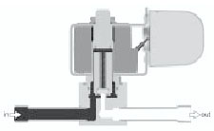

Coil de-energized, valve closed

**Pilot Operated Valves**

Pilot operated valves are the most widely used solenoid valves. Pilot operated valves utilize system line pressure to open and close the main orifice in the valve body. In a piston-style valve, the main orifice is held closed with a piston seal pressed against the main orifice by the combined fluid pressure and spring pressure. In a normally closed valve, the piston is shifted or opened when the pilot operator is energized. This allows fluid behind the piston to evacuate through the valve outlet. At this point, the system line pressure moves the piston, opening the main orifice of the valve allowing high capacity flow through the valve. When energizing the coil of a normally open valve, fluid pressure builds up behind the piston, forcing the piston to seal the main orifice of the valve.

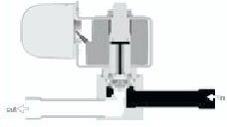

Coil de-energized, valve closed

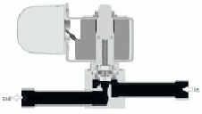

Coil energized, valve open

**Design Terminology**

**Continuous Duty**

 A rating given to a valve that can be energized continuously without overheating.

**Correction Factor**

A mathematical relationship related to a fluid’s specific gravity used to convert specific flows from a standard media to the media in question.

**Current drain**

The amount of current (expressed in amperes) that flows through the coil of a solenoid valve when it is energized.

**Cv Factor**

A mathematical factor that represents the quantity of water, in gallons per minute, that will pass through a valve with a 1 psi pressure drop across the valve.

**Flow**

Movement of fluid created by a pressure differential.

**Flow Capacity**

The quantity of fluid that will pass through a valve under a given set of temperature and pressure conditions.

**Manual Stem**

A mechanical device that permits the manual opening or closing of a valve in the case of emergency or power failure. A manual stem is available on all normally closed valves.

**Maximum Operating Pressure Differential (MOPD)**

The maximum pressure difference between the inlet and outlet pressures of the valve must not be exceeded, allowing the solenoid to operate in both the energized and de-energized positions.

**Minimum Operating Pressure Differential**

The minimum pressure difference between the inlet and outlet pressures required for proper operation. This minimum operating pressure differential must be maintained throughout the operating cycle of pilot operated valves to assure proper shifting from the closed position to the open position and visa versa. In the absence of the minimum operating pressure, the valve may close or will not fully open.

**Orifice**

The main opening through which fluid flows.

**Safe Working Pressure**

The maximum pressure a valve may be exposed to without experiencing any damage. The valve does not have to be operable at this pressure, but merely withstand the pressure without damage.

**Different parts of a solenoid valve**

The illustration below depicts the basic components of a solenoid valve. The valve shown in the picture is a [normally-closed](http://www.solenoid-valve-info.com/solenoid-valve-terminology.html#normally_closed), [direct-acting valve](http://www.solenoid-valve-info.com/solenoid-valve-terminology.html#direct_acting). This type of solenoid valve has the most simple and easy to understand principle of operation.

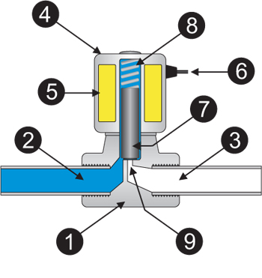

|  |  |  |
| --- | --- | --- |
| **1. Valve Body** | **4. Coil / Solenoid** | **7. Plunger** |
| **2. Inlet Port** | **5. Coil Windings** | **8. Spring** |
| **3. Outlet Port** | **6. Lead Wires** | **9. Orifice** |

**Working of solenoid valve**

The media controlled by the solenoid valve enters the valve through the[inlet port](http://www.solenoid-valve-info.com/solenoid-valve-terminology.html#port_inlet) (Part 2 in the illustration above). The [media](http://www.solenoid-valve-info.com/solenoid-valve-terminology.html#media) must flow through the [orifice](http://www.solenoid-valve-info.com/solenoid-valve-terminology.html#orifice) (9) before continuing into the [outlet port](http://www.solenoid-valve-info.com/solenoid-valve-terminology.html#port_outlet) (3). The orifice is closed and opened by the [plunger](http://www.solenoid-valve-info.com/solenoid-valve-terminology.html#plunger) (7).

The valve pictured above is a normally-closed solenoid valve. Normally-closed valves use a spring (8) which presses the plunger tip against the opening of the orifice. The sealing material at the tip of the plunger keeps the media from entering the orifice, until the plunger is lifted up by an electromagnetic field created by the [coil](http://www.solenoid-valve-info.com/solenoid-valve-terminology.html#valve_coil).

### **Battery**

Lead acid batteries were invented in 1859 by Gaston Planté and first demonstrated to the French Academy of Sciences in 1860. They remain the technology of choice for automotive SLI (Starting, Lighting and Ignition) applications because they are robust, tolerant to abuse, tried and tested and because of their low cost. For higher power applications with intermittent loads however, Lead acid batteries are generally too big and heavy and they suffer from a shorter cycle life and typical usable power down to only 50% Depth of Discharge (DOD). Despite these shortcomings Lead acid batteries are still being specified for PowerNet applications (36 Volts 2 kWh capacity) because of the cost, but this is probably the limit of their applicability and NiMH and Li-Ion batteries are making inroads into this market. For higher voltages and cyclic loads other technologies are being explored.

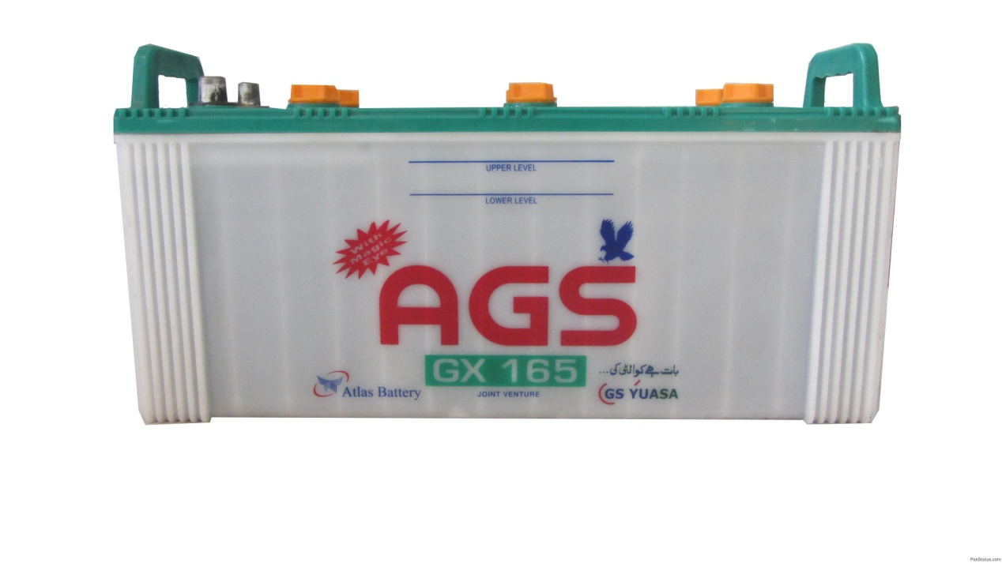

Lead-acid batteries are composed of a Lead-dioxide cathode, a sponge metallic Lead anode and a Sulphuric acid solution electrolyte. This heavy metal element makes them toxic and improper disposal can be hazardous to the environment.

The cell voltage is 2 Volts.

**Discharge**During discharge, the lead dioxide (positive plate) and lead (negative plate) react with the electrolyte of sulfuric acid to create lead sulfate, water and energy.

**Charge**  
During charging, the cycle is reversed: the lead sulfate and water are electro-chemically converted to lead, lead oxide and sulfuric acid by an external electrical charging source.

Many new competitive cell chemistries are being developed to meet the requirements of the auto industry for EV and HEV applications.

Even after 150 years since its invention, improvements are still being made to the lead acid battery and despite its shortcomings and the competition from newer cell chemistries the lead acid battery still retains the lion's share of the high power battery market.

**Advantages**

* Low cost.
* Reliable. Over 140 years of development.
* Robust. Tolerant to abuse.
* Tolerant to overcharging.
* Low internal impedance.
* Can deliver very high currents.
* Indefinite shelf life if stored without electrolyte.
* Can be left on trickle or float charge for prolonged periods.
* Wide range of sizes and capacities available.
* Many suppliers world wide.
* The world's most recycled product.

**Shortcomings**

* Very heavy and bulky.
* Typical coulombic charge efficiency only 70% but can be as high as 85% to 90% for special designs.
* Danger of overheating during charging
* Not suitable for fast charging
* Typical cycle life 300 to 500 cycles .
* Must be stored in a charged state once the electrolyte has been introduced to avoid deterioration of the active chemicals.

Gassing is the production and release of bubbles of hydrogen and oxygen due to the breakdown of water in the electrolyte during the charging process, particularly due to excessive charging, causing loss of electrolyte. In large battery installations this can cause an explosive atmosphere in the battery room. Because of the loss of electrolyte, Lead acid batteries need regular topping up with water. Sealed batteries however are designed to retain and recombine these gases.

 Sulphation may occur if a battery is stored for prolonged periods in a completely discharged state or very low state of charge, or if it is never fully charged, or if electrolyte has become abnormally low due to excessive water loss from overcharging and/or evaporation. Sulphation is the increase in internal resistance of the battery due to the formation of large lead sulphate crystals which are not readily reconverted back to lead, lead dioxide and sulphuric acid during re-charging. In extreme cases the large crystals may cause distortion and shorting of the plates. Sometimes sulphation can be corrected by charging very slowly (at low current) at a higher than normal voltage.

Completely discharging the battery may cause irreparable damage.

 Shedding or loss of material from the plates may occur due to excessive charge rates or excessive cycling. The result is chunks of lead on the bottom of the cell, and actual holes in the plates for which there is no cure. This is more likely to occur in SLI batteries whose plates are composed of a Lead "sponge", similar in appearance to a very fine foam sponge. This gives a very large surface area enabling high power handling, but if deep cycled, this sponge will quickly be consumed and fall to the bottom of the cells.

**Toxic chemicals**

Lead acid batteries can work down to temperatures below -45 °C, however, like all batteries the discharge rate and effective capacity are reduced at low temperatures. In the case of Lead acid batteries the capacity falls by about 1% per degree for temperatures below +20 °C so that at the lowest temperatures cranking capacity is seriously impaired.

Decomposition of the Electrolyte Cells with gelled electrolyte are prone to deterioration of the electrolyte and unexpected failure. Such cells are commonly used for emergency applications such as UPS back up in case of loss of mains power. So as not to be caught unawares by an unreliable battery in an emergency situation, it is advisable to incorporate some form of regular self test into the battery.

**Charging**

* Charge immediately after use.
* Lasts longer with partial discharges.
* Charging method: constant voltage followed by float charge.
* Fast charge not possible but charging time can be reduced using the[V Taper charge control](http://www.mpoweruk.com/chargers.htm#taper) method.

**Applications**

* Automotive and traction applications.
* Standby/Back-up/Emergency power for electrical installations.
* Submarines
* UPS (Uninterruptible Power Supplies)
* Lighting
* High current drain applications.
* Sealed battery types available for use in portable equipment.
* [Grid scale energy storage](http://www.mpoweruk.com/grid_storage.htm)

**Costs**

* Low cost
* Flooded lead acid cells are one of the least expensive sources of battery power available.
* Deep cycle cells may cost up to double the price of the equivalent flooded cells.

**Varieties of Lead Acid Batteries**

Over the years battery manufacturers have introduced a range of additives such as Calcium, Antimony and Selenium to improve various battery performance parameters. For the same reason, different cell and battery constructions have been developed to optimise various aspects of battery performance.

**Lead Calcium Batteries**

Lead acid batteries with electrodes modified by the addition of Calcium providing the following advantages:

* More resistant to corrosion, overcharging, gassing, water usage, and self-discharge, all of which shorten battery life.
* Larger electrolyte reserve area above the plates.
* Higher Cold Cranking Amp ratings.
* Little or No maintenance.

**Lead Antimony Batteries**

Lead acid batteries with electrodes modified by the addition of Antimony providing the following advantages:

* Improved mechanical strength of electrodes - important for EV and deep discharge applications
* Reduced internal heat and water loss due to gassing, however the water loss is still greater than the equivalent loss in Lead Calcium batteries.
* Longer service life than Calcium batteries.
* Easier to recharge when completely discharged.
* Lower cost.
* Lead Antimony batteries have a higher self discharge rate of 2% to 10% per week compared with the 1% to 5% per month for Lead Calcium batteries.

**Valve Regulated Lead Acid (VRLA) Batteries****:**

This construction is designed to prevent electrolyte loss through evaporation, spillage and gassing and this in turn prolongs the life of the battery and eases maintenance. Instead of simple vent caps on the cells to let gas escape, VRLA have pressure valves that open only under extreme conditions. Valve-regulated batteries also need an electrolyte design that reduces gassing by impeding the release to the atmosphere of the oxygen and hydrogen generated by the galvanic action of the battery during charging. This usually involves a catalyst that causes the hydrogen and oxygen to recombine into water and is called a recombinant system. Because spillage of the acid electrolyte is eliminated the batteries are also safer.

**AGM Absorbed Glass Mat Battery****:**

Also known as Absorptive Glass Micro-Fibre

Used in VRLA batteries the Boron Silicate fibreglass mat which acts as the separator between the electrodes and absorbs the free electrolyte acting like a sponge. Its purpose is to promote recombination of the hydrogen and oxygen given off during the charging process. No silica gel is necessary. The fibreglass matt absorbs and immobilises the acid in the matt but keeps it in a liquid rather than a gel form. In this way the acid is more readily available to the plates allowing faster reactions between the acid and the plate material allowing higher charge/discharge rates as well as deep cycling.

This construction is very robust and able to withstand severe shock and vibration and the cells will not leak even if the case is cracked.

AGM batteries are also sometimes called "starved electrolyte" or "dry", because the fibreglass mat is only 95% saturated with Sulfuric acid and there is no excess liquid.

Nearly all AGM batteries are sealed valve regulated "VRLA".

AGM's have a very low self-discharge rate of from 1% to 3% per month

**Gel Cell**

This is an alternative recombinant technology to also used in VRLA batteries to promote recombination of the gases produced during charging. It also reduces the possibility of spillage of the electrolyte. Prone to damage if gassing is allowed to occur, hence charging rates may be limited. They must be charged at a slower rate (C/20) to prevent excess gas from damaging the cells. They cannot be fast charged on a conventional automotive charger or they may be permanently damaged.

Used for UPS applications.

**SLI Batteries (Starting Lighting and Ignition)**

This is the typical automotive battery application. Automotive batteries are designed to be fully charged when starting the car; after starting the vehicle, the lost charge, typically 2% to 5% of the charge, is replaced by the alternator and the battery remains fully charged. These batteries are not designed to be discharged below 50% Depth of Discharge (DOD) and discharging below these levels can damage the plates and shorten battery life.

**Deep Cycle Batteries**

Marine applications, golf buggies, fork lift trucks and electric vehicles use deep cycle batteries which are designed to be completely discharged before recharging. Because charging causes excessive heat which can warp the plates, thicker and stronger or solid plate grids are used for deep cycling applications. Normal automotive batteries are not designed for repeated deep cycling and use thinner plates with a greater surface area to achieve high current carrying capacity.

Automotive batteries will generally fail after 30-150 deep cycles if deep cycled, while they may last for thousands of cycles in normal starting use (2-5% discharge).

If batteries designed for deep cycling are used for automotive applications they must be "oversized" by about 20% to compensate for their lower current carrying capacity.

**Advanced Lead-Acid Batteries**

Carbon doping of the electrodes improves the durability and efficiency of lead-acid batteries by sharply reducing the accumulation of lead sulphate deposits that previously inhibited their performance.

**The Ultrabattery - Sometimes called the Supercabattery**

Inserting a supercapacitor into the battery acts as a "buffer" improving its high-rate charge/discharge performance so that the unit can operate within a state-of-charge window below 70 percent successfully. By attaching a separate carbon electrode to the negative lead plate, the battery takes on some of the characteristics of a [supercapacitor](http://www.mpoweruk.com/supercaps.htm). This extra electrode accepts very high charge/discharge rates thus relieving the original lead plate electrode from this duty and thus avoiding the lead shedding which plagued lead acid batteries and limited their use. The ultrabattery is thus also able to deliver a much longer cycle life of over 10 times the cycle life of an AGM battery.

### **7812 IC**

7812 is a famous IC which is being widely used in 12V voltage regulator circuits. Truly speaking it is a complete standalone voltage regulator. We only need to use two capacitors, one on the input and second one on the output of 7812 in order to achieve clean voltage output and even these capacitors are optional to use. To achieve 12V 1A current, 7812 should be mounted on a good heatsink plate. Thanks to the transistor like shape of 7812 which makes it easy to mount on a heatsink plate. 7812 has built in over heat and short circuit protection which makes it a good choice for making power supplies.

[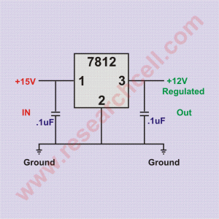](http://www.researchcell.com/electronics/7812-pin-and-circuit-diagram/attachment/7812-circuit-diagram/)

In electronics markets, 7812 is sold under various names such as 7812a, 7812act, 7812t and lm7812. All of them are almost identical with a little to no differences at all. 7812 input voltage range is 14V to 35V. Exceeding the voltage range may damage the IC. Given bellow is 7812 pin diagram to make the pinout connections clear in case you want to do some experiments.

### **SPDT Relay**

This type of a relay has a total of five terminals. Out f these two are the coil terminals. A common terminal is also included which connects to either of two others. Single Pole Double Throw Relay an electromagnetic switch, consist of a coil, 1 common terminal , 1 normally closed terminal, and one normally open terminal. When the coil of an SPDT relay is at rest (not energized), the common terminal and the normally closed terminal have continuity. When the coil is energized, the common terminal and the normally open terminal have continuity. When energizing the coil of a relay, polarity of the coil does not matter unless there is a [diode](http://www.the12volt.com/diodes/diodes.asp) across the coil. If a diode is not present, you may attach positive voltage to either terminal of the coil and negative voltage to the other, otherwise you must connect positive to the side of the coil that the cathode side (side with stripe) of the diode is connected and negative to side of the coil that the anode side of the diode is connected.

**Relay Applications**

* Relays are used to realize logic functions. They play a very important role in providing safety critical logic.
* Relays are used to provide time delay functions. They are used to time the delay open and delay close of contacts.
* Relays are used to control high voltage circuits with the help of low voltage signals. Similarly they are used to control high current circuits with the help of low current signals.

### **2N2222 Transistor**

The 2N2222 is a common [NPN](https://en.wikipedia.org/wiki/NPN_transistor) [bipolar junction transistor](https://en.wikipedia.org/wiki/Bipolar_junction_transistor) (BJT) used for general purpose low-power [amplifying](https://en.wikipedia.org/wiki/Amplifier) or switching applications. It is designed for low to medium[current](https://en.wikipedia.org/wiki/Electric_current), low [power](https://en.wikipedia.org/wiki/Electric_power), medium [voltage](https://en.wikipedia.org/wiki/Voltage), and can operate at moderately high speeds.

The 2N2222 is considered a very common transistor, and is used as an exemplar of an NPN transistor. It is frequently used as a small-signal transistor, and it remains a small general purpose transistor of enduring popularity.

Operational characteristics make the 2N2222 a low- to medium-current (up to 600 milliamps), low-power (up to 625 milliwatts), medium-voltage (up to 40 volts) device. Though these parameters may seem to limit the 2N2222’s usefulness, the 2N2222 is perfect for a host of signal manipulation and handling applications prior to high-power amplification. 2N2222 transistors are also used to condition signals before and after application to more advanced digital devices.

While the 2N2222 was the first of its kind, it has spawned a number of variants collectively called “2N2222 type” transistors, because they all share functional-construction and operational characteristics identical to the original 2N2222 transistor. Chief among these variants is the P2N2222 transistor, which is enclosed in a small black TO-92 package made of either epoxy or plastic. The combination of the large number of uses for the 2N2222 and the cost-effective TO-92 package has made the P2N2222 the least expensive and most used transistor in electronics.

* The main characteristics of this device may be understood with the following points:
* The transistor 2N2222 or 2N2222A are NPN types and has the following electrical parameters:
* The device’s maximum voltage tolerance (breakdown voltage) across its collector and base is 60 volts for 2N2222 and 75 volts for 2N2222A, with the emitters kept open.
* With their base open, the above tolerance across their collector and emitter leads is 30 volts for 2N2222 and 40 volts for 2N2222A.
* As expressed earlier, the maximum current that can be applied across the transistors collector and emitter, via a load is not more than 800 mA.
* Total power dissipation of the device should not exceed above 500 mW.
* hFE or the dC current gain of 2N2222 transistors will be around 75 minimum, at voltages near 10, with 10 mA collector current.
* Maximum frequency handling capacity or the transition frequency is 250 MHz for 2N2222 and 300 MHz for 2N2222A.
* The base-emitter saturation voltage for 2N2222 is typically 1.3 volts @ 15 mA, when the collector current is around 150 mA. With collector current exceeding 500 mA, the base optimal trigger voltage becomes 2.6 volts. For a 2N2222A, the figures are 1.2 and 2 volts respectively.

## Software(s), simulation tool(s) used

### Arduino development environment

This software is used for the programming of Arduino which have built in microcontroller controller. Arduino IDE is open source software. It is very easy to write code and upload it to the Arduino board. It can easily run on windows, Mac and Linux. It is based on based on the Processing multimedia programming environment. Arduino uno is preburned with bootloader that allows uploading new code with use of an external hardware programmer. The protocol used is STK500. [4]

## Testing Procedures

### Ultrasonic module HC-SR04

Ultrasonic module HC-SR04 is first connected to Arduino. First we measure a distance by scale manually and then by ultrasonic module HC-SR04 the result is accurate.

### Arduino uno

Connect the Arduino uno with computer and programmed it with LED blink code. When we burn the LED blink code in Adruino and start it, the on board LED starts blinking. This shows that the Arduino uno is working properly.

## Summary

In this chapter we discuss the technical specifications of hardware and software that we use in our project. The complete specification of components, Input voltages, Input currents, Input/output pins, dimensions, uses of each component, reliability and other factors are discussed in details. Application of every component is also listed. We also discuss about the software compiler that is used to program adruino uno. In last we discuss the testing procedure on each component.