**FINAL YEAR PROJECT REPORT**

**Design and Fabrication of Solar Concentrator using Fresnel Mirrors**

**Abstract**

In textile and other industries hot water and steam is used extensively in different processes i.e. washing, bleaching, dyeing and other chemical treatment processes. In tanneries, hot water and steam is used for cleaning and drying of leather respectively. Some polyester industries such heats up the oil and circulates all over the industry and at different workstations heat energy is extracted and used for various processes. So, these industries use natural gas and heavy furnace oil for generation of steam and heating purposes. Alternative energy can be used as a substitute of this fossil fuel. Alternative energy which is under consideration is solar energy which is abundant in Pakistan.

So to utilize this solar energy, solar concentrator using Fresnel mirrors was designed and fabricated. It consists of frame made up of steel pipes of dimension $72×48$ inch and mirrors were attached with it in a way that they can be rotated manually at angles. There are seven rectangular slabs of mirrors of approximately 0.2 inch thickness, set at particular angles so that these mirrors reflect and concentrate sunlight onto a linear receiver. Angle simulation for mirrors was done on MATLAB software as to check at which angle maximum solar radiations are reflected and concentrated on the receiver. Mirrors used were of dimension $69.6×5.00$ inch each, set at an angle on a frame, at focal point of mirrors solar vacuum tube is attached which act as a receiver. This tube allows light to pass through but traps radiant heat and the small air space acts to insulate the receiver and minimize heat losses. Receiver is filled with heat transfer fluid, this is basically a fluid with high thermal capacity and does not change phase at high temperatures. Sodium nitrate and therminol-66 are the best examples of heat transfer media. Due to limited finance heat transfer fluid used in this project is cooking oil. The unit was tested in a clear sunny day and the maximum temperature of oil achieved was about 200 0C. Hourly reading were taken from 9 am to 5 pm while mirrors were rotated manually 10 to 20 after every hour. Energy balance was done and energy output was 512 Watt.

Up-scaling of the project can results in production of enough steam through which we can drive steam turbines and produce megawatts of power.

**Acknowledgment**

Solar concentrator using Fresnel mirror has been successfully developed with a great contribution of some people in a period of one year. We like to appreciate their guidance, encouragement and willingness since without their support the project would not have been a success.

We would like to give our serious gratitude to Assistant Professor Zia Ud Din ([ziauddin@gmail.com](mailto:ziauddin@gmail.com)) who is the supervisor of our project for helping us in many ways. He gave us advices which were so helpful for us, which results in success of our project.

We are also grateful to the whole staff of School of Mechanical and Manufacturing Engineering NUST including Head of Department Dr Shahid Ikramullah Butt for their support.

Moreover thanks to Lecturer Adnan Hanif, and technicians at manufacturing resource center who also gave us advices related to our project.

Above all thanks to Al Mighty Allah for giving us will to do this project.

**Declaration**

We hereby declare that this submission is our own work and that to be the best of our knowledge and belief it contains neither material nor facts previously published or written by another person. Further it does not contain material or facts which to substantial extent has been accepted for award of any degree of university or any other institution of tertiary education except where an acknowledgment.

**Table of Content**

[1. **Objectives goals of projects** 9](#_Toc358711261)

[1.1 What do we stand to gain? 9](#_Toc358711262)

[1.2 This project can: 9](#_Toc358711263)

[2. **BACKGROUND** 9](#_Toc358711264)

[2.1 Need of Solar Power 10](#_Toc358711265)

[3. **THEORY** 10](#_Toc358711266)

[3.1 Photovoltaic cell 10](#_Toc358711267)

[3.1.1 Advantages 11](#_Toc358711268)

[3.1.2 Disadvantages 11](#_Toc358711269)

[3.2 Three types of collector used 12](#_Toc358711270)

[3.2.1 Low temperature solar collectors 12](#_Toc358711271)

[3.2.1.1 Unglazed, "transpired" air collector 12](#_Toc358711272)

[3.2.1.1.1 How they work 12](#_Toc358711273)

[3.2.1.1.2 Advantages of transpired air collectors 12](#_Toc358711274)

[3.2.1.1.2 Disadvantages 13](#_Toc358711275)

[3.2.2 High temperature solar collectors: 13](#_Toc358711276)

[3.3 Solar dish 14](#_Toc358711277)

[3.3.1 Solar Concentrator 14](#_Toc358711278)

[3.3.2 Power Conversion Unit 14](#_Toc358711279)

[3.4 Solar power tower 15](#_Toc358711280)

[3.4.1 Advantage 16](#_Toc358711281)

[3.4.2 Disadvantage 16](#_Toc358711282)

[3.5 Parabolic troughs 16](#_Toc358711283)

[3.5.1 Mirrors 17](#_Toc358711284)

[3.5.2 Mirror coatings 17](#_Toc358711285)

[3.5.3 Energy storage 18](#_Toc358711286)

[3.6 Fresnel lens collector 18](#_Toc358711287)

[3.6.1 Concentrating Linear Fresnel Reflector: 18](#_Toc358711288)

[3.6.1.1 Introduction 18](#_Toc358711289)

[3.6.1.2 General Description of a Linear Solar Fresnel Solar Plant 19](#_Toc358711290)

[3.6.2 CFLR components 19](#_Toc358711291)

[3.8 Heat Transfer Fluid: 20](#_Toc358711292)

[3.8.1 Thermally Stable 20](#_Toc358711293)

[3.8.2 Low Fouling 20](#_Toc358711294)

[3.9.3 Environment Friendly 20](#_Toc358711295)

[3.8.4 Ease of Pump and Circulation 20](#_Toc358711296)

[3.8.5 Minimized Make up Oil 20](#_Toc358711297)

[3.9 Therminol XP 20](#_Toc358711298)

[3.10 Salts 21](#_Toc358711299)

[3.10.1 Advantages 21](#_Toc358711300)

[3.10.2 Disadvantages 22](#_Toc358711301)

[3.12 Hot Oils 22](#_Toc358711302)

[3.12.1 Santhotherm 22](#_Toc358711303)

[3.12.2 Dowtherm 23](#_Toc358711304)

[3.12.2.1 Description 23](#_Toc358711305)

[3.13 Conclusion 23](#_Toc358711306)

[3.14 Absorber/ receiver tube 24](#_Toc358711307)

[3.15 Absorber 24](#_Toc358711308)

[4. **Design Phase** 25](#_Toc358711309)

[4.1 Calculation of output temperature of HTF 25](#_Toc358711310)

[4.3 Angle calculations and simulations 26](#_Toc358711311)

[4.4 Earth angles 28](#_Toc358711312)

[4.4.1 Hour angle (h) 28](#_Toc358711313)

[4.4.2 Declination angle 28](#_Toc358711314)

[4.4.3 Solar altitude angle (∝) 28](#_Toc358711315)

[4.4.4 Solar zenith angle (*wps_clip_image-14181*) 28](#_Toc358711316)

[4.4.5 Solar azimuth angle (z) 29](#_Toc358711317)

[4.5 Simulation results 29](#_Toc358711318)

[5. **Fabrication** 38](#_Toc358711319)

[5.1 First stage 38](#_Toc358711320)

[5.2 Second stage 38](#_Toc358711321)

[5.3 Third stage 38](#_Toc358711322)

[6. **Experimental Setup** 39](#_Toc358711323)

[Energy balance: 40](#_Toc358711324)

[*At 12:30* 40](#_Toc358711325)

[*At 13:00* 41](#_Toc358711326)

[*At 15:00* 41](#_Toc358711327)

[*At 16:00* 41](#_Toc358711328)

[At 1800 42](#_Toc358711329)

[6.1 Conclusion 43](#_Toc358711330)

[7. **Applications** 43](#_Toc358711331)

[8. **Future work** 44](#_Toc358711332)

[8.1 Automation 44](#_Toc358711333)

[8.2 Solar vacuum tube (double end open) 44](#_Toc358711334)

[8.3 Better heat transfer fluid: 44](#_Toc358711335)

[**Bibliography** 46](#_Toc358711336)

**LIST OF FIGURES**

[Figure 1: Solar Dish 17](#_Toc357470444)

[Figure 2: Solar Power Tower 17](#_Toc357470445)

[Figure 3: Parabolic Trough 19](#_Toc357470446)

[Figure 4: solar evacuated tube 26](#_Toc357470447)

[Figure 5: photograph of Solar Concentrator with Fresnel Mirrors 26](#_Toc357470448)

[Figure 6: model of solar concentrator frame made on Pro Engineer 28](#_Toc357470449)

[Figure 7: graph between altitude, azimuthal, zenith, declination angle and G. 31](#_Toc357470450)

[Figure 8: Graph between altitude, azimuthal, zenith, declination angle and Gb. 31](#_Toc357470451)

[Figure 9: graph between altitude, azimuthal, declination , zenith angle and G 32](#_Toc357470452)

[Figure 10: graph between altitude, azimuthal, declination, zenith angle and Gb 32](#_Toc357470453)

[Figure 11: graph between altitude, azimuthal, declination, zenith angle and 32](#_Toc357470454)

[Figure 12: graph between altitude, azimuthal, declination , zenith angle and Gb 33](#_Toc357470455)

[Figure 13: graph between altitude, azimuthal, declination, zenith angle and G 33](#_Toc357470456)

[Figure 14: graph between altitude, azimuthal, declination, zenith angle and Gb 34](#_Toc357470457)

[Figure 15: Graph between altitude, zenith, declination, azimuthal and G. 34](#_Toc357470458)

[Figure 16: Graph between altitude, azimuthal, zenith, declination angle and Gb. 35](#_Toc357470459)

[Figure 17: Graph between altitude, zenith, declination, azimuthal angle and G. 35](#_Toc357470460)

[Figure 18: graph between altitude, azimuthal, zenith, declination angle and Gb 36](#_Toc357470461)

[Figure 19: graph between altitude, azimuthal, declination , zenith angle and G 36](#_Toc357470462)

[Figure 20: Graph between altitude, azimuthal, zenith, declination angle and Gb 37](#_Toc357470463)

[Figure 21: graph between altitude, azimuthal, declination , zenith angle and G 37](#_Toc357470464)

[Figure 22: Graph between altitude, azimuthal, zenith, declination angle and Gb. 38](#_Toc357470465)

[Figure 23: Graph between altitude, zenith, declination, azimuthal and G. 38](#_Toc357470466)

[Figure 24: Graph between altitude, azimuthal, zenith, declination angle and Gb 39](#_Toc357470467)

[Figure 25: graph between temperature difference in 0C and time in hours. 40](#_Toc357470468)

[Figure 26: graph is plotted between heat energy and time in hours 43](#_Toc357470469)

**LIST OF TABLES**

[Table 1: properties of different heat transfer media 23](#_Toc357467479)

[Table 2: table shows boiling point of therminol-66 and maximum bulk, minimum film temperature. 24](#_Toc357467480)

[Table 3: table shows change in properties of therminol-66 at different temperature 25](#_Toc357467481)

[Table 4: table shows at different tilt angle and time interval, hour angle, declination anglem altitude angle, zenith angle, azimuthal angle and radiation at tilt surface and horizenatal surface for mirrors 29](#_Toc357467482)

[Table 5: Table shows at different time interval initial and final temperatures and their difference 40](#_Toc357467483)

[Table 6: Table shows at different time intervals initial and final temperature of cooking oil and heat energy. 43](#_Toc357467484)

# Objectives goals of projects

The aim of this project is to design simulate and fabricate 2.0  1.0 meter solar concentrator using Fresnel mirrors that utilizes solar radiation for generation of energy of 500 Watt

* It has least running cost
* High reliability to demonstrate students on regular basis the use of solar power during the day.
* Validate the solar concentrator cost less than Rs 16000/ - for production of 500 Watt.

## What do we stand to gain?

Considering the exponential growth in the prices of fossil fuel and hence utilities using fuel, alternative methods need to be found immediately.

## This project can:

* Highlight the potential of solar energy used in Pakistan

.

* Create a great platform for the future students to work and make it more efficient in a way that they can increase production of power at low cost.

# BACKGROUND

With the advancement of technology and the usage of many electronic devices, life becomes very difficult without electricity. Hence the ample supply of electricity that can match the power requirement of industry is key to progress.

Fossil fuels are nonrenewable resources because they take millions of years to form and reserves are being depleted much faster than new ones are being formed. The production and usage of fossil fuels such as coal, natural gas and nuclear also raise the environmental concerns therefore the global movement toward the generation of renewable energy is under way to help meet increased energy needs. Wood, wind, water and sun power have been used for cooking, heating and other tasks. During industrial revolution these forms of renewable energy was replaced by fossil fuels such as coal and petroleum. Attention has refocused on renewable energy sources since 1960s and 1970s not because of concern over fossil fuel depletion, but also because of apprehension over acid rain and global warming from the accumulation of carbon dioxide in the atmosphere.

Fossil fuels are becoming even more expensive especially after oil embargo of 1970s. As price of oil is rising and its supply is uncertain. Even if supply of oil is continuous, the cost of importing oil is tremendous (which will deplete the National exchequer) and Pakistan therefore has to borrow from institution like IMF and World Bank which deepens the debt problem. In year 2006, Pakistan imported crude worth 6.7 Billion Dollars. In such situation solar power is the need of the hour since these problems will be eliminated. Also land of Pakistan is well endowed for solar energy projects since it has vast tracts of desert region that receives large amount of sunshine throughout the year.

Renewable energy resources are cleaner and far more abundant than fossil resources but they tend to dispersed and more expensive to collect. Many of them such as wind and solar are intermittent in nature, making energy storage or distributed product systems necessary. Therefore direct cost of renewable energy is generally higher than the direct cost of fossil fuels. At the same time fossil fuel have significant indirect or external costs such as pollution acid rain, and global warming.

## Need of Solar Power

We live in an energy starved country. There are widespread power outages across cities and towns in Pakistan. Even if abundant power was available, tariff will continue to increase at astronomical rates. In our uncertain energy environment, on-site solar power is the only way to secure energy future for households, businesses, factories, and farms. On-site production of electric power using generators is expensive and polluting. Generator fuel supply is uncertain. UPS as a backup source is insufficient because the duration of power outage is very long. Solar power is a pollution-free, noise-free, fuel-free, maintenance-free, and cost effective method to produce electric power.

Recent report on current status of the reserves of fossil fuels point to the need to switch to alternative energies such as solar power, even without considering environmental impact, it is clear that some stage we will not be able to meet our ever increasing energy needs from finite supply of these nonrenewable resources.

# THEORY

In today world some of methods to harness solar power are:

* Photovoltaic cells

Solar thermal power plants

* Parabolic troughs/ dish collector
* Flat plate collector
* Solar power towers
* Solar updraft towers
* Solar ponds
* Solar dishes

## 3.1 Photovoltaic cell

Solar photovoltaic cells are arrays of cell containing a material that converts solar radiation into DC electricity. Materials that presently used for photovoltaic include amorphous silicon, cadmium telluride and copper indium selenide/sulphide.

At the end of 2008, the cumulative global PV installation reached 15200 Megawatts. Roughly 90% of generating capacity consist of grid tied electrical systems. Such as installation may be ground mounted and sometime integrated with farming and grazing or built into roof or walls of a building, known as integrated photovoltaic. Solar PV have capacities ranging from 10-60 MW although proposed solar PV power station have capacity of 150 MW or more.

### 3.1.1 Advantages

* PV installation can operate for many years as solar cells have a life of 25 years, little maintenance and or intervention after initial setup, so after initial capital cost of building any solar power plant, operating cost extremely low compared to existing power technologies.
* PV is economically superior where grid connection or fuel transport is difficult, costly or impossible. Long standing examples include satellites, island communities, remote location and ocean vessels.
* When grid connected solar electric generation replaces some or all of highest cost electricity used during times of peak demand (in most climatic region). This can reduce grid loading and can eliminated need for local battery power for use in times of darkness. These features are enabled by net metering.
* Grid connected solar electricity can be used locally thus reducing transmission and distribution losses.
* Compared to fossil and nuclear energy sources, very little research money has been invested in the development of solar cells so there is considerable room for improvement nevertheless, experimentally high efficiency solar cells already have efficiencies of 40 percent and efficiencies are rapidly rising while mass production cost is rapidly falling.

### 3.1.2 Disadvantages

* Photovoltaic are costly to install. While modules are often warranted for 25 years. An investment in home mounted system is mostly lost if you move.
* Solar electricity is seen to be expensive. Once a PV system is installed it will produce electricity for no further cost until the inverter needs replacing but timetable for payback is too long for most.
* Solar electricity is not available at night and is less available in cloudy and weather conditions from conventional silicon based technologies therefore a storage or complementary power system is required. However the use of germanium ( more expensive then silicon) in amorphous silicon-germanium thin film solar cells provides residual power generating capacity at night due to background infrared radiation.
* Solar cell produce DC which must be converted to AC (using grid tie inverter) when used in current existing distribution grids. This incurs energy loss of 4-12 percent.
* Silicon solar cell manufacturer is not available in Pakistan and quite expensive to import and install so it is not a feasible option to generate required output.

## 3.2 Three types of collector used

### 3.2.1 Low temperature solar collectors

Glazed Solar Collectors are designed primarily for space heating and they recirculate building air through a solar air panel where the air is heated and then directed back into the building. These solar space heating systems require at least two penetrations into the building and only perform when the air in the solar collector is warmer than the building room temperature. Most glazed collectors are used in the residential sector.

#### 3.2.1.1 Unglazed, "transpired" air collector

A device that uses the sun's energy to heat cold outside air for use in buildings. In so doing, it reduces the amount of space heating needed to keep buildings comfortable on cold days. Because transpired air collectors dramatically reduce utility bills, they can pay for themselves in just a few years. This new technology provides an effective means for substituting renewable energy for fossil fuel consumption, particularly in cold climates

##### **3.2.1.1.1 How they work**

Transpired air collectors use a simple, elegant technology to capture the sun's heat to warm buildings. The collectors consist of dark, perforated metal plates installed over a building's south-facing wall. An air space is created between the old wall and the new facade. The dark outer facade absorbs solar energy and rapidly heats up on sunny days – even when the outside air is cold.

A fan or blower draws ventilation air into the building through hundreds of tiny holes in the collectors and up through the air space between the collectors and the south wall. The solar energy absorbed by the collectors warms the air flowing through them by as much as 40°F.

Unlike older space heating technologies, transpired air collectors require no expensive glazing, which caused energy loss due to reflection. The lack of glazing, together with design refinements, allows the new collectors to capture a remarkable 80% of available solar energy.

##### 

##### **3.2.1.1.2 Advantages of transpired air collectors**

Transpired air collectors have many advantages. They are the most efficient solar collectors in the world. They pay for themselves quickly and produce environmental and economic benefits with no negative side effects. They are suitable for many large buildings.

Transpired air collectors are virtually maintenance free and contain no moving parts other than the ventilation system fans. At night, they reduce the amount of heat escaping from buildings by recapturing heat lost through the building wall behind the collectors. Transpired air collectors also help improve indoor air quality because good ventilation is an integral part of the system.

Transpired air collectors are versatile. They can be added to existing buildings or designed as part of a new building's facade. Commercial transpired air collectors use attractive metal sheeting and are available in many colors. When used in new construction, "solar walls" can save money on the building's facade. They pay for themselves even faster when installed in new buildings than when they are retrofitted to existing ones.

Transpired airs collectors are easier to use, cost less, and are more efficient than older solar air collectors made with glazing. Their installation is simple. They require fewer materials. And they absorb more solar energy, making them more efficient. Transpired air collectors reduce the amount of energy needed for space heating in cold climates. Lower energy requirements translate into reduced building operation costs and less reliance on fossil fuels such as natural gas, heating oil, and coal. To the extent renewable energy replaces fossil fuels, there are fewer emissions of pollutants and greenhouse gases.

##### 

##### **3.2.1.1.2 Disadvantages**

There are few disadvantages to using transpired air collectors. However, some multistory buildings have fire codes that make transpired collectors impractical. Existing heat-recovery systems in some buildings may also be incompatible with transpired air collectors.

### 

### 3.2.2 High temperature solar collectors:

Where temperatures below about 95°C are sufficient, as for space heating, flat-plate collectors of the non concentrating type are generally used. Because of the relatively high heat losses through the glazing, flat plate collectors will not reach temperatures much above 200 °C even when the heat transfer fluid is stagnant. Such temperatures are too low for efficient conversion to electricity.

The efficiency of heat engines increases with the temperature of the heat source. To achieve this in solar thermal energy plants, solar radiation is concentrated by mirrors or lenses to obtain higher temperatures – a technique called Concentrated Solar Power.

As the temperature increases, different forms of conversion become practical. Up to 600 °C, steam turbines, standard technology, have efficiency up to 41%. Above 600 °C, gas turbines can be more efficient. Higher temperatures are problematic because different materials and techniques are needed. One proposal for very high temperatures is to use liquid fluoride salts operating between 700 °C to 800 °C, using multi-stage turbine systems to achieve 50% or more thermal efficiencies. The higher operating temperatures permit the plant to use higher-temperature dry heat exchangers for its thermal exhaust, reducing the plant's water use critical in the deserts where large solar plants are practical. High temperatures also make heat storage more efficient, because more watt-hours are stored per unit of fluid.

Since the CSP plant generates heat first of all, it can store the heat before conversion to electricity. With current technology, storage of heat is much cheaper and more efficient than storage of electricity. In this way, the CSP plant can produce electricity day and night. If the CSP site has predictable solar radiation, then the CSP plant becomes a reliable power plant. Reliability can further be improved by installing a back-up combustion system. The back-up system can use most of the CSP plant, which decreases the cost of the back-up system.

CSP facilities utilize high electrical conductivity materials, such as copper, in field power cables, grounding networks, and motors for tracking and pumping fluids, as well as in the main generator and high voltage transformers.

With reliability, unused desert, no pollution, and no fuel costs, the obstacles for large deployment for CSP are cost, aesthetics, land use and similar factors for the necessary connecting high tension lines. Although only a small percentage of the desert is necessary to meet global electricity demand, still a large area must be covered with mirrors or lenses to obtain a significant amount of energy. An important way to decrease cost is the use of a simple design.

Some of high temperature solar concentrators are mentioned below:

## Solar dish

The dish/engine system is a concentrating solar power (CSP) technology that produces relatively small amounts of electricity compared to other CSP technologies typically in the range of 3 to 25 kilowatts. Dish/engine systems use a parabolic dish of mirrors to direct and concentrate sunlight onto a central engine that produces electricity. The two major parts of the system are the solar concentrator and the power conversion unit.

### 3.3.1 Solar Concentrator

The solar concentrator, or dish, gathers the solar energy coming directly from the sun. The resulting beam of concentrated sunlight is reflected onto a thermal receiver that collects the solar heat. The dish is mounted on a structure that tracks the sun continuously throughout the day to reflect the highest percentage of sunlight possible onto the thermal receiver.

### 3.3.2 Power Conversion Unit

The power conversion unit includes the thermal receiver and the engine/generator. The thermal receiver is the interface between the dish and the engine/generator. It absorbs the concentrated beams of solar energy, converts them to heat, and transfers the heat to the engine/generator. A thermal receiver can be a bank of tubes with a cooling fluid, usually hydrogen or helium that typically is the heat-transfer medium and also the working fluid for an engine. Alternate thermal receivers are heat pipes, where the boiling and condensing of an intermediate fluid transfers the heat to the engine.

The engine/generator system is the subsystem that takes the heat from the thermal receiver and uses it to produce electricity. The most common type of heat engine used in dish/engine systems is the Stirling engine. A Stirling engine uses the heated fluid to move pistons and create mechanical power. The mechanical work, in the form of the rotation of the engine's crankshaft, drives a generator and produces electrical power.

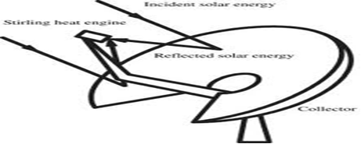

Figure 1: Solar Dish

Source: intechopen.com

## 

## 3.4 Solar power tower

Solar power towers generate electric power from sunlight by focusing concentrated solar radiation on a tower-mounted heat exchanger (receiver). The system uses hundreds to thousands of sun-tracking mirrors called heliostats to reflect the incident sunlight onto the receiver. These plants are best suited for utility-scale applications in the 30 to 400 MW range. In a molten-salt solar power tower, liquid salt at 290ºC is pumped from a ‘cold’ storage tank through the receiver where it is heated to 565ºC and then on to a ‘hot’ tank for storage. When power is needed from the plant, hot salt is pumped to a steam generating system that produces superheated steam for a conventional Rankine cycle turbine/generator system. From the steam generator, the salt is returned to the cold tank where it is stored and eventually reheated in the receiver. Determining the optimum storage size to meet power-dispatch requirements is an important part of the system design process. Storage tanks can be designed with sufficient capacity to power a turbine at full output for up to 13 hours. Consequently, a power tower could potentially operate for 65% of the year without the need for a back-up fuel source. Without energy storage, solar technologies are limited to annual capacity factors near 25%.

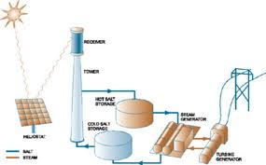

Figure 2: Solar Power Tower

Source: Alternativeenergy.primer.com

### 

### 3.4.1 Advantage

* High temperature can be achieved which lead to higher efficiencies.
* Flat mirror can be used which are cheap as compared to curved mirrors.

### 3.4.2 Disadvantage

* Large areas of land required
* Technology requires storage for stable power output
* Cost of this energy is three times higher than conventional of power generation as with all technologies.
* The tall tower is also difficult to construct
* Each mirror needs its own heliostat which is quite expensive.

## 3.5 Parabolic troughs

A parabolic trough is a type of solar thermal energy collector. It is constructed as a long parabolic mirror (usually coated silver or polished aluminum) with a Dewar tube running its length at the focal point. Sunlight is reflected by the mirror and concentrated on the Dewar tube. The trough is usually aligned on a north-south axis, and rotated to track the sun as it moves across the sky each day. Alternatively the trough can be aligned on an east-west axis; this reduces the overall efficiency of the collector, due to cosine loss, but only requires the trough to be aligned with the change in seasons, avoiding the need for tracking motors. This tracking method works correctly at the spring and fall equinoxes with errors in the focusing of the light at other times during the year (the magnitude of this error varies throughout the day, taking a minimum value at solar noon). There is also an error introduced due to the daily motion of the sun across the sky, this error also reaches a minimum at solar noon. Due to these sources of error, seasonally adjusted parabolic troughs are generally designed with a lower solar concentration ratio. In order to increase the level of alignment, some measuring devices have also been invented. Parabolic trough concentrators have a simple geometry, but their concentration is about 1/3 of the theoretical maximum for the same acceptance angle, that is, for the same overall tolerances for the system. Approaching the theoretical maximum may be achieved by using more elaborate concentrators based on primary-secondary designs using non imaging optics. Heat transfer fluid (usually oil) runs through the tube to absorb the concentrated sunlight. This increases the temperature of the fluid to some 400°C. The heat transfer fluid is then used to heat steam in a standard turbine generator. The process is economical and, for heating the pipe, thermal efficiency ranges from 60-80%. The overall efficiency from collector to grid, i.e. (Electrical Output Power) / (Total Impinging Solar Power) is about 15%, similar to PV (Photovoltaic Cells) but less than Stirling dish concentrators. Current commercial plants utilizing parabolic troughs are hybrids; fossil fuels are used during night hours, but the amount of fossil fuel used is limited to a maximum 27% of electricity production, allowing the plant to qualify as a renewable energy source. Because they are hybrids and include cooling stations, condensers, accumulators and other things besides the actual solar collectors, the power generated per square meter of area varies enormously.

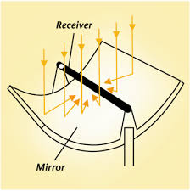

Figure 3: Parabolic Trough

Source: greenterrafirma.com

### 

### 3.5.1 Mirrors

Usually mirrors are used which are parabolic and are of single piece. In addition V type parabolic troughs exists which are made from two mirrors and placed at angle toward each other.

### 3.5.2 Mirror coatings

In 2009, scientists at National Renewable Energy Laboratory (NREL) and skyfuel teamed to develop large curved sheets of metal that have potential to be 30% less expensive than today’s best collector of concentrated solar power by replacing glass based models with a silver polymer sheet that has same performance as the heavy glass mirrors but at a much lower cost and much lower weight. It is also much easier to deploy and install. The glossy film use several layer of polymers with an inner layer of pure siver.

### 3.5.3 Energy storage

As this nonrenewable source of energy is inconsistent by nature, method of energy storage has been studied, for instance the single tank (thermocline) storage technology for large scale thermal power plants. The thermocline tank approach uses a mixture of silica sand and quartzite rock to displace a significant portion of volume in the tank. Then it is filled with heat transfer fluid, typically a molten nitrate salt.

## 3.6 Fresnel lens collector

A Fresnel lens is a type of lens developed by French physicist Augustin-Jean Fresnel for lighthouses. A similar design had previously been proposed by Buffon and Condorcet as a way to make large burning lens.

The design enables construction of lenses of large aperture and short focal length without the weight and volume of material that would be required in conventional lens design. Compared to earlier lenses, the Fresnel is much thinner; thus passing more light and allowing lighthouses to be more visible at long distances.

The Fresnel lens reduces the amount of material required compared to conventional spherical lens by breaking the lens into concentric annular sections known as Fresnel zones. In the first variation of lens, each zone was actually a different prism. Though Fresnel lens might look like a single piece of glass, closer examination reveals that it is many pieces. It was not until CNC could turn out large complex pieces that these lenses were manufactured from single piece of glass.

For each of these zones the overall thickness of these lenses is decreased, effectively chopping continuous surface of standard lens into a set of surfaces of the same curvature with discontinuities between them. This allows substantial reduction in thickness (and thus weight and volume of the material) of the lens, at the expense of reducing the image quality of the lens.

### 3.6.1 Concentrating Linear Fresnel Reflector:

The linear solar Fresnel system is one type of solar concentrator being developed to create a high fluid temperature for high efficiency solar plant electrical generation. The solar mirror in a solar Fresnel system sends concentrated solar power to a receiver fluid as part of a solar power plant.

#### 3.6.1.1 Introduction

The linear solar Fresnel solar power system, often called compact linear Fresnel reflector (CLFR) technology, uses a series of linear solar mirrors, but each solar mirror is flat instead of the more expensive parabolic shape used for a parabolic trough solar plant. This is one of the solar concentrator technologies being developed to improve the efficiency for conversion of solar power to electricity.

#### 3.6.1.2 General Description of a Linear Solar Fresnel Solar Plant

A linear solar Fresnel solar plant uses an array of single axis, linear solar mirrors to reflect sunlight onto a receiver tube. In that way it is similar to a solar parabolic trough system. The compact linear Fresnel solar power system, however, uses a 'parabola' made up of ten flat mirrors that each rotate to follow the sun, Instead of a more expensive parabolic shaped mirror, as in the solar parabolic trough system. This type of system allows the flat solar mirrors to remain near the ground, avoiding wind loads. The diagrams in this section show a couple different views of a set of compact linear Fresnel mirrors with an absorber tube above them.

Current designs for the linear solar Fresnel system heat water to produce steam at 545 0F in the absorber tubes. The steam is used directly to drive a turbine in a standard Rankine cycle to produce electricity, avoiding the need for a heat exchanger to produce steam from some other high temperature fluid.

### 3.6.2 CFLR components

Compact Linear Fresnel Reflector consists of following components:

* Heat transfer fluid
* Absorber tube/ receiver
* Storage
* Flat mirrors
* Heat exchanger
* Steam generator

**3.7 Why Fresnel Mirror technology selected?**

* Flat solar mirrors used in the solar Fresnel technology are less expensive than the parabolic shaped solar mirror of the parabolic trough or the parabolic dish.
* The absorber tube is simpler and less expensive than that of the parabolic trough system, because multiple solar mirrors reflect solar power to a single absorber tube and the absorber tube doesn't need couplings as the receiver tubes for the parabolic trough and parabolic dish systems do, because the absorber tube is fixed.
* A linear solar Fresnel solar plant can be hybridized with fossil fuel backup to be used for electrical generation when the sun isn't shining.
* Flat solar Fresnel reflectors don't need to support the absorber tube, so they are structurally simpler than the parabolic trough and parabolic dish systems.

## 

## 3.8 Heat Transfer Fluid:

Our next task is to select oil for heat transfer so for this purpose we kept following things in our mind which are mentioned below:-

### 3.8.1 Thermally Stable

HTF should be thermally stable. User can expect many years of reliable, trouble free operation even when operating continuously at the recommended maximum temperature.

### 3.8.2 Low Fouling

Chemical composition of oil should be carefully selected in order to minimize system fouling from oxidation and degradation of fluid.

### 3.9.3 Environment Friendly

It should be environmental friendly.

### 3.8.4 Ease of Pump and Circulation

Excellent Stability helps assure minimal oxidation and helps prevent sludging or deposit formation inside piping.

### 3.8.5 Minimized Make up Oil

Low vapor pressure combined with low volatility and high flash point means minimum evaporative loss.

Some of Heat transfer fluids are mentioned below:

## 3.9 Therminol XP

* Therminol XP heat transfer fluid is an extremely pure white mineral oil which provides reliable heat transfer at temperatures from 0° F to 600° F (-20° C to 315° C). Performance features of Therminol XP include:
* Low Fouling - Because Therminol 55 is a synthetic fluid, it resists the effects of oxidation 10 times better than mineral oils. Less oxidation means less solids formation and much less fouling. For systems without nitrogen inerting, the performance advantages are significant.
* Practically Non-Toxic - As an indicator of purity, Therminol XP meets FDA specifications defined in 21 CFR 172.878 and requirements of United States Pharmacopeia (USP) and National Formulary (NF).
* Thermal Stability - Therminol XP is stable to 600°F (315°C). Users can expect many years of reliable, trouble-free operation, even when operating continuously at the recommended maximum temperature of 600° F (315°C).
* Environmentally Friendly - Therminol XP has outstanding regulatory status for those seeking heat transfer fluids which have minimum environmental reporting requirements.
* Pumped at low temperature - Therminol 55 can be pumped at -15° F (-25° C), long after mineral oils have become jelly-like. In fact, some mineral oils will not pump at temperatures below 20° F (-7° C). With Therminol 55, your heat transfer fluid system can start-up quickly and easily.
* Long Life - Therminol 55 is a true 550° F (290° C) fluid. You will get years of reliable, cost effective performance, even when operating your system continuously at 550° F (290° C). This means you do not have to over specify your fluid.

## 3.10 Salts

We can also use different types of salts as a heat transfer fluid such as sodium nitrite, potassium nitrite, lithium nitrite, calcium nitrite etc.

Properties of these salts are mentioned in a table 1.

|  |  |  |  |  |  |
| --- | --- | --- | --- | --- | --- |
| Property | solar salt | Hitec | Hitec XL(calcium nitrate salt) | LiNO3 mixture | therminol VP-1 |
| composition% |  |  |  |  |  |
| NaNO3 | 60 | 7 | 7 |  |  |
| KNO3 | 40 | 53 | 45 |  |  |
| NaNO2 |  | 40 |  |  |  |
| Ca (NO3)2 |  |  | 48 |  |  |
| freezing point C | 220 | 142 | 120 | 120 | 13 |
| upper temperature | 600 | 535 | 500 | 550 | 400 |
| Density | 1899 | 1640 | 1992 |  | 815 |
| Viscosity | 3.26 | 3.16 | 6.37 |  | 0.2 |
| heat capacity | 1495 | 1560 | 1447 |  | 2319 |
| Temp. Rise | 200 | 200 | 150 |  | 100 |

Table 1: properties of different heat transfer media

### 3.10.1 Advantages

* Can raise solar field output temperature to 450-500°C
* Rankine cycle efficiency increases to ≥40% range
* ΔT for storage up to 2.5x greater
* Salt is less expensive and more environment friendly than present HTF
* Thermal storage cost drops 65% to <$20/kWh compared to VP-1 HTF plant (no oil-to-salt HX)
* Solar Two experience with salts pertinent and valuable (piping’s, valves, pumps).

### 3.10.2 Disadvantages

* High freezing point of candidate salts
  + - Leads to significant O&M challenges
    - Innovative freeze protection concepts required
* More expensive materials required in HTF system due to higher possible HTF temperatures.
* Selective surface durability and salt selection will determine temperature limits.
* Solar field heat losses will rise, though emissivity of 0.075(from 0.1) would regain performance.

## 

## 3.12 Hot Oils

The hot oils are petroleum-based and most consist of paraffinic and/or naphthenic hydrocarbons. The overall bulk fluid temperature operating range of the petroleum-based fluids is from -10°F to 600°F, with the high-grade hydrogenated white oils strongly recommended for applications requiring bulk fluid temperatures in the 575°F to 600°F range.

In **Ibrahim fibers** HTM (Heat Transfer Medium) used are mentioned below:

Santhotherm and Dowtherm are used as HTM (Heat Transfer Medium). HTM is heated in the furnaces. Natural Gas is being used as a fuel in the furnace.

### 3.12.1 Santhotherm

(Partially hydrogenated terephenyl liquid form) having temperature of 330oC as it circulates in coil. Some of the Physical properties of Santotherm are given by

* It has less thermal degradation
* It has low freezing point
* It has higher thermal conductivity
* It has high boiling point
* It is used again and again with no change in properties
* It is less volatile organic oil

### 3.12.2 Dowtherm

(Diphenyl- Diphenyl ether in vapor form) having temperature of 280-290oC. It is usually present in jackets. It is used for uniform heating.

#### 3.12.2.1 Description

Heating the santotherm and sending it to the reactor; ESI is main reactor and used up to 80% of this heat. Dowtherm vapors are heated by santotherm For heating two furnaces are used. Every furnace has its running time schedule which is mostly 6 months. At one time one furnace works while other is stand by.

The most important thing is the flow in and out of furnace pumps should supply a flow rate of $340 m3/h$. There is a steam line coming from boiler to HTM area to different place such as preheater in HTM.

### 3.13 Conclusion

Therminol-66 is a best heat transfer fluid for this project after analyzing all HTF's because boiling point of therminol-66 is about 3500C and with the help of this concentrator temperature achieved was about 2000C.

|  |  |
| --- | --- |
| Composition | Hydrogenated terephenyl |
| Appearance | Clear pale yellow liquid |
| Maximum bulk temperature | 345oC |
| Minimum film temperature | 375oC |
| Boiling point | 359oC` |

Table 2: table shows boiling point of therminol-66 and maximum bulk, minimum film temperature.

|  |  |  |  |  |  |
| --- | --- | --- | --- | --- | --- |
| Temperature | Density | Thermal conductivity | Heat capacity | Viscosity | |
| Dynamic | Kinematic |
| 0 | 1021.5 | 0.118 | 1.495 | 1324.87 | 1297.01 |
| 10 | 1014.9 | 0.118 | 1.529 | 344.26 | 339.20 |
| 20 | 1008.4 | 0.118 | 1.562 | 123.47 | 122.45 |
| 30 | 1001.8 | 0.117 | 1.596 | 55.60 | 55.51 |
| 40 | 995.2 | 0.117 | 1.630 | 29.50 | 29.64 |
| 50 | 988.6 | 0.116 | 1.665 | 17.64 | 17.84 |
| 60 | 981.9 | 0.116 | 1.699 | 11.53 | 11.74 |

Table 3: table shows change in properties of therminol-66 at different temperature

## 3.14 Absorber/ receiver tube

The receiver is the part of the system that converts solar radiation to heat energy in a working fluid. The receiver consists of an absorber, heat exchanger and possibly heat storage. The absorber is the impinging surface for reflected solar radiation to strike. Radiation is absorbed into the absorber material as heat. The heat exchanger transfers the energy to a working fluid that carries the energy out of the receiver. Equation shows an energy balance for a receiver.

$$Qout-Qabs=Qloss$$

Where:

$Qout=$ Useful energy transferred to working fluid.

$Qabs=$ Energy collected by the absorber

$Qloss=$ Receiver energy losses

Total receiver efficiency is given by Equation

$$Efficiency= Qout/Qabs$$

## 3.15 Absorber

There are 2 types of absorbers; external and cavity. An external absorber is essentially a flat plate. The reflected radiation impinges on the plate and heats the surface. External absorbers are extremely simple and cheap but have much inefficiency. External absorbers are directly exposed to ambient air and at high temperatures convection losses can be extreme. Temperature stratification will also occur inside the receiver. With all of the heating being done solely on one end of the receiver, the internal temperature will vary depending on the distance away from the absorber surface. Consequently, the heat exchanger efficiency can be reduced. The last drawback discussed is reflective absorption. For an external absorber, if any radiation is reflected off the surface, it is reflected away from the absorber and lost. These problems can be reduced by using a cavity absorber. The absorber is recessed inside the receiver. Solar radiation is reflected by the concentrator through an opening, referred to as the receiver aperture, and is collected on the absorber surface. Most modern receivers are of this type. Cavity absorbers are more expensive and complicated than external absorbers, but are much more efficient. If any radiation reflects off the absorber surface it is reflected onto another part of the absorber. In this way, the absorber has an increased chance of absorbing radiation each time light strikes its surface. If we assumed a cavity receiver with an inner surface 5 times the aperture area, and surface absorptivity of 0.7, the effective absorptivity would increase to 0.92. The effective absorptivity of a cavity is always higher than that of a flat plate. A receiver is completely insulated except for the absorber. As absorber size increases, energy intercepted from the concentrator increases, as given by the intercept factor. Although as this happens, thermal loses to the environment also increase. We are using three target solar vacuum tube with cavity as an absorber tube its features are following:

* Excellent performance of absorbing, but low heat loss, especially adapted to sever cold regions,(super heat preservation).
* Excellent resistance of burst.
* Excellent resistance of corrosion, long life span ( up to 15 years).
* Reducing the fouling on the tube wall, keeping water clean.
* Evacuated tubes are aligned in parallel; the angle of mounting depends upon the latitude of your location. In a North South orientation the tubes can passively track heat from the sun all day. In an East West orientation they can track the sun all year round.
* The efficiency of an evacuated water heater is dependent upon a number of factors, one important one being the level of evacuated radiation (insulation) in your region.

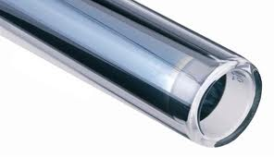

Figure 4: solar evacuated tube

Source: solarpower.co.uk

# Design Phase

Picture shows the model of solar concentrator which is able to produce energy of 500 Watt.

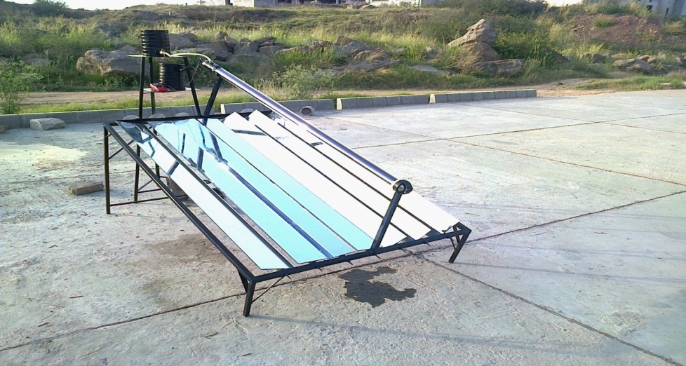

Figure 5: photograph of Solar Concentrator with Fresnel Mirrors

## 

## 4.1 Calculation of output temperature of HTF

We calculated output temperature theoretically; this shows that to achieve power output of 500 Watt, the temperature of Heat transfer fluid therminol-66 should rise up to 1550C.

**Energy balance**:

30 0C

1550C

**4.2 Design of frame:**

*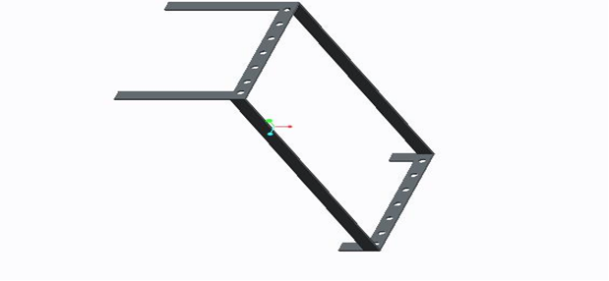*

Figure 6: model of solar concentrator frame made on Pro Engineer

## 4.3 Angle calculations and simulations

Frame was at an angle of 300 with respect to the ground facing south and mirrors were attached with it in a way that they can be rotated manually. Angle simulation for these mirrors was done on MATLAB software in order to check at which particular angle of mirrors will result in maximum reflection of solar radiations. So table and graphs are shown below which shows the result of simulation.

|  |  |  |  |  |  |  |  |  |
| --- | --- | --- | --- | --- | --- | --- | --- | --- |
| B (Tilt angle) = 0 | | | | | | | | |
|  | H(Hour angle)=-30 | | | H(Hour angle)=0 | | H(Hour angle)=30 | | H(Hour angle)=60 | |
| Altitude angle(a) | | Azimuthal Angle(z) | Altitude angle(a) | Azimuthal Angle(z) | Altitude angle(a) | Azimuthal Angle(z) | Altitude angle(a) | Azimuthal Angle(z) |
| G | 48.69(3899W/m^2) | | |  | | --- | | 41.31(3899W/m ^2) | | |  | | --- | | 59.60(4500W/m ^2) | | |  | | --- | | 30.40(4500W/m ^2) | | |  | | --- | | 61.31(3947W/m ^2) | | |  | | --- | | 28.69(3947W/m ^2) | | |  |  | | --- | --- | | 36.54(3899W/m ^2) |  | | 53.46(3899W/m ^2) |
| G­b | 61.31(3947W/m ^2) | | 28.69(3947W/m ^2) | 78.63(4412 W/m ^2) | 11.37(4412 W/m ^2) | 61.31(3947 W/m ^2) | 28.69(3947 W/m ^2) | 36.54(2679 W/m ^2) | 53.46(2679 W/m ^2) |
|  | B (Tilt angle) = 30 | | | | | | | | |
| G | 48.69(3899W/m ^2) | | 41.31(3899 W/m ^2) | 59.60(4500 W/m ^2) | 30.40(4500 W/m ^2) | 61.31(3947 W/m ^2) | 28.69(3947 W/m ^2) | 36.54(3899 W/m ^2) | 53.46(3899 W/m ^2) |
| G­b | 36.98(3920W/m ^2) | | 56.02(3920 W/m ^2) | 45.32(4500 W/m ^2) | 44.68(4500 W/m ^2) | 36.98(3920 W/m ^2) | 53.02(3920 W/m ^2) | 9.621(2635 W/m ^2) | 80.38(2635 W/m ^2) |
|  | B (Tilt angle) = 45 | | | | | | | | |
| G | 61.31(3947 W/m ^2) | | 28.69(3947 W/m ^2) | 78.63(4412 W/m ^2) | 11.37(4412 W/m ^2) | 61.31(3947 W/m ^2) | 28.69(3947 W/m ^2) | 36.54(2679 W/m ^2) | 53.46(2679 W/m ^2) |
| G­b | 36.98(3920 W/m ^2) | | 36.98(3920 W/m ^2) | 45.32(4500 W/m ^2) | 44.68(4500 W/m ^2) | 36.98(3920 W/m ^2) | 53.02(3920 W/m ^2) | 9.621(2635 W/m ^2) | 80.38(2635 W/m ^2) |
|  | B (Tilt angle) = 60 | | | | | | | | |
| G | 61.31(3947W/m ^2) | | 28.69(3947 W/m ^2) | 78.63(4412 W/m ^2) | 11.37(4412 W/m ^2) | 61.31(3947 W/m ^2) | 28.69(3947 W/m ^2) | 36.54(2679 W/m ^2) | 53.46(2679 W/m ^2) |
| G­b | 26.59(3995W/m ^2 | | 63.41(3995 W/m ^2) | 33.39(4492W/m ^2) | 55.61(4492 W/m ^2) | 26.59(3995 W/m ^2) | 63.41(3995 W/m ^2) | 9.621(2635 W/m ^2) | 80.38(2635 W/m ^2) |
|  | B (Tilt angle) = 90 | | | | | | | | |
| G | 61.31(3447W/m ^2) | | 28.69(3947 W/m ^2) | 78.63(4412 W/m ^2) | 11.37(4412 W/m ^2) | 61.31(3947 W/m ^2) | 28.69(3947 W/m ^2) | 36.54(2679 W/m ^2) | 53.46(2679 W/m ^2) |
| G­b | 26.59(3449W/m ^2) | | 63.41(3449 W/m ^2) | 33.39(3757W/m ^2) | 56.61(3757 W/m ^2) | 26.59(3449 W/m ^2) | 63.41(3449 W/m ^2) | 9.621(2608 W/m ^2) | 80.38(2608 W/m ^2) |

Table 4: table shows at different tilt angle and time interval, hour angle, declination angle, altitude angle, zenith angle, azimuthal angle and radiation at tilt surface and horizontal surface for mirrors

* \*G = beam radiation on horizontal surface
* Gb = beam radiation on tilt surface

$*59.60(4500)= angle(amount of radiation in W/m2)$ From the table it is clear that maximum radiation is received at an hour angle of 30◦. And maximum radiation is received for tilt angle at 30 degree i.e. 4500 W/m2, for which altitude angle is 59.60 degree for horizontal radiation and 45.32 degree for tilt radiation

$*59.60(4500)= angle(amount of radiation in W/m2)$ From the table it is velar that maximum radiation is received at an hour angle of 30◦. And maximum radiation is received for tilt angle at 30 degree i.e. 4500 W/m2, for which altitude angle is 59.60 degree for horizontal radiation and 45.32 degree for tilt radiation.

## 4.4 Earth angles

For better understanding some of solar earth angles which were under consideration are described below, it will help to analyze the angle simulation which was done in MATLAB software.

#### 4.4.1 Hour angle (h)

Hour angle is the angular distance between the meridian of the observer and the meridian whose plane contains the sun. The hour angle is zero at solar noon (when the sun reaches its highest point in the sky). At this time the sun is said to be ‘due south’ (or ‘due north’, in the Southern Hemisphere) since the meridian plane of the observer contains the sun. The hour angle increases by 15 degrees every hour.

#### 

#### 4.4.2 Declination angle

The plane that includes the earth’s equator is called the equatorial plane. If a line is drawn between the center of the earth and the sun, the angle between this line and the earth's equatorial plane is called the declination angle.

#### 4.4.3 Solar altitude angle (∝)

It is defined as the angle between the sun rays and a horizontal plane containing the observer.

#### 4.4.4 Solar zenith angle (wps_clip_image-14181)

The angle between the sun rays and the vertical. It is simply the complement of the solar altitude angle.

#### 4.4.5 Solar azimuth angle (z)

It is angle measured clockwise on the horizontal plane from the north-pointing coordinate axis to the projection of the sun’s rays for Southern Hemisphere

## 4.5 Simulation results

We have calculated azimuthal angle and altitude angle at different time of day for the complete year and at different tilt angle and hour angle using MATLAB. The results are shown below

**Tilt angle 00**

**Hour angle -300**

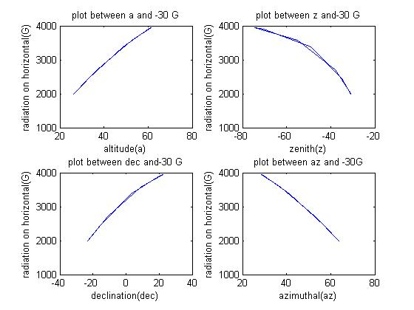

Figure 7: graph between altitude, azimuthal, zenith, declination angle and G.

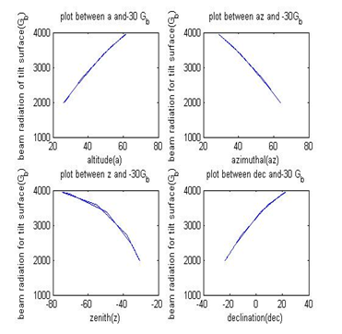

Figure 8: Graph between altitude, azimuthal, zenith, declination angle and Gb.

So At time 10:00 am, tilt angle of 00, hour angle, declination angle, altitude angle, azimuthal angle and zenith angle, beam radiation on horizontal surface calculated and plotted graph between radiation on horizontal surface and altitude, zenith, declination and azimuthal angle as shown above. Then we find radiation on tilt surface Gb and again plotted graph between azimuthal, zenith, declination and altitude angle. Same is done next in other graphs just tilt angle and time is changed and graphs are plotted accordingly. Data for time 10:00 am, 12:00 am, 2:00 pm and 4:00 pm is plotted with tilt angles of 00, 300, 600, 900.

**Hour angle 00**

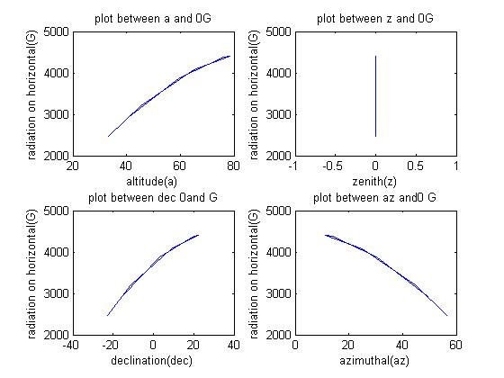

Figure 9: graph between altitude, azimuthal, declination , zenith angle and G

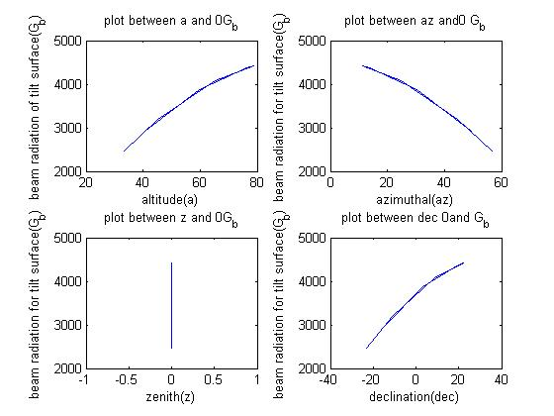

Figure 10: graph between altitude, azimuthal, declination, zenith angle and Gb

**Hour angle 300**

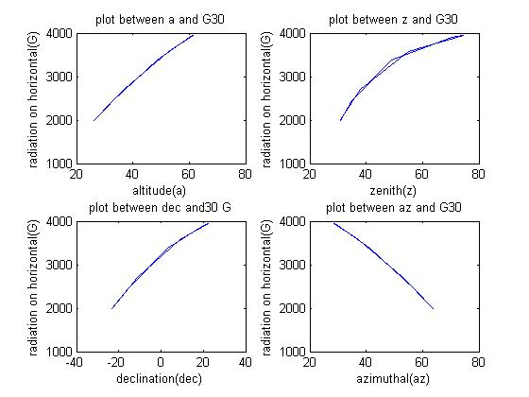

Figure 11: graph between altitude, azimuthal, declination, zenith angle and

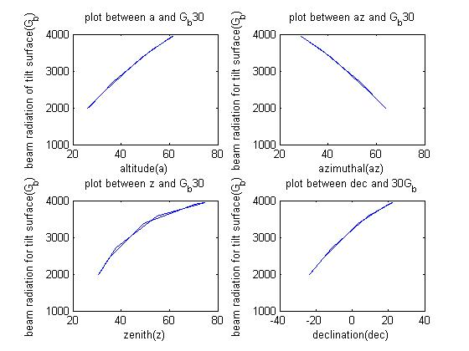

Figure 12: graph between altitude, azimuthal, declination , zenith angle and Gb

**Tilt angle 30⁰**

**Hour angle -30⁰**

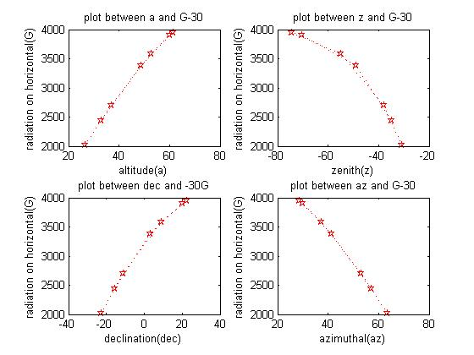

Figure 13: graph between altitude, azimuthal, declination, zenith angle and G

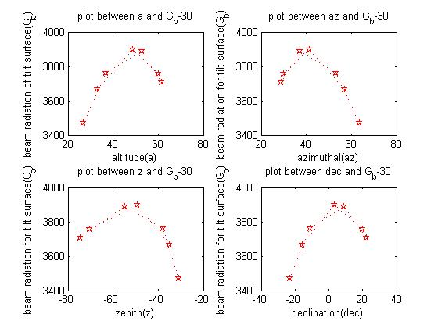

Figure 14: graph between altitude, azimuthal, declination, zenith angle and Gb

**Hour angle 0⁰**

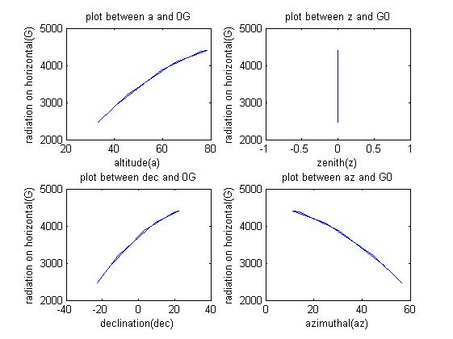

Figure 15: Graph between altitude, zenith, declination, azimuthal and G.

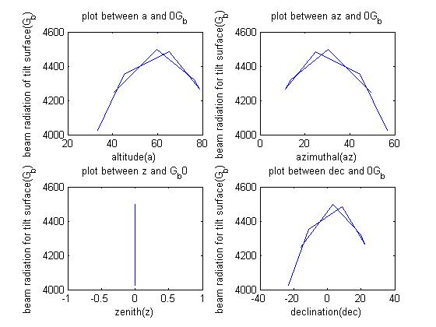

Figure 16: Graph between altitude, azimuthal, zenith, declination angle and Gb.

**Hour angle 30⁰**

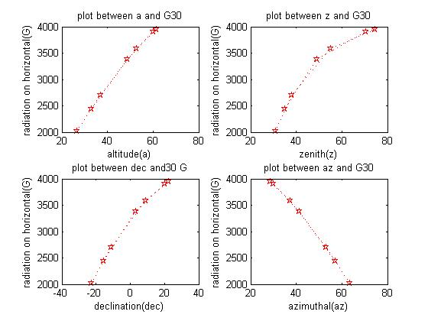

Figure 17: Graph between altitude, zenith, declination, azimuthal angle and G.

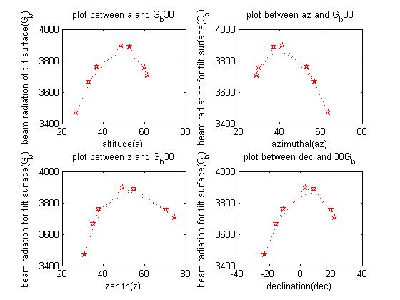

Figure 18: graph between altitude, azimuthal, zenith, declination angle and Gb

**Tilt angle 45⁰**

**Hour angle -30⁰**

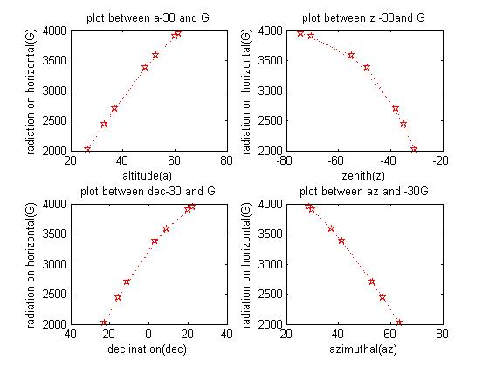

Figure 19: graph between altitude, azimuthal, declination , zenith angle and G

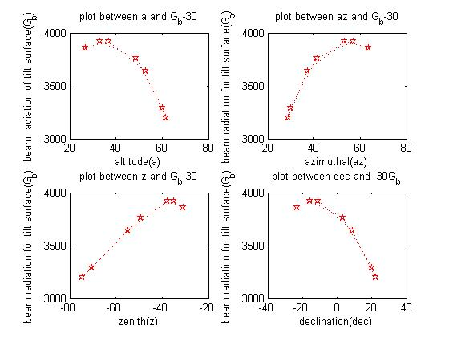

Figure 20: Graph between altitude, azimuthal, zenith, declination angle and Gb

**Hour angle 0⁰**

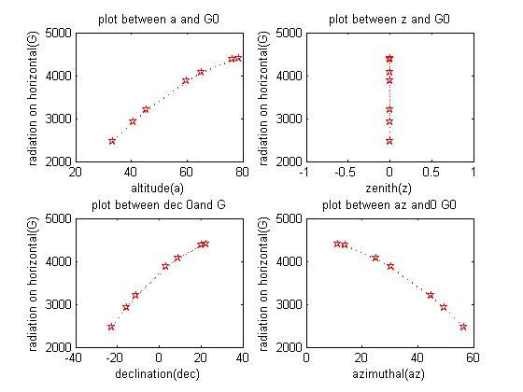

Figure 21: graph between altitude, azimuthal, declination , zenith angle and G

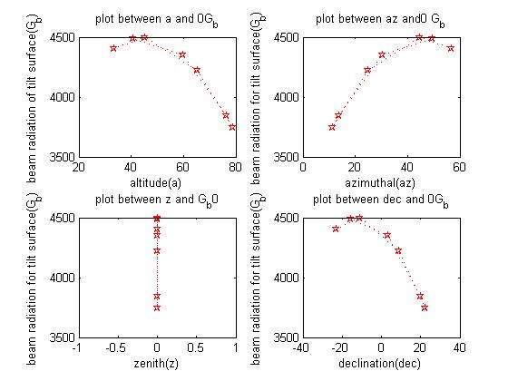

Figure 22: Graph between altitude, azimuthal, zenith, declination angle and Gb.

**Hour angle 30⁰**



Figure 23: Graph between altitude, zenith, declination, azimuthal and G.

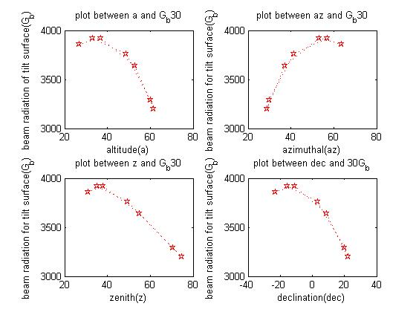

Figure 24: Graph between altitude, azimuthal, zenith, declination angle and Gb

# Fabrication

Fabrication of solar concentrator with Fresnel mirrors took place in three main stages as discussed below:

## 5.1 First stage

Fabrication of solar concentrator was completed in three stages:

In first stage frame of $2.00 × 1.00 meter$ was fabricated using steel pipes. Frame was set at an angle of 300 with respect to the ground based on the results obtained from angle simulations and the support of solar vacuum tube is attached at the height of 3.5 feet with respect to the ground in the center of the frame.

## 5.2 Second stage

On that frame rotatable rectangular mirrors are attached. There are seven pieces of rectangular mirrors which were cut and were given dimension $2.00 x 0.15 meter$ these mirrors were fixed on steel rod which can be rotated manually at an angle as to reflect maximum solar rays. Angle simulation for these mirrors is done on MATLAB software in order to check at which angles maximum radiations are reflected these simulations are done for different time intervals so according to these simulation mirrors slabs are rotated manually.

## 5.3 Third stage

Solar vacuum tube is attached on to that frame in a tilted position and these rays are reflected and concentrated on that vacuum tube which has internal diameter of 47 mm and outer diameter 58 mm and length of the tube is 1800 mm. This tube has one open end so inlet and outlet are at same place so for this cylinder piece is used in which entrance and exit is defined. The tube is filled with heat transfer fluid, the oil used here is cooking oil as heat transfer fluid therminol-66 is quite expensive so as substitute cooking oil is used, reason for using oil is that it has high thermal conductivity and does not change phase with the rise of temperature. There are two storage tanks for both hot oil and cold oil. Cold oil storage tank is connected with valve as to control the flow of oil in the tube. For experimental setup solar concentrator was placed in sun and temperature readings were taken from 12 p.m. to 6 p.m. Temperature Readings were recorded after every 30 minutes interval. Mirrors angle were set according to sun position manually. For experimental purposes instead of using any mineral oil like Therminol-66 as a HTF, simple cooking oil was used which is cheaper than Therminol-66.

# Experimental Setup

As shown in the figure above the model of solar concentrator with Fresnel mirrors. For this frame of $2.00 1.00 meter$ was designed in pro engineer. Then it was fabricated using steel pipes. As mirror was attached in a way that it can be rotated at any angle as to reflect as many solar radiations as possible, angle simulation for mirrors is done on MATLAB software. So while performing experiment solar concentrator was adjusted in a direction facing south and it is at 300 angle with respect to the ground.

After every hour mirror is tilted for about 10 or 20 so that it reflects as many radiations as possible.

Solar vacuum tube is attached at $3.5 feet$ from ground, this is one side open ended tube in which when valve is open cold storage tank cold oil enters in a pipe and it heats up and thermosyphon effect takes place. It is a method of passive heat exchange based on natural convection, which circulates a substance (liquid, or gas such as air) without the necessity of a mechanical pump. Heat transfer fluid or oil used here is simple cooking oil as therminol-66 is quite expensive one. Specific heat capacity of oil is about $1.67 KJ/Kg.K$. and with the help of temperature difference, we calculated heat energy as shown in table 5 and table 6.

Temperature was measured using thermocouple attached to a digital multimeter and was dipped in cold oil storage tank as well as in hot storage oil tank in order to measure both initial and final temperature at different time interval. Temperature results & graph between time and temperature difference are shown below:

|  |  |  |  |
| --- | --- | --- | --- |
| Time (hours) | Initial temperature  0C | Final temperature  0C | Temperature difference |
| 1215 | 32 | 32 | 0 |
| 1230 | 32 | 83 | 51 |
| 1300 | 32 | 128 | 196 |
| 1330 | 33 | 142 | 109 |
| 1400 | 33 | 155 | 122 |
| 1430 | 33 | 160 | 127 |
| 1500 | 35 | 163 | 128 |
| 1530 | 35 | 164 | 129 |
| 1600 | 33 | 161 | 128 |
| 1630 | 33 | 157 | 124 |
| 1700 | 30 | 149 | 119 |
| 1730 | 30 | 134 | 104 |
| 1800 | 30 | 124 | 94 |

Table 5: Table shows at different time interval initial and final temperatures and their difference

This table shows the initial temperature, final temperature of cooking oil and difference in temperature at different time intervals from 1215 till 1800. Readings were taken with gap of 30 minutes and results were plotted.

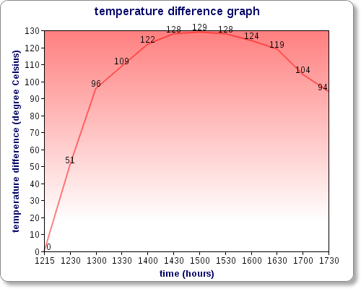

Figure 25: graph between temperature difference in 0C and time in hours.

This graph shows how temperature changes at different time intervals. In this difference in temperature (final temperature - initial temperature) is measured at different time interval and graph plotted. Temperature difference is at Y axis (dependent quantity) and time in hours is at X axis (Independent quantity).

#### 

#### Energy balance:

This graph is plotted by calculating heat energy at different time intervals.

Heat Energy is calculated by equation:

##### ***At 12:30***

320C

830C

##### 

##### ***At 13:00***

320C

1280C

##### 

##### ***At 15:00***

350C

1630C

##### 

##### ***At 16:00***

330C

1610C

**At 17:00**

300C

1490C

##### 

##### **At 1800**

$Initial temperature =$ 30

$Final temperature =$ 124

$$Cp of cooking oil = 1.67 KJ/kg.K$$

$$Mass flow rate = m = 0.0025 Kg/s$$

$$Q = mCp∆T$$

$$Q = mCpT2-T1)$$

$$Q$$

$$Q=0.392450 KW$$

Above results obtained are shown in the following table and a graph is plotted between energy and time

|  |  |  |  |  |
| --- | --- | --- | --- | --- |
| Time ( hours) | Inlet temperature 0C | Outlet temperature 0C | Temperature  Difference 0C | Energy KW |
| 1215 | 32 | 32 | 0 | 0 |
| 1230 | 32 | 83 | 51 | 0.212925 |
| 1300 | 32 | 128 | 96 | 0.400800 |
| 1330 | 33 | 142 | 109 | 0.455075 |
| 1400 | 33 | 155 | 122 | 0.509350 |
| 1500 | 35 | 163 | 128 | 0.534400 |
| 1530 | 35 | 164 | 129 | 0.538575 |
| 1600 | 33 | 161 | 128 | 0..534400 |
| 1630 | 33 | 157 | 124 | 0.517700 |
| 1700 | 30 | 149 | 119 | 0.496825 |
| 1730 | 30 | 134 | 104 | 0.434200 |
| 1800 | 30 | 124 | 94 | 0.392450 |

Table 6: Table shows at different time intervals initial and final temperature of cooking oil and heat energy.

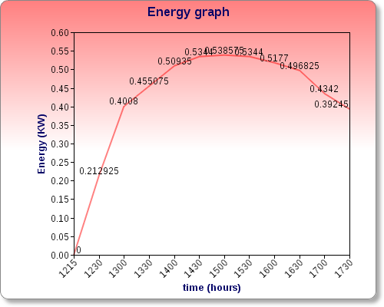

Figure 26: graph is plotted between heat energy and time in hours

## 

Graph shows that amount of energy rises with time till 1530 hrs and then starts to drop as sun starts to set. Maximum amount of energy as cleared from graph is obtained during 1400 hrs to 1530 hrs and graph is almost a flat in this region. Maximum energy received in this time was 530 Watt.

## 6.1 Conclusion

During experimentation we were able to achieve temperature around 200 0C and we were successful in achieving energy of 500 W.

.

# Applications

Solar concentrator can be used for water and space heating.

It can be used for providing process heat for a wide range of industries and chemical processing plants using boilers or heaters, textile mills, sugar mills, paper mills, vegetable oil mills, agro and food processing industries, timber industry, milk processing, drying of horticultural, food and fruits products, drying of chemicals, for Cold Storage Units for perishable food, marine and horticultural products at remote places as well as units using vapor absorption refrigeration for space cooling. It is also suitable for Hotels and Hospitals for providing hot water, steam and Cooling.

In textile industry hot water and steam is used in various processes such as in washing, dyeing, bleaching and chemical treatments.

In tannery, hot water and steam is used in cleaning and drying of leather respectively.

Large scale solar concentrator is used for production of large amount of steam which can be used for power generation.

# Future work

## 8.1 Automation

Automatic tracking system can be attached with mirrors. The mirrors do the intermittent ways movement from the beginning Position to Appropriate Position, following the sun's relative movement, so that mirrors can concentrate more radiations onto the receiver tube. When the sunsets ,the replacement circuit of the rotary controls circuit actives automatically, leading the mirror to the beginning place and into the hibernation ;when the sun rises in the morning ,the circuit sets up ,controlling the circuit to search for the sun automatically. Automatic sun-tracking system is consist of machine part and automatic sun-tracking control circuit part .Machine part is mainly consist of silicon photo-cell assessment circuit, biaxial machinery ,tracking system and battery .Automatic sun-tracking control circuit is made up of sensor signal processing circuit, microcontroller circuit and order circuit. These are the work demand:

(1) Safe and reliable work, ensure that the panel can face the sun any time (design tracking time) in the day.

(2) It can back the beginning place automatically at night, preparing for the work demand the next day.

(3) Adopting the silicon photo-cell to provide energy by them, there is no need to put other energy.

(4) Adopting the intermittent work ways, therefore, it can reduce energy consumption.

## Solar vacuum tube (double end open)

In this project, solar tube (single end open) was used but to achieve more temperature of about 3000 C or above solar vacuum tube (double end open) must be used. This tube is open from both sides and it contains copper tube enclosed in a glass with vacuum in it. It is more efficient.

## 8.3 Better heat transfer fluid:

Better heat transfer media must be used such as therminol-66 as it provides reliable heat transfer from -200C to 350 and it is not decomposed easily.it is a synthetic fluid so it resists the effects of oxidation 10 times better than mineral oils. Less oxidation means less solids formation and much less fouling. Tube carrying hot oil is connected to heat exchanger which results in generation of steam. Upsizing of project can generate more steam hence used for power generation.

# Bibliography

[1] (n.d.). (National Renewable Energy Labortary) Retrieved April 28, 2013, from www.nrel.gov: http://www.nrel.gov/docs/fy06osti/29913.pdf

[2] (1887). (Kipps and Zonen) Retrieved April 20, 2013, from www.kippzonen.com: www.kippzonen.com/?product/2141/2AP.aspx (kipp and zonen

[3] *Therminol Heat transfer fluid by Solutia*. (1995, January 1). (Solutia Therminol Co.,Ltd Suzhou) Retrieved January 20, 2013, from www.szsolutia.com: http://www.szsolutia.com/template/p5e.htm

[4] (2013). (Pakistan Renewable Energy Society) Retrieved March 12, 2013, from

www.pres.org.pk: http//www.pres.org.pk/category/re-technologies/solar-energy/solar-thermal/parabolic-trough/

[5] (2013). (Pakistan Renewable Energy Society) Retrieved March 12, 2013, from www.pres.org.pk: http//www.pres.org.pk/category/energy/energy-sources/

[6] *EASTMAN*. (2013). (Solutia Inc) Retrieved April 20, 2013, from www.therminol.com: http://ww.therminol.com/pages/products/66.asp

[7] Heller, D. P. (1974). *SolarPaces*. (IEA SolarPaces) Retrieved March 10, 2013, from www.solarpaces.org: http://www,solarpaces.org/CSP Technology/docs/solar tower.pdf?

[8] Heller, D. P. (1974). *SolarPaces*. (IEA SolarPaces) Retrieved March 10, 2013, from www.solarpaces.org: http://www.solarpaces.org/CSP\_Technology/docs/solar\_troughs.pdf

[9] Palmer, J. a. (2012, Februrary 06). *global heat transfer*. (Global Heat Transfer Ltd) Retrieved April 20, 2013, from www.globalheattransfer.co.uk

[10] Taylor, R. (n.d.). (Global Solar Thermal Energy Council) Retrieved March 12, 2013, from www.solarthermalworld.org: http://solarthermalworld.org/sites/gstec/files/course solar taylor thermal.pdf

[11] William and Flora Hewlett Foundation. (2009). *connextion consortium*. (Connextions) Retrieved 20 April, 2013, from http://cnx.org

[12] Zhang Bao-Jian, Gao Guo-hong, Zhu Li. (n.d.). (Computer Science Department, Henan Insititute of Science and Tecnhonolgy Xinxiang, China 453003) Retrieved April 25, 2013, from http://59.69.174.6:8086/self-digital/qarticle/data/13721.pdf