# ACKNOWLEDGMENT

By the grace of Allah Almighty, who is the most merciful and beneficent! It is a matter of great pleasure and privilege for us to complete this project under the supervision of Mr..

# ABSTRACT

This project presents the analysis of digital differential protection for three phase power transformers. Power transformer is the key element in electrical power system. Proper protection is needed for economical and safe operation of electrical power system. Power transformer protective relay should block the tripping during external fault or magnetising inrush and speedily operate the tripping during internal faults. The foremost objective of this paper is to analyse digital differential protection during internal and external fault and to operate the relay with proper fault discrimination.

# TABLE OF CONTENTS

ACKNOWLEDGMENT 1

ABSTRACT 2

TABLE OF CONTENTS 3

LIST OF FIGURES 6

Chapter 1 7

INTRODUCTION 7

1.1 Overview 7

1.2 Background 7

1.3 Purpose of the project 8

1.4 Role of Protection 8

1.5 Techniques 8

1.6 Material 9

1.7 Differential protection difficulties 9

Chapter 2 11

LITERATURE REVIEW 11

2.1 Digital Protection System 11

2.2 Differential Protection Methods 11

2.3 DESIGN CONSIDERATION 12

**2.3.1 The Matching of CT Ratios** 12

**2.3.2 Current Imbalance Produced by Tap Changing** 13

**2.3.3Dealing with Zero Sequence Currents** 13

**2.3.4 Phase Shift through the Transformer** 13

**2.3.4 Magnetising Inrush Current** 13

Chapter 3 15

PROJECT DESIGN AND IMPLEMENTATION 15

3.1 Differential Relay contents 16

3.2 Compartor block 18

**3.2.1Harmonic Comparator Block** 19

**3.2.2 Amplitude Comparator Block** 21

3.3 The results and discussions 21

3.4 Output waveforms 22

Chapter 4 24

TOOLS AND TECHNIQUES 24

4.1 Simulink 24

4.2 Three-Phase Source 24

Load Flow Tab 27

4.3 Three Phase Circuit breaker 29

4.4 Three-Phase Transformer 32

Standard Notation for Winding Connections 33

4.5 Current Measurement 37

4.6 Voltage Measurement 37

4.7 Scope 38

4.8 Three Phase VI measurement 39

4.9 AND 43

4.10Relational Operators 43

4.12 MUX 44

4.13 DEMUX 45

Chapter 5 47

CONCLUSION 47

REFERNCES 48

**LIST OF ACRONYMS**

IC Integrated Circuit

AC Alternating Current

DC Direct Current

W.R.T With Respect To

CT Current transformer

# LIST OF FIGURES

Fig 3.1 Main block.................................................................................................................... 14

Fig 3.2 Differential relay.............................................................................................................16

Fig 3.3 Comparator subsystem................................................................................................... 17

Fig 3.4 Harmonic comparator..................................................................................................... 18

Fig 3.5 Subsystem of ratio.......................................................................................................... 19

Fig 3.6 Amplitude comparator System....................................................................................... 20

Fig 3.7 Output waveforms........................................................................................................... 22

Fig 4.1 Three Phase source...........................................................................................................24

Fig 4.2 Circuit breaker................................................................................................................. 28

Fig 4.3 Three Phase Transformer................................................................................................ 34

Fig 4.4 current measurement....................................................................................................... 36

Fig 4.5 voltage measurement...................................................................................................... 37

Fig 4.6 Scope............................................................................................................................... 37

Fig 4.7 VI measurement.............................................................................................................. 38

Fig 4.8 AND................................................................................................................................ 42

Fig 4.9 Relational block............................................................................................................... 43

Fig 4.10 Mux................................................................................................................................ 43

Fig 4.11 DeMux........................................................................................................................... 44

# Chapter 1

# INTRODUCTION

## Overview

Digital differential protection is a developed idea of the old system of conventional differential

protection, which had made perfect solution to the problems that the old systems suffer. This paper simulates small power system with a differential relay connected to protect the power transformer in this system. The test points are selected to simulate different cases of operation and faults. The first case is for power transformer energization by closing the Circuit Breaker

(CB) existing in the primary side of power transformer and analyzing the behaviour of the whole system during energization. In this situation, it was noted that the behaviour of the digital relay did not release a trip signal due to inrush current. The second case is for closing the CB exists in the secondary side of the power transformer. In this case the load starting current will flow and the inrush current component disappeared. Also the digital relay did not release a trip signal. The third case is for creation of an internal fault inside the protected zone. In this case the system was disturbed and the digital relay released a trip signal towards certain CBs in order to isolate the power transformer from the system. The relay responds to the fault after 10.7 msec. The forth case is for creation of an external fault outside the protected zone. In this case, no trip signal was released from the relay.

## Background

Transformer is a vital and expensive component of electrical power system. The unplanned outage of a power transformer is costly for utilities and hence need adequate protection. It is

necessary to study the various operating conditions of transformer to explore new protection algorithm .The aim of this paper is to simulate various conditions of a transformer like

load condition, internal faults, abnormal conditions like magnetizing inrush current, over fluxing, etc. In this paper, the physical model of a two winding 230 V/230 V is simulated in MATLAB-SIMULINK. The block parameters of transformer are obtained using experiment conducted on laboratory transformer. All the mentioned operating conditions are applied in this model one by one and are analyzed from differential protection point of view. An example presented in this paper demonstrates the capabilities and underline the advantages of Matlab-Simulink environment to study differential current pattern for various conditions which can be subsequently used for designing suitable digital relay. This data can be used to improve transformer protection using intelligent techniques.

## Purpose of the project

THE main purpose of power systems is to generate, transmit, and distribute electric energy to customers without interruptions and in the most economical and safe manner. Power systems are divided into subsystems (generation, transformation, transmission and distribution) which are

Composed of costly components. Protection of these elements is crucial.

## Role of Protection

The role of protection ensures that, in the event of a fault, the faulted element must be disconnected from the system for isolating the fault to prevent further damage to the components

of the system through which the fault currents were flowing.

## Techniques

Over the years, various incipient fault detection techniques, such as dissolved gas analysis and

partial discharge analysis have been successfully applied to large power transformer fault diagnosis. Since these techniques have high-cost and some are offline, a low-cost, online incipient fault detection technique for transformers using terminal measurements would be very

useful. Online condition monitoring of transformers can give early warning of electrical failure and could prevent catastrophic losses. Hence a powerful method based on signal analysis should be used in monitoring. The method should discriminate between normal and abnormal operating cases that occur in distribution systems related to transformers such as external faults, internal faults, magnetizing inrush, load changes, arcing, etc. One of the most effective methods of protection to protect Power transformers is the Differential protection method by using

differential relay circuits. This scheme is based on the principle of that the power input to the transformer under normal conditions is equal to the power out. By proper connection of the secondaries of current transformers (CT), under normal conditions, no current will flow into the relay coil. Whenever a fault occurs the current balance will no longer exist and relay contacts will close and release a trip signal to cause a certain Circuit Breakers (CB) to operatein order to disconnect the faulty equipment.

## Material

Power system is a set of interactive components of generation, transmission, distribution and utilization. These work as a unit system to supply electricity to the consumer end from generation side. To have practical aspects of power system, SIMULINK toolbar of MATLAB is used. This provides variety of built-in components that could be easily connected with each other to form a complete system. The set of monitoring blocks provide ease to visualize the behavior of system at any time of simulation. Before the design of transformer protective relay system, a model of the power transformer is required to generate the fault data required to calibrate the fault detector. The Simulink Power system library browser in the Matlab / Simulink environment is used to model the power transformer protection system.

The following components make up the fault simulation model:

a. Three-Phase Breaker

b. Three-Phase Source

c. Three-Phase Transformer

d. Three-Phase Fault

e. Three- Phase V-I Measurement

f. Subsystem

g. Three-Phase Series RLC Load

i. Scope

h. Current Measurement

## Differential protection difficulties

Generally, three main difficulties handicap the conventional differential protection. They

induce the differential relay to release a false trip signal without the existing of any fault.

These complications must be overcome in order to make the differential relay working

properly :

• Magnetizing inrush current during initial energization,

• CTs Mismatch and saturation,

• Transformation ratio changes due to Tap changer.

# Chapter 2

# LITERATURE REVIEW

## Digital Protection System

Digital differential protection is a developed idea of the old system of conventional differential protection which had made quite satisfactory solutions to the above mentioned problems. The advances of the art of relays and protection schemes have involved many disturbing compromises. Some of the previous studies will now be presented in order to be familiarized by what the recent researcher have done . Hayward a new type relay using the principle of harmonic

restraint, which is able to distinguish between the internal fault and the magnetizing-inrush by their difference in waveform. But also this method is characterized by complicated circuits and consists of mechanical parts.

## Differential Protection Methods

One of the most important means of protecting a power transformer is differential protection based on the comparison of the transformer primary and secondary currents. When these currents deviate from a predefined relationship, an Internal fault is considered and the transformer is de-energized. However, during transient primary magnetizing inrush conditions, the transformer can carry very high primary current and no secondary current. The resulting differential current can falsely trip the transformer. The most common technique used for preventing false tripping during the above condition is the use of second harmonic restraint. If the second harmonic content of the differential current exceeds a pre-defined percentage of the fundamental, inrush is indicated and the relay is prevented from tripping.

Probably every utility has experienced a false operation of a differential relay when energizing a transformer bank. Over the years, many different methods of preventing differential relay operation on inrush have been implemented.

1. **Power differential method** : This method is based on the idea that the average power drawn by a power transformer is almost zero on inrush, while during a fault the average power is significantly higher .

2. **Rectifier relay** : This method is based on the fact that magnetizing inrush current is in effect a halffrequency wave. Relays based on this method use rectifiers and have one element functioning on positive current and one on negative current. Both elements must operate in order to produce a trip. On inrush, the expectation is that one element only will operate, while on an internal fault, the waveform will be sinusoidal and both elements will operate.

3. **Waveform recognition :** it is the method of measuring “dwell-time” of the current waveform, that is, how long it stays close to zero, indicating a full dc-offset, which uses to declare an inrush condition. Such relays typically expect the dwell time to be at least ¼ of a cycle, and will restrain tripping if this is measured.

4. **Flux-current :** A new simple and efficient technique for inrush current reduction based on the

calculated flux in the core. As its advantage, this approach tides together the cause of the problem (saturation of the core as a source of the current unbalance) with the phenomenon used for recognition (flux in the core). Flux reduction can be achieved by applying a voltage to the core with the help of a tertiary winding .

**5. Cross blocking:** It is a “method” that blocks all tripping if any relay detects inrush. Any of the relays that use single-phase inrush detection methods can utilize cross blocking.

**6. Harmonic current restraint**: This is the most common method and widely used for the detection of inrush current in power transformer.

## DESIGN CONSIDERATION

A number of factors have to be taken into account in designing a scheme to meet these objectives. These include: i. The matching of CT ratios ii. Current imbalance produced by tap changing iii. Dealing with zero sequence currents iv. Phase shift through the transformer v. Magnetizing inrush current.

### **2.3.1 The Matching of CT Ratios**

The CTS used for the Protection Scheme will normally be selected from a range of current transformers with standard ratios such as 1600/1, 1200/1, 600/1, 300/1, 200/1, etc. This could mean that the currents fed into the relay from the two sides of the power transformer may not balance perfectly. Any imbalance must be compensated for and methods used include the application of biased relays and/or the use of the interposing CTS.

### **2.3.2 Current Imbalance Produced by Tap Changing**

A transformer equipped with an on-load tap changer (OLTC) will by definition experience a change in voltage ratio as it moves its tapping range. This in turn changes the ratios of primary to secondary current and produces out-of-balance (or spill) current in the relay. As the transformer taps further from the balance position, so the magnitude of the spill current increases. To make the situation worse, as the load on the transformer increases the magnitude of the spill current also increases. Consequently through faults could produce spill currents that exceed the setting of the relay.

### **2.3.3Dealing with Zero Sequence Currents**

Earth faults downstream of the transformer may give rise to zero sequence current, depending upon winding connections and earthing arrangements. Since zero sequence current does not pass through a transformer, it will be seen on one side only producing spill current and possible relay operation for an out-of-zone fault. To prevent such occurrence, zero sequence current must be eliminated from the differential scheme. This is achieved by using delta connections on the secondary side of CTs that are associated with main transformer windings connected in star. Where CT secondaries are connected in star on one side of a transformer and delta on the other, allowance must made for the fact that the secondary currents outside the delta will only be 13 of the star equivalent.

### **2.3.4 Phase Shift through the Transformer**

Having eliminated the problem of zero sequence currents through faults will still produce positive and negative sequence currents that will be seen by the protection CTs. These currents may experience a phase shift as they pass through the transformer depending upon the transformer vector group. CT secondary connections must compensate to avoid imbalance and a possible mal-operation .

### **2.3.4 Magnetising Inrush Current**

When a transformer is first energized, magnetizing inrush has the effect of producing a high magnitude current for a short period of time. This will be seen by the supply side CTs only and could be interpreted as an internal fault. Precautions must therefore be taken to prevent a protection operation. Solutions include building a time delay feature into the relay and the use of harmonic restraint driven, typically, by the high level of second harmonic associated with inrush current.

# Chapter 3

# PROJECT DESIGN AND IMPLEMENTATION

This implementation is done using Matlab/Simulink environment. Figure shows the simulated power system built in Matlab/Simulink environment. In which a three phase, 250MVA, 60Hz, (735/315) kV, Y/ power transformer is used in this system. The contents of each designed block are illustrated in separate.

.

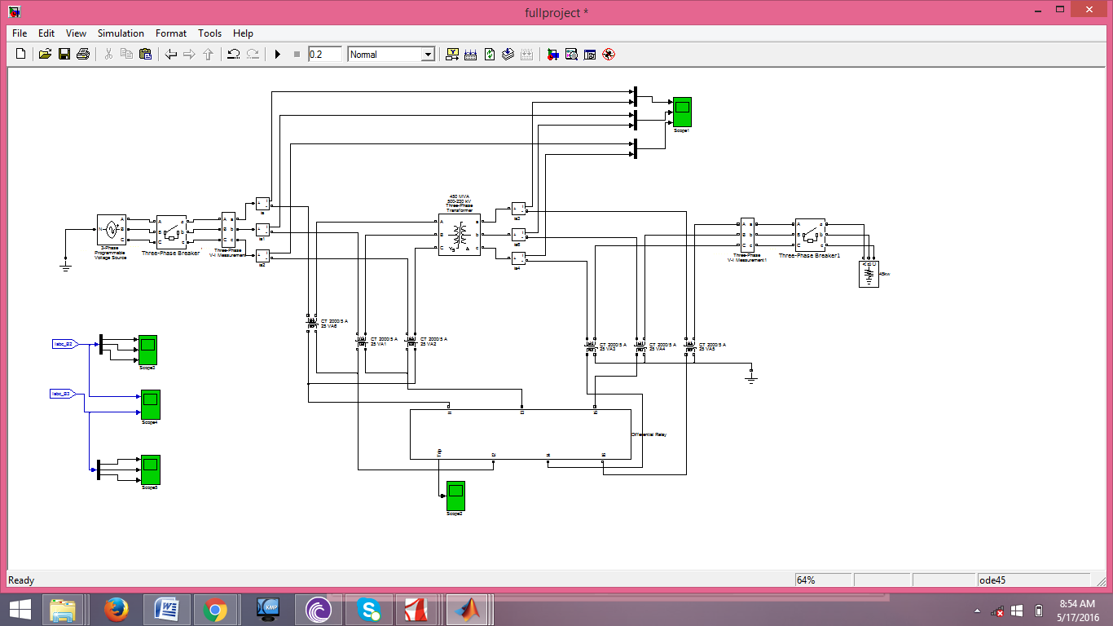

**Fig 3.1 Main block**

This is the main block diagram of the the protection system. Breaker is connected with the three phase voltage source. VI block is connected with the other end of the breaker which will be used for the voltage and current measurement. The Current measurement block is used for measuring the current. At the other end VI measurement block Circuit breaker and Resistive load is connected.

Step 1. Reading data from the ct.

Step 2. Data calculation, which is given as follows;

For the amplitude calculation, if the absolute difference () between the output currents is greater than zero the logic (1) takes place, which indicates the case of an inrush

current or an internal fault. Otherwise, the logic (0) takes place, which indicates a detection

of an external fault.

## 3.1 Differential Relay contents

The differential protection converts the primary and secondary currents to a common base and compares them. The distinction between these currents is small during normal operating conditions. The variance is also small for external faults, but is larger than the difference for normal operating conditions. However, difference becomes significant during an internal fault in a transformer. The differential protection is then based on matching the primary and secondary current of the transformer for ideal operation. Transformer core generally retains some residual flux when transformer is switched off. Later, the core is likely to saturate when the transformer is re-energized. If the transformer is saturated, the primary windings draw large magnetizing currents from the power system . These results in a large differential current which cause the differential protection relay to operate. The design is implemented to protect the power transformer against internal faults and prevent overreaction or malfunctioning due to inrush currents .

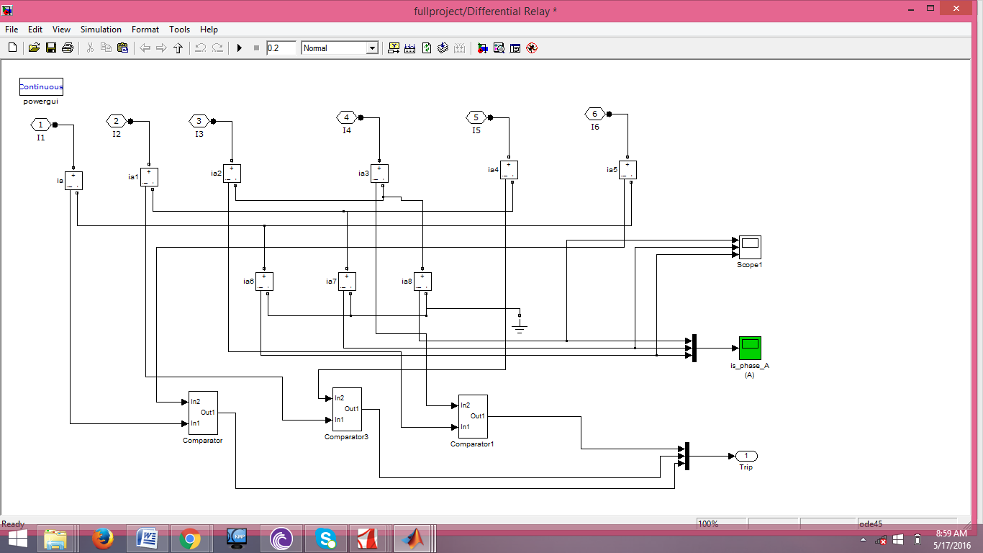

**Fig 3.2 Differential relay**

This is the internal circuit of the differential relay system in which we have current measurement block for measuring current then we have further three comparators.

## 3.2 Compartor block

## 

**Fig 3.3 Comparator subsystem**

In comparator block we have amplitude and harmonic comparator . The amplitude comparator will find the amplitude of the wave and harmonic comparator will be find the harmonics of the waves. Then the output of the comparator will be given to the AND gate which will given 1 if both outputs are one.

### **3.2.1Harmonic Comparator Block**

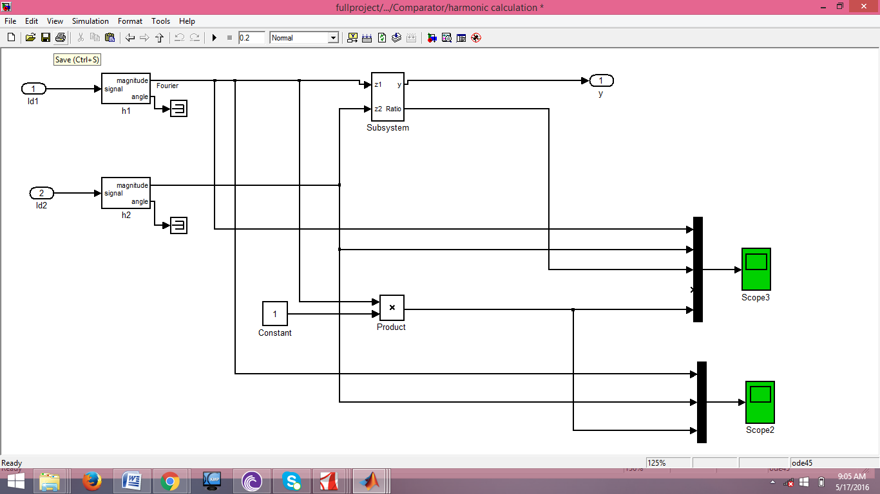

**Fig 3.4 Harmonic comparator**

In Harmonic comparator we have signal generator which will do the fourier analysis of the signal. We will only find the magnitude of the signal. As we do not need the angle so we have connected the teerminator with it.In Harmonic comparator we have another subsystem for the calculation of the ratio.

**Subsystem of Ratio**

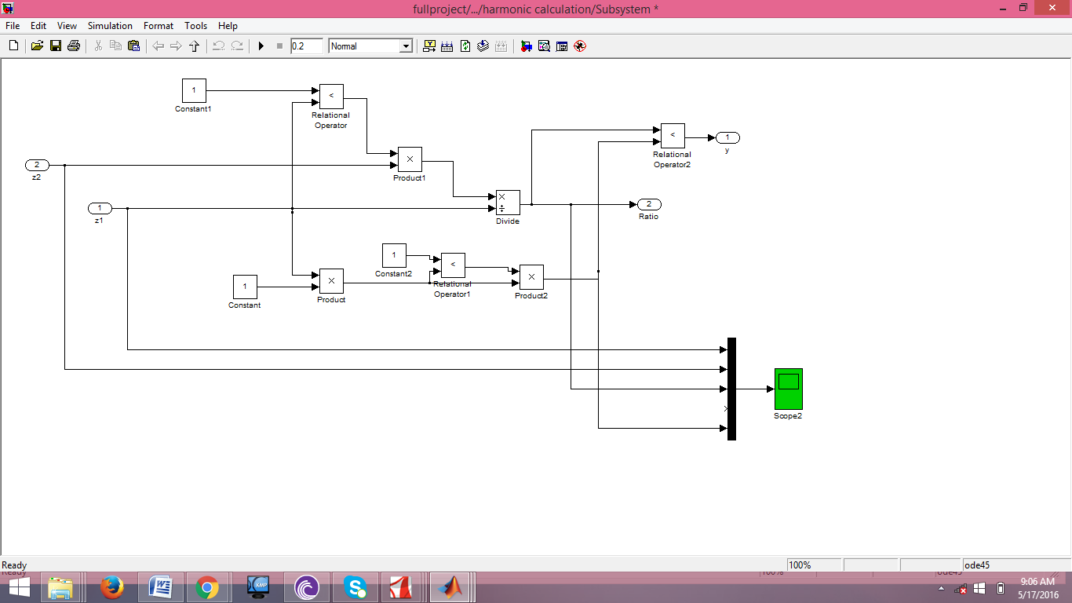

**Fig 3.5 Subsystem of ratio**

In the ratio subsystem we have mathematical and relational operator which will be used for the calculation of the ratio of the signals. The mux block is used for the transfer of all waves in single wave form.

### **3.2.2 Amplitude Comparator Block**

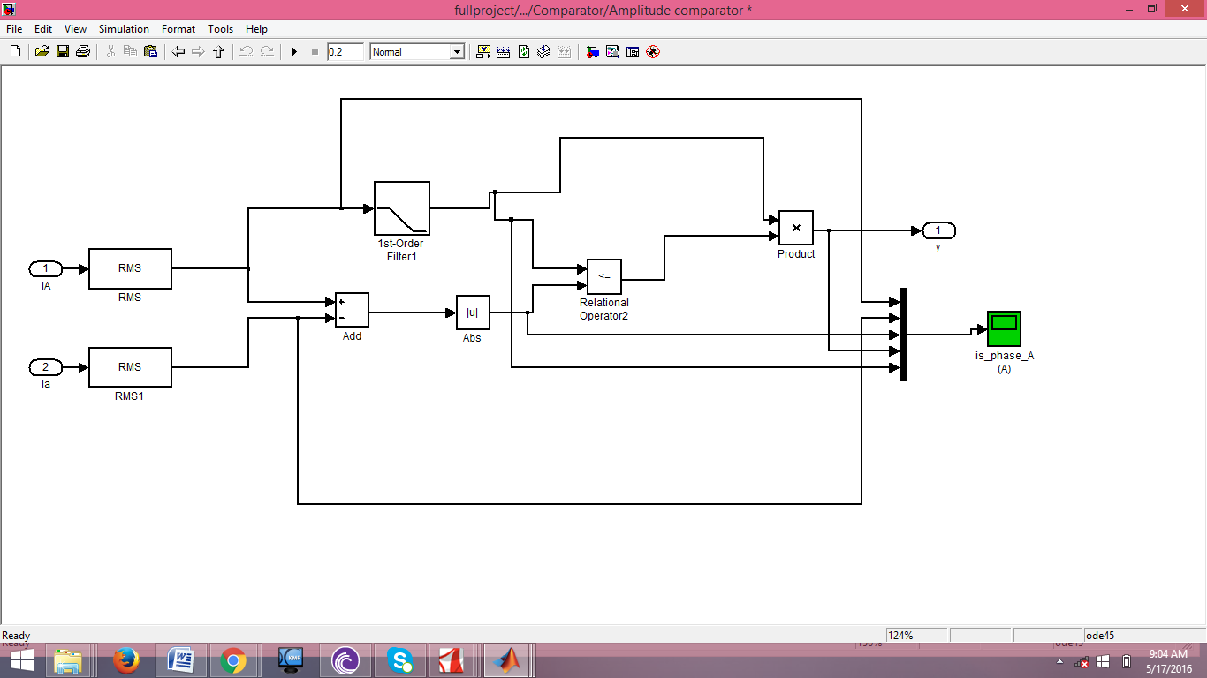

**Fig 3.6 Amplitude comparator System**

In amplitude block we calculate the amplitude of the waves. First we will find the rms value of the waves by dividing the value on sqrt(2). Then it will be passed through three phase filter for removing the ripples and distortion. Then we will take the difference of the waves and takes it absolute value which will be then passed through relational operator.

## 3.3 The results and discussions

The results will be given for different cases:

Case 1: magnetizing inrush current,

Case 2: magnetizing inrush with adding load,

Case 3: Three phase to ground fault at loaded transformer,

Case 4: Phase A to ground external fault at loaded transformer,

Other cases of different types of faults and inrush currents such as single line to ground

fault, line-to-line fault, line to line to ground fault and three phase fault in both cases loaded

and unloaded transformer are illustrated.

## 3.4 Output waveforms

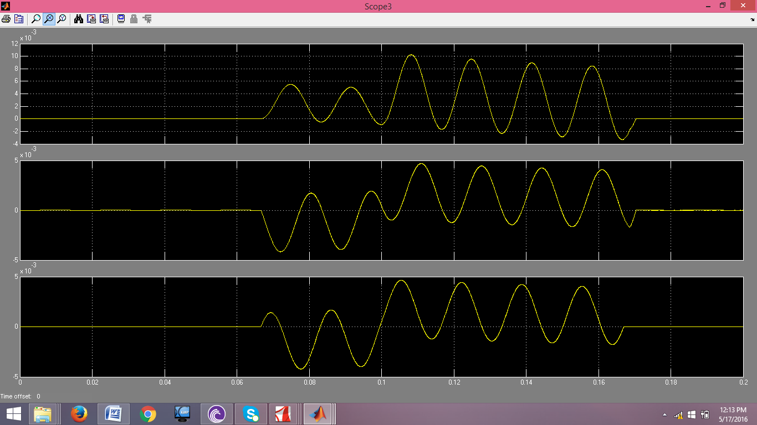

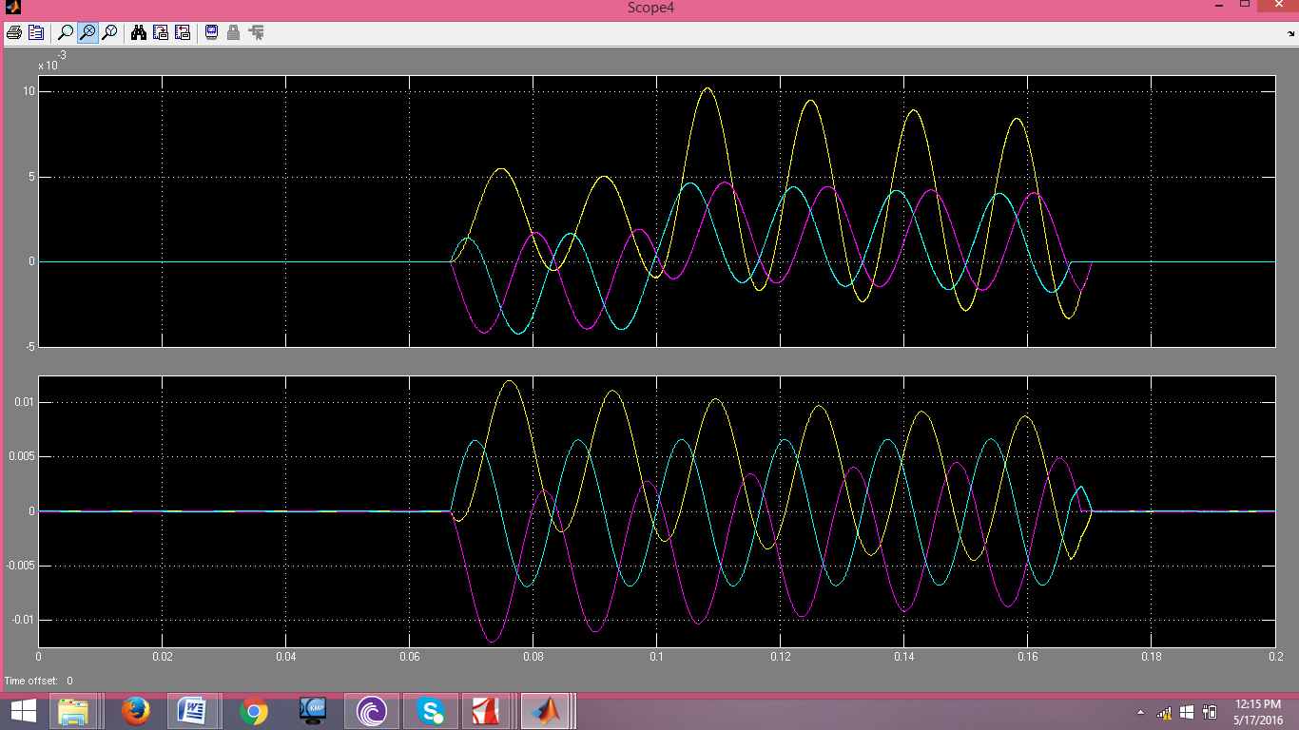

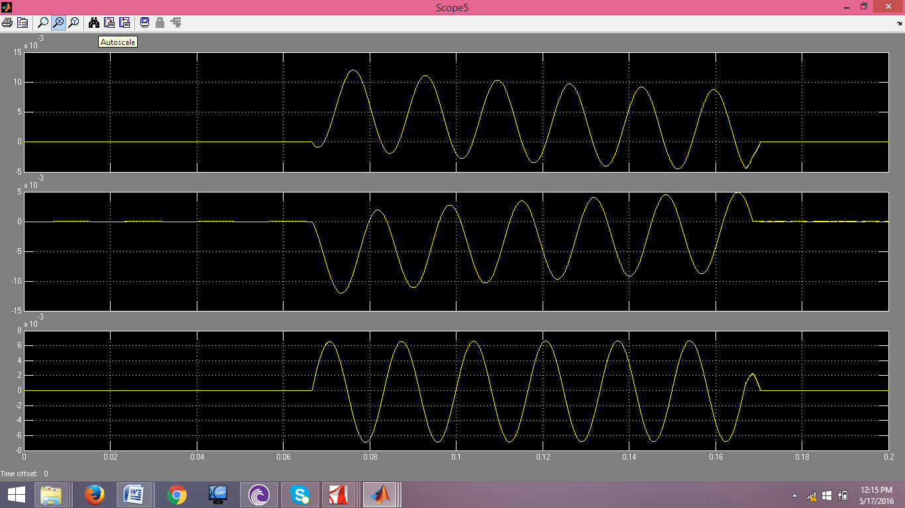

**Fig 3.7 Output waveforms**

# Chapter 4

# TOOLS AND TECHNIQUES

## Simulink

Simulink is an “add-on” to MATLAB.

• You need to have MATLAB in order to use Simulink

• Simulink is used Simulations of dynamic models

• In Simulink we create a Graphical Block Diagram for the system (based on thedifferential equations(s))

## Three-Phase Source

The Three-Phase Source block implements a balanced three-phase voltage source with an internal R-L impedance. The three voltage sources are connected in Y with a neutral connection that can be internally grounded or made accessible. You can specify the source internal resistance and inductance either directly by entering R and L values or indirectly by specifying the source inductive short-circuit level and X/R ratio.

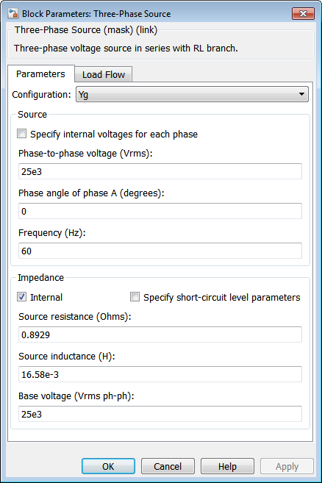

**Fig 4.1 Three Phase source**

**Specify internal voltages for each phase**

Select to specify internal voltage for each phase.

**Phase-to-phase rms voltage**

The internal phase-to-phase voltage in volts rms. This parameter is available only if **Specify internal voltages for each phase** is not selected.

**Phase angle of phase A**

The phase angle of the internal voltage generated by phase A, in degrees. The three voltages are generated in a positive sequence. Thus, phase B and phase C internal voltages lag phase A by 120 degrees and 240 degrees, respectively. This parameter is available only if **Specify internal voltages for each phase** is not selected.

**Line-to-neutral voltages [Va Vb Vc]**

The internal line-to neutral voltage of phase A, B, and C, in volts rms. This parameter is available only if **Specify internal voltages for each phase** is selected.

**Phase angle of line-to-neutral voltages [phia phib phic]**

The phase angles of the internal voltages generated by phase A, B, and C, in degrees. This parameter is available only if **Specify internal voltages for each phase** is selected.

**Frequency**

The source frequency in hertz (Hz).

**Internal**

When this check box is selected, the block implements an internal RL inductance. When the check box is cleared, the internal inductance is not modeled.

**Specify short-circuit level parameters**

Select to specify internal impedance using the inductive short-circuit level and X/R ratio. This parameter is available only if **Internal** is selected.

**3-phase short-circuit level at base voltage**

The three-phase inductive short-circuit power, in volts-amperes (VA), at specified base voltage, used to compute the internal inductance L. This parameter is available only if **Internal** and **Specify short-circuit level parameters** are selected.

The internal inductance L (in H) is computed from the inductive three-phase short-circuit power Psc (in VA), base voltage Vbase (in Vrms phase-to-phase), and source frequency f (in Hz) as follows:

*L*=*V*2*basePsc*⋅12*πf*.

**Base voltage**

The phase-to-phase base voltage, in volts RMS, used to specify the three-phase short-circuit level. The base voltage is usually the nominal source voltage. This parameter is available only if **Internal** and **Specify short-circuit level parameters** are selected.

**X/R ratio**

The X/R ratio at nominal source frequency or quality factor of the internal source impedance. This parameter is available only if **Internal** and **Specify short-circuit level parameters** are selected.

The internal resistance R (in Ω) is computed from the source reactance X (in Ω) at specified frequency, and X/R ratio as follows:

*R*=*X*(*X*/*R*)=2*πfLX*/*R*.

**Source resistance**

This parameter is available only if **Internal** is selected and **Specify short-circuit level parameters** is not selected.

The source internal resistance in ohms (Ω).

**Source inductance**

This parameter is available only if **Internal** is selected and **Specify short-circuit level parameters** is not selected.

The source internal inductance in henries (H).

### Load Flow Tab

The parameters on this tab are used by the Load Flow tool of the powergui block. These load flow parameters are used for model initialization only, they have no impact on the block model and on the simulation performance.

The configuration of the **Load Flow** tab depends on the option selected for the **Generator type** parameter.

**Generator type**

Specify the generator type of the voltage source.

Select swing to implement a generator controlling magnitude and phase angle of its terminal voltage. The reference voltage magnitude and angle are specified by the **Swing bus or PV bus voltage** and **Swing bus voltage angle** parameters of the Load Flow Bus block connected to the voltage source terminals.

Select PV to implement a generator controlling its output active power P and voltage magnitude V. P is specified by the **Active power generation P** parameter of the block. V is specified by the **Swing bus or PV bus voltage** parameter of the Load Flow Bus block connected to the voltage source terminals. You can control the minimum and maximum reactive power generated by the block by using the **Minimum reactive power Qmin** and **Maximum reactive power Qmax** parameters.

Select PQ to implement a generator controlling its output active power P and reactive power Q. P and Q are specified by the **Active power generation P** and **Reactive power generation Q** parameters of the block, respectively.

**Active power generation P**

Specify the desired active power generated by the source, in watts. This parameter is available if you specify **Generator type** as PV or PQ, and if the **Specify internal voltages for each phase** parameter is selected.

**Reactive power generation Q**

Specify the desired reactive power generated by the source, in vars. This parameter is available only if you specify **Generator type** as PQ.

**Active power generation [Pa Pb Pc]**

Specify the desired active power generated by each phase of the source, in watts. This parameter is available only if you specify **Generator type** as PV or PQ, and if **Specify internal voltages for each phase** is selected.

**Reactive power generation [Qa Qb Qc]**

Specify the desired reactive power generated by each phase of the source, in vars. This parameter is available only if you specify **Generator type** as PQ, and if **Specify internal voltages for each phase** is selected.

**Minimum reactive power Qmin or [Qamin,Qbmin Qcmin]**

This parameter is available only if you specify **Generator type** as PV. Indicates the minimum reactive power that can be generated by the source while keeping the terminal voltage at its reference value. This reference voltage is specified by the **Swing bus or PV bus voltage** parameter of the Load Flow Bus block connected to the source terminals. The default value is -inf, which means that there is no lower limit on the reactive power output.

**Maximum reactive power Qmax or [Qamax,Qbmax Qcmax]**

This parameter is available only if you specify **Generator type** as PV. Indicates the maximum reactive power that can be generated by the source while keeping the terminal voltage at its reference value. This reference voltage is specified by the **Swing bus or PV bus voltage** parameter of the Load Flow Bus block connected to the source terminals. The default value is inf, which means that there is no upper limit on the reactive power output.

## Three Phase Circuit breaker

Implement three-phase circuit breaker opening at current zero crossing

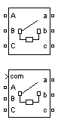

**Fig 4.2 Circuit breaker**

The Three-Phase Breaker block implements a three-phase circuit breaker where the opening and closing times can be controlled either from an external Simulink® signal (external control mode), or from an internal control timer (internal control mode).

The Three-Phase Breaker block uses three Breaker blocks connected between the inputs and the outputs of the block. You can use this block in series with the three-phase element you want to switch. The arc extinction process of the Three-Phase Fault block is the same as for the Breaker block. See the Breaker block reference pages for details on the modeling of the single-phase breakers.

If the Three-Phase Breaker block is set in external control mode, a control input appears in the block icon. The control signal connected to the Simulink input must be either 0, which opens the breakers, or any positive value, which closes the breakers. For clarity, a 1 signal is commonly used to close the breakers. If the Three-Phase Breaker block is set in internal control mode, the switching times are specified in the dialog box of the block. The three individual breakers are controlled with the same signal.

Series Rs-Cs snubber circuit are included in the model. They can be optionally connected to the three individual breakers. If the Three-Phase Breaker block happens to be in series with an inductive circuit, an open circuit or a current source, you must use the snubbers.

Dialog Box and Parameters

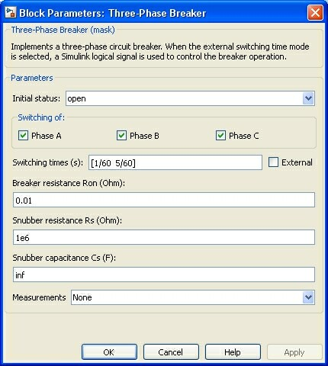

Initial status

The initial status of the breakers. The initial status is the same for the three breakers. Depending on the initial status, the icon shows a closed contact or an open contact.

Switching of: Phase A

If selected, the switching of phase A is activated. If not selected, the breaker of phase A stays in its initial status specified in the Initial status parameter.

Switching of: Phase B

If selected, the switching of phase B is activated. If not selected, the breaker of phase B stays in its initial status specified in the Initial status parameter.

Switching of: Phase C

If selected, the switching of phase C is activated. If not selected, the breaker of phase C stays in its initial status specified in the Initial status parameter.

Switching times (s)

The Switching times (s) parameter is available only if the External check box is not selected.

Specify the vector of switching times when using the Three-Phase Breaker block in internal control mode. At each transition time the selected breakers opens or closes depending to their initial state.

External

If selected, adds a fourth input port to the Three-Phase Breaker block for an external control of the switching times of the breakers. The switching times are defined by a Simulink signal (0-1 sequence).

Breakers resistance Ron

The internal breaker resistances, in ohms (Ω). The Breaker resistance Ron parameter cannot be set to 0.

Snubbers resistance Rs

The snubber resistances, in ohms (Ω). Set the Snubber resistance Rs parameter to inf to eliminate the snubbers from the model.

Snubbers capacitance Cs

The snubber capacitances, in farads (F). Set the Snubber capacitance Cs parameter to 0 to eliminate the snubbers, or to inf to get resistive snubbers.

**Measurements**

Select Breaker voltages to measure the voltage across the three internal breaker terminals.

Select Breaker currents to measure the current flowing through the three internal breakers. If the snubber devices are connected, the measured currents are the ones flowing through the breakers contacts only.

Select Breaker voltages and currents to measure the breaker voltages and the breaker currents.

Place a Multimeter block in your model to display the selected measurements during the simulation. In the Available Measurements list box of the Multimeter block, the measurements is identified by a label followed by the block name and the phase:

## 4.4 Three-Phase Transformer

When activated, the saturation characteristic is the same as the one described for the Saturable Transformer block. If the fluxes are not specified, the initial values are automatically adjusted so that the simulation starts in steady state.

The leakage inductance and resistance of each winding are given in pu based on the transformer nominal power Pn and on the nominal voltage of the winding (V1 or V2). For a description of per units, refer to the [Linear Transformer](http://www.mathworks.com/help/physmod/sps/powersys/ref/lineartransformer.html) and to the [Saturable Transformer](http://www.mathworks.com/help/physmod/sps/powersys/ref/saturabletransformer.html).

The two windings of the transformer can be connected as follows:

* Y
* Y with accessible neutral
* Grounded Y
* Delta (D1), delta lagging Y by 30 degrees
* Delta (D11), delta leading Y by 30 degrees

If you select the Y connection with accessible neutral for winding 1, an input port labeled N is added to the block. If you ask for an accessible neutral on winding 2, an extra output port labeled n is generated.

The D1 and D11 notations refer to the clock convention that assumes that the reference Y voltage phasor is at noon (12) on a clock display. D1 and D11 refer respectively to 1:00 p.m. (delta voltages lagging Y voltages by 30 degrees) and 11:00 a.m. (delta voltages leading Y voltages by 30 degrees).

### Standard Notation for Winding Connections

The conventional notation for a two-winding three-phase transformer uses two letters followed by a number. The first letter (Y or D) indicates a high-voltage wye or delta winding connection. The second letter (y or d) indicates a low-voltage wye or delta winding connection. The number, an integer between 0 and 12, indicates the position of the low-voltage positive-sequence voltage phasor on a clock display when the high-voltage positive-sequence voltage phasor is at 12:00.

The following three figures are examples of standard winding connections. The dots indicate polarity marks, and arrows indicate the position of phase A-to-neutral voltage phasors on high-voltage and low-voltage windings. The phasors are assumed to rotate in a counterclockwise direction so that rising numbers indicate increasing phase lag.

* Yd1: The low-voltage winding (d) is lagging high-voltage winding (Y) by 30 degrees. The **Winding 2 connection** parameter is set to **D1**.

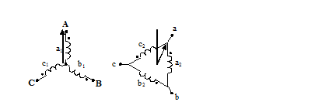

* Dy11: The low-voltage winding (y) is leading high-voltage winding (D) by 30 degrees. The **Winding 1 connection** parameter is set to **D1**.

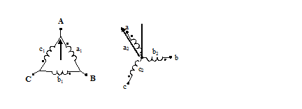

* Dy1: The low-voltage winding (y) is lagging high-voltage winding (D) by 30 degrees. The **Winding 1 connection** parameter is set to **D11**.

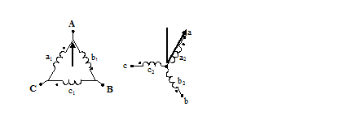

You can represent many other connections with phase shifts between 0 and 360 degrees (by steps of 30 degrees) by combining the +30- or –30-degree phase shift provided by the D1 and D11 block parameter settings and, in some cases, an additional +/–120-degree phase shift obtained by connecting the output terminals of delta winding to the appropriate phases of the network.

The table explains how to set up the Three-Phase Transformer block to obtain common connections.

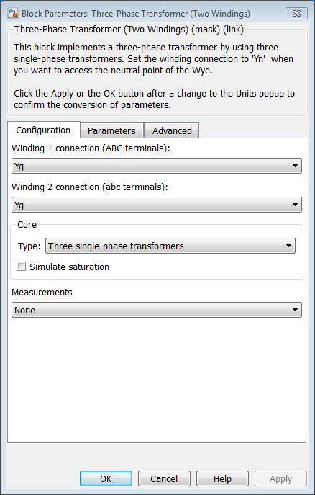

**Fig 4.3 Three Phase Transformer**

**Winding 1 connection (ABC terminals)**

The winding connections for winding 1.

**Winding 2 connection (abc terminals)**

The winding connections for winding 2.

**imulate saturation**

If selected, implements a saturable three-phase transformer.

If you want to simulate the transformer in the phasor mode of the Powergui block, you must clear this parameter.

**Simulate hysteresis**

Select to model a saturation characteristic including hysteresis instead of a single-valued saturation curve. This parameter is visible only if the **Saturable core** parameter is selected.

If you want to simulate the transformer in the phasor mode of the Powergui block, you must clear this parameter.

**Hysteresis Mat file**

Thisparameter is visible only if the **Simulate hysteresis**parameter is selected.

Specify a .mat file containing the data for use in the hysteresis model. When you open the **Hysteresis Design Tool** of the Powergui block, the default hysteresis loop and parameters saved in the hysteresis.mat fileare displayed. Use the **Load**button of the Hysteresis Design tool to load another .mat file. Use the **Save** button of the Hysteresis Design tool to save your model in a new .mat file.

**Specify initial fluxes**

If selected, the initial fluxes are defined by the **Initial fluxes** parameter on the **Parameters** tab. The **Specify initial fluxes** parameter is visible only if the **Saturable core**parameter is selected.

When the **Specify initial fluxes** parameter is not selected upon simulation, Simscape™ Power Systems™ software automatically computes the initial fluxes to start the simulation in steady state. The computed values are saved in the **Initial Fluxes** parameter and will overwrite any previous values.

**Measurements**

Select Winding voltages to measure the voltage across the winding terminals.

Select Winding currents to measure the current flowing through the windings.

Select Fluxes and excitation currents (Im + IRm) to measure the flux linkage, in volt seconds (V.s), and the total excitation current including iron losses modeled by Rm.

Select Fluxes and magnetization currents (Im) to measure the flux linkage, in volt seconds (V.s), and the magnetization current, in amperes (A), not including iron losses modeled by Rm.

Select All measurements (V, I, Flux)to measure the winding voltages, currents, magnetization currents, and the flux linkages.

Place a Multimeter block in your model to display the selected measurements during the simulation. In the **Available Measurements** list box of the Multimeter block, the measurements are identified by a label followed by the block name.

## 4.5 Current Measurement

The Current Measurement block is used to measure the instantaneous current flowing in any electrical block or connection line. The Simulink® output provides a Simulink signal that can be used by other Simulink blocks.

**Output signal**

Specifies the format of the output signal when the block is used in a phasor simulation. The **Output signal** parameter is disabled when the block is not used in a phasor simulation. The phasor simulation is activated by a Powergui block placed in the model.

Set to Complex to output the measured current as a complex value. The output is a complex signal.

Set to Real-Imag to output the real and imaginary parts of the measured current. The output is a vector of two elements.

Set to Magnitude-Angle to output the magnitude and angle of the measured current. The output is a vector of two elements.

Set to Magnitude to output the magnitude of the measured current. The output is a scalar value.

http://www.mathworks.com/help/physmod/sps/powersys/ref/current_measurement_ic.png

**Fig 4.4 current measurement**

## 4.6 Voltage Measurement

The Voltage Measurement block measures the instantaneous voltage between two electric nodes. The output provides a Simulink® signal that can be used by other Simulink blocks

**Output signal**

Specifies the format of the output signal when the block is used in a phasor simulation. The **Output signal** parameter is disabled when the block is not used in a phasor simulation. The phasor simulation is activated by a Powergui block placed in the model.

Set to Complex to output the measured current as a complex value. The output is a complex signal.

Set to Real-Imag to output the real and imaginary parts of the measured current. The output is a vector of two elements.

Set to Magnitude-Angle to output the magnitude and angle of the measured current. The output is a vector of two elements.

Set to Magnitude to output the magnitude of the measured current. The output is a scalar value.

http://www.mathworks.com/help/physmod/sps/powersys/ref/icon59.png

**Fig 4.5 voltage measurement**

## 4.7 Scope

Display signals generated during simulation

The Simulink® Scope block displays time domain signals with respect to simulation time.

http://www.mathworks.com/help/simulink/slref/timescope_icon.png

**Fig 4.6 Scope**

Input signal characteristics:

* **Signal** — Continuous (sample-based) or discrete (sample-based and frame-based).
* **Signal data type** — Any data type that Simulink supports including real, complex, fixed-point, and enumerated data types. See [Data Types Supported by Simulink](http://www.mathworks.com/help/simulink/ug/data-types-supported-by-simulink.html).
* **Signal dimension** — Scalar, one-dimensional (vector), two dimensional (matrix), or multidimensional. Display multiple channels within one signal depending on the dimension. See [Signal Dimensions](http://www.mathworks.com/help/simulink/ug/signal-dimensions.html) and [Determine Output Signal Dimensions](http://www.mathworks.com/help/simulink/ug/determining-output-signal-dimensions.html).

Scope display features:

* **Simulation** **control** — Debug models from a Scope window using Run, Step Forward, and Step Backward toolbar buttons.
* **Multiple signals** — Plot multiple signals on the same y-axis (display) using multiple input ports.
* **Multiple**y**-axes (displays)** — Display multiple y-axes. All of the y-axes have a common time range on the x-axis.
* **Modify parameters** — Modify scope parameter values before and during a simulation.
* **Axis autoscaling** — During or at the end of a simulation. Margins are drawn at the top and bottom of the axes.
* **Display data after simulation** — If a Scope is closed at the start of a simulation, scope data is still written to the scope during a simulation. As a result, if you open the Scope after a simulation, the Scope displays simulation results for attached input signals.

Oscilloscope features:

* **Triggers** — Set triggers to sync repeating signals and pause the display when events occur.
* **Data analysis** — Measure time and value differences between two signal data points. If you have a DSP System Toolbox™ license, measure signal characteristics including signal statistics, transitions, and peaks.

## 4.8 Three Phase VI measurement

Measure three-phase currents and voltages in circuit

http://www.mathworks.com/help/physmod/sps/powersys/ref/icon54.png

**Fig 4.7 VI measurement**

The Three-Phase V-I Measurement block is used to measure instantaneous three-phase voltages and currents in a circuit. When connected in series with three-phase elements, it returns the three phase-to-ground or phase-to-phase peak voltages and currents.

The block can output the voltages and currents in per unit (pu) values or in volts and amperes.

If you choose to measure phase-to-ground voltages in per unit, the block converts the measured voltages based on peak value of nominal phase-to-ground voltage:

Vabc(pu)=Vphase to ground(V)Vbase(V)

where

Vbase=Vnom(Vrms)G3⋅G2

If you choose to measure phase-to-phase voltages in per unit, the block converts the measured voltages based on peak value of nominal phase-to-phase voltage:

Vabc(pu)=Vphase to phase(V)Vbase(V)

where

Vbase=Vnom(Vrms)⋅G2

If you choose to measure currents in per unit, the block converts the measured currents based on the peak value of the nominal current:

Iabc(pu)=Iabc(A)Ibase(A)

where

Ibase=PbaseVnom∗sqrt(2)sqrt(3)

Vnom and Pbase are specified in the Three-Phase V-I Measurement block dialog box.

The steady-state voltage and current phasors measured by the Three-Phase V-I Measurement block can be obtained from the Powergui block by selecting Steady-State Voltages and Currents. The phasor magnitudes displayed in the Powergui stay in peak or RMS values even if the output signals are converted to pu.

Dialog Box and Parameters

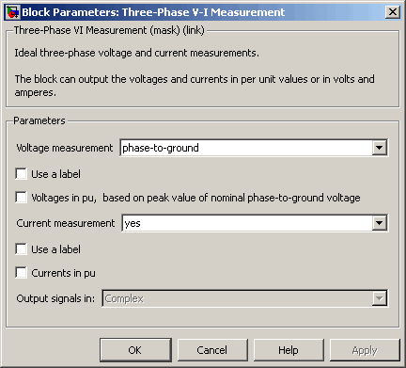

Voltage measurement

Select no if you do not want to measure three-phase voltage. Select phase-to-ground if you want to measure the phase-to-ground voltages. Select phase-to-phase if you want to measure the phase-to-phase voltages.

Use a label

If selected, the voltage measurements are sent to a labeled signal. Use a From block to read the voltages. The Goto tag of the From block must correspond to the label specified by the Signal label parameter. If not selected, the voltage measurements are available via the Vabc output of the block.

Signal label

Specifies a label tag for the voltage measurements.

Voltages in pu, based on peak value of nominal phase-to-ground voltage

If selected, the measured phase-to-ground voltages are converted in pu.

Voltages in pu, based on peak value of nominal phase-to-phase voltage

If selected, the measured phase-to-phase voltages are converted in pu. This parameter is not visible in the dialog box if Voltage measurement parameter is set to phase-to-ground or no.

Nominal voltage used for pu measurement (Vrms phase-phase)

The nominal voltage, in volts RMS, used to convert the measured voltages in pu. This parameter is not visible in the dialog box if Voltage measurement parameter is set to no.

Current measurement

Select yes if you want to measure the three-phase currents that flow through the block.

Use a label

If selected, the current measurements are sent to a labeled signal. Use a From block to read the currents. The Goto tag of the From block must correspond to the label specified by the Signal label parameter. If not selected, the current measurements are available via the Iabc output of the block.

**Signal label**

Specifies a label tag for the current measurements.

**Currents in pu**

If selected, the three-phase currents are measured in pu. Otherwise they are measured in amperes.

**Base power (VA 3 phase)**

The three-phase base power, in volt-ampere (VA), used to convert the measured currents in pu. The Base power (VA 3 phase) parameter is not visible in the dialog box ifCurrents in pu is not selected.

**Output signal**

Specifies the format of the measured signals when the block is used in a phasor simulation. The Output signal parameter is disabled when the block is not used in a phasor simulation. The phasor simulation is activated by a Powergui block placed in the model.

Set to Complex to output the measured voltages and currents as complex values. The outputs are complex signals.

Set to Real-Imag to output the real and imaginary parts of the measured voltages and currents.

Set to Magnitude-Angle to output the magnitudes and angles of the measured voltages and currents.

Set to Magnitude to output the magnitudes of the measured voltages and currents. The output is a scalar value.

## 4.9 AND

Perform specified logical operation on input

Logic and Bit Operations

Description

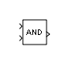

**Fig 4.8 AND**

The Logical Operator block performs the specified logical operation on its inputs. An input value is TRUE (1) if it is nonzero and FALSE (0) if it is zero.

You select the Boolean operation connecting the inputs with the Operator parameter list. If you select rectangular as the Icon shape property, the block updates to display the name of the selected operator.

## 4.10Relational Operators

Relational Operator

Perform specified relational operation on inputs

Library

Logic and Bit Operations

Description   
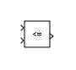 **Fig 4.9 Relational block**

## 4.12 MUX

Combine several input signals into vector

Library

Signal Routing

Description   
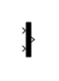

**Fig 4.10 Mux**

The Mux block combines its inputs into a single vector output. An input can be a scalar or vector signal. All inputs must be of the same data type and numeric type. The elements of the vector output signal take their order from the top to bottom, or left to right, input port signals. See [How to Rotate a Block](http://www.mathworks.com/help/simulink/ug/changing-a-blocks-appearance.html#f13-83952) for a description of the port order for various block orientations. To avoid adding clutter to a model, Simulink® hides the name of a Mux block when you copy it from the Simulink library to a model. See [Mux Signals](http://www.mathworks.com/help/simulink/ug/virtual-signals.html#brp5v4k-1) for information about creating and decomposing vectors.

## 4.13 DEMUX

Extract and output elements of vector signal

Library

Signal Routing

Description   
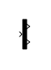

**Fig 4.11 DeMux**

The Demux block extracts the components of an input signal and outputs the components as separate signals. The output signals are ordered from top to bottom output port. See[How to Rotate a Block](http://www.mathworks.com/help/simulink/ug/changing-a-blocks-appearance.html#f13-83952) for a description of the port order for various block orientations. To avoid adding clutter to a model, Simulink® hides the name of a Demux block when you copy it from the Simulink library to a model. See [Mux Signals](http://www.mathworks.com/help/simulink/ug/virtual-signals.html#brp5v4k-1) for information about creating and decomposing vectors.

The Number of outputs parameter allows you to specify the number and, optionally, the dimensionality of each output port. If you do not specify the dimensionality of the outputs, the block determines the dimensionality of the outputs for you.

The Demux block operates in either vector mode or bus selection mode, depending on whether you selected the Bus selection mode parameter. The two modes differ in the types of signals they accept. Vector mode accepts only a vector-like signal, that is, either a scalar (one-element array), vector (1-D array), or a column or row vector (one row or one column 2-D array). Bus selection mode accepts only a bus signal.

The Number of outputs parameter determines the number and dimensionality of the block outputs, depending on the mode in which the block operates.

Specifying the Number of Outputs in Vector Mode

In vector mode, the value of the parameter can be a scalar specifying the number of outputs or a vector whose elements specify the widths of the block's output ports. The block determines the size of its outputs from the size of the input signal and the value of the Number of outputs parameter.

# Chapter 5

# CONCLUSION

In this simulation a new toolboxes has been added to serve the simulation of thebdifferential relay (CTs and digital differential relay). This simulation is tested for four cases and gave good

satisfactory results with a 10.7 msec speed to sensitize the internal fault in order to isolate the transformer.

This simulation is tested for various cases and for all cases it gave satisfactory results. All the tests gave satisfactory results. There are some difficulties are faced in the implantation of this system such as the lack of some toolbox in the Sim-power-system. For example, there is no current transformer in the toolbox. In this case, there are two choices to solve this problem. The first one is to use a regular single phase and make some changes in its specification to fit the current transformer specifications. The second one is to use a current measurement, but this one will not simulate the problems of the CTs.

# REFERNCES

<http://www.mathworks.com/help/physmod/sps/powersys/ref/threephasesource.html>

<http://www.mathworks.com/help/physmod/sps/powersys/ref/distributedparameterline.html>

<http://www.mathworks.com/help/simulink/slref/scope.html>

<http://www.mathworks.com/help/physmod/sps/powersys/ref/voltagemeasurement.html>

<http://www.mathworks.com/help/physmod/sps/powersys/ref/currentmeasurement.html>

<http://www.mathworks.com/help/physmod/sps/powersys/ref/threephasebreaker.html;jsessionid=027028bf38dd218521e2eb2948d4>