We would not be going justice in presenting this final year report without mentioning the people around us who have been inextricably related with the completion of this report. I wish to record my honorable regards to all those who helped a lot in completion of this report especially to
Supervisor.

ACKNOWLEDGMENT
Absolute praise for Almighty Allah, provider of hope, guidance and knowledge without whose constant remembrance, I would not have overcome my moments of despair.

I am grateful to Allah almighty, for enabling me to fulfill this final year project

ABSTRACT

This project describes the design and implementation of an energy efficient solar tracking system from a normal mechanical single axis to a hybrid dual axis. For optimizing the solar tracking mechanism electromechanical systems were evolved through implementation of different evolutional algorithms and methodologies. To present the tracker, a hybrid dual-axis solar tracking system is designed, built, and tested based on both the solar map and light sensor based continuous tracking mechanism. These light sensors also compare the darkness and cloudy and sunny conditions assisting daily tracking. The designed tracker can track sun’s apparent position at different months and seasons; thereby the electrical controlling device requires a real time clock device for guiding the tracking system in seeking solar position for the seasonal motion. So the combination of both of these tracking mechanisms made the designed tracker a hybrid one.
The power gain and system power consumption are compared with a static and continuous dual axis solar tracking system. It is found that power gain of hybrid dual axis solar tracking system is almost equal to continuous dual axis solar tracking system, whereas the power saved in system operation by the hybrid tracker is 44.44% compared to the continuous tracking system.
Table of Contents
ACKNOWLEDGMENT ii
ABSTRACT 3
Chapter 1 7
INTRODUCTION 7
1.1Overview 7
1.2 Project description 7
1.4 Background 7
1.5 Tracking system 9
1.5.1 Active tracking 9
1.5.2 Passive Tracking 9
1.5.2 Sensors 9
1.6 MOTIVATION 10
1.7 PROBLEM STATEMENT AND OBJECTIVE 10
1.8 APPLICATIONS OF SOLAR ENERGY 11
1.9 ADVANTAGES OF SOLAR ENERGY 12
Chapter 2 13
LITERATURE REVIEW 13
2.1 Difference between single and dual axis tracker 13
2.2 Solar Tracking 13
2.3 Technology of Solar Panel 14
2.4 Evolution of Solar Tracker 15
Chapter 3 16
PROJECT DESIGN AND IMPLEMENTATION 16
3.1 Prototype of Designed Tracker. 16
3.2 Operation of the Solar Tracker 17
3.3 TYPES OF SOLAR TRACKERS (BASED ON THE DESIGN OF PANEL) 18
3.4 TRACKER COMPONENTS 20
3.5 Mounting System 21
Chapter 4 22
TOOLS AND TECHNIQUES 22
4.1 Hardware used with technical specifications 22
4.1.1 2n2222 Transistor 22
4.1.2 SPDT Relay 24
4.1.3 Capacitors 27
4.1.4 Arduino Uno 30
4.1.5 H-Bridge 33
4.1.6 Motors 41
4.1.7 Resistor: 41
4.1.8 Light Dependent Resistor: 42
4.1.9 Solar Panel: 43
Chapter 5 46
Conclusion 46
Refrences 47

LIST OF ACRONYMS
BJT Bipplar Junction Transistor
LDR Light dependent resistor
Spdt single pole double throw

Chapter 1

INTRODUCTION

1.1Overview
The tracker actively track the sun and change its position accordingly to maximize the energy output. To prevent wasting power by running the motor continuously, the tracker corrects it's position after 2 to 3 degrees of misalignment. The sensors compare the light intensities of each side and move the panels until the tracker detects equal light on both sides. Additionally, it prevents rapid changes in direction that might be caused by reflections, such as cars passing by. A rear sensor circuit is also incorporated to aid in repositioning the solar panels for the next sunrise. The gear motor has overturn triggers to prevent the panel from rotating 360° and entangling wires. The motor control and sensing circuitry runs on batteries charged by the solar panel. This system uses three small 10W solar panels of approximately 15 inches by 10 inches to model larger panels used in industry.

1.2 Project description
This project proposes a novel design of a dual-axis solar tracking PV system which utilizes the feedback control theory along with a four-quadrant light dependent resistor (LDR) sensor and simple electronic circuits to provide robust system performance. The proposed system uses a unique dual-axis AC motor and a stand-alone PV inverter to accomplish solar tracking. The control implementation is a technical innovation that is a simple and effective design. In addition, a scaled-down laboratory prototype is constructed to verify the feasibility of the scheme. The effectiveness of the Sun tracker is confirmed experimentally. To conclude, the results of this study may serve as valuable references for future solar energy applications.

1.4 Background
There is a great and growing need for renewable energy, in particular green energy. In years to come we will want a source of energy that will leave future generations with a sustainable energy source. A few good reasons to improve our green energy market are because not only do we want to have renewable energy for future generations, but we also want to have a sustainable energy market in future. Green energy has shown sustainable growth in past years, where oil has obviously not. In order to power our homes, businesses, and most aspects of our daily lives we require electricity, which requires massive power plants and spending billions of dollars to run them. But what if we could avoid all the resources that are used generating this energy, and replace them with green energy that could provide power directly to the consumers like businesses, the military or even private homes.
Overall it is dangerous to depend strictly on fossil fuels. It is dangerous politically, economically, and naturally. Politically we want the country to not have to depend on petroleum from other countries. Being dependent on other countries, especially as the top consumer of fossil fuels, would have a negative impact on our country in the future; that is when they resources disappeared. On the economic side, our country would be in better shape to be more self sustaining in future. On the environmental side, when it comes to burning these fossil fuels, although debated on how bad the environmental effect is, it is known to produce large amounts of carbon dioxide.
The purpose of solar panels is to meet the growing demand for renewable energy resources. In the modern world, the demand for electricity has grown at alarming rates to meet the needs of society. Many other benefits to solar energy include the lack of pollution directly created by these systems and their inexpensive and practical nature in the long term. As the demand for solar panels grow, so will the need for ways to optimize their energy collection. Tracking systems are designed to orient solar panels toward the sun. By adding a tracking system, the energy a solar panel can output could be increased by up to 50% during the summer months. This project is very practical and feasible as there are many types solar tracker designs in industry today. In addition, a similar senior project was done in 1994 on the "Sun Luis solar racer 101" electric car by a physics major, David Babbitt. However, the 1994 project dealt with manual panel adjustments given sensor data.

Tracking system

1.5.1 Active tracking
Active tracking uses motors, gears, and actuators to position the solar tracker so that it is perpendicular to the sunlight. Trackers that use sensors to track the sun position inputs data into the controller, which in turns drives the motors and actuators to position the tracker. There are also trackers that uses solar map. Depending on the location, solar maps give information on where the sun is at different time of day throughout the year. Trackers that use solar map do not need sensors input to track the sun. But there are also tracker that uses both sensors and solar map. During sunny weather, the sensor would be used to track the sun. But during cloud-covered times, the information from the solar map would be used. It is important to track the sun even in cloudy condition since solar panels can produce energy during cloudy conditions.

Passive Tracking
Passive trackers use compressed gas to move the tracker. Depending on the position sunlight is falling on the gas containers difference in gas pressure is created, moving the tracker until it gets to an equilibrium position. The advantage of passive tracker is that the tracking system does not require a controller. But passive trackers are slow in response and are vulnerable to wind gusts.

Sensors
Any device that is sensitive to the intensity of light can be used as solar tracking sensors. Two of those similar devices can be placed at an angle as shown in the figure below.

When the sun is on the left, the sensor on the left receives more light than the one on the left. If the sensors produce voltage with light intensity, the left sensor would produce more voltage than the one on the left. From the result, we can know that the sun is on the left. When the two sensors are outputting the same value, we know that the sun must be at the top, perpendicular to the sensor unit.

MOTIVATION

Commercial made solar trackers are a nice addition to any solar panel array. They help increase the time that panels directly face the sun and allow them to produce their maximum power. Unfortunately they can be expensive to buy. To reduce its cost solar tracking can be done using time instead of using a device that would sense where the sun is and move the panels toward it. The objective of this system is to control the position of a solar panel in accordance with the motion of sun.

PROBLEM STATEMENT AND OBJECTIVE
Renewable energy is rapidly gaining importance as an energy resource as fossil fuel prices fluctuate. At the educational level, it is therefore critical for engineering and
technology students to have an understanding and appreciation of the technologies associated with renewable energy. One of the most popular renewable energy sources is solar energy. Many researches were conducted to develop some methods to increase the efficiency of Photo Voltaic systems (solar panels). One such method is to employ a solar panel tracking system. This system deals with a RTC based solar panel tracking system. Solar tracking enables more energy to be generated because the solar panel is always able to maintain a perpendicular profile to the sun’s rays. Development of solar panel tracking systems has been ongoing for several years now.
As the sun moves across the sky during the day, it is advantageous to have the solar panels track the location of the sun, such that the panels are always perpendicular to the solar energy radiated by the sun. This will tend to maximize the amount of power absorbed by PV systems. It has been estimated that the use of a tracking system, over a fixed system, can increase the power output by 30% - 60%. The increase is significant enough to make tracking a viable preposition despite of the enhancement in system cost. It is possible to align the tracking heliostat normal to sun using electronic control by a micro controller. Design requirements are:
1) During the time that the sun is up, the system must follow the sun’s position in the sky.
2) This must be done with an active control, timed movements are useful. It should be totally automatic and simple to operate.

APPLICATIONS OF SOLAR ENERGY
- Architecture and urban planning
- Agriculture and horticulture
- Solar lightning-street lightning
- Solar thermal energy
- Solar water heater systems
- Heating, cooling and ventilation
- Water treatment
- Solar cooker
- Solar electricity
- Solar vehicles
- Solar water treatment

ADVANTAGES OF SOLAR ENERGY
1.No green house gases:- The major benefit of solar is avoiding green house gases that fossil fuels produce. The first and foremost advantage of solar energy is that it does not emit any green house gases. Solar energy is produced by conducting the sun’s radiation – a process void of any smoke, gas, or other chemical by-product. This is the main driving force behind all green energy technology, as nations attempt to meet climate change obligations in curbing emissions. Italy’s Montalto di Castro solar park is a good example of solar’s contribution to curbing emissions. It avoids 20,000 tons per year of carbon emissions compared to fossil fuel energy production.
2. Infinite Free Energy:- Another advantage of using solar energy is that beyond initial installation and maintenance, solar energy is one hundred percent free. Solar doesn’t require expensive and ongoing raw materials like oil or coal, and requires significantly lower operational labor than conventional power production. Lower costs are direct as well as indirect less staff working at the power plant as the sun and the solar semi conductors do all the work, as well as no raw materials that have to be extracted, refined, and transported to the power plant.
3. Renewable Source: Solar energy is a renewable source of energy and will continue to produce electricity as long as sun exists. Although solar energy cannot be produce during night and cloudy days but it can be used again and again during
day time. Solar energy from sun is consistent and constant power source and can be used to harness power in remote locations.
4. Low maintenance: Solar cells generally don’t require any maintenance and run for long time. More solar panels can be added from time to time when needed. Although, solar panels have initial cost but there are no recurring costs. Initial
cost that is incurred once can be recovered in the long run. Apart from this, solar panel does not create any noise and does not release offensive smell.
5. Easy Installation: Solar panels are easy to install and does not require any wires, cords or power sources. Unlike wind and geothermal power stations which require them to be tied with drilling machines, solar panels does not require them and can be installed on the rooftops which means no new space is needed and each home or business user can generate their own electricity. Moreover, they can be installed in distributed fashion which means no large scale installations are needed.

Chapter 2

LITERATURE REVIEW
The recent decades have seen the increase in demand for reliable and clean form of electricity derived from renewable energy sources. One such example is solar power. The challenge remains to maximize the capture of the rays from the sun for conversion into electricity. This paper presents fabrication and installation of a solar panel mount with a dual-axis solar tracking controller. This is done so that rays from the sun fall per-pendicularly unto the solar panels to maximize the capture of the rays by pointing the solar panels towards the sun and following its path across the sky. Thus electricity and efficiency increased.

2.1 Difference between single and dual axis tracker
A single-axis solar tracker follows the movement of the sun from east to west by rotating the structure along the vertical axis. The solar panels are usually tilted at a fixed angle corresponding to the latitude of the location. According to the use of single-axis tracking can in-crease the electricity yield by as much as 27 to 32 per-cent. On the other hand, a dual-axis solar tracker follows the angular height position of the sun in the sky in addi-tion to following the sun’s east-west movement re-ports that dual-axis tracking increases the electricity output as much as 35 to 40 percent.

2.2 Solar Tracking

Solar tracking is best achieved when the tilt angle of the solar tracking systems is synchronized with the seasonal changes of the sun’s altitude. An ideal tracker would allow the solar modules to point towards the sun, compensating for both changes in the altitude angle of the sun (throughout the day) and latitudinal offset of the sun (during seasonal changes). So the maximum efficiency of the solar panel is not being used by single axis tracking system whereas double axis tracking would ensure a cosine effectiveness of one.
In active tracking or continuous tracking, the position of the sun in the sky during the day is continuously determined by sensors. The sensors will trigger the motor or actuator to move the mounting system so that the solar panels will always face the sun throughout the day. If the sunlight is not perpendicular to the tracker, then there will be a difference in light intensity on one light sensor compared to another. This difference can be used to determine in which direction the tracker has to be tilted in order to be perpendicular to the sun. This method of sun tracking is reasonably accurate except on very cloudy days when it is hard for the sensors to determine the position of the sun in the sky.
Passive tracker, unlike an active tracker which determines the position of the sun in the sky, moves in response to an imbalance in pressure between two points at both ends of the tracker. The imbalance is caused by solar heat creating gas pressure on a “low boiling point compressed gas fluid, that is, driven to one side or the other” which then moves the structure. However, this method of sun tracking is not accurate.
A solar tracker is a device for orienting a solar photovoltaic panel, day lighting reflector or concentrating solar reflector or lens toward the sun. Solar power generation works best when pointed directly at the sun, so a solar tracker can increase the effectiveness of such equipment over any fixed position. The solar panels must be perpendicular to the sun's rays for maximum energy generation. Deviating from this optimum angle will decrease the efficiency of energy generation from the panels. A few degrees of misalignment will only cause 1% to 5% of energy loss, while larger angles of 10° to 20° will significantly decrease the energy generation of up to 35%. Although, this loss is also dependent on the material and
pattern of the protective glass that covers the solar panel. An active tracker uses motors to direct the panel toward the sun by relying on a sensing circuit to detect light intensity.

2.3 Technology of Solar Panel
Solar panels are devices that convert light into electricity. They are called solar after the sun or "Sol" because the sun is the most powerful source of the light available for use. They are sometimes called photovoltaic which means "lightelectricity".
Solar cells or PV cells rely on the photovoltaic effect to absorb the energy of the sun and cause current to flow between two oppositely charge layers. A solar panel is a collection of solar cells. Although each solar cell provides a relatively small amount of power, many solar cells spread over a large area can provide enough power
to be useful. To get the most power, solar panels have to be pointed directly at the Sun. The development of solar cell technology begins with 1839 research of French physicist Antoine-Cesar Becquerel. He observed the photovoltaic effect while experimenting with a solid electrode in an electrolyte solution. After that he saw a
voltage developed when light fell upon the electrode. According to Encyclopedia Britannica the first genuine for solar panel was built around 1883 by Charles Fritts. He used junctions formed by coating selenium (a semiconductor) with an extremely thin layer of gold. Crystalline silicon and gallium arsenide are typical choices
of materials for solar panels. Gallium arsenide crystals are grown especially for photovoltaic use, but silicon crystals are available in less-expensive standard ingots, which are produced mainly for consumption in the microelectronics industry.

2.4 Evolution of Solar Tracker
Since the sun moves across the sky throughout the day, in order to receive the best angle of exposure to sunlight for collection energy. A tracking mechanism is often incorporated into the solar arrays to keep the array pointed towards the sun. A solar tracker is a device onto which solar panels are fitted which tracks the motion of the sun across the sky ensuring that the maximum amount of sunlight strikes the panels throughout the day. When compare to the price of the PV solar panels, the cost of a solar tracker is relatively low. Most photovoltaic (PV) solar panels are fitted in a fixed location- for example on the sloping roof of a house, or on framework fixed to the ground. Since the sun moves across the sky though the day, this is far from an ideal solution. Solar panels are usually set up to be in full direct sunshine at the middle of the day facing South in the Northern Hemisphere, or North in the Southern Hemisphere. Therefore morning and evening sunlight hits the panels at an acute angle reducing the total amount of electricity which can be generated each day.

Chapter 3

PROJECT DESIGN AND IMPLEMENTATION

It is completely automatic and keeps the panel in front of sun until that is visible. The unique feature of this system is that instead of taking the earth as its reference, it takes the sun as a guiding source. Its active sensors constantly monitor the sunlight and rotate the panel towards the direction where the intensity of sunlight is maximum.

3.1 Prototype of Designed Tracker.
The major components those are used in the prototype are given below:-
- Photo resistor
- Microcontroller
- DC motor
- H-Bridge
Cadmium sulphide (CDS) photo resistor is used in the designed prototype. The
CdS photo resistor is a passive element that has a resistance inversely proportional to
the amount of light incident on it. To utilize the photo resistor, it is placed in series
with another resistor. A voltage divider is thus formed at the junction between photo
resistor and another resistor; the output is taken at the junction point to pass the
measured voltage as input to microcontroller.

3.2 Operation of the Solar Tracker
In solar tracking systems, solar panels are mounted on a structure which moves to track the movement of the sun throughout the day. There are three methods of tracking: active, passive and chronological tracking. These methods can then be configured either as sin-gle-axis or dual-axis solar trackers. In active tracking, the position of the sun in the sky during the day is continu-ously determined by sensors. The sensors will trigger the motor or actuator to move the mounting system so that the solar panels will always face the sun throughout the day. This method of sun-tracking is reasonably accurate except on very cloudy days when it is hard for the sensor to determine the position of the sun in the sky thus mak ing it hard to reorient the structure.
Solar tracker provides three ways of operation and control mechanism through the
programme written in microcontroller.
A. Normal day light condition: -
Two photo resistors are used in the solar tracker to
compare the output voltages from two junctions. As the sun rotates from east to west in
the day time, AIN0 needs to provide higher voltage than AIN1 to sense the rotation of
the sun. This condition is considered as normal day light condition and tracker rotates
the panel 3.75° after every 15 minutes.
B. Bad weather condition: - When the sky gets cloudy, there will be less striking of
light on both the photo resistors and so sufficient voltages might not be available at
junction point. The difference of voltage at junction point will not be greater than the
threshold value to rotate the tracker. At the meantime, sun continues rotating in the
western direction. To solve this problem, a short delay is provided which will check
for voltage input from junction point in every 1.5 minutes. Microcontroller will use the
variable Count to check for consecutively 10 times to make the ‘wait’ state equal to 15 minutes (moderate delay) to rotate the stepper motor one step.
C. Bidirectional rotation: - At day time, the solar tracker will rotate in only one
direction from east to west. Variable I will count the total rotation in day time and that
is approximately calculated as 40 rotations considering 150° rotation. When the sun
sets, no more rotation is needed in western direction. For the next day, the solar panel
needs to go to the initial position in the morning to track the sun’s position again. To
do so, the variable I that counts the number of rotation in the day time will work out.
When the variable (I) shows value greater than 40, the tracker stops rotating in the
western direction and rotates reversely in the eastern direction to set the tracker to the
initial position for the next day. When it goes to initial position, power supply to the
tracker will be turned off and the tracker will be in stand by till sunlight in the next
morning.

3.3 TYPES OF SOLAR TRACKERS (BASED ON THE DESIGN OF PANEL)
There are many different types of solar tracker which can be grouped into single axis and double axis models:-
Single axis trackers:-
single axis solar trackers can either have a horizontal or a vertical axle. The horizontal type is used in tropical regions where the sun gets very high at noon, but the days are short. The vertical type is used in high latitudes (such as in UK) where the sun does not get very high, but summer days can be very long. These have a manually adjustable tilt angle of 0-45 degrees and automatic tracking of the sun from east to west. They use the PV modules to themselves as light sensor to avoid unnecessary tracking movement and for the reliability. At night the trackers take up a horizontal position. This kind of tracker is most effective at equatorial latitudes where the sun is more or less overhead at noon. Due to the annual motion of the earth the sun also moves in the north and south direction depending on the season and due to this the
efficiency of single-axis is reduced since the single-axis tracker only tracks the movement of sun from east to west. During cloudy days the efficiency of the single axis tracker is almost close to the fixed panel.
Dual axis trackers:-
In dual-axis tracking system the sun rays are captured to the maximum by tracking the
movement of the sun in four different directions. The dual-axis solar tracker follows the angular height position of the sun in the sky in addition to following the sun’s east-west movement double axis trackers have both a horizontal and a vertical axle
and so can track the sun’s apparent motion exactly anywhere in the world. This type of system is used to control astronomical telescopes, and so there is plenty of software available to automatically predict and track the motion of sun across the sky. When the sun moves in the northern direction the tracker has to track the path of the sun in anti-clockwise direction along the horizontal axis (east to west). If the sun moves in the southern direction then the tracker has to track the path of the sun in clockwise.
Dual axis solar trackers track the sun in both directions i.e.from east to west and north to south for added output power (approx 40% gain) and convenience.

3.4 TRACKER COMPONENTS
1.Sun tracking algorithm: This algorithm calculates the solar azimuth and zenith angles of the sun. These angles are then used to position the solar panel or reflector to point toward the sun. Some algorithms are purely mathematical based on astronomical references while others utilize real-time lightintensity readings.
2. Control unit: The control unit executes the sun tracking algorithm and coordinates the movement of the positioning system.
3. Positioning system: The positioning system moves the panel or reflector to face the sun at the optimum angles. Some positioning systems are electrical and some are hydraulic.
Electrical systems utilize encoders and variable frequency drives or linear actuators to monitor the current position of the panel and move to desired positions.

3.5 Mounting System
The mounting system refers to the structure which holds the solar panels; the structure consists of movable and fixed parts based on a set of criteria.
Firstly, the structure must be able to support the weight of the solar panels which are mounted on it. In this work, two solar panels are used. The total weight is 31 kg, 15.5 kg each. Besides that, the column and the base of the structure should also be able to support the weight of the frame, which is estimated to be about 70 kg . That gives a total weight of slightly more than 100 kg.
Secondly, since the structure will be erected outdoors, the structure must be able to withstand the elements of nature, most notably the effects from the sun (heat), rain (water) and the wind (air). Of utmost concern will be effect of wind load on the structure when wind load is acting upon the solar panels.

Chapter 4

TOOLS AND TECHNIQUES

In this chapter the hardware used in the project are discussed. It also contains the technical details and specifications.

4.1 Hardware used with technical specifications

4.1.1 2n2222 Transistor
The 2N222 transistor is a common negative-positive-negative (NPN) bipolar junction transistor (BJT) that finds use in many different kinds of electronic equipment. It is used for both analog signal amplification and switching applications. The functioning parts of the 2N2222 transistor are enclosed in what is known as a TO-18 package, which resembles a small metal can. The broad range of uses for the 2N2222 transistor, and its small size, make it and its variants the most widely used transistors in electronics.
The functioning portion of the 2N2222 transistor is a NPN BJT construct. The 2N2222 transistor is made of either germanium or silicon that has been saturated with either a positively or negatively changed material in a process called “doping.” The 2N2222 has a positively charged section sandwiched between two negatively charged sections. The resulting two connections between the three sections are where the 2N2222 derives the name “bipolar junction transistor.” The materials used are arranged in the order of negative, positive, then negative, so the device is also said to be a NPN transistor.
The 2N2222 has three wire leads used to solder it to circuit boards: the collector, theemitter, and the base. When an electronic signal is present at the transistor’s collector, applying a signal to the transistor’s base will cause a signal to emit from the device’s emitter. In this way, the 2N2222 is often used to switch signals on and off.

Manufacturer | Vce | Collector current | PD | fT
ST Microelectronics[12]  2N2222A | 40V | 800mA | 50mW/1.8W | 300MHz

Switching:
The switching abilities of the 2N2222 transistor also make it useful as a simple “and” gate. When used in this capacity, the transistor will only send a signal when two separate signals are present: one at its collector and one at its base. This allows the 2N2222 to be used to automatically control signal flow in a circuit depending on what signals.
Amplification:
In amplification applications, the 2N2222 receives an analog signal, such as an audio signal, through its collector and a separate signal is applied to its base. The output at the transistor’s emitter will then be identical to the collector signal with the exception that it increases in power by an amount proportional to the signal applied to its base. Additionally, varying the signal applied to the base will vary the amplification of the signal leaving the emitter.
Characteristics:
The main characteristics of this device may be understood with the following points:
- The transistor 2N2222 or 2N2222A are NPN types and has the following electrical parameters:
- The device’s maximum voltage tolerance (breakdown voltage) across its collector and base is 60 volts for 2N2222 and 75 volts for 2N2222A, with the emitters kept open.
- With their base open, the above tolerance across their collector and emitter leads is 30 volts for 2N2222 and 40 volts for 2N2222A.
- As expressed earlier, the maximum current that can be applied across the transistors collector and emitter, via a load is not more than 800 mA.
- Total power dissipation of the device should not exceed above 500 mW.
- hFE or the dC current gain of 2N2222 transistors will be around 75 minimum, at voltages near 10, with 10 mA collector current.
- Maximum frequency handling capacity or the transition frequency is 250 MHz for 2N2222 and 300 MHz for 2N2222A.
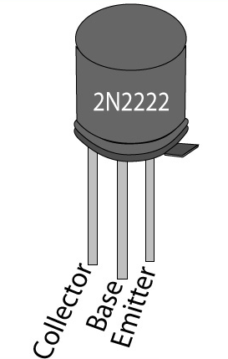

4.1.2 SPDT Relay
The Single Pole Double Throw SPDT relay is quite useful because of its internal configuration. It has one common terminal and 2 contacts in 2 different configurations: one can be Normally Closed and the other one is opened or it can be Normally Open and the other one closed. So basically you can see the SPDT relay as a way of switching between 2 circuits: when there is no voltage applied to the coil one circuit “receives” current, the other one doesn’t and when the coil gets energised the opposite is happening.The relay driver is used to isolate both the controlling and the controlled device.The relay is an electromagnetic device, which consists of solenoid, moving contacts (switch) and restoring spring and consumes comparatively large amount of power. Hence it is possible for the interface IC to drive the relay satisfactorily. To enable this,the driver circuitry senses the presence of a “high” level at the input and drives the relay from another voltage source. Hence the relay is used to switch the electrical supply to the appliances. when we connect the rated voltage across the coil the back emf opposes the current flow but after the short time the supplied voltage will overcome the back emf and the current flow through the coil increase. When the current is equal to the activating current of relay the core is magnetized and it attracts the moving contacts. Now the moving contact leaves from its initial position denoted “(N/C)” normally closed terminal The common contact or moving contact establishes the connection with a new terminal which is indicated as a normally open terminal “(N/O)”. Whenever, the supply coil is withdrawn the magnetizing force is vanished. Now, the spring pulls the moving contact back to initial position, where it makes a connection makes with N/C terminal. However, it is also to be noted that at this time also a back emf is produced. The withdrawal time may be in microsecond, the back emf may be in the range of few kilovolts and in opposite polarity with the supplied terminals the voltage is known as surge voltage. It must be neutralized or else it may damage the system.

A relay is an electrically operated switch used to isolate one electrical circuit from another. In its simplest form, a relay consists of a coil used as an electromagnet to open and close switch contacts. Since the two circuits are isolated from one another, a lower voltage circuit can be used to trip a relay, which will control a separate circuit that requires a higher voltage or amperage. Relays can be found in early telephone exchange equipment, in industrial control circuits, in car audio systems, in automobiles, on water pumps, in high-power audio amplifiers and as protection devices.

Types of Relays:
Single Pole Single Throw (SPST) – This type of relay has a total of four terminals. Out of these two terminals can be connected or disconnected. The other two terminals are needed for the coil.
Single Pole Double Throw (SPDT) – This type of a relay has a total of five terminals. Out f these two are the coil terminals. A common terminal is also included which connects to either of two others.
Double Pole Single Throw (DPST) – This relay has a total of six terminals. These terminals are further divided into two pairs. Thus they can act as two SPST’s which are actuated by a single coil. Out of the six terminals two of them are coil terminals.
Double Pole Double Throw (DPDT) – This is the biggest of all. It has mainly eight relay terminals. Out of these two rows are designed to be change over terminals. They are designed to act as two SPDT relays which are actuated by a single coil.
Relay Applications
- Relays are used to realize logic functions. They play a very important role in providing safety critical logic.
- Relays are used to provide time delay functions. They are used to time the delay open and delay close of contacts.
- Relays are used to control high voltage circuits with the help of low voltage signals. Similarly they are used to control high current circuits with the help of low current signals.
Relay Selection
You must note some factors while selecting a particular relay. They are
- Protection – Different protections like contact protection and coil protection must be noted. Contact protection helps in reducing arcing in circuits using inductors. Coil protection helps in reducing surge voltage produced during switching.Look for a standard relay with all regulatory approvals.
- Switching time – Ask for high speed switching relays if you want one.
- Ratings – There are current as well as voltage ratings. The current ratings vary from a few amperes to about 3000 amperes. In case of voltage ratings, they vary from 300 Volt AC to 600 Volt AC. There are also high voltage relays of about 15,000 Volts.
- Type of contact used – Whether it is a NC or NO or closed contact.
- Select Make before Break or Break before Make contacts wisely.
- Isolation between coil circuit and contacts

4.1.3 Capacitors
The Capacitor, sometimes referred to as a Condenser, is a simple passive device that is used to “store electricity”. The capacitor is a component which has the ability or “capacity” to store energy in the form of an electrical charge producing a potential difference (Static Voltage) across its plates, much like a small rechargeable battery. the Capacitor, sometimes referred to as a Condenser, is a simple passive device that is used to “store electricity”. The capacitor is a component which has the ability or “capacity” to store energy in the form of an electrical charge producing a potential difference (Static Voltage) across its plates, much like a small rechargeable battery. In its basic form, a Capacitor consists of two or more parallel conductive (metal) plates which are not connected or touching each other, but are electrically separated either by air or by some form of a good insulating material such as waxed paper, mica, ceramic, plastic or some form of a liquid gel as used in electrolytic capacitors. The insulating layer between a capacitors plates is commonly called the Dielectric.

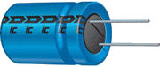

Due to this insulating layer, DC current can not flow through the capacitor as it blocks it allowing instead a voltage to be present across the plates in the form of an electrical charge.
The conductive metal plates of a capacitor can be either square, circular or rectangular, or they can be of a cylindrical or spherical shape with the general shape, size and construction of a parallel plate capacitor depending on its application and voltage rating.
When used in a direct current or DC circuit, a capacitor charges up to its supply voltage but blocks the flow of current through it because the dielectric of a capacitor is non-conductive and basically an insulator. However, when a capacitor is connected to an alternating current or AC circuit, the flow of the current appears to pass straight through the capacitor with little or no resistance.
There are two types of electrical charge, positive charge in the form of Protons and negative charge in the form of Electrons. When a DC voltage is placed across a capacitor, the positive (+ve) charge quickly accumulates on one plate while a corresponding negative (-ve) charge accumulates on the other plate. For every particle of +ve charge that arrives at one plate a charge of the same sign will depart from the -ve plate.
Then the plates remain charge neutral and a potential difference due to this charge is established between the two plates. Once the capacitor reaches its steady state condition an electrical current is unable to flow through the capacitor itself and around the circuit due to the insulating properties of the dielectric used to separate the plates.
The flow of electrons onto the plates is known as the capacitors Charging Current which continues to flow until the voltage across both plates (and hence the capacitor) is equal to the applied voltageVc. At this point the capacitor is said to be “fully charged” with electrons. The strength or rate of this charging current is at its maximum value when the plates are fully discharged (initial condition) and slowly reduces in value to zero as the plates charge up to a potential difference across the capacitors plates equal to the source voltage.
The amount of potential difference present across the capacitor depends upon how much charge was deposited onto the plates by the work being done by the source voltage and also by how much capacitance the capacitor has and this is illustrated below.
Capacitor Construction
The parallel plate capacitor is the simplest form of capacitor. It can be constructed using two metal or metallised foil plates at a distance parallel to each other, with its capacitance value in Farads, being fixed by the surface area of the conductive plates and the distance of separation between them. Altering any two of these values alters the the value of its capacitance and this forms the basis of operation of the variable capacitors.
Also, because capacitors store the energy of the electrons in the form of an electrical charge on the plates the larger the plates and/or smaller their separation the greater will be the charge that the capacitor holds for any given voltage across its plates. In other words, larger plates, smaller distance, more capacitance.By applying a voltage to a capacitor and measuring the charge on the plates, the ratio of the charge Qto the voltage V will give the capacitance value of the capacitor and is therefore given as:
C = Q/V
this equation can also be re-arranged to give the more familiar formula for the quantity of charge on the plates as:
Q = C x V
Although we have said that the charge is stored on the plates of a capacitor, it is more correct to say that the energy within the charge is stored in an “electrostatic field” between the two plates. When an electric current flows into the capacitor, charging it up, the electrostatic field becomes more stronger as it stores more energy. Likewise, as the current flows out of the capacitor, discharging it, the potential difference between the two plates decreases and the electrostatic field decreases as the energy moves out of the plates.
The property of a capacitor to store charge on its plates in the form of an electrostatic field is called the Capacitance of the capacitor. Not only that, but capacitance is also the property of a capacitor which resists the change of voltage across it.
Voltage Rating of a Capacitor
All capacitors have a maximum voltage rating and when selecting a capacitor consideration must be given to the amount of voltage to be applied across the capacitor. The maximum amount of voltage that can be applied to the capacitor without damage to its dielectric material is generally given in the data sheets as: WV, (working voltage) or as WV DC, (DC working voltage).
If the voltage applied across the capacitor becomes too great, the dielectric will break down (known as electrical breakdown) and arcing will occur between the capacitor plates resulting in a short-circuit. The working voltage of the capacitor depends on the type of dielectric material being used and its thickness.
- Surface Area – the surface area, A of the two conductive plates which make up the capacitor, the larger the area the greater the capacitance.
- Distance – the distance, d between the two plates, the smaller the distance the greater the capacitance.
- Dielectric Material – the type of material which separates the two plates called the “dielectric”,
We have also seen that a capacitor consists of metal plates that do not touch each other but are separated by a material called a dielectric. The dielectric of a capacitor can be air, or even a vacuum but is generally a non-conducting insulating material, such as waxed paper, glass, mica different types of plastics etc. The dielectric provides the following advantages:
- The dielectric constant is the property of the dielectric material and varies from one material to another increasing the capacitance by a factor of k.
- The dielectric provides mechanical support between the two plates allowing the plates to be closer together without touching.
- Permittivity of the dielectric increases the capacitance.
- The dielectric increases the maximum operating voltage compared to air.

4.1.4 Arduino Uno
The Arduino Uno is a microcontroller board based on the ATmega328. It has 14 digital input/output pins (of which 6 can be used as PWM outputs),6 analog inputs, a 16MHz crystal oscillator, a USB connection, a power jack, an ICSP header, and a reset button. It contains everything needed to support the microcontroller; simply connect it to a computer with a USB cable or power it with a AC-to-DC adapter or battery to get started. The Uno differs from all preceding boards in that it does not use the FTDI USB-to-serial driver chip. Instead, it features the Atmega8U2 programmed as a USB-to-serial converter.

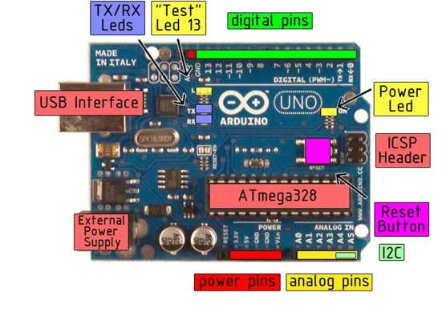

Microcontroller | ATmega328
Operating Voltage | 5V
Input Voltage (recommended | 7-12V
Input Voltage (limits) | 6-20V
Digital I/O Pins | 14 (of which 6 provide PWM output)
Analog Input Pins | 6
DC Current per I/O Pin | 40 mA
DC Current for 3.3V Pin | 50 mA
Flash Memory | 32 KB ofwhich0.5 KB used by bootloader
SRAM | 2 KB
EEPROM | 1 KB
Clock Speed | 16 MHz

The power pins are as follows:
- VIN. The input voltage to the Arduino board when it's using an external power source (as opposed to 5 volts from the USB connection or other regulated power source). You can supply voltage through this pin, or, if supplying voltage via the power jack, access it through this pin.
- 5V. The regulated power supply used to power the microcontroller and other components on the board. This can come either from VIN via an on-board regulator, or be supplied by USB or another regulated 5V supply.
- 3V3. A 3.3 volt supply generated by the on-board regulator. Maximum current draw is 50 mA.
- GND. Ground pins.
- Serial: 0 (RX) and 1 (TX). Used to receive (RX) and transmit (TX) TTL serial data.These pins are connected to the corresponding pins of the ATmega8U2 USB-to-TTL Serial chip.
- External Interrupts: 2 and 3. These pins can be configured to trigger an interrupt on a low value, a rising or falling edge, or a change in value. See the attachInterrupt() function for details.
- PWM: 3, 5, 6, 9, 10, and 11. Provide 8-bit PWM output with the analogWrite() function.
- SPI: 10 (SS), 11 (MOSI), 12 (MISO), 13 (SCK). These pins support SPI communication, which, although provided by the underlying hardware, is not currently included in the Arduino language.
- LED: 13. There is a built-in LED connected to digital pin 13. When the pin is HIGH value, the LED is on, when the pin is LOW, it's off.

4.1.5 H-Bridge
Normal DC gear-head motors requires current greater than 250mA. ICs like 555 timer, ATmega16 Microcontroller, 74 series ICs cannot supply this amount of current. If we directly connect motors to the output of any of the above IC's, they might get damaged.
There is a need of a circuitry that can act as a bridge between the above mentioned ICs and the motors. There are several ways of making it, some of them are mentioned below.
- Using Transistor
- Using L293D/L298
- Using relays
Using Transistor
Single direction control
If you want to rotate your motor in only one direction, then this is the easiest way to do so. Here power transistor is used as a switch to turn a motor on or off depending upon the applied voltage at base. Its circuit is shown below. The same motor driver circuit is used in making a simple line follower robot.

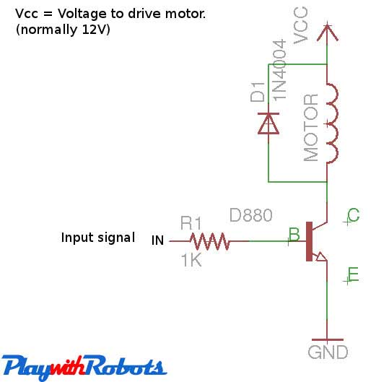
One direction motor control
Both direction control ( H-Bridge circuit)
For controlling motor in both directions H bridge circuit is used. Its working is very simple and is described below.
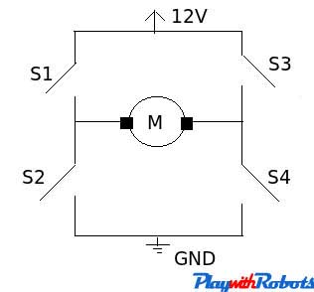
H-bridge working
Closed Switches | Open Switches | Voltage across motor | Motion
Nil | S1,S2,S3,S4 | 0 | No motion
S1,S4 | S2,S3 | 12V (say) | Clockwise (say)
S2,S3 | S1,S4 | -12V | Anti-clockwise
S1,S3 | S2,S4 | 0V | Brake

So there are four possible conditions out of 16 combinations of the switch that we are working on. This is met by using 2 npn and 2 pnp transistor as shown below.
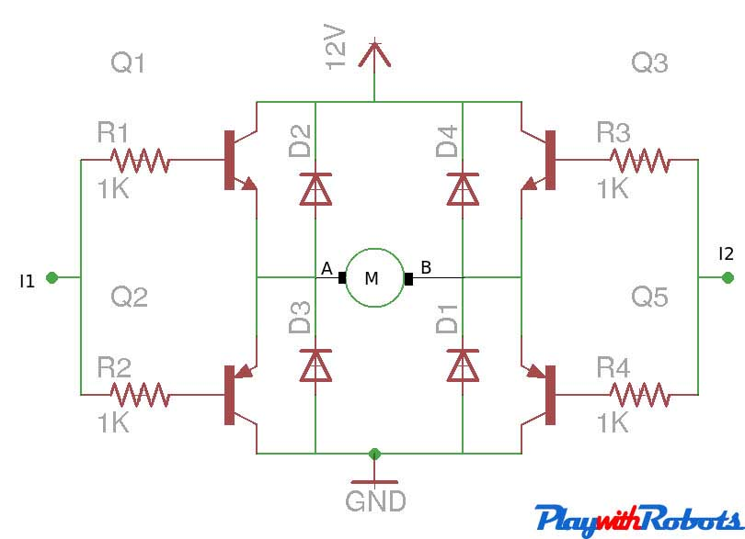
Transistor H-bridge
I1 | I2 | A | B | Motion
Logic 0 | Logic 0 | 0 | 0 | Stop
Logic 1 | Logic 0 | 12V | 0 | Clockwise
Logic 0 | Logic 1 | 0 | 12V | Anti-clockwise
Logic 1 | Logic 1 | 12V | 12V | Brake

Logic 1 means 5V and Logic 0 means GND. Choose npn and pnp power transistors according to the current requirement of the motor under load.

The above circuit works well but L298/L293D IC's are prefered over them, as they are compact and offer PWM channels to control motor's speed.
Using L293D/L298
L293D and L298 are dual H-bridge motor driver ICs. We can control the rotation of two motors in both clockwise and anti-clockwise direction. The pin-outs of both ICs are shown below along with their differences.
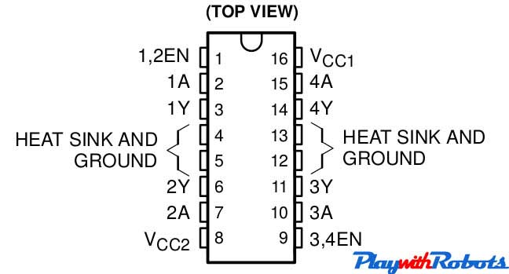
L293D pin configuration
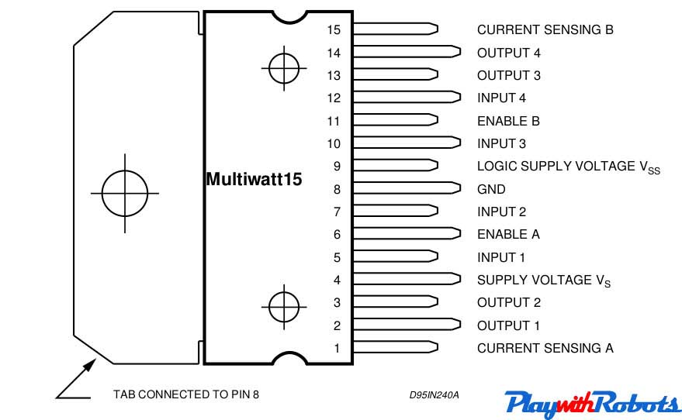
L298 pin configuration

Main difference between L293D and L298
Characteristic | L298 | L293D
Continuous max. output current per channel | 2A | 0.6A
Peak max. output current per channel ( <100us) | 3A | 1A
Protection diodes across motors | Use externally | Internally available
Source: L293D and L298 datasheets.
Here we prefer L293D as a rating of 600mA is good for driving small DC motors and protection diodes are included in the IC itself. The description of each pin is as follows:
- Enable pins: These are pin no. 1 and pin no. 9. Pin no. 1 is used to enable Half-H driver 1 and 2.( H bridge on Left side). Pin no. 9 is used to enable H-bridge driver 3and 4.(H bridge on right side). The concept is simple, if you want to use a particular H bridge you have to give a high logic to corresponding enable pins along with the power supply to the IC. This pin can also be used to control speed of the motor using PWM technique.
- VCC1 (Pin 16): Power supply pin. Connect it to 5V supply.
- VCC2 (Pin 8): Power supply for motor. Apply +ve voltage to it as per motor rating. If you want to drive your motor at 12V, apply 12V on this pin. It is also possible to drive motor directly on a battery, other than the one used for supplying power to the circuit, Just connect +ve terminal of that battery to VCC2 pin and make GND of both the batteries common. (MAX voltage at this pin is 36V as per its datasheet).
- GND (Pins 4,5,12,13): Connect them to common GND of circuit.
- Inputs (Pins 2,7,10,15): These are input pins through which control signals are given by microcontrollers or other circuits/ICs. For example, if on pin 2 (Input of 1st half H driver) we give Logic 1 ( 5V), we will get a voltage equal to VCC2 on corresponding output pin of 1st half H driver i.e pin no. 3. Similarly for Logic 0 (0V) on Pin 2, 0V on Pin 3 appears.
- Outputs ( Pin 3,6,11,14): Outputs pins. According to input signal output signal comes.
Circuit diagram :
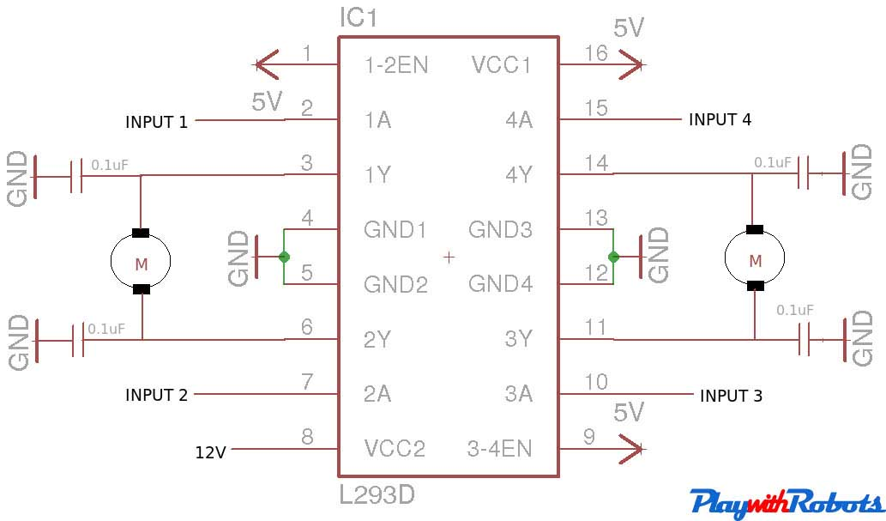

Circuit diagram
1A | 2A | 1Y | 2Y | Motor 1
Logic 0 | Logic 0 | 0 | 0 | Stop
Logic 1 | Logic 0 | 12V | 0 | Clockwise
Logic 0 | Logic 1 | 0 | 12V | Anti-clockwise
Logic 1 | Logic 1 | 12V | 12V | Brake
For driving high power motors relays are used like cars Wiper motor.

Using Relays
Relays are electromechanical switches. They have very high current rating and both AC and DC motors can be controlled through them because motor will be completely isolated from the remaining circuit. Two common available SPDT relays are shown in the picture below
Working of a relay : Relays consist of a electromagnet, armature, spring and electrical contacts. The spring holds the armature at one electrical contact and as soon as a voltage is applied across the electromagnet, it coils the armature, changes its contact and moves to another electrical contact. The figure below describes its working.
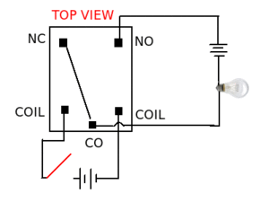
Relays

Terms associated with relays:
- Normally Open (NO): contacts connect the circuit when the relay is activated; the circuit is disconnected when the relay is inactive.
- Normally Closed(NC): contacts disconnect the circuit when the relay is activated; the circuit is connected when the relay is inactive.
- Change Over (CO): Its the common contact.
- COIL: Its the electromagnet coil inside relay.

Relay ratings :
- Coil rating: Its the Voltage at which the coil gets fully activated. Some also have coil resistance mentioned on them. Relay coil voltage rated 6V and 12V are the most commonly available.
- Contact rating: It depends on whether AC or DC current is passing through the contacts. The blue colored relay shown in the start of this page has a rating of 12A at 120V AC , 5A at 250V AC and 10A at 24V DC.

Relay triggering circuit:
Depending upon a relay's coil rating, some may require current greater than 100mA. If an IC cannot provide this much current, a transistor is used as a switch to trigger the relay as shown below. Don't avoid the protection diode (D1 shown in circuit) as it will protect transistor from back emf induced in relay coil.
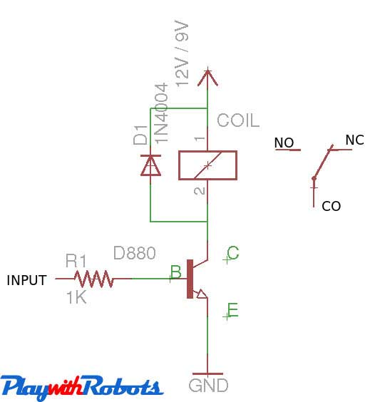
Relay triggering circuit
Switching speed of a relay is slow, around 10ms. Relays are used to drive an AC load from a small DC circuit, or to drive a high current consuming motors. Have you noticed a sound of tic -tic while car wiper is on, This is the sound of relay inside the car that drives the wiper motor.

4.1.6 Motors
A DC motor is any of a class of electrical machines that converts direct current electrical power into mechanical power. The most common types rely on the forces produced by magnetic fields. Nearly all types of DC motors have some internal mechanism, either electromechanical or electronic, to periodically change the direction of current flow in part of the motor. Most types produce rotary motion; a linear motor directly produces force and motion in a straight line.
DC motors were the first type widely used, since they could be powered from existing direct-current lighting power distribution systems. A DC motor's speed can be controlled over a wide range, using either a variable supply voltage or by changing the strength of current in its field windings. Small DC motors are used in tools, toys, and appliances. The universal motor can operate on direct current but is a lightweight motor used for portable power tools and appliances. Larger DC motors are used in propulsion of electric vehicles, elevator and hoists, or in drives for steel rolling mills. The advent of power electronics has made replacement of DC motors with AC motors possible in many applications

4.1.7 Resistor:
Resistors are electronic components which have a specific, never-changing electrical resistance. The resistor’s resistance limits the flow of electrons through a circuit.They are passive components, meaning they only consume power (and can’t generate it). Resistors are usually added to circuits where they complement active components like op-amps, microcontrollers, and other integrated circuits. Commonly resistors are used to limit current, divide voltages, and pull-up I/O lines.
Resistors can be fabricated in a variety of ways. The most common type in electronic devices and systems is the carbon-composition resistor. Fine granulated carbon (graphite) is mixed with clay and hardened. The resistance depends on the proportion of carbon to clay; the higher this ratio, the lower the resistance.
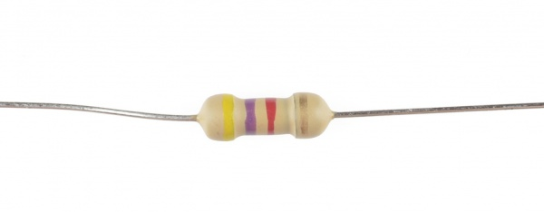

Pull-up resistor:
In digital circuits, pull-up resistor is a regular resistor that is connected to the high voltage supply (e.g +5V or +12V) and sets the input or output level of a device to '1'.
The pull-up resistor set the level to '1' when the input / output is disconnected. When the input / output is connected, the level is determined by the device and overrides the pull-up resistor.
Pull-down resistor:
In digital circuits, pull-down resistor is a regular resistor that is connected to the ground (0V) and sets the input or output level of a device to ' 0 '.
The pull-down resistor set the level to ' 0 ' when the input / output is disconnected. When the input / output is connected, the level is determined by the device and overrides the pull-down resistor.

4.1.8 Light Dependent Resistor:
A light sensor is the most common electronic component which can be easily found.
The simplest optical sensor is a photon resistor or photocell which is a light sensitive
resistor these are made of two types, cadmium sulfide (CdS) and gallium arsenide
(GaAs).
The sun tracker system designed here uses two cadmium sulfide (CdS) photocells
for sensing the light. The photocell is a passive component whose resistance is
inversely proportional to the amount of light intensity directed towards it. It is
connected in series with capacitor.
The photocell to be used for the tracker is based on its dark resistance and light
saturation resistance.
The term light saturation means that further increasing the light intensity to the
CdS cells will not decrease its resistance any further. Light intensity is measured in
Lux, the illumination of sunlight is approximately 30,000 lux.
Concept of using two LDRs for sensing is explained in figure 1.The stable position
is when the two LDRs having the same light intensity (position A).When the light
source moves, i.e. the sun moves from west to east, the level of intensity falling on
both the LDRs changes and this change is calibrated into voltage using voltage
dividers. The changes in voltage are compared using built-in comparator of
microcontroller and motor is used to rotate the solar panel in a way so as to track the
light source.

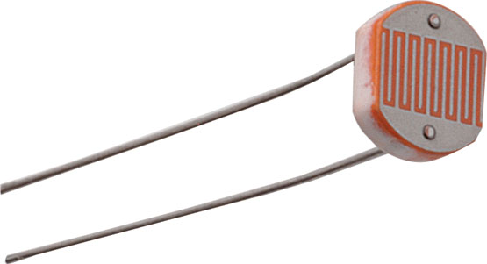

4.1.9 Solar Panel:
Solar panel refers to a panel designed to absorb the sun's rays as a source of energy for generating electricity or heating.
A photovoltaic (in short PV) module is a packaged, connected assembly of typically 6×10 solar cells. Solar Photovoltaic panels constitute the solar array of a photovoltaic system that generates and supplies solar electricity in commercial and residential applications. Each module is rated by its DC output power under standard test conditions, and typically ranges from 100 to 365 watts. The efficiency of a module determines the area of a module given the same rated output – an 8% efficient 230 watt module will have twice the area of a 16% efficient 230 watt module. There are a few solar panels available that are exceeding 19% efficiency. A single solar module can produce only a limited amount of power; most installations contain multiple modules. A photovoltaic system typically includes a panel or an array of solar modules, a solar inverter, and sometimes a battery and/or solar tracker and interconnection wiring.
Theory and construction
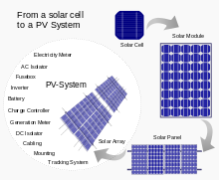

From a solar cell to a PV system Solar modules use light energy (photons) from the sun to generate electricity through the photovoltaic effect. The majority of modules usewafer-based crystalline silicon cells or thin-film cells based on cadmium telluride or silicon. The structural (load carrying) member of a module can either be the top layer or the back layer. Cells must also be protected from mechanical damage and moisture. Most solar modules are rigid, but semi-flexible ones are available, based on thin-film cells.
Electrical connections are made in series to achieve a desired output voltage and/or in parallel to provide a desired current capability. The conducting wires that take the current off the modules may contain silver, copper or other non-magnetic conductive [transition metals]. The cells must be connected electrically to one another and to the rest of the system. Externally, popular terrestrial usage photovoltaic modules use MC3 (older) or MC4 connectors to facilitate easy weatherproof connections to the rest of the system.
Bypass diodes may be incorporated or used externally, in case of partial module shading, to maximize the output of module sections still illuminated.
Some recent solar module designs include concentrators in which light is focused by lenses or mirrors onto an array of smaller cells. This enables the use of cells with a high cost per unit area (such as gallium arsenide) in a cost-effective way.

Chapter 5

Conclusion
It achieves the following attractive features: (1) a simple and cost-effective control implementation, (2) a stand-alone PV power the entire system, (3) ability to move the two axes simultaneously within their respective ranges, (4) ability to adjust the tracking accuracy, and (5) applicable to moving platforms with the Sun tracker. The empirical findings lead us to believe that the research work may provide some contributions to the development of solar energy applications.

Install a solar panel mount with dual-axis sun tracking capability has been achieved. The work was made possible through the cooperation and involvement of many different parties. Planning and communication skills were essential to ensure that the project went smoothly.
There is still room for improvement for this system and it is hoped that further study can be carried out to further develop the system. Improvements can be done to the design of the structure, for example by adding covers for the motors and also improving the design of the sensor holder by making it waterproof. Besides that, improve-ments can be made to the current method of turning back the frame to its original position, removing the need to manually adjust the limit switches. Also, a detailed study should be carried out to ascertain the percentage increase of electricity yield by using this system to establish whether or not the system is viable.

Refrences
https://www.wpi.edu/Pubs/E-project/Available/E-project-011113-104735/unrestricted/Solar_Tracker_Report.pdf
http://onlinefreeprojectdownload.com/Project-Report-On-Automatic-Sun-Tracking-System.html
https://www.arduino.cc/en/Main/arduinoBoardUno
https://learn.sparkfun.com/tutorials/what-is-an-arduino
https://en.wikipedia.org/wiki/Resistor
https://en.wikipedia.org/wiki/2N2222
www.electroschematics.com/9598/spdt-relay-switch/
https://en.wikipedia.org/wiki/DC_motor

