# SECURITY SYSTEM FOR HOMES AND OFFICES

# ABSTRACT

In this project, a multilevel home security system (MHSS) has been designed, developed, tested and validated. MHSS is basically a multilevel security system which consists of different sensor nodes as the input elements while the output elements react to the signal received from the input elements. The sensor nodes consist of a thief alarm, presence detecting circuit and the break-in camera. A UART is applied as the communication tool between the hardware and the computer If somebody comes in front of the camera his picture will be saved in the computer. The captured images are delivered to the house owners and the police forces.A graphic user interface (GUI) is developed and configured which enables the function of capturing images . The task is performed in order to prevent the thieves’ invasion.

# CHAPTER 1

# INTRODUCTION

Home security has been a concern of worldwide. As the technology is emerging every second, abundant home based security systems have been developed and implemented to keep their welfare safe. Home security system is an essential mean of protecting our home from illegal invasion. A conventional home security system consists of a Closed Circuit Television, CCTV and burglar alarm. CCTV captures video in 24 hour to identify what goes on around the house and in the house as well as get a hold of the evidence if there is a house breaking around the captured areas. Burglar alarm acts as the tool to alert the house owners and their neighbors. In additional, it may also chase away the burglar as the system may emit a high frequency sound wave. Nevertheless, the memory consumption is considerably large as the camera keeps recording non-stop. The power consumption is considered as a concern of installing a security system. In this project, a multilevel home security system that sends alert messages to the house owner and police station has also been designed. The final year project aims at exposing the students undergoing higher technical studies to the thoughts and logic that must be developed to ensure that one is able to integrate his/her ideas into something concrete. This generally is initiated by the inception of an idea or a concept, which not only aims at developing a product (Hardware or Software), but also the in-depth study of the earlier existing products in the same category and their deficiencies. Accordingly an approach is taken to propose a solution, which is better from the previous ones in one respect or the other. With the same approach in mind, we, the final year students of Bachelor of Technology (Electronics and Telecommunication), have taken up the Advance GSM Based Home Security System As our final year project. Automated security systems are a useful addition to today‟s home where safety is an important issue. Vision-based security systems have the advantage of being easy to set up, inexpensive and non-obtrusive. Home security system for detecting an intrusion into a monitored area by an infrared detector. A security system has a free-standing intrusion detector. The free standing intrusion detector has a transmitter coupled with a portable receiver to alert a homeowner that an intrusion has taken place or occurred within a pre-set time period.This project deals with the design & development of a theft control system for home, which is being used to prevent/control any theft attempt. The developed system makes use of an embedded system (comprises an open hardwaremicrocontroller and a gsm modem) based on Global System for Mobile communication (GSM) technology. In today‟s age of digital technology and intelligent systems, home automation has become one of the fastest developing application-based technologies in the world. The idea of comfortable living in home has since changed for the past decade as digital, vision and wireless technologies are integrated into it. Intelligent homes, in simple terms, can be described as homes that are fully automated in terms of carrying out a predetermined task, providing feedback to the users, and responding accordingly to situations. In other words, it simply allows many aspects of the home system such as temperature and lighting control, network and communications, entertainment system, emergency response and security monitoring systems to be automated and controlled, both near and at a distance. Automated security systems play an important role of providing an extra layer of security through user authentication to prevent break-ins at entry points and also to track illegal intrusions or unsolicited activities within the vicinity of the home (indoor sand outdoors). There has been much research done in the design of various types of automated security systems. Sensor-based systems that rely on contact or movement-sensors or contact-based systems such as fingerprint and palm print scan or keypad-activation that require substantial amount of contact with an input device. Many security systems are based on only a single system. In an event of system failure or intrusion of the user authentication, there is no backup system to monitor the home continually. This shortcoming can be dealt with using multiple security systems (or multi-layered security systems). However, multi-system implementations will definitely be more demanding in terms of computational cost and organization. This requires careful integration and sharing of resources. Thus, a feasible system should be effective, practical and reasonable in cost. In this paper, we proposed an integrated dual-level sensor based home security system, consisting of two sub systems an IR sensor, burglar alarm module and fire alarm module. Both subsystems work independently but are incorporated into a single automated system for practical implementationthe integrated architecture of the system is further elaborated. Finally, section will give the conclusion and future directions

**1.1.LITERATURE REVIEW**

Security has becoming an important issue everywhere. Home security is becoming necessary nowadays as the possibilities of intrusion are increasing day by day. Safety from theft, leaking of raw gas and fire are the most important requirements of home security system for people. A traditional home security system gives the signals in terms of alarm. However, the GSM (Global System for Mobile communications) based security systems provides enhanced security as whenever a signal from sensor occurs, a text message is sent to a desired number to take necessary actions. There are two types of sensor nodes applied in the system which include the, motion sensors and infrared sensor nodes.This architecture includes components such as filters, amplifiers, analog to digital converters and communication interfaces. The system used a wireless transceiver module to transfer data between gateway and sensor nodes. Every sensor node comprises a microprocessor and a wireless transceiver module. The function of the microprocessor is to receive and analyze the signal from the sensors’ node as well as the current status of the nodes.Home security has changed a lot from the last century and will be changing in coming years. Security is an important aspect or feature in the smart home applications. The new and emerging concept of smart homes offers a comfortable, convenient, and safe environment for occupants. Conventional security systems keep homeowners, and their property, safe from intruders by giving the indication in terms of alarm. However, a smart home security system offers many more benefits. This paper mainly focuses on the security of a home when the user is away from the place. Two systems are proposed, one is based on GSM technology and other uses web camera to detect the intruder. The first security system uses a web camera, installed in house premises, which is operated by software installed on the PC and it uses Internet for communication. The camera detects motion of any intruder in front of the camera dimensions or camera range.

Motion detectors are mainly used in security systems. It is typically positioned near exterior doorways or windows of a building to monitor the area around it. Since motion detectors are so flexible and have so many uses, it offers feelings of protection and security for the average homeowner as well as commercial organizations,

An electronic motion detector is a device used to detect any physical movement in a given area and transforms motion into an electric signal. It consist of sensor that electrically connected to other devices such as security system, lighting, audio alarms, and other applications. Motion sensors are used in a wide variety of applications and as a result, many different types of motion sensors are available including the infrared sensor.

Infrared sensors are widely known in the arts of intrusion detection and in fire or smoke detection. It is a device that often used in automatic light switches and security systems to turn on a light or to activate some other form of alarm or warning indicator when a person enters a monitored area. The infrared sensors have basically two forms: active and passive.An active infrared detector includes a radiation source and an infrared sensor which is sensitive to interruptions in the radiation sensed from the source.These detectors are used as intrusion detectors by providing a path of radiation from the source to the sensor in a place where the path is likely to be interrupted by an intruder.The proposed active infrared method of motion detection has the advantage of fast speed response of a relatively large sensor. This advantage permits simpler optical system design, especially for wide fields of view. Besides, it is insensitivity to mechanical and acoustic noise, which presents substantial problems in the passive infrared (PIR) sensors. Low production cost is another advantage of these active infrared detectors.

Passive infrared motion detection detects heat energy radiated or emitted by an object, such as a body of a person, moving across a field of view of a heat sensor of the motion detection system. It is generally use an optical collection system and multiple sensing elements of alternating polarity to create a detection pattern in the volume of interest. PIR detectors employ a group of radiation sensors coupled through amplifiers to a logic circuit. The radiation sensors detect changes in ambient infrared radiation. The detection system has an electrical circuit operatively coupled to the heat sensor for producing a detection signal in response to the heat sensor detecting a change of temperature caused by the body heat of a person entering the detection pattern. PIR motion detectors are perhaps the most frequently used home security device.Passive IR motion detectors are usually designed to provide an indication to an alarm panel in response to detecting IR that is indicative of motion of the object. The alarm panel is responsive to receipt of the breach indication to cause an alarm condition to occur. The other motion detector used in security system is an ultrasonic motion detector. It is commonly used for automatic door openers and security alarm. It is inexpensive and can operate with narrow beam-widths. The ultrasonic transducers are the sensor that used in ultrasonic motion detector. It can be used to detect motion in an area where there are not supposed to be any moving objects. This type of motion detector is most commonly used in burglar alarm systems since they are very effective in this application.

While the passive infrared motion detectors offers problem where it can be falsely triggered by warm air movement or other disturbances that can alter the infrared radiation levels in an area. In order to prevent this problem, newer systems use two infrared sensors, which monitor different zones within a protected area. Logic within system triggers the alarm only when the two zones are activated in sequence, as would occur if a person walked through the protected area. For that reason, the purpose of using the active infrared as a sensor to detect motion for this project is surely on the advantage offers by the sensor. Its capability on detecting motion with a simple design at lowest cost is needed to build an effective house security system based on motion detection.

**1.2.Market Survey**

According to the market research, the common parameters or characteristics of home security system are 24 hours monitoring of the intruder, ease of use, reliability, efficient, fast and precise notification system. Today numbers of home security systems are available in market. In paper, a design which contains a home network including a GPRS/GSM gateway and three kinds of wireless security sensor nodes is presented. This system has a user interface and it can respond quickly to alarm incidents. In paper, a new method of moving object detection by combination of pixel illumination with its chroma in YUV color space is implemented. The algorithm of maintenance with 3 key values is discussed in this paper. In case of swaying objects, it is very robust and effective way of false alarms.The detection and description based on an object oriented, statistical multi feature analysis of video sequences. The system described in monitors everything by moving cameras. The system can increase the efficiency of monitoring and can eliminate the blind spots of fixed cameras. In this system, a mobile manipulator is developed which is equipped with cameras at the arm end for purpose of monitoring. The system is based on SMS technology using any GSM modem/mobile is presented in. The proposed remote control system works from anywhere in the world. A low cost Short Message System (SMS) based home security system equipped with motion sensor,laser,infrared sensors has been studied in . The sensors are controlled by a microprocessor PIC 18F4520 through the SMS having password.

**1.3. Proposed System**

Our system consists of an infrared sensor,laser and motion sensor.Also a wireless camera is installed which will save the picture of the person coming in front of it.Camera will be directly connected to GUI interface.The proposed system is controlled by an Atmeg328 microcontroller.There are several steps to be applied in designing an active infrared motion detector for house security system. The relevant information is gathered through literature review from previous chapter. Data on motion detection and security system projects has been collected where the theoretical design is studied based on the motion detector for security concept. The understanding on the electrical structure for the hardware development is needed for the design circuit process of the motion detector and the basic security circuit.The next is the hardware development according to the circuit designed. This process is just only being proceed if each part of the circuit being improved is valid, else, it will be repeated until it is valid as the theoretical. Once the hardware development circuits have the output as the expected, then, the comparison for both hardware and theoretical analysis will be done.

Next is the step where software structure is developed for the security system to be interface with the hardware development. While the final step of this research is on applying the whole project to the real house entrance like doors and windows.

**1.4.Block Diagram**

**1.5.Circuit diagram**

# CHAPTER 2

# HARDWARE USED

Hardware requirements of the system are as follow:

In this project we have planned to develop a Home security system .Home security system for detecting an intrusion into a monitored area by an infrared detector. A security system has a flee-standing intrusion detector. The free standing intrusion detector has a transmitter coupled with a portable receiver to alert a homeowner that an intrusion has taken place or occurred within a pre-set time period .The area under surveillance is monitored by an infrared detector which activates the transmitter upon the detection of abrupt differences in infrared radiation levels, associated with the presence of a warm body in an otherwise equilibrated environment. A radio signal is emitted by the transmitter which is received by the portable hand-held remote receiver. A first signal, indicating that an intrusion has been detected less than a preselected period of time in the past in the monitored areas, is displayed on the receiver for that preselected period of time. After the preselected period of time has elapsed, a second signal is generated to indicate that the intrusion took place at a time greater than the preselected period of time in the past and that the probability of the intruder still being present is less. Once the intrusion detector is activated, the signal is continuously transmitted to the portable receiver until the intrusion detector has been-reset A security system for a home comprising: A free standing intrusion detector to be set in an area of said home to be protected, said-free standing intrusion detector comprising: An intrusion detector to generate an intrusion signal in response to an intrusion into said area ;A radio signaling transmitter responsive to said intrusion signal to transmit a radio-signal means for modulating said radio signal for a predetermined time in response to said intrusion signal; and time delay means for delaying the actuation of said intrusion detector to allow a person sufficient time to exit said area to be protected after setting said intrusion detector; and a portable receiver adapted to be hand carried comprising. Means for generating an output signal in response to said radio signal. Display means for generating a visual display indicating an intrusion has occurred in response to said output signal.

**2.1.GSM MODULE(sim900)**

This is a GSM/GPRS-compatible Quad-band cell phone, which works on a frequency of 850/900/1800/1900MHz and which can be used not only to access the Internet, but also for oral communication (provided that it is connected to a microphone and a small loud speaker) and for SMSs. Externally, it looks like a big package (0.94 inches x 0.94 inches x 0.12 inches) with L-shaped contacts on four sides so that they can be soldered both on the side and at the bottom. Internally, the module is managed by an AMR926EJ-S processor, which controls phone communication, data communication (through an integrated TCP/IP stack), and (through an UART and a TTL serial interface) the communication with the circuit interfaced with the cell phone itself.The processor is also in charge of a SIM card (3 or 1,8 V) which needs to be attached to the outer wall of the module.In addition, the GSM900 device integrates an analog interface, an A/D converter, an RTC, an SPI bus, an I²C, and a PWM module. The radio section is GSM phase 2/2+ compatible and is either class 4 (2 W) at 850/ 900 MHz or class 1 (1 W) at 1800/1900 MHz.The TTL serial interface is in charge not only of communicating all the data relative to the SMS already received and those that come in during TCP/IP sessions in GPRS (the data-rate is determined by GPRS class 10: max. 85,6 kbps), but also of receiving the circuit commands (in our case, coming from the PIC governing the remote control) that can be either AT standard or AT-enhanced SIMCom type.The module is supplied with continuous energy (between 3.4 and 4.5 V) and absorbs a maximum of 0.8 A during transmission.

**Features**

* E-GSM 900/1800 MHz and GSM 1800/1900 with GSM Phase 2 / 2+.
* Output Power Class 4 (2W) at GSM850/900 MHz and Class 1 (1W) at GSM1800/1900 MHz.
* Control via AT commands (ITU, GSM,GPRS and manufacturersupplementary)
* Supply Voltage range: 3.22 V - 4.2 V,nominal: 3.8 V.
* Power consumption: Idle mode: <1.8mA, speech mode: 200 mA (average)
* Dimensions (mm): 3 x 20 x 20 andweight (g): 3.2 (including shielding)

The GSM module offers the advantages asbelow

* Ultra small size (22x22x3 mm),lightweight (3.2 g) and easy to integrate
* Low power consumption
* R&TTE type approval plus CE, GCF,FCC, PTCRB, IC
* Full RS232 on CMOS level with flowcontrol (RX, TX, CTS, RTS, CTS, DTR,DSR, DCD, RI).
* Embedded TCP/IP Stack UDP/IP Stack ,Embedded FTP and SMTP Client
* High performance on low price.

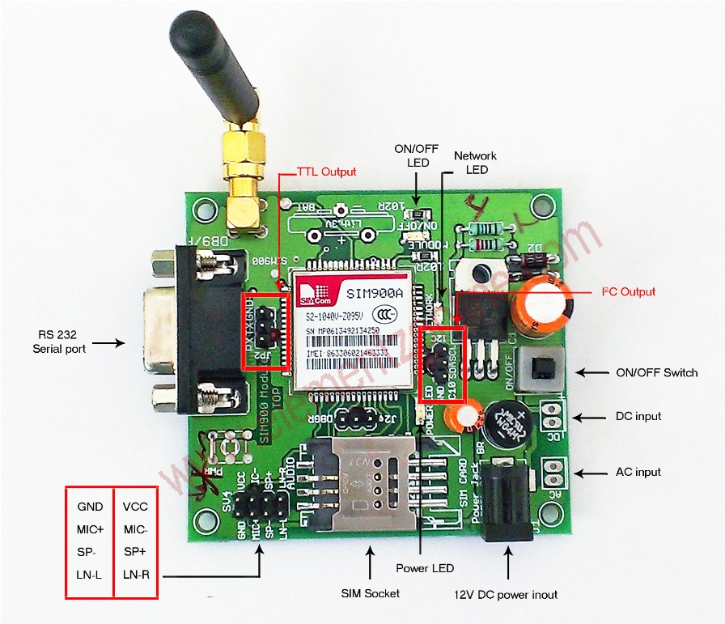

**FIGURE 2.1.: GSM(sim900)**

# 2.2.Laser Sensors

|  |
| --- |
| Outline |
| http://www.sensorcentral.com/common/img/spacer.gif |
| A proximity sensor can detect metal targets approaching the sensor, without physical contact with the target. Proximity sensors are roughly classified into the following three types according to the operating principle: the high-frequency oscillation type using electromagnetic induction, the magnetic type using a magnet, and the capacitance type using the change of capacitance. KEYENCE proximity sensors are of the high-frequency oscillation type. |

http://www.sensorcentral.com/common/img/spacer.gif

|  |
| --- |
| **Features** |
| http://www.sensorcentral.com/common/img/spacer.gif |

|  |  |
| --- | --- |
| http://www.sensorcentral.com/common/img/maru.gif | Non-contact detection, eliminating damage to sensor head and target. |
| http://www.sensorcentral.com/common/img/maru.gif | Non-contact output, ensuring long service life. |
| http://www.sensorcentral.com/common/img/maru.gif | Stable detection even in harsh environments exposed to water or oil splash. |
| http://www.sensorcentral.com/common/img/maru.gif | High response speed. |

## Methods Include Triangulation And Time-of-flight

The method used to measure distance depends on the accuracy and distance capability required of the device. Measurement principles include triangulation, time-of-flight measurement, pulse-type time-of-flight systems, and modulated beam systems

For distances of a few inches with high accuracy requirements, "triangulation" sensors measure the location of the spot within the field of view of the detecting element.

Time of flight sensors derive range from the time it takes light to travel from the sensor to the target and return. For very long range distance measurements (up to many miles) "time-of-flight" laser rangefinders using pulsed laser beams are used.

**Modulated Beam Systems** use the time light takes to travel to the target and back, but the time for a single round-trip is not measured directly. Instead, the strength of the laser is rapidly varied to produce a signal that changes over time.

### Triangulation measurement principle

One method for accurately measuring the distance to targets is through the use of laser triangulation sensors. They are so named because the sensor enclosure, the emitted laser and the reflected laser light form a triangle.

The laser beam is projected from the instrument and is reflected from a target surface to a collection lens. This lens is typically located adjacent to the laser emitter. The lens focuses an image of the spot on a linear array camera (CMOS array). The camera views the measurement range from an angle that varies from 45 to 65 degrees at the center of the measurement range, depending on the particular model. The position of the spot image on the pixels of the camera is then processed to determine the distance to the target. The camera integrates the light falling on it, so longer exposure times allow greater sensitivity to weak reflections. The beam is viewed from one side so that the apparent location of the spot changes with the distance to the target.

Triangulation devices are ideal for measuring distances of a few inches with high accuracy. Triangulation devices may be built on any scale, but the accuracy falls off rapidly with increasing range. The depth of field (minimum to maximum measurable distance) is typically limited, as triangulation sensors can not measure relative to their baseline, the distance between the emitter and the detector.

The exposure and laser power level are typically controlled to optimize the accuracy of the measurements for the signal strength and environmental light level measured. The range data may be internally averaged over multiple exposures prior to transmitting if the sample rate is set appropriately.

**Time of flight**

Modulated beam systems also use the time light takes to travel to a target and back, but the time for a single round trip is not measured directly. Instead, the strength of the laser is rapidly varied to produce a signal that changes over time. The time delay is indirectly measured by comparing the signal from the laser with the delayed signal returning from the target. One common example of this approach is “phase measurement” in which the laser’s output is typically sinusoidal and the phase of the outgoing signal is compared with that of the reflected light.

Phase measurement is limited in accuracy by the frequency of modulation and the ability to resolve the phase difference between the signals. Some modulated beam rangefinders work on a range-to-frequency conversion principle, which offers several advantages over phase measurement. In these cases, laser light reflected from a target is collected by a lens and focused onto a photodiode inside the instrument. The resulting signal is amplified up to a limited level and inverted, and used directly to modulate a laser diode. The light from the laser is collimated and emitted from the center of the front face of the sensor. This configuration forms an oscillator, with the laser switching itself on and off using its own signal. The time that the light takes to travel to the target and return plus the time needed to amplify the signal determines the period of oscillation, or the rate at which the laser is switched on and off. This signal is then divided and timed by an internal clock to obtain a range measurement. The measurement is somewhat nonlinear and dependent on signal strength and temperature, so a calibration process can be performed in the sensor to remove these effects.

Modulated beam sensors are typically used in intermediate range applications, for distances from a few inches to several tens of feet on uncooperative targets. With cooperative targets, like reflectors, range can be extended to several hundreds or thousands of feet.

### Confocal chromatic

Acuity's most accurate and most resolute distance sensor employs a unique measuring principle, confocal chromatic sensing. Unlike our time-of-flight and triangulation sensors which use lasers, the CCS Prima Confocal sensors use a white light source to accurately measure the distance to surfaces. Some models are accurate to within 20 nanometers. Additionally, this technology permits measurement and profile of transparent materials like glass, lenses, liquids, etc.

The essence of our confocal chromatic imaging principle

[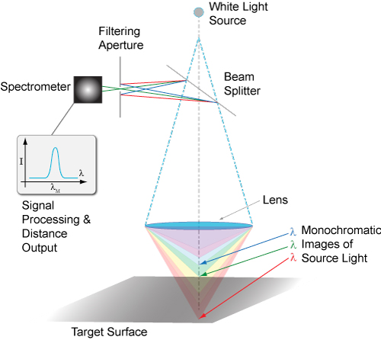](http://www.acuitylaser.com/images/confocal-chromatic-measurement-principle.jpg)

accurate detection of colors from light that is reflected back from target surfaces. The white light is focused onto the target surface by a multi-lens optical system. These lenses disperse the light into monochromatic stages (colors) along the measurement axis. A specific distance to the target is assigned to each color’s wavelength in a factory calibration. Only the wavelength which is exactly focused on the target is used for the measurement. This light reflected from the target surface is transmitted from the probe, through a confocal aperture and onto a spectrometer which detects and processes the spectral changes and calculates distances. These distance measurements are transmitted at high speed via ethernet communications protocol.

|  |
| --- |
| Security & Surveillance |
| From military and Homeland Security applications to private security and law enforcement, LTI laser sensors can be a driving force behind any intrusion detection or monitoring system. Due to the narrow beam width, rapid pulse rates and long range capabilities, you can rest assure that the instant anyone or thing breaks the beam, you’ll know exactly when and where. From triggering a video camera to start recording to guiding assistance of a manned and autonomous-reconnaissance vehicles, the applications for these sensors in security and surveillance are unlimited. Detect Combining long range with reflectorless technology and a constant rapid fire read-out, you will always know the exact time and location when ever the beam breaks.  **Mapping**  For topographic mapping, combine the distance to ground data with GPS and get the coordinates of all your raw measurements. Height Precise and reliable height measurements can help with a safe landing, especially through fog or airborne particulates generated from propellers or high winds.  LTI laser sensors can range to over a mile with accuracies as good as 1 inch depending on the model. Ultrafast repetition rates are available to ensure fast moving targets are captured. You can choose a fast repetition rate or an output that will directly trigger a camera or any other integrated system. If you need to penetrate through moderate dust or fog, LTI sensors can be extremely effective just by toggling into a selected target mode. All LTI sensors are intended for rugged environments and perform accurately and reliably every time. |

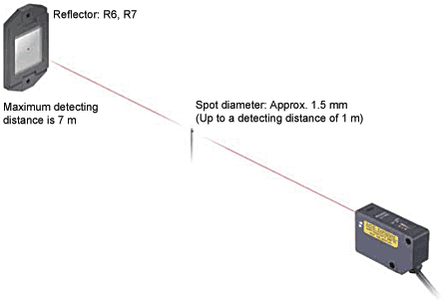

**FIGURE 2.2.: LASER SENSOR**

**2.3.MOTION Sensor**

A **motion detector** is a device that detects moving objects, particularly people. A motion detector is often integrated as a component of a system that automatically performs a task or alerts a user of motion in an area. Motion detectors form a vital component of security, [automated lighting control](http://en.wikipedia.org/wiki/Lighting_control_system), home control, energy efficiency, and other useful systems.

An electronic motion detector contains an optical, microwave, or acoustic sensor, and in many cases a transmitter for illumination. However, a *passive* sensor only senses a signal emitted by the moving object itself. Changes in the optical, microwave, or acoustic field in the device's proximity are interpreted by the electronics based on one of the technologies listed below. Most inexpensive motion detectors can detect up to distances of at least 15 feet (5 meters). Specialized systems are more expensive but have much longer ranges. Tomographic motion detection systems can cover much larger areas because the radio waves are at frequencies which penetrate most walls and obstructions, and are detected in multiple locations, not just at the location of the transmitter.

Motion detectors have found wide use in domestic and commercial applications. One common application is activation of automatic door openers in businesses and public buildings. Motion sensors are also widely used in lieu of a true [occupancy sensor](http://en.wikipedia.org/wiki/Occupancy_sensor) in activating street lights or indoor lights in walkways (such as lobbies and staircases). In such "[Smart Lighting](http://en.wikipedia.org/wiki/Smart_Lighting)" systems, energy is conserved by only powering the lights for the duration of a timer, after which the person has presumably left the area. A motion detector may be among the sensors of a [burglar alarm](http://en.wikipedia.org/wiki/Burglar_alarm) that is used to alert the home owner or security service when it detects the motion of a possible intruder. Such a detector may also trigger a [security camera](http://en.wikipedia.org/wiki/Security_camera) in order to record the possible intrusion.

## Sensor technology

There are several motion detection technologies in wide use:

**Passive infrared (PIR)**

Passive infrared sensors are sensitive to a person's skin temperature through emitted [black body radiation](http://en.wikipedia.org/wiki/Black_body_radiation) at [mid-infrared](http://en.wikipedia.org/wiki/Infrared#ISO_20473_scheme) wavelengths, in contrast to background objects at room temperature. No energy is emitted from the sensor, thus the name "passive infrared" (PIR). This distinguishes it from the [electric eye](http://en.wikipedia.org/wiki/Electric_eye) for instance (not usually considered a "motion detector"), in which the crossing of a person or vehicle interrupts a visible or infrared beam.

**Microwave**

These detect motion through the principle of Doppler [radar](http://en.wikipedia.org/wiki/Radar), and are similar to a [radar speed gun](http://en.wikipedia.org/wiki/Radar_speed_gun). A [continuous wave](http://en.wikipedia.org/wiki/Continuous_wave) of [microwave](http://en.wikipedia.org/wiki/Microwave" \o "Microwave)radiation is emitted, and phase shifts in the reflected microwaves due to motion of an object toward (or away from) the receiver result in a[heterodyne](http://en.wikipedia.org/wiki/Heterodyne) signal at low [audio frequencies](http://en.wikipedia.org/wiki/Audio_frequencies).

**Ultrasonic**

An ultrasonic wave (sound at a frequency higher than a human can hear) is emitted and reflections from nearby objects are received.[[1]](http://en.wikipedia.org/wiki/Motion_detector#cite_note-1)Exactly as in Doppler radar, heterodyne detection of the received field indicates motion. The detected [doppler shift](http://en.wikipedia.org/wiki/Doppler_shift" \o "Doppler shift) is also at low audio frequencies (for walking speeds) since the ultrasonic [wavelength](http://en.wikipedia.org/wiki/Wavelength) of around a centimeter is similar to the wavelengths used in microwave motion detectors. One potential drawback of ultrasonic sensors is that the sensor can be sensitive to motion in areas where coverage isn't desired, for instance, due to reflections of sound waves around corners.[[2]](http://en.wikipedia.org/wiki/Motion_detector#cite_note-2) Such extended coverage may be desirable for lighting control, where the point is detection of any occupancy in an area. But for opening an automatic door, for example, one would prefer a sensor selective to traffic in the path toward the door.

**Tomographic motion detector**

Tomographic motion detection systems sense disturbances to radio waves as they pass from node to node of a mesh network. They have the ability to detect over complete areas because they can sense through walls and obstructions.

**Video camera software**

With the proliferation of inexpensive [digital cameras](http://en.wikipedia.org/wiki/Digital_camera) capable of shooting video, it is possible to use the output of such a camera to detect motion in its field of view using[software](http://en.wikipedia.org/wiki/Software). This solution is particularly attractive when the intention was to record video triggered by motion detection, as no hardware beyond the camera and computer is required. Since the observed field may be normally illuminated, this may be considered another *passive* technology. However it can also be used in conjunction with [near-infrared](http://en.wikipedia.org/wiki/Near-infrared) illumination to detect motion in the "dark" (that is, with the illumination at a wavelength not detected by the human eye).

## Dual-technology motion detectors

Many modern motion detectors use combinations of different technologies. While combining multiple sensing technologies into one detector can help reduce false triggering, it does so at the expense of reduced detection probabilities and increased vulnerability. For example, many dual-tech sensors combine both a PIR sensor and a microwave sensor into one unit. In order for motion to be detected, both sensors must trip together. This lowers the probability of a false alarm since heat and light changes may trip the PIR but not the microwave, or trees may trigger the microwave but not the PIR. If an intruder is able to fool either the PIR or microwave, however, the sensor will not detect.

Often, PIR technology will be paired with another model to maximize accuracy and reduce energy usage. PIR draws less energy than microwave detectionand so many sensors are calibrated so that when the PIR sensor is tripped, it activates a microwave sensor. If the latter also picks up an intruder, then the alarm is sounded.

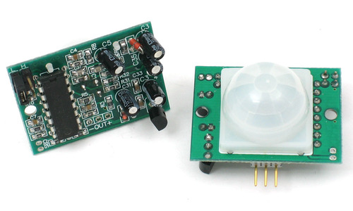

**FIGURE 2.3.: MOTION SENSOR**

**2.4.INFRARED SENSOR**

An [infrared sensor](https://www.elprocus.com/ir-remote-control-basics-operation-application/) is an electronic device, that emits in order to sense some aspects of the surroundings. An IR sensor can measure the heat of an object as well as detects the motion.These types of sensors measures only infrared radiation, rather than emitting it that is called as a [passive IR sensor](https://www.elprocus.com/passive-infrared-pir-sensor-with-applications/). Usually in the infrared spectrum, all the objects radiate some form of thermal radiations. These types of radiations are  invisible to our eyes, that can be detected by an infrared sensor.The emitter is simply an IR LED ([Light Emitting Diode](http://www.elprocus.com/explain-different-types-leds-working-applications-engineering-students/)) and the detector is simply an IR photodiode which is sensitive to IR light of the same wavelength as that emitted by the IR LED. When IR light falls on the photodiode, The resistances and these output voltages, change in proportion to the magnitude of the IR light received.

## IR Sensor Circuit Diagram and Working Principle

An infrared  sensor circuit is one of the basic and popular sensor module in an [electronic device](http://www.elprocus.com/basic-components-used-electronics-electrical/). This sensor is analogous to human’s visionary senses, which can be used to detect obstacles and it is one of the common applications in real time.This circuit comprises of the following components

* [LM358 IC](http://www.elprocus.com/op-amp-ics-pin-configuration-features-working/) 2 IR transmitter and receiver pair
* Resistors of the range of kilo ohms.
* Variable resistors.
* LED (Light Emitting Diode).

[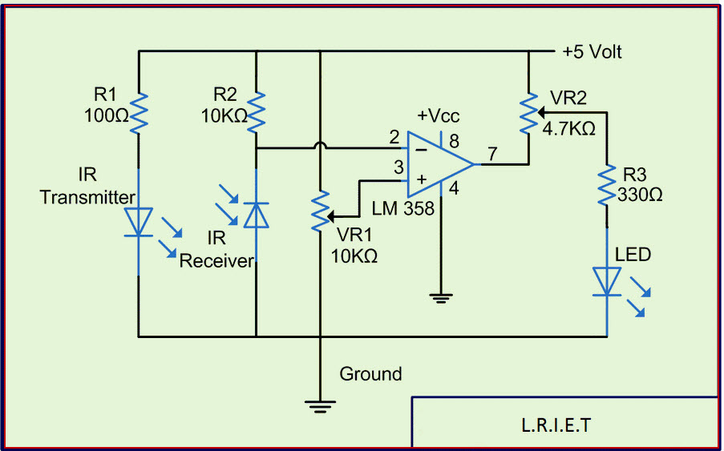](http://www.elprocus.com/wp-content/uploads/2015/01/IR-sensor-circuit-diagram.jpg)

**FIGURE:2.4.IR Sensor Circuit**

In this project, the transmitter section includes an IR sensor, which transmits continuous IR rays to be received by an IR receiver module. An IR output terminal of the receiver varies depending upon its receiving of IR rays. Since this variation cannot be analyzed as such, therefore this output can be fed to a comparator circuit. Here an[operational amplifier](https://www.elprocus.com/op-amp-ics-pin-configuration-features-working/) (op-amp) of LM 339 is used as comparator circuit.

When the IR receiver does not receive a signal, the potential at the inverting input goes higher than that non-inverting input of the comparator IC (LM339). Thus the output of the comparator goes low, but the LED does not glow. When the IR receiver module receives signal to the potential at the inverting input goes low. Thus the output of the comparator (LM 339) goes high and the LED starts glowing. Resistor R1 (100 ), R2 (10k ) and R3 (330) are used to ensure that minimum 10 mA current passes through the IR LED Devices like Photodiode and normal LEDs respectively. Resistor VR2 (preset=5k ) is used to adjust the output terminals. Resistor VR1 (preset=10k ) is used to set the sensitivity of the circuit Diagram. Read more about IR sensors.

### 2.4.1.Different Types of IR Sensors and Their Applications

IR sensors are classified into different types depending on the applications. Some of the typical applications of different [types of sensors](https://www.elprocus.com/types-of-sensors-with-circuits/) are

The speed sensor is used for synchronizing the speed of multiple motors. The [temperature sensor](http://www.elprocus.com/temperature-sensors-applications/) is used for industrial temperature control. [PIR sensor](http://www.elprocus.com/pir-sensor-basics-applications/) is used for automatic door opening system and  [Ultrasonic sensor](http://www.elprocus.com/motion-detector-circuit-with-working-description-and-its-applications/" \t "_blank) are used for distance measurement.

### IR Sensor Applications

IR sensors are used in various [Sensor based projects](http://www.elprocus.com/infrared-ir-sensor-circuit-and-working/www.elprocus.com/sensor-based-electronics-projects/) and also in various electronic devices which measures the temperature that are discussed in the below.

#### Radiation Thermometers

IR sensors are used in radiation thermometers to measure the temperature depend upon the temperature and the material of the object and these thermometers have some of the following features

* Measurement without direct contact with the object
* Faster response
* Easy pattern measurements

#### Flame Monitors

These types of devices are used for detecting the light emitted from the flames and to monitor how the flames are burning. The Light emitted from flames extend from UV to IR region types. PbS, PbSe, Two-color detector, pyro electric detector are some of the commonly employed detector used in flame monitors.

#### Moisture Analyzers

Moisture analyzers use wavelengths which are absorbed by the moisture in the IR region. Objects are irradiated with light having these wavelengths(1.1 µm, 1.4 µm, 1.9 µm, and 2.7µm) and also with reference wavelengths. The Lights reflected from the objects depend upon the moisture content and is detected by analyzer to measure moisture (ratio of reflected light at these wavelengths to the reflected light at reference wavelength). In GaAs PIN photodiodes, Pbs photoconductive detectors are employed in moisture analyzer circuits.

#### Gas Analyzers

IR sensors are used in gas analyzers which use absorption characteristics of gases in the IR region. Two types of methods are used to measure the density of gas such as dispersive and non dispersive.

[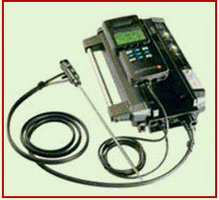](http://www.elprocus.com/wp-content/uploads/2015/01/gas-analizer.jpg)

**FIGURE:2.5.Gas Analizer**

**Dispersive:** An Emitted light is spectroscopically divided and their absorption characteristics are used to analyze the gas ingredients and the sample quantity.

**Non dispersive:** It is most commonly used method and it uses absorption characteristics without dividing the emitted light. Non dispersive types use discrete optical band pass filters, similar to sunglasses that are used for eye protection to filter out unwanted UV radiation.

This type of configuration is commonly referred to as non dispersive infrared (NDIR) technology. This type of analyzer is used for carbonated drinks, whereas non dispersive analyzer is used in most of the commercial IR instruments, for an automobile exhaust gas fuel leakages.

#### 2.4.2.IR Imaging Devices

IR image device is one of the major applications of IR waves, primarily by virtue of its property that is not visible. It is used for thermal imagers, night vision devices, etc.

[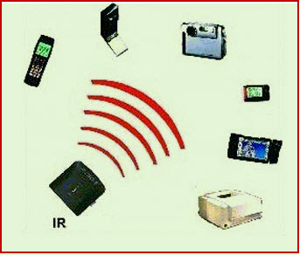](http://www.elprocus.com/wp-content/uploads/2015/01/ir-sensor-devices.jpg)

**FIGURE 2.6**.**IR Imaging Devices**

For examples Water, rocks, soil, vegetation, an atmosphere, and human tissue all features emit IR radiation. The Thermal infrared detectors measure these radiations in IR range and map the spatial temperature distributions of the object/area on an image. Thermal imagers usually composed of a Sb (indium antimonite), Gd Hg (mercury-doped germanium), Hg Cd Te (mercury-cadmium-telluride) sensors.

An electronic detector is cooled to low temperatures using liquid helium or liquid nitrogen’s.  Then the Cooling the detectors ensures that the radiant energy (photons) recorded by the detectors comes from the terrain and not from the ambient temperature of objects within the scanner itself an IR imaging electronic devices.

Thus, this is all about IR sensor circuit with working and applications. These sensors are used in many sensor based[electronics projects](https://www.elprocus.com/latest-electronics-projects-ideas/).

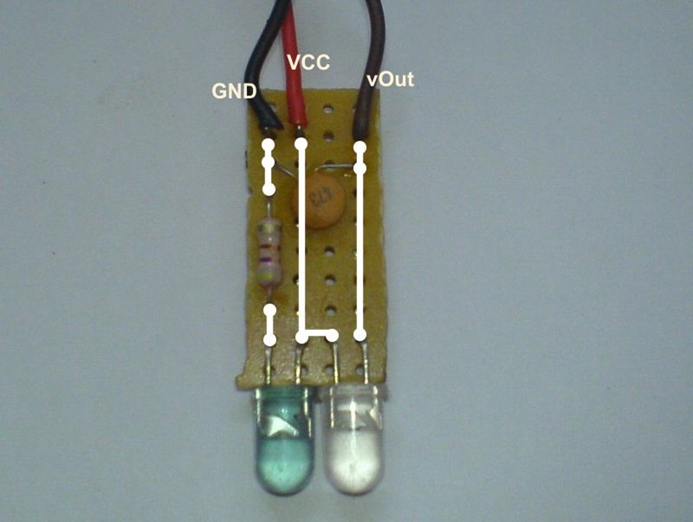

**FIGURE 2.7.:Infrared Sensor**

**2.5.GUI DESIGN**

In computing, a graphical user interface (GUI) is a type of interface that allows users to interact with electronic devices through graphical icons and visual indicators such as secondary notation, as opposed to text-based interfaces, typed command labels or text navigation. GUIs were introduced in reaction to the perceived steep learning curve of command-line interfaces (CLIs), which require commands to be typed on the keyboard.

The actions in a GUI are usually performed through direct manipulation of the graphical elements. In addition to computers, GUIs can be found in hand-held devices such as MP3 players, portable media players, gaming devices and smaller household, office and industry equipment. The term "GUI" tends not to be applied to other low-resolution types of interfaces with display resolutions, such as video games or not restricted to flat screens, like volumetric displays because the term is restricted to the scope of two-dimensional display screens able to describe generic information, in the tradition of the computer science research at the PARC (Palo Alto Research Center).

**2.6.ARDUINO(Mega328)**

The Arduino Uno is a microcontroller board based on the ATmega328 (datasheet). It has 14 digital input/output pins (of which 6 can be used as PWM outputs), 6 analog inputs, a 16 MHz crystal oscillator, a USB connection, a power jack, an ICSP header, and a reset button. It contains everything needed to support the microcontroller; simply connect it to a computer with a USB cable or power it with a AC-to-DC adapter or battery to get started. The Uno differs from all preceding boards in that it does not use the FTDI USB-to-serial driver chip. Instead, it features the Atmega8U2 programmed as a USB-to-serial converter.

**2.6.1.Technical specifications**

Microcontroller ATmega328

Operating Voltage 5V

Input Voltage (recommended) 7-12V

Input Voltage (limits) 6-20V

Digital I/O Pins 14 (of which 6 provide PWM output)

Analog Input Pins 6

DC Current per I/O Pin 40 mA

DC Current for 3.3V

Pin 50 mA

Flash Memory 32 KB of which 0.5 KB used by bootloader

SRAM 2 KB

EEPROM 1 KB

Clock Speed 16 MHz

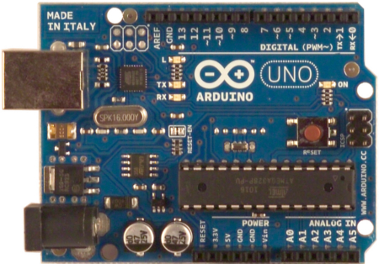

**FIGURE 2.8.:ARDUINO(mega328)**

**2.7.10k RESISTOR**

A **resistor** is a [passive](http://en.wikipedia.org/wiki/Passivity_(engineering)) [two-terminal](http://en.wikipedia.org/wiki/Terminal_(electronics)) [electrical component](http://en.wikipedia.org/wiki/Electronic_component) that implements [electrical resistance](http://en.wikipedia.org/wiki/Electrical_resistance) as a circuit element. Resistors act to reduce current flow, and, at the same time, act to lower voltage levels within circuits. In electronic circuits resistors are used to limit current flow, to adjust signal levels, [bias](http://en.wikipedia.org/wiki/Biasing) active elements, terminate [transmission lines](http://en.wikipedia.org/wiki/Transmission_line) among other uses. High-power resistors that can dissipate many [watts](http://en.wikipedia.org/wiki/Watt) of electrical power as heat may be used as part of motor controls, in power distribution systems, or as test loads for [generators](http://en.wikipedia.org/wiki/Electric_generator). Fixed resistors have resistances that only change slightly with temperature, time or operating voltage. Variable resistors can be used to adjust circuit elements (such as a volume control or a lamp dimmer), or as sensing devices for heat, light, humidity, force, or chemical activity.

Resistors are common elements of [electrical networks](http://en.wikipedia.org/wiki/Electrical_network) and [electronic circuits](http://en.wikipedia.org/wiki/Electronic_circuit) and are ubiquitous in [electronic equipment](http://en.wikipedia.org/wiki/Electronics). Practical resistors as discrete components can be composed of various compounds and forms. Resistors are also implemented within[integrated circuits](http://en.wikipedia.org/wiki/Integrated_circuits).

The electrical function of a resistor is specified by its resistance: common commercial resistors are manufactured over a range of more than nine [orders of magnitude](http://en.wikipedia.org/wiki/Orders_of_magnitude). The nominal value of the resistance will fall within a [manufacturing tolerance](http://en.wikipedia.org/wiki/Engineering_tolerance#Electrical_component_tolerance). . Resistors are carefully manufactured to provide a predetermined value of electrical resistance which may range from 0.1 ohms to 100,000,000 ohms, depending on the application. The physical size of a resistor also varies dependant on the amount of power passing through the resistor, given by: P = V x I (Power = Voltage x Current) (power measured in watts) There are also many types of resistors including: · Variable Resistor - changes resistance when its shaft is rotated (volume knob on a stereo). · Thermistor - changes resistance when the temperature changes (used in a thermostat). · Light Dependant Resistor (LDR) - changes resistance when the lighting changes (used in children's night-lights).

**Resistor Example:** An LED is a small red light (such as the one on the front of most TVs) and requires 2.0 volts and 0.02 amps to operate correctly. If we connected that LED up directly to a 12 volt battery, the voltage would be too high, and too much current would flow… the LED would blow up. We need to use a resistor to limit the voltage and current. But which value of resistance should the have resistor? Uses ohms law: R = V / I = (12.0 - 2.0) / 0.02 = 500 ohms *(*Note: the voltage across the resistor is the battery voltage minus the voltage we want across the *LED)* But which value of power should the resistor be capable of handling? P = V x I = (12.0 - 2.0) / 0.02 = 0.2 Watts

Note: k = x1,000 M = x1,000,000 G = x1,000,000,000 So a 10k resistor = 10kohms = 10,000ohms

**2.7.1.Specifications**

|  |  |
| --- | --- |
| **Specification** | **Value** |
| Product Type | RESISTOR |
| Resistance (ohm) | 10000 |
| Power (Watts) | 0.25 |
| Tolerance (%) | 5 |
| Package | AXIAL LEADED |

|  |  |
| --- | --- |
| Size | STANDARD |
| Packing Method | CUT TAPE |
| Mounting Feature | THROUGH HOLE |
| Resistor Type | CARBON FILM |

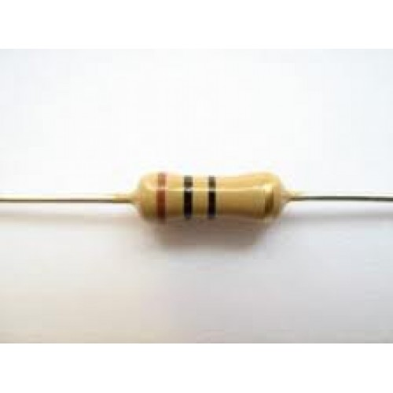

**FIGURE 2.9.:10k RESISTOR**

**2.8.WIRELESS Security Camera**

Wireless security cameras are [closed-circuit television](http://en.wikipedia.org/wiki/Closed-circuit_television) (CCTV) [cameras](http://en.wikipedia.org/wiki/Video_camera) that transmit a video and audio signal to a wireless receiver through a radio band. Many wireless security cameras require at least one cable or wire for power; "wireless" refers to the transmission of video/audio. However, some wireless security cameras are battery-powered, making the cameras truly wireless from top to bottom.

Wireless cameras are proving very popular among modern security consumers due to their low installation costs (there is no need to run expensive video extension cables) and flexible mounting options; wireless cameras can be mounted/installed in locations previouslyunavailable to standard wired cameras. In addition to the ease of use and convenience of access, wireless security camera allows users to leverage broadband wireless internet to provide seamless [video streaming over-internet](http://en.wikipedia.org/wiki/IP_camera).

**2.8.1.Types of cameras**

### Analog wireless

[Analog](http://en.wikipedia.org/wiki/Analog_video) wireless is the transmission of audio and video signals using radio frequencies. Typically, analog wireless has a transmission range of around 300 feet (91 meters) in open space; walls, doors, and furniture will reduce this range.

Analog wireless is found in three frequencies: 900 MHz, 2.4 GHz, and 5.8 GHz. Currently, the majority of wireless security cameras operate on the 2.4 GHz frequency. Most household routers, cordless phones, video game controllers, and microwaves operate on the 2.4 GHz frequency and may cause interference with your wireless security camera. 900 MHz is known as Wi-Fi Friendly because it will not interfere with the Internet signal of your wireless network.[[1]](http://en.wikipedia.org/wiki/Wireless_security_camera#cite_note-1)

Advantages include:

* Cost effective: the cost of individual cameras is low.
* Multiple receivers per camera: the signal from one camera can be picked up by any receiver; you can have multiple receivers in various locations to create your wireless surveillance network

Disadvantages:

* Susceptible to interference from other household devices, such as microwaves, cordless phones, video game controllers, and routers.
* No signal strength indicator: there is no visual alert (like the bars on a cellular phone) indicating the strength of your signal.
* Susceptible to interception: because analog wireless uses a consistent frequency, it is possible for the signals to be picked up by other receivers.
* One-way communication only: it is not possible for the receiver to send signals back to the camera.

### Digital wireless cameras

[Digital](http://en.wikipedia.org/wiki/Digital_video) wireless is the transmission of audio and video analog signals encoded as digital packets over high-bandwidth radio frequencies.

Advantages include:

* Wide transmission range—usually close to 450 feet (open space, clear line of sight between camera and receiver)
* High quality video and audio
* Two-way communication between the camera and the receiver
* Digital signal means you can transmit commands and functions, such as turning lights on and off
* You can connect multiple receivers to one recording device, such as security DVR

**2.8.2.Uses and applications**

### Home security systems

Wireless security cameras are becoming more and more popular in the consumer market, being a cost-effective way to have a comprehensive surveillance system installed in a home or business for an often less expensive price. Wireless cameras are also ideal for people renting homes or apartments. Since there is no need to run video extension cables through walls or ceilings (from the camera to the receiver or recording device) one does not need approval of a landlord to install a wireless security camera system. Additionally, the lack of wiring allows for less "clutter," avoiding damage to the look of a building.

A wireless security camera is also a great option for seasonal monitoring and surveillance. For example, one can observe a pool or patio in summer months and take down the camera in the winter.

### Law enforcement

Wireless security cameras are also used by [law enforcement agencies](http://en.wikipedia.org/wiki/Law_enforcement_agency) to deter crimes. The cameras can be installed in many remote locations and the video data is transmitted through government-only wireless network. An example of this application is the deployment ofhundreds of wireless security cameras by [New York City Police Department](http://en.wikipedia.org/wiki/New_York_City_Police_Department) on [lamp posts](http://en.wikipedia.org/wiki/Lamp_post) at many streets throughout the city

**Wireless range**

Wireless security cameras function best when there is a clear line of sight between the camera(s) and the receiver. Outdoors, and with clear line of sight, digital wireless cameras typically have a range between 250 to 450 feet. Indoors, the range can be limited to 100 to 150 feet. Cubical walls, drywall, glass, and windows generally do not degrade wireless signal strength. Brick, concrete floors, and walls degrade signal strength. Trees that are in the line of sight of the wireless camera and receiver may impact signal strength.

The signal range also depends on whether there are competing signals using the same frequency as the camera. For example, signals from cordless phones or routers may affect signal strength. When this happens, the camera image may freeze, or appear "choppy". Typical solution involves locking the channel that wireless router operates on.

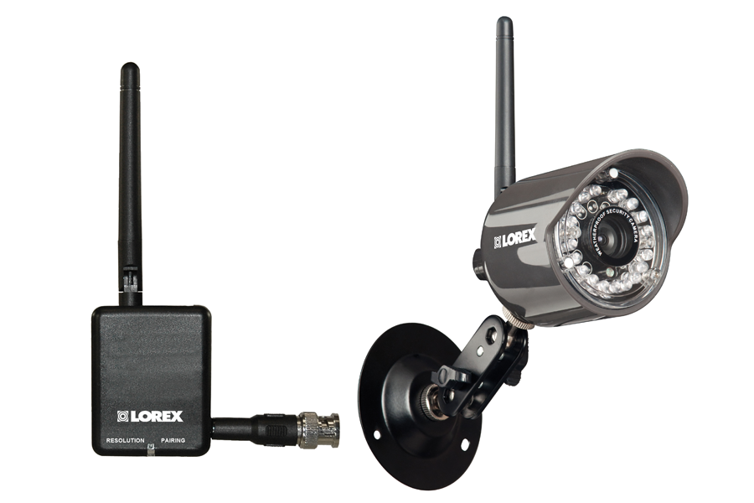

**FIGURE 2.10.:Wireless security camera**

# CHAPTER 3

# DETAILED DESCRIPTION OF THE SYSTEM DESIGNED

This project deals with the design & development of a theft control system for home, which is being used to prevent/control any theft attempt. The developed system makes use of an embedded system (comprises an open hardware microcontroller and a gsm modem) based on Global System for Mobile communication (GSM) technology.

The designed & developed system can be installed in the home. An interfacing intrusion-detector unit is also connected to the microcontroller-based security system.  
In case of an intrusion attempt, a warning message is being transmitted by the system (as an sms) to the owner’s mobile phone, or to any pre-configured mobile phone number for further processing.

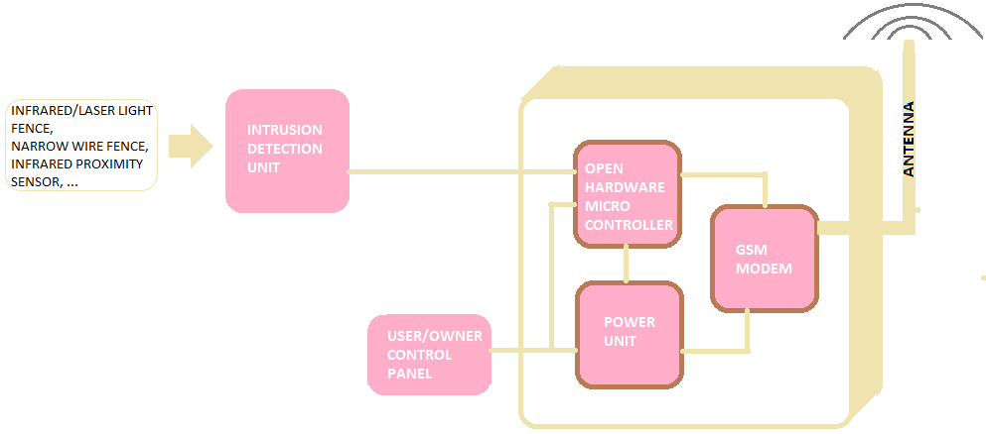

Infrared sensor,motion sensor and laser are used in this project for security measures to be at a high level.Whenever any stranger will come by any of these three a message will be sent to the residents if the home and at police station.An additional feature too is that a wireless security camera is also installed which will save the picture of the intruder coming in-front of it.Picture can be visualized via gui design and visual basic studio.

**POWER SUPPLY:**

Power supply is a reference to a source of electrical power. A device or system that supplies electrical or other types of energy to an output load or group of loads is called a power supply unit or PSU. The term is most commonly applied to electrical energy supplies, less often to mechanical ones, and rarely to others. Here in our application we need a 5v DC power supply for all electronics involved in the project. This requires step down transformer, rectifier, voltage regulator, and filter circuit for generation of 5v DC power.

TRANSFORMER: transformer is a device that transfers electrical energy from one circuit to another through inductively coupled conductors — the transformer's coils or "windings". Except for air-core transformers, the conductors are commonly wound around a single iron-rich core, or around separate but magneticallycoupled cores. A varying current in the first or "primary" winding creates a varying magnetic field in the core (or cores) of the transformer. This varying magnetic field induces a varying electromotive force (EMF) or "voltage" in the "secondary" winding. This effect is called mutual induction. If a load is connected to the secondary circuit, electric charge will flow in the secondary winding of the transformer and transfer energy from the primary circuit to the load connected in the secondary circuit. The secondary induced voltage VS, of an ideal transformer, is scaled from the primary VP by a factor equal to the ratio of the number of turns of wire in their respective windings: By appropriate selection of the numbers of turns, a transformer thus allows an alternating voltage to be stepped up by making NS more than NP — or stepped down, by making it

**BASIC PARTS OF A TRANSFORMER**

In its most basic form a transformer consists of:

• A primary coil or winding.

• A secondary coil or winding.

• A core that supports the coils or windings.

The primary winding is connected to a 60-hertz ac voltage source. The magnetic field (flux) builds up (expands) and collapses (contracts) about the primary winding. The expanding and contracting magnetic field around the primary winding cuts the secondary winding and induces an alternating voltage into the winding. This voltage causes alternating current to flow through the load. The voltage may be stepped up or down depending on the design of the primary and secondary windings.

# CHAPTER 4

# MICROCONTROLLER(Atmega328)

A microcontroller (sometimes abbreviated µC, uC or MCU) is a small [computer](http://en.wikipedia.org/wiki/Computer) on a single integrated circuit containing a processor core,memory,and programmable [input/output](http://en.wikipedia.org/wiki/Input/output) peripherals. Program memory in the form of [Ferroelectric RAM](http://en.wikipedia.org/wiki/Ferroelectric_RAM), [NOR flash](http://en.wikipedia.org/wiki/NOR_flash) or [OTP ROM](http://en.wikipedia.org/wiki/Programmable_read-only_memory)is also often included on chip, as well as a typically small amount of [RAM](http://en.wikipedia.org/wiki/Random-access_memory). Microcontrollers are designed for embedded applications, in contrast to the [microprocessors](http://en.wikipedia.org/wiki/Microprocessor) used in [personal computers](http://en.wikipedia.org/wiki/Personal_computer) or other general purpose applications.Microcontrollers are used in automatically controlled products and devices, such as automobile engine control systems, implantable medical devices, remote controls, office machines, appliances, power tools, toys and other [embedded systems](http://en.wikipedia.org/wiki/Embedded_system). By reducing the size and cost compared to a design that uses a separate microprocessor, memory, and input/output devices, microcontrollers make it economical to digitally control even more devices and processes. [Mixed signal](http://en.wikipedia.org/wiki/Mixed-signal_integrated_circuit) microcontrollers are common, integrating analog components needed to control non-digital electronic systems.

Some microcontrollers may use four-bit [words](http://en.wikipedia.org/wiki/Word_(computer_architecture)) and operate at [clock rate](http://en.wikipedia.org/wiki/Clock_rate) frequencies as low as 4 kHz, for low power consumption (single-digit milliwatts or microwatts). They will generally have the ability to retain functionality while waiting for an event such as a button press or other interrupt; power consumption while sleeping (CPU clock and most peripherals off) may be just nanowatts, making many of them well suited for long lasting battery applications. Other microcontrollers may serve performance-critical roles, where they may need to act more like a [digital signal processor](http://en.wikipedia.org/wiki/Digital_signal_processor) (DSP), with higher clock speeds and power consumption.

## 4.1.Key parameters for ATmega328

**Parameter Value**

**Flash (Kbytes):**32 Kbytes

**Pin Count**:32

**Max. Operating Freq. (MHz):**20 MHz

**CPU**:8-bit AVR

**# of Touch Channels**:16

**Hardware QTouch Acquisition**:No

**Max I/O Pins**:23

**Ext Interrupts**:24

**USB Speed**:No

**USB Interface**:No

**SPI**:2

**TWI (I2C):**1

**UART**:1

**Graphic LCD**:No

**Video Decoder**:No

**Camera Interface**:No

**ADC channels**:8

**ADC Resolution (bits):**10

**ADC Speed (ksps):**15

**Analog Comparators**:1

**Resistive Touch Screen**:No

**DAC Resolution (bits):**0

**Temp. Sensor**:Yes

**Crypto Engine**:No

**SRAM (Kbytes):**2

**EEPROM (Bytes):**1024

**Self Program Memory**:YES

**External Bus Interface**:0

**DRAM Memory:**No

**NAND Interface**:No

**picoPower**:No

**Temp. Range (deg C):-**40 to 85

**I/O Supply Class**:1.8 to 5.5

**Operating Voltage (Vcc):**1.8 to 5.5

**FPU**:No

**MPU / MMU**:no / no

**Timers**:3

**Output Compare channels:**6

**Input Capture Channels**:1

**PWM Channels**:6

**32kHz RTC**:Yes

**Calibrated RC Oscillator**:Yes

**Watchdog**:Yes

**CAN**:0

**LIN**:0

**Etherne**t:0

**Debug Interface**:debugWIRE

**I2S**:No

**RTC**:Counter

## 4.2. Introduction to ATmega32 (AVR Series) 8bit Microcontroller

In our days, there have been many advancement in the field of Electronics and many cutting edge technologies are being  developed every day, but still 8 bit microcontrollers have its own role in the digital electronics market dominated by 16-32 & 64 bit digital devices. Although powerful microcontrollers with higher processing capabilities exist in the market, 8bit microcontrollers still hold its value because of their easy-to-understand-operation, very much high popularity, ability to simplify a digital circuit, low cost compared to features offered, addition of many new features in a single IC and interest of manufacturers and consumers.Today’s microcontrollers are much different from what it were in the initial stage, and the number of manufacturers are much more in count than it was a decade or two ago. At present some of the major manufacturers are Microchip (publication: PIC microcontrollers), Atmel (publication: AVR microcontrollers), Hitachi, Phillips, Maxim, NXP, Intel etc.  Our interest is upon **ATmega32**. It belongs to **Atmel’s AVR series micro controller family**. Let’s see the features.

**PIN count:** Atmega32 has got 40 pins. Two for Power (pin no.10: +5v, pin no. 11: ground), two for oscillator (pin 12, 13), one for reset (pin 9), three for providing necessary power and reference voltage to its internal ADC, and 32 (4×8) I/O pins.

**About I/O pins:** ATmega32 is capable of handling analogue inputs. Port A can be used as either DIGITAL I/O Lines or each individual pin can be used as a single input channel to the internal ADC of ATmega32, plus a pair of pins AREF, AVCC & GND (refer to [**ATmega32 datasheet**](http://www.atmel.com/Images/doc2503.pdf)) together can make an ADC channel.No pins can perform and serve for two purposes (for an example: Port A pins cannot work as a Digital I/O pin while the Internal ADC is activated) at the same time. It’s the programmers responsibility to resolve the conflict in the circuitry and the program. Programmers are advised to have a look to the priority tables and the internal configuration from the datasheet.

**Digital I/O pins:** ATmega32 has 32 pins (4portsx8pins) configurable as Digital I/O pins.

**Timers:** 3 Inbuilt timer/counters, two 8 bit (timer0, timer2) and one 16 bit (timer1).

**ADC:** It has one successive approximation type ADC in which total 8 single channels are selectable. They can also be used as 7 (for TQFP packages) or 2 (for DIP packages) differential channels. Reference is selectable, either an external reference can be used or the internal 2.56V reference can be brought into action.  There external reference can be connected to the AREF pin.

**Communication Options:**  ATmega32 has three data transfer modules embedded in it. They are

* Two  Wire Interface
* USART
* Serial Peripheral Interface

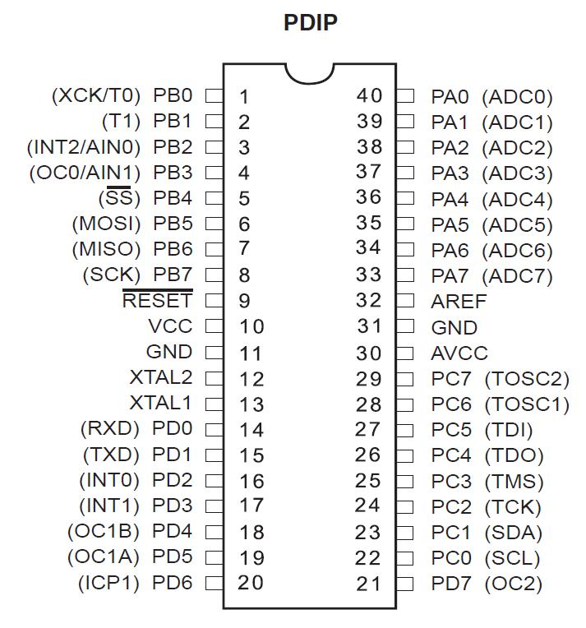

**Atmega32 pin diagram**

**Analog comparator:**  On-chip analog comparator is available. An interrupt is assigned for different comparison result obtained from the inputs.

**External Interrupt:** 3External interrupt is accepted. Interrupt sense is configurable.

**Memory:**  It has 32Kbytes of In-System Self-programmable Flash program memory, 1024 Bytes EEPROM, 2Kbytes Internal SRAM. Write/Erase Cycles: 10,000 Flash / 100,000 EEPROM.

**Clock:** It can run at a frequency from 1 to 16 MHz. Frequency can be obtained from external Quartz Crystal, Ceramic crystal or an R-C network. Internal calibrated RC oscillator can also be used.

**More Features**: Up to 16 MIPS throughput at 16MHz. Most of the instruction executes in a single cycle. Two cycle on-chip multiplication. 32 × 8 General Purpose Working Registers

**Debug:** JTAG boundary scan facilitates on chip debug.

**Programming:** Atmega32 can be programmed either by In-System Programming via Serial peripheral interface or by Parallel programming. Programming via JTAG interface is also possible. Programmer must ensure that SPI programming and JTAG are not be disabled using  fuse bits; if the programming is supposed to be done using SPI or JTAG.

[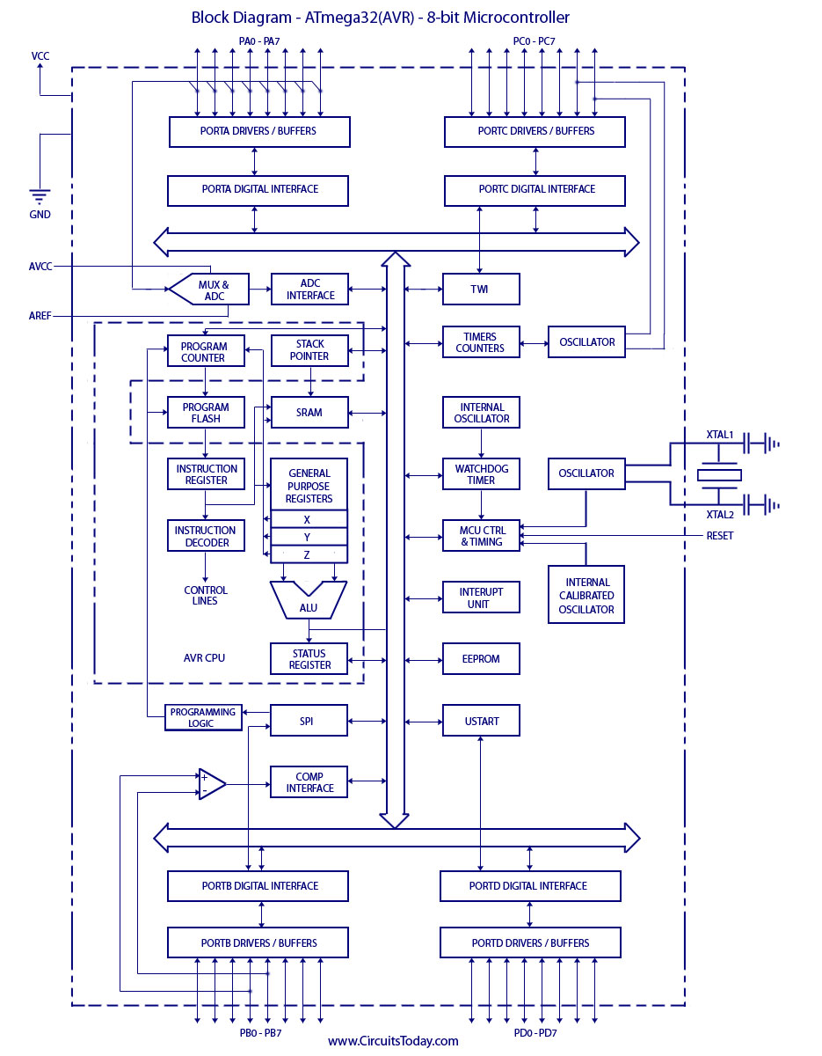](http://www.circuitstoday.com/wp-content/uploads/2012/01/Block-Diagram-ATmega32AVR-8-bit-Microcontroller.jpg)**BLOCK DIAGRAM OF Atmega328**

**4.2.1.Arduino Digital and Analog I/O Pins**

**Digital pins**

Pins 0 – 7: PORT D [0:7]

Pins 8 – 13: PORT B [0:5] }

Pins 14 – 19: PORT C [0:5] (Arduino analog pins 0 – 5) }

digital pins 0 and 1 are RX and TX for serial communication }

digital pin 13 connected to the base board LED }

**Digital Pin I/O Functions**

* **pinMode(pin, mode)**

Sets pin to INPUT or OUTPUT mode }

Writes 1 bit in the DDRx register }

* **digitalWrite(pin, value)**

Sets pin value to LOW or HIGH (0 or 1) }

Writes 1 bit in the PORTx register }

* **int value = digitalRead(pin)**

Reads back pin value (0 or 1)

Read 1 bit in the PINx register

**4.2.2.Arduino Analog I/O**

**Analog input pins**: 0 – 5

**Analog output pins**: 3, 5, 6, 9, 10, 11 (digital pins)

* **Analog input functions**

int val = analog Read(pin)

Converts 0 – 5v. voltage to a 10-bit number (0 – 1023)

Don’t use pin Mode

Analog Reference(type)

Used to change how voltage is converted (advanced) }

* **Analog output**

Analog Write(pin, value)

value is 0 – 255

Generates a PWM output on digital pin (3, 5, 6, 9, 10, 11)

@490Hz frequency

**4.3.PWM – Pulse Width Modulation**

* Use one wire to represent a multi-bit value.
* A clock with a variable duty cycle.
* Duty cycle used to represent value.
* We can turn it into a analog voltage using an integrating filter.

**4.4.APPLICATIONS**

Today the ATmega328 is commonly used in many projects and autonomous systems where a simple, low-powered, low-cost micro-controller is needed. Perhaps the most common implementation of this chip is on the popular [Arduino](http://en.wikipedia.org/wiki/Arduino) development platform, namely the [Arduino Uno](http://en.wikipedia.org/wiki/Arduino_Uno) and [Arduino Nano](http://en.wikipedia.org/w/index.php?title=Arduino_Nano&action=edit&redlink=1) models.

# CHAPTER 5

# GSM MODULE AND PIR SENSOR

**GSM MODULE**

A **GSM module** is a specialized type of modem which accepts a SIM card, and operates over a subscription to a mobile operator, just like a mobile phone. From the mobile operator perspective, a GSM modem looks just like a mobile phone.

When a GSM modem is connected to a computer, this allows the computer to use the GSM modem to communicate over the mobile network.  While these GSM modems are most frequently used to provide mobile internet connectivity, many of them can also be used for sending and receiving SMS and MMS messages.

A GSM modem can be a dedicated modem device with a serial, USB or Bluetooth connection, or it can be a mobile phone that provides GSM modem capabilities.

For the purpose of this document, the term GSM modem is used as a generic term to refer to any modem that supports one or more of the protocols in the GSM evolutionary family, including the 2.5G technologies GPRS and EDGE, as well as the 3G technologies WCDMA, UMTS, HSDPA and HSUPA.

A GSM modem exposes an interface that allows applications such as NowSMS to send and receive messages over the modem interface. The mobile operator charges for this message sending and receiving as if it was performed directly on a mobile phone. To perform these tasks, a GSM modem must support an “extended AT command set” for sending/receiving SMS messages, as defined in the [ETSI GSM 07.05](http://www.etsi.org/) and and [3GPP TS 27.005](http://www.3gpp.org/ftp/specs/html-info/27005.htm) specifications.

GSM modems can be a quick and efficient way to get started with SMS, because a special subscription to an SMS service provider is not required. In most parts of the world, GSM modems are a cost effective solution for receiving SMS messages, because the sender is paying for the message delivery.

A GSM modem can be a dedicated modem device with a serial, USB or Bluetooth connection, such as the Falcom Samba 75. (Other manufacturers of dedicated GSM modem devices include Wavecom, Multitech and iTegno.  We’ve also reviewed a number of modems on our [technical support blog](http://www.nowsms.com/tag/gsm-modem).) To begin, insert a GSM SIM card into the modem and connect it to an available USB port on your computer.

A GSM modem could also be a standard GSM mobile phone with the appropriate cable and software driver to connect to a serial port or USB port on your computer. Any phone that supports the “extended AT command set” for sending/receiving SMS messages, as defined in [ETSI GSM 07.05](http://www.etsi.org/) and/or [3GPP TS 27.005](http://www.3gpp.org/ftp/specs/html-info/27005.htm), can be supported by the Now SMS & MMS Gateway. Note that not all mobile phones support this modem interface.

Due to some compatibility issues that can exist with mobile phones, using a dedicated GSM modem is usually preferable to a GSM mobile phone. This is more of an issue with MMS messaging, where if you wish to be able to receive inbound MMS messages with the gateway, the modem interface on most GSM phones will only allow you to send MMS messages. This is because the mobile phone automatically processes received MMS message notifications without forwarding them via the modem interface.

It should also be noted that not all phones support the modem interface for sending and receiving SMS messages. In particular, most smart phones, including Blackberries, iPhone, and Windows Mobile devices, do not support this GSM modem interface for sending and receiving SMS messages at all at all. Additionally, Nokia phones that use the S60 (Series 60) interface, which is Symbian based, only support sending SMS messages via the modem interface, and do not support receiving SMS via the modem interface.

### GSM Modem Principle

**FACTS OF GSM MODEM:**

The GSM/GPRS Modem comes with a serial interface through which the modem can be controlled using AT command interface. An antenna and a power adapter are provided.The basic segregation of working of the modem is as under:

**•Voice calls**

**•SMS**

**•GSM Data calls**

**• GPRS**

**Voice calls:**

Voice calls are not an application area to be targeted. In future if interfaces like a microphone and speaker are provided for some applications then this can be considered.  
  
**SMS**:

SMS is an area where the modem can be used to provide features like:  
• Pre-stored SMS transmission, these SMS can be transmitted on certain trigger events in an automation system.

• SMS can also be used in areas where small text information has to be sent. The transmitter can be an automation system or machines like vending machines, collection machines or applications like positioning systems where the navigator keeps on sending SMS at particular time intervals  
• SMS can be a solution where GSM data call or GPRS services are not available  
  
**GSM Data Calls**:

  Data calls can be made using this modem. Data calls can be made to a normal PSTN modem/phone line also (even received). Data calls are basically made to send/receive data streams between two units either PC’s or embedded devices. The advantage of Data calls over SMS is that both parties are capable of sending/receiving data through their terminals.  
Some points to be remembered in case of data calls:

• The data call service doesn’t come with a normal SIM which is purchased but has to be

requested with the service provider (say Airtel).

• Upon activation of data/fax service you are provided with two separate numbers i.e. the Data call number and the Fax service number.

• Data calls are established using Circuit Switched data connections.  
• Right now the speed at which data can be transmitted is 9.6 kbps.  
• The modem supports speeds up to 14.4 kbps but the provider give a maximum data rate of 9.6 kbps during GSM data call.

• Technologies like HSCSD (high Speed Circuit Switched Data) will improve drastically the data rates, but still in pipeline.

Full Type Approved Quad Band Embedded GSM Module (GSM  850/900 1800/1900) with AT command set and RS232 interface on CMOS level.  
This GSM wireless data module is the ready a solution for remote wireless applications, machine to machine or user to machine and remote data communications in all vertical market applications.

## The GSM module offers the advantages as below

* Ultra small size (22x22x3 mm), lightweight (3.2 g) and easy to integrate
* Low power consumption
* R&TTE type approval plus CE, GCF, FCC, PTCRB, IC
* Full RS232 on CMOS level with flow control (RX, TX, CTS, RTS, CTS, DTR, DSR, DCD, RI)
* Embedded TCP/IP Stack UDP/IP Stack , Embedded FTP and SMTP Client
* High performance on low price

## Smallest size designed for tiny applications

Tracking (people, animals, people), container tracking, PDA, POS terminal, PCMCIA cards, AMR

## Pin to Pin upgrade policy to save your developing investments High level technical support to help you in the integration of your solution

* Exhaustive product documentation
* Evaluation kit and reference design
* Quick technical assistance by dedicated e-mail services and user forum
* Deep technical assistance by dedicated engineering support
* RD support and certification lab for all your needs

## Product Features

* E-GSM 900/1800 MHz and GSM 1800/1900 with GSM Phase 2 / 2+
* Output Power Class 4 (2W) at GSM 850/900 MHz and Class 1 (1W) at GSM 1800/1900 MHz
* Control via AT commands (ITU, GSM, GPRS and manufacturer supplementary)
* Supply Voltage range: 3.22 V - 4.2 V, nominal: 3.8 V
* Power consumption: Idle mode: <1.8 mA, speech mode: 200 mA (average)
* Dimensions (mm): 3 x 20 x 20 and weight (g): 3.2 (including shielding)

## Interfaces

* Power supply nominal 3,8 V
* 10 general purposes I/O ports  and serial bi-directional bus on CMOS 2,8 V
* External SIM
* Analogue audio for microphone, speaker and hands free set plus digital voice interface
* RS232 on CMOS 2,8 V (One RS232 (2,8V) with flow control (RX, TX, CTS, RTS, CTS, DTR, DSR, DCD, RI), baud rate 300 - 115.200 bps, autobauding  1200 -  57.600 bps
* 50 Ohm antenna connector

## Audio

* Telephony and emergency calls (Half Rate (HR), Full Rate (FR), Enhanced Full Rate (EFR))
* Echo cancellation and noise reduction
* DTMF
* Handset operations and basic handsfree operation

## SMS

* [SMS](http://www.gsm-modem.de/sms.html) Mobile Originated (MO), Mobile Terminated (MT) and [Cell Broadcast](http://www.gsm-modem.de/sms-cell-broadcast.html) (CB - DRX)

## GPRS, data and Fax

* [Circuit Switched Data](http://www.gsm-modem.de/gsm-data-call.html) (CSD) up to 14.4 kbps
* [Fax](http://www.gsm-modem.de/gsm-fax.html) Group 3
* Packed Data (GPRS class B, class 10) up to 115 kbps

## GSM Supplementary Services

* Call Barring and Call Forwarding
* Advice of Charge
* Call Waiting and Call Hold
* Calling Line Identification Presentation (CLIP)
* Calling Line Identification Restriction (CLIR)
* Unstructured SS Mobile Originated Data (USSD)
* Closed User Group

## Other Features

* SIM Phonebook management
* Fixed Dialling Number (FDN)
* SIM Toolkit class 2
* Real time clock
* Alarm management

**PIR SENSOR**

['''What is a PIR sensor?'''](http://www.adafruit.com/index.php?main_page=product_info&cPath=35&products_id=189)

PIR sensors allow you to sense motion, almost always used to detect whether a human has moved in or out of the sensors range. They are small, inexpensive, low-power, easy to use and don't wear out. For that reason they are commonly found in appliances and gadgets used in homes or businesses. They are often referred to as PIR, "Passive Infrared", "Pyroelectric", or "IR motion" sensors.

PIRs are basically made of a [pyroelectric sensor](http://en.wikipedia.org/wiki/Pyroelectric) (which you can see above as the round metal can with a rectangular crystal in the center), which can detect levels of infrared radiation. Everything emits some low level radiation, and the hotter something is, the more radiation is emitted. The sensor in a motion detector is actually split in two halves. The reason for that is that we are looking to detect motion (change) not average IR levels. The two halves are wired up so that they cancel each other out. If one half sees more or less IR radiation than the other, the output will swing high or low.

Along with the pyroelectic sensor is a bunch of supporting circuitry, resistors and capacitors. It seems that most small hobbyist sensors use the [BISS0001 ("Micro Power PIR Motion Detector IC")](http://www.ladyada.net/media/sensors/BISS0001.pdf), undoubtedly a very inexpensive chip. This chip takes the output of the sensor and does some minor processing on it to emit a digital output pulse from the analog sensor.  
For many basic projects or products that need to detect when a person has left or entered the area, or has approached, PIR sensors are great. They are low power and low cost, pretty rugged, have a wide lens range, and are easy to interface with. Note that PIRs won't tell you how many people are around or how close they are to the sensor, the lens is often fixed to a certain sweep and distance (although it can be hacked somewhere) and they are also sometimes set off by house pets. Experimentation is key!

**Some basic stats**

These stats are for the PIR sensor in the Adafruit shop which is very much [like the Parallax one](http://www.parallax.com/Store/Sensors/ObjectDetection/tabid/176/ProductID/83/List/0/Default.aspx?SortField=ProductName,ProductName). Nearly all PIRs will have slightly different specifications, although they all pretty much work the same. If there's a datasheet, you'll want to refer to it

* **Size:** Rectangular
* **Output:** Digital pulse high (3V) when triggered (motion detected) digital low when idle (no motion detected). Pulse lengths are determined by resistors and capacitors on the PCB and differ from sensor to sensor.
* **Sensitivity range:** up to 20 feet (6 meters) 110 degrees x 70 degrees detection range
* **Power supply:** 3.3V - 5V input voltage,
* [BIS0001 Datasheet](http://www.ladyada.net/media/sensors/BISS0001.pdf) (the decoder chip used)
* [RE200B datasheet](http://www.ladyada.net/media/sensors/RE200B.pdf) (most likely the PIR sensing element used)
* [NL11NH datasheet](http://www.ladyada.net/media/sensors/NL11NH.pdf) (equivalent lens used)
* [Parallax Datasheet on their version of the sensor](http://www.ladyada.net/media/sensors/PIRSensor-V1.2.pdf)

**Working principle of PIR sensor**

PIR sensors are more complicated than many of the other sensors explained in these tutorials (like photocells, FSRs and tilt switches) because there are multiple variables that affect the sensors input and output. To begin explaining how a basic sensor works, we'll use this rather nice diagram (if anyone knows where it originates plz let me know).

The PIR sensor itself has two slots in it, each slot is made of a special material that is sensitive to IR. The lens used here is not really doing much and so we see that the two slots can 'see' out past some distance (basically the sensitivity of the sensor). When the sensor is idle, both slots detect the same amount of IR, the ambient amount radiated from the room or walls or outdoors. When a warm body like a human or animal passes by, it first intercepts one half of the PIR sensor, which causes a*positive differential* change between the two halves. When the warm body leaves the sensing area, the reverse happens, whereby the sensor generates a negative differential change. These change pulses are what is detected.

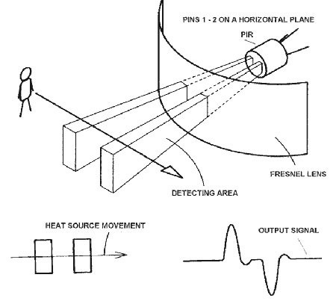

The IR sensor itself is housed in a hermetically sealed metal can to improve noise/temperature/humidity immunity. There is a window made of IR-transmissive material (typically coated silicon since that is very easy to come by) that protects the sensing element. Behind the window are the two balanced sensors.

### Motion Detection using PIR Sensor

A PIR or a Passive Infrared Sensor can be used to detect presence of human beings in its proximity. The output can be used to control the motion of door.

Basically motion detection use light sensors to detect either the presence of infrared light emitted from a warm object or absence of infrared light when a object interrupts a beam emitted by another part of the device.

A PIR sensor detects the infrared light radiated by a warm object. It consists of pyro electric sensors which introduce changes in their temperature (due to incident infrared radiation) into electric signal. When infrared light strikes a crystal, it generates an electrical charge.

Thus a PIR sensor can be used to detect presence of human beings within a detection area of approximately 14 meters.

### 7 areas of Applications of PIR Sensors

* All outdoor Lights
* Lift Lobby
* Multi Apartment Complexes
* Common staircases
* For Basement or Covered Parking Area
* Shopping Malls
* For garden lights

### PIR Sensor IC

The PIR sensor IC consists of 3 pins-  Vcc, Ground and Output.

[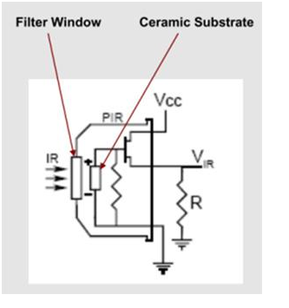](https://www.elprocus.com/wp-content/uploads/2013/08/Automatic1.png)

[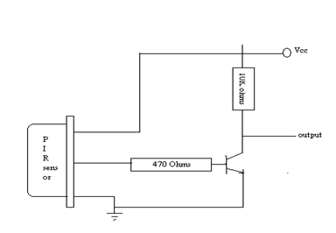](https://www.elprocus.com/wp-content/uploads/2013/08/Automatic-door.png)

In presence of human IR radiations, the sensor detects the radiations and converts it directly to electrical pulses, which is fed to the inverter circuit. The inverter circuit consists of a transistor,which gets into saturation with application of high base current and eventually develops a low collector voltage. Thus the transistor  output is low.

This low inverter output is connected to the microcontroller. Based on the input received by the microcontroller, it controls the motor driver , which in turn controls the motion of the motor.

# CONCLUSION

The project **“GSM BASED HOME SECURITY SYSTEM”** has been carefully designed and optimized.

In the paper low cost, secure, ubiquitously accessible, auto-configurable, remotely controlled solution for automation of homes has been introduced. The approach discussed in the paper is novel and has achieved the target to control home appliances remotely using the SMS-based system satisfying user needs and requirements.GSM technology capable solution has proved to be controlled remotely, provide home security and is cost-effective as compared to the previously existing systems. Hence we can conclude that the required goals and objectives of our project have been achieved. The basic level of home appliance control and remote monitoring has been implemented. The system is extensible and more levels can be further developed using automatic motion/glass breaking detectors so the solution can be integrated with the send other detection systems. In future the system will be small box combining the PC and GSM modem. The hardware will be self contained and cannot be prone to electric failure. This appliance will have its own encapsulated UPS and charging system.After the construction andcomponent assembly, it was tested and they were responding tothe GSM modem as detected by the infra-red sensors, hightemperature sensor and gas sensor etc. But misuse of the system by end users may probably lead to lapses in the system performance.The system was designed and constructed in sucha way that maintenance and repairs are easily done in the faults.The design and construction of a GSM based intelligent homesecurity system involves researches in different aspects of physics/electronics technology;this include; power electronics,operational amplifier, telecommunication, and softwareengineering. When the PIR finds intruders ( in form of variationin temperature, gas leakage, pressure, etc), the relevant sensingdevice(s) respond and the microcontroller sends encoded signal to the wireless sensor network established in home. Themoment the signal is received, it will send alarm shortmessage to the users (owners of the building) and to the police station through GSMnetwork immediately. The design analysis and calculations werecarried out and finally, a positive result was achieved.

The designing of the system wasn’t an easy task though.We searched for all the electronics market to purchase the components at a low cost and from a reliable place.All team members worked together to make it reach the final stage.

We with assurity say that all the parts assembled are 100% working and are best suitable for home security,office,malls and other places which require safety for theirpurpose.

**REFRENCES**

http://www.8051.projects.net

http://www.gsmworld.com/about-us/history.html

http//:en.wikipedia.org/wiki/gsm project

AT Commands Set for Nokia GSM and WCDMA products, Version 1.2, July 2005

Gerhart, James (1999): Home Automation and Wiring,McGraw-Hill Professional. ISBN 0070246742.[6]

 Harper, Richard (2003): Inside the Smart Home,Springer. ISBN 1852336889.

S.Am Yoon, H.Su Jeoung, Y.Sun Yoon and I.Cha," The Study on the Characteristic of Charge and Discharge of Security Alarm System Battery with PIC", Proceeding of IEEE Int. Conference on Industrial Electronics, vol.1, Chohla, Puebla, Mexico, 2000, pp. 48-51.

K. C. Lee "Network-based fire-detection system via controller area network for smart home automation", IEEE Trans. Consumer Electron., vol. 50, no. 4, pp.1093 -1100 2004.

PIR Sensor IC [engineersgarage](http://www.engineersgarage.com/sites/default/files/imagecache/Original/wysiwyg_imageupload/4214/HOW-DO-THEY-WORK.jpg" \t "_blank)

[www.wikipedia.com](http://www.wikipedia.com)

Antunes, R. (2007): Intruder alarm systems: The stateof the art, proceeding of the 2 NDb Internationalconference on electrical engineering (CEE”07): 251-261. ISBN 972-99064-4-2

Griffiths, M ( 2008): Smart Home Security:Homebuilding & Renovating. ABI Research Mobile(2012)//m.abireseach.com/

Schertz P. (2000). Practical Electronics for Inventors.Mc Graw Hills. 2ndedition.ISBN- 0-01-058078-2.