# 

# *Dedication*

*We dedicate this project to Allah Almighty who blessed us with knowledge and strength to make this project. Than we desiccate this project tour Supervisor, all faculty members, Lab Engineers and Lab Technicians who supported us is every manner both educationally and financially. Finally we dedicate this project to our parents, siblings and friends who supported us and increased our moral strength and appreciating us through every thick and thin.*

# ACKNOWLEDGMENT

 I would like to thank God for giving me this challenging work and for providing the strength to travel along the successful path. I sincerely express my gratitude to my honorable Department head and my parents for supporting me to do this project.

# ABSTRACT

In this project we are monitoring the theft on the lines. We will monitor the two valid users consumption then we will add these data and compare this data to the contribution line. We will have another user which will be illegal when he will try to get connection from the line the consumption will be increased and we will receive message that electricity theft is occur. Monitoring can provide information about power flow and demand and help to identify the cause of power system disturbances. Monitoring the power means calculating the power consumed exactly by the user at a given time. The power consumed by the user is measured and communicated to the controlling substation whenever needed by the person at the substation. The feedback from the user helps in identifying usages between authorized and unauthorized users which helps in controlling the power theft, one of the major challenges in current scenarios.

Table of Contents

*Dedication* 1

ACKNOWLEDGMENT 2

ABSTRACT 3

ABSTRACT 3

Chapter 1 7

1.1 Overview 7

1.2 EXISTING SYSTEM 7

1.3 CONTROL CENTRE 7

1.4 Advantages 8

1.5 Proposed System 8

1.6 GSM 8

1.7 Modification 9

1.8 limitations 9

Chapter 2 10

LITERATURE REVIEW 10

2.1 ANALYSIS OF LOSSES IN POWER SYSTEMS 10

2.2 Technical Losses 10

2.3 Non-Technical Losses (Commercial Losses) 11

2.4 Electricity Theft as a Major Component of Commercial Losses 12

2.5 METHODS OF ILLEGAL CONSUMING ELECTRICITY 12

Chapter 3 13

PROJECT DESIGN AND IMPLEMENTATION 13

3.1 Power Theft Detection 13

3.2 Power Measurement And Theft Detection 13

3.2.1 Voltage transformers 14

3.2.2 Current transformers 14

3.2.3 Theft detection method 15

3.3 STEALING 15

3.3.1 Un-hooking technology will electricity stealing 16

3.3.2 Violated wire connection. 16

3.3.3 Exchange fire wire and zero wire. 16

3.4 Interfacing Current sensors with arduino 17

Chapter 4 23

TOOLS AND TECHNIQUES 23

4.1 Arduino Uno 23

4.2 GSM Module 30

GSM Architecture 35

Features of GSM Module: 35

4.3 GSM modem and microcontroller interface: 36

4.4 BRIEF INTRODUCTION OF AT COMMAND 36

4.5 Current sensor 37

Chapter 5 42

Conclusion 42

Refrences 43

**LIST OF ACRONYMS**

IDE Integrated Development Environment

DC Direct Current

AC Alternating Current

GND Ground

VCC Voltage Supply

# Chapter 1

**INTRODUCTION**

## Overview

Electricity is the modern man‟s most convenient and useful form of energy without which the present social infrastructure would not be feasible. The increase in per capita production is the reflection of the increase in the living standard of people. When importance of electricity is on the increasing side, then how much should theft of this energy or illegal consumption of power from the transmission lines be averted? Power theft has become a great challenge to the electricity board.

## EXISTING SYSTEM

Detecting non-technical loss is an open research problem still so many researches is being processed to find the solution. In the existing system the electricity theft is detected only for separate house and are never be practiced in real time. One researcher implemented an algorithm to detect the energy theft but it cannot be included in the real time work. Another process is implemented with fixing energy meter in the house and the electrical pole but it alone cannot be useful for finding the energy theft. Some implemented

## CONTROL CENTRE

Control Centre plays vital role in monitoring the consumers i.e., energy consumption of individual consumer. This maintenance center keep track of the consumption details in a separate database also keeps the substation and feeder details. A separate control Centre also equipped with GSM/GRPS shield in order to send message to the staff personals to investigate the energy theft. Traditional electricity board does not featured withsuch wireless devices like Wi-Fi shield and GSM/GPRS modem. In this system, the electricity line is thoroughly monitored by the central control unit hence energy theft can be detected efficiently so that electricity will be conserved and illegal consumption will be eradicated.

## Advantages

The advantages are:

• The proposed system provides the solution for power theft

• This method will reduce the energy wastage and save a lot of energy for future use.

• Optimized use of energy.

• Real time theft monitoring

## Proposed System

The power theft monitoring is an important research in electric power system and electricity stealing prevention became a big problem to the electricity. Electricity stealing is a long term problem; however each power supply department has me huge investments of manpower and material, the phenomenon of defending stealing electricity has increased and not abated and the method of electricity stealing is continuously improved. The behaviour of electricity stealing not only makes the power industry suffering huge financial losses but also threatens the main power supply security and reliability.

## GSM

GSM is most suitable two way communication system that is equipped with SIM card that send and receive information i.e. message between the users just like a mobile phone. Here GSM modem is fixed in control Centre in order to alert the staff personals to investigate the energy theft. This modem will automatically send the information to the officials without any human intervention. This device is more cost effective and handy one that can transfer information’s to the required persons.

## Modification

One can decide the resolution of this system. Due to economic consideration, instead of installing this system for each consumer utility company can install one system for one colony. Then power theft on any line in that colony will be identified by this system.

## limitations

• One major disadvantage of this project is that it is not capable of detecting the exact location from where the power is being stolen.

• Cannot determine who is stealing, but no any other existing system is capable.

• If implemented on a large scale it may take a lot of time and manual input.

# Chapter 2

# LITERATURE REVIEW

## 2.1 ANALYSIS OF LOSSES IN POWER SYSTEMS

Losses occur at all levels, from generation, through transmission and distribution, to the consumer and the meter. It is normally at the distribution level where the majority of avoidable losses occur. All electrical power distribution companies operate with some accepted degree of losses. This is no different from the scenario in Pakistan. Losses incurred in electrical power systems have two components:

• Technical losses and

• Non-technical losses (Commercial losses)

## 2.2 Technical Losses

Technical losses will always arise as the physics of electricity transport means that, no power system can be perfect in its delivery of energy to the end customer. Technical losses are naturally occurring losses (caused by actions internal to the power system) and consist mainly of power dissipation in electrical system components such as transmission lines, power transformers, measurement systems, etc. Technical losses are possible to compute and control, provided the power system in question. consists of known quantities, viz., resistance,

reactance, capacitance, voltage, current and power. These are routinely calculated by utility companies as a way to specify what components will be added to the systems. Loads are not included in the losses because they are actually intended to receive as much energy as possible. Technical losses in power systems are caused by the physical properties of the components of power systems. Example, I2R loss or copper loss – in the conductor cables, transformers, switches and generators. The most obvious example is the power dissipated in transmission lines and transformers due to their internal impedance. Technical losses are easy to simulate and calculate; computation tools for calculating power flow, losses, and equipment status in power systems have been developed for some time. The instantaneous power loss, Ploss(t) in a transmission line can be expressed as:

where Psource(t) is the instantaneous power that the source injects into the transmission line and Pload(t) is the instantaneous power consumed by the load at the other end of the transmission line. Thus the energy loss, Wloss, is given by:

where a and b are respectively the starting point and ending point of the time interval being evaluated. It must be noted that a fairly accurate description of Ploss(t) as a function of time is always needed to make a reliable prediction of Wloss.

## 2.3 Non-Technical Losses (Commercial Losses)

These refer to losses that are independent of technical losses in the power system. Two common examples of sources of such losses are component breakdowns that drastically increase losses before they are replaced and electricity theft. Losses incurred by equipment breakdown are quite rare. These include losses from equipment struck by lightning, equipment damaged by time and neglect. Most power companies do not allow equipment to breakdown in such a way and virtually all companies maintain some form of maintenance policies.

Other probable causes of commercial losses are:

• Non-payment of bills by customers

• Errors in technical losses computation

• Errors in accounting and record keeping that distort technical information.

• Inaccurate or missing inventories of data on customers

The most prominent forms of commercial losses in Pakistan are electricity theft and non-payment of bills. Non-payment, as the name implies, refers to cases where customers refuse or are unable to pay for the electricity used. However, the other forms are not analyzed thoroughly in this project. Nontechnical losses are very difficult to quantify or detect and are more problematic than the other losses. Non-technical losses can also be viewed as know exist. When an undetected load is attached to the system, the actual losses increase while the losses expected by the utilities remains the same. The increased losses will show on the utilities’ accounts, and the costs will be passed to customers as transmission and distribution charges. Research has shown that, transmission and distribution costs in Pakistan are calculated as part of the customers’ bills, while in other countries, customers are usually charged a single flat energy rate that includes all services. This means that, the transmission and distribution losses that increased due to commercial losses would be charged either to the existing customer whose power lines are illegally tapped, or the utility, depending on the method of theft.

## 2.4 Electricity Theft as a Major Component of Commercial Losses

Commercial losses arising through electricity theft and other customer malfeasances is a universal problem in the electricity supply industry. Such loss may occur by a number of means, such as meter tampering, illegal connections, billing irregularities, and unpaid bills. The associated identification, detection, and prediction procedures are important for many utilities, particularly those in developing countries like Pakistan. Currently, most solutions are ad-hoc and can only be implemented after a long period of detection and observation. The use of electricity is considered illegal if:

• Electrical energy is consumed without legal agreement between the providers and consumers

• The consumer does not comply with the agreement clauses for the consumed energy such as entirely or partially not measuring the energy consumed and intentionally enforcing an error to the measuring device (Watt-hour Energy Meter).

In some areas in Pakistan, the loads are not metered or are metered communally rendering any loss calculations (technical or not) for that area useless. The majority of electricity theft cases involves meter tampering or meter destruction and often after one has been disconnected for nonpayment of bill..

## 2.5 METHODS OF ILLEGAL CONSUMING ELECTRICITY

1. Using a fixed magnet: As is well known, the recorded energy is proportional to electromagnetic field. A subscriber can use a fixed magnet to change the electromagnetic field of the current coils.

2. Seal tampering which is provided on energy meter: An electric meter tamper detection system for sensing removal of an electric meter from a corresponding meter socket and for generating a tamper signal is disclosed.

3. Bypassing in energy meter connection: This method gives subscribers free energy without any record.

# Chapter 3

# PROJECT DESIGN AND IMPLEMENTATION

## 3.1 Power Theft Detection

Digital energy meter (M1) will measure a consumed power by load (L1) over a period. It will send a data in proportion with consumed power to receiver with the help of wireless digital data transmitter. Receiver on the pole system will receive a data sent by transmitter in a load side meter. Receiver will send it to microcontroller. Also energy meter on pole will measure power sent over line1 and provide appropriate data to microcontroller. Now microcontroller has two readings one is power calculated on pole itself and another is power consumed by load (L1). Suppose there is tapping done by any unauthorized person on the line to connect his appliance as shown in figure, over a certain period there will be difference between meter reading (M1) and pole based reading. Microcontroller will compare these two values and if the measured value on pole is more than value send by meter (M1) by some tolerance, then power theft is happening on line1. This theft signal generated on pole system can be transmitted to substation and rectified by power line communication technique or by wireless technique whichever is suitable an economical. Tolerance should be provided for losses of line. Because over a long period there will be difference in reading of meter on load side and pole side due to loss of line between pole and load. Therefore tolerance should be provided through programming of micro-controller.

## 3.2 Power Measurement And Theft Detection

Aim of the Remote power monitoring is to measure the exact amount of power that is consumed by the user at a given instant of time so the power measurement unit is essential and is connected on the consumer side. The power is measured by using the instrument transformers. Instrument transformers are used for measurement and protective application, together with equipment such as meters and relays. Their role in electrical systems is of primary importance as they are a means of "stepping down" the current or voltage of a system to measurable values, such as 5A or 1A in the case of a current transformers or 110V or 100V in the case of a voltage transformer. This offers the advantage that measurement and protective equipment can be standardized on a few values of current and voltage. The types of instrument transformers available are

• Voltage transformers

• Current transformers.

### 3.2.1 Voltage transformers

The voltage transformer is one in which "the secondary voltage is substantially proportional to the primary voltage and differs in phase from it by an angle which is approximately zero for an appropriate direction of the connections." In an "ideal" transformer, the secondary voltage vector is exactly opposite and equal to the primary voltage vector, when multiplied by the turn’s ratio. In a "practical" transformer, errors are introduced because some current is drawn for the magnetization of the core and because of drops in the primary and secondary windings due to leakage reactance and winding resistance. One can thus talk of a voltage error, which is the amount by which the voltage is less than the applied primary voltage, and the phase error, which is the phase angle by which the reversed secondary voltage vector is displaced from the primary voltage vector.

### 3.2.2 Current transformers

A current transformer is defined as "as an instrument transformer in which the secondary current is substantially proportional to the primary current (under normal conditions of operation) and differs in phase from it by an angle which is approximately zero for an appropriate direction of the connections." This highlights the accuracy requirement of the current transformer but also important is the isolating function, which means no matter what the system voltage the secondary circuit need be insulated only for a low voltage. The current transformer works on the principle of variable flux. In the "ideal" current transformer, secondary current would be exactly equal (when multiplied by the turn’s ratio) and opposite of the primary current. But, as in the voltage transformer, some of the primary current or the primary ampere-turns are utilized for magnetizing the core, thus leaving less than the actual primary ampere turns to be "transformed" into the secondary ampere-turns. This naturally introduces an error in the transformation. The error is classified into two-the current or ratio error and the phase error. Thus by considering all these parameters we program micro controllers to calculate the amount of power actually consumed.

### 3.2.3 Theft detection method

The simple formula behind theft detection is whenever input power is passing from supplier to the receiver, at that time if the total amount of power is not received by the receiver then there is possibility of theft of energy.

ΣPsent = ΣPconsumed + Loss ……..No Theft ΣPsent ≠ ΣPconsumed + Loss ……..Theft Occur Here,

Psent = Power measured by pole side energy meter

Pconsumed = Power measured by load side energy meter

Consider a distribution system shown in conceptual diagram. Two single phase loads L1 and L2 are supplied from two different phases. M1 and M2 are the energy meters that measure power consumed by these loads over a period. Pole based system (P) have been installed to detect power theft.



## 3.3 STEALING

The metering of electric energy meter is mainly according to the relationship with voltage, electric current and power factor angle. The behaviour of electricity stealing not only makes the power industry suffering huge financial losses but also threatens the main power supply

security and reliability.

According to the analysis, there are many electricity stealing trick about electric energy meter, the methods could be approximately divided into under voltage, under current, phase shifted and difference expansion to their principle.

Some common tricks:

### 3.3.1 Un-hooking technology will electricity stealing

Secretly destroy the lead sealing of electric energy meter, open voltage hook of terminal in junction box and make no electric current through all using quantity of electricity steal.

One fire-one ground technology. Take the ground. Wire as naught line, generally take the water pipe or cal duct as ground wire, the risk is bigger (most dangerous).

### 3.3.2 Violated wire connection.

Loop of short electric current, which makes the electric energy meter shift slow. Cross meter to connect wire, added bypass to reel across electric energy meter, which makes no or less

electric current through, stall or rear measurement.

### 3.3.3 Exchange fire wire and zero wire.

Reverse the in and out of fire.

Make electric meter reverse by using external supply. Adopt hand generator with voltage and current output or inverter power supply to join into the electric meter, make the electric energy meter reverse rapidly (rarely used technique and dangerous)

Due to the kind of electricity stealing and actual demand of preventing electricity stealing, based on that equipment of electricity stealing with remote monitoring is designed, which not only monitors the time electricity stealing occur but also offers the electricity stealing quantity and sends SMS to the local field man to catch the thief with positive proof to handle lawbreakers with the behaviour of electricity stealing.

## 3.4 Interfacing Current sensors with arduino

Current flow in a system is depends on load characteristics. Due to a faulty condition or controlling scheme, the current flow in the system might be changed. So having knowledge about the current flow in a system is important for both protection and controlling purposes.

There are various methods available for sensing current flow in a system. Usage of shunt resistors, current transformers and usage of Hall-effects sensors are some such available methods. This articles talks about usage of Allegro ACS712 sensor [1] with an Arduino development board for measuring current in a system. Allegro ACS712 sensor operates according to the Hall-effect principal and it can be used for both AC and DC current measurement. There is no need of auxiliary circuits for this sensor it is an immense advantage over the other available methods.

**What is Hall Effect principle?**

“The Hall-effect is the production of a voltage difference (the Hall voltage) across an electrical conductor, transverse to an electric current in the conductor and a magnetic field perpendicular to the current. It was discovered by Edwin Hall in 1879.”[2]

**Allegro ACS712 sensor**

This is a bi-directional measuring device and therefore this can be used for both AC and DC current sensing. The ACS712 sensor is designed for three current ranges 5A, 20A and 30A. The sensor consists of an integrated circuit which works according to the Hall-effect principal. This IC generates a voltage proportional to the current flowing in the circuit. Breakout board of current sensors based on this device also available in the market and they make your life easier.

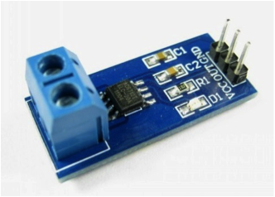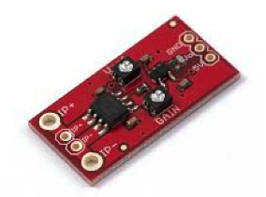

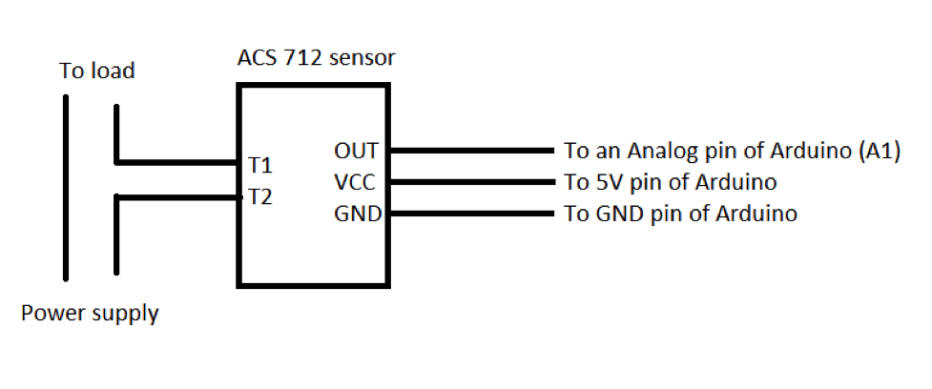

Code

The sensor outputs an analog voltage correspondence to the current flow. Therefore to get the current reading from the Arduino. So we need to perform analog to digital conversion inside the Arduino and multiply with calibrating constant to get the actual value.

We need to use little bit of mathematics for the actual current value calculation. Adruino has 10 bit analog to digital converter register. So ADC value is in range of 0-1023. Then the actual sensor voltage output can be obtained from

OutputSensorVoltage = analogRead(sensorPin)*5.0/1023.0 From the graph and the datasheet,

At zero current, OutputSenosrVoltage = 2.5

Gradient of the graph = 185mV/A (given in datasheet as sensitivity)

So the equation of the graph is

OutputSensorVoltage = 0.185*Current + 2.5

Therefore current can be expressed as

Current = (OutputSensorVoltage – 2.5)/0.185

If the current flows in negative direction, current value will be negative.

Following is an example code which can be used for measuring current using the sensor. It will display the current measurement on serial monitor.

[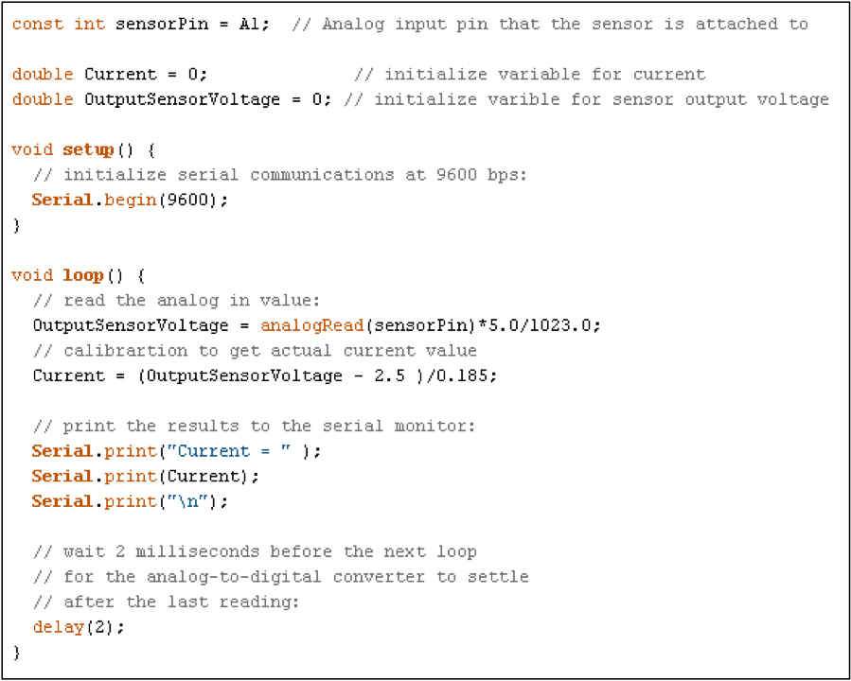](http://arduinosensors.com/wp-content/uploads/2014/04/HallCurrent_6.png)

To connect a CT sensor to an Arduino, the output signal from the CT sensor needs to be conditioned so it meets the input requirements of the Arduino analog inputs, i.e. a positive voltage between 0V and the ADC reference voltage.

Note: This page give the example of an Arduino board working at 5 V and of the EmonTx working at 3.3 V. Make sure you use the right supply voltage and bias voltage in your calculations that correspond to your setup.

This can be achieved with the following circuit which consists of two main parts:

The CT sensor and burden resistor

The biasing voltage divider (R1 & R2)

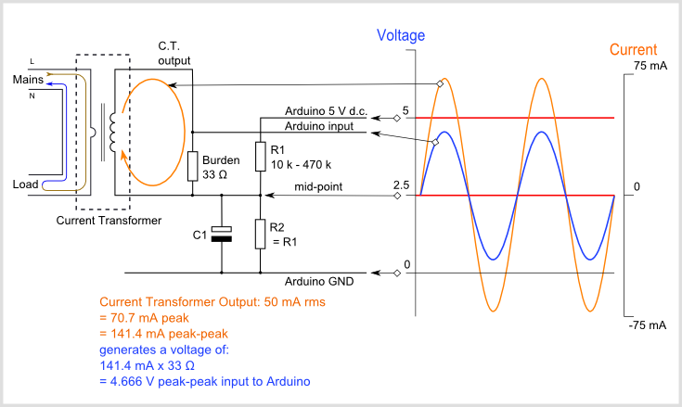

Calculating a suitable burden resistor size

If the CT sensor is a "current output" type such as the *YHDC SCT-013-000*, the current signal needs to be converted to a voltage signal with a burden resistor. If it is a voltage output CT you can skip this step and leave out the burden resistor, as the burden resistor is built into the CT.

**1) Choose the current range you want to measure**

The YHDC SCT-013-000 CT has a current range of 0 to 100 A. For this example, let's choose 100 A as our maximum current.

**2) Convert maximum RMS current to peak-current by multiplying by √2.**

Primary peak-current = RMS current × √2 = 100 A × 1.414 = 141.4A

**3) Divide the peak-current by the number of turns in the CT to give the peak-current in the secondary coil.**

The YHDC SCT-013-000 CT has 2000 turns, so the secondary peak current will be:

Secondary peak-current = Primary peak-current / no. of turns = 141.4 A / 2000 = 0.0707A

**4) To maximise measurement resolution, the voltage across the burden resistor at peak-current should be equal to one-half of the Arduino analog reference voltage. (AREF / 2)**

If you're using an Arduino running at 5V: AREF / 2 will be 2.5 Volts. So the ideal burden resistance will be:

Ideal burden resistance = (AREF/2) / Secondary peak-current = 2.5 V / 0.0707 A = 35.4 Ω

35 Ω is not a common resistor value. The nearest values either side of 35 Ω are 39 and 33 Ω. Always choose the smaller value, or the maximum load current will create a voltage higher than AREF. We recommend a 33 Ω ±1% burden. In some cases, using 2 resistors in series will be closer to the ideal burden value. The further from ideal the value is, the lower the accuracy will be.

Here are the same calculations as above in a more compact form:

**Burden Resistor (ohms) = (AREF * CT TURNS) / (2√2 * max primary current)**

**emonTx V2**

If you're using a battery powered emonTx V2, AREF will start at 3.3 V and slowly decrease as the battery voltage drops to 2.7 V. The ideal burden resistance for the minimum voltage would therefore be:

Ideal burden resistance = (AREF/2) / Secondary peak-current = 1.35V / 0.0707A = **19.1 Ω**

19 Ω is not a common value. We have a choice of 18 or 22 Ω. We recommend using an 18 Ω ±1% burden.

**emonTx V3**

The emonTx V3 uses a 3.3V regulator, so it's VCC and therefore AREF, will always be 3.3V regardless of battery voltage. The standard emonTx V3 uses 22 Ω burden resistors for CT 1, 2 and 3, and a 120 Ω resistor for CT4, the high sensitivity channel. See the emonTx V3 technical wiki at:<https://wiki.openenergymonitor.org/index.php?title=EmonTx_V3#Burden_Resistor_Calculations>

[Tool for calculating burden resistor size, CT turns and max Irms](https://tyler.anairo.com/?id=5.3.0)**-** thanks to Tyler Adkisson for building and sharing this.

(Note: this tool does not take into account maximum CT power output. Saturation and distortion will occur if the maximum output is exceeded. Nor does it take into account component tolerances, so the burden resistor value should be decreased by a few (~5) percent allow some "headroom." There is more info about component tolerances at: [ACAC Component tolerances.](https://openenergymonitor.org/emon/buildingblocks/acac-component-tolerances))

2) Adding a DC Bias

If you were to connect one of the CT wires to ground and measure the voltage of the second wire, relative to ground, the voltage would vary from positive to negative with respect to ground. However, the Arduino analog inputs require a *positive* voltage. By connecting the CT lead we connected to ground, to a source at half the supply voltage instead, the CT output voltage will now swing above and below 2.5 V thus remaining positive.

Resistors R1 & R2 in the circuit diagram above are a voltage divider that provides the 2.5 V source (1.65 V for the emonTx). Capacitor C1 has a low *reactance* - a few hundred ohms - and provides a path for the alternating current to bypass the resistor.

**Choosing a suitable value for resistors R1 & R2:**

Higher resistance lowers quiescent energy consumption.

We use 10 kΩ resistors for mains powered monitors. The [emonTx](https://openenergymonitor.org/emon/emontx) uses 470 kΩ resistors to keep the power consumption to a minimum, as it is intended to run on batteries for several months.

# Chapter 4

# TOOLS AND TECHNIQUES

## 4.1 Arduino Uno

#### Overview

The Arduino Uno is a microcontroller board based on the ATmega328. It has 14 digital input/output pins (of which 6 can be used as PWM outputs), 6 analog inputs, a 16 MHz ceramic resonator, a USB connection, a power jack, an ICSP header, and a reset button. It contains everything needed to support the microcontroller; simply connect it to a computer with a USB cable or power it with a AC-to-DC adapter or battery to get started.

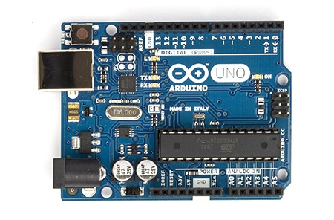

**Arduino Uno R3 Front**

The Uno differs from all preceding boards in that it does not use the FTDI USB-to-serial driver chip. Instead, it features the Atmega16U2 (Atmega8U2 up to version R2) programmed as a USB-to-serial converter.

1.0 pinout: added SDA and SCL pins that are near to the AREF pin and two other new pins placed near to the RESET pin, the IOREF that allow the shields to adapt to the voltage provided from the board. In future, shields will be compatible with both the board that uses the AVR, which operates with 5V and with the Arduino Due that operates with 3.3V. The second one is a not connected pin, that is reserved for future purposes.

Stronger RESET circuit.

Atmega 16U2 replace the 8U2.

"Uno" means one in Italian and is named to mark the upcoming release of Arduino 1.0. The Uno and version 1.0 will be the reference versions of Arduino, moving forward. The Uno is the latest in a series of USB Arduino boards, and the reference model for the Arduino platform;

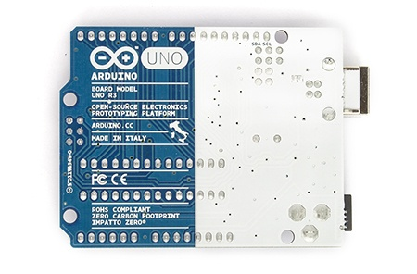

**Arduino Uno R3 Back**

#### Summary

|  |  |
| --- | --- |
| Microcontroller | ATmega328 |
| Operating Voltage | 5V |
| Input Voltage (recommended) | 7-12V |
| Input Voltage (limits) | 6-20V |
| Digital I/O Pins | 14 (of which 6 provide PWM output) |
| Analog Input Pins | 6 |
| DC Current per I/O Pin | 40 mA |
| DC Current for 3.3V Pin | 50 mA |
| Flash Memory | 32 KB (ATmega328) of which 0.5 KB used by bootloader |
| SRAM | 2 KB (ATmega328) |
| EEPROM | 1 KB (ATmega328) |
| Clock Speed | 16 MHz |

#### Schematic & Reference Design

The Arduino reference design can use an Atmega8, 168, or 328, Current models use an ATmega328, but an Atmega8 is shown in the schematic for reference. The pin configuration is identical on all three processors.

#### Power

The Arduino Uno can be powered via the USB connection or with an external power supply. The power source is selected automatically.

External (non-USB) power can come either from an AC-to-DC adapter (wall-wart) or battery. The adapter can be connected by plugging a 2.1mm center-positive plug into the board's power jack. Leads from a battery can be inserted in the Gnd and Vin pin headers of the POWER connector.

The board can operate on an external supply of 6 to 20 volts. If supplied with less than 7V, however, the 5V pin may supply less than five volts and the board may be unstable. If using more than 12V, the voltage regulator may overheat and damage the board. The recommended range is 7 to 12 volts.

The power pins are as follows:

**VIN.** The input voltage to the Arduino board when it's using an external power source (as opposed to 5 volts from the USB connection or other regulated power source). You can supply voltage through this pin, or, if supplying voltage via the power jack, access it through this pin.

**5V.**This pin outputs a regulated 5V from the regulator on the board. The board can be supplied with power either from the DC power jack (7 - 12V), the USB connector (5V), or the VIN pin of the board (7-12V). Supplying voltage via the 5V or 3.3V pins bypasses the regulator, and can damage your board. We don't advise it.

**3V3.** A 3.3 volt supply generated by the on-board regulator. Maximum current draw is 50 mA.

**GND.** Ground pins.

**IOREF.** This pin on the Arduino board provides the voltage reference with which the microcontroller operates. A properly configured shield can read the IOREF pin voltage and select the appropriate power source or enable voltage translators on the outputs for working with the 5V or 3.3V.

#### Memory

The ATmega328 has 32 KB (with 0.5 KB used for the bootloader). It also has 2 KB of SRAM and 1 KB of EEPROM (which can be read and written with the [EEPROM library](http://www.arduino.cc/en/Reference/EEPROM)).

#### Input and Output

Each of the 14 digital pins on the Uno can be used as an input or output, using [pinMode()](http://arduino.cc/en/Reference/PinMode), [digitalWrite()](http://arduino.cc/en/Reference/DigitalWrite), and[digitalRead()](http://arduino.cc/en/Reference/DigitalRead) functions. They operate at 5 volts. Each pin can provide or receive a maximum of 40 mA and has an internal pull-up resistor (disconnected by default) of 20-50 kOhms. In addition, some pins have specialized functions:

**Serial: 0 (RX) and 1 (TX).** Used to receive (RX) and transmit (TX) TTL serial data. These pins are connected to the corresponding pins of the ATmega8U2 USB-to-TTL Serial chip.

**External Interrupts: 2 and 3.** These pins can be configured to trigger an interrupt on a low value, a rising or falling edge, or a change in value. See the [attachInterrupt()](http://arduino.cc/en/Reference/AttachInterrupt) function for details.

**PWM: 3, 5, 6, 9, 10, and 11.** Provide 8-bit PWM output with the [analogWrite()](http://arduino.cc/en/Reference/AnalogWrite) function.

**SPI: 10 (SS), 11 (MOSI), 12 (MISO), 13 (SCK).** These pins support SPI communication using the [SPI library](http://arduino.cc/en/Reference/SPI).

**LED: 13.** There is a built-in LED connected to digital pin 13. When the pin is HIGH value, the LED is on, when the pin is LOW, it's off.

The Uno has 6 analog inputs, labeled A0 through A5, each of which provide 10 bits of resolution (i.e. 1024 different values). By default they measure from ground to 5 volts, though is it possible to change the upper end of their range using the AREF pin and the [analogReference](http://arduino.cc/en/Reference/AnalogReference)() function. Additionally, some pins have specialized functionality:

**TWI: A4 or SDA pin and A5 or SCL pin.** Support TWI communication using the [Wire library](http://arduino.cc/en/Reference/Wire).

There are a couple of other pins on the board:

**AREF.** Reference voltage for the analog inputs. Used with [analogReference](http://arduino.cc/en/Reference/AnalogReference)().

**Reset.** Bring this line LOW to reset the microcontroller. Typically used to add a reset button to shields which block the one on the board.

See also the [mapping between Arduino pins and ATmega328 ports](http://arduino.cc/en/Hacking/PinMapping168). The mapping for the Atmega8, 168, and 328 is identical.

#### Communication

The Arduino Uno has a number of facilities for communicating with a computer, another Arduino, or other microcontrollers. The ATmega328 provides UART TTL (5V) serial communication, which is available on digital pins 0 (RX) and 1 (TX). An ATmega16U2 on the board channels this serial communication over USB and appears as a virtual com port to software on the computer. The '16U2 firmware uses the standard USB COM drivers, and no external driver is needed. However, [on Windows, a .inf file is required](http://arduino.cc/en/Guide/Windows#toc4). The Arduino software includes a serial monitor which allows simple textual data to be sent to and from the Arduino board. The RX and TX LEDs on the board will flash when data is being transmitted via the USB-to-serial chip and USB connection to the computer (but not for serial communication on pins 0 and 1).

A [SoftwareSerial library](http://www.arduino.cc/en/Reference/SoftwareSerial) allows for serial communication on any of the Uno's digital pins.

The ATmega328 also supports I2C (TWI) and SPI communication. The Arduino software includes a Wire library to simplify use of the I2C bus; see the [documentation](http://arduino.cc/en/Reference/Wire) for details. For SPI communication, use the [SPI library](http://arduino.cc/en/Reference/SPI).

#### Programming

The Arduino Uno can be programmed with the Arduino software ([download](http://arduino.cc/en/Main/Software)). Select "Arduino Uno from the **Tools > Board** menu (according to the microcontroller on your board). For details, see the [reference](http://arduino.cc/en/Reference/HomePage) and [tutorials](http://arduino.cc/en/Tutorial/HomePage).

The ATmega328 on the Arduino Uno comes preburned with a [bootloader](http://arduino.cc/en/Tutorial/Bootloader) that allows you to upload new code to it without the use of an external hardware programmer. It communicates using the original STK500 protocol ([reference](http://www.atmel.com/dyn/resources/prod_documents/doc2525.pdf), [C header files](http://www.atmel.com/dyn/resources/prod_documents/avr061.zip)).

You can also bypass the bootloader and program the microcontroller through the ICSP (In-Circuit Serial Programming) header using [Arduino ISP](http://arduino.cc/en/Main/ArduinoISP) or similar; see [these instructions](http://arduino.cc/en/Hacking/Programmer) for details.

The ATmega16U2 (or 8U2 in the rev1 and rev2 boards) firmware source code is available . The ATmega16U2/8U2 is loaded with a DFU bootloader, which can be activated by:

On Rev1 boards: connecting the solder jumper on the back of the board (near the map of Italy) and then resetting the 8U2.

On Rev2 or later boards: there is a resistor that pulling the 8U2/16U2 HWB line to ground, making it easier to put into DFU mode.

You can then use [Atmel's FLIP software](http://www.atmel.com/dyn/products/tools_card.asp?tool_id=3886) (Windows) or the [DFU programmer](http://dfu-programmer.sourceforge.net/) (Mac OS X and Linux) to load a new firmware. Or you can use the ISP header with an external programmer (overwriting the DFU bootloader). See [this user-contributed tutorial](http://www.arduino.cc/cgi-bin/yabb2/YaBB.pl?num=1285962838) for more information.

#### Automatic (Software) Reset

Rather than requiring a physical press of the reset button before an upload, the Arduino Uno is designed in a way that allows it to be reset by software running on a connected computer. One of the hardware flow control lines (DTR) of theATmega8U2/16U2 is connected to the reset line of the ATmega328 via a 100 nanofarad capacitor. When this line is asserted (taken low), the reset line drops long enough to reset the chip. The Arduino software uses this capability to allow you to upload code by simply pressing the upload button in the Arduino environment. This means that the bootloader can have a shorter timeout, as the lowering of DTR can be well-coordinated with the start of the upload.

This setup has other implications. When the Uno is connected to either a computer running Mac OS X or Linux, it resets each time a connection is made to it from software (via USB). For the following half-second or so, the bootloader is running on the Uno. While it is programmed to ignore malformed data (i.e. anything besides an upload of new code), it will intercept the first few bytes of data sent to the board after a connection is opened. If a sketch running on the board receives one-time configuration or other data when it first starts, make sure that the software with which it communicates waits a second after opening the connection and before sending this data.

The Uno contains a trace that can be cut to disable the auto-reset. The pads on either side of the trace can be soldered together to re-enable it. It's labeled "RESET-EN". You may also be able to disable the auto-reset by connecting a 110 ohm resistor from 5V to the reset line; see [this forum thread](http://www.arduino.cc/cgi-bin/yabb2/YaBB.pl?num=1213719666/all) for details.

#### USB Overcurrent Protection

The Arduino Uno has a resettable polyfuse that protects your computer's USB ports from shorts and overcurrent. Although most computers provide their own internal protection, the fuse provides an extra layer of protection. If more than 500 mA is applied to the USB port, the fuse will automatically break the connection until the short or overload is removed.

#### Physical Characteristics

The maximum length and width of the Uno PCB are 2.7 and 2.1 inches respectively, with the USB connector and power jack extending beyond the former dimension. Four screw holes allow the board to be attached to a surface or case. Note that the distance between digital pins 7 and 8 is 160 mil (0.16"), not an even multiple of the 100 mil spacing of the other pins.

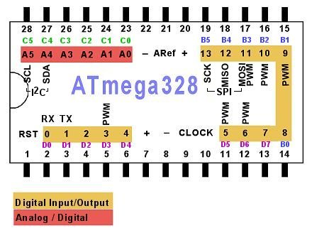

In our project we have used Arduino IDE for Atmega328 programming, and Eagle for PCB desiging. Before we explain our project code lets first discus some basic principles of the Arduino IDE.

## 4.2 GSM Module

This is a GSM/GPRS-compatible Quad-band cell phone, which works on a frequency of 850/900/1800/1900MHz and which can be used not only to access the Internet, but also for oral communication (provided that it is connected to a microphone and a small loud speaker) and for SMSs. Externally, it looks like a big package (0.94 inches x 0.94 inches x 0.12 inches) with L-shaped contacts on four sides so that they can be soldered both on the side and at the bottom. Internally, the module is managed by an AMR926EJ-S processor, which controls phone communication, data communication (through an integrated TCP/IP stack), and (through an UART and a TTL serial interface) the communication with the circuit interfaced with the cell phone itself.The processor is also in charge of a SIM card (3 or 1,8 V) which needs to be attached to the outer wall of the module.In addition, the GSM900 device integrates an analog interface, an A/D converter, an RTC, an SPI bus, an I²C, and a PWM module. The radio section is GSM phase 2/2+ compatible and is either class 4 (2 W) at 850/ 900 MHz or class 1 (1 W) at 1800/1900 MHz.The TTL serial interface is in charge not only of communicating all the data relative to the SMS already received and those that come in during TCP/IP sessions in GPRS (the data-rate is determined by GPRS class 10: max. 85,6 kbps), but also of receiving the circuit commands (in our case, coming from the PIC governing the remote control) that can be either AT standard or AT-enhanced SIMComtype.The module is supplied with continuous energy (between 3.4 and 4.5 V) and absorbs a maximum of 0.8 A during transmission.

**Features**

* E-GSM 900/1800 MHz and GSM 1800/1900 with GSM Phase 2 / 2+.
* Output Power Class 4 (2W) at GSM850/900 MHz and Class 1 (1W) at GSM1800/1900 MHz.
* Control via AT commands (ITU, GSM,GPRS and manufacturersupplementary)
* Supply Voltage range: 3.22 V - 4.2 V,nominal: 3.8 V.
* Power consumption: Idle mode: <1.8mA, speech mode: 200 mA (average)
* Dimensions (mm): 3 x 20 x 20 andweight (g): 3.2 (including shielding)

The GSM module offers the advantages asbelow

* Ultra small size (22x22x3 mm),lightweight (3.2 g) and easy to integrate
* Low power consumption
* R&TTE type approval plus CE, GCF,FCC, PTCRB, IC
* Full RS232 on CMOS level with flowcontrol (RX, TX, CTS, RTS, CTS, DTR,DSR, DCD, RI).
* Embedded TCP/IP Stack UDP/IP Stack ,Embedded FTP and SMTP Client
* High performance on low price.

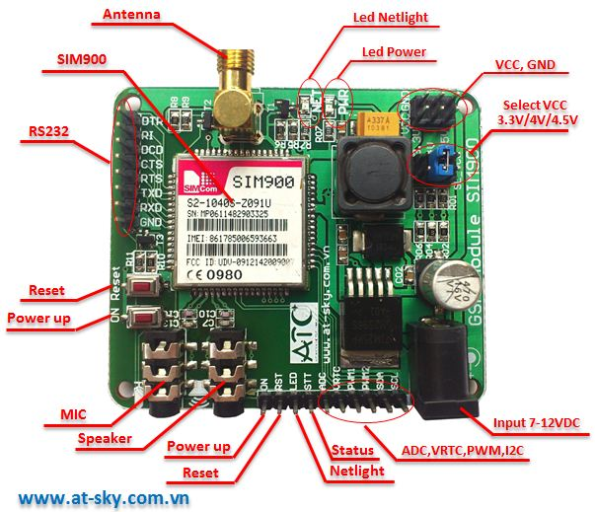

FIGURE 1:GSM MODULE SIM900

GSM/GPRS module is used to establish communication between a computer and a GSM-GPRS system. Global System for Mobile communication (GSM) is an architecture used for mobile communication in most of the countries. Global Packet Radio Service (GPRS) is an extension of GSM that enables higher data transmission rate. GSM/GPRS module consists of a GSM/GPRS modem assembled together with power supply circuit and communication interfaces (like RS-232, USB, etc) for computer. The MODEM is the soul of such modules.

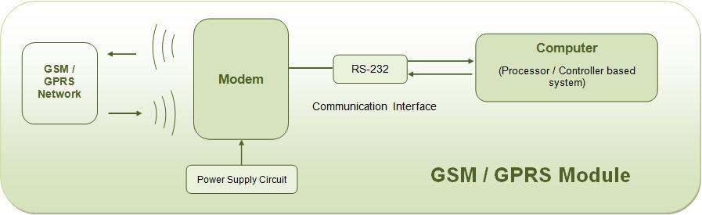

**Wireless MODEMs**

Wireless MODEMs are the MODEM devices that generate, transmit or decode data from a cellular network, for establishing communication between the cellular network and the computer. These are manufactured for specific cellular network (GSM/UMTS/[CDMA](http://www.engineersgarage.com/articles/cdma-technology)) or specific cellular data standard (GSM/UMTS/GPRS/[EDGE](http://www.engineersgarage.com/articles/what-is-edge-technology)/HSDPA) or technology ([GPS](http://www.engineersgarage.com/articles/global-positioning-system-gps)/SIM). Wireless MODEMs like other MODEM devices use serial communication to interface with and need Hayes compatible [AT commands](http://www.engineersgarage.com/tutorials/at-commands) for communication with the computer (any microprocessor or microcontroller system).

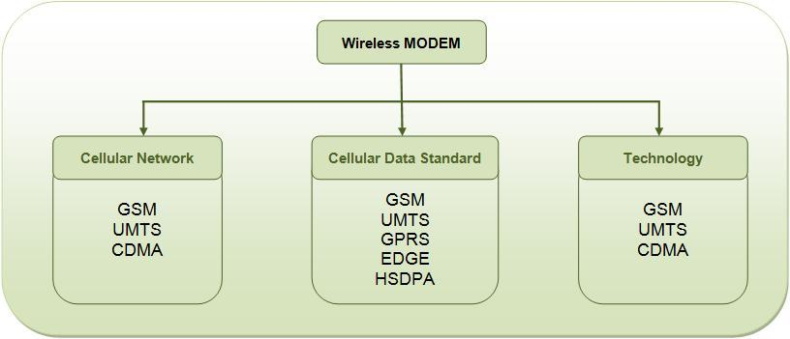

**GSM/GPRS MODEM**

GSM/GPRS MODEM is a class of wireless MODEM devices that are designed for communication of a computer with the GSM and GPRS network. It requires a SIM (Subscriber Identity Module) card just like mobile phones to activate communication with the network. Also they have IMEI(International Mobile Equipment Identity) number similar to mobile phones for their identification. A GSM/GPRS MODEM can perform the following operations:

1.      Receive, send or delete SMS messages in a SIM.

2.      Read, add, search phonebook entries of the SIM.

3.      Make, Receive, or reject a voice call.

The MODEM needs AT commands, for interacting with processor or controller, which are communicated through serial communication. These commands are sent by the controller/processor. The MODEM sends back a result after it receives a command. Different AT commands supported by the MODEM can be sent by the processor/controller/computer to interact with the GSM and GPRS cellular network.

**GSM/GPRS Module**

A GSM/GPRS module assembles a GSM/GPRS modem with standard communication interfaces like RS-232 (Serial Port), USB etc., so that it can be easily interfaced with a computer or a microprocessor / microcontroller based system. The power supply circuit is also built in the module that can be activated by using a suitable adaptor.

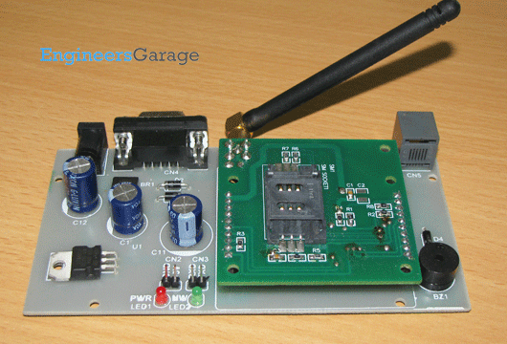

### GSM Architecture

A GSM network consists of the following components:

* **A Mobile Station:**  It is the mobile phone which consists of the transceiver, the display and the processor and is controlled by a SIM card operating over the network.
* **Base Station Subsystem:** It acts as an interface between the mobile station and the network subsystem. It consists of the Base Transceiver Station which contains the radio transceivers and handles the protocols for communication with mobiles. It also consists of the Base Station Controller which controls the Base Transceiver station and acts as a interface between the mobile station and mobile switching centre.
* **Network Subsystem:** It provides the basic network connection to the mobile stations. The basic part of the Network Subsystem is the Mobile Service Switching Centre which provides access to different networks like ISDN, PSTN etc. It also consists of the Home Location Register and the Visitor Location Register which provides the call routing and roaming capabilities of GSM. It also contains the Equipment Identity Register which maintains an account of all the mobile equipments wherein each mobile is identified by its own IMEI number. IMEI stands for International Mobile Equipment Identity.

### Features of GSM Module:

* Improved spectrum efficiency
* International roaming
* Compatibility with integrated services digital network (ISDN)
* Support for new services.
* SIM phonebook management
* Fixed dialing number (FDN)
* Real time clock with alarm management
* High-quality speech
* Uses encryption to make phone calls more secure
* Short message service (SMS)

The security strategies standardized for the GSM system make it the most secure telecommunications standard currently accessible. Although the confidentiality of a call and secrecy of the GSM subscriber is just ensured on the radio channel, this is a major step in achieving end-to- end security.

## 4.3 GSM modem and microcontroller interface:

GSM is widely used mobile communication architecture used in most of the countries. This project demonstrates the interfacing of micro controller ATMega328 and GSM module. It aims to familiarize with the syntax of AT Commands and their Information Response and Result Codes. The ASCII values of characters in the Information Response, Result Codes and their syntax can be monitored by an LED array. For the basic concepts, working and operation of AT commands and GSM module referGSM/GPRS Module. The Global System for Mobile (GSM) communication is the Second Generation of mobile technology. Although the world is moving towards Third and Fourth generation but GSM has been the most successful and widespread technology in the communication sector. GSM technology paved a new way for mobile communication.

## 4.4 BRIEF INTRODUCTION OF AT COMMAND

The GSM modem and the PC are wire-connected through serial ports.They communicate with AT commands. AT commands are a set of commands that has been standardized to communicate with terminal equipments such as modem, mobile phone as well as control them. Most GSM modems support AT commands. The command set is   
quite elaborate. However, only a small part of it is related to SMS operations. The most frequently used commands are:

AT+CMGS: To send a short message

AT+CMGR: To read a short message from the GSM module

AT+CMGL: To list SMS short messages stored in the GSM module

AT+CMGD: To delete a short message from the GSM module

AT+CNMI： Remind mode Setup when receive a new SMS

As the low-level function interface to the GSM modem, these commands play a fundamental role in the software developing of the gateway program.

## 4.5 Current sensor

A **current sensor** is a device that detects [electric current](https://en.wikipedia.org/wiki/Electric_current) (AC or DC) in a wire, and generates a signal proportional to it. The generated signal could be analog voltage or current or even digital output. It can be then utilized to display the measured current in an ammeter or can be stored for further analysis in a data acquisition system or can be utilized for control purpose.

The sensed current and the output signal can be:

* [Alternating current](https://en.wikipedia.org/wiki/Alternating_current) input,
  + analog output, which duplicates the wave shape of the sensed current
  + bipolar output, which duplicates the wave shape of the sensed current
  + unipolar output, which is proportional to the average or RMS value of the sensed current
* [Direct current](https://en.wikipedia.org/wiki/Direct_current) input,
  + unipolar, with a unipolar output, which duplicates the wave shape of the sensed current
  + digital output, which switches when the sensed current exceeds a certain threshold

**PASSIVE ELEMENT BASED CURRENT SENSING TECHNIQUES**

**1.  Sense Resistors**

Current sensing means developing a voltage signal which is representative of the current flowing at the particular place of interest inthe circuit. The traditional way of current sensing introduces a resistor in the path of the current to be sensed. The sense resistor can be placed in series with the inductor, switches, and the load.Thus, a current sensing resistor should be considered as a current-to-voltage converter.

The current sensing resistor should have following attributes

**Low value in order to minimize power losses**

Value of the current sense resistors primarily depend upon the voltage threshold of the following circuitry which is going to operate based upon the sensed current information. In circuits where amplification is available, emphasis is to minimize the voltage drop across the resistor.

Typical resistance values utilized in various control ICs are 20m? to 25m? .

**Low inductance because of high di/dt.**

Any inductance in the resistor, when exposed to high slew rate (di/dt), an inductive step voltage is superimposed upon the sense voltage and may be a cause of concern in many circuits. Hence sense resistors should have very low inductance.

**Tight tolerance**

For maximizing the current supply within the limit of acceptable current, the tolerance of the sense resistor must be ±1% or tighter.

**Low temperature coefficient for accuracy**

Normally specified in units of parts per million per degree centigrade (ppm/°C), temperature coefficient of resistance (TCR) is an important parameter for accuracy. Resistors with TCRs closer to zero, in the entire operating range should be used.

**High peak power rating to handle short duration high current pulses.**

Power rating is a driving factor for the selection of appropriate technology for sense resistors. Though the device may be intended to sense DC current, it may often experience transients.

Power derating curve provides allowable power at different temperatures.  But peak power capability is a function of energy; hence energy rating curve should be taken into account.

**High temperature rating for reliability**

Pros and Cons of current sensing resistors include:

**Pros:**

- Low cost

- High measurement accuracy

- Measurable current range from very low to medium

- Capability to measure DC or AC current

**Cons:**

- Introduces additional resistance into the measured circuit path, which may increase source output resistance and result in undesirable loading effect.

- Power loss due to power dissipation. Therefore, current sensing resistors are rarely used beyond the low and medium current sensing  applications.

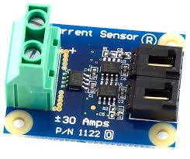

Technologies

* [Hall effect](https://en.wikipedia.org/wiki/Hall_effect) [IC](https://en.wikipedia.org/wiki/Integrated_circuit) sensor.
* [Transformer](https://en.wikipedia.org/wiki/Transformer) or [current clamp](https://en.wikipedia.org/wiki/Current_clamp) meter, (suitable for AC current only).
* [Fluxgate Transformer Type](https://en.wikipedia.org/w/index.php?title=Fluxgate_Transformer_Type&action=edit&redlink=1), (suitable for AC and/or DC current).
* [Resistor](https://en.wikipedia.org/wiki/Resistor), whose voltage is directly proportional to the current through it.
* [Fiber optic current sensor](https://en.wikipedia.org/wiki/Fiber_optic_current_sensor), using an [interferometer](https://en.wikipedia.org/wiki/Interferometry) to measure the phase change in the light produced by a magnetic field.
* [Rogowski coil](https://en.wikipedia.org/wiki/Rogowski_coil), electrical device for measuring alternating current (AC) or high speed current pulses.

Hall Effect current sensor is a type of current sensor which is based on phenomenon of Hall Effect discovered by Edwin Hall in 1879.

Hall Effect current sensors can measure all types of current signals i.e. AC,DC or pulsating current.

These sensors are currently being used widely in almost all the industries because of their vast applications and the type of output they provide, which can be manipulated and can be used for various application

Current measurement is of vital importance in many power and instrumentation systems. Traditionally, current sensing was primarily for circuit protection and control. However, with the advancement in technology, current sensing has emerged as a method to monitor and enhance performance.

Knowing the amount of current being delivered to the load can be useful for wide variety of applications. Current sensing is used in wide range of electronic systems, viz., Battery life indicators and chargers, 4-20 mA systems, over-current protection and supervising circuits, current and voltage regulators, DC/DC converters, ground fault detectors, programmable current sources, linear and switch-mode power supplies, communications devices , automotive power electronics, motor speed controls and overload protection, etc.

**CURRENT SENSING PRINCIPLES**

A current sensor is a device that detects and converts current to an easily measured output voltage, which is proportional to the current through the measured path.

When a current flows through a wire or in a circuit, voltage drop occurs. Also, a magnetic field is generated surrounding the current carrying conductor. Both of these phenomena are made use of in the design of current sensors. Thus, there are two types of current sensing: direct and indirect. Direct sensing is based on Ohm’s law, while indirect sensing is based on Faraday’s and Ampere’s law.

Direct Sensing involves measuring the voltage drop associated with the current passing through passive electrical components.

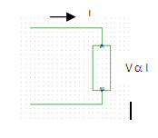

Indirect Sensing involves measurement of the magnetic field surrounding a conductor through which current passes.

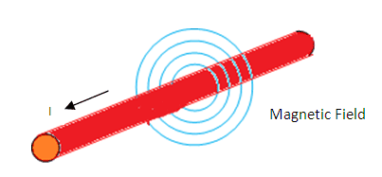

Generated magnetic field is then used to induce proportional voltage or current which is then transformed to a form suitable for measurement and/or control system.

# Chapter 5

# Conclusion

The progress in technology about electrical distribution network is a non-stop process. New things and new technology are being invented. The proposed system is an automated system of theft detection. It saves time as well as help to maximize profit margin for utility company working in electrical distribution network. Utility company can keep a constant eye on its costumer. And the extension of this project with GSM modules helps company to monitor the amount of usage by the specified customer and generate bill periodically and send it to customer via SMS, thus saving lot of labor work, time and cost of reading.

In developing countries electricity theft is a common practice especially in remote areas, as they do not pay utility bills to a government company in case of electricity and gas as well. To solve these problem governments must think of an idea to provide help in terms of subsidy to manage this issue. With this system the service provider can collect the bill any time with a single message. The data collection and manipulation task becomes fast and easier. Any modification can be made to the code in less time. Changes in rate or unit calculation can be done very effectively.

# Refrences

[https://en.wikipedia.org/wiki/**Arduino**](https://en.wikipedia.org/wiki/Arduino)

[**https://openenergymonitor.org/emon/buildingblocks/ct-sensors-interface**](https://openenergymonitor.org/emon/buildingblocks/ct-sensors-interface)

[**http://arduinosensors.com/index.php/interfacing-a-hall-effect-current-sensor-with-an-arduino/**](http://arduinosensors.com/index.php/interfacing-a-hall-effect-current-sensor-with-an-arduino/)