I.P BASED REMOTE MONITORING AND CONTROLSYSTEM WITH AUTOMATIC LIGHT CONTROLLER

University name

DEPARTMENT OF ENGINEERING

- Registration No. :___________
- Name of Students :___________________________________
- Contact No. :___________________________________
- Batch No. :___________________________________
- Date of Submission :___________________________________
- Name of Supervisor :___________________________________
- Major Area of Study :___________________________________

PROJECT TITLE:
I.P BASED REMOTE MONITORING AND CONTROLSYSTEM WITH AUTOMATIC LIGHT CONTROLLER
INTRODUCTION:
Embedded system is not a new concept. Embedded systems has become a buzz word in the last 15 years, but embedded system sand processors have been around for much longer than that.[2] One only needs to look around to see embedded system severy where: cell phones, alarm clocks, personal data assistants(PDAs), automobile subsystems such as ABS and cruise control etc. These embedded systems are now commonly interfaced with to any communication module to widen their scope and enhance the application areas to a greater extent. [1]. Here in this project, our goal is to control and monitor subjective area by using I.P address, instead of using GSM or other communication module, because a lot of work has been performed on these module, and secondly the problem is to reduce the cost of the product. Moreover frequency band and distance issues are also the big problem in using communication module.
The Internet Protocol (IP) is the principal communications protocol in the Internet protocol suite for relaying datagrams across network boundaries. Its routing function enables internetworking, and essentially establishes the Internet.
IP, as the primary protocol in the Internet layer of the Internet protocol suite, has the task of delivering packets from the source host to the destination host solely based on the IP addresses in the packet headers. For this purpose, IP defines packet structures that encapsulate the data to be delivered. It also defines addressing methods that are used to label the datagram with source and destination information.
Historically, IP was the connectionless datagram service in the original Transmission Control Program introduced by Vint Cerf and Bob Kahn in 1974; the other being the connection-oriented Transmission Control Protocol (TCP). The Internet protocol suite is therefore often referred to as TCP/IP.
The first major version of IP, Internet Protocol Version 4 (IPv4), is the dominant protocol of the Internet. Its successor is Internet Protocol Version 6 (IPv6).

ABSTRACT:
In past few years, home automation & remote control and monitoring systems have seen a rapid growth in terms of technology. This proposal gives a review of these systems based on existing technologies and also proposes a I.P based light controller and remote monitoring system. This system has simple features designed with the objective of minimum power for controlling lights, fans and other appliances which are controlled via software using specific address which will be interfaced with P.C. The system also informs user about any abnormal conditions like intrusion detection and temperature rise via P.C specific allotted address to the user’s P.C and actions are taken accordingly by the user

PROBLEM STATEMENT:
- A low cost device that can monitor the temperature and loads conditions.
- A system which sends all the information about the loads and temperature relibely using internet protocol.
- A reliable system for monitoring and controlling of the loads.
- Displaying the information on P.C.

OBJECTIVE OF PROJECT
The main objective of project is to design a microcontroller based system which is able to control the loads by using I.P through serial communication. Where the receiving end also updates the user about the current condition and also display the loads condition and temperature on the sender side P.C.

BLOCK DIAGRAM REPRESENTATION:

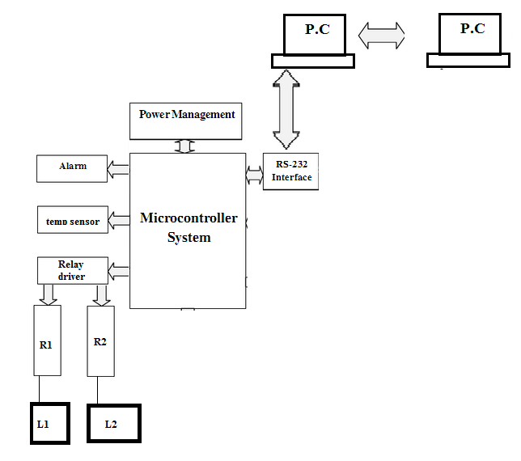

METHODOLOGY:
We will use simple P.C, on which team viewer software will be installed, to control the home appliances, the signal will be received by “receiving” P.C and decode the information and give it to microcontroller through serial communication link which read the information and decide the operation to perform, i.e. if load-1 is needed to be on so controller will select relay-1 which turn on the required appliances. Where for the monitoring of temperature lm35 measure the temperature in the form of analogue signal which is converted to digital by using ADC, so that it will be sanded to user by using microcontroller through same I.p.

LIST OF HARDWARE COMPONENTS:
So the methodology we are using is quite simple and reliable and it needs the following components.

- P.C
- Microcontroller
- Regulator
- ULN (relay driver)
- ADC
- Alarm
- LM35
- Relay etc...

WORK SCHEDULE
Work Schedule | Month 1 | Month 2 | Month 3 | Month 4 | Month 5 | Month 6
Literature Survey
Data collection
Hardware /software Implementation
Results Compilation & Thesis writing

APPLICATIONS
“Through proper implementation of this project, governments can improve program and infrastructure quality, increase information accessibility and use, With improved decision making application makes more interesting and decreases overall cost of the application, including the social and economic impacts on the controlling of industries, school, home and government sectors “

COST ESTIMATION
.
S.No | Item | Expected Cost (Rs.)
1 | LCD, controller, board | 3000/-
2 | GSM and Bluetooth module | 17000/-
3 | ADC, regulators | 1500/-
4 | Miscellaneous | 11000/-

REFERENCES:
[1] G. Aranguren, L. Nozal, A. Blazquez, and J. Arias, "Remotecontrol of Sensors and actuators by GSM", IEEE 2002 28thAnnual Conference of The Industrial Electronics SocietyIECON 02, vol. 3, 5-8 Nov. 2002, pp.2306 - 2310.
[2] A. R. Al-Ali and M. Al- Rousan, “Java -based home automation system,” IEEE Transactions on ConsumerElectronics, vol. 50, no. 2, pp.498-504, May 2004.
[3] A. Z. Alkar, and U. Buhur, “An Internet Based WirelessHome Automation System for Multifunctional Devices,” IEEE Transactions on Consumer Electronics, vol. 51, no. 4,pp. 1169-1174, Nov. 2005.
[4] Ran XueJun, Wang Jianqun, Li Zhenshan, Yao and Guozhong, “ Design of Parking Guidance System based on embedded Internet access Technology”, Control and Decision Conference, pp. 4167-4171, July 2010.
[5] Wijetunge, S.P., Wijetunge, U.S.; Peiris G.R.V., AluthgedaraC.S. and Samarasinghe A.T.L.K., “ Design andImplementation of a Bluetooth based General Purpose
Controlling Module”, 4 th International Conference onInformation and Automation for Sustainability,pp. 206-211,2008.
[6] N. Sriskanthan and Tan Karand, “Bluetooth Based Home Automation System”, Journal of Microprocessors and Microsystems, Vol. 26, pp.281-289, 2002.
[7] Kho T.K., Besar R., Tan Y.S. Tee K.H. and Ong K.C., “Bluetoothenabled ECG Monitoring System” IEEE TENCON 2005, pp. 1-5

Proposed Starting Date : _________________________

Expected Completion Date : _________________________

Resources Required
  - ___________________________________________________

  - ____________________________________________________

  - ____________________________________________________

  - ___________________________________________________

Signature of Student_______________

Date: ______________

PROJECT EVALUATION FORM

Name of Student:_____________________________________________________________

Project Title: _________________________________________________________________

- Project Supervisor’s Remarks and Recommendations
_________________________________________________________________

_________________________________________________________________

_________________________________________________________________

Name: ________________ Signature: ______________________ Date: __________

- Chairman’s Remarks and Recommendations
_________________________________________________________________

_________________________________________________________________

_________________________________________________________________

Name: ________________ Signature: ______________________ Date: __________

- Project Evaluation Committee’s Remarks and Recommendations
_________________________________________________________________

_________________________________________________________________

_________________________________________________________________

a. Name:_____________________ Signature: ______________________

b. Name:_____________________ Signature: ______________________

c. Name: _____________________ Signature: _______________________

