**Navigation System for Blind People**

**ABSTRACT**

Nowadays public buildings are changing constantly, often people have to take different routes to reach known destinations. At the same time, new services and places are made available to attract more people to the shopping center. This dynamic environment is usually signalled and labelled with visual marks and signs which are not appropriated for blind persons. Therefore, blind users are unintentionally deprived of a full participation in the society. With the purpose of equalize the access to services and spaces among all persons, this work proposes an innovative indoor navigation and information system for public buildings, namely shopping centers, based on existing technologies not used for this purpose. Intending to allow a comfortable and helpful aid on blind persons trips to the shopping center, this proposal system relies on users smartphone and wireless sensors deployed in the environment.

Table OfContents

CHAPTER 1 10

INTRODUCTION 10

1.1. Navigation systems for the blind in general 13

1.2. Difficulties faced by blinds 14

1.3. Challenges of Being Blind 14

1.3.1. Interaction with Environment 14

1.3.2. Social Interaction 14

1.3.3. Visual Symbols 15

1.3.4. Gainful Employment 15

1.3.5. Public Perception 15

1.4. A basic idea about project 15

1.5. Equipments and gadgets available for blinds 16

1.6. Some hybrid systems used in indoor as well as outdoor mode 17

1.7. Literature review 18

CHAPTER 2 19

HARDWARE COMPONENTS 19

2.1. GSM MODULE(sim900) 19

2.2. ARDUINO(Mega328) 21

2.2.1. Technical specifications 22

2.3. ULTRASONIC SENSORS 23

2.3.1. UM30-2 24

2.3.2. UM18 25

2.3.3. UM12 25

2.3.4. UC30 26

2.3.5. UC12 27

2.4. Microduino-NEO-6M 27

2.4.1. Features 27

2.4.2. Specifications 28

2.5. 2N2222(Transistors) 29

2.5.1. Specifications 29

2.6. NPN Switching transistors 30

2.7. 10k RESISTOR 31

2.7.1. Resistor Example: 32

2.7.2. Specifications 33

2.8. 1n4007 DIODE 34

2.8.1. Feautres 34

2.9. PRESSURE SENSOR 35

2.9.1. Types of pressure measurement 36

2.10. GPS MODULE 38

2.11. BUZZER 39

2.11.1. FEATURES 39

2.12. CAPACITOR 40

2.13. ELECTRICAL TRANSFORMER 42

2.13.1. Working Principle of Transformer 42

2.13.2. Faraday's Laws of Electromagnetic Induction 42

2.13.3. Basic Theory of Transformer 42

2.13.4. Main Constructional Parts of Transformer 44

CHAPTER 3 45

DETAILED WORKING OF THE SYSTEM 45

3.1. POWER SUPPLY 45

3.2. Rectifier 46

3.3. Bridge rectifier 46

3.4. Smoothing 47

3.5. Regulator 48

3.6. Power Supply Circuit Diagram 49

CHAPTER 4 50

MICROCONTROLLER(Atmega328) 50

4.1. Key parameters for ATmega328 50

4.2. Introduction to ATmega32 (AVR Series) 8bit Microcontroller 52

4.2.1. Arduino Digital and Analog I/O Pins 57

4.2.2. Arduino Analog I/O 57

4.3. PWM – Pulse Width Modulation 58

4.4. APPLICATIONS 58

CHAPTER 5 59

GPS RECEIVER 59

5.1. Working and Operation: 60

5.2. G.P.S network: 61

5.3. G.P.S data decoding: 61

5.4. Geo positioning -- Basic Concepts: 61

5.5. GPS - Components and Basic Facts: 62

5.5. Components of a GPS: 62

• **Control Segment:** 63

• **Space Segment:** 63

• **User Segment:** 64

5.6. How it works: 64

5.7. The GPS satellite system: 64

CHAPTER 6 66

CONCLUSION 66

REFRENCES 67

**Figure 2.1:**  **GSM MODULE SIM900** 21

**Figure 2.2:** **ARDUINO(mega328)** 23

**Figure2.3:**  **ULTRASONIC SENSOR 1** 24

**Figure2.4:** **GPS NEO** 29

# CHAPTER 1

# INTRODUCTION

The World Health Organization estimates that there are 285 million visually impaired people worldwide, mainly in developing countries. Visually impaired persons are defined as those with reduced visual capacity. They can be blind or partially sighted people. These conditions often limit peoples capabilities to perform common tasks and affect their quality of life.Blindness may result from a disease, injury or other conditions that limit vision. Legal blindness means that a person has vision that measures 20/200 or worse, explains the Iowa Department for the Blind. For example, someone with 20/200 vision sees an object from 20 feet that a person with perfect 20/20 vision is able to see from 200 feet. Knowing the challenges blindness creates may help sighted people understand what blind people face each day. People with complete blindness or low vision often have a difficult time self-navigating outside well-known environments. In fact, physical movement is one of the biggest challenges for blind people, explains World Access for the Blind. Traveling or simply walking down a crowded street may pose great difficulty. Because of this, many people with low vision will bring a sighted friend or family member to help navigate unknown environments.Aswell, blind people must learn every detail about the home environment. Large obstacles such as tables and chairs must remain in one location to prevent injury. If a blind person lives with others, each member of the household must diligently keep walkways clear and all items in designated locations.On the spectrum of daily activities and needs of visually impaired people, navigation plays a fundamental role since it enables, or disables, the person to independently move or safely walk. Currently, there is several visual information that helps visually enabled people to move in a right way (e.g. takes a right direction, avoid obstacles, choose the shortest path to a destination). Text information and arrow indications are frequently used, however this information is inaccessible to visually impaired people. Often blind people are unintended withdrawn from the society with the lack of an alternative path for information. Based on this real context we focused our work on developing assisting technologies that may help blinding people bringing them back to the society. In order to improve the quality of life for visual impaired people, in this work we focused on new technologies to help those persons in the access of public buildings, in particular shopping centers. Shopping centers have the great feature of display a lot of visual information to attract customers and orient them into the building. Therefore this work intends to play a special role in this field providing as much information as possible for visual impaired people, allowing them to take a comfortable navigation (e.g. short paths, shops, products) on the roads..This work aims to build a system to assist people with disabilities. The system intends to help them and not solely be an appendix providing information or useless knowledge. One important requirement is ease deployment and usage, in other words the developed system and support application (software) must be able to be used with much ease and low cost hardware by visual impaired persons. Generally speaking, this study is intended to contribute for the enhancement and independence of visually impaired people in society, as well as their inclusion and participation. Blindness is a state of lacking the visual perception due to physiological or neurological factors. The partial blindness represents the lack of integration in the growth of the optic nerve or visual centre of the eye, and total blindness is the full absence of the visual light perception. In this work, a simple, cheap, friendly user, smart blind guidance system is designed and implemented to improve the mobility of both blind and visually impaired people in a specific area. The proposed work includes a wearable equipment consists of head hat and mini hand stick to help the blind person to navigate alone safely and to avoid any obstacles that may be encountered, whether fixed or mobile, to prevent any possible accident.Walking safely and confidently without any human assistance in urban or unknown environments is a difficult task for blind people. Visually impaired people generally use either the typical white cane or the guide dog to travel independently. There are several systems designed to assist visually impaired persons on daily tasks. For instance, ShopTalk is a system designed to help visually impaired people finding specific products inside a supermarket, the system guides the user to the vicinity of the desired product with vocal instructions. A directed graph representing the topological map of the store is used for route calculations whose nodes are decision points like aisle entrances. Instructions delivered are set as done by user with a keypad, so the system is unaware of the user’s position or orientation. Product recognition is performed by scanning barcodes on the shelves, once a barcode is scanned and identified, user’s actual position is known. Although this system allows user positioning, guiding and finding specific products, it is a whole new device composed of a processor, a numeric keypad and a barcode scanner. ShopMobile is a proposal updated version of ShopTalk running on a mobile phone. Barcode scanning is performed by mobile phone’s camera.Many people suffer from serious visual impairments preventing them from travelling independently. Accordingly, they need to use a wide range of tools and techniques to help them in their mobility. One of these techniques is orientation and mobility specialist who helps the visually impaired and blind people and trains them to move on their own independently and safely depending on their other remaining senses. Another method is the guide dogs which are trained specially to help the blind people on their movement by navigating around the obstacles to alert the person to change his/her way. However, this method has some limitations such as difficulty to understand the complex direction by these dogs, and they are only suitable for about five years. The cost of these trained dogs is very expensive, also it is difficult for many of blind and visually impaired persons to provide the necessary care for another living being. There is an international symbol tool of blind and visually impaired people just like the white cane with a red tip which is used to enhance the blind movement. Nowadays, different types of these canes have been used such as the white cane , the smart cane, and the laser cane. However, this tool has several constraints: long length of the cane, limitations in recognizing obstacles, and also difficulty to keep it in public places. Recently, many techniques have been developed to enhance the mobility of blind people that rely on signal processing and sensor technology. These called electronic travel aid (ETA) devices help the blind to move freely in an environment regardless of its dynamic changes. According to the literature, ETAs are mainly classified into two major aspects: sonar input (laser signal, infrared signals, or ultrasonic signals) and camera input systems (consists mainly of a mini CCD camera). The way these devices operate just like the radar system that uses ultrasonic fascicle or laser to identify height, the direction, and speed of fixed and moving objects. The distance between the person and the obstacles is measured by the time of the wave travel. However, all existing systems inform the blind of the presence of an object at a specific distance in front of or near to him. These details permit the user to change his or her way. Information about the object characteristics can create additional knowledge to enhance space manifestation and memory of the blind. To overcome the above-mentioned limitations, this work offers a simple, efficient, configurable electronic guidance system for the blind and visually impaired persons to help them in their mobility regardless of where they are, outdoor or indoor.

## Navigation systems for the blind in general

For reliable navigation (of blind) pedestrians, it is necessary to determine current position of the user, using different sensors that are integrated into the system. This is called "Integrated Positioning" and it consists of the following tasks:

• Tracking the movement of pedestrians in real time using the appropriate location sensors in order to optimally estimate the current position of the user

• Ability to track in three-dimensional space with the accuracy sufficient to determine the floor a user on

• Achieving the uninterrupted monitoring of the position during the transition from outdoor and indoor areas. The integration of sensors in a modern system can be made using the Kalman filter, because that algorithm is suitable for operation in real time. Each system for blind people navigation generally consists of three main parts

• Module for determining the current location and orientation of the user

• A computer system that contains a Geographic Information System (GIS) with the information about the space through which the user will move

• The user interface, usually tactile and audio Various types of performance achieve it in a variety of ways.

So far, the determination of the users location technologies were described, and the following sections will describe the way the system designed for this project works. In this work we propose a system to assist blind and partially sighted people in the accessing of public buildings, in particular a shopping center. The system must provide sufficient information to the blind user, avoiding the need of asking for assistance. The system must be able to perform navigation through the building and find available services, stores or spaces as well as desired destinations or points of interest, without high volume of information that can confuse the user. The main objective of the proposed system is to enhance autonomy of visually impaired people and to make resources (e.g. text information, direction arrows) available for everyone, especially those usually only presented by visual means.

## Difficulties faced by blinds

With the increasing population and development there are a number of obstacles which occur and can cause collisions which is a big threat to blind people. It is a necessity these days to provide security and safety to Blind people. There have been few aids and devices designed to help the blind. There are certain devices which are used today for helping the blind. The basic ideas used were the white cane, and Guide dogs. White cane is the most successful and widely used travel aid for the blind. White cane purely mechanical device is used to detect obstacles on the ground, uneven surfaces, holes, steps, and other hazards. The main problem with this device is that users must be trained in its use for more than 100 hours; in addition, the white cane requires the user to actively scan the small area ahead of him/her. The white cane is also not suited for detecting potentially dangerous obstacles at head level. Guide dogs are very capable guides for the blind, but they require extensive training, and they are only useful for about five years. Furthermore many blind and visually impaired peoples are elderly and find it difficult to care appropriately for another living being.

## Challenges of Being Blind

The 1995 census showed that 2 million people in the United States are either completely sightless or have partially impaired sight. Blind people face challenges that the sighted do not have to overcome, and are often limited in their ability to live life.

### 1.3.1. Interaction with Environment

* Blind people can have difficulty interacting with their environment. Because it can become difficult to perceive where one is and to get from one place to another, movement can become restricted, leading to having little contact with the surrounding world. While other senses can be enhanced, this can be offset by a tendency toward over-protection.

### 1.3.2. Social Interaction

* Blind people are often restricted in their ability to interact socially. There can be an apprehension or awkwardness on the part of sighted people when dealing with the blind, which can lead to difficulty for the blind in developing relationships. As a result, they are often relegated to specific roles in society and are usually held to lower standards and expectations. According to Carrie Gilmer, president of Minnesota Parents of Blind Children, her 15-year-old visually impaired son Jordan has always been treated by his school with lowered expectations, despite the fact that Jordan was an honors student. At one point, school officials prohibited him from learning a nonvisual technique of woodworking.

### 1.3.3. Visual Symbols

* Much of how we communicate is through the use of visual symbols. We depend on what we see to warn us of danger, to provide direction and to interact with people. The blind person is often placed in a situation of being excluded from these symbols, which in effect cuts them off from a portion of the world.

### 1.3.4. Gainful Employment

* The blind have difficulty finding adequate employment. According to Independence Inc., 65 percent to 70 percent of blind people are either unemployed or underemployed, and the jobs they are able to obtain are often menial. Michelle Gittens, a blind music student and professional singer, said the worst part of being blind is the employment situation. "Not working is the biggest problem," she said. "It's dehumanizing."

### 1.3.5. Public Perception

* The blind have to deal with a public perception that they are not capable of functioning as well in society as sighted people. Gittens said that whenever she would sit in a regular bus seat and not one intended for the handicapped, others would sometimes tell her that she did not belong there. According to the National Federation of the Blind, the visually impaired face a form of prejudice that can hold them back, and can only be eliminated through continuous efforts to educate the public

## A basic idea about project

Technology provides the solution to all sorts of needs of the human today; therefore applying the existing technologies can provide a solution to the stated problem. There are these two systems, for localization and Positioning of vehicles using GPS and GPRS Technology and Device using ultrasonic sensors for blind and deaf person combines voice alert and vibration properties. These are being developed for sending command to the system in the form of SMS by system registered Cell phone and the system responds to it by transmitting its current coordinates in the form of Latitude and Longitude using a reply SMS to same Cell phone. And the device uses the sensors to detect obstacles within the designed range to avoid the blind person through the issuance of distinctive sound.Therefore using these concepts we come up with an idea of designing a device which could alert the blind person and also get information about his location using GPS and provide the same to his relatives via SMS using GSM technology.An ultrasonic sensor based navigation system for blind people is based on microcontroller with synthetic speech output and portable device to guide the user about urban walking paths to point out what decisions to make. This device uses the principle of reflection of high frequency ultrasonic beam to detect obstacles in the path. This mobility support instructions are given by vibro-tactile form in order to reduce navigation difficulties.A talking assistance type location finding system proposed for both indoor and outdoor navigation. System consists of GSM module to send message to authorized person at the time of tragedy, sonar sensors and RF transmitter and receiver.For the forward movement of the person the buzzer will ring in high node and for back side the buzzer will ring in low nodes as to let know the blind as where he is meant to move.

## Equipmentsand gadgets available for blinds

* Wearable and portable assistive technologies are also used for supporting people with disabilities such as the blind. Wearable devices are allowing hands-free interaction, or at least minimizing the use of hands when using the device, while portable assistive devices required a constant hand interaction. A wearable obstacle avoidance electronics device designed to serve the navigation system of visually impaired person. System consist of implementation of the voice-“seeing with sound” system which contains glasses with attached camera, portable computer and ear speakers. System emphasizes its characteristics like free hands, free ears, wearable and east to operate.
* An ultrasonic sensor based navigation system for blind people is based on microcontroller with synthetic speech output and portable device to guide the user about urban walking paths to point out what decisions to make. This device uses the principle of reflection of high frequency ultrasonic beam to detect obstacles in the path. This mobility support instructions are given by vibro-tactile form in order to reduce navigation difficulties.
* An indoor navigation system for visually impaired people constantly tracks the user through an RFID unit and communicated the user to obtain desired destination safely via wireless connection and through a tactile compass.
* “Blind audio Guidance system” is based on embedded system, uses ultrasonic sensor for distance measurement, IR sensor for object detection and AVR sound system for audio instructions. The main functions of this system are environment recognition and path detection. Ultrasonic sensors receive visual information and this visual information is transformed into auditory information. To represent the information about the position of obstacles audio components of intensity, frequency, binaural phase difference are used. This signal transformation system reduces the training time required to use a white cane. However, only issue of this system is the difficulty to know one’s location globally.
* Vibration and voice operated navigation system developed using ultrasonic sensors to detect obstacles. Since visually impaired people are more sensitive in hearing and possesses strong perception than ordinary people. So this system gives alert through vibration and voice feedback. System works in indoor as well as outdoor navigation and focus on continuously sensing surround obstacles and alerting through vibration and voice feedback. Depending upon the distance between obstacle and user different intensity levels are provided to vibration motor to alert user’s mobility
* A navigation system designed for blind people using RGB-D sensor with range expansion. System uses a consumer RGB-D camera for range and visual information, which support range based floor segmentation. Cheaper RGB sensor supports in object detection and color sensing. User interface is given through audio instructions and sound map information.

## Some hybrid systems used in indoor as well as outdoor mode

* A talking assistance type location finding system proposed for both indoor and outdoor navigation. System consists of walking stick having GSM module to send message to authorized person at the time of tragedy, sonar sensors and RF transmitter and receiver. For indoor localization RFID and for outdoor localization GPS system is used. Thus, this GPS system used in walking cane reduces the cost of installing many RFID tags in outdoor to identify the place
* GPS based technique is “Drishti” which can switch the system from an indoor to an outdoor environment and vice versa with a simple vocal command. To provide complete navigation system, authors extend indoor version of Drishti to the outdoor versions for blind pedestrians by adding only two ultrasonic transceivers that are smaller than a credit card and are tagged to the user’s shoulder. System provides a real-time communication between user and the mobile client via the headphone in which user can ask for the path, obstacle prompts, and even his/her current location in familiar or unfamiliar surrounding also. Unfortunately, this system has two limitations. As only two beacons attached to the user’s shoulder, so it becomes impossible to obtain the height data of the user. Used algorithm calculates the location of user in two dimensions assuming the average height of a person, which gives larger error if the user sits or lies down. Another limitation is that because of signals reflection or blocking by walls and furniture, there are some “dead spots” due to the bad faulty date reads

## Literature review

The development and application of technology for orientation and mobility has a long history covering the postwar period. Although some early endeavors envisaged systems that might replace the cane or dog guide, more recent efforts have focussed on devices and systems designed to supplement and provide a support system for these basic mobility tools. Mobility aids like walking stick and guide dogs are still used by the blind even today.

With the advances of technology, some different types of electronic travel aid have been developed to support the mobility of the blind. Most of the commonly used electronic travel aids use ultrasound. All such devices use the principle of reflection of the high frequency ultrasonic beam, and are available in different models. Sonic Pathfinder ,Mowat- Sensor, and Guide-Cane are called clear path indicators or obstacle detectors since the blind can only know whether there is an obstacle in the path ahead . These devices are used to search for obstacles in front of the blind person, and they operate in a manner similar to a flashlight, which has very narrow directivity. Sonic Guide and NavBelt, however, are called an environment sensor since it has wide directivity enabling it to search for several obstacles at the same time. The aim of this paper is to investigate the development of a navigation aid for blind and visually impaired People. It is based on a microcontroller with synthetic speech output. This aid is portable and gives information to the user about urban walking routes to point out what decisions to make. On the other hand, and in order to reduce navigation difficulties of the blind, an obstacle detection system using ultrasounds is added to this device. The proposed system detects the nearest obstacle via ultasonic system and for any incident it immediately informs the guardian of the blind via message.Main objective of our project is to alert a blind person whenever he gets nearby some obstacle. The idea we used is to sense obstacle using Ultrasonic Rx-Tx pair. Tx pair sends sonic booms at 40KHZ frequency and these booms are received by receiver whenever there is a obstacle in the path. Time of flight is then calculated which is scaled to give distance level of obstacle from sensor. 40 KHZ pulse to Tx and arithmetic calculation are done by microcontroller. Finally sound of different frequency is generated by Buzzer according to control signals send by microcontroller.

# CHAPTER 2

# HARDWARE COMPONENTS

## GSM MODULE(sim900)

This is a GSM/GPRS-compatible Quad-band cell phone, which works on a frequency of 850/900/1800/1900MHz and which can be used not only to access the Internet, but also for oral communication (provided that it is connected to a microphone and a small loud speaker) and for SMSs. Externally, it looks like a big package (0.94 inches x 0.94 inches x 0.12 inches) with L-shaped contacts on four sides so that they can be soldered both on the side and at the bottom. Internally, the module is managed by an AMR926EJ-S processor, which controls phone communication, data communication (through an integrated TCP/IP stack), and (through an UART and a TTL serial interface) the communication with the circuit interfaced with the cell phone itself.The processor is also in charge of a SIM card (3 or 1,8 V) which needs to be attached to the outer wall of the module.In addition, the GSM900 device integrates an analog interface, an A/D converter, an RTC, an SPI bus, an I²C, and a PWM module. The radio section is GSM phase 2/2+ compatible and is either class 4 (2 W) at 850/ 900 MHz or class 1 (1 W) at 1800/1900 MHz.The TTL serial interface is in charge not only of communicating all the data relative to the SMS already received and those that come in during TCP/IP sessions in GPRS (the data-rate is determined by GPRS class 10: max. 85,6 kbps), but also of receiving the circuit commands (in our case, coming from the PIC governing the remote control) that can be either AT standard or AT-enhanced SIMComtype.The module is supplied with continuous energy (between 3.4 and 4.5 V) and absorbs a maximum of 0.8 A during transmission.

**Features**

* E-GSM 900/1800 MHz and GSM 1800/1900 with GSM Phase 2 / 2+.
* Output Power Class 4 (2W) at GSM850/900 MHz and Class 1 (1W) at GSM1800/1900 MHz.
* Control via AT commands (ITU, GSM,GPRS and manufacturersupplementary)
* Supply Voltage range: 3.22 V - 4.2 V,nominal: 3.8 V.
* Power consumption: Idle mode: <1.8mA, speech mode: 200 mA (average)
* Dimensions (mm): 3 x 20 x 20 andweight (g): 3.2 (including shielding)

The GSM module offers the advantages asbelow

* Ultra small size (22x22x3 mm),lightweight (3.2 g) and easy to integrate
* Low power consumption
* R&TTE type approval plus CE, GCF,FCC, PTCRB, IC
* Full RS232 on CMOS level with flowcontrol (RX, TX, CTS, RTS, CTS, DTR,DSR, DCD, RI).
* Embedded TCP/IP Stack UDP/IP Stack ,Embedded FTP and SMTP Client
* High performance on low price.

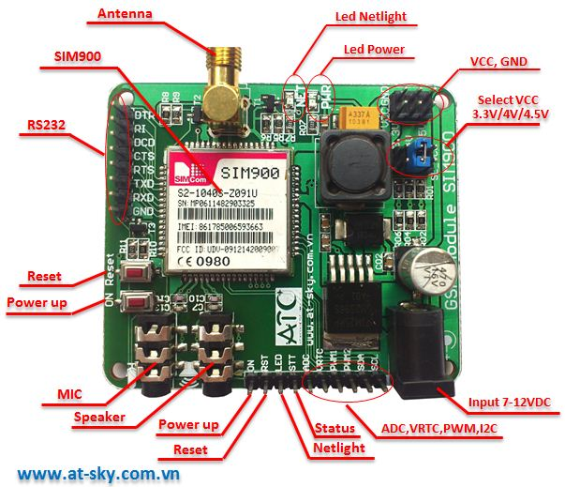

**Figure 2.1: GSM MODULE SIM900**

## ARDUINO(Mega328)

The Arduino Uno is a microcontroller board based on the ATmega328 (datasheet). It has 14 digital input/output pins (of which 6 can be used as PWM outputs), 6 analog inputs, a 16 MHz crystal oscillator, a USB connection, a power jack, an ICSP header, and a reset button. It contains everything needed to support the microcontroller; simply connect it to a computer with a USB cable or power it with a AC-to-DC adapter or battery to get started. The Uno differs from all preceding boards in that it does not use the FTDI USB-to-serial driver chip. Instead, it features the Atmega8U2 programmed as a USB-to-serial converter.

### Technical specifications

Microcontroller ATmega328

Operating Voltage 5V

Input Voltage (recommended) 7-12V

Input Voltage (limits) 6-20V

Digital I/O Pins 14 (of which 6 provide PWM output)

Analog Input Pins 6

DC Current per I/O Pin 40 mA

DC Current for 3.3V

Pin 50 mA

Flash Memory 32 KB of which 0.5 KB used by bootloader

SRAM 2 KB

EEPROM 1 KB

Clock Speed 16 MHz

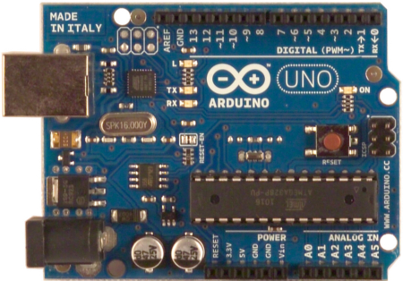

**Figure 2.2:** **ARDUINO(mega328)**

## ULTRASONIC SENSORS

Sound is a natural phenomenon which helps us to recognize our environment without physical contact over widely varying distances. SICK’s ultrasonic sensors use sound to accurately detect objects and measure distances. These sensors provide outstanding background suppression to reliably detect objects, regardless of the object’s appearance. The output used – switching, analog or both – is determined based on your application requirements.

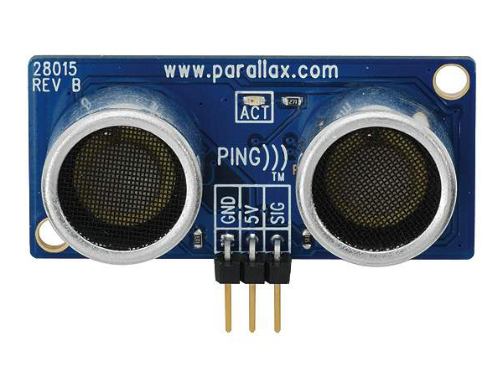

**Figure2.3: ULTRASONIC SENSOR 1**

|  |
| --- |
| UM30-2 |
| **The universal application solver**   * Integrated time-of-flight technology detects objects such as glass, liquids and transparent foils, independent of color * Range up to 8,000 mm * Display enables fast and flexible sensor adjustment * Immune to dust, dirt and fog * Available with combined analog and digital outputs * Synchronization and multiplexing * Adjustable sensitivity * Three operation modes: Distance to Object (DtO), Window (Wnd) or Object between sensor and background (OBSB) |

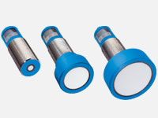

|  |
| --- |
| UM18 |
| **Simple set up, perfect detection**   * Reliable measurement independent of material color, transparency, gloss and ambient light * Four ranges up to 1,300 mm * Short metal or plastic M18 housing with a length of 41 mm * Straight or right-angle version * High immunity to dirt, dust, humidity and fog * PNP/NPN switching output, analog output or push-pull switching output with IO-Link * Synchronization and multiplex modes are available |

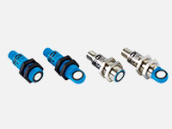

|  |
| --- |
| UM12 |
| **Small sensor, great benefits**   * Reliable measurement, regardless of material color, transparency, gloss, or ambient light * Very short and rugged M12 metal housing * Variants with PNP/NPN switching output or analog output * Immune to dirt, dust, humidity, and fog * Detection, measurement, or positioning with ultrasound technology * Cable teach-in |

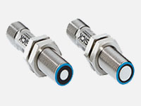

|  |
| --- |
| UC30 |
| **Rugged. Reliable. Rectangular.**   * Reliable operation, regardless of material color, transparency, gloss, and ambient light * Rugged rectangular housing with teach-in buttons * Range up to 8,000 mm * Variants with analog output, push-pull output with IO-Link or two PNP/NPN switching outputs * Immune to dirt, dust, humidity, and fog * Detection, measurement, and positioning with ultrasonic technology * Adjustable sensitivity |

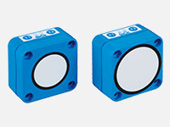

|  |
| --- |
| UC12 |
| **Ultrasonic technology housed in an industry-proven design**   * Object detection independent of material color and ambient light – even transparent foils, glass, liquids and bottles are reliably detected * Fast and easy teach-in with single push-button * Immune to dirt, dust and fog * Two ambivalent switching outputs (Q, ¯Q) * Excellent background suppression * Three operation modes: Distance to Object (DtO), Window (Wnd) or Object between sensor and background (OBSB) |

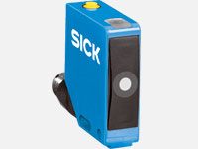

## Microduino-NEO-6M

Microduino-NEO module maybe the most beautiful GPS module that you've seen. Its core module use UBLOX NEO-6M, high sensitivity, update rate up to 5Hz, using mini ceramic antenna with IPEX interface, and build-in a rechargeable battery backup.

### Features

* High sensitivity；
* Update rate up to 5Hz；
* With a powerful PC support：u-center；
* PPS indicator，easily determine the current status of the module；
* Built-in rechargeable backup battery (to support warm start or hot start)；
* Small, cheap, stackable, opened platform;
* Open source hardware circuit design, compatible with the Arduino IDE development environment for programming; ；
* Define unified interface Microduino specification and contain rich peripheral modules. Set up the quick connection with other Microduino modules and sensors easily and flexibly.
* 2.54 pitch row female connector for easy integration into breadboard.

### Specifications

* Communication protocol：
  + Microduino NEO-6M module use NMEA-0183 protocol and output GPS data, using the UBX protocol to configure the module.
* Reception characteristics
  + 50 channels，GPS L1(1575.42Mhz) C/A 码，SBAS:WAAS/EGNOS/MSAS
  + Capture tracking sensitivity：-161dBm
* Positioning accuracy
  + 2.5 mCEP（SBAS：2.0mCEP）
* Update rate
  + Maximum 5Hz
* Capture time
  + cold start：27S（Fastest time）
  + warm start：27S
  + hot start：1S

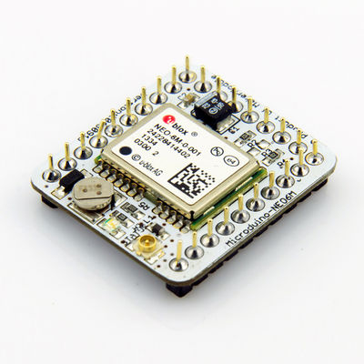

**Figure2.4: GPS NEO**

## 2N2222(Transistors)

The 2N2222 is a common [NPN](http://en.wikipedia.org/wiki/NPN_transistor) [bipolar junction transistor](http://en.wikipedia.org/wiki/Bipolar_junction_transistor) (BJT) used for general purpose low-power [amplifying](http://en.wikipedia.org/wiki/Amplifier) or switching applications. It is designed for low to medium [current](http://en.wikipedia.org/wiki/Electric_current), low [power](http://en.wikipedia.org/wiki/Electric_power), medium [voltage](http://en.wikipedia.org/wiki/Voltage), and can operate at moderately high speeds. It is made in the [TO-18](http://en.wikipedia.org/wiki/TO-18) metal can as shown in the picture.The 2N2222 is considered a very common transistor,[[1]](http://en.wikipedia.org/wiki/2N2222#cite_note-1)[[2]](http://en.wikipedia.org/wiki/2N2222#cite_note-2)[[3]](http://en.wikipedia.org/wiki/2N2222#cite_note-3) and is used as an exemplar of an NPN transistor. It is frequently used as a small-signal transistor, and it remains a small general purpose transistor[[6]](http://en.wikipedia.org/wiki/2N2222#cite_note-6) of enduring popularity.The 2N2222 was part of a family of devices described by Motorola at a 1962 [IRE](http://en.wikipedia.org/wiki/Institute_of_Radio_Engineers) convention Since then it has been made by many semiconductor companies, for example, [Texas Instruments](http://en.wikipedia.org/wiki/Texas_Instruments).

### Specifications

The [JEDEC](http://en.wikipedia.org/wiki/JEDEC) registration of a device number ensures particular rated values will be met by all parts offered under that number. JEDEC registered parameters include outline dimensions, small-signal current [gain](http://en.wikipedia.org/wiki/Gain), [transition frequency](http://en.wikipedia.org/wiki/Gain%E2%80%93bandwidth_product#Transistors), maximum values for voltage withstand, current rating, power dissipation and temperature rating, and others, measured under standard test conditions. Other part numbers will have different parameters. The exact specifications depend on the manufacturer, case type, and variation. Therefore it is important to refer to the datasheet for the exact part number and manufacturer.

|  |  |  |  |  |
| --- | --- | --- | --- | --- |
| **Manufacturer** | **Vce** | **Ic** | **PD** | **fT** |
| **ST Microelectronics**[[12]](http://en.wikipedia.org/wiki/2N2222#cite_note-12) **2N2222A** | 40 V | 800 mA | 500 mW/1.8 W | 300 MHz |

All variations have a [beta](http://en.wikipedia.org/wiki/Bipolar_junction_transistor#Transistor_.27alpha.27_and_.27beta.27) or current gain (hFE) of at least 100 in optimal conditions. It is used in a variety of analog amplification and switching applications.

## NPN Switching transistors

NPN silicon transistors with similar properties are also made in a variety of small through-hole and surface mount packages including [TO-92](http://en.wikipedia.org/wiki/TO-92), [SOT-23](http://en.wikipedia.org/wiki/SOT-23), and [SOT-223](http://en.wikipedia.org/w/index.php?title=SOT-223&action=edit&redlink=1).

Replacements for the 2N2222 are commonly available now in the cheaper [TO-92](http://en.wikipedia.org/wiki/TO-92) packaging, where it is known as the PN2222 or P2N2222, which has similar specifications except for the lower maximum collector current. The P2N2222 has a different order of pins than the metal case 2N2222, with its emitter and collector connections switched; other plastic-case transistors also have different pinouts.

Single transistors are also available in several different surface mount packages, and a number of manufacturers market surface mount packages that incorporate several 2N2222-type transistors in one package as an array of transistors. The general specifications of the various variants are similar, with the biggest difference being the maximum allowable current and power dissipation.

The [BC548](http://en.wikipedia.org/wiki/BC548) is a low voltage, low current, general-purpose switching transistor in a TO-92 package.

The [2N2907](http://en.wikipedia.org/wiki/2N2907) is an equally popular ([PNP](http://en.wikipedia.org/wiki/PNP_transistor)) transistor complementary to the 2N2222.

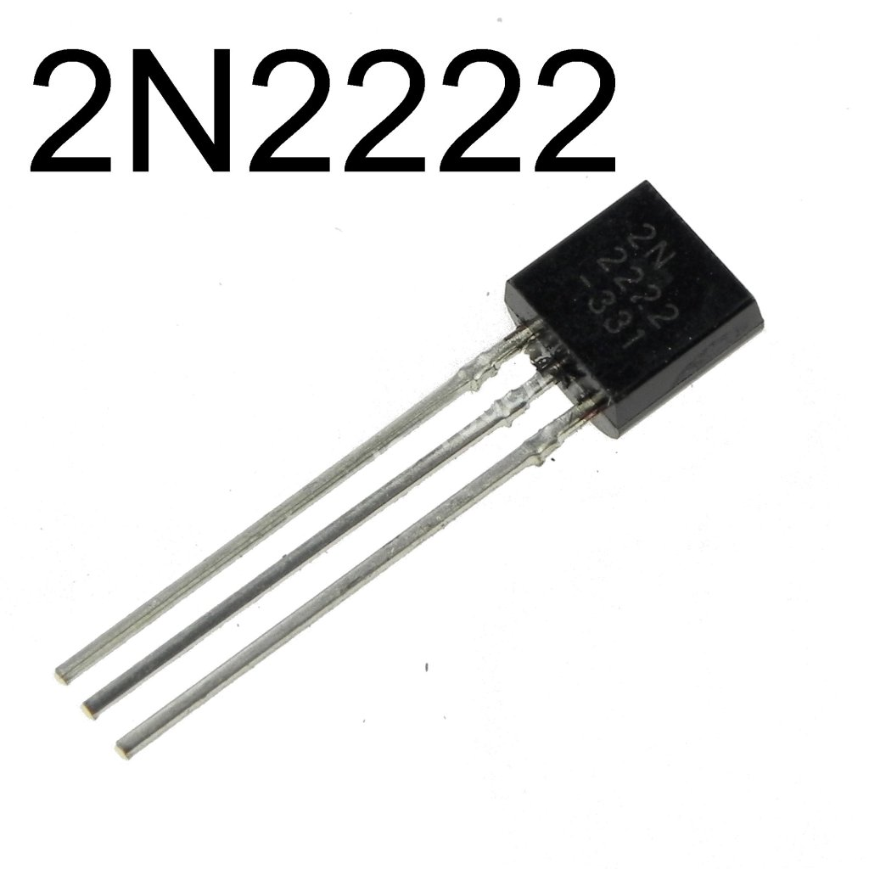

The [2N3904](http://en.wikipedia.org/wiki/2N3904) is an NPN transistor that can only switch one-third the current of the 2N2222 but has otherwise similar characteristics. The 2N3904 exhibits its forward gain (beta) peak at a lower current than the 2N2222, and is useful in amplifier applications with reduced Ic, e.g., (gain peak at 10 mA for the 2N3904 but 150 mA for the 2N2222).

The [2N2219](http://en.wikipedia.org/w/index.php?title=2N2219&action=edit&redlink=1) is very similar with higher power dissipation rating.

## 10k RESISTOR

A **resistor** is a [passive](http://en.wikipedia.org/wiki/Passivity_(engineering)) [two-terminal](http://en.wikipedia.org/wiki/Terminal_(electronics)) [electrical component](http://en.wikipedia.org/wiki/Electronic_component) that implements [electrical resistance](http://en.wikipedia.org/wiki/Electrical_resistance) as a circuit element. Resistors act to reduce current flow, and, at the same time, act to lower voltage levels within circuits. In electronic circuits resistors are used to limit current flow, to adjust signal levels, [bias](http://en.wikipedia.org/wiki/Biasing) active elements, terminate [transmission lines](http://en.wikipedia.org/wiki/Transmission_line) among other uses. High-power resistors that can dissipate many [watts](http://en.wikipedia.org/wiki/Watt) of electrical power as heat may be used as part of motor controls, in power distribution systems, or as test loads for [generators](http://en.wikipedia.org/wiki/Electric_generator). Fixed resistors have resistances that only change slightly with temperature, time or operating voltage. Variable resistors can be used to adjust circuit elements (such as a volume control or a lamp dimmer), or as sensing devices for heat, light, humidity, force, or chemical activity.

Resistors are common elements of [electrical networks](http://en.wikipedia.org/wiki/Electrical_network) and [electronic circuits](http://en.wikipedia.org/wiki/Electronic_circuit) and are ubiquitous in [electronic equipment](http://en.wikipedia.org/wiki/Electronics). Practical resistors as discrete components can be composed of various compounds and forms. Resistors are also implemented within[integrated circuits](http://en.wikipedia.org/wiki/Integrated_circuits).

The electrical function of a resistor is specified by its resistance: common commercial resistors are manufactured over a range of more than nine [orders of magnitude](http://en.wikipedia.org/wiki/Orders_of_magnitude). The nominal value of the resistance will fall within a [manufacturing tolerance](http://en.wikipedia.org/wiki/Engineering_tolerance#Electrical_component_tolerance). . Resistors are carefully manufactured to provide a predetermined value of electrical resistance which may range from 0.1 ohms to 100,000,000 ohms, depending on the application. The physical size of a resistor also varies dependant on the amount of power passing through the resistor, given by: P = V x I (Power = Voltage x Current) (power measured in watts) There are also many types of resistors including: · Variable Resistor - changes resistance when its shaft is rotated (volume knob on a stereo). · Thermistor - changes resistance when the temperature changes (used in a thermostat). · Light Dependant Resistor (LDR) - changes resistance when the lighting changes (used in children's night-lights).

### Resistor Example:

An LED is a small red light (such as the one on the front of most TVs) and requires 2.0 volts and 0.02 amps to operate correctly. If we connected that LED up directly to a 12 volt battery, the voltage would be too high, and too much current would flow… the LED would blow up. We need to use a resistor to limit the voltage and current. But which value of resistance should the have resistor? Uses ohms law: R = V / I = (12.0 - 2.0) / 0.02 = 500 ohms *(Note: the voltage across the resistor is the battery voltage minus the voltage we want across the LED)* But which value of power should the resistor be capable of handling? P = V x I = (12.0 - 2.0) / 0.02 = 0.2 Watts

Note: k = x1,000 M = x1,000,000 G = x1,000,000,000 So a 10k resistor = 10kohms = 10,000ohms

### Specifications

|  |  |
| --- | --- |
| **Specification** | **Value** |
| Product Type | RESISTOR |
| Resistance (ohm) | 10000 |
| Power (Watts) | 0.25 |
| Tolerance (%) | 5 |
| Package | AXIAL LEADED |

|  |  |
| --- | --- |
| Size | STANDARD |
| Packing Method | CUT TAPE |
| Mounting Feature | THROUGH HOLE |
| Resistor Type | CARBON FILM |

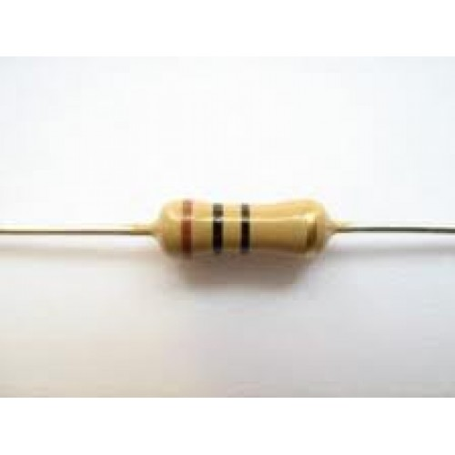

**FIGURE 6:10k RESISTOR**

## 1n4007 DIODE

In [electronics](http://en.wikipedia.org/wiki/Electronics), a **diode** is a two-[terminal](http://en.wikipedia.org/wiki/Terminal_(electronics)) [electronic component](http://en.wikipedia.org/wiki/Electronic_component) with asymmetric [conductance](http://en.wikipedia.org/wiki/Electrical_conductance); it has low (ideally zero) [resistance](http://en.wikipedia.org/wiki/Electrical_resistance_and_conductance) to [current](http://en.wikipedia.org/wiki/Electric_current)in one direction, and high (ideally [infinite](http://en.wikipedia.org/wiki/Infinity)) resistance in the other. A **semiconductor diode**, the most common type today, is a [crystalline](http://en.wikipedia.org/wiki/Crystallinity)piece of [semiconductor](http://en.wikipedia.org/wiki/Semiconductor) material with a [p–n junction](http://en.wikipedia.org/wiki/P%E2%80%93n_junction) connected to two electrical terminals.[[5]](http://en.wikipedia.org/wiki/Diode#cite_note-5) A [vacuum tube](http://en.wikipedia.org/wiki/Vacuum_tube) diode has two [electrodes](http://en.wikipedia.org/wiki/Electrode), a[plate](http://en.wikipedia.org/wiki/Plate_electrode) (anode) and a [heated cathode](http://en.wikipedia.org/wiki/Hot_cathode). Semiconductor diodes were the first [semiconductor electronic devices](http://en.wikipedia.org/wiki/Semiconductor_device). The discovery of [crystals](http://en.wikipedia.org/wiki/Crystal)'[rectifying](http://en.wikipedia.org/wiki/Rectification_(electricity)) abilities was made by German physicist [Ferdinand Braun](http://en.wikipedia.org/wiki/Ferdinand_Braun) in 1874. The first semiconductor diodes, called [cat's whisker diodes](http://en.wikipedia.org/wiki/Cat%27s_whisker_diode), developed around 1906, were made of mineral crystals such as [galena](http://en.wikipedia.org/wiki/Galena). Today, most diodes are made of [silicon](http://en.wikipedia.org/wiki/Silicon), but other semiconductors such as [selenium](http://en.wikipedia.org/wiki/Selenium) or [germanium](http://en.wikipedia.org/wiki/Germanium) are sometimes used.

### Feautres

* Peak Repet. Reverse Voltage (Vrrm): 1000V
* Max. RMS Reverse Voltage (Vr): 700V
* Average Rectified Current (Io): 1.0A
* Max. Reverse Current (Ir): 0.01mA
* Max. Forward Voltage Drop (Vf): 1V
* Low forward voltage drop
* High surge current capability

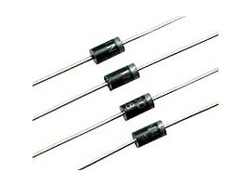

FIGURE: In4007 DIODE 1

## PRESSURE SENSOR

A pressure sensor measures [pressure](http://en.wikipedia.org/wiki/Pressure), typically of [gases](http://en.wikipedia.org/wiki/Gas) or [liquids](http://en.wikipedia.org/wiki/Liquids). Pressure is an expression of the force required to stop a fluid from expanding, and is usually stated in terms of force per unit area. A pressure sensor usually acts as a [transducer](http://en.wikipedia.org/wiki/Transducer); it generates a signal as a[function](http://en.wikipedia.org/wiki/Function_(mathematics)) of the pressure imposed. For the purposes of this article, such a signal is electrical.Pressure sensors are used for control and monitoring in thousands of everyday applications. Pressure sensors can also be used to indirectly measure other variables such as fluid/gas flow, speed, water level, and altitude. Pressure sensors can alternatively be called pressure transducers, pressure transmitters, pressure senders, pressure indicators, piezometers and manometers, among other names.Pressure sensors can vary drastically in technology, design, performance, application suitability and cost. A conservative estimate would be that there may be over 50 technologies and at least 300companies making pressure sensors worldwide.There is also a category of pressure sensors that are designed to measure in a dynamic mode for capturing very high speed changes in pressure. Example applications for this type of sensor would be in the measuring of combustion pressure in an engine cylinder or in a gas turbine. These sensors are commonly manufactured out of [piezoelectric](http://en.wikipedia.org/wiki/Piezoelectric) materials such as quartz.Some pressure sensors, such as those found in some [traffic enforcement cameras](http://en.wikipedia.org/wiki/Traffic_enforcement_camera), function in a binary (off/on) manner, i.e., when pressure is applied to a pressure sensor, the sensor acts to complete or break an electrical circuit. These types of sensors are also known as a[pressure switch](http://en.wikipedia.org/wiki/Pressure_switch).

### Types of pressure measurement

Pressure sensors can be classified in terms of pressure ranges they measure, temperature ranges of operation, and most importantly the type of pressure they measure. Pressure sensors are variously named according to their purpose, but the same technology may be used under different names.

#### Absolute pressure sensor

This sensor measures the pressure relative to [perfect vacuum](http://en.wikipedia.org/wiki/Vacuum).

#### Gauge pressure sensor

This sensor measures the pressure relative to [atmospheric pressure](http://en.wikipedia.org/wiki/Atmospheric_pressure). A tire pressure gauge is an example of gauge pressure measurement; when it indicates zero, then the pressure it is measuring is the same as the ambient pressure.

#### Vacuum pressure sensor

This term can cause confusion. It may be used to describe a sensor that measures pressures below atmospheric pressure, showing the difference between that low pressure and atmospheric pressure (i.e. negative gauge pressure), but it may also be used to describe a sensor that measures low pressure relative to perfect vacuum (i.e. absolute pressure).

#### Differential pressure sensor

This sensor measures the difference between two pressures, one connected to each side of the sensor. Differential pressure sensors are used to measure many properties, such as pressure drops across [oil filters](http://en.wikipedia.org/wiki/Oil_filter) or [air filters](http://en.wikipedia.org/wiki/Air_filter), fluid levels (by comparing the pressure above and below the liquid) or flow rates (by measuring the change in pressure across a restriction). Technically speaking, most pressure sensors are really differential pressure sensors; for example a gauge pressure sensor is merely a differential pressure sensor in which one side is open to the ambient atmosphere.

#### Sealed pressure sensor

This sensor is similar to a gauge pressure sensor except that it measures pressure relative to some fixed pressure rather than the ambient atmospheric pressure (which varies according to the location and the weather).

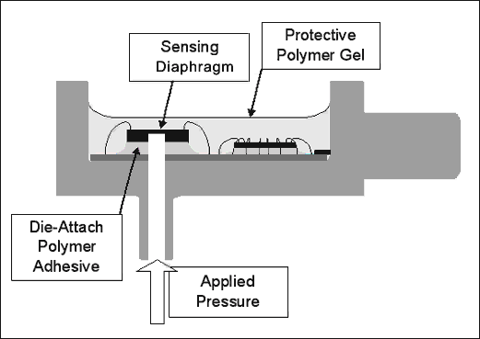

**FIGURE: PRESSURE SENSOR**

## GPS MODULE

A GPS navigation device is a device that accurately calculates geographical location by receiving information from [GPS satellites](http://en.wikipedia.org/wiki/GPS_satellites). Initially it was used by the United States military, but now most receivers are in automobiles and [smartphones](http://en.wikipedia.org/wiki/Smartphones).The [Global Positioning System](http://en.wikipedia.org/wiki/Global_Positioning_System) (GPS) is a [satellite-based navigation](http://en.wikipedia.org/wiki/Satellite_navigation) system made up of a network of a minimum of 24, but currently [30, satellites](http://en.wikipedia.org/wiki/List_of_GPS_satellites) placed into orbit by the [U.S. Department of Defense](http://en.wikipedia.org/wiki/United_States_Department_of_Defense). Military action was the original intent for GPS, but in the 1980s, the U.S. government decided to allow the GPS program to be used by civilians. The satellite data is free and works anywhere in the world.

GPS devices may have capabilities such as:

* maps, including streets maps, displayed in human readable format via text or in a graphical format,
* [turn-by-turn navigation](http://en.wikipedia.org/wiki/Turn-by-turn_navigation) directions to a human in charge of a vehicle or vessel via text or speech,
* directions fed directly to an [autonomous vehicle](http://en.wikipedia.org/wiki/Autonomous_car) such as a robotic probe,
* [traffic congestion maps](http://en.wikipedia.org/wiki/Traffic_congestion_map) (depicting either historical or real time data) and suggested alternative directions,
* information on nearby amenities such as restaurants, fueling stations, and [tourist attractions](http://en.wikipedia.org/wiki/Tourist_attraction).

GPS devices may be able to answer:

* the roads or paths available,
* traffic congestion and alternative routes,
* roads or paths that might be taken to get to the destination,
* if some roads are busy (now or historically) the best route to take,
* The location of food, banks, hotels, fuel, airports or other places of interests,
* the shortest route between the two locations,
* the different options to drive on highway or back roads.

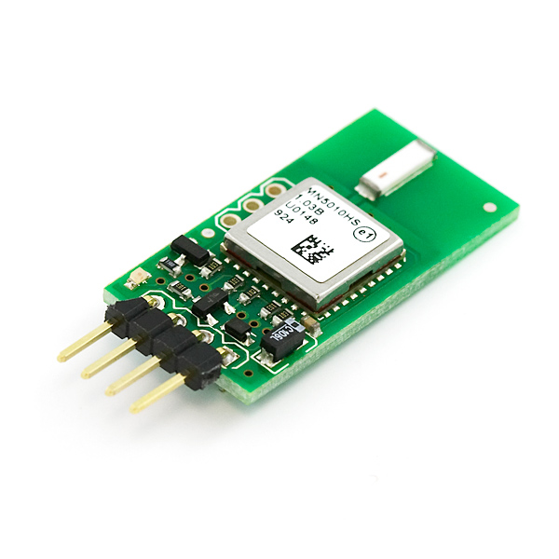

**FIGURE : GPS MODULE**

## BUZZER

A buzzer or beeper is an audio signaling device, which may be mechanical, electromechanical,or electronic. Typical uses of buzzers and beepers include alarms, timers and confirmation of user input such as a mouse click or keystroke.

### FEATURES

* A piezoelectric element may be driven by an oscillating electronic circuit or other audio signal source. Sounds commonly used to indicate that a button has been pressed are a click, a ring or a beep. Electronic buzzers find many applications in modern days.

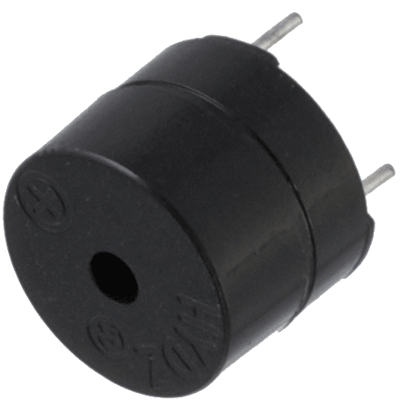

**FIGURE: BUZZER**

## CAPACITOR

A capacitor (originally known as a condenser) is a [passive](http://en.wikipedia.org/wiki/Passivity_(engineering)) [two-terminal](http://en.wikipedia.org/wiki/Terminal_(electronics)) [electrical component](http://en.wikipedia.org/wiki/Electronic_component) used to store [energy](http://en.wikipedia.org/wiki/Energy) [electrostatically](http://en.wikipedia.org/wiki/Electrostatic)in an [electric field](http://en.wikipedia.org/wiki/Electric_field). The forms of practical capacitors vary widely, but all contain at least two [electrical conductors](http://en.wikipedia.org/wiki/Electrical_conductor) (plates) separated by a [dielectric](http://en.wikipedia.org/wiki/Dielectric) (i.e. [insulator](http://en.wikipedia.org/wiki/Insulator_(electricity))). The conductors can be thin films, foils or sintered beads of metal or conductive electrolyte, etc. The nonconducting dielectric acts to increase the capacitor's charge capacity. A dielectric can be glass, ceramic, plastic film, air, vacuum, paper, mica, oxide layer etc. Capacitors are widely used as parts of [electrical circuits](http://en.wikipedia.org/wiki/Electrical_circuit) in many common electrical devices. Unlike a[resistor](http://en.wikipedia.org/wiki/Resistor), an ideal capacitor does not dissipate energy. Instead, a capacitor stores [energy](http://en.wikipedia.org/wiki/Energy) in the form of an [electrostatic field](http://en.wikipedia.org/wiki/Electric_field) between its plates.When there is a [potential difference](http://en.wikipedia.org/wiki/Potential_difference) across the conductors (e.g., when a capacitor is attached across a battery), an [electric field](http://en.wikipedia.org/wiki/Electric_field)develops across the dielectric, causing positive [charge](http://en.wikipedia.org/wiki/Electric_charge) +*Q* to collect on one plate and negative charge −*Q* to collect on the other plate. If a battery has been attached to a capacitor for a sufficient amount of time, no current can flow through the capacitor. However, if a time-varying voltage is applied across the leads of the capacitor, a [displacement current](http://en.wikipedia.org/wiki/Displacement_current) can flow.An ideal capacitor is characterized by a single constant value for its [capacitance](http://en.wikipedia.org/wiki/Capacitance). Capacitance is expressed as the ratio of the electric charge *Q* on each conductor to the potential difference *V* between them. The [SI](http://en.wikipedia.org/wiki/International_System_of_Units) unit of capacitance is the [farad](http://en.wikipedia.org/wiki/Farad) (F), which is equal to one [coulomb](http://en.wikipedia.org/wiki/Coulomb) per [volt](http://en.wikipedia.org/wiki/Volt) (1 C/V). Typical capacitance values range from about 1 pF (10−12 F) to about 1 mF (10−3 F).The capacitance is greater when there is a narrower separation between conductors and when the conductors have a larger surface area. In practice, the dielectric between the plates passes a small amount of [leakage current](http://en.wikipedia.org/wiki/Leakage_(electronics)) and also has an electric field strength limit, known as the [breakdown voltage](http://en.wikipedia.org/wiki/Breakdown_voltage). The conductors and [leads](http://en.wikipedia.org/wiki/Lead_(electronics)) introduce an undesired [inductance](http://en.wikipedia.org/wiki/Equivalent_series_inductance) and [resistance](http://en.wikipedia.org/wiki/Equivalent_series_resistance).Capacitors are widely used in [electronic circuits](http://en.wikipedia.org/wiki/Electronic_circuit) for blocking [direct current](http://en.wikipedia.org/wiki/Direct_current) while allowing [alternating current](http://en.wikipedia.org/wiki/Alternating_current) to pass. In [analog filter](http://en.wikipedia.org/wiki/Analog_filter)networks, they smooth the output of [power supplies](http://en.wikipedia.org/wiki/Power_supply). In [resonant circuits](http://en.wikipedia.org/wiki/LC_circuit) they tune [radios](http://en.wikipedia.org/wiki/Radio) to particular [frequencies](http://en.wikipedia.org/wiki/Frequency). In [electric power transmission](http://en.wikipedia.org/wiki/Electric_power_transmission) systems, they stabilize voltage and power flow.

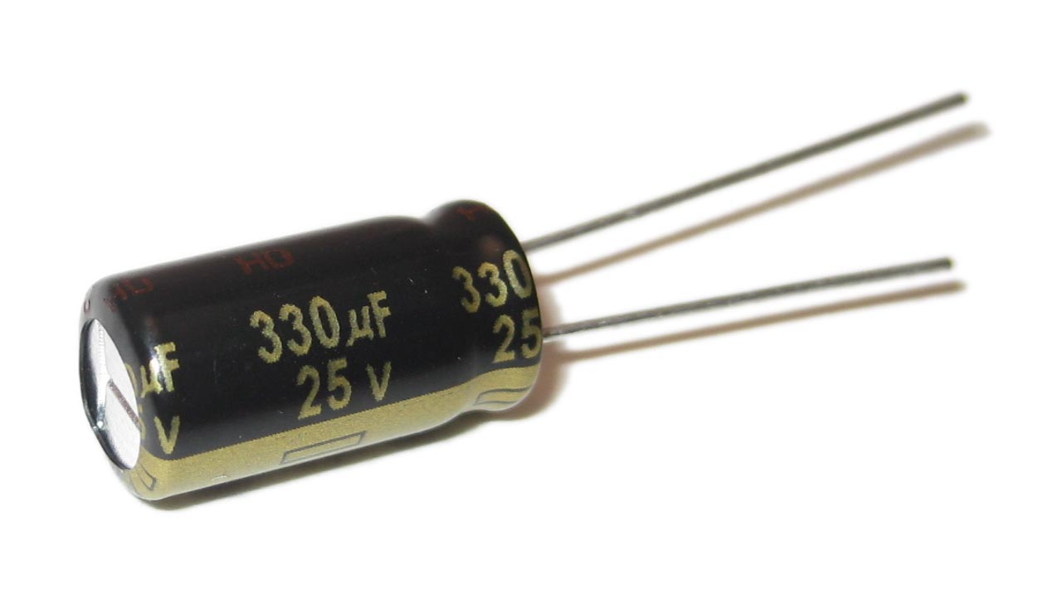

FIGURE :CAPACITOR

## ELECTRICAL TRANSFORMER

Electrical [power transformer](http://www.electrical4u.com/electrical-power-transformer-definition-and-types-of-transformer/) is a static device which transforms electrical energy from one circuit to another without any direct electrical connection and with the help of [mutual induction](http://www.electrical4u.com/what-is-inductor-and-inductance-theory-of-inductor/#Mutual-Inductance) between two windings. It transforms power from one circuit to another without changing its frequency but may be in different [voltage](http://www.electrical4u.com/voltage-or-electric-potential-difference/) level.

### Working Principle of Transformer

The **working principle of transformer** is very simple. It depends upon [Faraday's law of electromagnetic induction](http://www.electrical4u.com/faraday-law-of-electromagnetic-induction/). Actually, [mutual induction](http://www.electrical4u.com/what-is-inductor-and-inductance-theory-of-inductor/#Mutual-Inductance) between two or more winding is responsible for transformation action in an electrical transformer.

### Faraday's Laws of Electromagnetic Induction

According to these [Faraday's laws](http://www.electrical4u.com/faraday-law-of-electromagnetic-induction/),"Rate of change of flux linkage with respect to time is directly proportional to the induced EMF in a conductor or coil".

### Basic Theory of Transformer

Say you have one winding which is supplied by an alternating electrical source. The alternating [current](http://www.electrical4u.com/electric-current-and-theory-of-electricity/) through the winding produces a continually changing flux or alternating flux that surrounds the winding. If any other winding is brought nearer to the previous one, obviously some portion of this flux will link with the second. As this flux is continually changing in its amplitude and direction, there must be a change in flux linkage in the second winding or coil. According to [Faraday's law of electromagnetic induction](http://www.electrical4u.com/faraday-law-of-electromagnetic-induction/), there must be an EMF induced in the second. If the circuit of the later winding is closed, there must be an[current](http://www.electrical4u.com/electric-current-and-theory-of-electricity/) flowing through it. This is the simplest form of [electrical power transformer](http://www.electrical4u.com/electrical-power-transformer-definition-and-types-of-transformer/) and this is the most basic of **working principle of transformer**.

Whenever we apply alternating [current](http://www.electrical4u.com/electric-current-and-theory-of-electricity/) to an electric coil, there will be an alternating flux surrounding that coil. Now if we bring another coil near the first one, there will be an alternating flux linkage with that second coil. As the flux is alternating, there will be obviously a rate of change in flux linkage with respect to time in the second coil. Naturally emf will be induced in it as per [Faraday's law of electromagnetic induction](http://www.electrical4u.com/faraday-law-of-electromagnetic-induction/). This is the most basic concept of the **theory of transformer**.

The winding which takes [electrical power](http://www.electrical4u.com/electric-power-single-and-three-phase/) from the source, is generally known as primary winding of transformer. Here in our above example it is first winding. 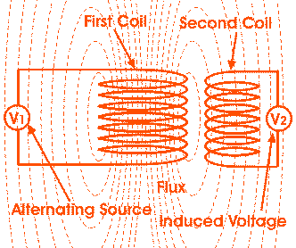The winding which gives the desired output [voltage](http://www.electrical4u.com/voltage-or-electric-potential-difference/) due to [mutual induction](http://www.electrical4u.com/what-is-inductor-and-inductance-theory-of-inductor/#Mutual-Inductance) in the transformer, is commonly known as secondary winding of transformer. Here in our example it is second winding.

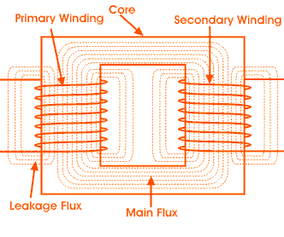

The above mentioned form of transformer is theoretically possible but not practically, because in open air very tiny portion of the flux of the first winding will link with second; so the [current](http://www.electrical4u.com/electric-current-and-theory-of-electricity/) that flows through the closed circuit of later, will be so small in amount that it will be difficult to measure.

The rate of change of flux linkage depends upon the amount of linked flux with the second winding. So, it is desired to be linked to almost all flux of primary winding to the secondary winding. This is effectively and efficiently done by placing one low reluctance path common to both of the winding. This low reluctance path is [core of transformer](http://www.electrical4u.com/core-of-transformer-and-design-of-transformer-core/), through which maximum number of flux produced by the primary is passed through and linked with the secondary winding. This is the most basic **theory of transformer**.

### Main Constructional Parts of Transformer

The three main parts of a transformer are,

1. Primary Winding of transformer - which produces [magnetic flux](http://www.electrical4u.com/what-is-magnetic-field/#Magnetic-Flux-or-Magnetic-Lines-of-Force) when it is connected to electrical source.
2. Magnetic Core of transformer - the [magnetic flux](http://www.electrical4u.com/what-is-magnetic-field/#Magnetic-Flux-or-Magnetic-Lines-of-Force) produced by the primary winding, that will pass through this low reluctance path linked with secondary winding and create a closed [magnetic circuit](http://www.electrical4u.com/what-is-magnetic-field/#Magnetic-Circuit).
3. Secondary Winding of transformer - the flux, produced by primary winding, passes through the core, will link with the secondary winding. This winding also wounds on the same core and gives the desired output of the transformer.

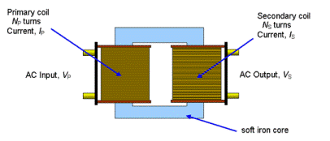

FIGURE: TRANSFORMER

# CHAPTER 3

# DETAILED WORKING OF THE SYSTEM

A linear power supply is used to the power the system .the output of the power supply will be +12V,+9V,+5V and -5V .+5V or -5V is applied to all ICs. The power required for the microcontroller is +5V and is generated by using regulated power supply.The power supply is given from regulated power supply .The destination point where a blind person wants to go is stored in micro controller .The current location of the blind person is stored in GPS(Global positioning system).Two buzzers are placed so that when the blind wants to move forward and an obstacle is on the way high beep nodes will be heard by him to change his path from that way.if an obstacle lies on the back side he will hear low beep nodes which will notify him to change his way.If an accident happens via GSM module message will be sent to the guardians of the blind person indicating the current location of the blind via gps module and pressure sensor will activate immediately.

**Block diagram of the system**

## 3.1. POWER SUPPLY

The block diagram of a power supply system which converts a 230V AC mains supply (230V is the UK mains voltage) into a regulated 5V DC supply.There are many types of power supply .which are designed to convert high voltage AC mains electricity to suitable low voltage supply for electronic circuits and other devices .A power supply can be broken in to a series of blocks each of which performs a particular function.

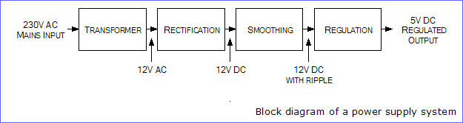

**Figure no.3.1**

Blocks are described in more detail below:

Transformer – steps down high voltage AC mains to low voltage AC

Rectifier- converts AC to DC but the DC output is varying

Smoothing- smoothes the DC from varying greatly to a small ripple

Regulator- eliminates ripple by setting DC output to a fixed voltage

## 3.2. Rectifier

|  |
| --- |
|  |

There are several ways of connecting diodes to make a rectifier to convert AC to DC. The [bridge rectifier](http://www.kpsec.freeuk.com/powersup.htm#bridgerectifier) is the most important and it produces full-wave varying DC. A full-wave rectifier can also be made from just two diodes if a centre-tap transformer is used, but this method is rarely used now that diodes are cheaper. A [single diode](http://www.kpsec.freeuk.com/powersup.htm#singlediode) can be used as a rectifier but it only uses the positive (+) parts of the AC wave to produce half-wavevaryingDC.

## 3.3. Bridge rectifier

A bridge rectifier can be made using four individual diodes, but it is also available in special packages containing the four diodes required. It is called a full-wave rectifier because it uses all the AC wave (both positive and negative sections). 1.4V is used up in the bridge rectifier because each diode uses 0.7V when conducting and there are always two diodes conducting, as shown in the diagram below. Bridge rectifiers are rated by the maximum current they can pass and the maximum reverse voltage they can withstand (this must be at least three times the supply [RMS](http://www.kpsec.freeuk.com/acdc.htm#rms) voltage so the rectifier can withstand the peak voltages). Please see the [Diodes](http://www.kpsec.freeuk.com/components/diode.htm#bridge) page for more details, includingpictures of bridge rectifiers.

|  |
| --- |
|  |

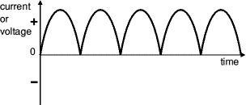

**Figure no.3.2**

## 3.4. Smoothing

Smoothing is performed by a large value [electrolytic capacitor](http://www.kpsec.freeuk.com/components/capac.htm#polarised) connected across the DC supply to act as a reservoir, supplying current to the output when the varying DC voltage from the rectifier is falling. The diagram shows the unsmoothed varying DC (dotted line) and the smoothed DC (solid line). The capacitor charges quickly near the peak of the varying DC, and then discharges as it supplies current to the output.   
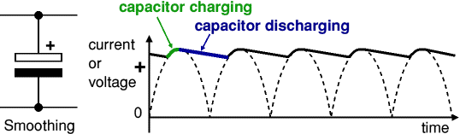

**Figure no.3.4**

Note that smoothing significantly increases the average DC voltage to almost the peak value (1.4 × [RMS](http://www.kpsec.freeuk.com/acdc.htm#rms) value). For example 6V RMS AC is rectified to full wave DC of about 4.6V RMS (1.4V is lost in the bridge rectifier), with smoothing this increases to almost the peak value giving 1.4 × 4.6 = 6.4V smooth DC. Smoothing is not perfect due to the capacitor voltage falling a little as it discharges, giving a small **ripple voltage**. For many circuits a ripple which is 10% of the supply voltage is satisfactory and the equation below gives the required value for the smoothing capacitor. A larger capacitor will give less ripple. The capacitor value must be doubled when smoothing half-wave DC

|  |  |
| --- | --- |
| Smoothing capacitor for 10% ripple, C = | 5 × Io |
| Vs × f |

C =smoothing capacitance in farads (F) Io  = output current from the supply in amps (A)  
Vs = supply voltage in volts (V), this is the peak value of the unsmoothed DC  
f    = frequency of the AC supply in hertz (Hz), 50Hz in the UK

## 3.5. Regulator

|  |  |
| --- | --- |
|  |  |

Voltage regulator ICs are available with fixed (typically 5,12 and 15V) or variable output voltages. They are also rated by the maximum current they can pass. Negative voltage regulators are available, mainly for use in dual supplies. Most regulators include some automatic protection from excessive current ('overload protection') and overheating ('thermal protection').

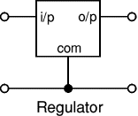

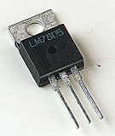

**FIGURE 3.5.Regulator**

## 3.6. Power Supply Circuit Diagram

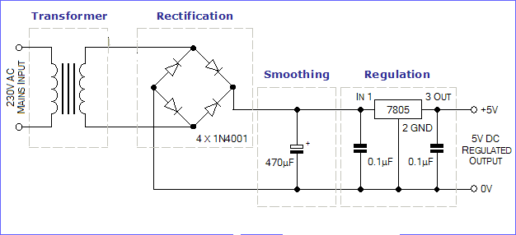 Figure No.3.5

The power supply units provides 5v regulate power supply to the system.it converts 230v ac to 5v dc.

# CHAPTER 4

# MICROCONTROLLER(Atmega328)

A microcontroller (sometimes abbreviated µC, uC or MCU) is a small [computer](http://en.wikipedia.org/wiki/Computer) on a single integrated circuit containing a processor core,memory,andprogrammable [input/output](http://en.wikipedia.org/wiki/Input/output) peripherals. Program memory in the form of [Ferroelectric RAM](http://en.wikipedia.org/wiki/Ferroelectric_RAM), [NOR flash](http://en.wikipedia.org/wiki/NOR_flash) or [OTP ROM](http://en.wikipedia.org/wiki/Programmable_read-only_memory)is also often included on chip, as well as a typically small amount of [RAM](http://en.wikipedia.org/wiki/Random-access_memory). Microcontrollers are designed for embedded applications, in contrast to the [microprocessors](http://en.wikipedia.org/wiki/Microprocessor) used in [personal computers](http://en.wikipedia.org/wiki/Personal_computer) or other general purpose applications.Microcontrollers are used in automatically controlled products and devices, such as automobile engine control systems, implantable medical devices, remote controls, office machines, appliances, power tools, toys and other [embedded systems](http://en.wikipedia.org/wiki/Embedded_system). By reducing the size and cost compared to a design that uses a separate microprocessor, memory, and input/output devices, microcontrollers make it economical to digitally control even more devices and processes. [Mixed signal](http://en.wikipedia.org/wiki/Mixed-signal_integrated_circuit) microcontrollers are common, integrating analog components needed to control non-digital electronic systems.

Some microcontrollers may use four-bit [words](http://en.wikipedia.org/wiki/Word_(computer_architecture)) and operate at [clock rate](http://en.wikipedia.org/wiki/Clock_rate) frequencies as low as 4 kHz, for low power consumption (single-digit milliwatts or microwatts). They will generally have the ability to retain functionality while waiting for an event such as a button press or other interrupt; power consumption while sleeping (CPU clock and most peripherals off) may be just nanowatts, making many of them well suited for long lasting battery applications. Other microcontrollers may serve performance-critical roles, where they may need to act more like a [digital signal processor](http://en.wikipedia.org/wiki/Digital_signal_processor) (DSP), with higher clock speeds and power consumption.

## 4.1. Key parameters for ATmega328

**Parameter Value**

**Flash (Kbytes):**32 Kbytes

**Pin Count**:32

**Max. Operating Freq. (MHz):**20 MHz

**CPU**:8-bit AVR

**# of Touch Channels**:16

**Hardware QTouchAcquisition**:No

**Max I/O Pins**:23

**Ext Interrupts**:24

**USB Speed**:No

**USB Interface**:No

**SPI**:2

**TWI (I2C):**1

**UART**:1

**Graphic LCD**:No

**Video Decoder**:No

**Camera Interface**:No

**ADC channels**:8

**ADC Resolution (bits):**10

**ADC Speed (ksps):**15

**Analog Comparators**:1

**Resistive Touch Screen**:No

**DAC Resolution (bits):**0

**Temp. Sensor**:Yes

**Crypto Engine**:No

**SRAM (Kbytes):**2

**EEPROM (Bytes):**1024

**Self ProgramMemory**:YES

**External Bus Interface**:0

**DRAM Memory:**No

**NAND Interface**:No

**picoPower**:No

**Temp. Range (deg C):-**40 to 85

**I/O Supply Class**:1.8 to 5.5

**Operating Voltage (Vcc):**1.8 to 5.5

**FPU**:No

**MPU / MMU**:no / no

**Timers**:3

**Output Compare channels:**6

**Input Capture Channels**:1

**PWM Channels**:6

**32kHz RTC**:Yes

**Calibrated RC Oscillator**:Yes

**Watchdog**:Yes

**CAN**:0

**LIN**:0

**Etherne**t:0

**Debug Interface**:debugWIRE

**I2S**:No

**RTC**:Counter

## 4.2. Introduction to ATmega32 (AVR Series) 8bit Microcontroller

In our days, there have been many advancement in the field of Electronics and many cutting edge technologies are being  developed every day, but still 8 bit microcontrollers have its own role in the digital electronics market dominated by 16-32 & 64 bit digital devices. Although powerful microcontrollers with higher processing capabilities exist in the market, 8bit microcontrollers still hold its value because of their easy-to-understand-operation, very much high popularity, ability to simplify a digital circuit, low cost compared to features offered, addition of many new features in a single IC and interest of manufacturers and consumers.Today’s microcontrollers are much different from what it were in the initial stage, and the number of manufacturers are much more in count than it was a decade or two ago. At present some of the major manufacturers are Microchip (publication: PIC microcontrollers), Atmel (publication: AVR microcontrollers), Hitachi, Phillips, Maxim, NXP, Intel etc.  Our interest is upon **ATmega32**. It belongs to **Atmel’s AVR series micro controller family**. Let’s see the features.

**PIN count:** Atmega32 has got 40 pins. Two for Power (pin no.10: +5v, pin no. 11: ground), two for oscillator (pin 12, 13), one for reset (pin 9), three for providing necessary power and reference voltage to its internal ADC, and 32 (4×8) I/O pins.

**About I/O pins:** ATmega32 is capable of handling analogue inputs. Port A can be used as either DIGITAL I/O Lines or each individual pin can be used as a single input channel to the internal ADC of ATmega32, plus a pair of pins AREF, AVCC & GND (refer to [**ATmega32 datasheet**](http://www.atmel.com/Images/doc2503.pdf)) together can make an ADC channel.No pins can perform and serve for two purposes (for an example: Port A pins cannot work as a Digital I/O pin while the Internal ADC is activated) at the same time. It’s the programmers responsibility to resolve the conflict in the circuitry and the program. Programmers are advised to have a look to the priority tables and the internal configuration from the datasheet.

**Digital I/O pins:** ATmega32 has 32 pins (4portsx8pins) configurable as Digital I/O pins.

**Timers:** 3 Inbuilt timer/counters, two 8 bit (timer0, timer2) and one 16 bit (timer1).

**ADC:** It has one successive approximation type ADC in which total 8 single channels are selectable. They can also be used as 7 (for TQFP packages) or 2 (for DIP packages) differential channels. Reference is selectable, either an external reference can be used or the internal 2.56V reference can be brought into action.  There external reference can be connected to the AREF pin.

**Communication Options:**  ATmega32 has three data transfer modules embedded in it. They are

* Two  Wire Interface
* USART
* Serial Peripheral Interface

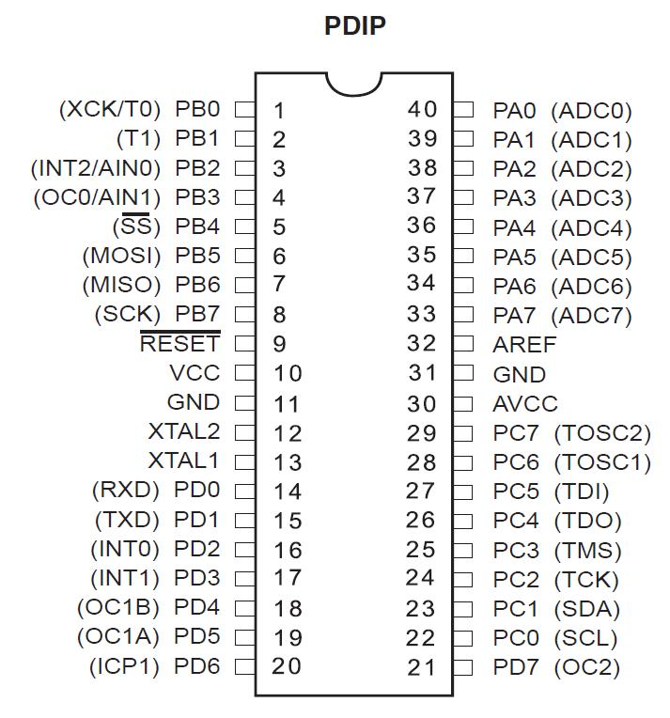

**Atmega32 pin diagram**

**Analog comparator:**  On-chip analog comparator is available. An interrupt is assigned for different comparison result obtained from the inputs.

**External Interrupt:** 3External interrupt is accepted. Interrupt sense is configurable.

**Memory:**  It has 32Kbytes of In-System Self-programmable Flash program memory, 1024 Bytes EEPROM, 2Kbytes Internal SRAM. Write/Erase Cycles: 10,000 Flash / 100,000 EEPROM.

**Clock:** It can run at a frequency from 1 to 16 MHz. Frequency can be obtained from external Quartz Crystal, Ceramic crystal or an R-C network. Internal calibrated RC oscillator can also be used.

**More Features**: Up to 16 MIPS throughput at 16MHz. Most of the instruction executes in a single cycle. Two cycle on-chip multiplication. 32 × 8 General Purpose Working Registers

**Debug:** JTAG boundary scan facilitates on chip debug.

**Programming:** Atmega32 can be programmed either by In-System Programming via Serial peripheral interface or by Parallel programming. Programming via JTAG interface is also possible. Programmer must ensure that SPI programming and JTAG are not be disabled using  fuse bits; if the programming is supposed to be done using SPI or JTAG.

[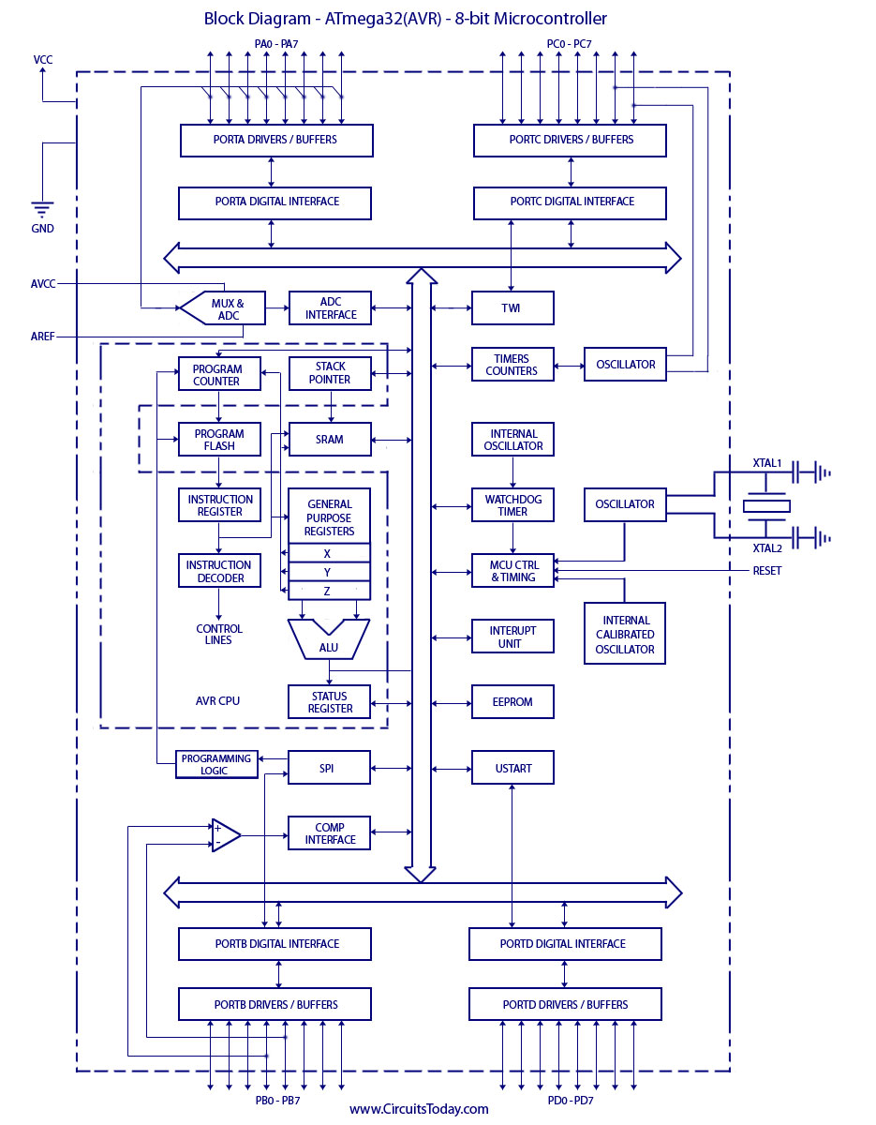](http://www.circuitstoday.com/wp-content/uploads/2012/01/Block-Diagram-ATmega32AVR-8-bit-Microcontroller.jpg)**BLOCK DIAGRAM OF Atmega328**

### 4.2.1. Arduino Digital and Analog I/O Pins

**Digital pins**

Pins 0 – 7: PORT D [0:7]

Pins 8 – 13: PORT B [0:5] }

Pins 14 – 19: PORT C [0:5] (Arduino analog pins 0 – 5) }

digital pins 0 and 1 are RX and TX for serial communication }

digital pin 13 connected to the base board LED }

**Digital Pin I/O Functions**

* **pinMode(pin, mode)**

Sets pin to INPUT or OUTPUT mode }

Writes 1 bit in the DDRx register }

* **digitalWrite(pin, value)**

Sets pin value to LOW or HIGH (0 or 1) }

Writes 1 bit in the PORTx register }

* **int value = digitalRead(pin)**

Reads back pin value (0 or 1)

Read 1 bit in the PINx register

### 4.2.2. Arduino Analog I/O

**Analog input pins**: 0 – 5

**Analog output pins**: 3, 5, 6, 9, 10, 11 (digital pins)

* **Analog input functions**

intval = analogRead(pin)

Converts 0 – 5v.voltage to a 10-bit number (0 – 1023)

Don’t use pinMode

analogReference(type)

Used to change how voltage is converted (advanced) }

* **Analog output**

analogWrite(pin, value)

value is 0 – 255

Generates a PWM output on digital pin (3, 5, 6, 9, 10, 11)

@490Hz frequency

## 4.3. PWM – Pulse Width Modulation

* Use one wire to represent a multi-bit value.
* A clock with a variable duty cycle.
* Duty cycle used to represent value.
* We can turn it into a analog voltage using an integrating filter.

## 4.4. APPLICATIONS

Today the ATmega328 is commonly used in many projects and autonomous systems where a simple, low-powered, low-cost micro-controller is needed. Perhaps the most common implementation of this chip is on the popular [Arduino](http://en.wikipedia.org/wiki/Arduino) development platform, namely the [Arduino Uno](http://en.wikipedia.org/wiki/Arduino_Uno) and [Arduino Nano](http://en.wikipedia.org/w/index.php?title=Arduino_Nano&action=edit&redlink=1) models.

# CHAPTER 5

# GPS RECEIVER

The **Global Positioning System (GPS)** is a Global Navigation Satellite System (GNSS) developed by the United States Department of Defense. It is the only fully functional GNSS in the world. It uses a constellation of between 24 and 32 Medium Earth Orbit satellites that transmit precise microwave signals, which enable GPS receivers to determine their current location, the time, and their velocity. Its official name is **NAVSTAR GPS**. Although NAVSTAR is not an acronym, a few backronyms have been created for it. The GPS satellite constellation is managed by the United States Air Force 50th Space Wing. GPS is often used by civilians as a navigation system.

After Korean Air Lines Flight 007 was shot down in 1983 after straying into the USSR's prohibited airspace, President Ronald Reagan issued a directive making GPS freely available for civilian use as a common good. As suggested by physicist D. Fanellia few years before. Since then, GPS has become a widely used aid to navigation worldwide, and a useful tool for map-making, land surveying, commerce, scientific uses, and hobbies such as geocaching. Also, the precise time reference is used in many applications including the scientific study of earthquakes. GPS is also a required key synchronization resource of cellular networks, such as the Qualcomm CDMA air interface used by many wireless carriers in a multitude of countries.The first satellite navigation system, Transit, used by the United States Navy, was first successfully tested in 1960. Using a constellation of five satellites, it could provide a navigational fix approximately once per hour. In 1967, the U.S. Navy developed the Timation satellite which proved the ability to place accurate clocks in space, a technology that GPS relies upon. In the 1970s, the ground-based Omega Navigation System, based on signal phase comparison, became the first worldwide radio navigation system.The design of GPS is based partly on similar ground-based radio navigation systems, such as LORAN and the Decca Navigator developed in the early 1940s, and used during World War II. Additional inspiration for the GPS came when the Soviet Union launched the first Sputnik in 1957. A team of U.S. scientists led by Dr. Richard B. Kershner were monitoring Sputnik's radio transmissions. They discovered that, because of the Doppler Effect, the frequency of the signal being transmitted by Sputnik was higher as the satellite approached, and lower as it continued away from them.

## 5.1. Working and Operation:

When people talk about "a GPS," they usually mean a GPS receiver. The Global Positioning System (GPS) is actually a constellation of 27 Earth-orbiting satellites (24 in operation and three extras in case one fails). The U.S. military developed and implemented this satellite network as a military navigation system, but soon opened it up to everybody else.  
Each of these 3,000- to 4,000-pound solar-powered satellites circles the globe at about 12,000 miles (19,300 km), making two complete rotations every day. The orbits are arranged so that at any time, anywhere on Earth, there are at least four satellites "visible" inthesky.  
A GPS receiver's job is to locate four or more of these satellites, figure out the distance to each, and use this information to deduce its own location. This operation is based on a simple mathematical principle called trilateration.GPS receiver calculates its position on earth based on the information it receives from four located satellites. This system works pretty well, but inaccuracies do pop up. For one thing, this method assumes the radio signals will make their way through the atmosphere at a consistent speed (the speed of light). In fact, the Earth's atmosphere slows the electromagnetic energy down somewhat, particularly as it goes through the ionosphere and troposphere. The delay varies depending on where you are on Earth, which means it's difficult to accurately factor this into the distance calculations.

Problems can also occur when radio signals bounce off large objects, such as skyscrapers, giving a receiver the impression that a satellite is farther away than it actually is. On top of all that, satellites sometimes just send out bad almanac data, misreporting their own position.  
 Differential GPS (DGPS) helps correct these errors. The basic idea is to gauge GPS inaccuracy at a stationary receiver station with a known location. Since the DGPS hardware at the station already knows its own position, it can easily calculate its receiver's inaccuracy. The station then broadcasts a radio signal to all DGPS-equipped receivers in the area, providing signal correction information for that area. In general, access to this correction information makes DGPS receivers much more accurate than ordinary receivers

## 5.2. G.P.S network:

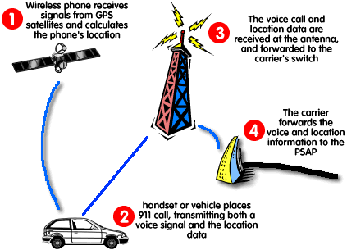

**FIGURE 5.1.G.P.S receiver communicating with the satellite and sending information through the wireless mobile phone**

## 5.3. G.P.S data decoding:

G.P.S receiver continuously sends data and the microcontroller receives the data when ever it requires. The data sent by the G.P.S is a string of characters which should be decoded to the standard format. This is done by the program which we implement in the controller.

## 5.4. Geo positioning -- Basic Concepts:

By positioning we can understand the determination of stationary or moving objects. These can be determined as follows:

1. In relation to a well-defined coordinate system, usually by three coordinate values and
2. In relation to other point, taking one point as the origin of a local coordinate system.

The first mode of positioning is known as point positioning, the second as relative positioning. If the object to be positioned is stationary, we can term it as static positioning. When the objectis moving, we call It kinematics positioning. isused in surveying and the.

## 5.5. GPS - Components and Basic Facts:

The GPS uses satellites and computers to compute positions anywhere on earth. The GPS is based on satellite ranging. That means the position on the earth is determined by measuring the distance from a group of satellites in space. The basic principles behind GPS are really simple, even though the system employs some of the high-techest equipment ever developed. In order to understand GPS basics, the system can be categorized into 5 Logical steps.

They are listed below:

1. Triangulation from the satellite is the basis of the system.
2. To triangulate, the GPS measures the distance using the travel time of the radio message.
3. To measure travel time, the GPS need a very accurate clock.
4. Once the distance to a satellite is known, then we need to know where the satellite is in space.
5. As the GPS signal travels through the ionosphere and the earth's atmosphere, the signal is delayed.

To compute a position in three dimensions, we need to have four satellite measurements. The GPS uses a trigonometric approach to calculate the positions, The GPS satellites are so high up that their orbits are very predictable and each of the satellites is equipped with a very accurate atomic clock.

## 5.5. Components of a GPS:

The GPS is divided into three major components

* The Control Segment
* The Space Segments
* The User Segment
* **Control Segment:**

The Control Segment consists of five monitoring stations (Colorado Springs, Accession Island, Diego Garcia, Hawaii, and Kwajalein Island). Three of the stations (Ascension, Diego Garcia, and Kwajalein) serve as uplink installations, capable of transmitting data to the satellites, including new ephemeredes (satellite positions as a function of time), clock corrections, and other broadcast message data, while Colorado Springs serves as the master control station.The DOD monitoring stations track all GPS signals for use in controlling the satellites and predicting their orbits.

Meteorological data also are collected at the monitoring stations, permitting the most accurate evaluation of tropospheric delays of GPS signals. Satellite tracking data from the monitoring stations are transmitted to the master control station for processing. This processing involves the computation of satellite ephemeredes and satellite clock corrections.

* **Space Segment:**

The Space Segment consists of the Constellation of NAVASTAR earth orbiting satellites. The current Defence Department plan calls for a full constellation of 24 Block II satellites (21 operational and 3 in-orbit spares). The satellites are arrayed in 6 orbital planes, inclined 55 degrees to the equator. They orbit at altitudes of about 12000, miles each, with orbital periods of 12 sidereal hours (i.e., determined by or from the stars), or approximately one half of the earth's periods, approximately 12 hours of 3-D position fixes. The next block of satellites is called Block IIR, and they will provide improved reliability and have a capacity of ranging between satellites, which will increase the orbital accuracy. Each satellite contains four precise atomic clocks (Rubidium and Cesium standards) and has a microprocessor on board for limited self-monitoring and data processing. The satellites are equipped with thrusters which can be used to maintain or modify their orbits.

* **User Segment:**

The user segment is a total user and supplier community, both civilian and military. The User Segment consists of all earth-based GPS receivers. Receivers vary greatly in size and complexity, though the basic design is rather simple. The typical receiver is composed of an antenna and preamplifier, radio signal microprocessor, control and display device, data recording unit, and power supply. The GPS receiver decodes the timing signals from the 'visible' satellites (four or more) and, having calculated their distances, computes its own latitude, longitude, elevation, and time.

## 5.6. How it works:

GPS satellites circle the earth twice a day in a very precise orbit and transmit signal information to earth. GPS receivers take this information and use triangulation to calculate the user's exact location. Essentially, the GPS receiver compares the time a signal was transmitted by a satellite with the time it was received. The time difference tells the GPS receiver how far away the satellite is. Now, with distance measurements from a few more satellites, the receiver can determine the user's position and display it on the unit's electronic map.GPS receiver must be locked on to the signal of at least three satellites to calculate a 2D position (latitude and longitude) and track movement. With four or more satellites in view, the receiver can determine the user's 3D position (latitude, longitude and altitude). Once the user's position has been determined, the GPS unit can calculate other information, such as speed, bearing, track, trip distance, distance to destination, sunrise and sunset time and more.

## 5.7. The GPS satellite system:

The 24 satellites that make up the GPS space segment are orbiting the earth about 12,000 miles above us. They are constantly moving, making two complete orbits in less than 24 hours. These satellites are traveling at speeds of roughly 7,000 miles anhour.GPS satellites are powered by solar energy. They have backup batteries onboard to keep them running in the event of a solar eclipse, when there's no solar power. Small rocket boosters on each satellite keep them flying in the correct path.

Here are some other interesting facts about the GPS satellites (also called NAVSTAR, the official U.S. Department of Defense name for GPS):

* The first GPS satellite was launched in 1978.
* A full constellation of 24 satellites was achieved in 1994
* Each satellite is built to last about 10 years. Replacements are constantly being built and launched into orbit.
* A GPS satellite weighs approximately 2,000 pounds and is about 17 feet across with the solar panels extended.
* Transmitter power is only 50 watts or less.

# CHAPTER 6

# CONCLUSION

The project **“GPS BASED BLIND MAN NAVIGATION SYSTEM”**has been successfully designed and analyzed.

Firstly integrating features of all the hardware components used have developed it.Presence of every module has been reasoned out and placed carefully thus contributing to the best working of unit.

Secondly using highly advanced IC’s and with the help of growing technology the project has been successfully implemented.

In this project an effort has been made to study and implement monitoring and cotrolling of real time industrial applications.

For blinds and physically disable persons in our country no as such arrangements are there.Although they also have the same rights as our’s and they also want to enjoy life as we do.Our aim to design a project for blinds is to facilitate them and help them out so they may need not help of any intruder and become self-reliant.Use of buzzers in this project is the way blind will be able to get know how and the way he will have to go.In case of any accidential happening blind’s guardian will get to know immediately and he will be able to help him.With this system now a blind can go out of home alone too easily.

# REFRENCES

1. Y. J. Szeto, "A navigational aid for persons with severe visual impairments: A project in progress," in Proc. Int. Conf IEEE Eng. Med Biol. Soc., Cancun, Mexico, Sep. 17-21, 2003
2. P. Mihajlik, M. Guttermuth, K. Seres, and P. Tatai, "DSP-based Ultrasonic Navigation Aid for the Blind," in Proc. IEEE Instrumentation and Measurement Technology Conference, Budapest, Hungary, May 21-23, 2001, pp.1535-1540.
3. Dodds, D. Clark-Carter, and C. Howarth, "The sonic PathFinder: an evaluation," Journal of Visual Impairment and Blindness, vol. 78, no. 5, pp. 206-207, 1984.
4. www[.wikipedia.com](http://WWW.wikipedia.com)
5. Heyes, "A polaroid ultrasonic travel aid for the blind," Journal of Visual Impairment and Blindness, vol. 76, pp. 199-201, 1982.
6. T. Ifukube, T. Sasaki, and C. Peng, "A blind mobility aid modeled after echolocation of bats," IEEE Transactions on Biomedical Engineering, vol. 38, no. 5, pp. 461-465, 1991.
7. I.L. Freeston, V.L. Callaghan and N.D. Russel, "A portable navigation aid for the blind," IEEEfrontiers of engineering and computing in health care, pp. 247-249, 1984.
8. www.aplus.com
9. [www.seminortopics.com](http://www.seminortopics.com)
10. www.mycollege projects.com
11. www.scribd.com
12. www.docstoc.com