# *Dedication*

*We dedicate this project to Allah Almighty who blessed us with knowledge and strength to make this project. Than we desiccate this project tour Supervisor, all faculty members, Lab Engineers and Lab Technicians who supported us.*

# ACKNOWLEDGMENT

The guidance and support given by **Our Supervisor** being supervisor of this project is really acknowledged. His deep support and appreciation means a lot in completion of project up till now.

# ABSTRACT

An embedded based power plant boiler automation using PLC and atmega 328 microcontroller is a project which shall be used for monitoring a given industry’s boiler through scada system. The water level in the main tank is controlled by a water level sensor through arduino in which we have defined two levels higher level and low level when the water level be goes down from the low level the solenoid valve will be open and when the water level will goes up from the higher level the solenoid valve will be closed. Then the feedback form the water level circuit is given to the plc. When the tank will be full it will give indications through scada system and when the level of the tank will be low it will also give the notification through scada. There are three solenoid valves one is used for water, second one is used for the pressure through which pressure will be goes out from the boiler and the third solenoid is used in the bottom through which water is exusted. The relay ciruit is used at the output of the plc. The temperature module will gives us the temperature of the boiler. For pressure we made two knobs in the scada which will show us the pressure of the boiler. The gas can be exusted through servo motor in case if the solenoid valve does not open.

Table of Contents

*Dedication* 1

ACKNOWLEDGMENT 2

ABSTRACT 3

Chapter 1 5

INTRODUCTION 5

**1.1** **Overview** 5

**1.2** **Objective** 5

**1.3** **Purpose** 6

**1.4** **Features** 6

**1.5** **Uses** 7

**1.6** **Thesis Layout** 8

Chapter 2 9

LITERATURE REVIEW 9

**2.1 Boiler** 9

**2.2 DIFFERENT SECTIONS OF THE PROJECT:** 11

**2.3 Automatic Soil-Water-Based Irrigation Control: Water Use, Yields and Implications** 12

Chapter 3 13

Tools and Techniques 13

**3.1 Solenoid velve** 13

**3.2 Arduino Uno** 18

**3.3 2n2222 Transistor** 23

**3.4 Diode** 27

**3.5 Spdt Relay** 28

**3.6 Resistor** 29

**3.7 Fatek PLC** 31

2.1.1 Basic PLC schema 35

**3.8 Pressure Sensor** 39

**3.9 Temperature Sensor** 42

Chapter 4 45

PROJECT DESIGN AND IMPLEMENTATION 45

Chapter 5 47

CONCLUSION 47

REFERNCES 48

# 

.

**LIST OF ACRONYMS**

ROM (Read-Only Memory)

RAM (Random Access Memory)

PROM (Programmable Read-Only Memory)

EPROM (Erasable Programmable Read-Only Memory)

EEPROM (Electronically Erasable Programmable Read-Only Memory)

# Chapter 1

## INTRODUCTION

### **Overview**

This project has various stages of operation involved in the conversion of a manually operated boiler towards a fully automated boiler. Over the years the demand for high quality, greater efficiency and automated machines has increased in this globalised world. The initial phase of th focuses on passing the inputs to the boiler at a required temperature, so as to constantly maintain a particular temperature in the boiler. The solenoid valves will helps in this process. And the project focuses on level, pressure and flow control at the various stages of the boiler plant. Thus the temperature in the boiler is constantly monitored and brought to a constant temperature as required by the power plant. The automation is further enhanced by constant monitoring using SCADA screen which is connected to the PLC by means of communication cable. By means of tag values set to various variable in SCADA the entire process is controlled as required. This project has proved to be very efficient practically as the need for automation grows day by day.

### **Objective**

The main objective of this project is to measure the boilers temperature tank level and pressure sensor measured in analog form. A circuit, having IC-LM 35 temperature sensors measures the temperature of the boilers and having the water tank level measures the level of the water tank.

And also having the pressure sensor measure the boiler in pressure. The obtained temperature, level and pressure measuring data are transferred through the atmega328 microcontroller. The microcontroller read the available data and processed.

Designing of a PLC controlled boiler for production of steam with temperature, pressure & level as control parameters.

### **Purpose**

We propose to develop a system of boiler automation using a controller and plc that monitors water levels, pressure and temperature and then automatically adjusts them according to pre-defined user levels, without any need for further human supervision. One of the most important constraints that the project adheres to, is economizing resources, both energy and financial.

### **Features**

We allow several features so that the system is user friendly, effective and financially viable for practical use. The system is aimed at being a marketable utility, so we have incorporated several aspects into achieving this aim.

Since energy conservation is a critical factor in our contemporary era, the system is built around this factor. It uses three solenoid valve to drive water and pressure. it also makes regular maintenance and upkeep of the system easy. Further, replacement of parts or fault detection during the course of its functioning is simplified if the fault will be occur it will be shown through scada system. Finally, it enables the project being extremely versatile; the pump to be used can be customized to the one that best suits the needs of the hour.

The second essential factor is reliability. Again we have ensured a reliable system by using standard parts and offering suitable alternatives wherever applicable.

Since the construction of the external system has been done by using products bought from the top of the shelf, and merely fitting them in the best possible way, it ensures reliability. We have conducted various tests that determine compatibility of used products, set thresholds of their usage and thus determine the most suitable range of running them.

Thirdly, we concentrated on making the system adaptable to different needs, and indeed varying capacities of workload. For this very reason, we have installed a system of dynamically setting levels on the water reservoirs being monitored. As mentioned earlier, the mechanical parts like valves, sensors, plc and tank system can be tailored to individual needs. All this makes the project intelligent to surrounding needs.

Furthermore, we set upon the task of making the system an “intelligent environment for boiler automation. We achieved this goal over various facets. This included incorporating Priority control of reservoirs. Our system is capable of setting priority levels to different water reservoirs, and hence servicing them accordingly.

### **Uses**

Since we designed the system primarily for boiler automation, the project can be also used in a host of settings related to water management.

* This could be installed in small towns where there is a need to monitor several water tanks filled from a central water reservoir. Since the system accommodates scalability, this could service any magnitude of need.
* It will also give the pressure and temperature through scada
* In industrial uses, this project could be used to regulate levels of any conducting fluid. Since the project essentially runs on the conducting nature of the fluid, the only requirement is that this fluid whose levels are being monitored should be conducting.
* In places where water and power is of high value, or is in dearth, the system is ideal as it incorporates a high degree of conservation of both these resources.
* Finally, in projects like dams, or hydro-power generating stations, this would be an invaluable accessory, to regulate water levels also in the place where temperature and pressure is very high and we cannot take the reading manually it will gives us the reading on scada no need to go towards the tank.

### **Thesis Layout**

In 1st chapter we explain our project and working mechanics. 2nd chapter covers the literature review and related project and research. 3rd chapter based on two parts: software and hardware work. In 4th chapter results and conclusion of the project.

# Chapter 2

## LITERATURE REVIEW

Over the years the demand for high quality, greater efficiency and automated machines has increased in the industrial sector of power plants. Power plants require continuous monitoring and inspection at frequent intervals. There are possibilities of errors at measuring and various stages involved with human workers and also the lack of few features of microcontrollers. Thus this paper takes a sincere attempt to explain the advantages the companies will face by implementing automation into them.

In order to automate a power plant and minimize human intervention, there is a need to develop a SCADA (Supervisory Control and Data Acquisition) system that monitors the plant and helps reduce the errors caused by humans. While the SCADA is used to monitor the system, PLC (Programmable Logic Controller) is also used for the internal storage of instruction for the implementing function such as logic, sequencing, timing, counting and arithmetic to control through digital or analog input/ out put modules various types of machines processes. Systems are used to monitor and control a plant or equipment in industries such as telecommunications, water and waste control, energy, oil and gas refining and transportation.

### **2.1 Boiler**

Steam boiler or simply a boiler is basically a closed vessel into which water is heated until the water is converted into steam at required pressure. This is most basic definition of boiler.

**Working Principle of Boiler**

The basic working principle of boiler is very very simple and easy to understand. The boiler is essentially a closed vessel inside which water is stored. Fuel (generally coal) is bunt in a furnace and hot gasses are produced. These hot gasses come in contact with water vessel where the heat of these hot gases transfer to the water and consequently steam is produced in the boiler. Then this steam is piped to the turbine of [thermal power plant](http://www.electrical4u.com/thermal-power-generation-plant-or-thermal-power-station/). There are many different types of boiler utilized for different purposes like running a production unit, sanitizing some area, sterilizing equipment, to warm up the surroundings etc.

**Types of Boiler**

There are mainly two types of boiler – [water tube boiler](http://www.electrical4u.com/water-tube-boiler-operation-and-types-of-water-tube-boiler/) and [fire tube boiler](http://www.electrical4u.com/fire-tube-boiler-operation-and-types-of-fire-tube-boiler/). In [fire tube boiler](http://www.electrical4u.com/fire-tube-boiler-operation-and-types-of-fire-tube-boiler/), there are numbers of tubes through which hot gases are passed and water surrounds these tubes. Water tube boiler is reverse of the [fire tube boiler](http://www.electrical4u.com/fire-tube-boiler-operation-and-types-of-fire-tube-boiler/). In [water tube boiler](http://www.electrical4u.com/water-tube-boiler-operation-and-types-of-water-tube-boiler/) the water is heated inside tubes and hot gasses surround these tubes. These are the main two types of boiler but each of the types can be sub divided into many which we will discuss later.

**Water Tube Boiler**

A water tube boiler is such kind of boiler where the water is heated inside tubes and the hot gasses surround them.

This is the basic definition of water tube boiler. Actually this boiler is just opposite of [fire tube boiler](http://www.electrical4u.com/fire-tube-boiler-operation-and-types-of-fire-tube-boiler/) where hot gasses are passed through tubes which are surrounded by water.

**Types of Water Tube Boiler**

There are many types of [water tube boilers](http://www.electrical4u.com/water-tube-boiler-operation-and-types-of-water-tube-boiler/), such as

1) Horizontal Straight Tube Boiler.

2) Bent Tube Boiler.

3) Cyclone Fired Boiler.

Horizontal Straight Tube Boiler again can be sub - divided into two different types,

i) Longitudinal Drum Water Tube Boiler.

ii) Cross Drum Water Tube Boiler.

Bent Tube Boiler also can be sub divided into four different types,

i) Two Drum Bent Tube Boiler.

ii) Three Drum Bent Tube Boiler.

iii) Low Head Three Drum Bent Tube Boiler.

iv) Four Drum Bent Tube Boiler.

**Advantages of Water Tube Boiler**

There are many advantages of [water tube boiler](http://www.electrical4u.com/water-tube-boiler-operation-and-types-of-water-tube-boiler/) due to which these types of boiler are essentially used in large [thermal power plant](http://www.electrical4u.com/thermal-power-generation-plant-or-thermal-power-station/).

1) Larger heating surface can be achieved by using more numbers of water tubes.

2) Due to convectional flow, movement of water is much faster than that of [fire tube boiler](http://www.electrical4u.com/fire-tube-boiler-operation-and-types-of-fire-tube-boiler/), hence rate of heat transfer is high which results into higher efficiency.

3) Very high pressure in order of 140 kg/cm2 can be obtained smoothly.

**Disadvantages of Water Tube Boiler**

1) The main disadvantage of water tube boiler is that it is not compact in construction.

2) Its cost is not cheap.

3) Size is a difficulty for transportation and construction.

### **2.2 DIFFERENT SECTIONS OF THE PROJECT:**

The project incorporates the requirement of a physical PLC trainer kitwhich is responsible for collection of data from field sensors (within the boiler),evaluate them & generate appropriate output for the boiler to operate in a specificdesired procedure. Initially, we divided our project into four sections viz., power supply section, water supply section, boiler(including sensors) section, processcontrolling section.

#### 2.2.1 Boiler Section:

Boiling container, sensors (presssure,temperature & level sensors) & a heater assemble altogether to give rise to the boiler section.

#### 2.2.2 Controlling Section:

This section includes the PLC trainer kit which is responsible for datacollection from field sensors, evaluation of collected data & generation of appropriate outputsignals for automatic actuation and termination of different peripherals incorporated in theoverall system.

#### 2.2.3 Water Supply Section:

Water supply to the boiler is ensured by a water pump whose actuation& termination is controlled by the PLC trainer.

#### 2.2.4 Power Supply Section:

This takes care of the power requirements for the whole project. Thismostly comprises of the circuits providing DC power for the field sensors and valves (solenoids).

#### 2.2.5 APPLICATIONS:

The main advantage of using PLCs is the drastic reduction in the requirement of electrical components in terms of number of switches, relays, wiring, etc.theapplications of this project are solely the applications of a boiler i.e., production of steam andusing it for numerous processes like rotating the generator fins and hence producing power for commercial or industrial purposes

# Chapter 3

## Tools and Techniques

“*Tools and techniques are keys to success”*

*-Anonymous*

Selection of tools and implementation of better techniques are considered very important for any project to be successful. For designing of this System different tools and techniques are used. This chapter includes details of these tools and techniques.

### **3.1 Solenoid velve**

A solenoid valve is an electronically operated device. It is used to control the flow of liquids or gases in a positive, fully-closed or fully-open mode. The valve is commonly used to replace a manual valve or where remote control is desirable. A solenoid is operated by opening and closing an orifice in a valve body that permits or prevents flow through the valve. The orifice is opened or closed through the use of a plunger that is raised or lowered within a sleeve tube by energizing the coil. The bottom of the plunger contains a compatible sealing material, which closes off the orifice in the body, stopping flow through the valve.

The solenoid assembly consists of a coil, plunger, and sleeve assembly. In a normally closed valve, a plunger return spring holds the plunger against the orifice, preventing flow through the valve. When the coil is energized, a magnetic field is produced, raising the plunger and allowing flow through the valve. In a normally open valve, when the coil is energized, the plunger seals off the orifice, stopping flow through the valve.

**Direct Operated Solenoid Valves**

Direct operated solenoid valves function to directly open or close the main valve orifice, which is the only flow path in the valve. Direct operated valves are used in systems requiring low flow capacities or in applications with low pressure differential across the valve orifice. The sealing surface that opens and closes the main valve orifice is connected to the solenoid plunger. The valve operates from zero pressure differential to maximum rated pressure differential (MOPD) regardless of line pressure. Pressure drop across the valve is not required to hold the valve open.

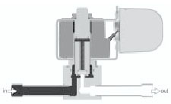

Coil de-energized, valve closed

**Pilot Operated Valves**

Pilot operated valves are the most widely used solenoid valves. Pilot operated valves utilize system line pressure to open and close the main orifice in the valve body. In a piston-style valve, the main orifice is held closed with a piston seal pressed against the main orifice by the combined fluid pressure and spring pressure. In a normally closed valve, the piston is shifted or opened when the pilot operator is energized. This allows fluid behind the piston to evacuate through the valve outlet. At this point, the system line pressure moves the piston, opening the main orifice of the valve allowing high capacity flow through the valve. When energizing the coil of a normally open valve, fluid pressure builds up behind the piston, forcing the piston to seal the main orifice of the valve.

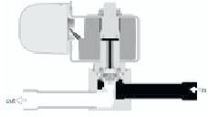

Coil de-energized, valve closed

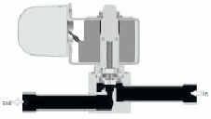

Coil energized, valve open

**Design Terminology**

**Continuous Duty**

 A rating given to a valve that can be energized continuously without overheating.

**Correction Factor**

A mathematical relationship related to a fluid’s specific gravity used to convert specific flows from a standard media to the media in question.

**Current drain**

The amount of current (expressed in amperes) that flows through the coil of a solenoid valve when it is energized.

**Cv Factor**

A mathematical factor that represents the quantity of water, in gallons per minute, that will pass through a valve with a 1 psi pressure drop across the valve.

**Flow**

Movement of fluid created by a pressure differential.

**Flow Capacity**

The quantity of fluid that will pass through a valve under a given set of temperature and pressure conditions.

**Manual Stem**

A mechanical device that permits the manual opening or closing of a valve in the case of emergency or power failure. A manual stem is available on all normally closed valves.

**Maximum Operating Pressure Differential (MOPD)**

The maximum pressure difference between the inlet and outlet pressures of the valve must not be exceeded, allowing the solenoid to operate in both the energized and de-energized positions.

**Minimum Operating Pressure Differential**

The minimum pressure difference between the inlet and outlet pressures required for proper operation. This minimum operating pressure differential must be maintained throughout the operating cycle of pilot operated valves to assure proper shifting from the closed position to the open position and visa versa. In the absence of the minimum operating pressure, the valve may close or will not fully open.

**Orifice**

The main opening through which fluid flows.

**Safe Working Pressure**

The maximum pressure a valve may be exposed to without experiencing any damage. The valve does not have to be operable at this pressure, but merely withstand the pressure without damage.

**Different parts of a solenoid valve**

The illustration below depicts the basic components of a solenoid valve. The valve shown in the picture is a [normally-closed](http://www.solenoid-valve-info.com/solenoid-valve-terminology.html#normally_closed), [direct-acting valve](http://www.solenoid-valve-info.com/solenoid-valve-terminology.html#direct_acting). This type of solenoid valve has the most simple and easy to understand principle of operation.

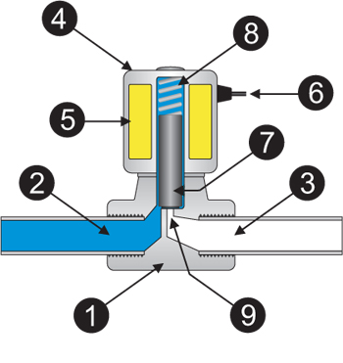

|  |  |  |
| --- | --- | --- |
| **1. Valve Body** | **4. Coil / Solenoid** | **7. Plunger** |
| **2. Inlet Port** | **5. Coil Windings** | **8. Spring** |
| **3. Outlet Port** | **6. Lead Wires** | **9. Orifice** |

**Working of solenoid valve**

The media controlled by the solenoid valve enters the valve through the[inlet port](http://www.solenoid-valve-info.com/solenoid-valve-terminology.html#port_inlet) (Part 2 in the illustration above). The [media](http://www.solenoid-valve-info.com/solenoid-valve-terminology.html#media) must flow through the [orifice](http://www.solenoid-valve-info.com/solenoid-valve-terminology.html#orifice) (9) before continuing into the [outlet port](http://www.solenoid-valve-info.com/solenoid-valve-terminology.html#port_outlet) (3). The orifice is closed and opened by the [plunger](http://www.solenoid-valve-info.com/solenoid-valve-terminology.html#plunger) (7).

The valve pictured above is a normally-closed solenoid valve. Normally-closed valves use a spring (8) which presses the plunger tip against the opening of the orifice. The sealing material at the tip of the plunger keeps the media from entering the orifice, until the plunger is lifted up by an electromagnetic field created by the [coil](http://www.solenoid-valve-info.com/solenoid-valve-terminology.html#valve_coil).

### **3.2 Arduino Uno**

**Introduction**

The Arduino microcontroller is an easy to use yet powerful single board computer. The Arduino is open-source, which means hardware is reasonably priced and development software is free. The Arduino project was started in Italy to develop low cost hardware for interaction design.

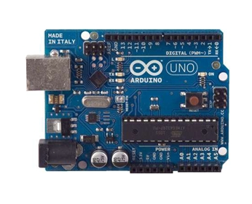

The project is based on microcontroller board designs, manufactured by several vendors, using various microcontrollers. These systems provide sets of digital and analog [I/O](https://en.wikipedia.org/wiki/I/O) pins that can be interfaced to various expansion boards ("shields") and other circuits. The boards feature serial communications interfaces, including [USB](https://en.wikipedia.org/wiki/USB) on some models, for loading programs from personal computers. For programming the microcontrollers, the Arduino project provides an [integrated development environment](https://en.wikipedia.org/wiki/Integrated_development_environment) (IDE) based on the [Processing](https://en.wikipedia.org/wiki/Processing_(programming_language)) project, which includes support for the [C](https://en.wikipedia.org/wiki/C_programming_language) and [C++](https://en.wikipedia.org/wiki/C%2B%2B_programming_language) programming languages.

|  |  |
| --- | --- |
| Microcontroller | ATmega328 |
| Operating Voltage | 5V |
| Input Voltage (recommended | 7-12V |
| Input Voltage (limits) | 6-20V |
| Digital I/O Pins | 14 (of which 6 provide PWM output) |
| Analog Input Pins | 6 |
| DC Current per I/O Pin | 40 mA |
| DC Current for 3.3V Pin | 50 mA |
| Flash Memory | 32 KB ofwhich0.5 KB used by bootloader |
| SRAM | 2 KB |
| EEPROM | 1 KB |
| Clock Speed | 16 MHz |

The power pins are as follows:

* **VIN**. The input voltage to the Arduino board when it's using an external power source (as opposed to 5 volts from the USB connection or other regulated power source). You can supply voltage through this pin, or, if supplying voltage via the power jack, access it through this pin.
* **5V.** The regulated power supply used to power the microcontroller and other components on the board. This can come either from VIN via an on-board regulator, or be supplied by USB or another regulated 5V supply.
* **3V3**. A 3.3 volt supply generated by the on-board regulator. Maximum current draw is 50 mA.
* GND. Ground pins.
* **Serial**: 0 (RX) and 1 (TX). Used to receive (RX) and transmit (TX) TTL serial data.These pins are connected to the corresponding pins of the ATmega8U2 USB-to-TTL Serial chip.
* **External Interrupts**: 2 and 3. These pins can be configured to trigger an interrupt on a low value, a rising or falling edge, or a change in value. See the [attachInterrupt()](http://arduino.cc/en/Reference/AttachInterrupt) function for details.
* **PWM**: 3, 5, 6, 9, 10, and 11. Provide 8-bit PWM output with the [analogWrite()](http://arduino.cc/en/Reference/AnalogWrite) function.
* **SPI**: 10 (SS), 11 (MOSI), 12 (MISO), 13 (SCK). These pins support SPI communication, which, although provided by the underlying hardware, is not currently included in the Arduino language.
* **LED**: 13. There is a built-in LED connected to digital pin 13. When the pin is HIGH value, the LED is on, when the pin is LOW, it's off.

**Working System**

* 1. Arduino Duemilanove board
* 2. USB programming cable (A to B)
* 3. 9V battery or external power supply (for stand-alone operation)
* 4. Solderless breadboard for external circuits, and 22 g solid wire for connections
* 5. Host PC running the Arduino development environment. Versions exist for Windows, Mac and Linux

The Arduino Uno has a number of facilities for communicating with a computer, another Arduino, or other microcontrollers. The ATmega328 provides UART TTL (5V) serial communication, which is available on digital pins 0 (RX) and 1 (TX). An ATmega8U2 on the board channels this serial communication over USB and appears as a virtual com port to software on the computer. The '8U2 firmware uses the standard USB COM drivers, and no external driver is needed. However, on Windows, an *.inf file is required. The Arduino software includes a serial monitor which allows simple textual data to be sent to and from the

Arduino board. The RX and TX LEDs on the board will flash when data is being transmitted via the USB-toserial chip and USB connection to the computer (but not for serial communication on pins 0 and 1). A SoftwareSerial library allows for serial communication on any of the Uno's digital pins. The ATmega328 also support I2C (TWI) and SPI communication. The Arduino software includes a Wire library to simplify use of the I2C bus; see the documentation for details. To use the SPI communication.

The Arduino Uno can be programmed with the Arduino software (download). Select "Arduino Uno w/ATmega328" from the Tools > Board menu (according to the microcontroller on your board). The ATmega328 on the Arduino Uno comes preburned with a bootloader that allows you to upload new code to it without the use of an external hardware programmer. It communicates using the original STK500 protocol (reference, C header files). You can also bypass the bootloader and program the microcontroller through the ICSP (In-Circuit Serial Programming) header; see these instructions for details. The ATmega8U2 firmware source code is available . The ATmega8U2 is loaded with a DFU bootloader, which can be activated by connecting the solder jumper on the back of the board (near the map of Italy) and then resetting the 8U2. You can then use Atmel's FLIP software (Windows) or the DFU programmer (Mac OS X and Linux) to load a new firmware. Or you can use the ISP header with an external programmer

**Installing the Software**

This is the indication that you have all software and drivers successfully installed and can start exploring with your own programs.

**Connecting a Battery**

For stand-alone operation, the board is powered by a battery rather than through the USB connection to the computer. While the external power can be anywhere in the range of 6 to 24V (for example, you could use a car battery), a standard 9 V battery is convenient. While you could jam the leads of a battery snap into the Vin and Gnd connections on the board, it is better to solder the battery snap leads to a DC power plug and connect to the power jack on the board.

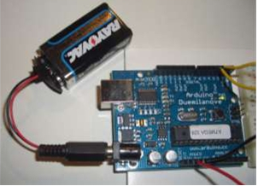

**Solderless Breadboards**

A solderless breadboard is an essential tool for rapidly prototyping electronic circuits.

Components and wire push into breadboard holes. Rows and columns of holes are internally connected to make connections easy. Wires run from the breadboard to the I/O pins on the Arduino board. Make connections using short lengths of 22 g solid wire stripped of insulation about 0.25” at each end. The pairs of horizontal runs at the top and bottom are useful for running power and ground. Convention is to make the red colored run +5 V and the blue colored run Gnd. The power runs are sometimes called “power busses”.

**Programming Concepts**

A computer program is a sequence of step-by-step instructions for the computer to follow. The computer will do exactly what you tell it to do, no more no less. The computer only knows what's in the program, not what you intended. Thus the origin of the phrase, "Garbage in, garbage out".

### **3.3 2n2222 Transistor**

The 2N222 [transistor](http://www.wisegeek.com/what-is-a-transistor.htm) is a common negative-positive-negative (NPN) bipolar junction transistor (BJT) that finds use in many different kinds of electronic equipment. It is used for both analog signal amplification and switching applications.The 2N2222 has three wire leads used to solder it to circuit boards: the collector, the [emitter](http://www.wisegeek.com/what-is-an-emitter.htm), and the base. When an electronic signal is present at the transistor’s collector, applying a signal to the transistor’s base will cause a signal to emit from the device’s emitter. In this way, the 2N2222 is often used to switch signals on and off.

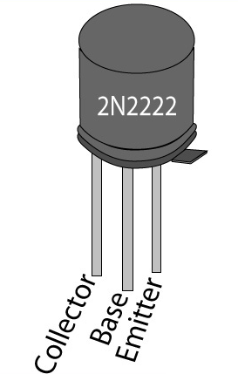

**Switching:**

The switching abilities of the 2N2222 transistor also make it useful as a simple “and” gate. When used in this capacity, the transistor will only send a signal when two separate signals are present: one at its collector and one at its base. This allows the 2N2222 to be used to automatically control signal flow in a circuit depending on what signals are, or are not, present.

**Amplification:**

In amplification applications, the 2N2222 receives an analog signal, such as an audio signal, through its collector and a separate signal is applied to its base. The output at the transistor’s emitter will then be identical to the collector signal with the exception that it increases in power by an amount proportional to the signal applied to its base. Additionally, varying the signal applied to the base will vary the amplification of the signal leaving the emitter.

**Operational characteristics:**

Operational characteristics make the 2N2222 a low- to medium-current (up to 600 milliamps), low-power (up to 625 milliwatts), medium-voltage (up to 40 volts) device. Though these parameters may seem to limit the 2N2222’s usefulness, the 2N2222 is perfect for a host of signal manipulation and handling applications prior to high-power amplification. 2N2222 transistors are also used to condition signals before and after application to more advanced digital devices.

While the 2N2222 was the first of its kind, it has spawned a number of variants collectively called “2N2222 type” transistors, because they all share functional-construction and operational characteristics identical to the original 2N2222 transistor. Chief among these variants is the P2N2222 transistor, which is enclosed in a small black TO-92 package made of either epoxy or plastic. The combination of the large number of uses for the 2N2222 and the cost-effective TO-92 package has made the P2N2222 the least expensive and most used transistor in electonics.

The transistor 2N2222 is one of the important and very commonly used transistor type which finds numerous switching application in electronic circuts.

**Features:**

The main feature of this transistor is its ability to handle relatively high magnitudes of currents compared to other simiar small signal types of transistors.Typically, a 2N2222 transistor is able to switch 800 mA of load current through it, which may be considered quite high compared to the miniature size owned by these devices.High current switching capability also makes this device ideally suited for linear amplifier applications.

**Characteristics:**

The main characteristics of this device may be understood with the following points:

* The transistor 2N2222 or 2N2222A are NPN types and has the following electrical parameters:
* The device’s maximum voltage tolerance (breakdown voltage) across its collector and base is 60 volts for 2N2222 and 75 volts for 2N2222A, with the emitters kept open.
* With their base open, the above tolerance across their collector and emitter leads is 30 volts for 2N2222 and 40 volts for 2N2222A.
* As expressed earlier, the maximum current that can be applied across the transistors collector and emitter, via a load is not more than 800 mA.
* Total power dissipation of the device should not exceed above 500 mW.
* hFE or the dC current gain of 2N2222 transistors will be around 75 minimum, at voltages near 10, with 10 mA collector current.
* Maximum frequency handling capacity or the transition frequency is 250 MHz for 2N2222 and 300 MHz for 2N2222A.

 The base-emitter saturation voltage for 2N2222 is typically 1.3 volts @ 15 mA, when the collector current is around 150 mA. With collector current exceeding 500 mA, the base optimal trigger voltage becomes 2.6 volts. For a 2N2222A, the figures are 1.2 and 2 volts respectively.Configuring the device practically in electronic circuits for any relevant application:

This may be done by following the below explained steps:

* The pin out or the leg that’s marked emitter must be connected to the negative line of the supply rail.
* The load which needs to be switched must be connected in between the collector of the transistor and the positive supply, that is, the positive lead of the load goes to the positive supply while the other lead of the load gets connected to the collector lead of the transistor.
* The base goes to the source voltage or the triggering voltage via a current limiting resistor.
* The value of the current limiting resistor may be calculated by using the formula explained at the end of [this article.](http://homemadecircuitsandschematics.blogspot.in/2012/01/how-to-make-relay-driver-stage-in.html)
* The transistor 2N2907 is complementary pair for 2N2222 and has identical specs as above, however being a PNP type the associated polarities are exactly opposite

### **3.4 Diode**

A diode is a very simple device and it has a lot of applications. We will cover some of its uses and explain exactly how it works in very simple terms.   A diode is a device that passes current in only one direction.  It is a bit like a water-valve that prevents water back flowing into the mains from your property.

There are many types of diodes to handle small currents, large currents, high frequencies and high voltages. And there are diodes made from different materials, but they can all be described in a simple way and that's what we will do. A diode has two leads. These are called ANODE and CATHODE

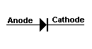

The cathode end is identified in a circuit diagram and on the body of the device. It may be identified with a line, chamfer or dimple or a symbol. There must be something on the diode that identifies this lead and you have to look for it.

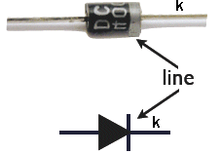

In the following diagram only the CATHODE is identified with the letter k (for kathode). The other lead is the ANODE.

As mentioned above, a diode does not start to TURN ON until a small voltage is present on its ANODE lead. Fora Germanium diode this voltage is approx 0.3v. For a Schottkey diode, this voltage is 0.3v. For a Silicon diode, this voltage is 0.7v. As the current increases, this voltage can rise to about 1.1v (at full current-flow for the diode).

### **3.5 Spdt Relay**

A relay is an electrically operated switch used to isolate one electrical circuit from another. In its simplest form, a relay consists of a coil used as an electromagnet to open and close switch contacts. Since the two circuits are isolated from one another, a lower voltage circuit can be used to trip a relay, which will control a separate circuit that requires a higher voltage or amperage. Relays can be found in early telephone exchange equipment, in industrial control circuits, in car audio systems, in automobiles, on water pumps, in high-power audio amplifiers and as protection devices.

**Operation and uses of Relays:**

The main operation of a relay comes in places where only a low-power signal can be used to control a circuit. It is also used in places where only one signal can be used to control a lot of circuits. The application of relays started during the invention of telephones. They played an important role in switching calls in telephone exchanges. They were also used in long distance telegraphy. They were used to switch the signal coming from one source to another destination. After the invention of computers they were also used to perform Boolean and other logical operations. The high end applications of relays require high power to be driven by electric motors and so on. Such relays are called contactors.

**Working of Relay:**

Working of relay is simple, when power is supplied to relay current start flowing through the control coil as a result electromagnetic starts energizing. Hear points A,B,C are used as control points. When power is applied to input terminal due to electromagnetic effect, B and C are connected thus closes the contacts causing a short circuit for the power to the load. If the relay was already de-energized when the contacts were closed, then thecontact move opposite and make an open circuit. When power supply is cut off point A and C are connected. This force is mainly provided by two factors they are spring and gravity.

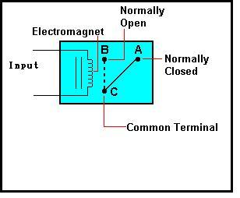

**Relay Applications**

* Relays are used to realize logic functions. They play a very important role in providing safety critical logic.
* Relays are used to provide time delay functions. They are used to time the delay open and delay close of contacts.
* Relays are used to control high voltage circuits with the help of low voltage signals. Similarly they are used to control high current circuits with the help of low current signals.

### **3.6 Resistor**

Resistor is electrical or electronic components which resist the flow of current across the resistor device. The resistance to current flow results in a voltage drop across the resistor device. Resistors are used extensively throughout electrical and electronic circuits.

Resistor devices may provide a fixed, variable, or adjustable value of resistance. Adjustable resistors are refers to as rheostats, or potentiometers. Resistor values are expressed in Ohms, the electric resistance unit. Resistors are incorporated within a electrical or electronic circuit create a known voltage drop or current to voltage relationship.

 If the electrical current in a circuit is known (current is measured in amperes), then a resistor can be used to create a known potential difference (voltage difference) proportional to that current.   
Conversely, if the voltage drop (potential difference) across two points in a circuit is known, a resistor can be used to create a known current proportional to that difference.

An attenuator is a network of two or more resistors (a voltage divider).   
A line terminator is a resistor at the end of a transmission line or daisy chain bus, designed to match impedance and minimize reflections of the electronic signal.

A resistor is a [passive](https://en.wikipedia.org/wiki/Passivity_(engineering)) [two-terminal](https://en.wikipedia.org/wiki/Terminal_(electronics)) [electrical component](https://en.wikipedia.org/wiki/Electronic_component) that implements [electrical resistance](https://en.wikipedia.org/wiki/Electrical_resistance) as a circuit element. Resistors act to reduce current flow, and, at the same time, act to lower voltage levels within circuits. In electronic circuits, resistors are used to limit current flow, to adjust signal levels, [bias](https://en.wikipedia.org/wiki/Biasing) active elements, and terminate [transmission lines](https://en.wikipedia.org/wiki/Transmission_line) among other uses. High-power resistors, that can dissipate many [watts](https://en.wikipedia.org/wiki/Watt) of electrical power as heat, may be used as part of motor controls, in power distribution systems, or as test loads for [generators](https://en.wikipedia.org/wiki/Electric_generator). Fixed resistors have resistances that only change slightly with temperature, time or operating voltage. Variable resistors can be used to adjust circuit elements (such as a volume control or a lamp dimmer), or as sensing devices for heat, light, humidity, force, or chemical activity.

Resistors are common elements of [electrical networks](https://en.wikipedia.org/wiki/Electrical_network) and [electronic circuits](https://en.wikipedia.org/wiki/Electronic_circuit) and are ubiquitous in [electronic equipment](https://en.wikipedia.org/wiki/Electronics). Practical resistors as discrete components can be composed of various compounds and forms. Resistors are also implemented within[integrated circuits](https://en.wikipedia.org/wiki/Integrated_circuits).

The electrical function of a resistor is specified by its resistance: common commercial resistors are manufactured over a range of more than nine [orders of magnitude](https://en.wikipedia.org/wiki/Orders_of_magnitude). The nominal value of the resistance will fall within a [manufacturing tolerance](https://en.wikipedia.org/wiki/Engineering_tolerance#Electrical_component_tolerance).

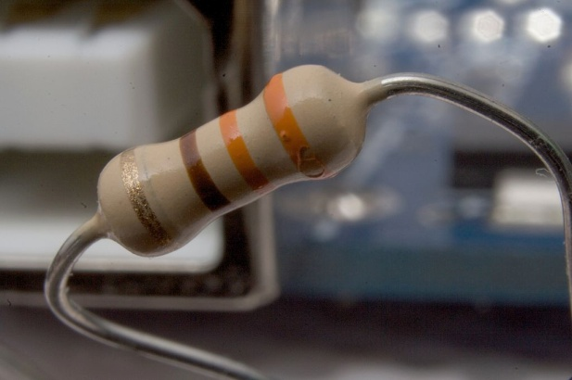

### **3.7 Fatek PLC**

PLC applications are extensively used in industry to control and facilitate repetitive processessuch as manufacturing cell management, fly-by-wire control, or nuclear plant shutdown systems.One of these applications is industrial automation which includes numerous automated processes. This again includes automation of boiler which demands determination of certain physical parameters (viz. pressure, temperature, etc.) & utilizing these parameters to make the boiler start-stop or function in any manner we want, but automatically, without involvement of any personal.

PLC is a Micro Processor based Electronic Device which is used to control certain process according to predefined programs which are saved in the PLC.  These programs can be change or modified as per the requirement. PLC is a Programmable Logic Controller. A programmer written program as per client requirement, which relates to inputs / outputs of PLC. Outputs can activate the field equipment(Motor, Solenoid valve etc.)  and Inputs can sense field equipment ( Limit Switch, Zero Speed Sensor etc.).

A **PROGRAMMABLE LOGIC CONTROLLER** (PLC) is an industrial computer control system that continuously monitors the state of input devices and makes decisions based upon a custom program to control the state of output devices.

Almost any production line, machine function, or process can be greatly enhanced using this type of control system. However, the biggest benefit in using a PLC is the ability to change and replicate the operation or process while collecting and communicating vital information.

Another advantage of a PLC system is that it is modular. That is, you can mix and match the types of Input and Output devices to best suit your application.

**History of PLCs**

The first Programmable Logic Controllers were designed and developed by Modicon as a relay re-placer for GM and Landis.

* These controllers eliminated the need for rewiring and adding additional hardware for each new configuration of logic.
* The new system drastically increased the functionality of the controls while reducing the cabinet space that housed the logic.
* The first PLC, model 084, was invented by Dick Morley in 1969
* The first commercial successful PLC, the 184, was introduced in 1973 and was designed by Michael Greenberg.

**PLC Operation**

The Central Processing Unit, the CPU, contains an internal program that tells the PLC how to perform the following functions:

* Execute the Control Instructions contained in the User's Programs. This program is stored in "nonvolatile" memory, meaning that the program will not be lost if power is removed
* Communicate with other devices, which can include I/O Devices, Programming Devices, Networks, and even other PLCs.
* Perform Housekeeping activities such as Communications, Internal Diagnostics, etc.

There are four basic steps in the operation of all PLCs; Input Scan, Program Scan, Output Scan, and Housekeeping. These steps continually take place in a repeating loop.

|  |  |  |  |  |  |  |  |  |
| --- | --- | --- | --- | --- | --- | --- | --- | --- |
| **Four Steps In The PLC Operations**   |  | | --- | | 1.) Input Scan | | * Detects the state of all input devices that are connected to the PLC |  |  | | --- | | 2.) Program Scan | | * Executes the user created program logic |  |  | | --- | | 3.) Output Scan | | * Energizes or de-energize all output devices that are connected to the PLC. |  |  | | --- | | 4.) Housekeeping | | * This step includes communications with programming terminals,  internal diagnostics, etc... | |

The hardware part of this project is Programmable logic controller (PLC) and a loadshedding model. FATEK 14MC is the type of PLC used in this project as the processor to control the loadshedding system. This type of PLC was been chosen because the characteristic is fully necessary by the development of loadshedding control system.

The loadshedding control system consists of the 220vac loads connected to the PLC to demonstrate the working of loadshedding management system.

**PLC configuration**

Many PLC configurations are available, even from a single vendor. But each of these has common components and concepts. The most essential component is are:

**Power supply**

This can be built into the PLC or be an external unit. Common voltage levels required by the PLC are 24Vdc 100Vac 240Vac.

**CPU (central Processing Unit)**

This is a computer where ladder logic is stored and processed.

**I/O (Input/output)**

A number of input/output terminals must be provided so that the PLC can monitor the process and initiate actions. Inputs to, and outputs from, a PLC is necessary to monitor and control a process. Both inputs and outputs can be categorized into two basic types: logical or continuous. Consider the example of a light bulb. If it can only be turned on or off, it is logical control. If the light can be dimmed to different levels, it is continuous.

**Indicator lights**

These indicate the status of the PLC including power on program running and

An error. These are essential when diagnosing problems.

**Rack Type :**

A rack can often be as large as 18” by 30” by 10”

**Mini:**

These are similar in function to PLC racks, but about the half size.

Dedicated Backplanes can be used to support the cards OR DIN rail

mountable with incorporated I/O bus in module.

**Shoebox:**

A compact, all-in-one unit that has limited expansion capabilities.

Lower cost and compactness make these ideal for small applications. DIN

rail mountable.

**Micro:**

These units can be as small as a deck of cards. They tend to have

fixed quantities of I/O and limited abilities, but costs will be lowest. DIN rail

mountable

### 2.1.1 Basic PLC schema

The basic PLC schema include CPU, power supply, memory, Input block, output block, communication and expansion connections. Figure 2.1 shows the PLC system overview.

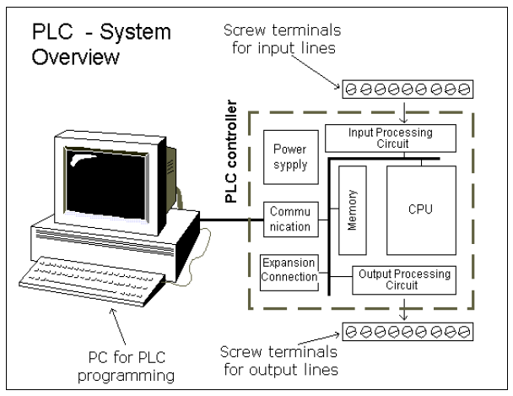

Figure 2.1 PLC system overview

**CPU modules**

The Central Processing Unit (CPU) Module is the brain of

the PLC.Primary role to read inputs, execute the control program, update outputs.

The CPU consists of the arithmetic logic unit (ALU), timing/control circuitry,

accumulator, scratch pad memory, program counter, address stack and instruction

register. A PLC works by continually scanning a program.

**Memory**

The memory includes pre-programmed ROM memory containing

the PLC’s operating system, driver programs and application programs and the

RAM memory. PLC manufacturer offer various types of retentive memory to save

user programs and data while power is removed, so that the PLC can resume execution of the user-written control program as soon as power is restored. Some

types of memory used in a PLC include:

ROM (Read-Only Memory)

RAM (Random Access Memory)

PROM (Programmable Read-Only Memory)

EPROM (Erasable Programmable Read-Only Memory)

EEPROM (Electronically Erasable Programmable Read-Only Memory)

FLASH Memory

Compact Flash – Can store complete program information, read & write text files

I/O Modules

Input and output (I/O) modules connect the PLC to sensors and actuators. Provide isolation for the low-voltage, low-current signals that the PLC uses internally from the higher-power electrical circuits required by most sensors and actuators. Wide range of I/O modules available including: digital (logical) I/O modules and analogue (continuous) I/O modules.

The FATEK FBS Series PLC is a new generation of micro PLC equipped with excellent functions comparable to medium or large PLC, with up to five communication ports. The maximum I/O numbers are 256 points for Digital Input (DI) and Digital Output (DO), 64 words for Numeric Input (NI) and Numeric Output (NO). The Main Units of FBS are available in three types: MA (Economy Type), MC (High-Performance Type), and MN (High-Speed NC Type). With the combination of I/O point ranges from 10 to 60, a total of 17 models are available. Fifteen DI/DO and 19 NI/NO models are available for Expansion Units/Modules. With interface options in RS232, RS485, USB, Ethernet, CANopen, Zigbee and GSM, the communication peripherals are available with 15 boards and modules.

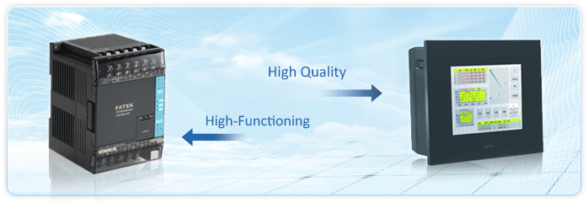

* All expansion cables (left) of expansion units/modules are flat ribbon cables (5cm long), which were soldered directly on the PCB,
* and the expansion header (right) is a 14Pin Header, with this to 35mm-width DIN RAIL
* ○2 DIN RAIL tab
* ○3 Hole for screw fixation (ψ4.5×2)
* ○4 Terminals of 24VDC power input and digital input
* (Pitch 7.62mm)
* ○5 Terminals of main power input and digital output
* (Pitch 7.62mm)
* ○6 Standard cover plate (without communication
* board)
* ○7 Cover plate of built-in communication port (Port 0)
* Indicators for transmit (TX) and receive (RX) status of built-in communication port (Port0).
* ○9 Indicator for Digital Input (Xn).
* ○10 Indicator for Digital Output (Yn).
* ○11 Indicator for system status (POW, RUN, ERR).
* ○12 I/O output expansion header cover [units of 20 points or beyond only], with esthetic purpose and capable of securing
* expansion cable.
* ○13 FBS-CB22 Communication Board (CB).
* ○14 FBS-CB22 CB cover plate (each CB has its own specific cover plate)
* ○15 Screw holes of communication board.
* ○16 Connector for communication board (for 7 types CB of CB2, CB22, CB5, CB55, CB25, CBE, CBCAN , 3 types AIO
* of B2DA, B2AD, B4AD, and 2 types DAP of BDAP and BPEP)
* ○17 Left side (communication) expansion header (only available in MC/MN model, for CM22, CM25, CM55, CM25E,
* CM55E, and CMGSM connection).
* ○18 Connector for Memory Pack.
* ○19 Connector for built-in communication port (Port 0) (With USB and RS232 optional, shown in the figure is for RS232)
* ○20 Right side (I/O) output expansion header (only available in units with 20 points or beyond), for connecting with
* cables from expansion units/modules.
* Appearance of Expansion Unit/Module
* There are three types of cases for expansion units/modules. One type uses the same case as main unit that of the 90mm,
* 130mm, and 175mm, while the other two have thinner 40mm connect the right adjacent expansion units/modules.
* 4 channel A/D analog input board



### **3.8 Pressure Sensor**

A pressure sensor measures [pressure](https://en.wikipedia.org/wiki/Pressure), typically of [gases](https://en.wikipedia.org/wiki/Gas) or [liquids](https://en.wikipedia.org/wiki/Liquids). Pressure is an expression of the force required to stop a fluid from expanding, and is usually stated in terms of force per unit area. A pressure sensor usually acts as a [transducer](https://en.wikipedia.org/wiki/Transducer); it generates a signal as a[function](https://en.wikipedia.org/wiki/Function_(mathematics)) of the pressure imposed. For the purposes of this article, such a signal is electrical.

Pressure sensors are used for control and monitoring in thousands of everyday applications. Pressure sensors can also be used to indirectly measure other variables such as fluid/gas flow, speed, water level, and altitude. Pressure sensors can alternatively be called pressure transducers, pressure transmitters, pressure senders, pressure indicators, piezometers and manometers, among other names.

Pressure sensors can vary drastically in technology, design, performance, application suitability and cost. A conservative estimate would be that there may be over 50 technologies and at least 300 companies making pressure sensors worldwide.

There is also a category of pressure sensors that are designed to measure in a dynamic mode for capturing very high speed changes in pressure. Example applications for this type of sensor would be in the measuring of combustion pressure in an engine cylinder or in a gas turbine. These sensors are commonly manufactured out of [piezoelectric](https://en.wikipedia.org/wiki/Piezoelectric) materials such as quartz.

Some pressure sensors, such as those found in some [traffic enforcement cameras](https://en.wikipedia.org/wiki/Traffic_enforcement_camera), function in a binary (off/on) manner, i.e., when pressure is applied to a pressure sensor, the sensor acts to complete or break an electrical circuit. These types of sensors are also known as a[pressure switch](https://en.wikipedia.org/wiki/Pressure_switch).

Pressure sensors can be classified in terms of pressure ranges they measure, temperature ranges of operation, and most importantly the type of pressure they measure. Pressure sensors are variously named according to their purpose, but the same technology may be used under different names.

* **Absolute pressure sensor**

This sensor measures the pressure relative to [perfect vacuum](https://en.wikipedia.org/wiki/Vacuum).

* **Gauge pressure sensor**

This sensor measures the pressure relative to [atmospheric pressure](https://en.wikipedia.org/wiki/Atmospheric_pressure). A tire pressure gauge is an example of gauge pressure measurement; when it indicates zero, then the pressure it is measuring is the same as the ambient pressure.

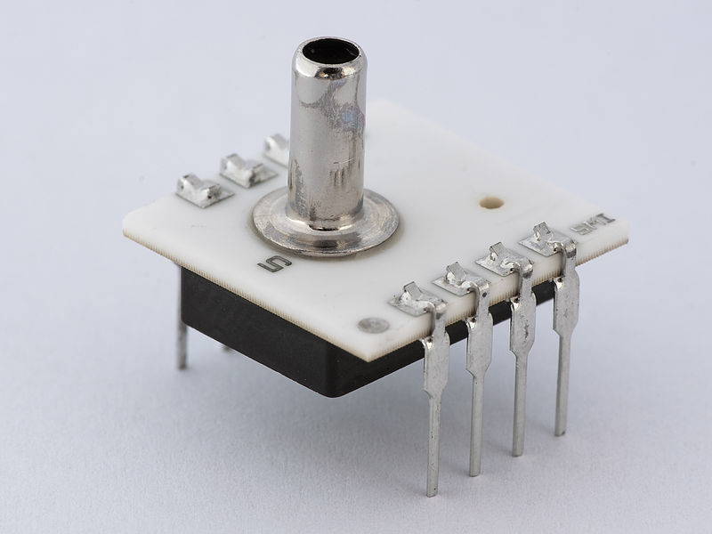

* **Vacuum pressure sensor**

This term can cause confusion. It may be used to describe a sensor that measures pressures below atmospheric pressure, showing the difference between that low pressure and atmospheric pressure (i.e. negative gauge pressure), but it may also be used to describe a sensor that measures low pressure relative to perfect vacuum (i.e. absolute pressure).

* **Differential pressure sensor**

This sensor measures the difference between two pressures, one connected to each side of the sensor. Differential pressure sensors are used to measure many properties, such as pressure drops across [oil filters](https://en.wikipedia.org/wiki/Oil_filter) or [air filters](https://en.wikipedia.org/wiki/Air_filter), fluid levels (by comparing the pressure above and below the liquid) or flow rates (by measuring the change in pressure across a restriction). Technically speaking, most pressure sensors are really differential pressure sensors; for example a gauge pressure sensor is merely a differential pressure sensor in which one side is open to the ambient atmosphere.

* **Sealed pressure sensor**

This sensor is similar to a gauge pressure sensor except that it measures pressure relative to some fixed pressure rather than the ambient atmospheric pressure (which varies according to the location and the weather).

### **3.9 Temperature Sensor**

This is the same temperature sensor that is included in our [SparkFun Inventor’s Kit](http://www.sparkfun.com/products/12060). The TMP36 is a low voltage, precision centigrade temperature sensor. It provides a voltage output that is linearly proportional to the Celsius temperature. It also doesn’t require any external calibration to provide typical accuracies of ±1°C at +25°C and ±2°C over the −40°C to +125°C temperature range. We like it because it’s so easy to use: Just give the device a ground and 2.7 to 5.5 VDC and read the voltage on the Vout pin. The output voltage can be converted to temperature easily using the scale factor of 10 mV/°C.

**Features:**

* Voltage Input: 2.7 V to 5.5 VDC
* 10 mV/°C scale factor
* ±2°C accuracy over temperature
* ±0.5°C linearity
* Operating Range: −40°C to +125°C

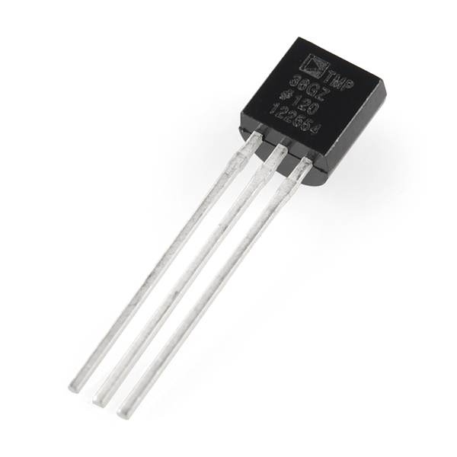

**Temperature Sensor Types**

The most commonly used type of all the sensors are those which detect **Temperature** or heat. These types of temperature sensor vary from simple ON/OFF thermostatic devices which control a domestic hot water heating system to highly sensitive semiconductor types that can control complex process control furnace plants.

We remember from our school science classes that the movement of molecules and atoms produces heat (kinetic energy) and the greater the movement, the more heat that is generated.**Temperature Sensors** measure the amount of heat energy or even coldness that is generated by an object or system, allowing us to “sense” or detect any physical change to that temperature producing either an analogue or digital output.

There are many different types of **Temperature Sensor** available and all have different characteristics depending upon their actual application. A [Temperature Sensor](http://www.amazon.com/Temperature-Transducer-Phung-Son-Thanh/dp/3845403969?tag=basicelecttut-20) consists of two basic physical types:

• Contact Temperature Sensor Types – These types of temperature sensor are required to be in physical contact with the object being sensed and use conduction to monitor changes in temperature. They can be used to detect solids, liquids or gases over a wide range of temperatures.

• Non-contact Temperature Sensor Types – These types of temperature sensor use convection and radiation to monitor changes in temperature. They can be used to detect liquids and gases that emit radiant energy as heat rises and cold settles to the bottom in convection currents or detect the radiant energy being transmitted from an object in the form of infra-red radiation (the sun).

### **3.10 Servo Motor**

Servo motors have been around for a long time and are utilized in many applications. They are small in size but pack a big punch and are very energy-efficient. These features allow them to be used to operate remote-controlled or radio-controlled [toy cars](http://www.jameco.com/webapp/wcs/stores/servlet/JamecoSearch?langId=-1&storeId=10001&catalogId=10001&categoryName=category_root&subCategoryName=Education%20%26%20Hobby%20Kits&category=70&refine=1&position=1&history=yajv7t0n%7CfreeText~cars%5Esearch_type~jamecoall%5EprodPage~15%5Epage~SEARCH%252BNAV), [robots](http://www.jameco.com/webapp/wcs/stores/servlet/JamecoSearch?langId=-1&storeId=10001&catalogId=10001&categoryName=category_root&subCategoryName=Robotics&category=75&refine=1&position=1&history=jpodqbl6%7CfreeText~robot%5Esearch_type~jamecoall%5EprodPage~15%5Epage~SEARCH%252BNAV) and airplanes. Servo motors are also used in industrial applications, robotics, in-line manufacturing, pharmaceutics and food services.

The servo circuitry is built right inside the motor unit and has a positionable shaft, which usually is fitted with a [gear](http://www.jameco.com/webapp/wcs/stores/servlet/ProductDisplay?langId=-1&storeId=10001&productId=1810072&catalogId=10001) (as shown below). The motor is controlled with an electric signal which determines the amount of movement of the shaft.

**Inside the servo**

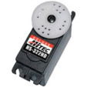

To fully understand how the servo works, you need to take a look under the hood. Inside there is a pretty simple set-up: a small [DC motor](http://www.jameco.com/webapp/wcs/stores/servlet/JamecoSearch?langId=-1&storeId=10001&catalogId=10001&categoryName=category_root&subCategoryName=Electromechanical&category=35&refine=1&position=1&history=28hlc38h%7CfreeText~dc%2Bmotor%5Esearch_type~jamecoall%5EprodPage~50%5Epage~SEARCH%252BNAV),[potentiometer](http://www.jameco.com/webapp/wcs/stores/servlet/JamecoSearch?langId=-1&storeId=10001&catalogId=10001&categoryName=category_root&subCategoryName=Passive%20Components&category=20&refine=1&position=1&history=d0ww5ora%7CfreeText~potentiometer%5Esearch_type~jamecoall%5EprodPage~50%5Epage~SEARCH%252BNAV), and a control circuit. The motor is attached by gears to the control wheel. As the motor rotates, the potentiometer's resistance changes, so the control circuit can precisely regulate how much movement there is and in which direction.   
  
When the shaft of the motor is at the desired position, [power](http://www.jameco.com/webapp/wcs/stores/servlet/JamecoSearch?langId=-1&storeId=10001&catalogId=10001&categoryName=category_root&subCategoryName=Power%20Supplies%20%26%20Wall%20Adapters&category=45) supplied to the motor is stopped. If not, the motor is turned in the appropriate direction. The desired position is sent via electrical pulses through the [signal wire](http://www.jameco.com/webapp/wcs/stores/servlet/JamecoSearch?langId=-1&storeId=10001&catalogId=10001&categoryName=cat_25&subCategoryName=Wire%20%26%20Cable%20%2F%20Bulk%20Wire&category=2550&refine=1&position=1&history=wus4q9hh%7CsubCategoryName~Wire%2B%2526%2BCable%5Ecategory~25%5EcategoryName~category_root%5EprodPage~50%5Epage~SEARCH%252BNAV). The motor's speed is proportional to the difference between its actual position and desired position. So if the motor is near the desired position, it will turn slowly, otherwise it will turn fast. This is called proportional control. This means the motor will only run as hard as necessary to accomplish the task at hand, a very efficient little guy.

To fully understand how the servo works, you need to take a look under the hood. Inside there is a pretty simple set-up: a small [DC motor](http://www.jameco.com/webapp/wcs/stores/servlet/JamecoSearch?langId=-1&storeId=10001&catalogId=10001&categoryName=category_root&subCategoryName=Electromechanical&category=35&refine=1&position=1&history=28hlc38h%7CfreeText~dc%2Bmotor%5Esearch_type~jamecoall%5EprodPage~50%5Epage~SEARCH%252BNAV),[potentiometer](http://www.jameco.com/webapp/wcs/stores/servlet/JamecoSearch?langId=-1&storeId=10001&catalogId=10001&categoryName=category_root&subCategoryName=Passive%20Components&category=20&refine=1&position=1&history=d0ww5ora%7CfreeText~potentiometer%5Esearch_type~jamecoall%5EprodPage~50%5Epage~SEARCH%252BNAV), and a control circuit. The motor is attached by gears to the control wheel. As the motor rotates, the potentiometer's resistance changes, so the control circuit can precisely regulate how much movement there is and in which direction.   
  
When the shaft of the motor is at the desired position, [power](http://www.jameco.com/webapp/wcs/stores/servlet/JamecoSearch?langId=-1&storeId=10001&catalogId=10001&categoryName=category_root&subCategoryName=Power%20Supplies%20%26%20Wall%20Adapters&category=45) supplied to the motor is stopped. If not, the motor is turned in the appropriate direction. The desired position is sent via electrical pulses through the [signal wire](http://www.jameco.com/webapp/wcs/stores/servlet/JamecoSearch?langId=-1&storeId=10001&catalogId=10001&categoryName=cat_25&subCategoryName=Wire%20%26%20Cable%20%2F%20Bulk%20Wire&category=2550&refine=1&position=1&history=wus4q9hh%7CsubCategoryName~Wire%2B%2526%2BCable%5Ecategory~25%5EcategoryName~category_root%5EprodPage~50%5Epage~SEARCH%252BNAV). The motor's speed is proportional to the difference between its actual position and desired position. So if the motor is near the desired position, it will turn slowly, otherwise it will turn fast. This is called proportional control. This means the motor will only run as hard as necessary to accomplish the task at hand, a very efficient little guy.

**servo controlling**

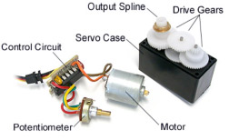

Servos are controlled by sending an electrical pulse of variable width, or pulse width modulation (PWM), through the control wire. There is a minimum pulse, a maximum pulse, and a repetition rate. A servo motor can usually only turn 90 degrees in either direction for a total of 180 degree movement. The motor's neutral position is defined as the position where the servo has the same amount of potential rotation in the both the clockwise or counter-clockwise direction. The PWM sent to the [motor](http://www.jameco.com/webapp/wcs/stores/servlet/JamecoSearch?langId=-1&storeId=10001&catalogId=10001&freeText=motor&search_type=jamecoall) determines position of the shaft, and based on the duration of the pulse sent via the control wire; the [rotor](http://www.jameco.com/webapp/wcs/stores/servlet/JamecoSearch?langId=-1&storeId=10001&catalogId=10001&categoryName=cat_3540&subCategoryName=Electromechanical%20%2F%20Switches%20%2F%20Rotary&category=354055&refine=1&position=1&history=kv7hqebe%7CfreeText~rotor%5Esearch_type~jamecoall%5EprodPage~50%5Epage~SEARCH%252BNAV%405hha4bcd%7Ccategory~35%5EcategoryName~category_root%5Eposition~1%5Erefine~1%5EsubCategoryName~Electromechanical%5EprodPage~50%5Epage~SEARCH%252BNAV) will turn to the desired position. The servo motor expects to see a pulse every 20 milliseconds (ms) and the length of the pulse will determine how far the motor turns. For example, a 1.5ms pulse will make the motor turn to the 90-degree position. Shorter than 1.5ms moves it to 0 degrees, and any longer than 1.5ms will turn the servo to 180 degrees.

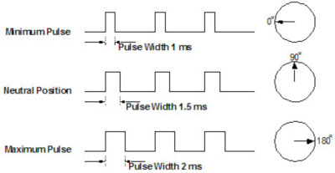

When these servos are commanded to move, they will move to the position and hold that position. If an external force pushes against the servo while the servo is holding a position, the servo will resist from moving out of that position. The maximum amount of force the servo can exert is called the torque rating of the servo. Servos will not hold their position forever though; the position pulse must be repeated to instruct the servo to stay in position. 

**Types of Servo Motors**

There are two types of servo motors - AC and DC. AC servo can handle higher current surges and tend to be used in industrial machinery.[DC servos](http://www.jameco.com/webapp/wcs/stores/servlet/JamecoSearch?langId=-1&storeId=10001&catalogId=10001&categoryName=cat_75&subCategoryName=Robotics%20%2F%20Motors&category=7545&refine=1&position=1&history=ko9l7dni%7CfreeText~servo%2Bmotor%5Esearch_type~jamecoall%5EprodPage~50%5Epage~SEARCH%252BNAV%40gu9oa7zv%7Ccategory~75%5EcategoryName~category_root%5Eposition~1%5Erefine~1%5EsubCategoryName~Robotics%5EprodPage~50%5Epage~SEARCH%252BNAV) are not designed for high current surges and are usually better suited for smaller applications. Generally speaking, DC motors are less expensive than their AC counterparts. These are also servo motors that have been built specifically for continuous rotation, making it an easy way to get your robot moving. They feature two ball bearings on the output shaft for reduced friction and easy access to the rest-point adjustment [potentiometer](http://www.jameco.com/webapp/wcs/stores/servlet/JamecoSearch?langId=-1&storeId=10001&catalogId=10001&categoryName=category_root&subCategoryName=Passive%20Components&category=20&refine=1&position=1&history=d0ww5ora%7CfreeText~potentiometer%5Esearch_type~jamecoall%5EprodPage~50%5Epage~SEARCH%252BNAV). 

**Servo Motor Applications**

Servos are used in radio-controlled airplanes to position control surfaces like elevators, rudders, walking a robot, or operating [grippers](http://www.jameco.com/webapp/wcs/stores/servlet/ProductDisplay?langId=-1&productId=358811&position=1&category=7540&catalogId=10001&subCategoryName=Robotics+%2F+Mechanical&storeId=10001&refine=1&app.products.maxperpage=15&parentCategoryId=75%24%247540&categ). Servo motors are small, have built-in control circuitry and have good power for their size.

In food services and pharmaceuticals, the tools are designed to be used in harsher environments, where the potential for corrosion is high due to being washed at high pressures and temperatures repeatedly to maintain strict hygiene standards. Servos are also used in in-line manufacturing, where high repetition yet precise work is necessary.

# Chapter 4

## PROJECT DESIGN AND IMPLEMENTATION

All the values can be filled up by the introduction of the automation technique into the power plants. The automation technique involving the automatic control of all the processes which includes the monitoring and inspection needs provides for a very efficient system. The automation process helps the power plant to reduce the amount of errors that occur , reduction in the human resources, increased efficiency, and most importantly very cost effective.

**A. Level Control**

Steam Drum level, De-aerator level and hot well level

**B.Pressure Control**

Force draft pressure, Induced draft pressure, Steam drum pressure, Deaerator pressure, Turbine inlet steam pressure, balanced draft pressure

**C. Flow Control**

Air flow, Steam flow, Water flow

**D. Temperature Control**

Deaerator temperature, Steam drum temperature, Underbed boiler temperature, Turbine inlet steam temperature, Flue gas temperature. Temperature is the degree of hotness or coolness of a body. When the temperature changes the internal resistance also changes to the corresponding material. For example, LM35 is used to measure the temperature in the range of -55˚C to +150˚C. . The LM35series are precision integrate-circuit temperature sensors whose output voltage is linearly proportional to the Celsius high temperature. The LM35 hence has an improvement more than linear temperature sensors calibrated in ° Kelvin, as the user is not required to subtract a large constant voltage from its output to obtain convenient Centigrade scaling. If we want to measure temperature greater than 1000˚C we have to use Thermocouples.

**How PLC works**

Basics of a PLC function are continual scanning of a program. The scanning process involves three basic steps.

**Step 1: Testing input status**

First the PLC checks each of its input with intention to see which one has status on or off. In other words it checks whether a switch or a sensor etc., is activated or not. The information that the processor thus obtains through this step is stored in memory in order to be used in the following steps.

**Step 2: Programming execution**

Here a PLC executes a program instruction by instruction based on the program and based on the status of the input has obtained in the preceding step, and appropriate action is taken. The action might be activation of certain outputs and the results can be put off and stored in memory to be retrieved later in the following steps.

**Step 3: Checking and Correction of output status**

Finally, a PLC checks up output signals and adjust it has needed. Changes are performed based on the input status that had been read during the first step and based on the result of the program execution in step two – following execution of step three PLC returns a beginning of the cycle and continually repeats these steps

**Interfacing**

* Open a SCADA application
* Create a tag of type I/O discrete, select the type as discrete
* Select read only if you don’t want to force values to PLC. Selecting read and write allows to the SCADA to read and force values to the PLC.
* Type an access name.
* The access name can visualized as a gateway for a group of resources.
* Most of PLC drivers communicate with SCADA package using DDE, DDE requires three parameters namely name of the DDE server, topic name and item name. In case of reading a number of items from a particular PLC driver application name topic name are common, so this application name that is name of the DDE server and Topic name combine to form an access name. Access name is required to be defined only once then other items of driver can be accessed by using the Access name and item name. These details will be provided by the driver vendor or developer.
* Click ok, the access name will be listed finally click done, then type the item name, click save to save the I/O tags. Go to run time to communicate with PLC.

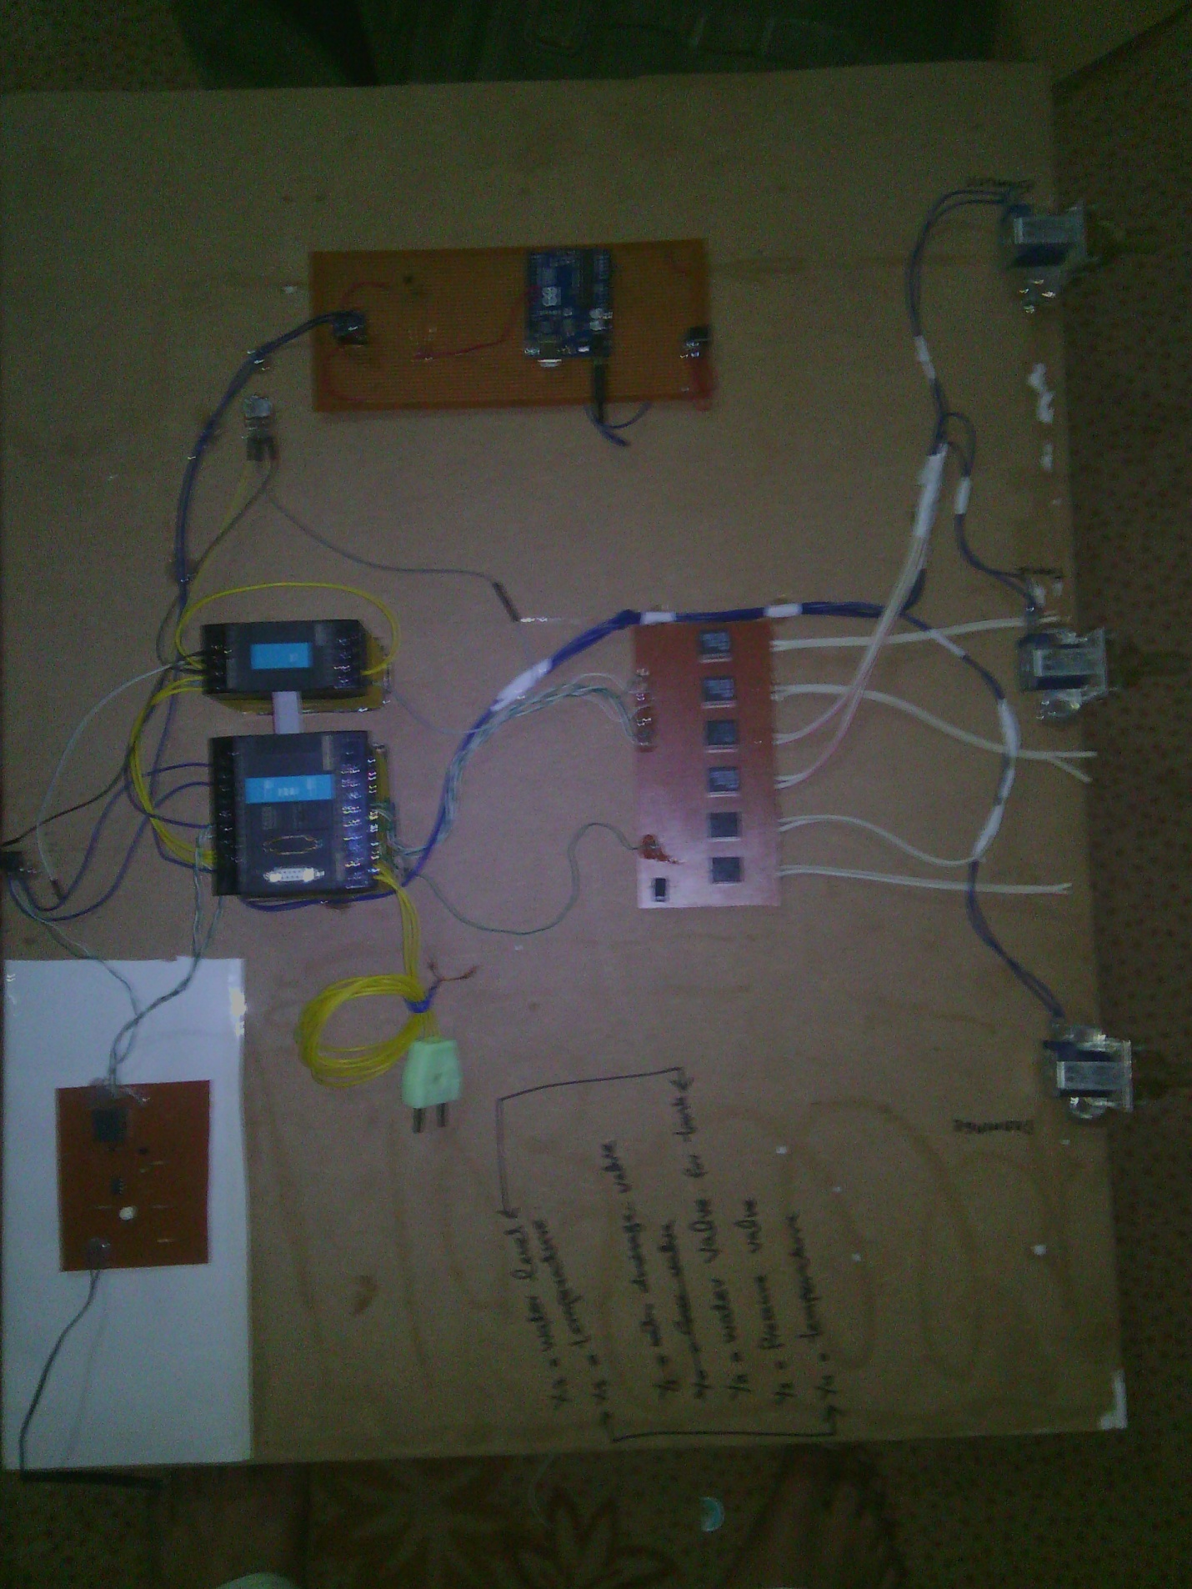

# Chapter 5

# CONCLUSION

The most important aspect of any power plant is the boiler control. Several techniques can be implemented to control the boiler in power plant. The method that has to be used relies on varied objectives like superior quality, increased efficiency, high profit and other such points depending upon the purpose of the company that implies it. With the prime objective of catering to these necessities and the needs of the industrial sector, significance has been given here to automation.

This paper presented here has kept in mind, the ceaseless changes that are relentlessly taking place in the contemporary scenario of the industrial segment. Emphasis has been given to the automation process that is now rapidly taking its place in all the power plants across the globe. The Paper has furnished itself to study the integral parts of the entire process involved, their implementation and the problems that may show up have also been given their due importance. The future work deals with the purification of water to the boiler and the air circulation for the boiler to burn the fuel using same automation technique.

# REFERNCES

<http://documents.mx/documents/final-report-boiler-automation.html>

<http://www.scribd.com/doc/31208511/Boiler-Automation-Using-Programmable-Logic-Control-Final#scribd>

<http://www.electrical4u.com/steam-boiler-working-principle-and-types-of-boiler/>