Dedication

We dedicate our project to our Supervisor for his support and guidance that lead us to fulfill our project. Than we dedicate our project to our parents who supported us throughout our Educational career financially and morally.

# ACKNOWLEDGMENT

By the grace of Allah Almighty, who is the most merciful and beneficent! It is a matter of great pleasure and privilege for us to complete this project under the supervision of -----. We are also grateful to our Teachers, lab Engineers and Technicians for their help and encouragement.

ABSTRACT

In this project we are monitoring the frequency monitoring of ac lines, over voltage, under voltage and normal voltage. Additionally we have overload system for which we have designed visual basic application in which there is buttons for faulty situation to provide disconnection. Additionally we have inverter which will convert 12v dc to 220v ac. We have location of check points circuits in each check point we have step down transformer with which there is bridge rectifier, regulator for constant voltage capacitor for filtering and we have connected a relay when the relay will be off a signal will be send in visual basic we will show that the load is off in the specified area. For over voltage under voltage we have separate application.

# TABLE OF CONTENTS

ACKNOWLEDGMENT 2

TABLE OF CONTENTS 4

LIST OF ACRONYMS 5

Chapter 1 6

INTRODUCTION 6

1.1 Frequency monitoring 7

1.2 Problem statement 7

1.3 Specifications of proposed solution 8

1.4 Objectives of the Project 8

1.5 JUSTIFICATION OF THE PROJECT 8

1.6 Applications of 12v DC to 220v AC Converter Circuit: 8

1.7 Over voltage and under voltage 8

LIERATURE REVIEW 9

2.1 INVERTER 10

2.1.1CLASSFICATION OF INVERTERS 11

2.1.2 Modified Sine Wave 11

2.1.3 Pure Sine Wave 11

2.2 Overvoltage and Undervoltage 12

2.2.1 Circuit Operation 13

2.3 Under and Over Voltage Protection Circuit using Timers 14

2.3.1 Circuit Operation: 15

METHODOLOGIES AND IMPLEMENTATION 17

3.1 Frequency Determination using Arduino 17

Chapter 4 19

TOOLS AND TECHNIQUES 19

4.1 Hardware Used With Technical Specifications 19

4.1.1 Transformer 19

4.1.2 MOSFET Drivers 28

4.1.3 Rectifier 29

4.1.4 LM-741 36

4.1.5 SPDT Relay 38

4.1.6 2N2222 Transistor 40

4.1.7 555 Timer 41

The important features of the 555 timer are : 41

555 Timer Basics 44

Block Diagram 46

4.1.8 Arduino 48

4.1.9 Capacitors 53

4.1.10 78L12 IC 57

4.1.10 Visual basic 57

CONCLUSION 59

REFRENCES 60

.

# LIST OF ACRONYMS

ADC Analog to digital convertor

DAC Digital to analog convertor

DAQ Data Acquisition

AC Alternating Current

DC Direct Current

PCB Printed Circuit Board

USB Universal Serial Bus

PWM Pulse Width Modulation

# Chapter 1

# INTRODUCTION

This project aims to build a system that monitors voltage and provides a breakpoint based low and high voltage tripping mechanism that avoids any damage to the load. Various industrial and domestic systems consist of fluctuation in the AC mains supply. There is a chance of damaging electronic devices that are quite sensitive to these fluctuations. So there needs to be a tripping system that avoids any damage to these loads.

Protection against fault in power systems (PS) is very essential and vital for reliable performance. A power system is said to be faulty when an undesirable condition occurs in that power system, where the undesirable condition might be short circuits, over-current, overvoltage etc.

Increase in population leads to increase in demands of electrical power. With the increase in demand of power, the existing systems may become overloaded. Overloading at the consumer end appears at the transformer terminals which can affect its efficiency and protection systems. One of the reported damage or tripping of the distribution transformer is due to thermal overload. To avoid the damaging of transformer due to overloading from consumer end, it involves the control against over-current tripping of distribution transformer.

## 1.1 Frequency monitoring

AC power is generally distributed at 50 or 60 Hz.This project aims to "Calculate the live ac power system frequency using Arduino" kit and small transformer ckt setup.

**The approach**

In order to measure the frequency of the power signal of such a high magnitude, the amplitude needs to be brought down to a lower magnitude so that the signal can be  
fed to the microcontroller. However the frequency is kept unaffected. This can be done in the following steps:

1. Using a 230V/6V step down transformer, the voltage is first brought down to 6V.  
2. Now, using a potentiometer the voltage is adjusted to 3V rms value.

3. This signal is now fed to one of the analog pins of the microcontroller.

Now we have been successful in giving the modified signal to one of the analog pins of the micro-controller.

## 1.2 Problem statement

The world demand for electric energy is constantly increasing, and conventional energy resources are diminishing and are even threatened to be depleted. Moreover;

their prices are rising. For these reasons, the need for alternative energy sources has

become indispensable. Also we need to provide protection system for the overvoltage undervoltage and normal voltage. We will design visual basic application for this purpose.

## 1.3 Specifications of proposed solution

Our goal is to design a low cost inverter circuit without sacrificing the integrity of a pure sine wave output signal. We are trying to design a project having low cost design that also has an appropriate sine wave output signal. Our Project will not have a sine-wave reference signal in order to reduce cost. It will be able to transform DC to a pure sine wave without the use of this reference signal. Also the design of application in visual basic and monitoring of frequency of ac lines.We will have different check points which will be displayed on the computer through visual basic application whenever the fault will occur.

## 1.4 Objectives of the Project

The major objective of this project is to design, test and implement a pure sine wave inverter that converts 12V dc to 240V ac.

Also to design the protective system.

## 1.5 JUSTIFICATION OF THE PROJECT

* Pure sine AC power reduces audible noise in devices such as fluorescent lights and runs inductive loads like motors faster and quieter due to the low harmonic distortion.
* Some device like laser printers, laptop computers, digital clocks and medical equipment are not immune to harmonic distortions thus they need a power source with least harmonics
* Power outages highly experienced in the country thus power backups systems are used during power switching from line to generators and vice versa.

## 1.6 Applications of 12v DC to 220v AC Converter Circuit:

* This circuit can be used in cars and other vehicles to charge small batteries.
* This circuit can be used to drive low power AC motors
* It can be used in solar power system.

## 1.7 Over voltage and under voltage

OVER VOLTAGE:

When the voltage in a circuit or part of it is raised above its upper design limit, this is known as overvoltage. The conditions may be hazardous. Depending on its duration, the overvoltage event can be transient a voltage spike or permanent, leading to a power surge

LOW VOLTAGE:

Under Voltage condition occurs when a load is suddenly connected to a power supply.The load will start to draw current, this causes the voltage to temporarily drop. Measuring instruments Multimeter set to measure voltage

**Chapter 2**

# LIERATURE REVIEW

Energy crisis are of special attention now-a-days. A need for power rating inverter is required to smoothly operate electrical and electronic appliances. Most of the commercially available UPS or IPS is actually square wave or quasi square wave inverters. Electronic devices run by this inverter will damage due to harmonic contents. Available sine wave inverters are expensive and their output is not so good. For getting pure sine wave we’ve to apply sinusoidal pulse width modulation (SPWM) technique.

## 2.1 INVERTER

An inverter is a device that converts the DC sources to AC sources  An inverter is nothing but a DC to AC converter. Inverters are very useful electronics products for compensating emergency power failure, as it performs DC to AC conversion.. The purpose of a DC/AC power inverter is typically to take DC power supplied by a battery, such as a 12 volt car battery, and transform it into a 240 volt AC power source operating at 50 Hz, emulating the power available at an ordinary household electrical outlet. Inverters are used in applications such as adjustable-speed ac motor drivers, uninterruptible power supplies (UPS) and ac appliances run from an automobile battery

AC can’t be stored for future use but DC can be stored for future use in a battery. The stored DC can be converted back to AC by using power inverters. Here is the simple inverter circuit diagram using 555 timer IC. The astable multivibratormode operation of 555 timer utilized here for AC oscillations and these oscillations are switched via transistor to a transformer. The transformer step ups the voltage to 220V AC. Use a 12V battery and Battery charger circuit for this project.

Phase controlled converters when operated in the inverter mode are called line commutated inverters. But line commutated inverters require at the output terminals an existing AC supply which is used for their commutation. This means that line commutated inverters can’t function as isolated AC voltage sources or as variable frequency generators with DC power at the input. Therefore, voltage level, frequency and waveform on the AC side of the line commutated inverters can’t be changed. On the other hand, force commutated inverters provide an independent AC output voltage of adjustable voltage and adjustable frequency and have therefore much wider application.

Inverters can be broadly classified into two types based on their operation:

• Voltage Source Inverters(VSI)

• Current Source Inverters(CSI)

Voltage Source Inverters is one in which the DC source has small or negligible impedance. In other words VSI has stiff DC voltage source at its input terminals. A current source inverter is fed with adjustable current from a DC source of high impedance,i.e;from a stiff DC current source. In a CSI fed with stiff current source, output current waves are not affected by the load.

From view point of connections of semiconductor devices, inverters are classified as under

• Bridge Inverters

• Series Inverters

• Parallel Inverters

### 2.1.1CLASSFICATION OF INVERTERS

On the market today there are two different types of inverters:

➢ Modified Square Wave (Modified Sine Wave)

➢ Pure Sine Wave (True Sine Wave)

These inverters differ in their outputs, providing varying levels of efficiency and distortion that can affect electronic devices in different ways.

### 2.1.2 Modified Sine Wave

A modified sine wave is similar to a square wave but instead has a “stepping” look to it that relates more in shape to a sine wave. This can be seen which displays how a modified sine wave tries to emulate the sine wave itself. The waveform is easy to produce because it is just the product of switching between three values at set frequencies, thereby leaving out the more complicated circuitry needed for a pure sine wave hence provides a cheap and easy solution to powering devices that need AC power. However it does have some drawbacks as not all devices work properly on a modified sine wave, products such as computers and medical equipment are not resistant to the distortion of the signal and must be run off of a pure sine wave power source Modified sine wave inverters approximate a sine wave and have low enough harmonics that do not cause problem with household equipment’s. The main disadvantage of the modified sine wave inverter is that peak voltage varies with the battery voltage.

### 2.1.3 Pure Sine Wave

Pure sine wave inverter represents the latest inverter technology. The waveform produced by these inverters is same as or better than the power delivered by the utility. Usually sine wave inverters are more expensive than the modified sine wave inverters due to their added circuitry.

There are two methods in which the low voltage DC power is inverted to AC power;

➢ The low voltage DC power is first boosted to high voltage power source using a DC-DC booster then converted to AC power using pulse width modulation.

➢ The low voltage DC power is first converted to AC power using pulse width modulation then boosted to high AC voltage using a boost transformer.

The second method is used in modern inverters extensively because of its ability to produce a constant output voltage compared to the first method that require additional circuit to boost the voltage.

## 2.2 Overvoltage and Undervoltage

For the satisfactory working of all [electrical and electronic devices](https://www.elprocus.com/basic-components-used-electronics-electrical/), it is recommended to allow voltage at prescribed limits. Voltage fluctuations in electric power supply certainly have adverse effects on connected loads. These fluctuations can be of over voltage and under voltages which are caused by several reasons like voltage surges, lightning, overload, etc. Over voltages are the voltages that exceed the normal or rated values which cause insulation damage to electrical appliances leading to short circuits. Similarly, under-voltage causes overloading of the equipment leading to lamp flickers and inefficient performance of the equipment. Thus intended to give [under and overvoltage protection circuit](https://www.elprocus.com/voltage-electrical-short-circuit-prevention/) schemes with different control structures.

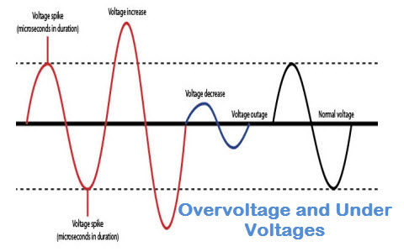

This voltage protection circuit is designed to develop a low-voltage and high-voltage tripping mechanism to protect a load from any damage. In many of the homes and industries fluctuations in AC mains supply take place frequently. The electronic devices get easily damaged due to fluctuations. To overcome this problem, we can implement a tripping mechanism of under / overvoltage protection circuit to protect the loads from the undue damage.

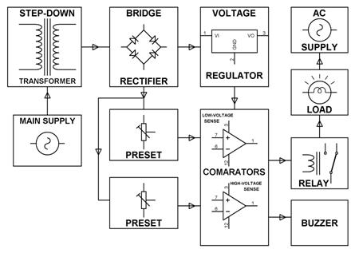

### 2.2.1 Circuit Operation

* As shown in the above block diagram, the [mains AC power supplies](https://www.elprocus.com/ac-power-supplies-home/) the power to the whole circuit and for operating loads by using relays, and also for tripping the load (lamps) in the presence of the input voltage which falls above or below a set value.
* Two comparators used as a window comparator formed out of one quad [comparator IC](https://www.elprocus.com/operational-amplifiers/). This operation delivers an error in the output if the input voltage to the comparator crosses the limit beyond the voltage window.
* In this circuit, an unregulated power supply is connected to both[op-amps terminals](https://www.elprocus.com/op-amp-ics-pin-configuration-features-working/), wherein each non-inverting terminal is connected through the two series resistors and a potentiometer arrangement. Similarly, the inverting terminal is also powered through [Zener diode](https://www.elprocus.com/how-does-a-zener-works-as-a-voltage-regulator/) and resistance arrangements, as shown in the given under or overvoltage protection circuit.
* he Potentiometer’s preset VR1 is adjusted such that the voltage at non-inverting is less than 6.8V for stable maintenance of load for the normal supply range of 180V-240V and the voltage of inverting terminal is 6.8V constant due to Zener diode.
* Hence the op-amp output is zero under this range and thus the[relay coil is de-energized](https://www.elprocus.com/how-relays-work/) and the load is not interrupted during this stable operation.
* When the voltage is beyond the 240 V the voltage at the non-inverting terminal is more than 6.8,  so the operational amplifier output goes high. This output drives the transistor and thus the relay coil gets energized and finally loads are turned off due to overvoltage.
* Similarly, for under voltage protection, lower comparator energizes the relay when the supply voltage falls below 180 V by maintaining 6V at the inverting terminal. These under and overvoltage settings can be changed by varying the respective potentiometers.

## 2.3 Under and Over Voltage Protection Circuit using Timers

This is another under / overvoltage protection circuit for designing low- voltage and [high voltage protection mechanism](https://www.elprocus.com/three-phase-induction-motor-protection-systems-and-its-applications/) to protect the load from damage. This [simple electronics circuit](https://www.elprocus.com/build-your-own-electronic-circuits-for-simple-applications/)uses timers in place of comparator as in the above case as a control mechanism. These two timers combination delivers an error output to switch the relay mechanism when the voltage violates its prescribed limits. Thus, it protects the appliances from the adverse effects of supply voltage.

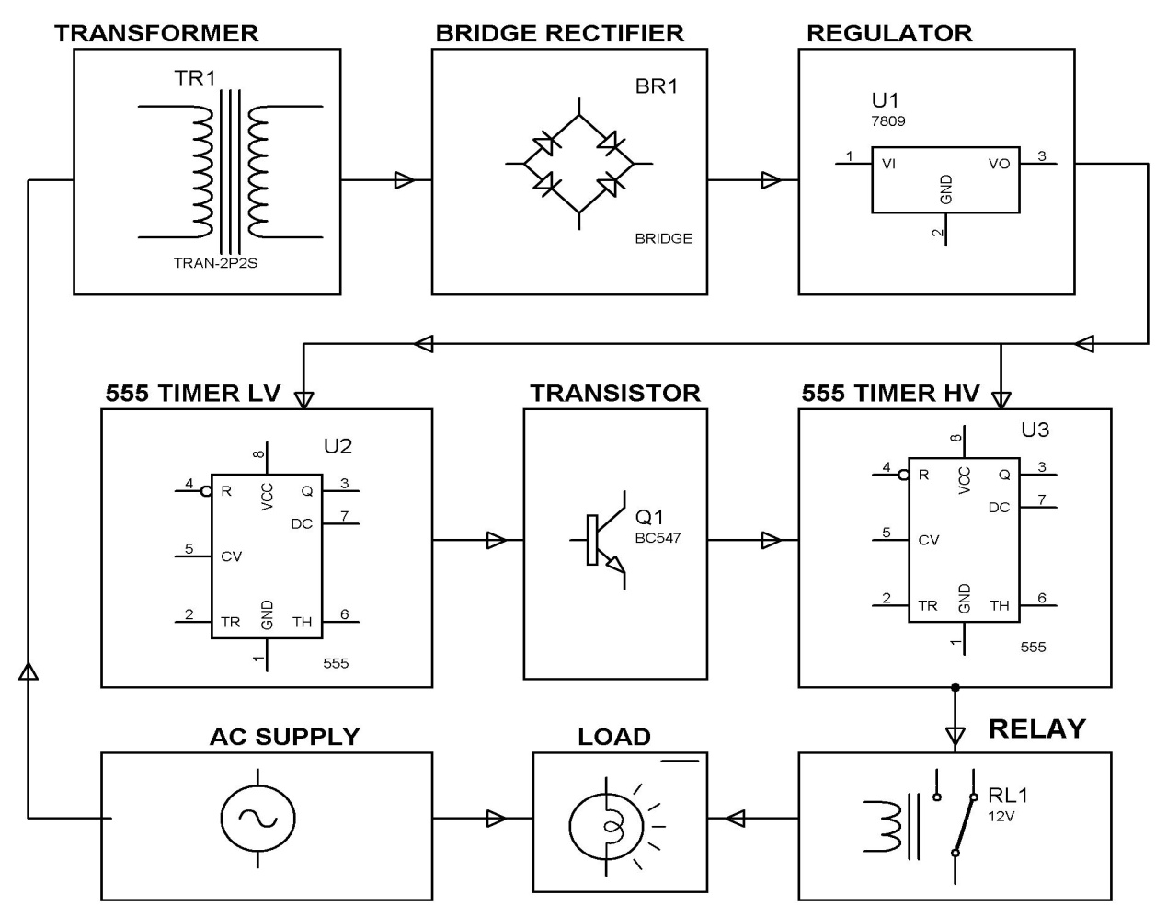

### 2.3.1 Circuit Operation:

* The entire circuit is powered with [rectified DC supply](https://www.elprocus.com/bridge-rectifier-circuit-theory-with-working-operation/), but the regulated power is connected to timers and unregulated power is connected to potentiometers to get the variable voltage.
* Both the timers are configured to work as comparators i.e., as long as the input present at the pin2 of timer is less positive than 1/3 Vcc then the output at pin 3 goes high and reverse will happen once the input at pin2 is more positive than the 1/3 Vcc.
* The Potentiometer VR1 is connected to timer 1 for under voltage cutoff, and the VR2 is to second timer for over-voltage cutoff. The two transistors are connected to two timers for making switch logic.
* In the normal operating conditions, (Between 160 and 250 V) the output of the timer 1 is held low so the[transistor 1 is in cutoff state](https://www.elprocus.com/transistors-basics-types-baising-modes/). As a result, the reset pin of the timer 2 is high which causes to output at pin 3 is high, so the transistor 2 conducts, and then the relay coil gets energized. Thus, in the normal or stable-voltage conditions the load doesn’t get interrupted.
* In the  overvoltage condition (above 260V), the input voltage at pin 2 of timer 2 is goes high. This causes low output at the pin 3, which in turn drives the transistor 2 into a cutoff state mode. Then, the relay coil gets de-energized and the load gets tripped from the main supply.
* Similarly, in under voltage condition, the timer 1 output is high and it drives the transistor 1 into conduction mode. As a result, the reset pin of timer 2 is goes low and therefor the transistor 2 is in cutoff mode. And finally, the relay is getting operated to isolate the loads from the main supply.
* These overvoltage and under voltage conditions status are also displayed as LED indication which are connected to respective timers as shown in the figure.

These are the two different overvoltage and under-voltage protection circuits. Both circuits work in a similar way, but the components used makes the difference between them. These circuits are simple, low cost and easy to implement and therefore, now you will be able to choose between these two for the best and reliable control with ease of implementation. So write your choice and for any other technical help to [build electronic projects](https://www.elprocus.com/latest-electronics-projects-for-eee-and-ece-projects-in-2014/) circuits in the comment section below.

**Chapter 3**

# METHODOLOGIES AND IMPLEMENTATION

## 3.1 Frequency Determination using Arduino

1. A set of continuous 250 samples of the voltage is taken in from the analog pin and stored in the microcontroller.

2. The time taken to read these 250 samples is calculated.

3. Now, the time taken to read one analog value of the input signal is the ratio of the total time taken to read 250 samples to 250.

4. It takes 28 milliseconds to take 250 samples. So, for one sample it takes 28/250 = 0.112 msec.

5. Thus, time taken to read one analog value is the sampling time interval of the inbuilt ADC of the microcontroller and it is calculated to be 0.112 msec.

**Frequency calculation**

It must be noted that the Arduino is unable to read one half cycle of the input AC signal i.e. the negative half wave and assumes it be zero.

So, when we observe the samples, it can be seen that we get a set of readings for which the value remains zero and then the value starts rising from zero to the peak  
value of the input signal and then steadily gets back to zero and remains zero for some time. This cycle keeps on repeating.

Now we set up a counter at zero. We now start reading the voltage samples and the counter starts when the first non-zero sample is detected after zero value signals.  
The counter stops when the next zero value signal is detected. It is mandatory to know that each sample is read at a time interval of 1 msec.

The frequency is now calculated:

Frequency (f) = 1000/ (2*k*0.112) … where k is the value of the counter.  
**Execution of the method**

After the above mentioned tasks are accomplished, it is now time to carry out the method. Firstly, the power signal is fed to a step down transformer and the output is  
adjusted to 3V using a potentiometer. The signal is now given to one of the analog pins of the micro-controller (analog pin A0 in this case).

Since the Arduino kit is interfaced with the computer, we can run the serial monitor of the Arduino software and see the calculated frequency.

# Chapter 4

# TOOLS AND TECHNIQUES

.

## 4.1 Hardware Used With Technical Specifications

### 4.1.1 Transformer

Electrical [power transformer](http://www.electrical4u.com/electrical-power-transformer-definition-and-types-of-transformer/) is a static device which transforms electrical energy from one circuit to another without any direct electrical connection and with the help of [mutual induction](http://www.electrical4u.com/what-is-inductor-and-inductance-theory-of-inductor/#Mutual-Inductance) between two windings. It transforms power from one circuit to another without changing its frequency but may be in different [voltage](http://www.electrical4u.com/voltage-or-electric-potential-difference/) level.   
**Working Principle:**

A transformer can be defined as a static device which helps in the transformation of electric power in one circuit to electric power of the same frequency in another circuit. The voltage can be raised or lowered in a circuit, but with a proportional increase or decrease in the current ratings.

The main principle of operation of a transformer is mutual inductance between two circuits which is linked by a common magnetic flux. A basic transformer consists of two coils that are electrically separate and inductive, but are magnetically linked through a path of reluctance. The working principle of the transformer can be understood from the figure below.

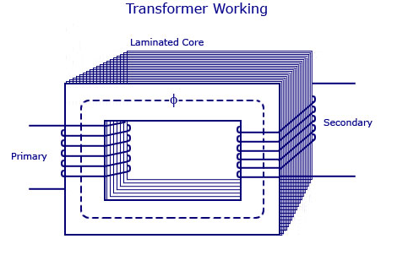

Figure 4.1 Transformer working

 As shown above the transformer has primary and secondary windings. The core laminations are joined in the form of strips in between the strips you can see that there are some narrow gaps right through the cross-section of the core. These staggered joints are said to be ‘imbricated’. Both the coils have high mutual inductance. A mutual electro-motive force is induced in the transformer from the alternating flux that is set up in the laminated core, due to the coil that is connected to a source of alternating voltage. Most of the alternating flux developed by this coil is linked with the other coil and thus produces the mutual induced electro-motive force. The so produced electro-motive force can be explained with the help of Faraday’s laws of Electromagnetic Induction as

e=M*dI/dt

If the second coil circuit is closed, a current flows in it and thus electrical energy is transferred magnetically from the first to the second coil.

The alternating current supply is given to the first coil and hence it can be called as the primary winding. The energy is drawn out from the second coil and thus can be called as the secondary winding.

In short, a transformer carries the operations shown below:

* Transfer of electric power from one circuit to another.
* Transfer of electric power without any change in frequency.
* Transfer with the principle of electromagnetic induction.
* The two electrical circuits are linked by mutual induction.

**Transformer Construction**

For the simple construction of a transformer, you must need two coils having mutual inductance and a laminated steel core. The two coils are insulated from each other and from the steel core. The device will also need some suitable container for the assembled core and windings, a medium with which the core and its windings from its container can be insulated.

In order to insulate and to bring out the terminals of the winding from the tank, apt bushings that are made from either porcelain or capacitor type must be used.

In all transformers that are used commercially, the core is made out of transformer sheet steel laminations assembled to provide a continuous magnetic path with minimum of air-gap included. The steel should have high permeability and low hysteresis loss. For this to happen, the steel should be made of high silicon content and must also be heat treated. By effectively laminating the core, the eddy-current losses can be reduced. The lamination can be done with the help of a light coat of core plate varnish or lay an oxide layer on the surface. For a frequency of 50 Hertz, the thickness of the lamination varies from 0.35mm to 0.5mm for a frequency of 25 Hertz.

**Types of Transformers**

The types of transformers differ in the manner in which the primary and secondary coils are provided around the laminated steel core. According to the design, transformers can be classified into two:

**1.      Core- Type Transformer**

In core-type transformer, the windings are given to a considerable part of the core. The coils used for this transformer are form-wound and are of cylindrical type. Such a type of transformer can be applicable for small sized and large sized transformers. In the small sized type, the core will be rectangular in shape and the coils used are cylindrical. The figure below shows the large sized type. You can see that the round or cylindrical coils are wound in such a way as to fit over a cruciform core section. In the case of circular cylindrical coils, they have a fair advantage of having good mechanical strength. The cylindrical coils will have different layers and each layer will be insulated from the other with the help of materials like paper, cloth, micarta board and so on. The general arrangement of the core-type transformer with respect to the core is shown below. Both low-voltage (LV) and high voltage (HV) windings are shown.

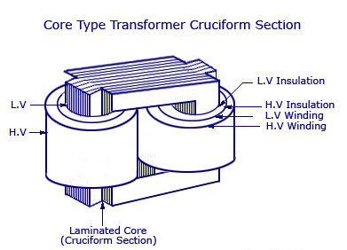

Figure 4.2 Core Type transformer

**Core Type Transformer Cruciform Section**

[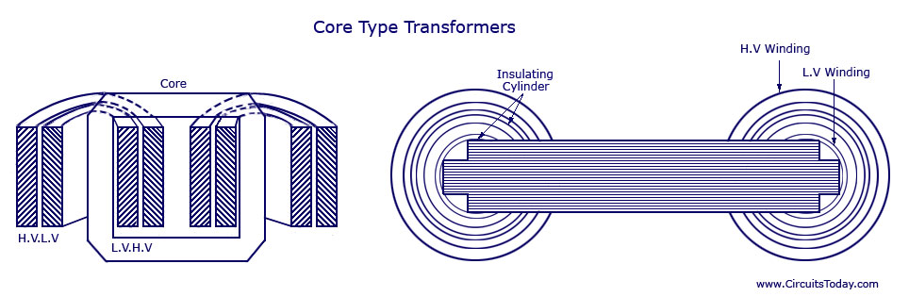](http://www.circuitstoday.com/wp-content/uploads/2011/12/Core-Type-Transformers.jpg)

**Core Type Transformers**

The low voltage windings are placed nearer to the core as it is the easiest to insulate. The effective core area of the transformer can be reduced with the use of laminations and insulation.

**2.      Shell-Type Transformer**

In shell-type transformers the core surrounds a considerable portion of the windings. The comparison is shown in the figure below.

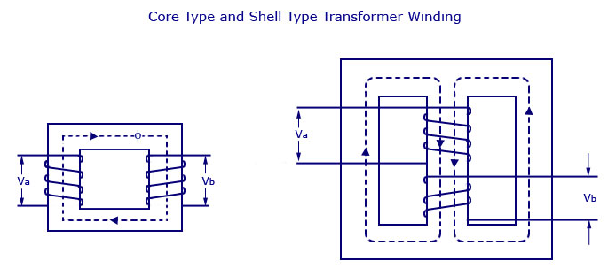

Figure 4.3 Shell Type Transformer winding

**Core Type and Shell Type Transformer Winding**

The coils are form-wound but are multi layer disc type usually wound in the form of pancakes. Paper is used to insulate the different layers of the multi-layer discs. The whole winding consists of discs stacked with insulation spaces between the coils. These insulation spaces form the horizontal cooling and insulating ducts. Such a transformer may have the shape of a simple rectangle or may also have a distributed form. Both designs are shown in the figure below:

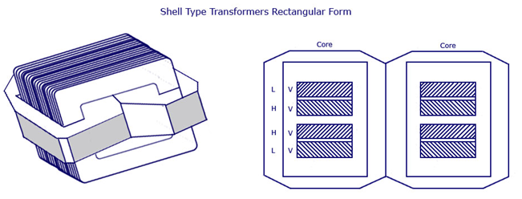

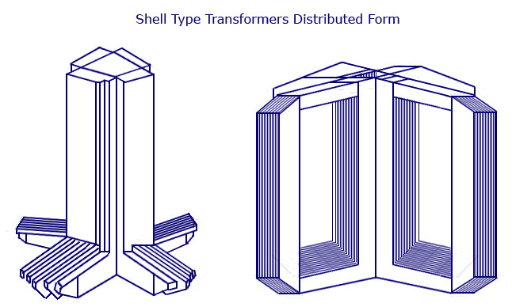

Figure 4.4 Shell Type Transformers Distributed Form

 A strong rigid mechanical bracing must be given to the cores and coils of the transformers. This will help in minimizing the movement of the device and also prevents the device from getting any insulation damage. A transformer with good bracing will not produce any humming noise during its working and will also reduce vibration.

A special housing platform must be provided for transformers. Usually, the device is placed in tightly-fitted sheet-metal tanks filled with special insulating oil. This oil is needed to circulate through the device and cool the coils. It is also responsible for providing the additional insulation for the device when it is left in the air.

There may be cases when the smooth tank surface will not be able to provide the needed cooling area. In such cases, the sides of the tank are corrugated or assembled with radiators on the sides of the device. The oil used for cooling purpose must be absolutely free from alkalis, sulphur and most importantly moisture. Even a small amount of moistures in the oil will cause a significant change in the insulating property of the device, as it lessens the dielectric strength of the oil to a great extent. Mathematically speaking,  the presence of about 8 parts of water in 1 million reduces the insulating quality of the oil to a value that is not considered standard for use. Thus, the tanks are protected by sealing them air-tight in smaller units. When large transformers are used, the air tight method is practically difficult to implement. In such cases, chambers are provided for the oil to expand and contract as its temperature increases and decreases. These breathers form a barrier and resists the atmospheric moisture from contact with oil. Special care must also be taken to avoid sledging. Sledging occurs when oil decomposes due to over exposure to oxygen during heating. It results in the formation of large deposits of dark and heavy matter that clogs the cooling ducts in the transformer.

The quality, durability and handling of these insulating materials decide the life of the transformer. All the transformer leads are brought out of their cases through suitable bushings. There are many designs of these, their size and construction depending on the voltage of the leads. Porcelain bushings may be used to insulate the leads, for transformers that are used in moderate voltages. Oil-filled or capacitive-type bushings are used for high voltage transformers.

The selection between the core and shell type is made by comparing the cost because similar characteristics can be obtained from both types. Most manufacturers prefer to use shell-type transformers for high-voltage applications or for multi-winding design. When compared to a core type, the shell type has a longer mean length of coil turn. Other parameters that are compared for the selection of transformer type are voltage rating, kilo-volt ampere rating, weight, insulation stress, heat distribution and so on.

Transformers can also be classified according to the type of cooling employed. The different types according to these classifications are:

**1.      Oil Filled Self-Cooled Type**

Oil filled self cooled type uses small and medium-sized distribution transformers. The assembled windings and core of such transformers are mounted in a welded, oil-tight steel tanks provided with a steel cover. The tank is filled with purified, high quality insulating oil as soon as the core is put back at its proper place. The oil helps in transferring the heat from the core and the windings to the case from where it is radiated out to the surroundings. For smaller sized transformers the tanks are usually smooth surfaced, but for large size transformers a greater heat radiation area is needed, and that too without disturbing the cubical capacity of the tank. This is achieved by frequently corrugating the cases. Still larger sizes are provided with radiation or pipes.

**2.      Oil Filled Water Cooled Type**

This type is used for much more economic construction of large transformers, as the above told self cooled method is very expensive. The same method is used here as well- the windings and the core are immersed in the oil. The only difference is that a cooling coil is mounted near the surface of the oil, through which cold water keeps circulating. This water carries the heat from the device. This design is usually implemented on transformers that are used in high voltage transmission lines. The biggest advantage of such a design is that such transformers do not require housing other than their own. This reduces the costs by a huge amount. Another advantage is that the maintenance and inspection of this type is only needed once or twice in a year.

**3.      Air Blast Type**

This type is used for transformers that use voltages below 25,000 volts. The transformer is housed in a thin sheet metal box open at both ends through which air is blown from the bottom to the top.

E.M.F Equation of a Transformer

[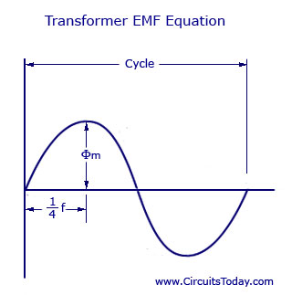](http://www.circuitstoday.com/wp-content/uploads/2011/12/Transformer-EMF-Equation.jpg)

Figure 4.5 Transformer EMF Equation

Let,

 NA =  Number of turns in primary

 NB = Number of turns in secondary

Ømax  = Maximum flux in the core in webers = Bmax X A

f   = Frequency of alternating current input in hertz (HZ)

As shown in figure above, the core flux increases from its zero value to maximum value Ømax  in one quarter of the cycle , that is in ¼ frequency second.

Therefore, average rate of change of flux = Ømax/ ¼ f = 4f ØmaxWb/s

Now, rate of change of flux per turn means induced electro motive force in volts.

Therefore, average electro-motive force induced/turn = 4f Ømaxvolt

If flux Ø varies sinusoidally, then r.m.s value of induced e.m.f is obtained by multiplying the average value with form factor.

Form Factor = r.m.s. value/average value = 1.11

Therefore, r.m.s value of e.m.f/turn = 1.11 X 4f Ømax = 4.44f Ømax

Now, r.m.s value of induced e.m.f in the whole of primary winding

= (induced e.m.f./turn) X Number of primary turns

Therefore,

 E­A = 4.44f NAØmax = 4.44fNABmA

Similarly, r.m.s value of induced e.m.f  in secondary is

E­B = 4.44f NB Ømax = 4.44fNBBmA

In an ideal transformer on no load,

VA = EA  and VB = EB  , where VB is the terminal voltage

Voltage Transformation Ratio (K)

From the above equations we get

EB/ EA = VB/ VA = NB/NA = K

This constant K is known as voltage transformation ratio.

(1)   If NB>NA , that is K>1 , then transformer is called step-up transformer.

(2)   If NB<1, that is K<1 , then transformer is known as step-down transformer.

Again for an ideal transformer,

Input VA = output VA

VAIA = VBIB

Or, IB/IA = VA/VB = 1/K

Hence, currents are in the inverse ratio of the (voltage) transformation ratio.

### 4.1.2 MOSFET Drivers

When utilizing N-Channel MOSFETs to switch a DC voltage across a load, the drain terminals of the high side MOSFETs are often connected to the highest voltage in the system. This creates a difficulty, as the gate terminal must be approximately 10V higher than the drain terminal for the MOSFET to conduct. Often, integrated circuit devices known as MOSFET drivers are utilized to achieve this difference through charge pumps or bootstrapping techniques. These chips are capable of quickly charging the input capacitance of the MOSFET (Cgiss) quickly before the potential difference is reached, causing the gate to source voltage to be the highest system voltage plus the capacitor voltage, allowing it to conduct. A diagram of an N- channel MOSFET with gate, drain, and source terminals is shown in Figure 5

### 

There are many MOSFET drivers available to power N-Channel MOSFETs through level translation of low voltage control signals into voltages capable of supplying sufficient gate voltage. Advanced drivers contain circuitry for powering high and low side devices as well as N and P-Channel MOSFETs. In this design, all MOSFETs are N-Channel due to their increased current handling capabilities. To overcome the difficulties of driving high side N-Channel MOSFETs, the driver devices use an external source to charge a bootstrapping capacitor connected between Vcc and source terminals. The bootstrap capacitor provides gate charge to the high side MOSFET. As the switch begins to conduct, the capacitor maintains a potential difference, rapidly causing the MOSFET to further conduct, until it is fully on. The name bootstrap component refers to this process and how the MOSFET acts as if it is “pulling itself up by its own boot strap”.

### 4.1.3 Rectifier

A rectifier is an electrical device composed of one or more diodes that converts alternating current (AC) to direct current (DC). A diode is like a one-way valve that allows an electrical current to flow in only one direction. This process is called rectification.   
  
A rectifier can take the shape of several different physical forms such as solid-state diodes, vacuum tube diodes, mercury arc valves, silicon-controlled rectifiers and various other silicon-based semiconductor switches.

Rectifiers are used in various devices, including:

* DC power supplies
* Radio signals or detectors
* A source of power instead of generating current
* As flame rectification to detect the presence of flame
* High-voltage direct current power transmission systems
* Several household appliances use power rectifiers to create power, like notebooks or laptops, video game systems and televisions.

**Full Wave Rectifier**

We can reduced the ripple or voltage variations on a direct DC voltage by conecting capacitors across the load resistance. While this method may be suitable for low power applications it is unsuitable to applications which need a “steady and smooth” DC supply voltage. One method to improve on this is to use every half-cycle of the input voltage instead of every other half-cycle. The circuit which allows us to do this is called a Full Wave Rectifier.

Like the half wave circuit, a [Full Wave Rectifier Circuit](http://amazon.com/dp/0123820367/?tag=basicelecttut-20) produces an output voltage or current which is purely DC or has some specified DC component. Full wave rectifiers have some fundamental advantages over their half wave rectifier counterparts. The average (DC) output voltage is higher than for half wave, the output of the full wave rectifier has much less ripple than that of the half wave rectifier producing a smoother output waveform.

In a Full Wave Rectifier circuit two diodes are now used, one for each half of the cycle. A [multiple winding transformer](http://www.electronics-tutorials.ws/transformer/multiple-winding-transformers.html) is used whose secondary winding is split equally into two halves with a common centre tapped connection, (C). This configuration results in each diode conducting in turn when its anode terminal is positive with respect to the transformer centre point C producing an output during both half-cycles, twice that for the half wave rectifier so it is 100% efficient as shown below.

Figure 4.8 Full Wave Rectifier Circuit

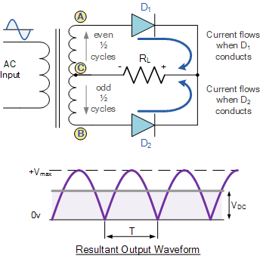

The full wave rectifier circuit consists of two power diodes connected to a single load resistance (RL) with each diode taking it in turn to supply current to the load. When point A of the transformer is positive with respect to point C, diode D1 conducts in the forward direction as indicated by the arrows.

When point B is positive (in the negative half of the cycle) with respect to point C, diode D2 conducts in the forward direction and the current flowing through resistor R is in the same direction for both half-cycles. As the output voltage across the resistor R is the phasor sum of the two waveforms combined, this type of full wave rectifier circuit is also known as a “bi-phase” circuit.

As the spaces between each half-wave developed by each diode is now being filled in by the other diode the average DC output voltage across the load resistor is now double that of the single half-wave rectifier circuit and is about  0.637Vmax  of the peak voltage, assuming no losses.

full wave rectifier voltage

Where: VMAX is the maximum peak value in one half of the secondary winding and VRMS is the rms value.

The peak voltage of the output waveform is the same as before for the half-wave rectifier provided each half of the transformer windings have the same rms voltage value. To obtain a different DC voltage output different transformer ratios can be used. The main disadvantage of this type of full wave rectifier circuit is that a larger transformer for a given power output is required with two separate but identical secondary windings making this type of full wave rectifying circuit costly compared to the “Full Wave Bridge Rectifier” circuit equivalent.

**The Full Wave Bridge Rectifier**

Another type of circuit that produces the same output waveform as the full wave rectifier circuit above, is that of the Full Wave Bridge Rectifier. This type of single phase rectifier uses four individual rectifying diodes connected in a closed loop “bridge” configuration to produce the desired output. The main advantage of this bridge circuit is that it does not require a special centre tapped transformer, thereby reducing its size and cost. The single secondary winding is connected to one side of the diode bridge network and the load to the other side as shown below.

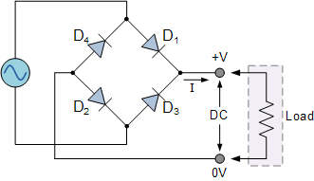

The Diode Bridge Rectifier

The four diodes labelled D1 to D4 are arranged in “series pairs” with only two diodes conducting current during each half cycle. During the positive half cycle of the supply, diodes D1 and D2conduct in series while diodes D3 and D4 are reverse biased and the current flows through the load as shown below.

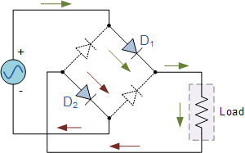

The Positive Half-cycle

During the negative half cycle of the supply, diodes D3 and D4 conduct in series, but diodes D1 andD2 switch “OFF” as they are now reverse biased. The current flowing through the load is the same direction as before.

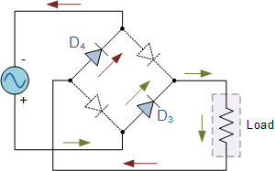

The Negative Half-cycle

As the current flowing through the load is unidirectional, so the voltage developed across the load is also unidirectional the same as for the previous two diode full-wave rectifier, therefore the average DC voltage across the load is 0.637Vmax.

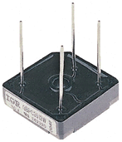

**Typical Bridge Rectifier**

However in reality, during each half cycle the current flows through two diodes instead of just one so the amplitude of the output voltage is two voltage drops ( 2 x 0.7 = 1.4V ) less than the input VMAXamplitude. The ripple frequency is now twice the supply frequency (e.g. 100Hz for a 50Hz supply or 120Hz for a 60Hz supply.)

Although we can use four individual power diodes to make a full wave bridge rectifier, pre-made bridge rectifier components are available “off-the-shelf” in a range of different voltage and current sizes that can be soldered directly into a PCB circuit board or be connected by spade connectors.

The image to the right shows a typical single phase bridge rectifier with one corner cut off. This cut-off corner indicates that the terminal nearest to the corner is the positive or +ve output terminal or lead with the opposite (diagonal) lead being the negative or -veoutput lead. The other two connecting leads are for the input alternating voltage from a transformer secondary winding.

**The Smoothing Capacitor**

The single phase half-wave rectifier produces an output wave every half cycle and that it was not practical to use this type of circuit to produce a steady DC supply. The full-wave bridge rectifier however, gives us a greater mean DC value (0.637 Vmax) with less superimposed ripple while the output waveform is twice that of the frequency of the input supply frequency. We can therefore increase its average DC output level even higher by connecting a suitable smoothing capacitor across the output of the bridge circuit as shown below.

Full-wave Rectifier with Smoothing Capacitor

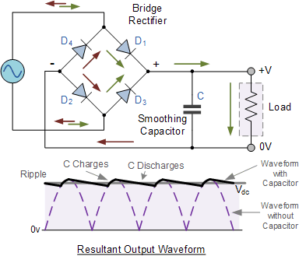

The smoothing capacitor converts the full-wave rippled output of the rectifier into a smooth DC output voltage. Generally for DC power supply circuits the smoothing capacitor is an Aluminium Electrolytic type that has a capacitance value of 100uF or more with repeated DC voltage pulses from the rectifier charging up the capacitor to peak voltage.

However, their are two important parameters to consider when choosing a suitable smoothing capacitor and these are its Working Voltage, which must be higher than the no-load output value of the rectifier and its Capacitance Value, which determines the amount of ripple that will appear superimposed on top of the DC voltage.

Too low a capacitance value and the capacitor has little effect on the output waveform. But if the smoothing capacitor is sufficiently large enough (parallel capacitors can be used) and the load current is not too large, the output voltage will be almost as smooth as pure DC. As a general rule of thumb, we are looking to have a ripple voltage of less than 100mV peak to peak.

The maximum ripple voltage present for a Full Wave Rectifier circuit is not only determined by the value of the smoothing capacitor but by the frequency and load current, and is calculated as:

Bridge Rectifier Ripple Voltage



Where: I is the DC load current in amps, ƒ is the frequency of the ripple or twice the input frequency in Hertz, and C is the capacitance in Farads.

The main advantages of a full-wave bridge rectifier is that it has a smaller AC ripple value for a given load and a smaller reservoir or smoothing capacitor than an equivalent half-wave rectifier. Therefore, the fundamental frequency of the ripple voltage is twice that of the AC supply frequency (100Hz) where for the half-wave rectifier it is exactly equal to the supply frequency (50Hz).

The amount of ripple voltage that is superimposed on top of the DC supply voltage by the diodes can be virtually eliminated by adding a much improved π-filter (pi-filter) to the output terminals of the bridge rectifier. This type of low-pass filter consists of two smoothing capacitors, usually of the same value and a choke or inductance across them to introduce a high impedance path to the alternating ripple component

Another more practical and cheaper alternative is to use an off the shelf 3-terminal voltage regulator IC, such as a LM78xx (where “xx” stands for the output voltage rating) for a positive output voltage or its inverse equivalent the LM79xx for a negative output voltage which can reduce the ripple by more than 70dB (Datasheet) while delivering a constant output current of over 1 amp.

### 4.1.4 LM-741

A LM741 is a 8-pin op amp, meaning it has 8 pins all having their different functions.

Below is the pinout diagram of a LM741 Op amp chip:

**Pin 1: Offset Null**

This is the pin where we add voltage to if we want to eliminate the offset voltage. This is if we want to completely balance the input voltages. More on this at [offset terminals](http://www.learningaboutelectronics.com/Articles/Op-amp-offset-null-terminals)  
**Pin 2: Inverting Input**

This is where the positive part of the input signal that we want to amplify goes if we want our amplified signal inverted. If we don't want it inverted, we place the positve part of the signal into the Non-inverting terminal and place the negative or ground part of our signal here.

**Pin 3: Non-inverting Input**

This is where the positive part of the input signal that we want amplified goes if we want our signal non-inverted.

**Pin 4: V--**

The LM741 Op amp is a dual power supply op amp, meaning it must be supplied positive DC voltage and negative DC voltage. Pin 4 is where the op amp gets supplied with negative DC voltage.

**Pin 5: Offset Null**

This is the pin where we add voltage to if we want to eliminate the offset voltage. This is if we want to completely balance the input voltages. More on this at [offset terminals](http://www.learningaboutelectronics.com/Articles/Op-amp-offset-null-terminals)  
**Pin 6: Output**

This is the terminal where the output, the amplified signal, comes out of. Whatever output the amplifier will drive gets connected to this terminal.   
**Pin 7: V+**

This is the terminal which receives the positive DC voltage.  
**Pin 8: NC**

This pin stands for Not Connected. It is not used for anything and should be left open.

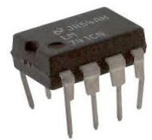

Figure 4.9 LM741

We will now wire up the LM741 so that it provides amplification by a factor of 10.

This is how the circuit of the LM741 Op Amp will be connected in a circuit to provide an amplification of 10, meaning the output signal will be 10 times larger than the input signal.

Place +15VDC to pin 7 and -15VDC to pin 4. This is necessary so the op amp can have bias power to allow it to perform amplification. Without this DC power, the op amp cannot work.

When you connect the signal input to the inverting side of an op amp, the voltage output is equal to:

Formula for voltage output of an op amp inverting mode

The gain of the op amp is equal to:

Gain output of Op Amp Formula

If you want to increase the gain of the op amp, all you have to do is put a larger resistance for Rf. If you want to decrease the gain of the op amp, you just put a lower resistance value for Rf.

This is how you connect a LM741 Op amp for amplification.

### 4.1.5 SPDT Relay

#### **Overview Of Relays**

A relay is an electrically operated switch used to isolate one electrical circuit from another. In its simplest form, a relay consists of a coil used as an electromagnet to open and close switch contacts. Since the two circuits are isolated from one another, a lower voltage circuit can be used to trip a relay, which will control a separate circuit that requires a higher voltage or amperage. Relays can be found in early telephone exchange equipment, in industrial control circuits, in car audio systems, in automobiles, on water pumps, in high-power audio amplifiers and as protection devices.

Single Pole Double Throw Relay an electromagnetic switch, consist of a coil, 1 common terminal , 1 normally closed terminal, and one normally open terminal. When the coil of an SPDT relay is at rest (not energized), the common terminal and the normally closed terminal have continuity. When the coil is energized, the common terminal and the normally open terminal have continuity. When energizing the coil of a relay, polarity of the coil does not matter unless there is a [diode](http://www.the12volt.com/diodes/diodes.asp) across the coil. If a diode is not present, you may attach positive voltage to either terminal of the coil and negative voltage to the other, otherwise you must connect positive to the side of the coil that the cathode side (side with stripe) of the diode is connected and negative to side of the coil that the anode side of the diode is connected.

A relay.

#### **Relay Switch Contacts**

The switch contacts on a relay can be "normally open" (NO) or "normally closed" (NC)--that is, when the coil is at rest and not energized (no current flowing through it), the switch contacts are given the designation of being NO or NC. In an open circuit, no current flows, such as a wall light switch in your home in a position that the light is off. In a closed circuit, metal switch contacts touch each other to complete a circuit, and current flows, similar to turning a light switch to the "on" position. In the accompanying schematic diagram, points A and B connect to the coil. Points C and D connect to the switch. When you apply a voltage across the coil at points A and B, you create an electromagnetic field, which attracts a lever in the switch, causing it to make or break contact in the circuit at points C and D (depending if the design is NO or NC). The switch contacts remain in this state until you remove the voltage to the coil. Relays come in different switch configurations. The switches may have more than one "pole," or switch contact. The diagram shows a "single pole single throw" configuration, referred to as SPST. This is similar to a wall light switch in your home. With a single "throw" of the switch, you close the circuit.

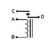

### 

### 4.1.6 2N2222 Transistor

The 2N222 [transistor](http://www.wisegeek.com/what-is-a-transistor.htm) is a common negative-positive-negative (NPN) bipolar junction transistor (BJT) that finds use in many different kinds of electronic equipment. It is used for both analog signal amplification and switching applications.The 2N2222 has three wire leads used to solder it to circuit boards: the collector, the [emitter](http://www.wisegeek.com/what-is-an-emitter.htm), and the base. When an electronic signal is present at the transistor’s collector, applying a signal to the transistor’s base will cause a signal to emit from the device’s emitter. In this way, the 2N2222 is often used to switch signals on and off.

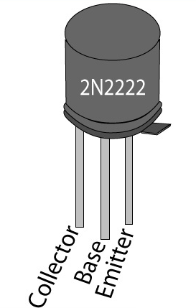

#### **Characteristics**

The main characteristics of this device may be understood with the following points:

* The transistor 2N2222 or 2N2222A are NPN types and has the following electrical parameters:
* The device’s maximum voltage tolerance (breakdown voltage) across its collector and base is 60 volts for 2N2222 and 75 volts for 2N2222A, with the emitters kept open.
* With their base open, the above tolerance across their collector and emitter leads is 30 volts for 2N2222 and 40 volts for 2N2222A.
* As expressed earlier, the maximum current that can be applied across the transistors collector and emitter, via a load is not more than 800 mA.
* Total power dissipation of the device should not exceed above 500 mW.
* hFE or the dC current gain of 2N2222 transistors will be around 75 minimum, at voltages near 10, with 10 mA collector current.
* Maximum frequency handling capacity or the transition frequency is 250 MHz for 2N2222 and 300 MHz for 2N2222A.

### 4.1.7 555 Timer

The 555 timer IC was introduced in the year 1970 by Signetic Corporation and gave the name SE/NE 555 timer. It is basically a  monolithic timing circuit that produces accurate and highly stable time delays or oscillation. When compared to the applications of an op-amp in the same areas, the 555IC is also equally reliable and is cheap in cost. Apart from its applications as a [monostable multivibrator](http://www.circuitstoday.com/555-timer-as-monostable-multivibrator) and [astable multivibrator](http://www.circuitstoday.com/555-timer-as-an-astable-multivibrator), a 555 timer can also be used in [dc-dc converters](http://www.circuitstoday.com/6-to-15v-dc-to-dc-converter), digital logic probes, [waveform generators](http://www.circuitstoday.com/function-generators), analog frequency meters and tachometers, [temperature measurement](http://www.circuitstoday.com/led-bargraph-thermometer) and control devices, [voltage regulators](http://www.circuitstoday.com/category/voltage-regulators) etc. The timer IC is setup to work in either of the two modes – one-shot or monostabl or as a free-running or astable multivibrator.The SE 555 can be used for temperature ranges between – 55°C to 125° . The NE 555 can be used for a temperature range between 0° to 70°C.

### The important features of the 555 timer are :

* It operates from a wide range of [**power supplies**](http://www.circuitstoday.com/category/power-supplies) ranging from + 5 Volts to + 18 Volts supply voltage.
* Sinking or sourcing 200 mA of load current.
* The external components should be selected properly so that the timing intervals can be made into several minutes along with the frequencies exceeding several hundred kilo hertz.
* The output of a 555 timer can drive a transistor-transistor logic (TTL) due to its high current output.
* It has a temperature stability of 50 parts per million (ppm) per degree Celsius change in temperature, or equivalently 0.005 %/°C.
* The duty cycle of the timer is adjustable.
* The maximum power dissipation per package is 600 mW and its trigger and reset inputs has logic compatibility. More features are listed in the datasheet.

### 555 timer ic pin configuration and diagram

The 555 Timer IC is available as an 8-pin metal can, an 8-pin mini DIP (dual-in-package) or a 14-pin DIP. The pin configuration is shown in the figures.

This IC consists of 23 transistors, 2 diodes and 16 [resistors](http://www.circuitstoday.com/resistors-and-types-of-resistors). The use of each pin in the IC is explained below. The pin numbers used below refers to the 8-pin DIP and 8-pin metal can packages. These pins are explained in detail, and you will get a better idea after going through the entire post.

**Pin 1**: **Grounded Terminal:**All the voltages are measured with respect to the Ground terminal.

**Pin 2: Trigger Terminal:** The trigger pin is used to feed the trigger input hen the 555 IC is set up as a monostable multivibrator. This pin is an inverting input of a [**comparator**](http://www.circuitstoday.com/op-amp-comparator) and is responsible for the transition of [**flip-flop**](http://www.circuitstoday.com/flip-flops)from set to reset. The output of the timer depends on the amplitude of the external trigger pulse applied to this pin. A negative pulse with a dc level greater than Vcc/3 is applied to this terminal. In the negative edge, as the trigger passes through Vcc/3, the output of the lower comparator becomes high and the complimentary of Q becomes zero. Thus the 555 IC output gets a high voltage, and thus a quasi stable state.

**Pin 3:** **Output Terminal:**Output of the timer is avail­able at this pin. There are two ways in which a load can be connected to the output terminal. One way is to connect between output pin (pin 3) and ground pin (pin 1) or between pin 3 and supply pin (pin 8). The load connected between output and ground supply pin is called the **normally on load**and that connected between output and ground pin is called the ***normally off load***.

**Pin 4:** **Reset Terminal:**Whenever the timer IC is to be reset or disabled, a negative pulse is applied to pin 4, and thus is named as reset terminal. The output is reset irrespective of the input condition. When this pin is not to be used for reset purpose, it should be connected to + VCC to avoid any possibility of false triggering.

**Pin 5:** **Control Voltage Terminal:**The threshold and trigger levels are controlled using this pin. The pulse width of the output waveform  is determined by connecting a POT or bringing in an external voltage to this pin.  The external voltage applied to this pin can also be used to modulate the output waveform. Thus, the amount of voltage applied in this terminal will decide when the comparator is to be switched, and thus changes the pulse width of the output. When this pin is not used, it should be bypassed to ground through a 0.01 micro Farad to avoid any noise problem.

**Pin 6**: **Threshold Terminal:**This is the non-inverting input terminal of comparator 1, which compares the voltage applied to the terminal with a reference voltage of 2/3 VCC. The amplitude of voltage applied to this terminal is responsible for the set state of flip-flop. When the voltage applied in this terminal is greater than 2/3Vcc, the upper comparator switches to +Vsat and the output gets reset.

**Pin 7**: **Discharge Terminal:**This pin is connected internally to the collector of transistor and mostly a capacitor is connected between this terminal and ground. It is called discharge terminal because when transistor saturates, capacitor discharges through the transistor. When the transistor is cut-off, the capacitor charges at a rate determined by the external resistor and capacitor.

**Pin 8:** **Supply Terminal:**A supply voltage of + 5 V to + 18 V is applied to this terminal with respect to ground (pin 1).

## 555 Timer Basics

The **555 timer**combines a relaxation oscillator, two comparators, an R-S flip-flop, and a discharge capacitor

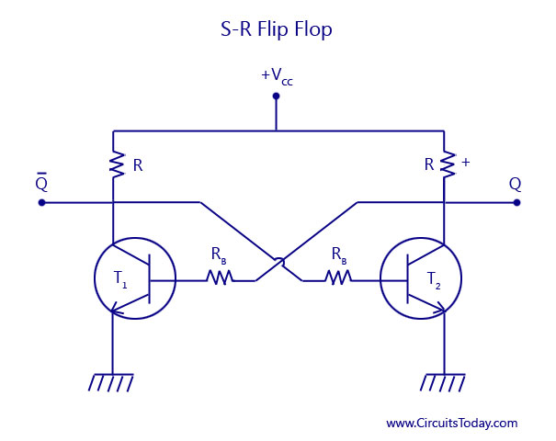

As shown in the figure, two transistors T1 and T2 are cross coupled. The collector of transistor T1 drives the base of transistor T2 through the resistor Rb2. The collector of transistor T2 drives the base of transistor T1 through resistor Rb1. When one of the transistor is in the saturated state, the other transistor will be in the cut-off state. If we consider the transistor T1 to be saturated, then the collector voltage will be almost zero. Thus there will be a zero base drive for transistor T2 and will go into cut-off state and its collector voltage approaches +Vcc. This voltage is applied to the base of T1 and thus will keep it in saturation.

### S-R Flip Flop Symbol

Now, if we consider the transistor T1 to be in the cut-off state, then the collector voltage of T1 will be equal to +Vcc. This voltage will drive the base of the transistor T2 to saturation. Thus, the saturated collector output of transistor T2 will be almost zero. This value when fedback to the base of the transistor T1 will drive it to cut-off. Thus, the saturation and cut-off value of anyone of the transistors decides the high and low value of Q and its compliment. By adding more components to the circuit, an R-S flip-flop is obtained. R-S flip-flop is a circuit that can set the Q output to high or reset it low*.*Incidentally, a complementary (opposite) output Q is available from the collector of the other transistor. The schematic symbol for a S-R flip flop is also shown above. The circuit latches in either the Q state or its complimentary state. A high value of S input sets the value of Q to go high. A high value of R input resets the value of Q to low. Output Q remains in a given state until it is triggered into the opposite state.

**Basic Timing Concept**

From the figure above, assuming the output of the S-R flip flop, Q to be high. This high value is passed on to the base of the transistor, and the transistor gets saturated, thus producing a zero voltage at the collector. The capacitor voltage is clamped at ground, that is, the capacitor C is shorted and cannot charge.

The inverting input of the comparator is fed with a control voltage, and the non-inverting input is fed with a threshold voltage. With R-S flip flop set, the saturated transistor holds the threshold voltage at zero. The control voltage, however, is fixed at 2/3 VCC, that is, at 10 volts, because of the voltage divider.

Suppose that a high voltage is applied to the R input. This resets the flip-flop R-Output Q goes lowand the transistor is cut-off. Capacitor C is now free to charge. As this capacitor C charges, the threshold voltage rises. Eventually, the threshold voltage becomes slightly greater than (+ 10 V). The output of the comparator then goes high*,* forcing the R S flip-flop to set. The high Q output saturates the transistor, and this quickly discharges the capacitor. An exponential rise is across the capacitor C, and a positive going pulse appears at the output Q. Thus capacitor voltage VC is exponential while the output is rectangular. This is shown in the figure above.

## Block Diagram

[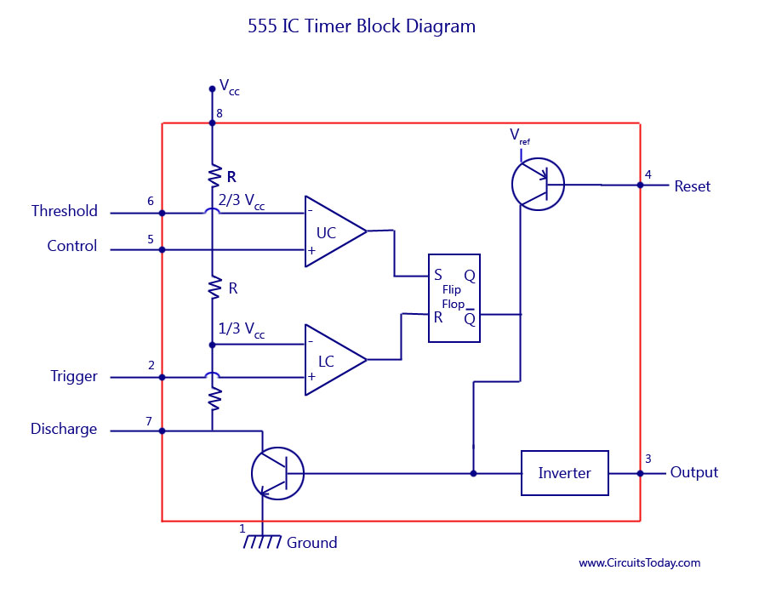](http://www.circuitstoday.com/wp-content/uploads/2009/09/555-IC-Timer-Block-Diagram.jpg)

The block diagram of a **555 timer** is shown in the above figure. A 555 timer has two comparators, which are basically 2 op-amps), an R-S flip-flop, two transistors and a resistive network.

* Resistive network consists of three equal resistors and acts as a voltage divider.
* Comparator 1 compares threshold voltage with a reference voltage + 2/3VCC volts.
* Comparator 2 compares the trigger voltage with a reference voltage + 1/3 VCC volts.

Output of both the comparators is supplied to the flip-flop. Flip-flop assumes its state according to the output of the two compa­rators. One of the two transistors is a discharge transistor of which collector is connected to**pin** 7. This tran­sistor saturates or cuts-off according to the output state of the flip-flop. The saturated transis­tor provides a discharge path to a capacitor con­nected externally. Base of another transistor is connected to a reset terminal. A pulse applied to this terminal resets the whole timer irrespective of any input.

**Working Principle**

The internal resistors act as a voltage divider network, providing (2/3)Vcc at the non-inverting terminal of the upper comparator and (1/3)Vcc at the inverting terminal of the lower comparator. In most applications, the control input is not used, so that the control voltage equals +(2/3) VCC. Upper comparator has a threshold input (pin 6) and a control input (pin 5). Output of the upper comparator is applied to set (S) input of the flip-flop. Whenever the threshold voltage exceeds the control voltage, the upper comparator will set the flip-flop and its output is high. A high output from the flip-flop when given to the base of the discharge transistor saturates it and thus discharges the transistor that is connected externally to the discharge pin 7. The complementary signal out of the flip-flop goes to pin 3, the output. The output available at pin 3 is low. These conditions will prevail until lower comparator triggers the flip-flop. Even if the voltage at the threshold input falls below (2/3) VCC, that is upper comparator cannot cause the flip-flop to change again. It means that the upper comparator can only force the flip-flop’s output high.

To change the output of flip-flop to low, the voltage at the trigger input must fall below + (1/3) Vcc. When this occurs, lower comparator triggers the flip-flop, forcing its output low. The low output from the flip-flop turns the discharge transistor off and forces the power amplifier to output a high. These conditions will continue independent of the voltage on the trigger input. Lower comparator can only cause the flip-flop to output low.

From the above discussion it is concluded that for the having low output from the timer 555, the voltage on the threshold input must exceed the control voltage or + (2/3) VCC. This also turns the discharge transistor on. To force the output from the timer high, the voltage on the trigger input must drop below +(1/3) VCC. This turns the discharge transistor off.

A voltage may be applied to the control input to change the levels at which the switching occurs. When not in use, a 0.01 nano Farad capacitor should be connected between pin 5 and ground to prevent noise coupled onto this pin from causing false triggering.

Connecting the reset (pin 4) to a logic low will place a high on the output of flip-flop. The discharge transistor will go on and the power amplifier will output a low. This condition will continue until reset is taken high. This allows synchronization or resetting of the circuit’s operation. When not in use, reset should be tied to +VCC.

### 4.1.8 Arduino

[Arduino](http://arduino.cc/) is an open-source platform used for building electronics projects. Arduino consists of both a physical programmable circuit board (often referred to as a [microcontroller](http://en.wikipedia.org/wiki/Microcontroller)) and a piece of[software](http://arduino.cc/en/Main/Software), or IDE (Integrated Development Environment) that runs on your computer, used to write and upload computer code to the physical board.

The Arduino platform has become quite popular with people just starting out with electronics, and for good reason. Unlike most previous programmable circuit boards, the Arduino does not need a separate piece of hardware (called a programmer) in order to load new code onto the board – you can simply use a USB cable. Additionally, the Arduino IDE uses a simplified version of C++, making it easier to learn to program. Finally, Arduino provides a standard form factor that breaks out the functions of the micro-controller into a more accessible package.

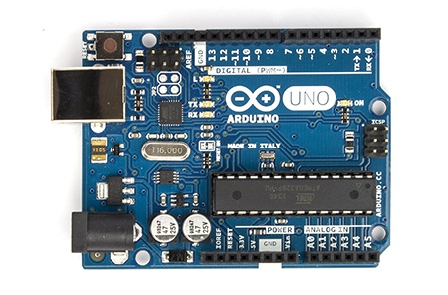

**Arduino Uno R3 Front**

The Arduino hardware and software was designed for artists, designers, hobbyists, hackers, newbies, and anyone interested in creating interactive objects or environments. Arduino can interact with buttons, LEDs, motors, speakers, GPS units, cameras, the internet, and even your smart-phone or your TV! This flexibility combined with the fact that the Arduino software is free, the hardware boards are pretty cheap, and both the software and hardware are easy to learn has led to a large community of users who have contributed code and released instructions for ahuge variety of Arduino-based projects.

For everything from [robots](https://learn.sparkfun.com/tutorials/building-the-hub-ee-buggy) and a [heating pad hand warming blanket](https://learn.sparkfun.com/tutorials/heating-pad-hand-warmer-blanket) to [honest fortune-telling machines](https://learn.sparkfun.com/tutorials/the-uncertain-7-cube), and even a [Dungeons and Dragons dice-throwing gauntlet](http://www.sparkfun.com/tutorials/333), the Arduino can be used as the brains behind almost any electronics project.

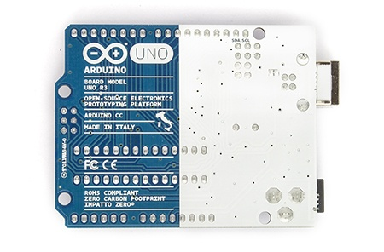

**Arduino Uno R3 Back**

#### 4.1.4.2 Summary

|  |  |
| --- | --- |
| Microcontroller | ATmega328 |
| Operating Voltage | 5V |
| Input Voltage (recommended) | 7-12V |
| Input Voltage (limits) | 6-20V |
| Digital I/O Pins | 14 (of which 6 provide PWM output) |
| Analog Input Pins | 6 |
| DC Current per I/O Pin | 40 mA |
| DC Current for 3.3V Pin | 50 mA |
| Flash Memory | 32 KB (ATmega328) of which 0.5 KB used by bootloader |
| SRAM | 2 KB (ATmega328) |
| EEPROM | 1 KB (ATmega328) |
|  |  |

**Power (USB / Barrel Jack)**

Every Arduino board needs a way to be connected to a power source. The Arduino UNO can be powered from a USB cable coming from your computer or a wall power supply ([like this](https://www.sparkfun.com/products/8269)) that is terminated in a barrel jack.

The USB connection is also how you will load code onto Arduino board. Do NOT use a power supply greater than 20 Volts as you will overpower (and thereby destroy) your Arduino. The recommended voltage for most Arduino models is between 6 and 12 Volts.

**Pins (5V, 3.3V, GND, Analog, Digital, PWM, AREF)**

The pins on your Arduino are the places where you connect wires to construct a circuit (probably in conjuction with a [breadboard](https://learn.sparkfun.com/tutorials/how-to-use-a-breadboard/) and some [wire](https://learn.sparkfun.com/tutorials/working-with-wire). They usually have black plastic ‘headers’ that allow you to just plug a wire right into the board. The Arduino has several different kinds of pins, each of which is labeled on the board and used for different functions.

**GND**

Short for ‘Ground’. There are several GND pins on the Arduino, any of which can be used to ground your circuit.

**5V & 3.3V**

The 5V pin supplies 5 volts of power, and the 3.3V pin supplies 3.3 volts of power. Most of the simple components used with the Arduino run happily off of 5 or 3.3 volts.

**Analog**

The area of pins under the ‘Analog In’ label (A0 through A5 on the UNO) are Analog In pins. These pins can read the signal from an analog sensor (like a [temperature sensor](https://www.sparkfun.com/products/10988)) and convert it into a digital value that we can read.

**Digital**

Across from the analog pins are the digital pins (0 through 13 on the UNO). These pins can be used for both digital input (like telling if a button is pushed) and digital output (like powering an LED).

**PWM**

You may have noticed the tilde (~) next to some of the digital pins (3, 5, 6, 9, 10, and 11 on the UNO). These pins act as normal digital pins, but can also be used for something called Pulse-Width Modulation (PWM). We have [a tutorial on PWM](https://learn.sparkfun.com/tutorials/pulse-width-modulation), but for now, think of these pins as being able to simulate analog output (like fading an LED in and out).

**AREF**

Stands for Analog Reference. Most of the time you can leave this pin alone. It is sometimes used to set an external reference voltage (between 0 and 5 Volts) as the upper limit for the analog input pins.

**Reset Button**

Just like the original Nintendo, the Arduino has a reset button (10). Pushing it will temporarily connect the reset pin to ground and restart any code that is loaded on the Arduino. This can be very useful if your code doesn’t repeat, but you want to test it multiple times. Unlike the original Nintendo however, blowing on the Arduino doesn’t usually fix any problems.

**Power LED Indicator**

Just beneath and to the right of the word “UNO” on your circuit board, there’s a tiny LED next to the word ‘ON’ (11). This LED should light up whenever you plug your Arduino into a power source. If this light doesn’t turn on, there’s a good chance something is wrong. Time to re-check your circuit!

**TX RX LEDs**

TX is short for transmit, RX is short for receive. These markings appear quite a bit in electronics to indicate the pins responsible for [serial communication](https://learn.sparkfun.com/tutorials/serial-communication). In our case, there are two places on the Arduino UNO where TX and RX appear – once by digital pins 0 and 1, and a second time next to the TX and RX indicator LEDs (12). These LEDs will give us some nice visual indications whenever our Arduino is receiving or transmitting data (like when we’re loading a new program onto the board).

**Main IC**

The black thing with all the metal legs is an IC, or Integrated Circuit (13). Think of it as the brains of our Arduino. The main IC on the Arduino is slightly different from board type to board type, but is usually from the ATmega line of IC’s from the ATMEL company. This can be important, as you may need to know the IC type (along with your board type) before loading up a new program from the Arduino software. This information can usually be found in writing on the top side of the IC. If you want to know more about the difference between various IC’s, reading the datasheets is often a good idea.

**Voltage Regulator**

The voltage regulator (14) is not actually something you can (or should) interact with on the Arduino. But it is potentially useful to know that it is there and what it’s for. The voltage regulator does exactly what it says – it controls the amount of voltage that is let into the Arduino board. Think of it as a kind of gatekeeper; it will turn away an extra voltage that might harm the circuit. Of course, it has its limits, so don’t hook up your Arduino to anything greater than 20 volts.

**The Arduino Family**

Arduino makes several different boards, each with different capabilities. In addition, part of being open source hardware means that others can modify and produce derivatives of Arduino boards that provide even more form factors and functionality. If you’re not sure which one is right for your project, [check this guide](https://www.sparkfun.com/arduino_guide) for some helpful hints. Here are a few options that are well-suited to someone new to the world of Arduino.

### 4.1.9 Capacitors

Capacitors are two-terminal electrical elements.  Capacitors are essentially two conductors, usually conduction plates but any two conductors  separated by an insulator  a dielectric with connection wires connected to the two conducting plates.

Capacitors occur naturally. On printed circuit boards two wires running parallel to each other on opposite sides of the board form a capacitor. That's a capacitor that comes about inadvertently, and we would normally prefer that it not be there. But, it's there.  It has electrical effects, and it will affect your circuit.

At other times, we specifically want to use capacitors because of their frequency dependent behaviour. There are lots of situations where we want to design for some specific frequency dependent behaviour. May be we want to filter out some high frequency noise from a lower frequency signal. May be we want to filter out power supply frequencies in a signal running near a 60 Hz line.

Sometimes we can use a capacitor to store energy.  In a subway car, an insulator at a track switch may cut off power from the car for a few feet along the line. We might use a large capacitor to store energy to drive the subway car through the insulator in the power feed.

Capacitors are used for all these purposes, and more. In this chapter you're going to start learning about this important electrical component. Remember capacitors do the following and more.

* Store energy
* Change their behaviour with frequency
* Come about naturally in circuits and can change a circuit's behavior

#### **Working of a Capacitor**

A capacitor consists of two metal plates which are separated by a non-conducting substance or dielectric. Take a look at the figure given below to know about dielectric in a capacitor.

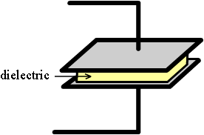

Though any non-conducting substance can be used as a dielectric, practically some special materials like porcelain, mylar, teflon, mica, cellulose and so on.

A capacitor is defined by the type of dielectric selected. It also defines the application of the capacitor. According to the size and type of dielectric used, the capacitor can be used for high voltage as well as low voltage applications. For applications in radio tuning circuits air is commonly used as the dielectric. for applications in timer circuits mylar is used as the dielectric. For high voltage applications glass is normally used. For application in X-ray and MRI machines, ceramic is mostly preferred. The metal plates are separated by a distance “d”, and a dielectric material is placed between the plates.

The dielectric material is the main substance that helps in storing the electrical energy.

#### **Capacitor connected to a battery**

A Capacitor that is connected to a battery is shown below.

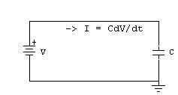

A voltage “V” appears across the capacitor, producing a capacitance “C” and a current “I”. The voltage produced by the battery is accepted by the plate that is connected to the negative of the battery. Similarly, the plate on the capacitor that attaches to the positive terminal of the battery loses electrons to the battery. Thus the capacitor begins charging given by the equation:

dq = C*dV

where dQ is the small change in charge and dV is the small change in voltage.  
Thus the current can be expressed as:

I=C*dV/dt

When the capacitor is fully charged it will have the same voltage as the battery.

#### **Capacitor connected in series:**

Capacitors C1 and C2 connected in series are shown in the figure below.

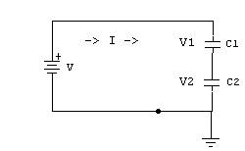

When the capacitors have a series connection the total voltage “V” from the battery is split into V1 and V2 across the capacitors C1 and C2. The overall charge “Q” will be the charge of the total capacitance.

V = V1 + V2

As in any series circuit the current I is the same throughout

Therefore total capacitance of the circuit,

Ctotal = Q/V = Q/(V1 + V2)

This can be further calculated as

1/Ctotal  = 1/C1  +  1/C2

Thus, for a circuit having “n” number of capacitors in series

1/Ctotal  = 1/C1  +  1/C2 + 1/C3 + …… + 1/Cn

#### **Capacitor connected in parallel**

Two capacitors C1 and C2 are kept in parallel. The voltage across both the capacitors will be the same, “V”. The charge in the capacitor C1 is Q1 and the charge in capacitor C2 is Q2. Thus we can write the equations as:

C1=Q1/V

C2=Q2/V

Total Capacitance

Ctotal = (Q1+Q2)/V = Q1/V  +  Q2/V = C1 + C2

If there are “n” capacitors kept in parallel, then total capacitance can be written as

Ctotal = C1 + C2 + C3 + … + Cn

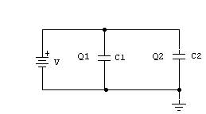

#### **Advantages**

* Since the capacitor can discharge in a fraction of a second, it has a very large advantage. Capacitors are used for appliances which require high speed use like in camera flash and laser techniques.
* Capacitors are used to remove ripples by removing the peaks and filling in the valleys.
* A capacitor allows ac voltage to pass through and blocks dc voltage. This has been used in many electronic applications.

### 4.1.10 78L12 IC

This 7812 is fixed-voltage integrated-circuit voltage regulators is designed for a wide range of applications. These applications include on-card regulation for elimination of noise and distribution problems associated with single-point regulation. In addition, they can be used with power-pass elements to make high-current voltage regulators. It can deliver up to 100 mA of output current.

7812 has built in over heat and short circuit protection which makes it a good choice for making power supplies.If we hold the ic upside down (pins up) and the IC number is facing you then the left pin will be the voltage regulator output, the center pin will be ground and the right pin will be the voltage input pin. Under my experience, the maximum safe current you can get from one 7812 IC is 1A.

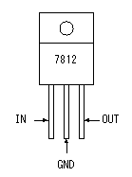

### 4.1.10 Visual basic

Visual Basic is a [third-generation](https://en.wikipedia.org/wiki/Third-generation_programming_language) [event-driven programming language](https://en.wikipedia.org/wiki/Event-driven_programming) and [integrated development environment](https://en.wikipedia.org/wiki/Integrated_development_environment) (IDE) from[Microsoft](https://en.wikipedia.org/wiki/Microsoft) for its [COM](https://en.wikipedia.org/wiki/Component_Object_Model) programming model first released in 1991 and declared legacy in 2008. Microsoft intended Visual Basic to be relatively easy to learn and use. Visual Basic was derived from [BASIC](https://en.wikipedia.org/wiki/BASIC) and enables the [rapid application development (RAD)](https://en.wikipedia.org/wiki/Rapid_application_development) of [graphical user interface (GUI)](https://en.wikipedia.org/wiki/Graphical_user_interface) applications, access to [databases](https://en.wikipedia.org/wiki/Database) using [Data Access Objects](https://en.wikipedia.org/wiki/Data_Access_Object), [Remote Data Objects](https://en.wikipedia.org/wiki/Remote_Data_Objects), or [ActiveX Data Objects](https://en.wikipedia.org/wiki/ActiveX_Data_Object), and creation of [ActiveX](https://en.wikipedia.org/wiki/ActiveX) controls and objects.

A programmer can create an application using the [components](https://en.wikipedia.org/wiki/Component-based_software_engineering) provided by the Visual Basic program itself. Over time the community of programmers developed third party components. Programs written in Visual Basic can also use the[Windows API](https://en.wikipedia.org/wiki/Windows_API), which requires external function declarations.

The final release was version 6 in 1998 (now known simply as Visual Basic). On April 8, 2008 Microsoft stopped supporting Visual Basic 6.0 [IDE](https://en.wikipedia.org/wiki/Integrated_development_environment). The Microsoft Visual Basic team still maintains compatibility for Visual Basic 6.0 applications on [Windows Vista](https://en.wikipedia.org/wiki/Windows_Vista), [Windows Server 2008](https://en.wikipedia.org/wiki/Windows_Server_2008) including R2, [Windows 7](https://en.wikipedia.org/wiki/Windows_7), [Windows 8](https://en.wikipedia.org/wiki/Windows_8), [Windows 8.1](https://en.wikipedia.org/wiki/Windows_8.1), [Windows Server 2012](https://en.wikipedia.org/wiki/Windows_Server_2012) and [Windows 10](https://en.wikipedia.org/wiki/Windows_10)through its "It Just Works" program. In 2014, some [software developers](https://en.wikipedia.org/wiki/Software_developer) still preferred Visual Basic 6.0 over its successor,[Visual Basic .NET](https://en.wikipedia.org/wiki/Visual_Basic_.NET). In 2014 some developers lobbied for a new version of Visual Basic 6.0. In 2016, Visual Basic 6.0 won the technical impact award at The 19th Annual D.I.C.E. Awards.



A dialect of Visual Basic, [Visual Basic for Applications](https://en.wikipedia.org/wiki/Visual_Basic_for_Applications) (VBA), is used as a macro or scripting language within several Microsoft applications, including [Microsoft Office](https://en.wikipedia.org/wiki/Microsoft_Office).

**Chapter 5**

# CONCLUSION

A simple and cost-effective system is developed in this project. It is an implementation of power alert monitor based on atmega micro controller. It can measure and monitor electrical power parameters to avoid disturbances. A new application capable to detect faults in power transmission lines presented to this system is capable to give instantaneous notice to the user about problems in distribution line on the computer.

# REFRENCES

<https://www.elprocus.com/under-and-overvoltage-protection-circuit/>

<https://www.researchgate.net/publication/271646898_Implementation_of_Over-Voltage_Under-Voltage_Protection_System>

<https://www.maximintegrated.com/en/app-notes/index.mvp/id/4545>

<http://www.homemade-circuits.com/p/sine-wave-inverters.html>

<http://www.circuitsgallery.com/2012/09/inverter-circuit-schematic-555-timer2.html>

<http://www.mycircuits9.com/2012/06/simple-inverter-circuit-230v.html>