ABSTRACT

The majority of Pakistani and Indian people depends on agriculture and depends largely on the country's economy on agriculture. Good irrigation is therefore a prerequisite for efficient farming and therefore we can improve the country's economy. We can reach it with the help of several electronic devices. By using it, we can automatically achieve the correct irrigation on the field. For automation, we need various hardware and software tools, such as different types of sensors to check the status of the field and the GSM module for wireless communication and the microcontroller for decision-making purposes.
Table of Contents
DECLARATION vii
ACKNOWLEDGMENT x
ABSTRACT 11
Chapter 1 15
INTRODUCTION 15
1.1 Overview 15
1.2 Statement of Problem 16
1.3 Objectives 16
1.4 Aim 16
1.5 Advantages of the project 16
1.6 Justification 16
Chapter 2 18
LITERATURE REVIEW 18
1.1 SOIL MOISTURE 18
2.2 Irrigation 18
2.3 Technologies in Agriculture 20
Chapter 3 22
PROJECT DESIGN AND IMPLEMENTATION 22
3.1 Project Design 22
3.2 Block Diagram 23
TOOLS AND TECHNIQUES 25
4.1 Hardware used with technical specifications 25
4.1.1 Transistor 25
Characteristics of the 2SA1015 bipolar transistor 30
Pin Configuration (Pinout) 31
4.1.2 Relay 31
4.1.3 Diode 36
4.1.4 Arduino Uno 37
4.1.5 REGULATORS 40
4.1.6 Gsm Module 43
4.1.7 Resistor: 47
4.1.8 Moisture Sensor 48
Application 50
4.1.9 Solar Panel 50
4.1.10 12V Battery 53
4.1.11 LCD 54
Chapter 5 57
Conclusion 57

LIST OF ACRONYMS
BJT Bipplar Junction Transistor
FET Field Effect Transistor
LED Light Emitting Diode
MOSFET Metal Oxide Semiconductor FET
VMOS Vertical MOSFET
UJT Uni-Junction Transistor
LDR Light dependent resistor

Chapter 1

INTRODUCTION

Solar energy is the largest source of energy around the world. Solar energy is not only an answer to the current energy crisis, but also a form of energy that respects the environment. Solar panels (a series of photovoltaic cells) are widely used today to operate street lights, feed water heaters and cover household loads. The cost of solar power Panels are gradually decreasing and encouraged in various sectors. An application of this technology is used in agricultural irrigation systems [1].The solar irrigation system can be a viable alternative to farmers in the current state of the energy crisis in Pakistan. This is a way to produce green energy that provides free energy when the initial investment is made.
The irrigation system is an experimental method of misleading water supply for the area or soil that forms the main base of our crop system. The water must be supplied mainly to the fields or through the ditches. This system should reduce the workload of farmers and help maintain adequate soil quality for better growth. From that moment on, the development of innovation was conceivable that killed the cadres emphasizing the immediate insertion of farmers' agriculture in their fields.
The entire irrigation system is controlled through a microcontroller atmega328 which is used in Arduino uno. The message related with moisture is sent through a gsm module, this gsm module as a prepaid type sim and can be used for sending messages. This irrigation system is fully automated the valve is controlled automatically.

1.1 Overview
The analysis of power in rural areas of Pakistan shows that the energy supplied by the electricity company is highly unpredictable and highly disrupted. Most farmers have their own piece of land away from the distance. All crops in these lands depend on proper irrigation, allowing them to sit in the field and monitor the power and turn the pump on or off. This makes them more annoying when approaching the ground to the irrigation pump. Almost a human resource is spent on this operation . A time of human resources is taken twenty-four hours a day for every day in a year and making them more worried. To get around this problem, it was possible to reach a GSM solution to reach the farmer regardless of his position [2]. The solution aims to automate the control of the irrigation pump at a very low cost and relives the farmer from his usual duty to keep the phone with an irrigation pump is one of the most common and useful consumer electronic gadgets in the world today. It incorporates both the communication and the stored digital electronics.

1.2 Statement of Problem
The supply of electricity is not reached up to every place. A suitable alternative for farmers in the present state of energy crisis in Pakistan (also it is an ecofriendly – green way for energy production).

1.3 Objectives
- To design and implementation of automatic solar irrigation system.
- To Control a pump on the condition of soil moisture.
- Develop a GSM-based module to obtain the status of the switching operation of the engine used for irrigation

Aim
The project seeks to design and implement an irrigation system based on GSM. The application will integrate a microcontroller, a soil moisture sensor and GSM module. The information collected by the soil moisture sensor and the water level detector will trigger actions through the microcontroller.

Advantages of the project
- Any Type of irrigation.
- Agriculture field.
- Where the power system is not available.
- Reduce of power & water Dissipation.

Justification
- The system will communicate actions and events to the user through the mobile, thereby eliminating need for user`s physical presence .
- The system will cut on labor costs.
- The system will optimize conditions for plant growth thereby increasing production.

Software’s used:
Proteus
Arduino IDE for programming.

Chapter 2

LITERATURE REVIEW
This chapter includes all the work before starting the core of the report. Literature review contains all the articles, research papers and books studied as an inspiration for the project.
The power based on sunlight is not exclusively related to the grades that were a response to today's vitality emergency, but jointly a kind of inviting and ecological vitality. The era of electric wonder is a moderate approach to the misuse of sunlight. The structure of the sun-controlled high-water system could be an appropriate distinguishing feature for breeders within the blessing condition of the vital emergency.

SOIL MOISTURE
Soil moisture is an important component in the atmospheric water cycle, both on a small-scale agricultural scale and in the large-scale modeling of ground / atmosphere interaction. Vegetation and crops are increasingly dependent on the moisture available at the root level rather than precipitation. The water balance for irrigation planning and effective irrigation planning requires information on local soil moisture. Knowing the degree of soil moisture helps to predict the risk of sudden flooding or the occurrence of fog [3]. The water content in the soil is an expression of the mass or volume of water in the soil, while the water potential of the soil is an expression of the state of water energy in the soil. The relationship between content and potential is not universal and depends on the characteristics of the local soil, such as the density of the soil and the consistency of the soil. The geometric method is used for measuring the content of soil. Because this method is based on direct measurements, it is the standard by which all other methods are compared. Unfortunately, gravimetric sampling is destructive, making repeated measurements on the same soil sample impossible. Because of the difficulty of accurately measuring dry soil and water volume, the volumetric content of water is usually not directly determined.

2.2 Irrigation
The irrigation system uses valves to turn irrigation on and off. These valves can be easily automated using controllers and solenoids. The automation of agricultural irrigation or nurseries allows farmers to apply the right amount of water at the right time, regardless of the availability of labor to turn the valves on and off [4]. In addition, farmers who use automation equipment are able to reduce runoff from saturated irrigation soils, avoid irrigating at the wrong time of day, which will improve crop performance by ensuring adequate water and nutrients when needed. Automatic drip irrigation is a valuable tool for accurate soil moisture control in highly specialized greenhouse production and is a simple and precise method for irrigation. It also helps to save time, to remove human error in regulating available soil moisture levels and maximizing net profits. Irrigation is the artificial application of ground water usually to assist in growing crops. In agricultural production it is mainly used in dry areas and in periods of insufficient rainfall, but also to protect plants from freezing.

Types of Irrigation
- Surface irrigation
- Localized irrigation
- Drip Irrigation
- Sprinkler irrigation

Conventional irrigation methods such as overhead sprinklers, alluvial-type feed systems usually wet the lower leaves and stems of plants. The entire soil surface is saturated and often remains wet long after irrigation is completed. This condition promotes fungal leaf infections. In contrast, drip irrigation is a type of modern irrigation technique that slowly applies small amounts of water to a part of the plant root zone. Water is supplied frequently, often every day to maintain favorable soil moisture conditions and to prevent stress from moisture in the plant with proper use of water resources. Drip irrigation saves water because only the root area of ​​the plant receives moisture.[26] Little water is lost to deep percolation if the right amount is applied. Drip irrigation is popular because it can increase crops and reduce both water and labor requirements. Drip irrigation requires about half the water needed for irrigation or surface irrigation. Less operating pressures and flow rates result in lower energy costs. A higher degree of water control is reachable. The precise amount of water is supplied to the water. The disease and damage of insects are reduced because the foliage of the plant remains dry. The operating cost is generally reduced.
The federations can continue during the irrigation process because the files between the plants remain dry.

2.3 Technologies in Agriculture
Sensors help agriculture by allowing real-time traceability and diagnosis of crop, livestock and agricultural machinery. Food can benefit directly from genetic tailoring and potentially from meat production directly in the laboratory. Automation will help agriculture through robotic robots and large micro robots to control and maintain plant-level crops. The economy of the country can be increased by using different type of engineering technologies. Air and soil sensors are key additions to the automated farm, these sensors would allow a real-time understanding of the current conditions of the farm, forest or water body [5]. With crop sensors instead of prescribing field fertilization prior to application, high-resolution culture sensors inform the application equipment of the correct quantities required. Optical sensors or drones are able to identify crop health in the field. Based on existing geographic technologies, future control of the swath could save on seeds, minerals, fertilizers and herbicides reducing overlapping inputs. By pre-calculating the shape of the field in which the inputs are to be used and by understanding the relative productivity of different areas of the field, tractors can apply variable speed input processes across the field. Agricultural robots are used to automate agricultural processes, such as harvesting, harvesting, plowing, soil maintenance, weeding, seeding and irrigation.

Soil and crop sensors
Smart sensors replaced farming equipment.

These have the ability to read various plant abnormalities from their health, water needs for crops and nitrogen levels in the soil. The sensors activate the application of the required inputs according to the field conditions in real time. The sensor avoids unnecessary waste of water. The Trimble GreenSeeker, Topcon's CropSpec and Ag Leader Opt-Rx are some of the recently innovative optical detection technologies used to determine crop health.
The reflectance of light on the crop is measured and translated into nitrogen levels. The signal application systems for applying the correct amount of nitrogen required by the crop are therefore evoked by the electronic controllers. Sensor technology is also available to measure soil characteristics, such as organic matter content, electrical conductivity of the soil, even terrain elevation. Manufacturers such as Dualem, Veris Technologies and Geonics all make different soil sensor types.
Satellite or aerial imaging is another type of detection. It also referred to as remote sensing. The satellites project images of the main agricultural areas on certain intervals capturing differences in crop health. Farmers then apply nutrients based on a prescription from satellite images.
.

Chapter 3

PROJECT DESIGN AND IMPLEMENTATION

Research methods show a systematic theoretical analysis of different methods utilized in the project and also the principles associating with the project.
This chapter examines the hardware and software requirements. Our solution to the research problem can be further clarified by modeling all the ideas at the base. The analysis and design of the system can highlight the abstract vision of the direction taken in solving problems. A correct analysis of the existing systems has led to a correct system design. All this is done to produce a system that is relevant to solve the identified problems.

3.1 Project Design
The components used in this project are listed below:-
- Arduino
- Moisture sensor
- Solar Panel
- Water Pump
- 12 Volt Battery
- GSM Module
- LCD 16*2
- LM 7805
- 2sa1015 PNP Transistor
- 1N4007 Diode
- Relay Switch DC 12V
The Software requirements include:
- Proteus Design Suite for simulation
- Arduino IDE for programming via USB

3.2 Block Diagram
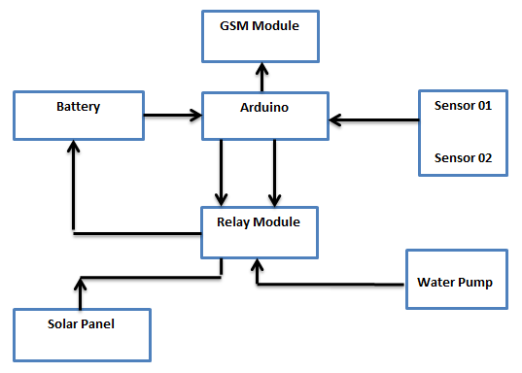

The proposed irrigation system consists of two main parts, solar pumping and the automatic irrigation part. The solar panel charges the battery through the charge controller. The sensors used are soil moisture sensors, we used two of these sensors, the over all working principle of the project is very simple. The Solar panel is used to charge the 12 volt battery, then using this 12v battery we power up the electronics, and also used to power up the pump. Then moisture sensors are used to monitor the soil moisture, then the controller analyze the data and send a message accordingly, along with the valve controlling. All this operation is performed automatically. The relay module controls the pump and solar panel as per the commands received from the controller.

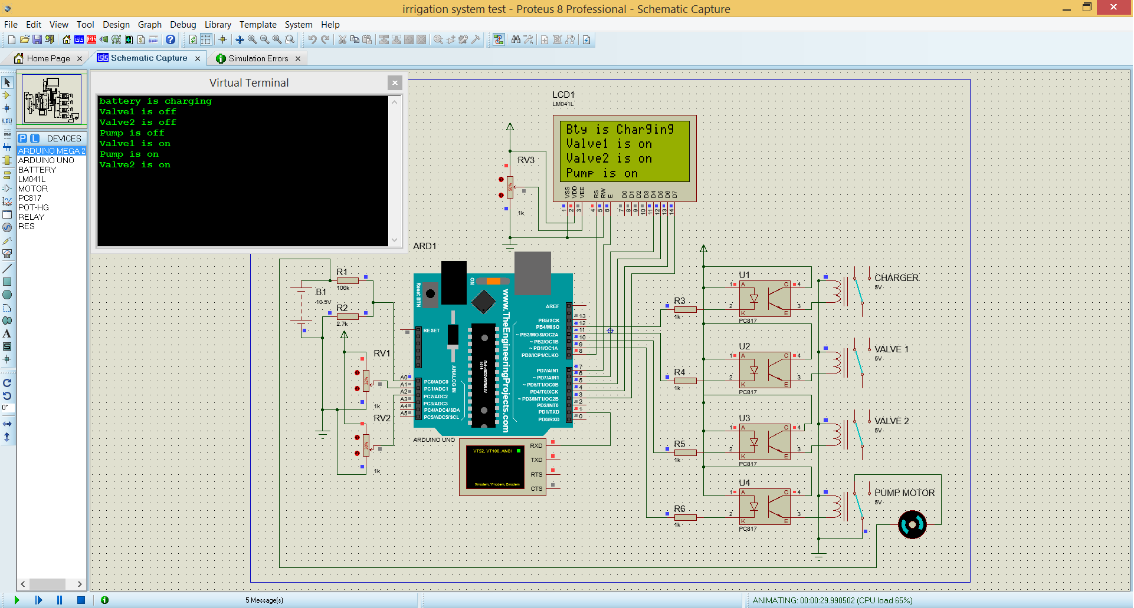

This is the Proteus simulation, this simulation was used to check our programming and basic interface connections. Two variable resistors are connected with analog pins of the Arduino, which are used as the moisture sensors, on the right side optocouplers are used to control the relays, the relays used are of the type spdt “ single pole double throw”. Then these relays are used to control the loads like for example valves, motor pump and battery charging.
Results:
When the moisture falls below certain threshold value, which is already defined in the programming, the Values will automatically turn ON and when the moisture reaches to its pre-determined value the values automatically turn off. These threshold values can be changed.

Chapter 4

TOOLS AND TECHNIQUES

In this chapter the hardware used in the project are discussed. It also contains the technical details and specifications.

4.1 Hardware used with technical specifications

4.1.1 Transistor

Most microcontrollers operate in a 5-volt environment and the I / O port can only handle current up to 20 mA; so if we want to connect the I / O port of the microcontroller to different circuits at the voltage level or to drive devices with more than 20mA; we need to use the interface circuit. One of the most common methods is to use the bipolar junction transistor (BJT) or we called it transistor. We need to clarify this type of BJT to differentiate other types of transistor family such as FET (Field Effect Transistor), Metal Oxide Semiconductor FET (MOSFET), VMOS (Vertical MOSFET) and UJT (Uni-Junction Transistor) [6].
A. The Switch
The transistor can be used as a current gainer; the current gain can be multiplied with the current which applied at the base terminal of transistor known as hFE. Therefore transistor which is a bjt bipolar junction transistor can be used as an amplifier; even very small current applied to the base terminal will be amplified by the transistor by the factor of hFE and reflected as a collector current on the collector terminal side
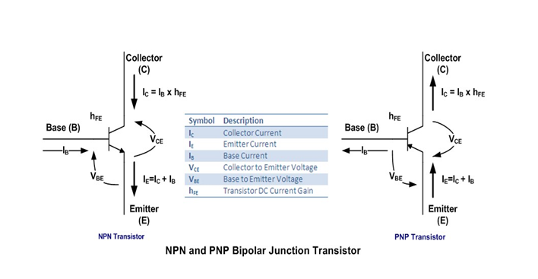
All transistors have three operating states:
Off State: in this state the base current is not applied or IB = 0.
In active state: in this state any change in IB will also cause changes in the IC or IC = IB x hFE. This type of state is suitable when using the transistor as a signal amplifier because the transistor is said to be in the linear state. For example if we have a transistor with a gain of 100 and increase the IB from 10uA to 100uA; this will cause the integrated circuit to oscillate from 1000uA to 10000uA (from 1 mA to 10 mA).
In the saturated state: in this state any change in IB will not cause more changes in the IC (nonlinear) or we could say that IC is almost constant. We never use this state to make the transistor work as a signal amplifier (class A amplifier) ​​because the output signal will be blocked when the transistor is saturated.

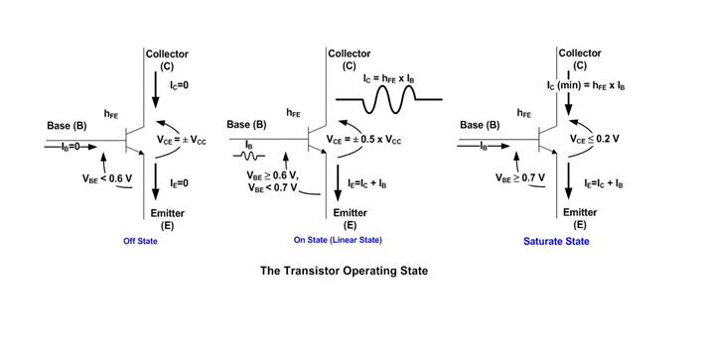
The voltage and the current condition of the transistor on each state; if you notice when the transistor is in the off state, the voltage between the collector and the emitter terminal is equal to the supplied voltage, this is equivalent to the open circuit and when the transistor is in saturation the collector at the emitter voltage is equal or less than 0.2 Volt which is equivalent to the closed circuit. So to use the transistor as a switch we need to make the transistor OFF which is equivalent to the logical "0" and SATURATE which equals the logical "1".

The transistor operating state is called the transistor static characteristic curve as shown on this following figure:
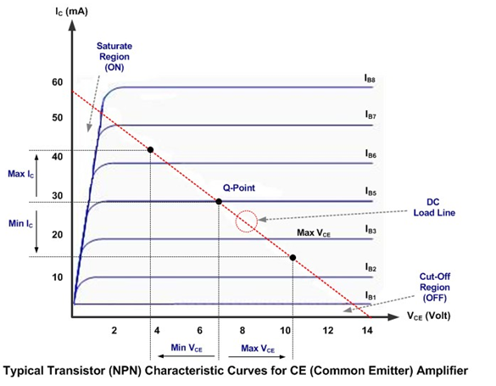
When we use the transistor as a class A common emitter amplifier we usually choose to polarize the transistor (apply voltage on VBE and VCE) in this way (Q-Point) that IC and VCE (output) will oscillate at its maximum or minimum value without no distortion (oscillation in saturation or cutting region) when the IB (input) fluctuates to its maximum or minimum value; but when we operate the transistor as a switch, we intentionally push the transistor into its saturation region to get the lowest possible VCE (ie close to 0.2 volts) when we need to turn the transistor ON (switch ON) and in its cut-off region off when it is necessary to turn off the transistor (switch off).

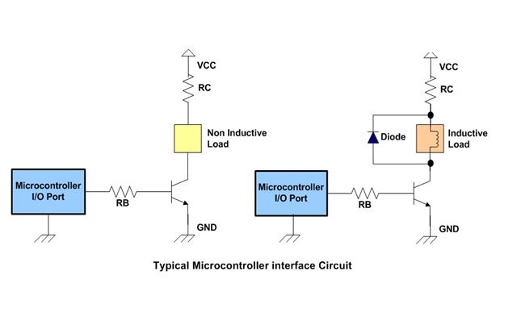
The diagram above shows a typical microcontroller interface circuit that uses an NPN transistor; the resistor RB is used to control the current on the base terminal which makes the transistor OFF and ON (saturated); while the RC resistor is the current limiter for the load. if the load works with the same voltage as the supplied power (Vcc), we can pass the remote control (do not use).
The inductive load circuit is necessary to protect the transistor from the EMF voltage (electromotive force) generated by the inductor component again when the transistor is switched on and off rapidly, this voltage is contrary to the source voltage. The diode will act as a short circuit to the high voltage generated by the inductor component, we can use any general purpose diode with ability to manage at least 1 A current such as 1N4001, 1N4002, etc.

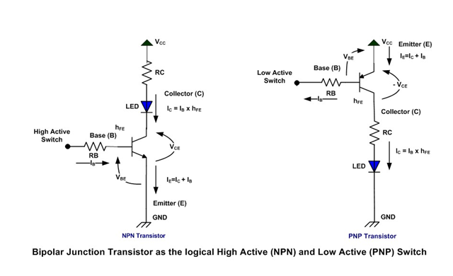

Characteristics of the 2SA1015 bipolar transistor
- Type - p-n-p
- Transition Frequency - 80 MHz
- Noise Figure - 1 dB
- The Storage Junction Temperature Range -55 to +150 °C
- The DC Current Gain (h_{fe}) - 70 to 400
- Emitter-Base Voltage: -5 V
- Collector Current: -0.15 A
- Collector Dissipation - 0.4 W
- Collector-Emitter Voltage: -50 V
- Collector-Base Voltage: -50 V
- Package - TO-92 [7]

Pin Configuration (Pinout)
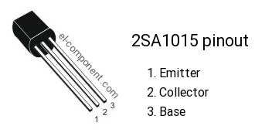

4.1.2 Relay

We know that most high-end industrial application devices have relays for their effective operation. The relays are simple switches operated both electrically and mechanically. The relays consist of an electromagnet and also a series of contacts. The switching mechanism is executed with the help of the electromagnet. There are also other operational principles for its operation. But they differ according to their applications. Most devices have relay application.

Operation and uses of Relays:
The main operation of a relay arrives in places where only a low power signal can be used to control a circuit. It is also used in places where only one signal can be used to control many circuits. The application of the relays began during the invention of the telephones. They played an important role in changing calls to telephone exchanges. They were also used in long distance telegraphy. They have been used to switch the signal from one source to another destination. After the invention of computers they were also used to perform Boolean operations and other logical operations. High-end relay applications require high power to be driven by electric motors and so on. These relays are called contactors.
Relay Design
There relay consists of four parts. They are
• Electromagnet
• Mobile scaffolding
• Switch point contacts
• Spring
It is an electromagnetic relay with a coil of wire, surrounded by an iron core. A very low reluctance path for the magnetic flux is provided for the mobile armature and also the contacts of the switching point. The mobile armature is connected to the yoke which is mechanically connected to the contacts of the switching point. These parts are held securely with the help of a spring. The spring is used to produce an air gap in the circuit when the relay becomes de-energized.
Relay operation:
Relay operation is simple, when power is supplied to the relay, the start of the current flows through the control coil, so the electromagnet starts to energize. Listening points A, B, C are used as control points. When power is applied to the input terminal due to the electromagnetic effect, B and C are connected, and then close the contacts causing a short circuit to supply the load. If the relay was already de-energized when the contacts were closed, the contact moves in front and creates an open circuit. When the power supply is interrupted, points A and C are connected. This force is mainly provided by two factors: spring and gravity.

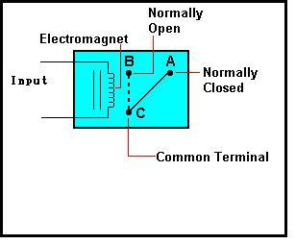
WORKING OF SINGLE-POLE DOUBLE-THROW RELAY:
SPDT relay is an electromagnetic switch consisting of a coil (terminals 85 & 86), 1 common terminal (30), 1 normally closed terminal (87a) and a normally open terminal (87).
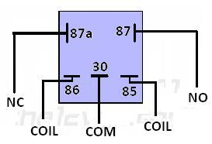
Poles of a SPDT Relay Switch

Relay Design
The control coil surrounded the iron core. The power source is supplied to the solenoid via a control switch and through contacts to the load. When the current starts flowing through the control coil, the electromagnet starts to excite and then intensifies the magnetic field. Therefore, the upper contact arm begins to be attracted by the lower fixed arm and then closes the contacts causing a short circuit to supply the load. On the other hand, if the relay was already de-energized when the contacts were closed, the contact moves in the opposite way and creates an open circuit. As soon as the coil current is turned off, the moving armature will be brought back of a force to its initial position. Relays are mainly made for two basic operations. One is the low voltage application and the other is high voltage. For low voltage applications, more noise reduction will be given to the whole circuit. For high voltage applications, they are primarily designed to reduce a phenomenon called an arc.
Relay basics
The bases for all the relays are the same. A relay consists of four pins. Two colors are shown. The control circuit is represented by green color load circuit by red color. A small control coil is connected to the control circuit. A switch is connected to the load. The coil in the control circuit is controlled by the switch. Now let's take the different steps that take place in a relay.
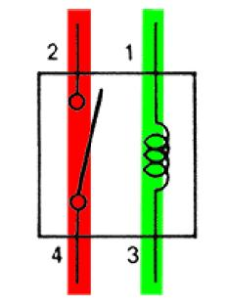
Energized Relay (ON)
As shown in the circuit, the current flowing through the coils represented by pins 1 and 3 causes a magnetic field to be generated. This magnetic field causes pins 2 and 4 to close. Therefore the switch plays an important role in the operation of the relay. Since it is part of the charging circuit, it is used to control an electrical circuit that is connected to it. Therefore, when the relay is energized, current flow will pass through pins 2 and 4.
Types of Relays:
Single Pole Single Throw (SPST) – This is four terminal relay in which two terminals can be connected or disconnected. The other two terminals are necessary for the coil.
Single Pole Double Throw (SPDT) - This type of relay has a total of five terminals. Outside these two are the coil terminals. A common terminal that connects to one of the other two is also included.
Double Pole Single Throw (DPST) - This is six terminal relay. These terminals are further divided into two pairs. Thus they can act as two SPSTs that are driven by a single coil. Of the six terminals, two are spiral terminals.
Double Pole Double Throw (DPDT) - It has mainly eight relay terminals. Of these two files are designed to be changed on the terminals. They are designed to function as two SPDT relays driven by a single coil.
Forwarding applications
• Relays are used to perform logical functions. They play a very important role in providing critical safety logic.
• Relays are used to provide delay functions. They are used to delay the delay and delay the closing of contacts.
• Relays are used to control high voltage circuits with the aid of low voltage signals. In the same way they are used to control high current circuits with the help of low current signals.
Relay selection
Some factors need to be noted when selecting a particular relay. They are
• Protection - Various protections such as contact protection and coil protection must be noted. Contact protection helps reduce the arc in circuits by inductors. The coil protection helps to reduce the peak voltage produced during switching. Consult a standard relay with all regulatory approvals.
• Switching time - Request high-speed switching relays, if desired.
• Nominal values ​​- Current voltage and voltage values ​​exist. Current ratings range from a few amps to around 3000 amperes. In the case of voltage values, they range from 300 Volts AC to 600 Volts AC. In the market you can also find high voltage relays of about 15,000 volts.
• Type of contact used: whether it is an NC or NO contact or closed.
• Select Create before interrupting or interrupting before Creating contacts wisely.
• Isolation between coil circuit and contacts [8]

4.1.3 Diode

A diode is a very simple device and has many applications. A diode is a device that transmits power in one direction. It's a bit like a water valve that prevents water from returning to the net from your property.
Various types of diodes are used to handle small currents, large currents, high frequencies and high voltages. And there are diodes made of different materials, but they can be described simply and that's what we will do. A diode has two derivations. These are called ANODE and CATHODE

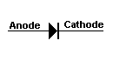
The end of the cathode is identified in a circuit diagram and on the body of the device. It can be identified with a line, a chamfer or a dimple or a symbol.

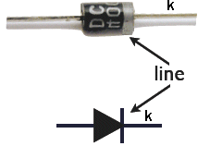
The end of the cathode is identified in a circuit diagram and on the body of the device. It can be identified with a line, a chamfer or a dimple or a symbol. A diode anode and cathode can be identified through a silver line, the silver line side is the cathode side. While the opposite side is the anode. As mentioned earlier, a diode does not start to turn ON until there is a small voltage on its ANODE cable. Germanium diode Fora this voltage is about 0.3V. [9]
- 0.3V is for Schottkey diode
- 0.7 v is for silicon diode

4.1.4 Arduino Uno
The Arduino Uno has ATmega328 microcontroller . It has 6 analog inputs 14 digital input/output pins (of which 6 can be used as PWM outputs), an ICSP header, a 16MHz crystal oscillator, a power jack, a USB connection , and a reset button. It AC-to-DC adapter or battery to get started it contains everything needed to support the microcontroller; simply connect it to a computer with a USB cable, it features the Atmega328 programmed as a USB-to-serial converter. The Arduino Uno is different from all the other boards in that, Arduino uno does not use the FTDI USB-to-serial driver chip

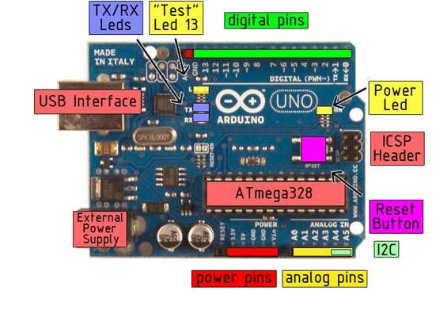

Microcontroller | ATmega328
Operating Voltage | 5V
Input Voltage (recommended | 7-12V
Input Voltage (limits) | 6-20V
Digital I/O Pins | 14 (of which 6 provide PWM output)
Analog Input Pins | 6
DC Current per I/O Pin | 40 mA
DC Current for 3.3V Pin | 50 mA
Flash Memory | 32 KB ofwhich0.5 KB used by bootloader
SRAM | 2 KB
EEPROM | 1 KB
Clock Speed | 16 MHz

The power pins are as follows:
• VIN.
The input voltage to the Arduino board when using an external power source (unlike 5 volts from the USB connection or other regulated power source). It is possible to supply the voltage through this pin or, if the voltage is supplied via the power jack, access it via this pin.
• 5V
In Arduino uno Voltage regulators are used to supply regulated voltage to the atmega328 microcontroller, you can find two regulators 5v and 3.3v regulators. The Arduino uno can be powered up using a 12v adaptor, or computer, or you can also connected any external power supply with the vin pin of the Arduino, so far the applied voltage is within the limits.
• GND.
Pin of earth.
• LED: 13. There on onboard led in Arduino uno which is connected with pin number 13 of the Arduino. this led can be turned on and turned off using the HIGH and LOW commands. So the led remains off when low and remains On when HIGH.
• 3V3. A 3.3 volt power supply generated by the on-board regulator. The maximum current consumption is 50 mA.
• Arduino uno has a default serial port on pin0 and pin1. Which are used for the serial communication, it can be used for the debugging purposes to check any error in coding and can also be used to communicate with other devices which make use of serial communication like for example, gsm module, Bluetooth module and so on, there are thousands of devices which uses serial communication.
• External interrupts: 2 and 3.
These pins can be configured to trigger an interrupt on a low value, a rising or falling edge or a change in value. See the attachInterrupt () function for details.
• Arduino uno has PWM”pulse width modulation “: these pins are 3, 5, 6, 9, 10 and 11.
Provide the 8-bit PWM output with the analogWrite () function. • SPI Bus: In arduino the spi bus lines are , 10, 11, 12 and 13. 10 is the ss, 11 is the mosi, 12 is the miso and 13 is the sck.
These pins are used for the devices which uses spi lines like for example the RFID module which is most commonly used. There can be thousands of other devices that make use of spi bus to communicate. [10]

4.1.5 REGULATORS

The LM7805A series of three terminal positive regulators is available in the T0 / 220 / D-PAK package and with different fixed output voltages, making them useful in a wide range of applications. The output voltage from the condenser is more filtered and finally regulated. The voltage regulator is a device that keeps the output voltage constant regardless of the change in the supply variation, load variation and temperature variations. Here we use the fixed voltage regulator ie LM7805. IC LM7805 is a + 5V regulator used for the microcontroller.

Each type uses internal current limitation, thermal shutdown and safe protection of the operating area, making it essentially indestructible. If adequate heat dispersion is provided, they can supply more than 1A of output current. These are designed mainly as fixed voltage regulators, these devices can be used with external components to obtain adjustable voltages and currents. [12]

LM7805A ELECTRICAL FEATURES
The load and the regulation of the line are specified at constant junction temperature. The variation of V0 due to the effects of heating must be taken into consideration separately; Pulse test with low duty cycle is used.
DESCRIPTION
The LM78XX / LM78XXA series of three-terminal positive regulator is available in the TO-220 / D-PAK package and with different fixed output voltages, making them useful in a wide range of applications. Each type uses internal current limitation, thermal shutdown and safe operating area protection, making it essentially indestructible. If adequate heat dispersion is provided, they can supply more than 1A of output current. Although designed primarily as fixed voltage regulators, these devices can be used with external components to obtain adjustable voltages and currents.

Voltage Regulator
FEATURES
- Output Current up to 1A
- Available in different Output Voltages of 5 volt , 6 volt, 8, 9, 10, 12, 15, 18, 24V
- Thermal Overload Protection
- Short Circuit Protection
- Output Transistor Safe Operating Area Protection

INTERNAL BLOCK DIAGRAM

Block Diagram of IC LM7805 (Voltage Regulator)

4.1.6 Gsm Module
This is a quad-band GSM / GPRS compatible cell phone, which operates on a frequency of 850/900/1800 / 1900MHz and which can be used not only for accessing the Internet, but also for oral communications (as long as it is connected to a microphone and a small speaker) and for text messages. Externally, it looks like a large package (0.94 inches x 0.94 inches x 0.12 inches) with L-shaped contacts on four sides so they can be welded on both the side and the bottom. Internally, the module is managed by an AMR926EJ-S processor, which controls the telephone communications, the data communication (through an integrated TCP / IP stack) and (through a serial UART and TTL interface) the communication with the circuit interfaced with the phone cell itself. The processor is also responsible for a SIM card (3 or 1.8 V) that must be connected to the external wall of the module. In GSM900 device has an SPI bus A / D converter, an RTC, PWM module and I²C . The radio section is GSM phase 2/2 + compatible and is class 4 (2W) at 850/900 MHz or class 1 (1W) at 1800/1900 MHz. The TTL serial interface is responsible not only for the communication of all data relating to the SMS already received and those arriving during the TCP / IP sessions in GPRS (the data rate is determined by the GPRS class 10: maximum 85.6 kbps), but also to receive the circuit commands (in our case , coming from the PIC that governs the remote control) that can be either standard AT type or AT-enhanced SIMComtype. The module works (between 3.4 and 4.5 V) and absorbs current 0.8 A during transmission.

Features
- GSM Module is Controlled through AT commands
- 3.8V is nominal supply voltage
- the average power consumption current is about 200mA
- Dimensions (mm): 3 x 20 x 20 andweight (g): 3.2 (including shielding)
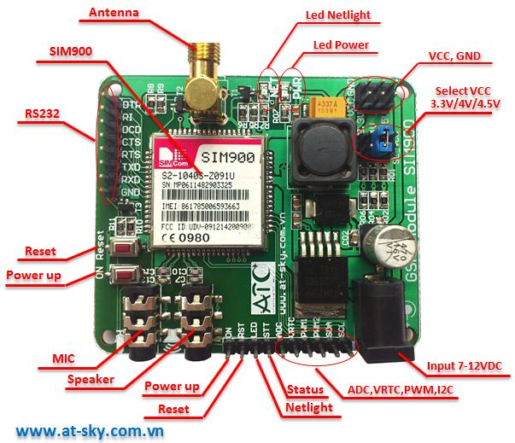
FIGURE 1:GSM MODULE SIM900

GSM architecture
A GSM network consists of the following components:
o A mobile station:
it is the mobile phone that includes the transceiver, the display and the processor and is controlled by a SIM card that operates on the network.
o Base Station
Subsystem: acts as an interface between the mobile station and the network subsystem. It consists of the base transceiver station which contains the radio transceivers and manages the protocols for communication with mobile phones. It also includes the base station controller that controls the base station of the transceiver and serves as the interface between the mobile station and the mobile switching center.
o Network subsystem:
provides the basic network connection to mobile stations. The basic part of the network subsystem is the switching center of the mobile service that provides access to different networks such as ISDN, PSTN, etc. It also includes the location log and the visitor position log which provides the routing capabilities of GSM calls. It also contains the equipment identification register that maintains an account of all mobile equipment in which each mobile phone is identified by its IMEI number. IMEI stands for International Mobile Equipment Identity.
Features of the GSM module:
o Better spectrum efficiency
o International roaming
o Compatibility with the integrated services digital network (ISDN)
o Support for new services.
o Management of the SIM directory
o Fixed number (FDN)
o Real-time clock with alarm management
o High quality speech
o Use encryption to make telephone calls safer
o Short message service (SMS)

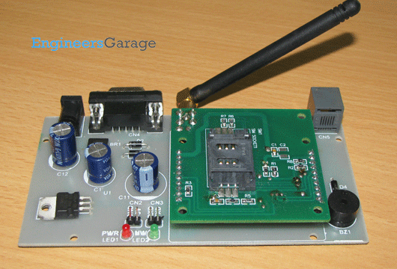

The standardized security strategies for the GSM system make it the most secure telecommunications standard currently accessible. Although the confidentiality of a call and secrecy of the GSM subscriber is just guaranteed on the radio channel, this is an important step to achieve end-to-end security. GSM modem and microcontroller interface: GSM is a mobile communication architecture widely used in most countries. This project demonstrates the interfacing of the ATMega328 microcontroller and the GSM module. It aims to familiarize with the syntax of AT commands and their response to information and result codes. ASCII values ​​of characters in response to information, result codes and their syntax can be monitored by an LED array. For the basic concepts, the operation and operation of the AT commands and the refergSM / GPRS module of the GSM module. Global System for Mobile (GSM) communication is the second generation of mobile technology. Although the world is moving towards the Third and Fourth Generation, GSM has been the most successful technology in the communication sector. GSM technology has opened a new way for mobile communication.[13]
BRIEF INTRODUCTION OF THE COMMAND
The GSM modem and the PC are connected via serial ports. They communicate with the AT commands. AT commands are a set of commands that has been standardized to communicate with terminal equipment such as modems, cell phones and control them. Most GSM modems support AT commands. The command set is rather elaborate. However, only a small part of it is linked to SMS operations. The most used commands are:
AT + CMGS: this at command is used to send a message
AT + CMGR: this is used to read a message from gsm module
AT + CMGL: to list the short SMS messages stored in the GSM module
AT + CMGD: this at command is used to delete a message
AT + CNMI: Remind Setup mode when a new SMS is received Like the low-level function interface for the GSM modem, these commands play a fundamental role in the software development of the gateway program.[14]

4.1.7 Resistor:
Resistors are electronic components that have a specific electrical resistance and are constantly evolving. Resistor resistance limits the flow of electrons through a circuit. They are passive components, in the sense that they consume only energy (and can not generate it).
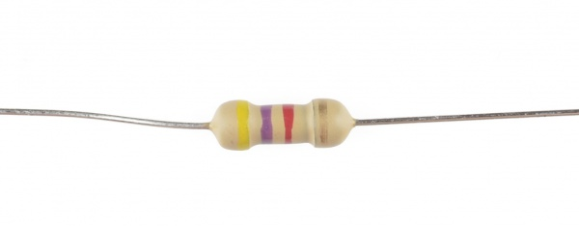

Resistors are generally added to circuits in which they integrate active components such as operational amplifiers, microcontrollers and other integrated circuits. Normally the resistors are used to limit the current, to divide the voltages and the pull-up I / O lines. Resistors can be manufactured in various ways. The most common type of electronic devices and systems is the carbon composition resistor. Fine granulated coal (graphite) is mixed with clay and hardened. The resistance depends on the percentage of carbon in clay; the higher this relationship, the lower the resistance. Pull-up resistance: In digital circuits, the pull-up resistor is a normal resistance connected to the high voltage power supply (for example + 5V or + 12V) and sets the input or output level of a device to "1". The pull-up resistor sets the level to "1" when the input / output is disconnected. When the input / output is connected, the level is determined by the device and replaces the pull-up resistor. Pull-down resistance: In digital circuits, the pull-down resistor is a normal resistance connected to ground (0V) and sets the input or output level of a device to "0". The pull-down resistor sets the level to '0' when the input / output is disconnected. When the input / output is connected, the level is determined by the device and overwrites the pull-down resistor.[15]

4.1.8 Moisture Sensor
The soil moisture sensor uses the capacity to measure soil water content (by measuring the dielectric permittivity of the soil, which is a function of water content). Just insert this robust sensor into the soil to be tested and the volumetric water content of the soil is shown as a percentage. Southern humidity sensors measure the volume of volumetric water in the soil. Since the direct gravimetric measurement of free soil moisture requires the removal, drying and weighting of a sample, soil moisture sensors measure the volumetric water content indirectly by using some other soil properties, such as electrical resistance, dielectric constant or interaction with neutrons, as a proxy for moisture content. The relationship between the measured property and the soil moisture must be calibrated and can vary according to environmental factors such as soil type, temperature or electrical conductivity. Reflected microwave radiation is influenced by soil moisture and is used for remote sensing in hydrology and agriculture. [16]

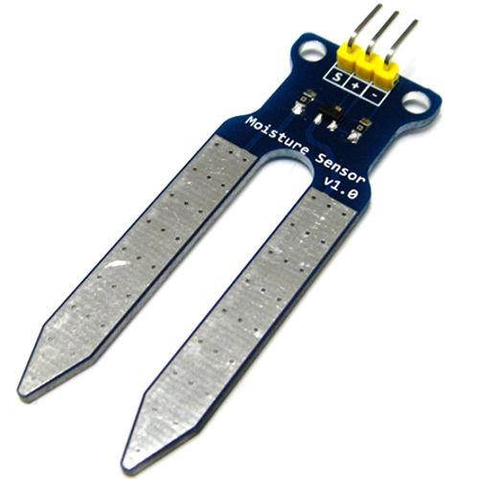
Soil moisture sensors generally refer to sensors that estimate the volume of volumetric water. Another class of sensors measures another moisture property in soils called water potential; these sensors are generally referred to as sensors of soil water potential and include tensiometers and gypsum blocks.[25]
Technology
The technologies commonly used to indirectly measure the volume of volumetric water (soil moisture) include)
• Frequency domain reflectance (FDR): the dielectric constant of a given volume element around the sensor is obtained by measuring the operating frequency of an oscillating circuit.
• Time Domain Transmission (TDT) and Time Domain Reflectometry (TDR): the dielectric constant of a given volume element around the sensor is obtained by measuring the propagation speed along an underground transmission line.
• Neutron moisture indicators: the properties of the water moderator for neutrons are used to estimate the soil moisture content between a source and a sensing probe.
• Soil resistance: to determine the moisture content of the soil it is possible to measure the force with which the ground resists the flow of electricity between two electrodes.
• Galvanic cell: the amount of water present can be determined according to the voltage produced by the ground because the water acts as an electrolyte and produces electricity. The technology behind this concept is the galvanic cell.

Application
agriculture
Measuring the soil moisture is very important for agricultural applications this really help farmers manage their irrigation systems more efficiently. Knowing the exact soil moisture conditions in their fields, not only farmers are able to use less water to grow a crop, but they are also able to increase crop yields and crop quality by improving soil moisture management. during critical phases of plant growth. Irrigation of the landscape In urban and suburban areas, landscapes and residential lawns use soil moisture sensors to interface with an irrigation controller. Connecting a soil moisture sensor to a simple irrigation clock will convert it into a "smart" irrigation controller that prevents irrigation cycles when the ground is already wet, e.g. after a recent rainy event. Golf courses use soil moisture sensors to increase the efficiency of their irrigation systems to prevent excessive irrigation and leaching of fertilizers and other chemicals into the soil. Search Soil moisture sensors are used in numerous research applications, e.g. in agricultural sciences and horticulture including irrigation planning, climate research or environmental sciences, including studies on solute transport and as auxiliary sensors for measurements of soil respiration. Simple sensors for gardeners There are relatively inexpensive and simple devices that do not require an energy source to check whether the plants have sufficient moisture to thrive. After inserting a probe into the ground for about 60 seconds, a meter indicates if the soil is too dry, humid or wet for the plants. specifications
• Range: 0 to 45% of volumetric water content in the ground (VWC 0 to 100% with alternating calibration)
• Accuracy: ± 4% typical
• The Resolution: 0.1% • Power: 3 mA @ 5VDC
• The Operating temperature: from -40 ° C to + 60 ° C
• the Dimensions: 8.9 cm × 1.8 cm × 0.7 cm (active sensor length 5 cm)

4.1.9 Solar Panel
The solar panel gives us energy by absorbing sun light. A photovoltaic module (in short PV) is a packaged and connected set of typically 6 × 10 solar cells. Photovoltaic solar panels form the solar array of a photovoltaic system that generates and supplies solar energy in commercial and residential applications. Each module is evaluated based on the DC output power under standard test conditions and typically ranges from 100 to 365 watts. The efficiency of a module determines the area of ​​a module with the same nominal power: a 230-watt efficient 8% module will have twice the area of ​​an efficient 230-watt module of 16%. There are some solar panels available that exceed 19% efficiency. A limited energy can be produced by single cell; most installations contain multiple modules. A photovoltaic system typically includes a panel or series of solar modules, a solar inverter and sometimes a battery and / or solar tracker and interconnection wiring.

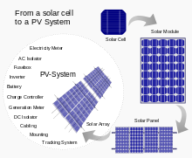

Theory and construction
The light contains photon which is used by the solar cell for production of energy. Most modules use crystalline silicon wafer-based cells or thin-film cells based on cadmium or silicon telluride. The structural member (which carries the load) of a module can be the top layer or the back layer. Most solar modules are rigid, but they are available semi-flexible, based on thin-film cells. These first solar modules were used for the first time in space in 1958. The electrical connections are made in series to obtain a desired output voltage and / or in parallel to provide a desired current capacity. The conductor wires that remove the current from the modules may contain silver, copper or other non-magnetic conductive transition metals. The cells must be electrically connected to each other and to the rest of the system. Externally, the most common photovoltaic modules used on land use use MC3 (older) or MC4 connectors to facilitate weatherproof connections to the rest of the system. The bypass diodes can be incorporated or used externally, in case of partial shading of the module, to maximize the output of the sections of the module still illuminated. Some recent solar module designs include concentrators in which light is focused by lenses or mirrors on a series of smaller cells. This allows the use of cells with a high cost per unit area (such as gallium arsenide) in a cost-effective way.
Efficiencies
Depending on the construction, photovoltaic modules can produce electricity from a range of light frequencies, but usually they cannot cover the entire solar range (in particular, ultraviolet, infrared and low or diffused light). Thus, much of the incident solar energy is wasted by solar modules, and can give much higher efficiencies if illuminated with monochromatic light. Therefore, another design concept is to subdivide the light into different wavelength ranges and direct the beams to different cells tuned to these ranges. [Citation needed] This was designed to be able to increase the efficiency of 50.[23] Currently, the best conversion rate of sunlight reached (solar module efficiency) is about 21.5% in new commercial products , generally lower than the efficiencies of their isolated cells. The most efficient photovoltaic modules in series [contested - discuss] have power density values ​​up to 175 W / m2 (16.22 W / ft2). The research of the Imperial College of London has shown that the efficiency of a solar panel can be improved by studying the surface of the semiconductor that receives light with aluminum nano cylinders similar to the ridges of the Lego blocks. The diffused light then travels along a longer path in the semiconductor, which means that more photons can be absorbed and converted into current. Although these nanocylinders were previously used (aluminum was preceded by gold and silver), light scattering occurred in the near infrared region and visible light was strongly absorbed. It was found that aluminum absorbed the ultraviolet part of the spectrum, while the visible and near-infrared parts of the spectrum were found scattered from the aluminum surface. This, according to research, could significantly reduce costs and improve efficiency as aluminum is more abundant and less expensive than gold and silver. [18]
• The efficiency of the solar panel can be calculated from the MPP (Maximum power point) value of the solar panels
• Solar inverters convert direct current into alternating current by running the MPPT process: the solar inverter samples the output power (I-V curve) from the solar cell and applies the appropriate resistance (load) to the solar cells to obtain maximum power
. • MPP (Maximum power point) of the solar panel consists of MPP voltage (V mpp) and MPP current (I mpp): it is a capacity of the solar panel and the highest value can make the MPP higher. The micro-inverted solar panels are wired in parallel, which produces more output than normal panels that are connected in series with the output of the series determined by the panel with the lowest yield (this is known as "Christmas light effect") . The micro-inverters operate independently so that each panel contributes to the maximum possible yield given the available sunlight.[17]

4.1.10 12V Battery
Almost all batteries of cars, motorcycles and tractors are 12 volt lead-acid batteries. These batteries can supply hundreds of amps of electrical current for a short period of time. This is the reason why these batteries are commonly used in automotive applications. However, not all 12 volt lead batteries are interchangeable. It is important to consider the electrical requirements of the car before installing a 12 volt battery. Battery voltage Although most car, motorcycle and tractor batteries are sold as "12 volt" batteries, the nominal voltage of a fully charged battery is closer to 12.6 volts. The electrochemical reaction between the guide plates and the battery electrolyte is what produces the voltage difference between the positive and negative terminals on a battery. Over time, the lead plates inside the battery will be covered with lead sulphate crystals. These crystals inhibit the electrochemical reaction between the lead plates and the electrolyte, causing a fall in battery voltage. Capacity of electric current The capacity of electric current for each battery is evaluated using two parameters: "crank amplifiers" and "cold start amplifiers". Elbow amplifiers are a measure of the amount of electrical current (measured in amps) that a battery can supply for 30 seconds at 32 degrees Fahrenheit. Cold-rotation amplifiers are a measure of how much electric current can supply a battery for 30 seconds at 0 degrees Fahrenheit. Because the electrochemical processes that produce electricity in a battery are affected by cold temperatures, a battery will produce more and more starter amps compared to cold amps.[19]
Reserve capacity
• If the alternator (or generator of some older vehicles) does not work, the battery is the only source of electricity for that vehicle. The batteries are designed to work for several minutes in the event of an electrical fault.
• The "spare capacity" of the battery is a measure of the duration, in minutes, of a battery capable of delivering 25 amps of electrical current during a failure of the charging system.

4.1.11 LCD
LCD-Liquid Crystal Display is an electronic device for displaying text orcharacters. We are using 14 pin LCD. 16*2 represents 16 characters and 2 line display.
LCD’s are economical and easily programmable and can easily display special andcustom characters.
Pin description is as follows
1. Pin 7 to pin 14-All 8 pins are responsible for the transfer of data.
2. Pin 4-This is RS i.e., register select pin.
3. Pin 5-This is R/W i.e., Read/Write pin.
4. Pin 6-This is E i.e., enable pin.
5. Pin 2-This is VDD i.e., power supply pin.
6. Pin 1-This is VSS i.e., ground pin.
7. Pin 3-This is short pin
A 16x2 character LCD with black text on green background display is used. Being sufficiently wide it serves the purpose of a notice board display screen. It operates at 5V DC with a duty cycle of 1/16. Multiple LCD displays are used among which any one display can be chosen for displaying the notice.[21]
- 20 characters wide, 4 rows
- White text on blue background
- Connection port is 0.1" pitch, single row for easy breadboarding and wiring
- Single LED backlight with a resistor included, you can power it directly from 5V. If it's too bright for you, it can be dimmed easily with a resistor or PWM and uses much less power than LCD with EL (electroluminescent) backlights
- Can be fully controlled with only 6 digital lines!
- Built in character set supports English/Japanese text, see the HD44780 datasheet for the full character set
- Up to 8 extra characters can be created for custom glyphs or 'foreign' language support (like special accents)
- Comes with necessary contrast potentiometer and strip of header
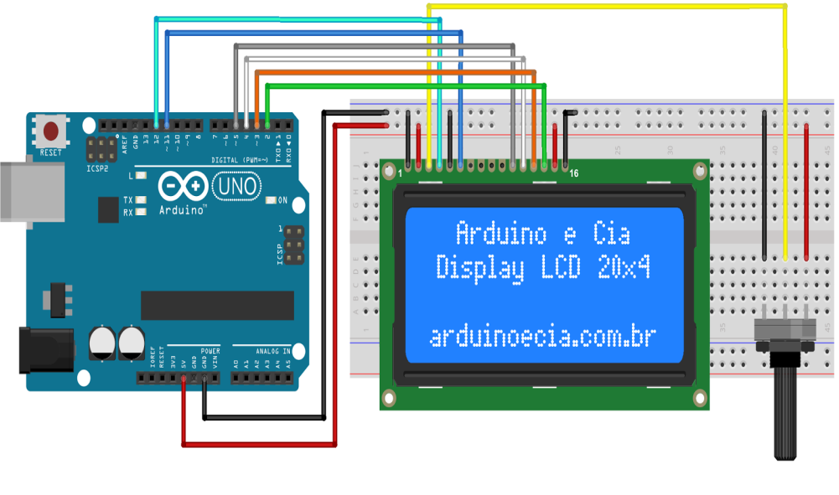

Chapter 5

Conclusion

At the end of this project we successfully tested our project based on irrigation, we successfully monitored the soil moisture and successfully sent messages on the pre defined numbers using a gsm module. The use of Solar panels can really help the farmers to reduce billing. The entire project is fully automatic and it can really help the farmers, and divide the loads on their shoulders. The solar irrigation concept is really great and can be implemented throughout the country. It has a global scope. This project can be further modified and can can be made much smarter than it is right now.
References
[1] https://en.wikipedia.org/wiki/Solar_panel
[2]https://www.researchgate.net/publication/272712580_GSM_based_Automatic_Irrigation_Control_System_for_Efficient_Use_of_Resources_and_Crop_Planning_by_Using_an_Android_Mobile
[3]http://www.agriinfo.in/?page=topic&superid=4&topicid=274
[4] http://file.scirp.org/Html/2-2860004_30725.htm
[5] http://www.horizons.gc.ca/en/content/agricultural-and-natural-manufacturing-technology
[6] https://en.wikipedia.org/wiki/Transistor
[7] https://www.el-component.com/bipolar-transistors/2sa1015
[8] http://www.circuitstoday.com/working-of-relays
[9] https://en.wikipedia.org/wiki/Diode
[10] https://en.wikipedia.org/wiki/Arduino
[11] https://en.wikipedia.org/wiki/Voltage_regulator
[12] https://electronicsforu.com/resources/learn-electronics/7805-ic-voltage-regulator
[13] https://www.elprocus.com/gsm-architecture-features-working/
[14] https://www.engineersgarage.com/tutorials/at-commands
[15] https://en.wikipedia.org/wiki/Resistor
[16] https://en.wikipedia.org/wiki/Soil_moisture_sensor
[17] https://en.wikipedia.org/wiki/Solar_panel
[18] https://economictimes.indiatimes.com/definition/solar-panel
[19] https://en.wikipedia.org/wiki/Electric_battery
[20] http://www.qrg.northwestern.edu/projects/vss/docs/power/2-how-do-batteries-work.html
[21] https://www.arduino.cc/en/Tutorial/LiquidCrystalDisplay
[22] http://www.circuitstoday.com/interfacing-lcd-to-arduino
[23] https://blog.pickmysolar.com/what-is-solar-panel-efficiency
[24] https://www.greenmatch.co.uk/blog/2014/09/what-is-solar-panel-efficiency
[25] https://www.seeedstudio.com/Grove-Moisture-Sensor-p-955.html
[26]https://www.researchgate.net/publication/296348322_Design_and_management_of_reclaimed_water_irrigation_systems
[27] https://www.engineersgarage.com/electronic-components/7805-voltage-regulator-ic
[28]http://www.hobbytronics.co.uk/arduino-uno-r3
[29]www.iosrjournals.org/iosr-jmce/papers/vol11-issue4/Version-1/I011414955.pdf

[30]https://ece.gmu.edu/~jkaps/courses/ece511-f11/project/Team6-Report.pdf

