**CHAPTER 1** **Introduction**

With advancement of technology things are becoming simpler and easier for us. Automation is the use of control systems and information technologies to reduce the need

for human work in the production of goods and services. In the scope of industrialization or power sector automation is a step beyond mechanization. Whereas mechanization provided human operators with machinery to assist them with the muscular.

Requirements of work, automation greatly decreases the need for human sensory and mental requirements as well. Automation plays an increasingly important role in the world economy and in daily experience.

Automatic systems are being preferred over manual system. Through this project we have

tried to show automatic control system for fire Alarm and substation.

**1.1 NEED OF AUTOMATION**

Earlier, we looked into the face of future when we talked about automatic devices, which

could do anything on instigation of a controller, but today it has become a reality. An automatic device can replace good amount of human working force, moreover humans are more prone to errors and in intensive conditions the probability of error increases whereas, an automatic device can work with diligence, versatility and with almost zero error. Replacing human operators in tasks that involve hard physical or monotonous Work .Replacing humans in tasks done in dangerous environments (i.e. fire, space, volcanoes, nuclear facilities, underwater, etc)

Performing tasks that are beyond human capabilities of size, weight, speed, endurance, etc. Economy improvement. Automation may improve in economy of enterprises,

society or most of humankind. For example, when an enterprise that has invested in automation technology recovers its investment, or when a state or country increases its income due to automation like Germany or Japan in the 20th Century.

This is why this project looks into construction and implementation of a system involving hardware to control the sorting of different items.

* 1. **Project Objective**

To obtain a system which indicates the wapda authority through a visual and signal indication by the help of using scada if the problem occur in transmission line substation, in any industry, home, office or any big building but now this system will identify the fault anywhere in the above areas the concerned authority will immediately informed to take a quick response and also this system will provide a protection to power system from fire.

**1.3 Problem Statement**

In our daily life we always see when any fault or short circuit occur in 3 phase 4 wire system it also damages our transformers due to that reason the residential suffer hardship due to long interruption of power because that concerned transformer required rehabilitation so to avoid from this our system will provide earth leakage breaker system which totally keep our transformer in safe mood and there is no such real indication to wapda authority who can know where is the problem occur is it is in transmission line ,substation, in any industry, home, office or any big building but now this system will identify the fault anywhere in the above areas the concerned authority will immediately informed through this system and they will take a quick response to solve the problem.

* 1. **Assessment Methodology**

The implementation of the PLC AND SCADA BASED Substation automation is mainly carried out by PLC AND SCADA. The signals from different sensing circuits are fed to the PLC which make a decision and then through some processing by the PLC those signals are given to the computer to be displayed on the computer screen with the help of the specially designed GUI.

**1.5 Block Diagram**

**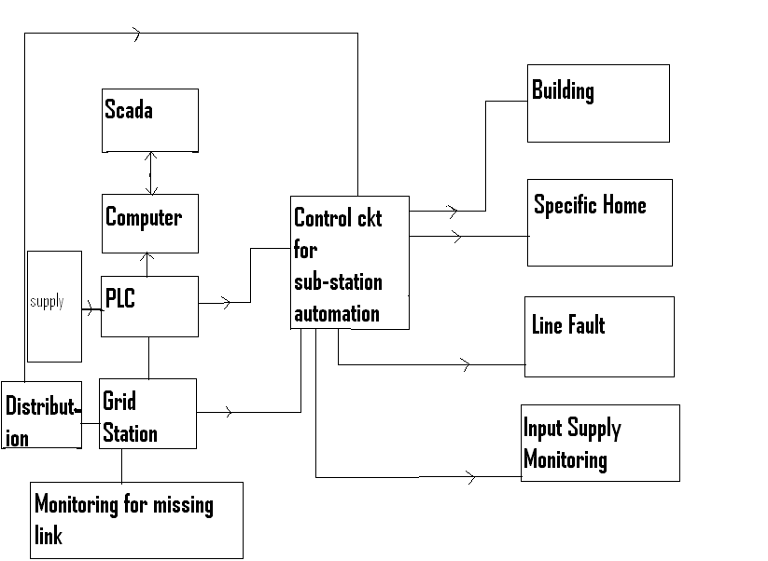**

* 1. **Components list**
     1. Fatek PLC 14-FBS
     2. Spdt relay 12Vdc
     3. 2n222 npn general purpose transistor
     4. Connecting wires
     5. Dc socket
     6. Pcb
     7. 10k resistor
     8. 1k resistor
     9. Variable resistor
     10. Lm741 opm
     11. 470 ohm resistors
     12. Diode
     13. Rs232 cable
     14. Capacitor
     15. Transformer
     16. Regulator
  2. **Project Outlines**

Chapter 2 provides theoretical background about all the components used in this Project in a very detailed way.

Chapter 3 explains the Project Methodology.

Chapter 4 explains the programming.

The conclusions can be found in Chapter 5.

References

**CHAPTER 2 Theoretical Backgrounds**

**2.1 CAPACITORS**

**2.1.1 Function**

Capacitors store electric charge. They are used with resistors in timing circuits because it takes time for a capacitor to fill with charge. They are used to smooth varying DC supplies by acting as a reservoir of charge. They are also used in filter circuits because capacitors easily pass AC (changing) signals but they block DC (constant) signals.

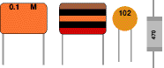    Circuit symbol:   capacitor symbol

Fig: 2.1 Fig: 2.2

Small value capacitors are unpolarised and may be connected either way round. They are not damaged by heat when soldering, except for one unusual type (polystyrene). They have high voltage ratings of at least 50V, usually 250V or so. It can be difficult to find the values of these small capacitors because there are many types of them and several different labeling systems!

**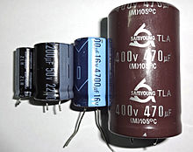**

Fig:2.3

**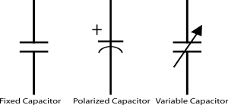**

Fig:2.4

**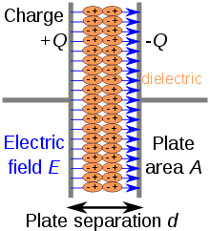** Fig:2.5

C= \frac{Q}{V}

**2.1.2 For capacitors in parallel**

Capacitors in a parallel configuration each have the same applied voltage. Their capacitances add up. Charge is apportioned among them by size. Using the schematic diagram to visualize parallel plates, it is apparent that each capacitor contributes to the total surface area.

**2.1.3 For capacitors in parallel**

Connected in series, the schematic diagram reveals that the separation distance, not the plate area, adds up. The capacitors each store instantaneous charge build-up equal to that of every other capacitor in the series. The total voltage difference from end to end is apportioned to each capacitor according to the inverse of its capacitance. The entire series acts as a capacitor *smaller* than any of its components.

\frac{1}{C_\mathrm{eq}} = \frac{1}{C_1} + \frac{1}{C_2} + \cdots + \frac{1}{C_n}

**2.2 RESISTORS**

**2.2.1 Function**

Resistors restrict the flow of electric current, for example a resistor is placed in series with a light-emitting diode (LED) to limit the current passing through the LED.

**2.2.2 Connecting and soldering**

Resistors may be connected either way round. They are not damaged by heat when soldering.

|  |  |
| --- | --- |
| **The Resistor Color Code** | |
| Color | Number |
| Black | 0 |
| Brown | 1 |
| Red | 2 |
| Orange | 3 |
| Yellow | 4 |
| Green | 5 |
| Blue | 6 |
| Violet | 7 |
| Grey | 8 |
| White | 9 |

**2.2.3 Resistor values - the resistor colour code**

Resistance is measured in ohms; the symbol for ohm is an omegaohm.   
1 ohmis quite small so resistor values are often given in kohm and Mohm.   
1 kohm = 1000 ohm    1 Mohm = 1000000ohm.

Resistor values are normally shown using colored bands.   
Each color represents a number as shown in the table.

Most resistors have 4 bands:

* The **first band** gives the **first digit**.
* The **second band** gives the **second digit**.
* The **third band** indicates the **number of zeros**.
* The fourth band is used to shows the tolerance (precision) of the resistor, this may be ignored for almost all circuits but further details are given below.

resistor Fig: 2.7

This resistor has red (2), violet (7), yellow (4 zeros) and gold bands.   
So its value is 270000 ohm= 270 kohm.   
On circuit diagrams the ohmis usually omitted and the value is written 270K.

Fig: 2.8

Small value resistors (less than 10 ohm)

The standard colour code cannot show values of less than 10ohm. To show these small values two special colors are used for the **third band**: **gold** which means × 0.1 and **silver** which means × 0.01. The first and second bands represent the digits as normal.

For example:  
**red**, **violet**, **gold** bands represent 27 × 0.1 = 2.7 ohm  
**green**, **blue**, **silver** bands represent 56 × 0.01 = 0.56 ohm

**2.2.4 Tolerance of resistors (fourth band of colour code)**

The tolerance of a resistor is shown by the **fourth band** of the colour code. Tolerance is the **precision** of the resistor and it is given as a percentage. For example a 390ohm resistor with a tolerance of ±10% will have a value within 10% of 390ohm, between 390 - 39 = 351ohm and 390 + 39 = 429ohm (39 is 10% of 390).

A special colour code is used for the **fourth band** tolerance:  
**silver** ±10%,   **gold** ±5%,   **red** ±2%,   **brown** ±1%.   
If no fourth band is shown the tolerance is ±20%.

Tolerance may be ignored for almost all circuits because precise resistor values are rarely required.

**2.2.5 Power Ratings of Resistors**

Electrical energy is converted to heat when current flows through a resistor. Usually the effect is negligible, but if the resistance is low (or the voltage across the resistor high) a large current may pass making the resistor become noticeably warm. The resistor must be able to withstand the heating effect and resistors have power ratings to show this.

Power ratings of resistors are rarely quoted in parts lists because for most circuits the standard power ratings of 0.25W or 0.5W are suitable. For the rare cases where a higher power is required it should be clearly specified in the parts list, these will be circuits using **low value resistors** (less than about 300ohm) or **high voltages** (more than 15V).

The power, P, developed in a resistor is given by:

|  |  |  |
| --- | --- | --- |
| **P = I² × R** or  **P = V² / R** | where: | P = power developed in the resistor in watts (W)  I  = current through the resistor in amps (A)  R = resistance of the resistor in ohms (ohm)  V = voltage across the resistor in volts (V) |

**2.3 RELAY:**

|  |
| --- |
| relay symbol |
| Circuit symbol for a relay |
| Relay, photograph © Rapid Electronics |
| Relay, photograph © Rapid ElectronicsFig:2.9 |
| Relays |
|  |

A relay is an **electrically operated switch**. Current flowing through the coil of the relay creates a magnetic field which attracts a lever and changes the switch contacts. The coil current can be on or off so relays have two switch positions and they are **double throw** (**changeover**) switches.

Relays allow one circuit to switch a second circuit which can be completely separate from the first. For example a low voltage battery circuit can use a relay to switch a 230V AC mains circuit. There is no electrical connection inside the relay between the two circuits; the link is magnetic and mechanical.

The coil of a relay passes a relatively large current, typically 30mA for a 12V relay, but it can be as much as 100mA for relays designed to operate from lower voltages. Most ICs (chips) cannot provide this current and a transistor is usually used to amplify the small IC current to the larger value required for the relay coil. The maximum output current for the popular 555 timer IC is 200mA so these devices can supply relay coils directly without amplification.

**2.3.1 Advantages of relays:**

* Relays can switch **AC and DC**, transistors can only switch DC.
* Relays can switch **high voltages**, transistors cannot.
* Relays are a better choice for switching **large currents** (> 5A).
* Relays can switch **many contacts** at once.

**2.3.2 Disadvantages of relays:**

* For Relays are **bulkier** than transistors for switching small currents.
* Relays **cannot switch rapidly** (except reed relays), transistors can switch many times per second.
* Relays **use more power** due to the current flowing through their coil.
* Relays **require more current than many ICs can provide**, so a low power transistor may be needed to switch the current the relay's coil.

**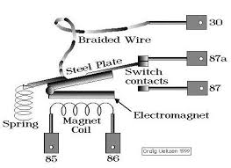** Fig:2.10

**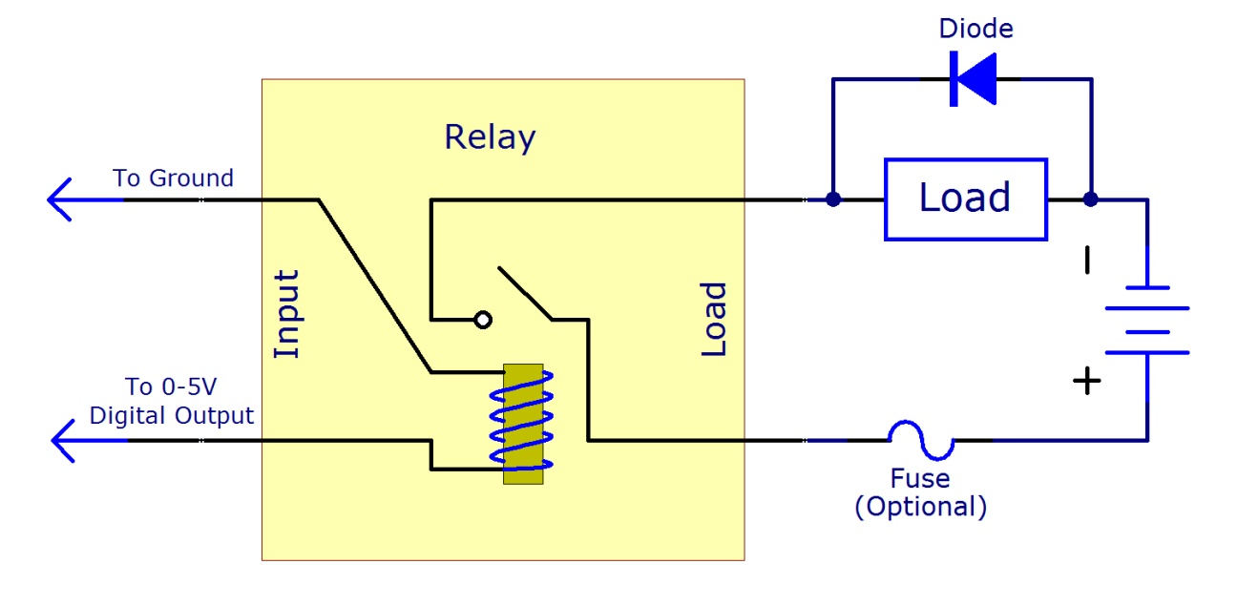**

Fig:2.11

**2.4 Diode:**

* The most basic property of a junction diode is that it conducts an electric current in one direction and blocks it in the other. This behavior arises from the electrical characteristics of a junction, called a *p-n junction.* Fabricated within a semiconductor crystal. The most commonly used semiconductor material is silicon. The junction diode is useful in a wide variety of applications including the rectification of ac signals (producing dc from ac), the detection of radio signals, the conversion of solar power to electricity, and in the generation and detection of light. It also finds use in a variety of electronic circuits as a switch, as a voltage reference or even as a tunable capacitor. The p-n junction is also the basic building block of a host of other electronic devices, of which the most well-known is the junction transistor.
* In our project we have used a diode as a rectifier basically it is a full wave rectifier used to convert ac in to dc in the power supply portion of the project.
* 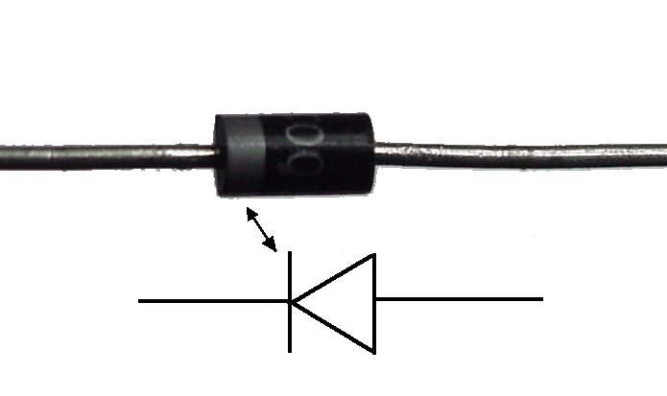

Fig:2.12

2.5 DB-9 Connector:

This connector is occasionally found on smaller RS-232 lab equipment. It is compact yet has enough pins for the "core" set of serial pins (with one pin extra).

Important: The DB-9 pin numbers for transmit and receive (3 and 2) are opposite of those of the DB-25 connector (2 and 3).

The images show the male and female versions of the DB-9 connector with pin numbers.

Some of the early Macs also used the DB-9 connector as a serial port.

In this project we used db-9 connectors to provide interface between terminal and control board. More over the interface between control board and server computer is also through db-9 connectors and 8-wire cables

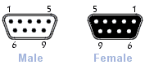

Fig: 2.13

**2.6 Light-emitting diode**

[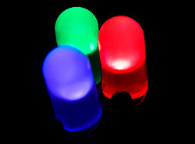](http://en.wikipedia.org/wiki/File:RBG-LED.jpg)

Fig:2.14

Basically, LEDs are just tiny light bulbs that fit easily into an electrical circuit. But unlike ordinary incandescent bulbs ,they don't have a filament that will burn out, and they don't get especially hot. They are illuminated solely by the movement of electrons in a semiconductor material, and they last just as long as a standard transistor.

A light-emitting-diode (LED) is a semiconductor diode that emits light when an electric current is applied in the forward direction of the device, as in the simple LED circuit

[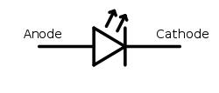](http://en.wikipedia.org/wiki/File:LED_symbol.svg) LED schematic symbol

Fig: 2.15

The effect is a form of electroluminescence where incoherent and narrow-spectrum light is emitted from the p-n junction in a solid state material.

2.7 Bridge Rectifier

Bridge rectifier is an electronic component which converts an input AC current into a DC current as an output. Electronic devices and particularly portable electronic devices typically make the use of alternating current to direct current adapters either as a direct source of power to charge on-board batteries. Fig: 2.16

A bridge rectifier makes use of four diodes in a bridge arrangement to achieve full-wave rectification. It is called a full-wave rectifier because it uses the entire AC wave (both positive and negative sections). 1.4V is used up in the bridge rectifier because each diode uses 0.7V when conducting and there are always two diodes conducting, as shown in the diagram below. Bridge rectifiers are rated by the maximum current they can pass and the maximum reverse voltage they can withstand (this must be at least three times the supply RMS voltage so the rectifier can withstand the peak voltages). This is a widely used configuration, both with individual diodes wired as shown and with single component bridges where the diode bridge is wired internally.

The input to the circuit is applied to the diagonally opposite corners of the network, and the output is taken from the remaining two corners. 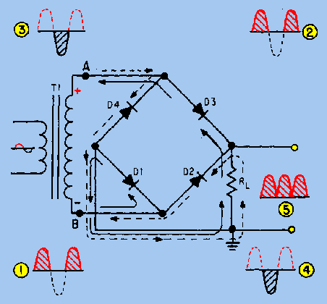Let us assume the transformer is working properly and there is a positive potential at point A and a negative potential at point B.

Figure: Bridge Rectifier. The positive potential at point A will forward bias D3 and reverse bias D4. The negative potential at point B will forward bias D1 and reverse bias D2. At this time D3 and D1 are forward biased and will allow current flow to pass through them; D4 and D2 are reverse biased and will block current flow. The path for current flow is from point B through D1, up through RL, through D3, through the secondary of the transformer back to point B. This path is indicated by the solid arrows. Waveforms (1) and (2) can be observed across D1 and D3.

One-half cycle later the polarity across the secondary of the transformer reverses, forward biasing D2 and D4 and reverse biasing D1 and D3. Current flow will now be from point A through D4, up through RL, through D2, through the secondary of T1, and back to point A. This path is indicated by the broken arrows. Waveforms (3) and (4) can be observed across D2 and D4. You should have noted that the current flow through RL is always in the same direction. In flowing through RL this current develops a voltage corresponding to that shown in waveform (5). Since current flows through the load (RL) during both half cycles of the applied voltage, this bridge rectifier is a full-wave rectifier.

One advantage of a bridge rectifier over a conventional full-wave rectifier is that with a given transformer the bridge rectifier produces a voltage output that is nearly twice that of the conventional full-wave circuit.

**2.7.1 Current Flow in the Bridge Rectifier**

For both positive and negative swings of the transformer, there is a forward path through the diode bridge. Both conduction paths cause current to flow in the same direction through the load resistor, accomplishing full-wave rectification. While one set of diodes is forward biased, the other set is reverse biased and effectively eliminated from the circuit.

**2.7.2 Applications**

The primary application of rectifiers is to derive DC power from an AC supply. Virtually all electronics require a DC supply but mains power is AC so rectifiers find uses inside the power supplies of virtually all electronic equipment.

**2.8 Transformer**

A transformer is a device that transfers electrical energy from one circuit to another through inductively coupled electrical conductors. A changing current in the first circuit (the primary) creates a changing magnetic field. This changing magnetic field induces a changing voltage in the second circuit (the secondary). This effect is called mutual induction.

Transformers are passive electrical devices that transform alternating or intermittent electric energy in one circuit into energy of a similar type in another circuit, commonly with altered values of voltage and current. It typically contains two or more electrical circuits comprising primary and secondary windings, each made of a multi-turn coil of electrical conductors with one or more magnetic cores coupling the coils by transferring a magnetic flux there between. Increasingly, modern day appliances are constructed using low voltage transformers for many purposes including as lighting transformers or to supply power to electronic components.

**2.8.1 How does a transformer work?**

A transformer is based on a very simple fact about electricity: when a fluctuating electric current flows through a wire, it generates a magnetic field (an invisible pattern of magnetism) or "magnetic flux" all around it. The strength of the magnetism (which has the rather technical name of magnetic flux density) is directly related to the size of the electric current. So the bigger the current, the stronger the magnetic field. Now there's another interesting fact about electricity too. When a magnetic field fluctuates around a piece of wire, it generates an electric current in the wire. So if we put a second coil of wire next to the first one, and send a fluctuating electric current into the first coil, we will create an electric current in the second wire. This is called electromagnetic induction because the current in the first coil causes (or "induces") a current in the second coil. The current in the first coil is usually called the primary current and the current in the second wire is (surprise, surprise) the secondary current. What we've done here is pass an electric current through empty space from one coil of wire to another. This phenomenon is called electromagnetic induction. We can make electrical energy pass more efficiently from one coil to the other by wrapping them around a soft iron bar (sometimes called a core):

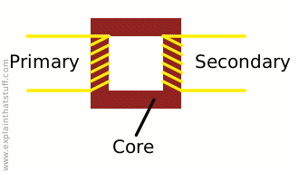Fig: 2.17

To make a coil of wire, we simply curl the wire round into loops or ("turns" as physicists like to call them). If the second coil has the same number of turns as the first coil, the electric current in the second coil will be virtually the same size as the one in the first coil. But (and here's the clever part) if we have more or fewer turns in the second coil, we can make the secondary current and voltage bigger or smaller than the primary current and voltage.

One important thing to note is that this trick works only if the electric current is fluctuating in some way. In other words, you have to use a type of constantly reversing electricity called alternating current (AC) with a transformer. Transformers do not work with direct current (DC), where the current constantly flows in the same direction.

**2.8.2 Step-down transformers**

If the first coil has more turns that the second coil, the secondary voltage is smaller than the primary voltage:

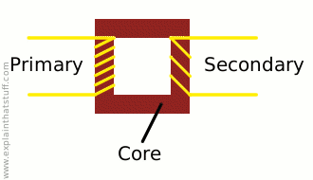

This is called a step-down transformer. If the second coil has half as many turns as the first coil, the secondary voltage will be half the size of the primary voltage; if the second coil has one tenth as many turns; it has one tenth the voltage. In general:

Secondary voltage ÷ Primary voltage = Number of turns in secondary ÷ Number of turns in primary

The current is transformed the opposite way—increased in size—in a step-down transformer:

Secondary current ÷ Primary current = Number of turns in primary ÷ Number of turns in secondary

So a step-down transformer with 100 coils in the primary and 10 coils in the secondary will reduce the voltage by a factor of 10 but multiply the current by a factor of 10 at the same time. The power in an electric current is equal to the current times the voltage (watts = volts x amps is one way to remember this), so you can see the power in the secondary coil is theoretically the same as the power in the primary coil. (In reality, there is some loss of power between the primary and the secondary because some of the "magnetic flux" leaks out of the core; some energy is lost because the core heats up, and so on.)

**Ideal power equation**

Pincoming = IPVP = Poutgoing = ISVS

**Ideal transformer equation**


\frac{V_{S}}{V_{P}} = \frac{N_{S}}{N_{P}} = \frac{I_{P}}{I_{S}}


**2.9 PLC and SCADA**

**2.9.1 PLC configuration**

1. Many PLC configurations are available, even from a single vendor. But each of these has common components and concepts. The most essential component is are:
2. Power supply –

This can be built into the PLC or be an external unit. Common voltage levels required by the PLC are 24Vdc 100Vac 240Vac.

1. CPU (central Processing Unit) –

This is a computer where ladder logic is stored and processed.

iv. I/O (Input/output) –

A number of input/output terminals must be provided so that the PLC can monitor the process and initiate actions. Inputs to, and outputs from, a PLC is necessary to monitor and control a process. Both inputs and outputs can be categorized into two basic types: logical or continuous. Consider the example of a light bulb. If it can only be turned on or off, it is logical control. If the light can be dimmed to different levels, it is continuous.

Indicator lights –

These indicate the status of the PLC including

power on

program running

and

An error.

These are essential when diagnosing problems.

vi. Rack Type :

A rack can often be as large as 18” by 30” by 10”

Mini:

These are similar in function to PLC racks, but about the half size.

Dedicated Backplanes can be used to support the cards OR DIN rail

mountable with incorporated I/O bus in module.

viii. Shoebox:

A compact, all-in-one unit that has limited expansion capabilities.

Lower cost and compactness make these ideal for small applications. DIN

rail mountable.

ix. Micro:

These units can be as small as a deck of cards. They tend to have

fixed quantities of I/O and limited abilities, but costs will be lowest. DIN rail

mountable

**2.9.2 Basic PLC schema**

The basic PLC schema include CPU, power supply, memory, Input block, output block, communication and expansion connections. Figure 2.1 shows the PLC system overview.

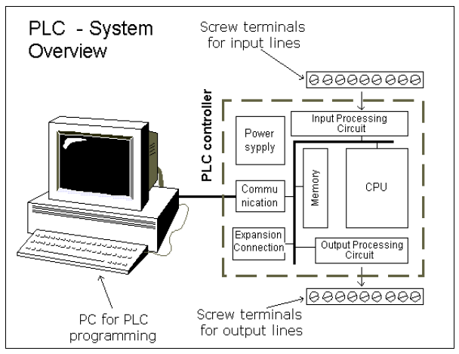

Figure 2.18 PLC system overview

CPU modules –

The Central Processing Unit (CPU) Module is the brain of

the PLC.Primary role to read inputs, execute the control program, update outputs.

The CPU consists of the arithmetic logic unit (ALU), timing/control circuitry,

accumulator, scratch pad memory, program counter, address stack and instruction

register. A PLC works by continually scanning a program.

Memory –

The memory includes pre-programmed ROM memory containing

the PLC’s operating system, driver programs and application programs and the

RAM memory. PLC manufacturer offer various types of retentive memory to save

user programs and data while power is removed, so that the PLC can resume

12

execution of the user-written control program as soon as power is restored. Some

types of memory used in a PLC include:

ROM (Read-Only Memory)

RAM (Random Access Memory)

PROM (Programmable Read-Only Memory)

iv. EPROM (Erasable Programmable Read-Only Memory)

v EEPROM (Electronically Erasable Programmable Read-Only Memory)

vi. FLASH Memory

Compact Flash – Can store complete program information, read & write text files

viii. I/O Modules - Input and output (I/O) modules connect the PLC to sensors and actuators. Provide isolation for the low-voltage, low-current signals that the PLC uses internally from the higher-power electrical circuits required by most sensors and actuators. Wide range of I/O modules available including: digital (logical) I/O modules and analogue (continuous) I/O modules.

* + 1. PLC Hardware

A programmable logic controller (PLC) is an industrial computer used to control and automate complex systems. Programmable logic controllers are a relatively recent development in process control technology. It is designed for use in an industrial environment, which uses a programmable memory for the integral storage of user-oriented instructions for implementing specific functions such as logic, sequencing, timing, counting, and arithmetic to control through digital or analog inputs and outputs, various types of machines or processes. Programmable logic controllers are used throughout industry to control and monitor a wide range of machines and other movable components and systems. PLC is used to monitor input signals from a variety of input points (input sensors) which report events and conditions occurring in a controlled process. Programmable logic controllers are typically found in factory type settings. PLCs are used to control robots, assembly lines and various other applications that require a large amount of data monitoring and control.

A typical programmable logic controller employs a backplane to serve as the communications bus for interconnecting the PLC processor with the array of individual input/output devices with which the processor interacts in terms of receiving input data for use in executing the control program and transmitting control data for use in controlling the targeted objects. A PLC includes a rack into which a plurality of input/output cards may be placed. A rack includes several slots into which these input/output cards are installed. Each input/output card has a plurality of I/O points. The I/O modules are typically pluggable into respective slots located on a backplane board in the PLC. An I/O bus couples the cards in the slots back to the processor of the programmable logic controller. The slots are coupled together by a main bus which couples any I/O modules plugged into the slots to a central processing unit (CPU). The CPU itself can be located on a card which is pluggable into a dedicated slot on the backplane of the PLC. The particular processor employed in a PLC together with the particular choice of input and output cards installed in the PLC rack are often referred to as the hardware configuration of the programmable logic controller. The hardware configuration also includes the particular addresses which the I/O cards. Each option module typically has a plurality of input/output points. The option modules are coupled through an interface bus, for example via a backplane, to a main controller having a microprocessor executing a user program.

Option modules may also include a microprocessor and a memory containing separate user programs and data directed to a particular operation of the PLC system. During the execution of a stored control program, the PLC's read inputs from the controlled process and, per the logic of the control program, provide outputs to the controlled process. The outputs typically provide analog or binary voltages or "contacts" implemented by solid state switching devices. PLC's are normally constructed in modular fashion to allow them to be easily reconfigured to meet the demands of the particular process being controlled. The processor and I/O circuitry are normally constructed as separate modules that may be inserted in a chassis and connected together through a common backplane using permanent or releasable electrical connectors.

**2.9.3.1 Introduction of FATEK FBS Series PLC**

The FATEK FBS Series PLC is a new generation of micro PLC equipped with excellent functions comparable to medium or large PLC, with up to five communication ports. The maximum I/O numbers are 256 points for Digital Input (DI) and Digital Output (DO), 64 words for Numeric Input (NI) and Numeric Output (NO). The Main Units of FBS are available in three types: MA (Economy Type), MC (High-Performance Type), and MN (High-Speed NC Type). With the combination of I/O point ranges from 10 to 60, a total of 17 models are available. Fourteen DI/DO and 12 NI/NO models are available for Expansion Units/Modules. With interface options in RS232, RS485, USB and Ethernet, the communication peripherals are available with 14 boards and modules. The various models are described in the following:

**2.9.3.2 Appearance of Main Unit**

All the Main Units of FBS-PLC have the same physical structure. The only difference is the case width. There are four different

case sizes, which are 60mm, 90mm, 130mm, and 175mm. The figure below will use the Main Unit case of the FBS-24MC as

an example for illustration:

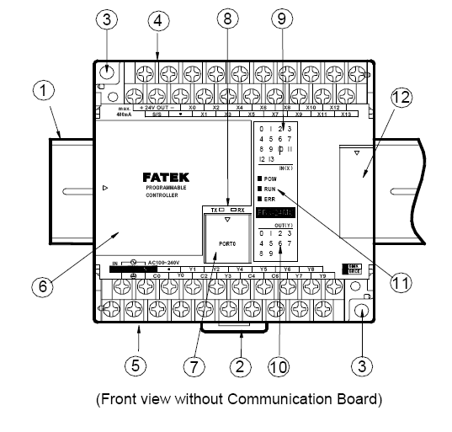

Fig: 2.19

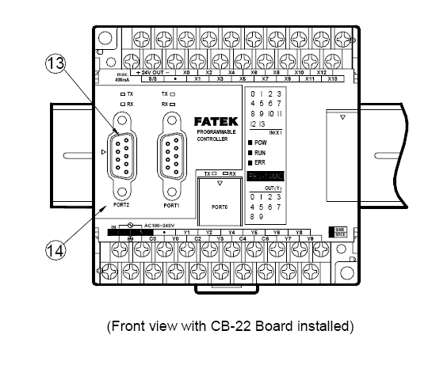

Fig: 2.20

1 35mm-width DIN RAIL

2 DIN RAIL tab

3 Hole for screw fixation (ψ4.5×2

)

4 Terminals of 24VDC power input and digital input

(Pitch 7.62mm)

5 Terminals of main power input and digital output

(Pitch 7.62mm)

6 Standard cover plate (without communication

board)

7 Cover plate of built-in communication port (Port 0)

8 Indicators for transmit (TX) and receive (RX) status of built-in communication port (Port0).

9 Indicator for Digital Input (Xn).

10 Indicator for Digital Output (Yn).

11 Indicator for system status (POW, RUN, ERR).

12 I/O output expansion header cover [units of 20 points or beyond only], with esthetic purpose and capable of securing

expansion cable.

13 FBS-CB22 Communication Board (CB).

14 FBS-CB22 CB cover plate (each CB has its own specific cover plate)

15 Screw holes of communication board.

16 Connector for communication board (for CB2, CB22, CB5, CB55, and CB25)

17 Connector for Communication Module (CM) (only available in MC/MN model, for CM22, CM25, CM55, CM25E, and

CM55E connection).

18 Connector for Memory Pack.

19 Connector for built-in communication port (Port 0) (With USB and RS232 optional, shown in the figure is for RS232)

20 I/O output expansion header (only available in units with 20 points or beyond), for connecting with cables from

expansion units/modules

**2.9.3.3 Specifications of Main Unit**

Execution Speed 0.33uS/per Sequence Command

Space of Control Program 20K Words

Program Memory FLASH ROM or SRAM + Lithium battery for Back-up

Sequence Command 36

Application Command 300 (113 types)

Flow Chart (SFC) Command 4

X Output Contact(DI) X0~X255 (256)

Y Output Relay(DO) Y0~Y255 (256)

TR Temporary Relay TR0~TR39 (40)

Internal relays

Non-retentive

M0~M799 (800)\*

can be configured as retentive type

M1400～M1911 (512)

Retentive

M800～M1399 (600)\*

Special Relays

M1912～M2001 (90)

Timer ”Time Up” Status Contact T0~T255 (256)

Counter ”Count Up” Status Contact C0~C255 (256)

0.01S Time base T0~T49 (50)\*

0.1S Time base T50~T199 (150)\*

1STime base T200~T255 (56)\*

Retentive C0~C139 (140)\*

Non-retentive C140~C199 (60)\*

Retentive C200~C239 (40)\*

Non-retentive C240~C255 (16)\*

DATA REGISTERS

Retentive R0~R2999 (3000)\*

Retentive D0~D3999 (4000)

Non-retentive R3000~R3839 (840)\*

**2.9.4 PLC Operation**

CHECK INPUT STATUS-First the PLC takes a look at each input to

determine whether it is on or off condition.

EXECUTE PROGRAM-Next the PLC executes a program by one

instruction at a time. If the first input is on then it should turn on the first output.

Since it already knows then it will be able to decide whether the first output should

be turned on based on the state of the first input. It will store the execution results

for use later during the next step.

UPDATE OUTPUT STATUS-Finally the PLC updates the status of the

outputs. It updates the outputs based on which inputs are on during the first step and

the results of executing your program during the second step. Based on the example

in step 2 it would now turn “ON” the first output because the first input is “ON” and

your program said to turn “ON” the first output when this condition is true.

**2.9.5 SCADA**

**2.9.5.1 Introduction**

Widely used in industry for Supervisory Control and Data Acquisition of industrial

processes, SCADA systems are now also penetrating the experimental physics laboratories for the controls of ancillary systems such as cooling, ventilation, power distribution, etc.

SCADA systems have made substantial progress over the recent years in terms of

functionality, scalability, performance and openness such that they are an alternative to in house development even for very demanding and complex control systems as those of physics experiments.

**2.9.5.2 What does SCADA MEAN?**

SCADA stands for Supervisory Control And Data Acquisition. As the name indicates, it

is not a full control system, but rather focuses on the supervisory level. As such, it is a

purely software package that is positioned on top of hardware to which it is interfaced, in

general via Programmable Logic Controllers (PLCs), or other commercial hardware

modules.

SCADA systems are used not only in industrial processes: e.g. steel making, power

generation (conventional and nuclear) and distribution, chemistry, but also in some

experimental facilities such as nuclear fusion. The size of such plants range from a few

1000 to several 10 thousands input/output (I/O) channels. However, SCADA systems

evolve rapidly and are now penetrating the market of plants with a number of I/O

channels of several 100 K: we know of two cases of near to 1 M I/O channels currently

under development.

SCADA systems used to run on DOS, VMS and UNIX; in recent years all SCADA

vendors have moved to NT and some also to Linux.

**2.9.5.3 SCADA SOFTWARE LOOK**

**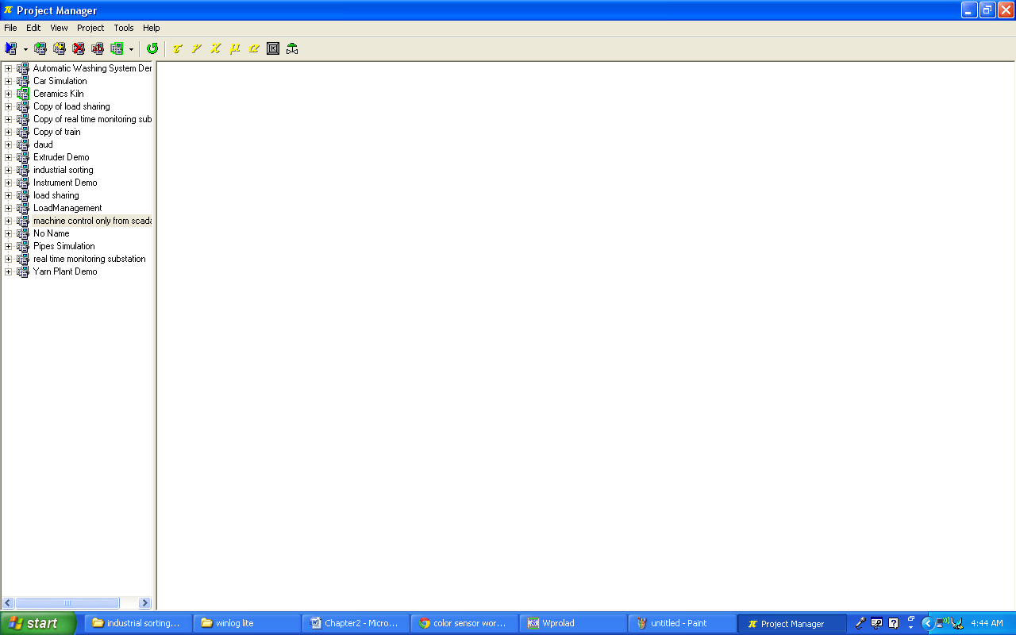**

**Fig: 2.21**

**Configuraton:**

**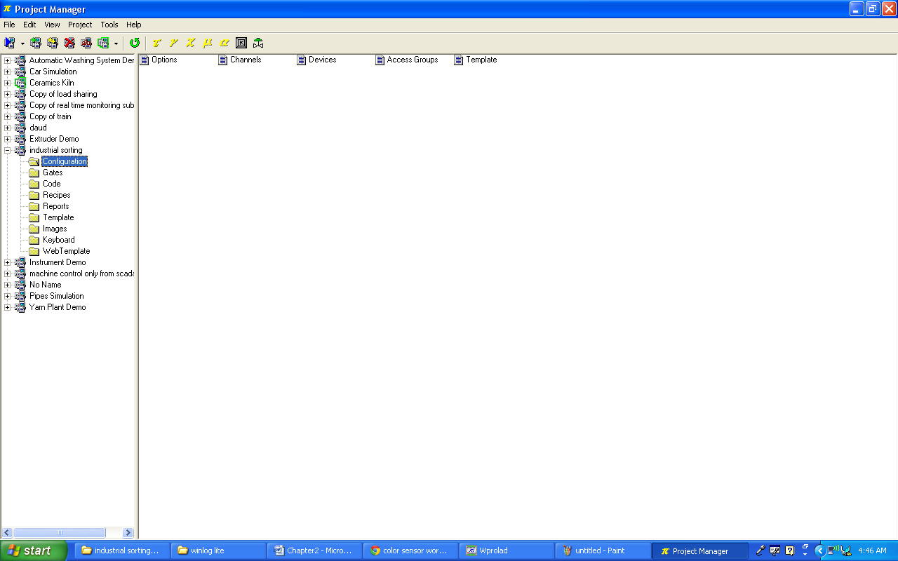**

**Fig: 2.22**

**Gates:**

**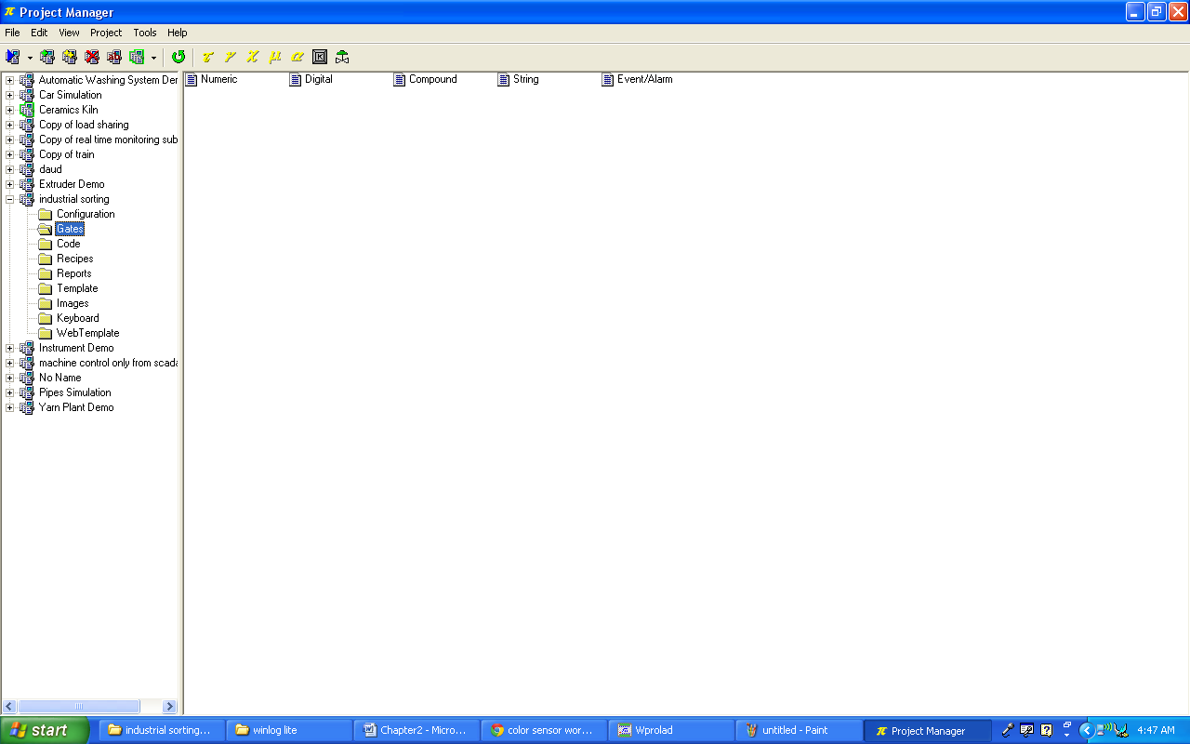**

**Fig: 2.23**

**Project Template:**

**Add a screen shot of the GUI APPLICATION HERE**

**Fig: 2.24**

* 1. **7812 Voltage Regulator**

7812 is a famous IC which is being widely used in 12V voltage regulator circuits. Truly speaking it is a complete standalone voltage regulator. We only need to use two capacitors, one on the input and second one on the output of 7812 in order to achieve clean voltage output and even these capacitors are optional to use. To achieve 12V 1A current, 7812 should be mounted on a good heatsink plate. Thanks to the transistor like shape of 7812 which makes it easy to mount on a heatsink plate. 7812 has built in over heat and short circuit protection which makes it a good choice for making power supplies.

[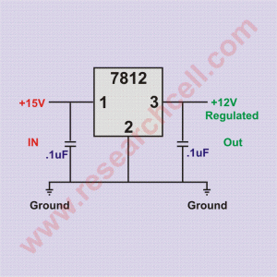](http://www.researchcell.com/electronics/7812-pin-and-circuit-diagram/attachment/7812-circuit-diagram/)

**7812 circuit diagram Fig: 2.25**

In electronics markets, 7812 is sold under various names such as 7812a, 7812act, 7812t and lm7812. All of them are almost identical with a little to no differences at all. 7812 input voltage range is 14V to 35V. Exceeding the voltage range may damage the IC. Given bellow is 7812 pin diagram to make the pinout connections clear in case you want to do some experiments.

[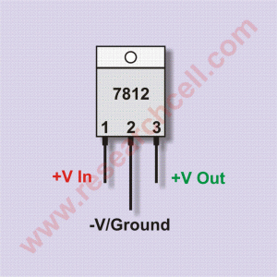](http://www.researchcell.com/electronics/7812-pin-and-circuit-diagram/attachment/7812-pin-diagram/)

**7812 pin diagram Fig: 2.26**

If you hold upside down (pins up) and the IC number is facing you then the left pin will be the voltage regulator output, the center pin will be ground and the right pin will be the voltage input pin. Under my experience, the maximum safe current you can get from one 7812 IC is 1A. If you need more power then there are a few ways to do so.  
More than one 7812 can be used in parallel in order to achieve more than 1A current but output voltage of each 7812 can slightly vary resulting in unbalanced load on all of them. This can result in load balancing issues and can damage the IC carrying most current. However there is a way to overcome this problem. I have given bellow a schematic diagram in which two 7812 ICs are attached together and both of them are carrying almost equal load. At least the current difference is not too much to damage any IC.

[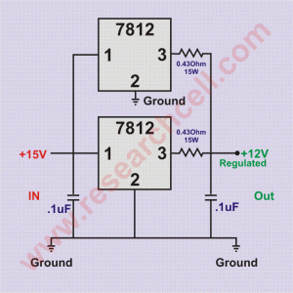](http://www.researchcell.com/electronics/7812-pin-and-circuit-diagram/attachment/7812-in-parallel-circuit-diagram/)

**7812 in parallel circuit diagram Fig: 2.27**

Please note that in this circuit diagram, I have used resistors for load balancing purpose so the output of this voltage regulator circuit may slightly inaccurate. Both resistors should be minimum 15 Watt or above. If you don’t find such resistors in your area then you can make them using 32 gauge or thinner copper wire. This parallel 7812 circuit will provide 12V and approximately 2A current. You can increase number of 7812 but each additional 7812 will require a resistor on its output.  
Following is the link to a simple but complete power supply circuit diagram developed using 7812.

* 1. **THERMISTOR:**

A thermistor is a type of [resistor](https://en.wikipedia.org/wiki/Resistor) whose [resistance](https://en.wikipedia.org/wiki/Electrical_resistance) is dependent on [temperature](https://en.wikipedia.org/wiki/Temperature), more so than in standard resistors. The word is a[portmanteau](https://en.wikipedia.org/wiki/Portmanteau) of [*thermal*](https://en.wikipedia.org/wiki/Thermal_(disambiguation)) and [*resistor*](https://en.wikipedia.org/wiki/Resistor). Thermistors are widely used as [inrush current limiter](https://en.wikipedia.org/wiki/Inrush_current_limiter), temperature [sensors](https://en.wikipedia.org/wiki/Sensors) (NTC type typically),[self-resetting overcurrent protectors](https://en.wikipedia.org/wiki/Resettable_fuse), and self-regulating [heating elements](https://en.wikipedia.org/wiki/Heating_element).

Thermistors differ from [resistance temperature detectors](https://en.wikipedia.org/wiki/Resistance_thermometer) (RTDs) in that the material used in a thermistor is generally a ceramic or polymer, while RTDs use pure metals. The temperature response is also different; RTDs are useful over larger temperature ranges, while thermistors typically achieve a greater precision within a limited temperature range, typically −90 °C to 130 °C.[[1]](https://en.wikipedia.org/wiki/Thermistor#cite_note-1)

* 1. **NPN TRANSISTOR:**

A **bipolar junction transistor** (**BJT** or **bipolar transistor**) is a type of [transistor](https://en.wikipedia.org/wiki/Transistor) that relies on the contact of two types of [semiconductor](https://en.wikipedia.org/wiki/Semiconductor) for its operation. BJTs can be used as [amplifiers](https://en.wikipedia.org/wiki/Electronic_amplifier), switches, or in [oscillators](https://en.wikipedia.org/wiki/Electronic_oscillator). BJTs can be found either as individual discrete components, or in large numbers as parts of [integrated circuits](https://en.wikipedia.org/wiki/Integrated_circuit).

*Bipolar* [transistors](https://en.wikipedia.org/wiki/Transistor) are so named because their operation involves both [electrons](https://en.wikipedia.org/wiki/Electron) and [holes](https://en.wikipedia.org/wiki/Electron_hole). These two kinds of charge carriers are characteristic of the two kinds of [doped](https://en.wikipedia.org/wiki/Doping_(semiconductor)) [semiconductor](https://en.wikipedia.org/wiki/Semiconductor) material; electrons are majority charge carriers in n-type semiconductors, whereas holes are majority charge carriers in p-type semiconductors. In contrast, unipolar transistors such as the [field-effect transistors](https://en.wikipedia.org/wiki/Field-effect_transistor) have only one kind of charge carrier.

Charge flow in a BJT is due to [diffusion](https://en.wikipedia.org/wiki/Diffusion) of [charge carriers](https://en.wikipedia.org/wiki/Charge_carriers_in_semiconductors) across a junction between two regions of different charge concentrations. The regions of a BJT are called *emitter*, *collector*, and *base*. A discrete transistor has three leads for connection to these regions. Typically, the emitter region is heavily doped compared to the other two layers, whereas the majority charge carrier concentrations in base and collector layers are about the same. By design, most of the BJT collector current is due to the flow of charges injected from a high-concentration emitter into the base where there are [minority carriers](https://en.wikipedia.org/wiki/Minority_carrier) that diffuse toward the collector, and so BJTs are classified as minority-carrier devices.

**Regions of operation:**

Bipolar transistors have five distinct regions of operation, defined by BJT junction biases.

* **Forward-active** (or simply, **active**): The base–emitter junction is forward biased and the base–collector junction is reverse biased. Most bipolar transistors are designed to afford the greatest common-emitter current gain, βF, in forward-active mode. If this is the case, the collector–emitter current is approximately[proportional](https://en.wikipedia.org/wiki/Proportionality_(mathematics)) to the base current, but many times larger, for small base current variations.
* **Reverse-active** (or **inverse-active** or **inverted**): By reversing the biasing conditions of the forward-active region, a bipolar transistor goes into reverse-active mode. In this mode, the emitter and collector regions switch roles. Because most BJTs are designed to maximize current gain in forward-active mode, the βF in inverted mode is several times smaller (2–3 times for the ordinary germanium transistor). This transistor mode is seldom used, usually being considered only for failsafe conditions and some types of bipolar logic. The reverse bias breakdown voltage to the base may be an order of magnitude lower in this region.
* **Saturation**: With both junctions forward-biased, a BJT is in saturation mode and facilitates high current conduction from the emitter to the collector (or the other direction in the case of NPN, with negatively charged carriers flowing from emitter to collector). This mode corresponds to a logical "on", or a closed switch.
* **Cutoff**: In cutoff, biasing conditions opposite of saturation (both junctions reverse biased) are present. There is very little current, which corresponds to a logical "off", or an open switch.

**CHAPTER 3 Methodology**

In our project we have used WinProladder for PLC programming. Before we explain our project code lets first discus some basic principles of ladder diagram.

**3.1 The Operation Principle of Ladder Diagram**

Ladder diagram is a type of graphic language for automatic control system it had been used for a long period since world war 2. until today, it is the oldest and most popular language for automatic control systems. Originally there are only few basic elements available such as A-contact (normally ON), B contact (Normally OFF), output coil. Timers and Counters. Not until the appearance of microprocessor based PLC, more elements for ladder Diagram, such as differential contact, retentive coil and other instructions that a conventional system cannot provide, became available.

The basic operation principle for both conventional and PLC Ladder Diagram is the same. The main difference between the two systems is that the appearance of the symbols for conventional Ladder Diagram are more closer to the real devices, while for PLC system, symbols are simplified for computer display. There are two types of logic system available for Ladder Diagram logic, namely combination logic and sequential logic. Detailed explanations for these two logics are discussed below.

**3.1.1 Ladder logic Software “WinProladder” software look**

**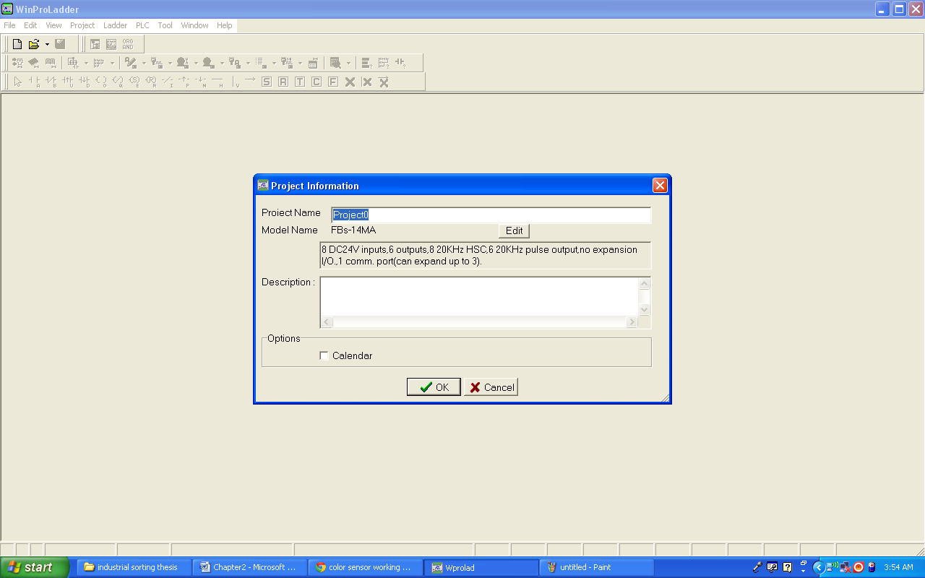**

**Fig: 3.1**

**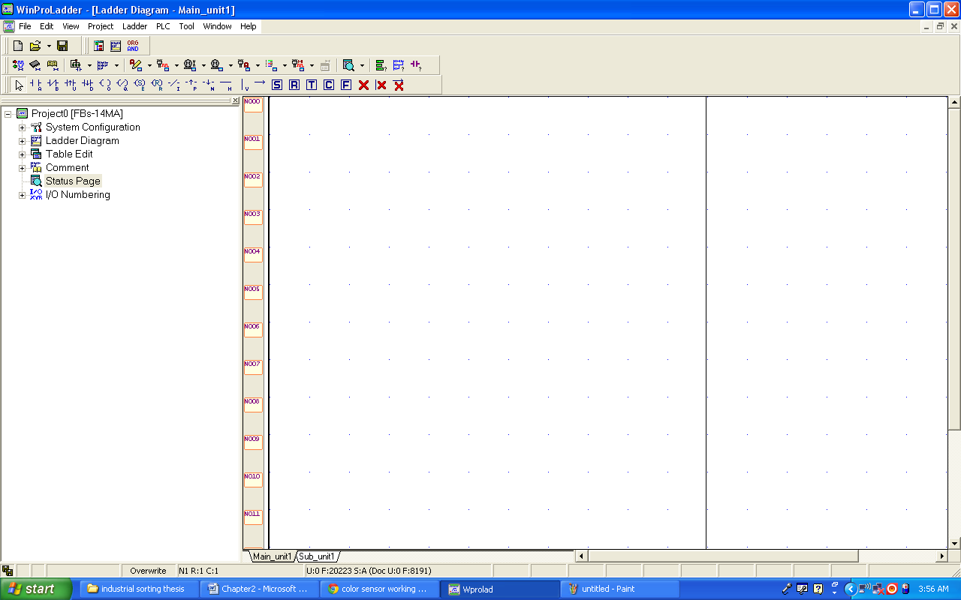**

**Fig: 3.2**

**3.1.2 Combination Logic**

Combination logic of the Ladder Diagram is a circuit that combines one or more input elements in series or parallel and then send the results to the output elements, such as

Coils, Timers/Counters, and other application instructions.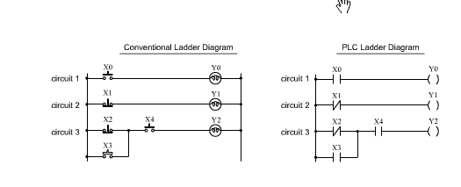

Figure 3.3

The above example

The above example illustrated the combination logic using the actual wiring diagram, conventional ladder Diagram, and PLC Ladder Diagram. Circuit 1 uses a NO(normally open) switch that is also called 'A' switch or contact. Under normal condition(switch is not pressed), the switch contact is at OFF state and the light is off if the switch is pressed, the contact status turns ON and the light is on, in contrast circuit 2 uses a NC (normally Close) switch that is all called "B" switch or contact. Under normal condition, the switch contact is at ON state and the light is on, if the switch is pressed the contact status turns OFF and the light also turns OFF.

Circuit 3 contains more than one input element. Output Y2 light will turn ON under the condition when X2 is closed or X3 switches to ON, and X4 must switch ON too.

Operation manual for ladder program simulation

**3.2 Features**

Can simulate the FATEK PLC ladder program execution without PLC

connection.

With providing single/multiple/continuous scan mode, the execution result

at each scan end can be easily checked.

With providing program address breakpoint and data breakpoint, it is

convenient to check any intermediate execution result and to identify

any data changed.

Provides communication interface allows external program or device (For

example, graphic panel or HMI) to modify or monitor the variable value

during the simulation.

With run time editing feature, during the simulation process the program

can be modified without stop the execution.

**3.3 Limitation of program simulation**

Besides the I/O operation, most of the instructions can be simulated. When

the ladder program contains the unsupported instruction, the operation of

unsupported instruction will be ignored and will be shown with yellow

background color as follows.

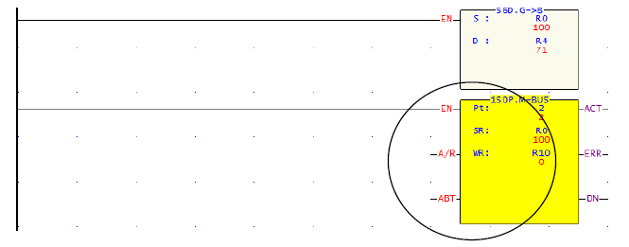

Fig: 3.4

**3.4 Operation of program simulation**

The following is an example of “ssi.pdw” project. With this project to explain

the related operations for program simulation.

**3.4.1 Open ladder program**

Follow the following main menu operation to open the “ ssi.pdw” project file.

File > Open project > Open file > select ssi.pdw. After select the project,

the screen will display as follows:

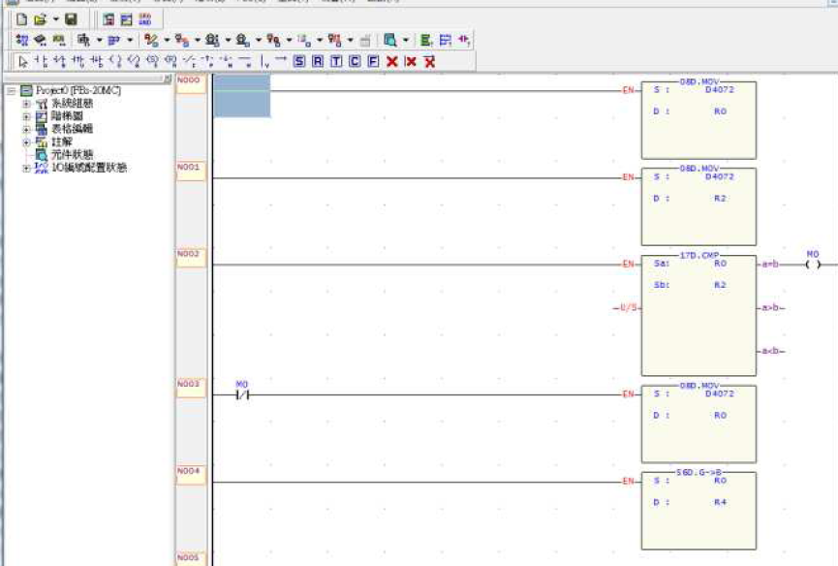

Fig: 3.5

**3.4.2 Enter simulation mode**

Main Menu: PLC > Simulation

It will enter into the simulation mode after execution.

**3.4.3 Start execution of program simulation**

Main Menu: PLC > Run

After execution, the color of power line of ladder program will become to red

color as the screen shown below:

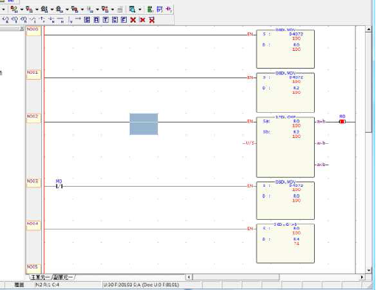

Fig: 3.6

During the execution, there is a blinking red dot at the left side of status bar.

On the right of the red dot has SC:xx, xx means the number of time have been

scanned. During simulation, can use the status page to monitor or modify the

value of register or discrete point.

**3.4.4 Pause of program simulation**

Main Menu: PLC > Pause Simulation or the easiest way is to click the space

Bar

At this point, the blinking red dot stop blinking and it will become pink color.

**3.4.5 Proceed to program simulation**

Main Menu: PLC > Resume Simulation or the easiest way is to click the

space bar

At this point, the dot becomes blinking again and the program continues the

operation.

**Control scanning**

The above pause/Resume program simulation is operated by manual way of

controlling the program execution, which will pause the program execution at

the next scan end point right after you issue the command. But if you would

like to control the exact times of scan execution after pause, you can use set

scan mode to control.

**Single scan**

Main Menu: PLC > Setup Simulation choose ”single scan”

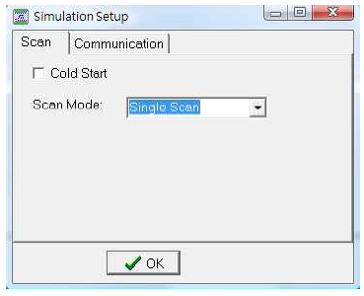

Fig: 3.7

After set this mode, you can use space bar or

Main menu: PLC >Resume Simulation to start a new scanning work.

**Multiple scan**

Main menu: PLC > Setup Simulation choose “multiple scan”

After selected the mode, you can set number of scans to be performed in the

number of scanning field.

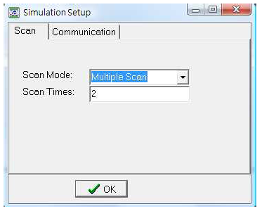

Fig: 3.8

After that, press space bar or

Main menu: PLC > Resume Simulation to start up next scanning work.

When the scan has reached the set number, it will pause the scanning.

**Continuous scan**

Main menu: PLC > Setup Simulation choose “continuous scan”

This is the default scan mode after enter the simulation.

**3.5 Project Ladder Diagram**:

Screenshot of the ladder program

**3.6 Hardware Methodology**

**Schematic**

**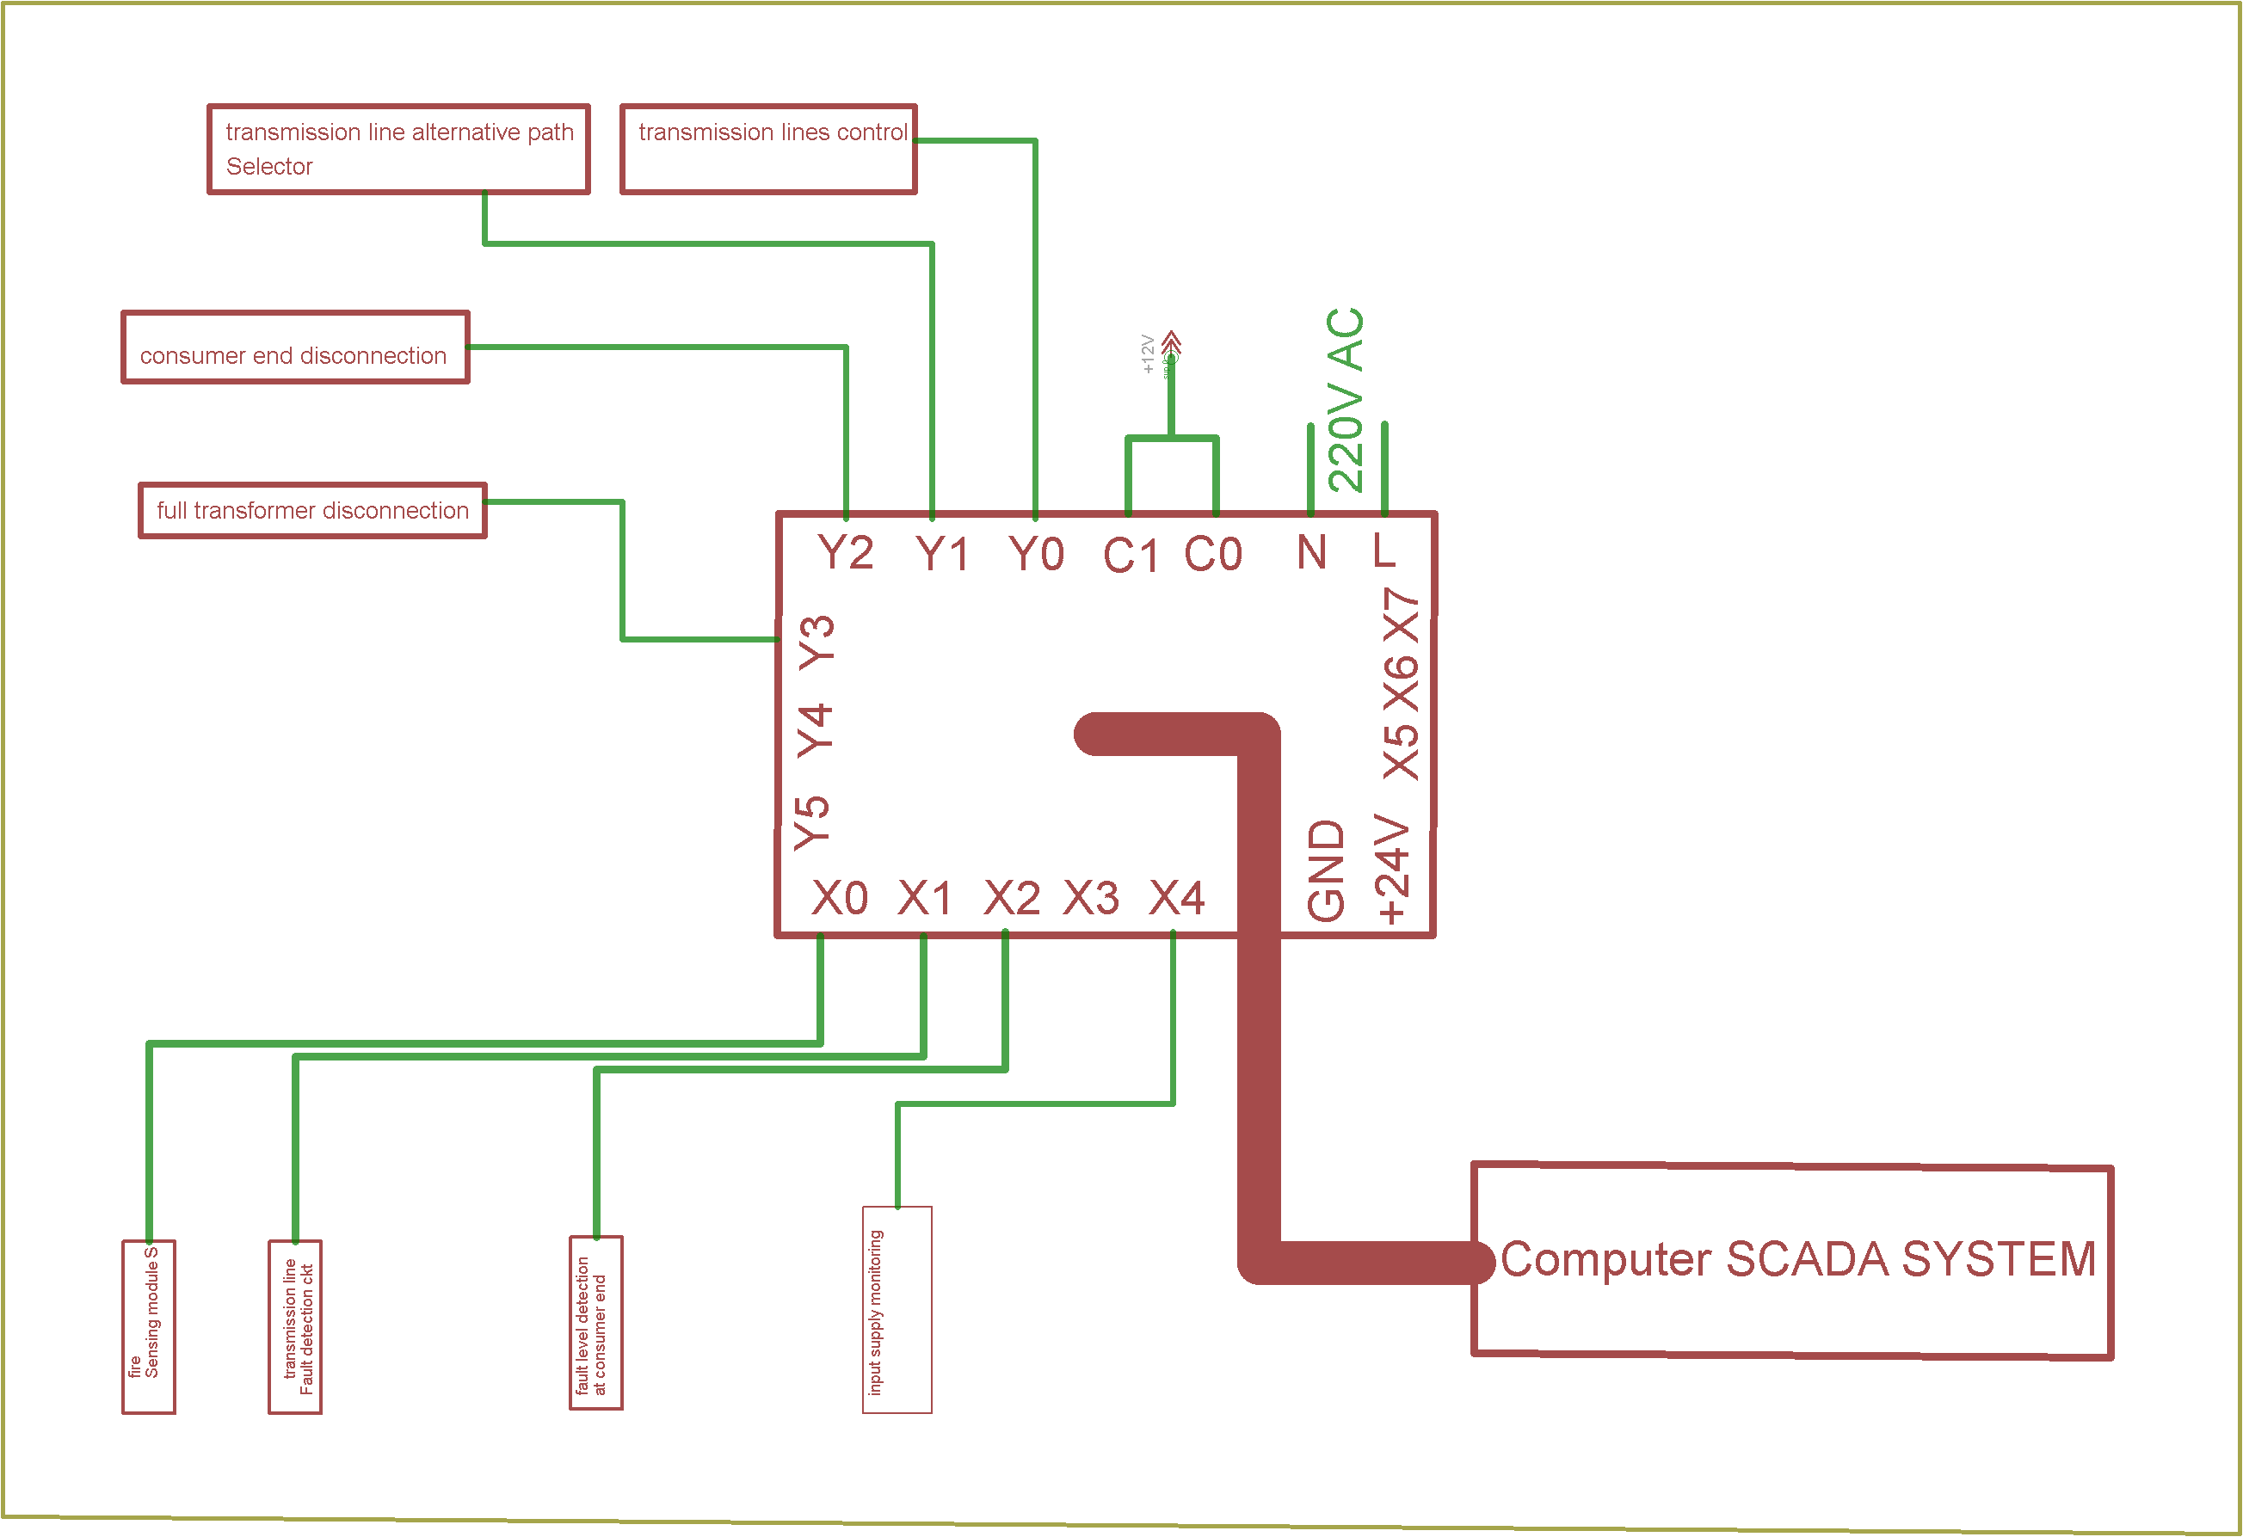**

**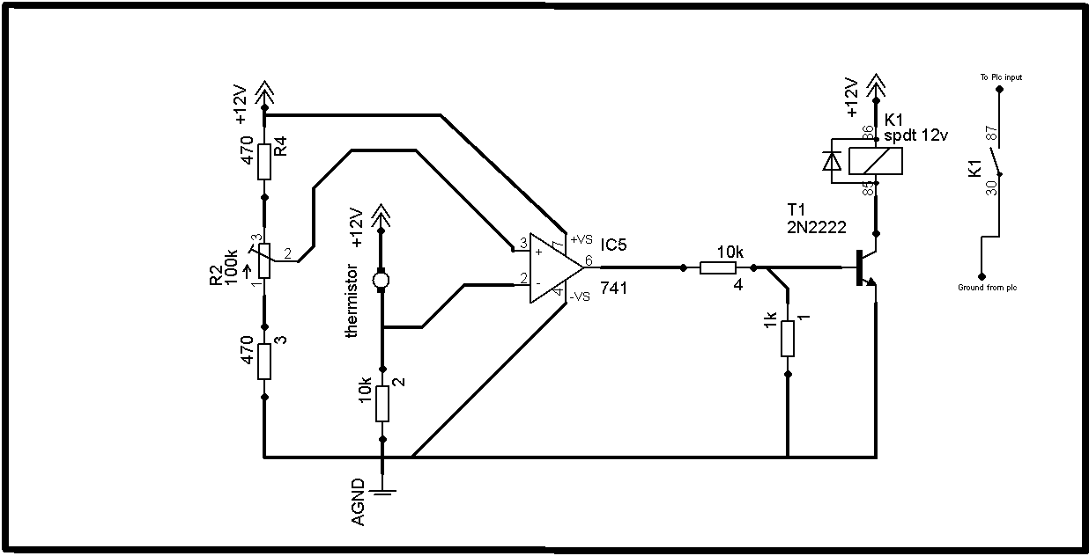**

**The temperature sensing circuit is build around the lm741 operational amplifier. In this circuit the lm741 is used as a voltage comparator. As we know that for the voltage comparator we need inverting, non inverting and output pin, as these pins are already available in the lm741 so we can use it as the voltage comparator. And also by definition we know that any operational amplifier can be used as the voltage comparator. As lm741 is easily available that why we used it in our project.**

**The thermistor is connected in series with 10k ohm which makes the voltage divider. When the temperature varies so the voltage is changed and is fed to the non inverting input of the lm741.**

**A 100k ohm variable resistor is connected in series with the two 470 ohm resistors. Here the two 470 ohm resistors are used for the protection. If incase the resistance of the 100k ohm resistor falls to zero then the these two resistors protects from the shor circuit. 100k ohm resistor is used to set the pre defined voltage level which is compared with the voltage that comes from the thermistor and 10k ohm resistor. the lm741 then gives output wether zero or high. The output is then adjusted with the help of 1k ohm resistor to make sure that the voltage does not exceed 6v. as the base of 2n2222 transistor can not withstand the voltages above 6v. the output of the lm741 operates the transistor in saturation region and acts as the switch. When the output is high the transistor is on and so the relay turns on.**

**The selection of the transistor depends on the relay coil current. before we select the transistor first we find the relay coil energizing current then using the ohm law we find the current. then we select the npn transistor whose collector current is greater than the calculated value.**

**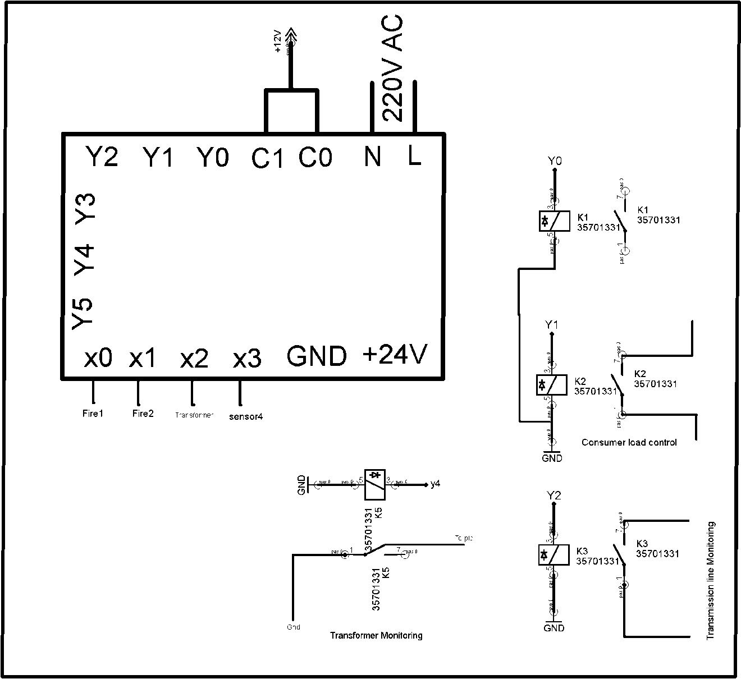**

**To power up the plc we give 220Vac. As our controlling circuit consists of the 12v relays so we give 12v dc to the C0 and C1 of the plc. In this circuit one side of the relays coil is connected to the gnd permanently and the other pins are connected to the plc outputs “ y0….. yn”**

**3.6.1 Project PCBs:**

Relay module:

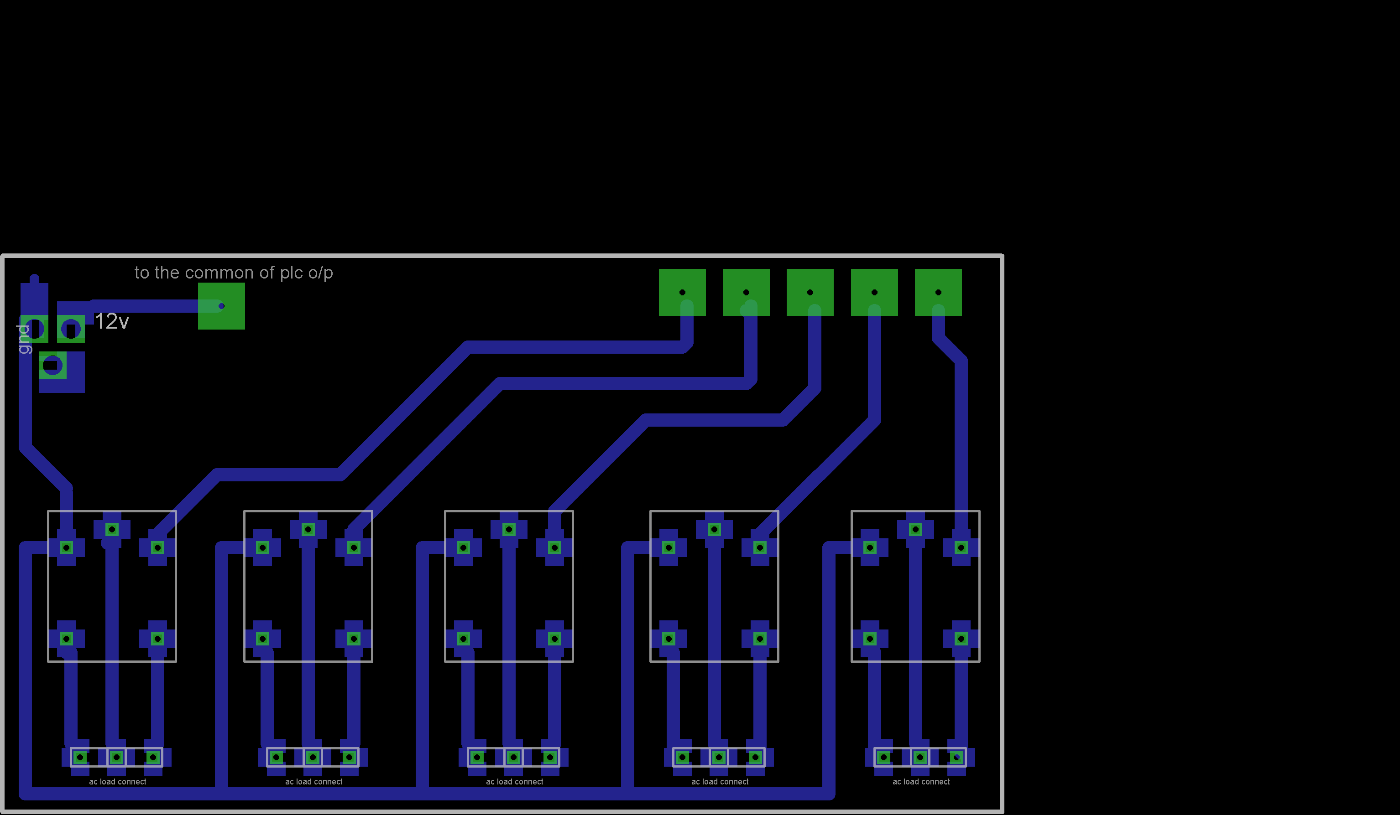

**Thermistor module:**

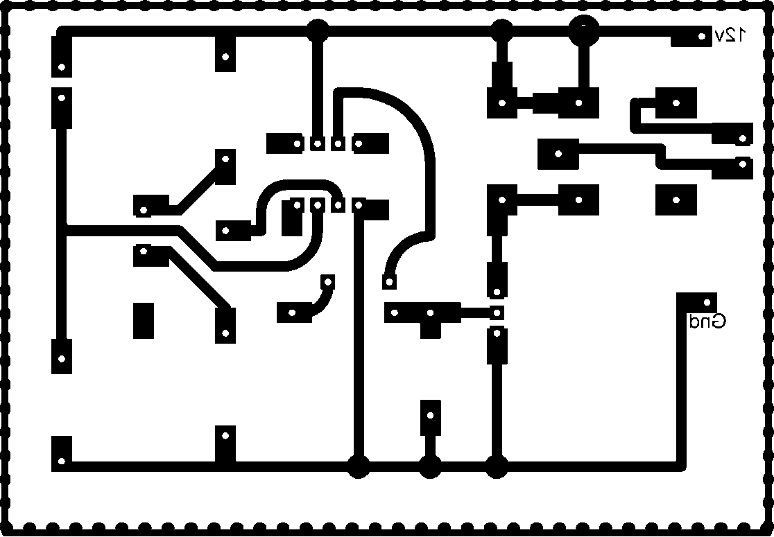

Transformer module:

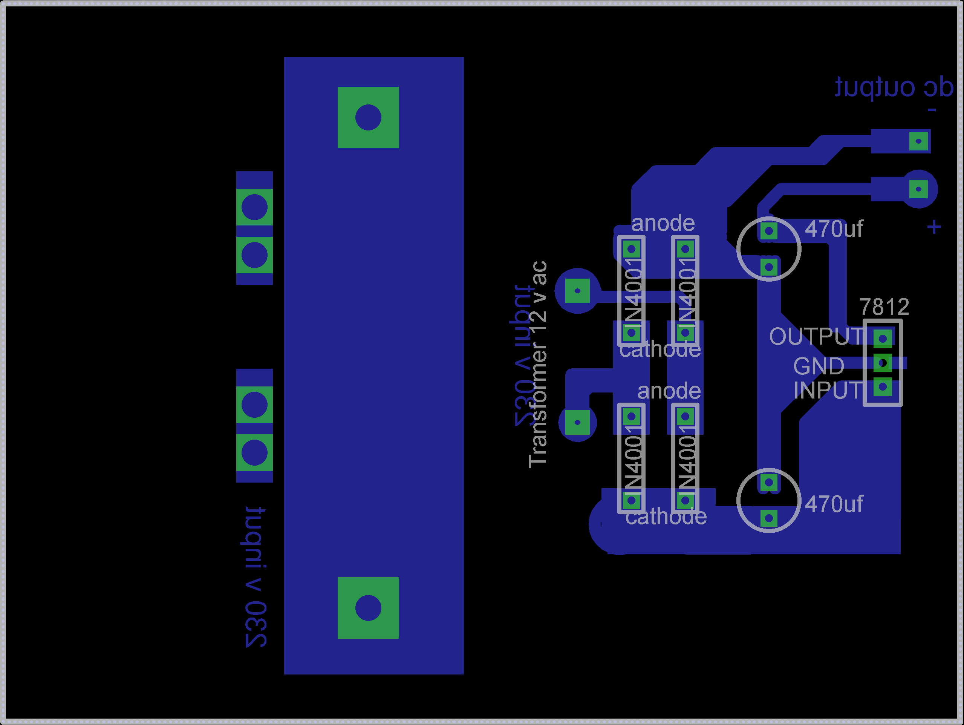

The project PCBs are made in a computer application called CadSoft Eagle.

This application is worldwide used for making PCBs and Schematics.

**CHAPTER 4 Programming**

**Screenshots of the ladder logic programming**

**CHAPTER 5 Results And Conclusion**

**5.1 Future enhancement**