**CHAPTER 1** **Introduction**

With advancement of technology things are becoming simpler and easier for us. Automation is the use of control systems and information technologies to reduce the need

for human work in the production of goods and services. In the scope of industrialization,

automation is a step beyond mechanization. Whereas mechanization provided human operators with machinery to assist them with the muscular.

Requirements of work, automation greatly decreases the need for human sensory and mental requirements as well. Automation plays an increasingly important role in the world economy and in daily experience.

Automatic systems are being preferred over manual system. Through this project we have

tried to show automatic control for the Items sorting.

**1.1 NEED OF AUTOMATION**

Earlier, we looked into the face of future when we talked about automatic devices, which

could do anything on instigation of a controller, but today it has become a reality. An automatic device can replace good amount of human working force, moreover humans are more prone to errors and in intensive conditions the probability of error increases whereas, an automatic device can work with diligence, versatility and with almost zero error. Replacing human operators in tasks that involve hard physical or monotonous Work .Replacing humans in tasks done in dangerous environments (i.e. fire, space, volcanoes, nuclear facilities, underwater, etc)

Performing tasks that are beyond human capabilities of size, weight, speed, endurance, etc. Economy improvement. Automation may improve in economy of enterprises,

society or most of humankind. For example, when an enterprise that has invested in automation technology recovers its investment, or when a state or country increases its income due to automation like Germany or Japan in the 20th Century.

This is why this project looks into construction and implementation of a system involving hardware to control the sorting of different items.

* 1. **Project Objective**

Our objective is to Design such a PLC and SCADA based conveyor Belt system that does the sorting by itself, gives fast production, reduces the number of personnel and durable.

**1.3 Project Scope**

Due to its small size and less number of input output functions we have used FATEK PLC 14-FBS, which has 8 inputs and 6 outputs.

DC Gear motor 12v and 4A is used to drive the Conveyor Belts. A dc battery of 12v and 40Amps is used to give power to the Conveyor Belt.

3 infrared sensors are used , two sensors on one CD ROM where the objects with more width will be detected and the other sensor is used on another CD ROM where the small object will be detected. The detected objects will be then pushed with the help of the CD ROMs on their respective Secondary conveyor belts.

* 1. **Assessment Methodology**

The implementation of the PLC AND SCADA BASED INDUSTRIAL CONTROL SYSTEM is mainly carried out by PLC AND SCADA. The signals from the infrared sensors are fed to the PLC which make a decision and then through some processing by the PLC that detected object/ item is then transferred to another conveyor belt which is carried to its destination.

We also have added Metal sensors and Color Sensors.

The conveyor Belts were designed with the help of the mechanical experts using lathe machines.

SCADA system is used to display the over all activity of the plc, like production, detection of the metal and colored item.

**1.5 Block Diagram**

**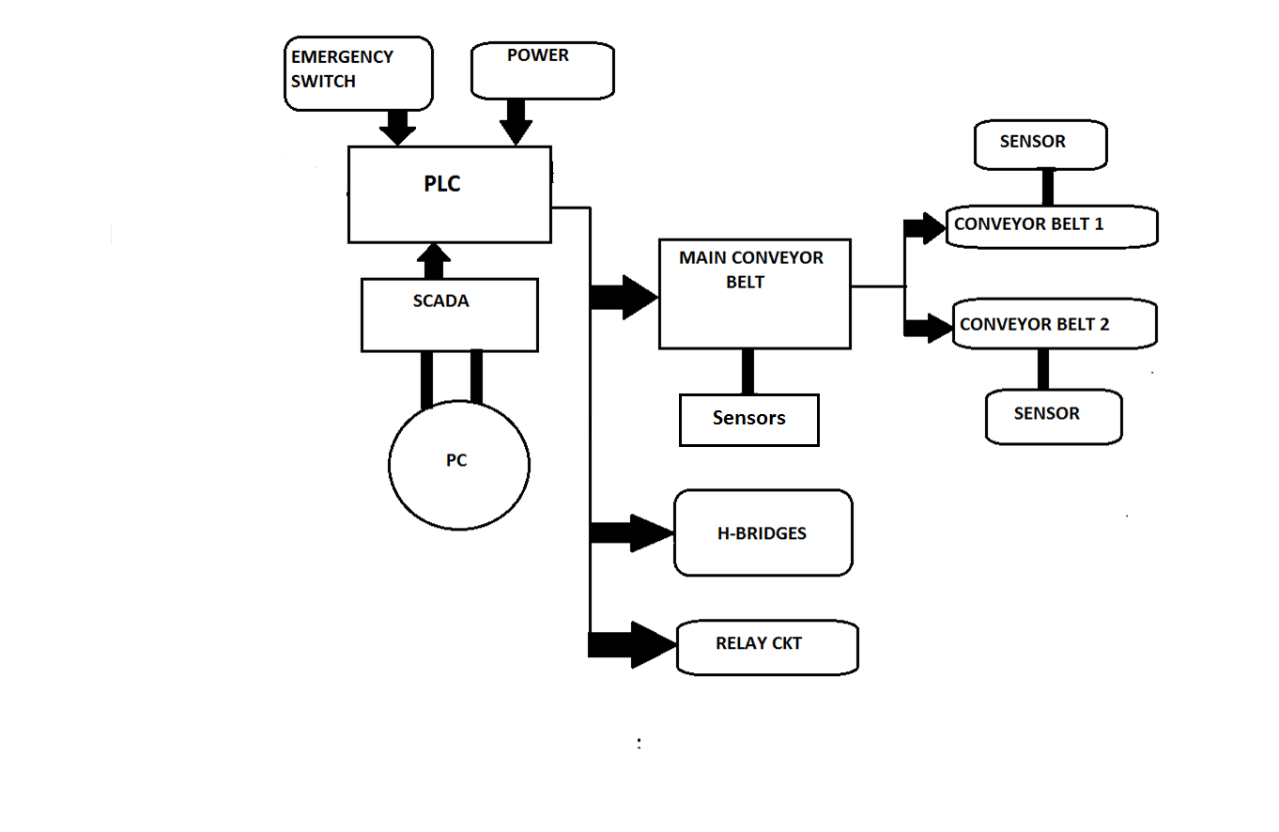**

* 1. **Components list**

5.1 PLC

5.2 INFRARED SENSORS

5.3 GEAR MOTOR

* 1. SCADA PORT
  2. Capacitors
  3. Resistors
  4. Dc socket
  5. LM7812
  6. PCB
  7. Relays
  8. Diode
  9. Supply
  10. Wires
  11. Led
  12. Computer supply
  13. Metal sensor
  14. Color Sensor
  15. **Project Outlines**

Chapter 2 provides theoretical background about all the components used in this Project in a very detailed way.

Chapter 3 explains the Project Methodology.

Chapter 4 explains the programming.

The conclusions can be found in Chapter 5.

References

**CHAPTER 2 Theoretical Backgrounds**

**2.1 CAPACITORS**

**2.1.1 Function**

Capacitors store electric charge. They are used with resistors in timing circuits because it takes time for a capacitor to fill with charge. They are used to smooth varying DC supplies by acting as a reservoir of charge. They are also used in filter circuits because capacitors easily pass AC (changing) signals but they block DC (constant) signals.

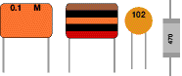    Circuit symbol:   capacitor symbol

Fig: 2.1 Fig: 2.2

Small value capacitors are unpolarised and may be connected either way round. They are not damaged by heat when soldering, except for one unusual type (polystyrene). They have high voltage ratings of at least 50V, usually 250V or so. It can be difficult to find the values of these small capacitors because there are many types of them and several different labeling systems!

**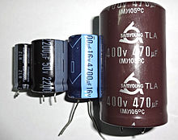**

Fig:2.3

**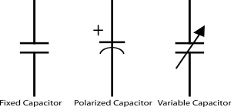**

Fig:2.4

**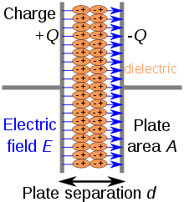** Fig:2.5

C= \frac{Q}{V}

**2.1.2 For capacitors in parallel**

Capacitors in a parallel configuration each have the same applied voltage. Their capacitances add up. Charge is apportioned among them by size. Using the schematic diagram to visualize parallel plates, it is apparent that each capacitor contributes to the total surface area.

**2.1.3 For capacitors in parallel**

Connected in series, the schematic diagram reveals that the separation distance, not the plate area, adds up. The capacitors each store instantaneous charge build-up equal to that of every other capacitor in the series. The total voltage difference from end to end is apportioned to each capacitor according to the inverse of its capacitance. The entire series acts as a capacitor *smaller* than any of its components.

\frac{1}{C_\mathrm{eq}} = \frac{1}{C_1} + \frac{1}{C_2} + \cdots + \frac{1}{C_n}

**2.2 RESISTORS**

**2.2.1 Function**

Resistors restrict the flow of electric current, for example a resistor is placed in series with a light-emitting diode (LED) to limit the current passing through the LED.

**2.2.2 Connecting and soldering**

Resistors may be connected either way round. They are not damaged by heat when soldering.

|  |  |
| --- | --- |
| **The Resistor Color Code** | |
| Color | Number |
| Black | 0 |
| Brown | 1 |
| Red | 2 |
| Orange | 3 |
| Yellow | 4 |
| Green | 5 |
| Blue | 6 |
| Violet | 7 |
| Grey | 8 |
| White | 9 |

**2.2.3 Resistor values - the resistor colour code**

Resistance is measured in ohms; the symbol for ohm is an omegaohm.   
1 ohmis quite small so resistor values are often given in kohm and Mohm.   
1 kohm = 1000 ohm    1 Mohm = 1000000ohm.

Resistor values are normally shown using colored bands.   
Each color represents a number as shown in the table.

Most resistors have 4 bands:

* The **first band** gives the **first digit**.
* The **second band** gives the **second digit**.
* The **third band** indicates the **number of zeros**.
* The fourth band is used to shows the tolerance (precision) of the resistor, this may be ignored for almost all circuits but further details are given below.

resistor Fig: 2.7

This resistor has red (2), violet (7), yellow (4 zeros) and gold bands.   
So its value is 270000 ohm= 270 kohm.   
On circuit diagrams the ohmis usually omitted and the value is written 270K.

Fig: 2.8

Small value resistors (less than 10 ohm)

The standard colour code cannot show values of less than 10ohm. To show these small values two special colors are used for the **third band**: **gold** which means × 0.1 and **silver** which means × 0.01. The first and second bands represent the digits as normal.

For example:  
**red**, **violet**, **gold** bands represent 27 × 0.1 = 2.7 ohm  
**green**, **blue**, **silver** bands represent 56 × 0.01 = 0.56 ohm

**2.2.4 Tolerance of resistors (fourth band of colour code)**

The tolerance of a resistor is shown by the **fourth band** of the colour code. Tolerance is the **precision** of the resistor and it is given as a percentage. For example a 390ohm resistor with a tolerance of ±10% will have a value within 10% of 390ohm, between 390 - 39 = 351ohm and 390 + 39 = 429ohm (39 is 10% of 390).

A special colour code is used for the **fourth band** tolerance:  
**silver** ±10%,   **gold** ±5%,   **red** ±2%,   **brown** ±1%.   
If no fourth band is shown the tolerance is ±20%.

Tolerance may be ignored for almost all circuits because precise resistor values are rarely required.

**2.2.5 Power Ratings of Resistors**

Electrical energy is converted to heat when current flows through a resistor. Usually the effect is negligible, but if the resistance is low (or the voltage across the resistor high) a large current may pass making the resistor become noticeably warm. The resistor must be able to withstand the heating effect and resistors have power ratings to show this.

Power ratings of resistors are rarely quoted in parts lists because for most circuits the standard power ratings of 0.25W or 0.5W are suitable. For the rare cases where a higher power is required it should be clearly specified in the parts list, these will be circuits using **low value resistors** (less than about 300ohm) or **high voltages** (more than 15V).

The power, P, developed in a resistor is given by:

|  |  |  |
| --- | --- | --- |
| **P = I² × R** or  **P = V² / R** | where: | P = power developed in the resistor in watts (W)  I  = current through the resistor in amps (A)  R = resistance of the resistor in ohms (ohm)  V = voltage across the resistor in volts (V) |

**2.3 RELAY:**

|  |
| --- |
| relay symbol |
| Circuit symbol for a relay |
| Relay, photograph © Rapid Electronics |
| Relay, photograph © Rapid ElectronicsFig:2.9 |
| Relays |
|  |

A relay is an **electrically operated switch**. Current flowing through the coil of the relay creates a magnetic field which attracts a lever and changes the switch contacts. The coil current can be on or off so relays have two switch positions and they are **double throw** (**changeover**) switches.

Relays allow one circuit to switch a second circuit which can be completely separate from the first. For example a low voltage battery circuit can use a relay to switch a 230V AC mains circuit. There is no electrical connection inside the relay between the two circuits; the link is magnetic and mechanical.

The coil of a relay passes a relatively large current, typically 30mA for a 12V relay, but it can be as much as 100mA for relays designed to operate from lower voltages. Most ICs (chips) cannot provide this current and a transistor is usually used to amplify the small IC current to the larger value required for the relay coil. The maximum output current for the popular 555 timer IC is 200mA so these devices can supply relay coils directly without amplification.

**2.3.1 Advantages of relays:**

* Relays can switch **AC and DC**, transistors can only switch DC.
* Relays can switch **high voltages**, transistors cannot.
* Relays are a better choice for switching **large currents** (> 5A).
* Relays can switch **many contacts** at once.

**2.3.2 Disadvantages of relays:**

* For Relays are **bulkier** than transistors for switching small currents.
* Relays **cannot switch rapidly** (except reed relays), transistors can switch many times per second.
* Relays **use more power** due to the current flowing through their coil.
* Relays **require more current than many ICs can provide**, so a low power transistor may be needed to switch the current the relay's coil.

**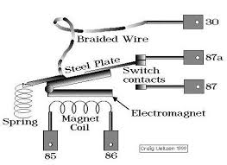** Fig:2.10

**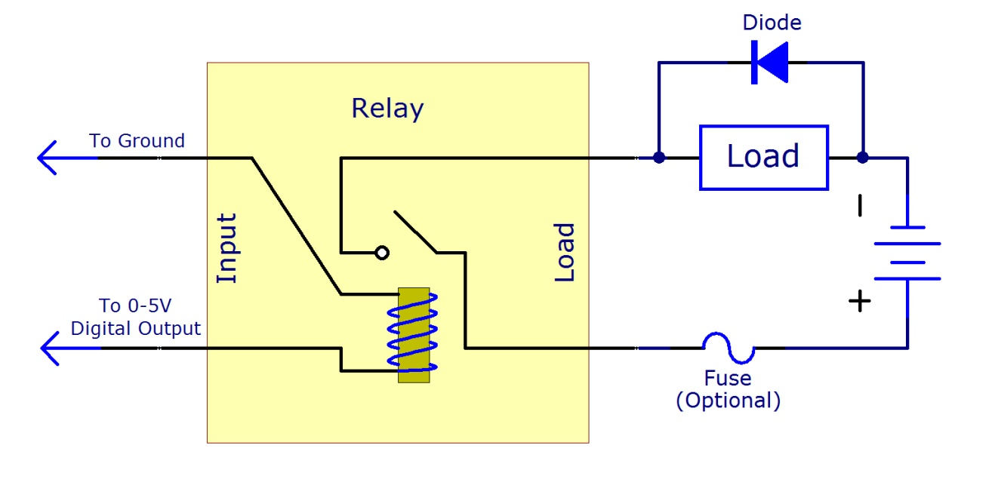**

Fig:2.11

**2.4 Diode:**

* The most basic property of a junction diode is that it conducts an electric current in one direction and blocks it in the other. This behavior arises from the electrical characteristics of a junction, called a *p-n junction.* Fabricated within a semiconductor crystal. The most commonly used semiconductor material is silicon. The junction diode is useful in a wide variety of applications including the rectification of ac signals (producing dc from ac), the detection of radio signals, the conversion of solar power to electricity, and in the generation and detection of light. It also finds use in a variety of electronic circuits as a switch, as a voltage reference or even as a tunable capacitor. The p-n junction is also the basic building block of a host of other electronic devices, of which the most well-known is the junction transistor.
* In our project we have used a diode as a rectifier basically it is a full wave rectifier used to convert ac in to dc in the power supply portion of the project.
* 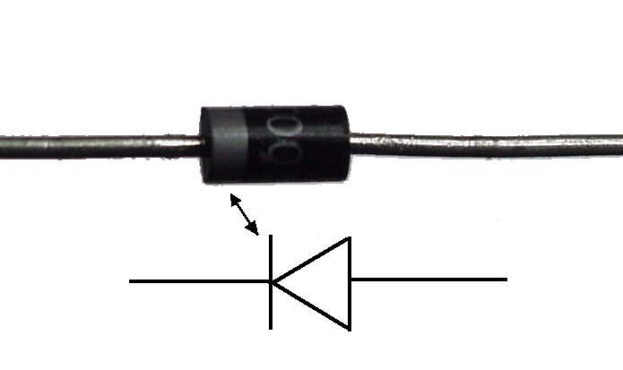

Fig:2.12

2.5 DB-9 Connector:

This connector is occasionally found on smaller RS-232 lab equipment. It is compact yet has enough pins for the "core" set of serial pins (with one pin extra).

Important: The DB-9 pin numbers for transmit and receive (3 and 2) are opposite of those of the DB-25 connector (2 and 3).

The images show the male and female versions of the DB-9 connector with pin numbers.

Some of the early Macs also used the DB-9 connector as a serial port.

In this project we used db-9 connectors to provide interface between terminal and control board. More over the interface between control board and server computer is also through db-9 connectors and 8-wire cables

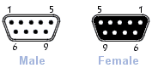

Fig: 2.13

**2.6 Light-emitting diode**

[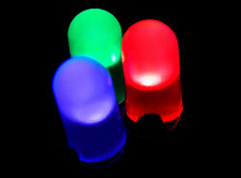](http://en.wikipedia.org/wiki/File:RBG-LED.jpg)

Fig:2.14

Basically, LEDs are just tiny light bulbs that fit easily into an electrical circuit. But unlike ordinary incandescent bulbs ,they don't have a filament that will burn out, and they don't get especially hot. They are illuminated solely by the movement of electrons in a semiconductor material, and they last just as long as a standard transistor.

A light-emitting-diode (LED) is a semiconductor diode that emits light when an electric current is applied in the forward direction of the device, as in the simple LED circuit

[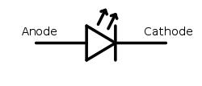](http://en.wikipedia.org/wiki/File:LED_symbol.svg) LED schematic symbol

Fig: 2.15

The effect is a form of electroluminescence where incoherent and narrow-spectrum light is emitted from the p-n junction in a solid state material.

2.7 Bridge Rectifier

Bridge rectifier is an electronic component which converts an input AC current into a DC current as an output. Electronic devices and particularly portable electronic devices typically make the use of alternating current to direct current adapters either as a direct source of power to charge on-board batteries. Fig: 2.16

A bridge rectifier makes use of four diodes in a bridge arrangement to achieve full-wave rectification. It is called a full-wave rectifier because it uses the entire AC wave (both positive and negative sections). 1.4V is used up in the bridge rectifier because each diode uses 0.7V when conducting and there are always two diodes conducting, as shown in the diagram below. Bridge rectifiers are rated by the maximum current they can pass and the maximum reverse voltage they can withstand (this must be at least three times the supply RMS voltage so the rectifier can withstand the peak voltages). This is a widely used configuration, both with individual diodes wired as shown and with single component bridges where the diode bridge is wired internally.

The input to the circuit is applied to the diagonally opposite corners of the network, and the output is taken from the remaining two corners. 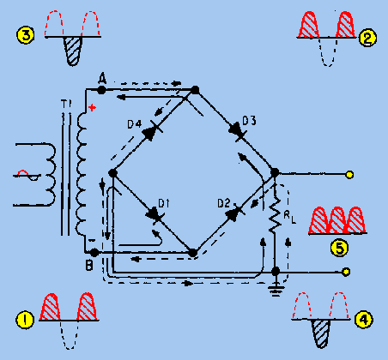Let us assume the transformer is working properly and there is a positive potential at point A and a negative potential at point B.

Figure: Bridge Rectifier. The positive potential at point A will forward bias D3 and reverse bias D4. The negative potential at point B will forward bias D1 and reverse bias D2. At this time D3 and D1 are forward biased and will allow current flow to pass through them; D4 and D2 are reverse biased and will block current flow. The path for current flow is from point B through D1, up through RL, through D3, through the secondary of the transformer back to point B. This path is indicated by the solid arrows. Waveforms (1) and (2) can be observed across D1 and D3.

One-half cycle later the polarity across the secondary of the transformer reverses, forward biasing D2 and D4 and reverse biasing D1 and D3. Current flow will now be from point A through D4, up through RL, through D2, through the secondary of T1, and back to point A. This path is indicated by the broken arrows. Waveforms (3) and (4) can be observed across D2 and D4. You should have noted that the current flow through RL is always in the same direction. In flowing through RL this current develops a voltage corresponding to that shown in waveform (5). Since current flows through the load (RL) during both half cycles of the applied voltage, this bridge rectifier is a full-wave rectifier.

One advantage of a bridge rectifier over a conventional full-wave rectifier is that with a given transformer the bridge rectifier produces a voltage output that is nearly twice that of the conventional full-wave circuit.

**2.7.1 Current Flow in the Bridge Rectifier**

For both positive and negative swings of the transformer, there is a forward path through the diode bridge. Both conduction paths cause current to flow in the same direction through the load resistor, accomplishing full-wave rectification. While one set of diodes is forward biased, the other set is reverse biased and effectively eliminated from the circuit.

**2.7.2 Applications**

The primary application of rectifiers is to derive DC power from an AC supply. Virtually all electronics require a DC supply but mains power is AC so rectifiers find uses inside the power supplies of virtually all electronic equipment.

**2.8 Transformer**

A transformer is a device that transfers electrical energy from one circuit to another through inductively coupled electrical conductors. A changing current in the first circuit (the primary) creates a changing magnetic field. This changing magnetic field induces a changing voltage in the second circuit (the secondary). This effect is called mutual induction.

Transformers are passive electrical devices that transform alternating or intermittent electric energy in one circuit into energy of a similar type in another circuit, commonly with altered values of voltage and current. It typically contains two or more electrical circuits comprising primary and secondary windings, each made of a multi-turn coil of electrical conductors with one or more magnetic cores coupling the coils by transferring a magnetic flux there between. Increasingly, modern day appliances are constructed using low voltage transformers for many purposes including as lighting transformers or to supply power to electronic components.

**2.8.1 How does a transformer work?**

A transformer is based on a very simple fact about electricity: when a fluctuating electric current flows through a wire, it generates a magnetic field (an invisible pattern of magnetism) or "magnetic flux" all around it. The strength of the magnetism (which has the rather technical name of magnetic flux density) is directly related to the size of the electric current. So the bigger the current, the stronger the magnetic field. Now there's another interesting fact about electricity too. When a magnetic field fluctuates around a piece of wire, it generates an electric current in the wire. So if we put a second coil of wire next to the first one, and send a fluctuating electric current into the first coil, we will create an electric current in the second wire. This is called electromagnetic induction because the current in the first coil causes (or "induces") a current in the second coil. The current in the first coil is usually called the primary current and the current in the second wire is (surprise, surprise) the secondary current. What we've done here is pass an electric current through empty space from one coil of wire to another. This phenomenon is called electromagnetic induction. We can make electrical energy pass more efficiently from one coil to the other by wrapping them around a soft iron bar (sometimes called a core):

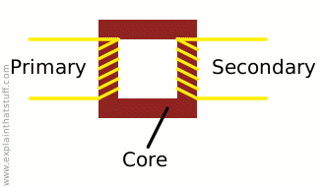Fig: 2.17

To make a coil of wire, we simply curl the wire round into loops or ("turns" as physicists like to call them). If the second coil has the same number of turns as the first coil, the electric current in the second coil will be virtually the same size as the one in the first coil. But (and here's the clever part) if we have more or fewer turns in the second coil, we can make the secondary current and voltage bigger or smaller than the primary current and voltage.

One important thing to note is that this trick works only if the electric current is fluctuating in some way. In other words, you have to use a type of constantly reversing electricity called alternating current (AC) with a transformer. Transformers do not work with direct current (DC), where the current constantly flows in the same direction.

**2.8.2 Step-down transformers**

If the first coil has more turns that the second coil, the secondary voltage is smaller than the primary voltage:

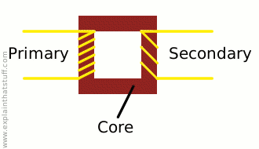

This is called a step-down transformer. If the second coil has half as many turns as the first coil, the secondary voltage will be half the size of the primary voltage; if the second coil has one tenth as many turns; it has one tenth the voltage. In general:

Secondary voltage ÷ Primary voltage = Number of turns in secondary ÷ Number of turns in primary

The current is transformed the opposite way—increased in size—in a step-down transformer:

Secondary current ÷ Primary current = Number of turns in primary ÷ Number of turns in secondary

So a step-down transformer with 100 coils in the primary and 10 coils in the secondary will reduce the voltage by a factor of 10 but multiply the current by a factor of 10 at the same time. The power in an electric current is equal to the current times the voltage (watts = volts x amps is one way to remember this), so you can see the power in the secondary coil is theoretically the same as the power in the primary coil. (In reality, there is some loss of power between the primary and the secondary because some of the "magnetic flux" leaks out of the core; some energy is lost because the core heats up, and so on.)

**Ideal power equation**

Pincoming = IPVP = Poutgoing = ISVS

**Ideal transformer equation**


\frac{V_{S}}{V_{P}} = \frac{N_{S}}{N_{P}} = \frac{I_{P}}{I_{S}}


**2.9 PLC and SCADA**

**2.9.1 PLC configuration**

1. Many PLC configurations are available, even from a single vendor. But each of these has common components and concepts. The most essential component is are:
2. Power supply –

This can be built into the PLC or be an external unit. Common voltage levels required by the PLC are 24Vdc 100Vac 240Vac.

1. CPU (central Processing Unit) –

This is a computer where ladder logic is stored and processed.

iv. I/O (Input/output) –

A number of input/output terminals must be provided so that the PLC can monitor the process and initiate actions. Inputs to, and outputs from, a PLC is necessary to monitor and control a process. Both inputs and outputs can be categorized into two basic types: logical or continuous. Consider the example of a light bulb. If it can only be turned on or off, it is logical control. If the light can be dimmed to different levels, it is continuous.

Indicator lights –

These indicate the status of the PLC including

power on

program running

and

An error.

These are essential when diagnosing problems.

vi. Rack Type :

A rack can often be as large as 18” by 30” by 10”

Mini:

These are similar in function to PLC racks, but about the half size.

Dedicated Backplanes can be used to support the cards OR DIN rail

mountable with incorporated I/O bus in module.

viii. Shoebox:

A compact, all-in-one unit that has limited expansion capabilities.

Lower cost and compactness make these ideal for small applications. DIN

rail mountable.

ix. Micro:

These units can be as small as a deck of cards. They tend to have

fixed quantities of I/O and limited abilities, but costs will be lowest. DIN rail

mountable

**2.9.2 Basic PLC schema**

The basic PLC schema include CPU, power supply, memory, Input block, output block, communication and expansion connections. Figure 2.1 shows the PLC system overview.

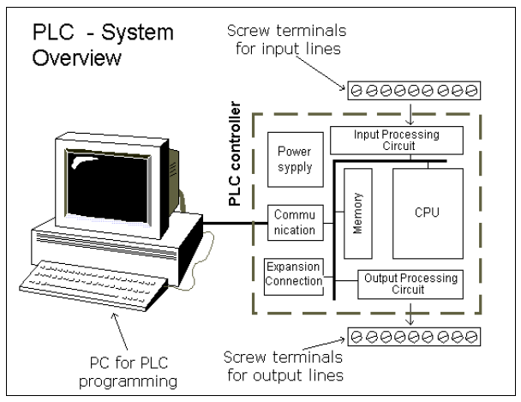

Figure 2.18 PLC system overview

CPU modules –

The Central Processing Unit (CPU) Module is the brain of

the PLC.Primary role to read inputs, execute the control program, update outputs.

The CPU consists of the arithmetic logic unit (ALU), timing/control circuitry,

accumulator, scratch pad memory, program counter, address stack and instruction

register. A PLC works by continually scanning a program.

Memory –

The memory includes pre-programmed ROM memory containing

the PLC’s operating system, driver programs and application programs and the

RAM memory. PLC manufacturer offer various types of retentive memory to save

user programs and data while power is removed, so that the PLC can resume

12

execution of the user-written control program as soon as power is restored. Some

types of memory used in a PLC include:

ROM (Read-Only Memory)

RAM (Random Access Memory)

PROM (Programmable Read-Only Memory)

iv. EPROM (Erasable Programmable Read-Only Memory)

v EEPROM (Electronically Erasable Programmable Read-Only Memory)

vi. FLASH Memory

Compact Flash – Can store complete program information, read & write text files

viii. I/O Modules - Input and output (I/O) modules connect the PLC to sensors and actuators. Provide isolation for the low-voltage, low-current signals that the PLC uses internally from the higher-power electrical circuits required by most sensors and actuators. Wide range of I/O modules available including: digital (logical) I/O modules and analogue (continuous) I/O modules.

* + 1. PLC Hardware

A programmable logic controller (PLC) is an industrial computer used to control and automate complex systems. Programmable logic controllers are a relatively recent development in process control technology. It is designed for use in an industrial environment, which uses a programmable memory for the integral storage of user-oriented instructions for implementing specific functions such as logic, sequencing, timing, counting, and arithmetic to control through digital or analog inputs and outputs, various types of machines or processes. Programmable logic controllers are used throughout industry to control and monitor a wide range of machines and other movable components and systems. PLC is used to monitor input signals from a variety of input points (input sensors) which report events and conditions occurring in a controlled process. Programmable logic controllers are typically found in factory type settings. PLCs are used to control robots, assembly lines and various other applications that require a large amount of data monitoring and control.

A typical programmable logic controller employs a backplane to serve as the communications bus for interconnecting the PLC processor with the array of individual input/output devices with which the processor interacts in terms of receiving input data for use in executing the control program and transmitting control data for use in controlling the targeted objects. A PLC includes a rack into which a plurality of input/output cards may be placed. A rack includes several slots into which these input/output cards are installed. Each input/output card has a plurality of I/O points. The I/O modules are typically pluggable into respective slots located on a backplane board in the PLC. An I/O bus couples the cards in the slots back to the processor of the programmable logic controller. The slots are coupled together by a main bus which couples any I/O modules plugged into the slots to a central processing unit (CPU). The CPU itself can be located on a card which is pluggable into a dedicated slot on the backplane of the PLC. The particular processor employed in a PLC together with the particular choice of input and output cards installed in the PLC rack are often referred to as the hardware configuration of the programmable logic controller. The hardware configuration also includes the particular addresses which the I/O cards. Each option module typically has a plurality of input/output points. The option modules are coupled through an interface bus, for example via a backplane, to a main controller having a microprocessor executing a user program.

Option modules may also include a microprocessor and a memory containing separate user programs and data directed to a particular operation of the PLC system. During the execution of a stored control program, the PLC's read inputs from the controlled process and, per the logic of the control program, provide outputs to the controlled process. The outputs typically provide analog or binary voltages or "contacts" implemented by solid state switching devices. PLC's are normally constructed in modular fashion to allow them to be easily reconfigured to meet the demands of the particular process being controlled. The processor and I/O circuitry are normally constructed as separate modules that may be inserted in a chassis and connected together through a common backplane using permanent or releasable electrical connectors.

**2.9.3.1 Introduction of FATEK FBS Series PLC**

The FATEK FBS Series PLC is a new generation of micro PLC equipped with excellent functions comparable to medium or large PLC, with up to five communication ports. The maximum I/O numbers are 256 points for Digital Input (DI) and Digital Output (DO), 64 words for Numeric Input (NI) and Numeric Output (NO). The Main Units of FBS are available in three types: MA (Economy Type), MC (High-Performance Type), and MN (High-Speed NC Type). With the combination of I/O point ranges from 10 to 60, a total of 17 models are available. Fourteen DI/DO and 12 NI/NO models are available for Expansion Units/Modules. With interface options in RS232, RS485, USB and Ethernet, the communication peripherals are available with 14 boards and modules. The various models are described in the following:

**2.9.3.2 Appearance of Main Unit**

All the Main Units of FBS-PLC have the same physical structure. The only difference is the case width. There are four different

case sizes, which are 60mm, 90mm, 130mm, and 175mm. The figure below will use the Main Unit case of the FBS-24MC as

an example for illustration:

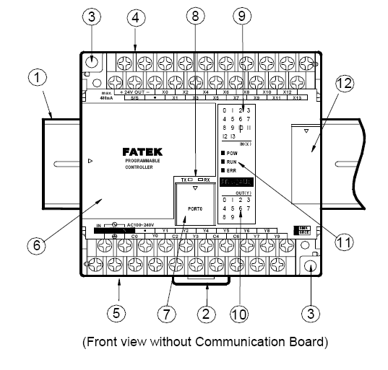

Fig: 2.19

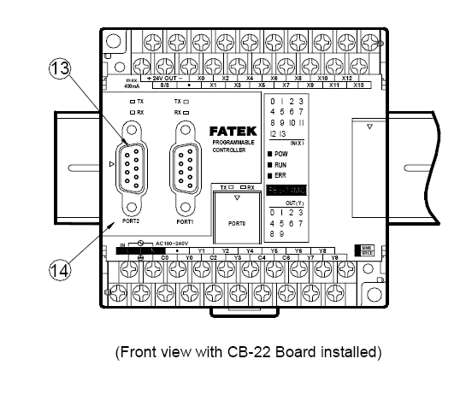

Fig: 2.20

1 35mm-width DIN RAIL

2 DIN RAIL tab

3 Hole for screw fixation (ψ4.5×2

)

4 Terminals of 24VDC power input and digital input

(Pitch 7.62mm)

5 Terminals of main power input and digital output

(Pitch 7.62mm)

6 Standard cover plate (without communication

board)

7 Cover plate of built-in communication port (Port 0)

8 Indicators for transmit (TX) and receive (RX) status of built-in communication port (Port0).

9 Indicator for Digital Input (Xn).

10 Indicator for Digital Output (Yn).

11 Indicator for system status (POW, RUN, ERR).

12 I/O output expansion header cover [units of 20 points or beyond only], with esthetic purpose and capable of securing

expansion cable.

13 FBS-CB22 Communication Board (CB).

14 FBS-CB22 CB cover plate (each CB has its own specific cover plate)

15 Screw holes of communication board.

16 Connector for communication board (for CB2, CB22, CB5, CB55, and CB25)

17 Connector for Communication Module (CM) (only available in MC/MN model, for CM22, CM25, CM55, CM25E, and

CM55E connection).

18 Connector for Memory Pack.

19 Connector for built-in communication port (Port 0) (With USB and RS232 optional, shown in the figure is for RS232)

20 I/O output expansion header (only available in units with 20 points or beyond), for connecting with cables from

expansion units/modules

**2.9.3.3 Specifications of Main Unit**

Execution Speed 0.33uS/per Sequence Command

Space of Control Program 20K Words

Program Memory FLASH ROM or SRAM + Lithium battery for Back-up

Sequence Command 36

Application Command 300 (113 types)

Flow Chart (SFC) Command 4

X Output Contact(DI) X0~X255 (256)

Y Output Relay(DO) Y0~Y255 (256)

TR Temporary Relay TR0~TR39 (40)

Internal relays

Non-retentive

M0~M799 (800)\*

can be configured as retentive type

M1400～M1911 (512)

Retentive

M800～M1399 (600)\*

Special Relays

M1912～M2001 (90)

Timer ”Time Up” Status Contact T0~T255 (256)

Counter ”Count Up” Status Contact C0~C255 (256)

0.01S Time base T0~T49 (50)\*

0.1S Time base T50~T199 (150)\*

1STime base T200~T255 (56)\*

Retentive C0~C139 (140)\*

Non-retentive C140~C199 (60)\*

Retentive C200~C239 (40)\*

Non-retentive C240~C255 (16)\*

DATA REGISTERS

Retentive R0~R2999 (3000)\*

Retentive D0~D3999 (4000)

Non-retentive R3000~R3839 (840)\*

**2.9.4 PLC Operation**

CHECK INPUT STATUS-First the PLC takes a look at each input to

determine whether it is on or off condition.

EXECUTE PROGRAM-Next the PLC executes a program by one

instruction at a time. If the first input is on then it should turn on the first output.

Since it already knows then it will be able to decide whether the first output should

be turned on based on the state of the first input. It will store the execution results

for use later during the next step.

UPDATE OUTPUT STATUS-Finally the PLC updates the status of the

outputs. It updates the outputs based on which inputs are on during the first step and

the results of executing your program during the second step. Based on the example

in step 2 it would now turn “ON” the first output because the first input is “ON” and

your program said to turn “ON” the first output when this condition is true.

**2.9.5 SCADA**

**2.9.5.1 Introduction**

Widely used in industry for Supervisory Control and Data Acquisition of industrial

processes, SCADA systems are now also penetrating the experimental physics laboratories for the controls of ancillary systems such as cooling, ventilation, power distribution, etc.

SCADA systems have made substantial progress over the recent years in terms of

functionality, scalability, performance and openness such that they are an alternative to in house development even for very demanding and complex control systems as those of physics experiments.

**2.9.5.2 What does SCADA MEAN?**

SCADA stands for Supervisory Control And Data Acquisition. As the name indicates, it

is not a full control system, but rather focuses on the supervisory level. As such, it is a

purely software package that is positioned on top of hardware to which it is interfaced, in

general via Programmable Logic Controllers (PLCs), or other commercial hardware

modules.

SCADA systems are used not only in industrial processes: e.g. steel making, power

generation (conventional and nuclear) and distribution, chemistry, but also in some

experimental facilities such as nuclear fusion. The size of such plants range from a few

1000 to several 10 thousands input/output (I/O) channels. However, SCADA systems

evolve rapidly and are now penetrating the market of plants with a number of I/O

channels of several 100 K: we know of two cases of near to 1 M I/O channels currently

under development.

SCADA systems used to run on DOS, VMS and UNIX; in recent years all SCADA

vendors have moved to NT and some also to Linux.

**2.9.5.3 SCADA SOFTWARE LOOK**

**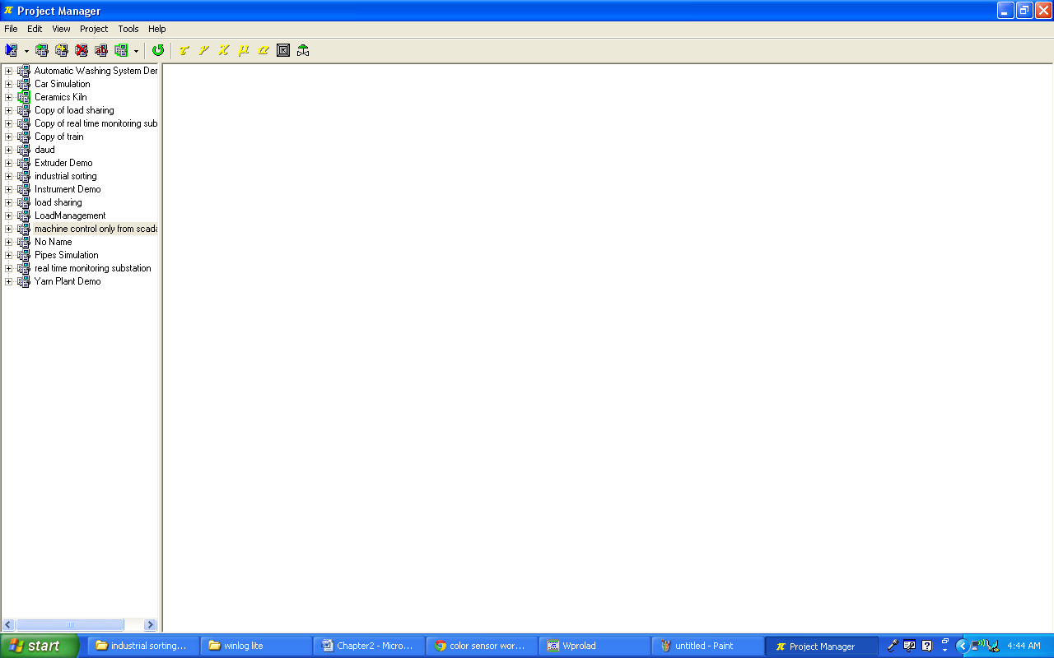**

**Fig: 2.21**

**Configuraton:**

**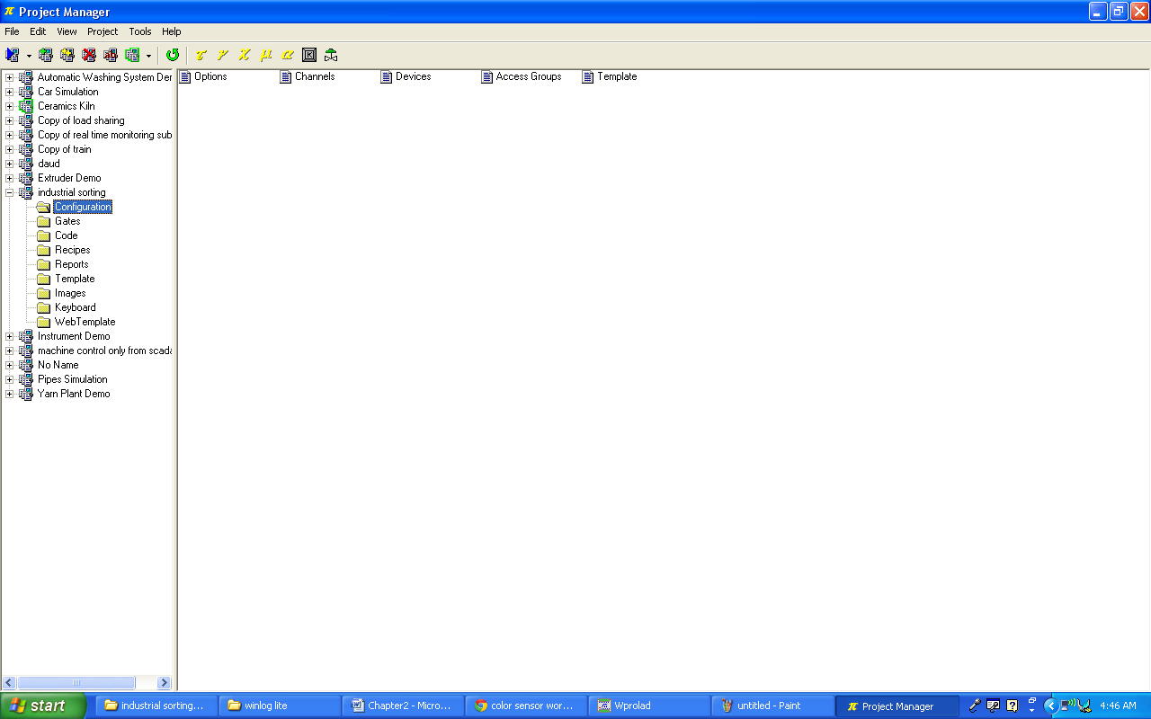**

**Fig: 2.22**

**Gates:**

**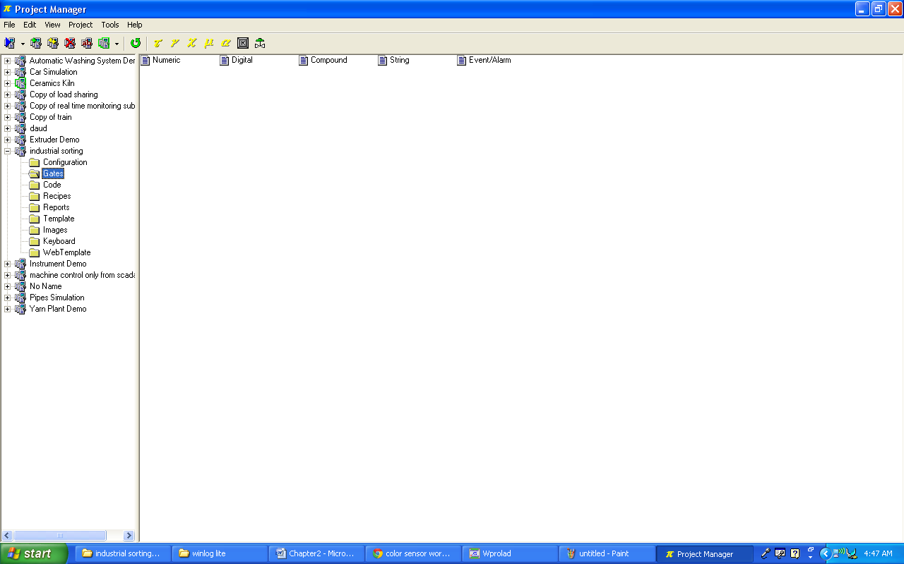**

**Fig: 2.23**

**Project Template:**

**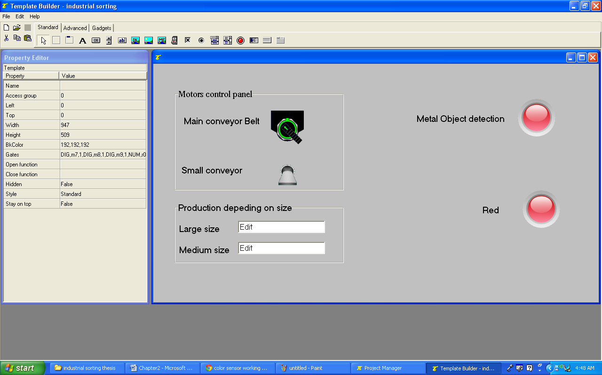**

**Fig: 2.24**

* 1. **7812 Voltage Regulator**

7812 is a famous IC which is being widely used in 12V voltage regulator circuits. Truly speaking it is a complete standalone voltage regulator. We only need to use two capacitors, one on the input and second one on the output of 7812 in order to achieve clean voltage output and even these capacitors are optional to use. To achieve 12V 1A current, 7812 should be mounted on a good heatsink plate. Thanks to the transistor like shape of 7812 which makes it easy to mount on a heatsink plate. 7812 has built in over heat and short circuit protection which makes it a good choice for making power supplies.

[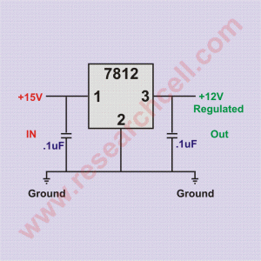](http://www.researchcell.com/electronics/7812-pin-and-circuit-diagram/attachment/7812-circuit-diagram/)

**7812 circuit diagram Fig: 2.25**

In electronics markets, 7812 is sold under various names such as 7812a, 7812act, 7812t and lm7812. All of them are almost identical with a little to no differences at all. 7812 input voltage range is 14V to 35V. Exceeding the voltage range may damage the IC. Given bellow is 7812 pin diagram to make the pinout connections clear in case you want to do some experiments.

[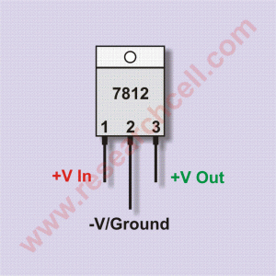](http://www.researchcell.com/electronics/7812-pin-and-circuit-diagram/attachment/7812-pin-diagram/)

**7812 pin diagram Fig: 2.26**

If you hold upside down (pins up) and the IC number is facing you then the left pin will be the voltage regulator output, the center pin will be ground and the right pin will be the voltage input pin. Under my experience, the maximum safe current you can get from one 7812 IC is 1A. If you need more power then there are a few ways to do so.  
More than one 7812 can be used in parallel in order to achieve more than 1A current but output voltage of each 7812 can slightly vary resulting in unbalanced load on all of them. This can result in load balancing issues and can damage the IC carrying most current. However there is a way to overcome this problem. I have given bellow a schematic diagram in which two 7812 ICs are attached together and both of them are carrying almost equal load. At least the current difference is not too much to damage any IC.

[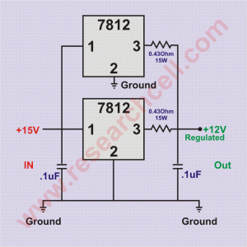](http://www.researchcell.com/electronics/7812-pin-and-circuit-diagram/attachment/7812-in-parallel-circuit-diagram/)

**7812 in parallel circuit diagram Fig: 2.27**

Please note that in this circuit diagram, I have used resistors for load balancing purpose so the output of this voltage regulator circuit may slightly inaccurate. Both resistors should be minimum 15 Watt or above. If you don’t find such resistors in your area then you can make them using 32 gauge or thinner copper wire. This parallel 7812 circuit will provide 12V and approximately 2A current. You can increase number of 7812 but each additional 7812 will require a resistor on its output.  
Following is the link to a simple but complete power supply circuit diagram developed using 7812.

**2.11 Metal detector**

A **metal detector** is an [electronic instrument](http://en.wikipedia.org/wiki/Electronic_instrument) which detects the presence of metal nearby. Metal detectors are useful for finding metal inclusions hidden within objects, or metal objects buried underground. They often consist of a handheld unit with a sensor probe which can be swept over the ground or other objects. If the sensor comes near a piece of metal this is indicated by a changing tone in earphones, or a needle moving on an indicator. Usually the device gives some indication of distance; the closer the metal is, the higher the tone in the earphone or the higher the needle goes. Another common type are stationary "walk through" metal detectors used for [security screening](http://en.wikipedia.org/wiki/Security_Screening) at access points in prisons, courthouses, and airports to detect concealed metal weapons on a person's body.

The simplest form of a metal detector consists of an [oscillator](http://en.wikipedia.org/wiki/Electronic_oscillator) producing an alternating current that passes through a coil producing an alternating [magnetic field](http://en.wikipedia.org/wiki/Magnetic_field). If a piece of electrically conductive metal is close to the coil, [eddy currents](http://en.wikipedia.org/wiki/Eddy_currents) will be induced in the metal, and this produces a magnetic field of its own. If another coil is used to measure the magnetic field (acting as a [magnetometer](http://en.wikipedia.org/wiki/Magnetometer)), the change in the magnetic field due to the metallic object can be detected.

The first industrial metal detectors were developed in the 1960s and were used extensively for mineral prospecting and other industrial applications. Uses include [de-mining](http://en.wikipedia.org/wiki/De-mining) (the detection of [land mines](http://en.wikipedia.org/wiki/Land_mine)), the detection of weapons such as knives and guns (especially in [airport security](http://en.wikipedia.org/wiki/Airport_security)), [geophysical prospecting](http://en.wikipedia.org/wiki/Geophysics), [archaeology](http://en.wikipedia.org/wiki/Archaeology) and [treasure hunting](http://en.wikipedia.org/wiki/Treasure_hunting). Metal detectors are also used to detect foreign bodies in food, and in the [construction industry](http://en.wikipedia.org/wiki/Construction_industry) to detect [steel reinforcing bars](http://en.wikipedia.org/wiki/Rebar) in concrete and pipes and wires buried in walls and floors.

2. 11.1 Industrial metal detectors

Industrial metal detectors are used in the pharmaceutical, food, beverage, textile, garment, plastics, chemicals, lumber, and packaging industries.

Contamination of food by metal shards from broken processing machinery during the manufacturing process is a major safety issue in the food industry. Metal detectors for this purpose are widely used and integrated into the production line.

Current practice at garment or apparel industry plants is to apply metal detecting after the garments are completely sewn and before garments are packed to check whether there is any metal contamination (needle, broken needle, etc.) in the garments. This needs to be done for safety reasons.

The industrial metal detector was developed by Bruce Kerr and David Hiscock in 1947. The founding company Goring Kerr[[12]](http://en.wikipedia.org/wiki/Metal_detector#cite_note-12) pioneered the use and development of the first industrial metal detector. [Mars Incorporated](http://en.wikipedia.org/wiki/Mars_Incorporated) was one of the first customers of Goring Kerr using their Metlokate metal detector to inspect [Mars bar](http://en.wikipedia.org/wiki/Mars_bar).

The basic principle of operation for the common industrial metal detector is based on a 3 coil design. This design utilizes an AM ([amplitude modulated](http://en.wikipedia.org/wiki/Amplitude_modulated)) transmitting coil and two receiving coils one on either side of the [transmitter](http://en.wikipedia.org/wiki/Transmitter). The design and physical configuration of the receiving coils are instrumental in the ability to detect very small metal contaminates of 1mm or smaller. Today modern metal detectors continue to utilize this configuration for the detection of tramp metal.

The coil configuration is such that it creates an opening whereby the product (food, plastics, pharmaceuticals, etc.) passes through the coils. This opening or aperture allows the product to enter and exit through the three coil system producing an equal but mirrored signal on the two receiving coils. The resulting signals are summed together effectively nullifying each other.

When a metal contaminant is introduced into the product an unequal disturbance is created. This then creates a very small electronic signal that is amplified through special electronics. The amplification produced then signals a mechanical device mounted to the [conveyor](http://en.wikipedia.org/wiki/Conveyor) system to remove the contaminated product from the production line. This process is completely automated and allows manufacturing to operate uninterrupted.

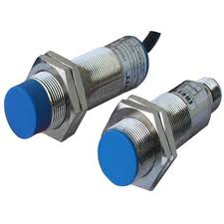Fig: 2.28

**2.12 Color Sensor**

Although the human eye is very strong ability to distinguish colors, but different people describe the same color will be different, which means that demand accurate color detection and management of applications, the verbal description is not enough. Despite the better the ability of the human eye distinguish colors is very strong, but different people will describe the same color are different, which means that demand accurate color detection and management of applications, the verbal description is not enough. A better solution is to use fully calibrated color sensing equipment to digitally describe the color. These devices include expensive laboratory grade spectrophotometer to the economy, RGB color sensors (such as the production of Avago color sensor). Avago has a variety of color sensors, many of the actual color of the current sensing and measurement applications provide a practical solution. The objective of this paper is to examine color perception, measurement and specification, and how to apply color sensor-generated data. Finally, the article discusses the Avago's RGB color sensor products and how for a variety of color sensing applications. The perception of color into the electronic devices in the theory of how the color sensor, it is necessary to understand how humans perceive color. Color is light, the interaction between object and observer results. In reflected light, the light falling on an object will be reflected or absorbed, depending on the surface characteristics, such as the reflection coefficient and transmission conditions. For example, the red paper will absorb most of the spectrum with the green part and the part with the blue, while reflecting part of the spectrum with the red, so the viewer will show in red. Luminous objects in their own, its the same principle: light will reach the human eye, and then processed by the receiver eye, from the nervous system and brain for interpretation. Human visual system can detect from about 400nm (violet) to about 700nm (red) of the electromagnetic spectrum, can adapt to a wide range of illumination changes and a lot of color saturation (pure white color in proportion.) Although the rod-shaped cells are able to work on a wide range of illumination, and provide rapid response to changes in light sensor element, but these rods can not detect color. Called cone cells, light sensors to provide high-resolution color image components. There are three cone cells, at different wavelengths to achieve peak sensitivity, the respective red (580nm), green (540nm) and blue (450nm). Visible spectrum of light at any wavelength will be in varying degrees, all three types of cone cells in the stimulation of one or more units, we feel that the color is our nerve and brain processes visual information. Obviously, people with normal color vision see the wavelengths in the same light, basically feel the same color. Scientific tests showed that humans can distinguish very subtle color differences, it is estimated the maximum could reach 1,000 million, the problem is that we do not have enough words to describe all of these have a slightly different color. Color measurement principle Figure 1.1 shows the use of color measurement instruments or sensors than the human eye detect the basic principles of color. The sensor device is high-end equipment, such as spectrophotometer or the British International Commission on Illumination (CIE) calibration of the camera, it can be low-end devices, such as RGB color sensors. Figure 1a measuring instruments are usually divided into two categories: color analysis and metering method. Analysis of the use of color, the device uses sensor with three filters light from the object (Figure 1.1b). Under normal circumstances, the sensor profile is optimized, and is therefore very similar to the human eye response. Triple output stimulus by CIE, said: X, Y, Z. Figure 1b metering method (Fig. 1c) using a variety of sensors, in large measure the color of a narrow wavelength range. Then, microcomputer equipment requirements through the integration of data obtained to calculate the value of the triple stimulation. Figure 1c Avago color sensor (Fig. 1d) is the third filter device, providing color analysis measurements. Sensor output voltage output from the VR, VG, and VB or analog-digital converted R, G and B digital values. Figure 1d The working principle of the color sensor is divided into three different types of color sensors: light to photocurrent conversion, light-to-analog voltage converter, light-to-digital conversion. The former usually represent the actual color of the sensor input part, because the original current amplitude is very low light, always require amplification to the optical flow into the available levels. Therefore, the most practical analog output color sensor at least one transimpedance amplifier, and provides the voltage output. The color of light to analog voltage sensor from the back of the color filter array with integrated photodiode current to voltage conversion circuit (usually a transimpedance amplifier) composition, as shown in Figure 1.2. Fall of light on each photodiode current is converted into light, the amplitude depends on the brightness and wavelength of incident light (due to color filters). Figure 1.2: Light-to-analog voltage converter using the color sensor if no color filter, a typical silicon photodiode would be visible from the area until the ultra-violet wavelength region to respond to the infrared part of the spectrum close to the peak response at 800nm region and between 950nm. Red, green and blue transmission color filter to reshape and optimize the spectral response of photodiodes. Properly designed filter will mimic the human eye photodiode array after filtering to provide spectral response. Each of the three photodiode photodiode photocurrent will use current to voltage converter, convert VRout, VGout and VBout. There are two color sensing modes: reflection and transmission sensor sensing. Reflection in the reflective sensing sensors, color sensors detect a surface or object from the reflected light, light and color sensors are placed near the target surface. From the light source (such as incandescent or fluorescent lamps, white LED or calibrated RGB LED module) to leave the light bouncing surface, measured by the color sensor. Leave the surface reflection color and the color on the surface. For example, the white light incident on the red surface, will be reflected in red. Reflecting the impact of red light color sensor, producing R, G and B output voltage. By interpreting the three-voltage, can determine the color. Since the three output voltage linearly increased the density of the reflected light, so the color sensor also can measure the reflection coefficient of a surface or object. Figure 1.3: The color of light reflected depends on surface reflection and absorption of the color of the color sensor in the transmission mode of transmission, the sensor toward the light. Filter color sensor with photodiode array converts the incident light R, G and B light current, and then amplified and converted to analog voltages. Since all three output will increase linearly with the optical density increased, so the sensor can measure the color of the light and the total density. Transmission sensor can be used to determine the color of transparent materials such as glass and transparent plastics, liquids and gases. In this application, the light through the transparent medium, and then hit the color sensor. Transparent medium depends on the color of the color sensor voltage understanding. Figure 1.4: Sensor R, G and B fall on the sensor output depends on the color of light Figure 1.5: color sensing transparent materials, such as color filters, liquid or gas can be used to explain the color sensor values of the three color sensor Analog output voltage directly controls the hardware, or converted into digital values, which a digital processor to analyze the data. Numeric values can then be obtained from these color and brightness information.

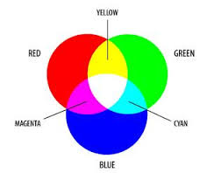fig:

Fig: 2.29

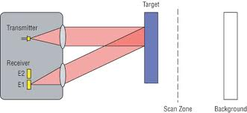

Fig: 2.30

**2.12.1 Infrared Sensors: Working Principle and Applications**

An infrared sensor is an electronic instrument that is used to sense certain characteristics of its surroundings by either emitting and/or detecting infrared radiation. It is also capable of measuring heat of an object and detecting motion. Infrared waves are not visible to the human eye.

In the electromagnetic spectrum, infrared radiation is the region having wavelengths longer than visible light wavelengths, but shorter than microwaves. The infrared region is approximately demarcated from 0.75 to 1000µm. The wavelength region from 0.75 to 3µm is termed as near infrared, the region from 3 to 6µm is termed mid-infrared, and the region higher than 6µm is termed as far infrared.

Infrared technology is found in many of our everyday products. For example, TV has an IR detector for interpreting the signal from the remote control. Key benefits of infrared sensors include low power requirements, simple circuitry, and their portable feature.

**2.12.2 Types of Infra-Red Sensors**

Infra-red sensors are broadly classified into two types:

* **Thermal infrared sensors** – These use infrared energy as heat. Their photo sensitivity is independent of wavelength. Thermal detectors do not require cooling; however, they have slow response times and low detection capability.
* **Quantum infrared sensors** – These provide higher detection performance and faster response speed. Their photo sensitivity is dependent on wavelength. Quantum detectors have to be cooled so as to obtain accurate measurements. The only exception is for detectors that are used in the near infrared region.

**2.12.3 Working Principle**

A typical system for detecting infrared radiation using infrared sensors includes the infrared source such as blackbody radiators, tungsten lamps, and silicon carbide. In case of active IR sensors, the sources are infrared lasers and LEDs of specific IR wavelengths. Next is the transmission medium used for infrared transmission, which includes vacuum, the atmosphere, and optical fibers.

Thirdly, optical components such as optical lenses made from quartz, CaF2, Ge and Si, polyethylene Fresnel lenses, and Al or Au mirrors, are used to converge or focus infrared radiation. Likewise, to limit spectral response, band-pass filters are ideal.

Finally, the infrared detector completes the system for detecting infrared radiation. The output from the detector is usually very small, and hence pre-amplifiers coupled with circuitry are added to further process the received signals.

**2.12.4 Applications**

The following are the key application areas of infrared sensors:

* Tracking and art history
* Climatology, meteorology, and astronomy
* Thermography, communications, and alcohol testing
* Heating, hyperspectral imaging, and night vision
* Biological systems, photobiomodulation, and plant health
* Gas detectors/gas leak detection
* Water and steel analysis, flame detection
* Anesthesiology testing and spectroscopy
* Petroleum exploration and underground solution
* Rail safety.

**CHAPTER 3 Methodology**

In our project we have used WinProladder for PLC programming. Before we explain our project code lets first discus some basic principles of ladder diagram.

**3.1 The Operation Principle of Ladder Diagram**

Ladder diagram is a type of graphic language for automatic control system it had been used for a long period since world war 2. until today, it is the oldest and most popular language for automatic control systems. Originally there are only few basic elements available such as A-contact (normally ON), B contact (Normally OFF), output coil. Timers and Counters. Not until the appearance of microprocessor based PLC, more elements for ladder Diagram, such as differential contact, retentive coil and other instructions that a conventional system cannot provide, became available.

The basic operation principle for both conventional and PLC Ladder Diagram is the same. The main difference between the two systems is that the appearance of the symbols for conventional Ladder Diagram are more closer to the real devices, while for PLC system, symbols are simplified for computer display. There are two types of logic system available for Ladder Diagram logic, namely combination logic and sequential logic. Detailed explanations for these two logics are discussed below.

**3.1.1 Ladder logic Software “WinProladder” software look**

**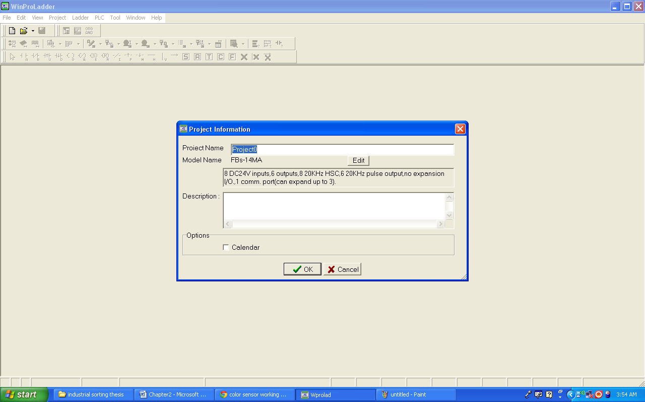**

**Fig: 3.1**

**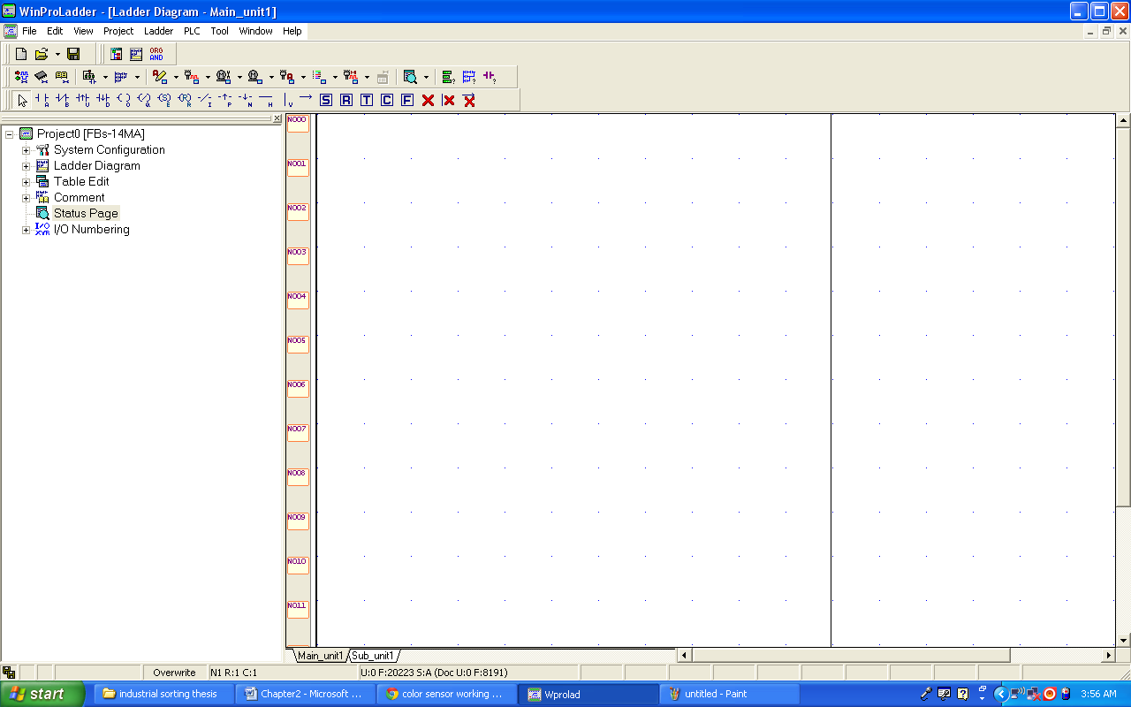**

**Fig: 3.2**

**3.1.2 Combination Logic**

Combination logic of the Ladder Diagram is a circuit that combines one or more input elements in series or parallel and then send the results to the output elements, such as

Coils, Timers/Counters, and other application instructions.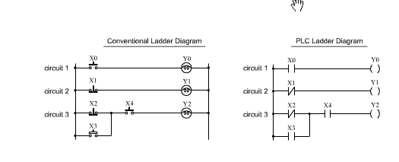

Figure 3.3

The above example

The above example illustrated the combination logic using the actual wiring diagram, conventional ladder Diagram, and PLC Ladder Diagram. Circuit 1 uses a NO(normally open) switch that is also called 'A' switch or contact. Under normal condition(switch is not pressed), the switch contact is at OFF state and the light is off if the switch is pressed, the contact status turns ON and the light is on, in contrast circuit 2 uses a NC (normally Close) switch that is all called "B" switch or contact. Under normal condition, the switch contact is at ON state and the light is on, if the switch is pressed the contact status turns OFF and the light also turns OFF.

Circuit 3 contains more than one input element. Output Y2 light will turn ON under the condition when X2 is closed or X3 switches to ON, and X4 must switch ON too.

Operation manual for ladder program simulation

**3.2 Features**

Can simulate the FATEK PLC ladder program execution without PLC

connection.

With providing single/multiple/continuous scan mode, the execution result

at each scan end can be easily checked.

With providing program address breakpoint and data breakpoint, it is

convenient to check any intermediate execution result and to identify

any data changed.

Provides communication interface allows external program or device (For

example, graphic panel or HMI) to modify or monitor the variable value

during the simulation.

With run time editing feature, during the simulation process the program

can be modified without stop the execution.

**3.3 Limitation of program simulation**

Besides the I/O operation, most of the instructions can be simulated. When

the ladder program contains the unsupported instruction, the operation of

unsupported instruction will be ignored and will be shown with yellow

background color as follows.

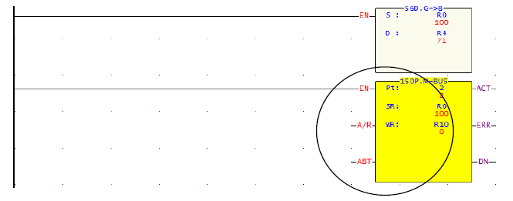

Fig: 3.4

**3.4 Operation of program simulation**

The following is an example of “ssi.pdw” project. With this project to explain

the related operations for program simulation.

**3.4.1 Open ladder program**

Follow the following main menu operation to open the “ ssi.pdw” project file.

File > Open project > Open file > select ssi.pdw. After select the project,

the screen will display as follows:

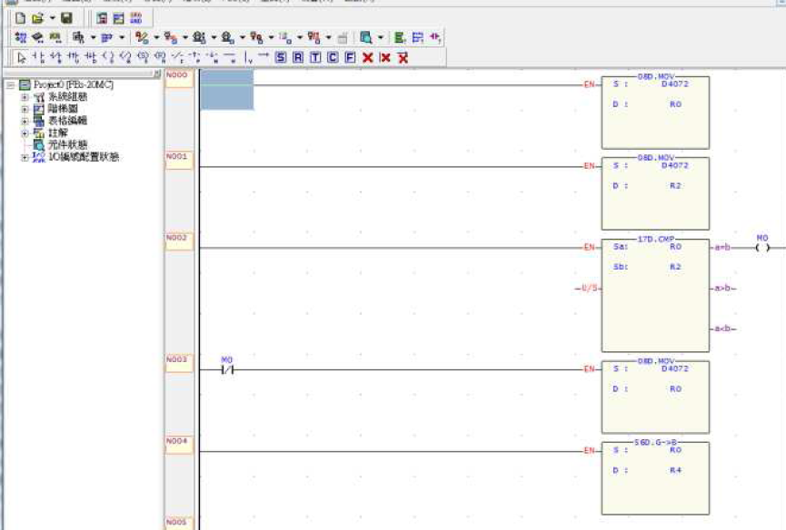

Fig: 3.5

**3.4.2 Enter simulation mode**

Main Menu: PLC > Simulation

It will enter into the simulation mode after execution.

**3.4.3 Start execution of program simulation**

Main Menu: PLC > Run

After execution, the color of power line of ladder program will become to red

color as the screen shown below:

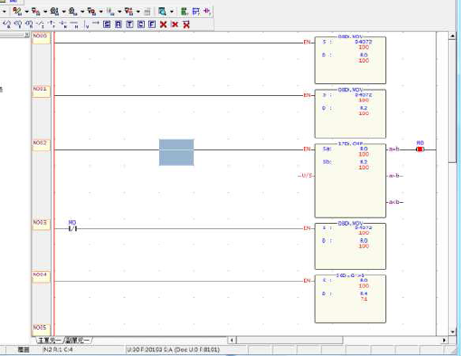

Fig: 3.6

During the execution, there is a blinking red dot at the left side of status bar.

On the right of the red dot has SC:xx, xx means the number of time have been

scanned. During simulation, can use the status page to monitor or modify the

value of register or discrete point.

**3.4.4 Pause of program simulation**

Main Menu: PLC > Pause Simulation or the easiest way is to click the space

Bar

At this point, the blinking red dot stop blinking and it will become pink color.

**3.4.5 Proceed to program simulation**

Main Menu: PLC > Resume Simulation or the easiest way is to click the

space bar

At this point, the dot becomes blinking again and the program continues the

operation.

**Control scanning**

The above pause/Resume program simulation is operated by manual way of

controlling the program execution, which will pause the program execution at

the next scan end point right after you issue the command. But if you would

like to control the exact times of scan execution after pause, you can use set

scan mode to control.

**Single scan**

Main Menu: PLC > Setup Simulation choose ”single scan”

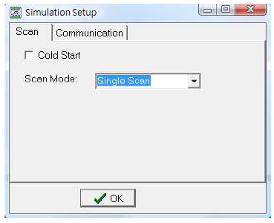

Fig: 3.7

After set this mode, you can use space bar or

Main menu: PLC >Resume Simulation to start a new scanning work.

**Multiple scan**

Main menu: PLC > Setup Simulation choose “multiple scan”

After selected the mode, you can set number of scans to be performed in the

number of scanning field.

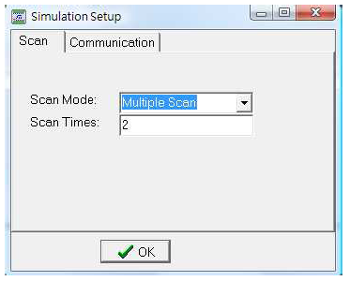

Fig: 3.8

After that, press space bar or

Main menu: PLC > Resume Simulation to start up next scanning work.

When the scan has reached the set number, it will pause the scanning.

**Continuous scan**

Main menu: PLC > Setup Simulation choose “continuous scan”

This is the default scan mode after enter the simulation.

**3.5 Project Ladder Diagram**:

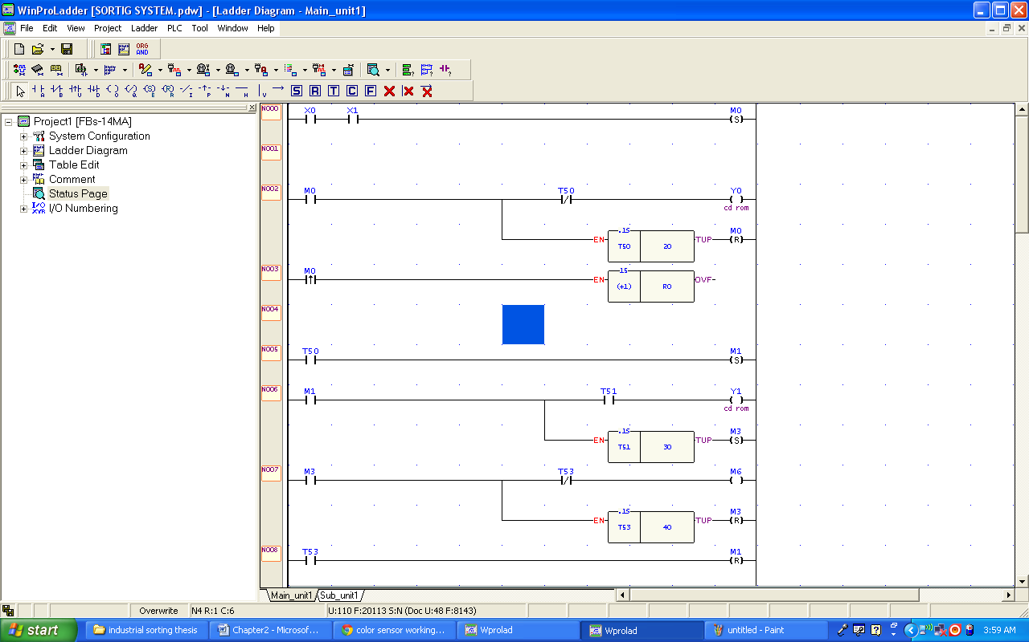

Fig: 3.9

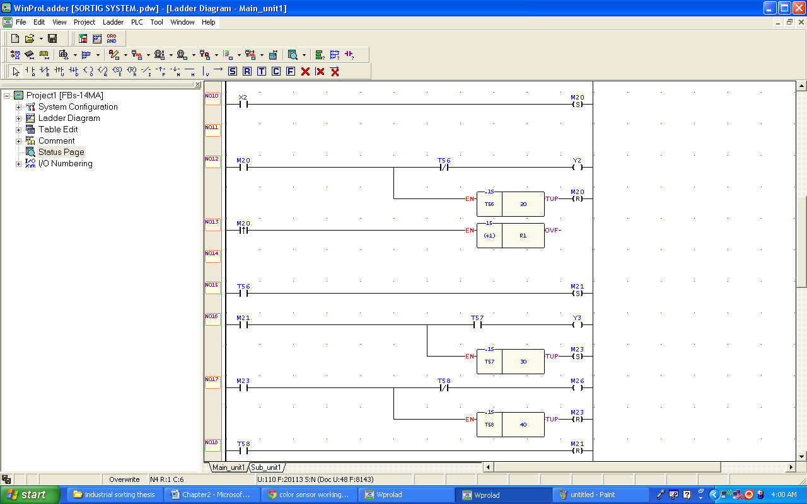

Fig: 3.10

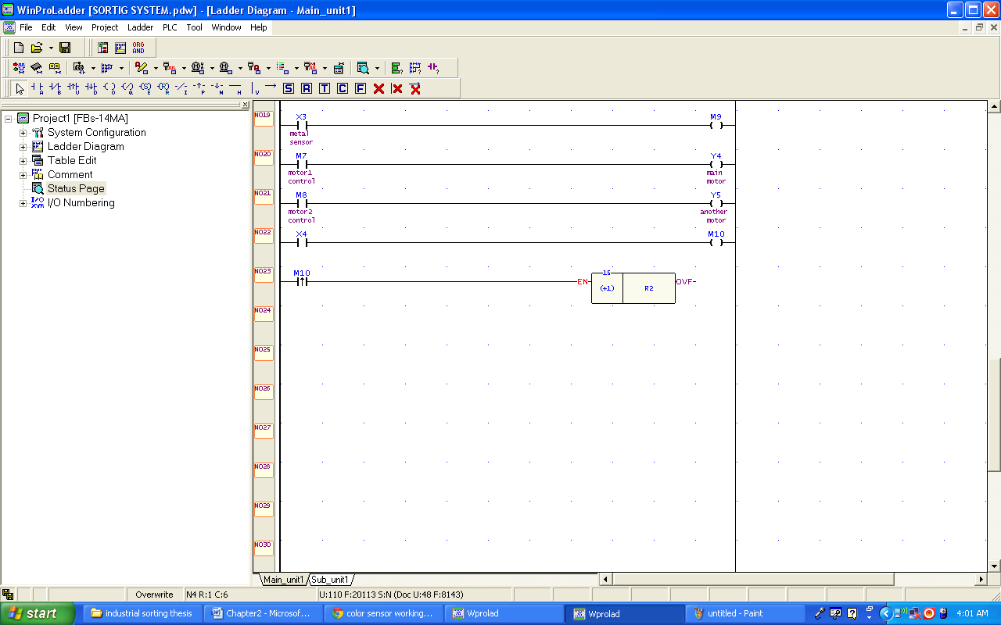

Fig: 3.11

This is the Ladder Logic Code of the Project. This program gives the PLC to perform the automatic sorting system. This code works along with 5 Sensors used on conveyor belts.

The inputs X0 and X1 are used to detect the larger items, when both the sensors are ON at the same time the object is detected and it Sets M0. When M0 is high the timer T50 is activated for a specific amount of time to open the CD Rom which is connected to the output Y0 through an SPDT Relay, and also increment the value in the register R0.

When T50 is UP, then another time is activated to close the CD ROM through output Y1.

Similarly the input X2 is used for the small items detection. And the program flow is exactly the same.

X3 and X4 are used for the Metal and color sensors respectively.

M7 and M8 are used for the motors control from the SCADA, through a GUI application designed in Win Log .

**3.6 Hardware Methodology**

**Schematic**

**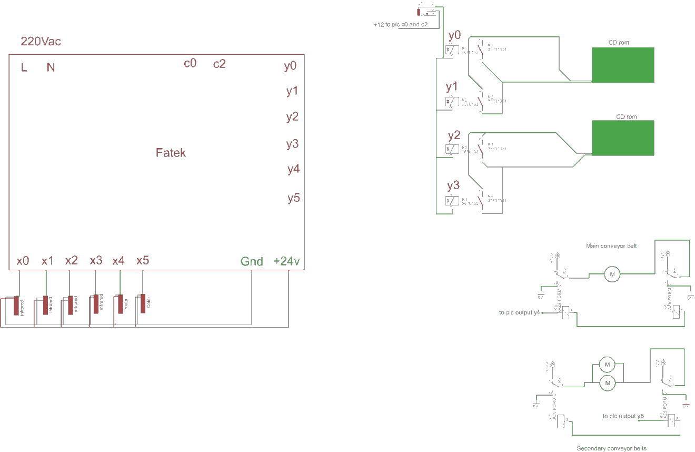**

**Fig: 3.12**

**Sensors wiring**

Brown = +24v

Blue = Gnd

Black = signal

220Vac is connected to the L and N ports of the Fatek Plc.

C0 And C1 are common contact and are internal short with the plc outputs when are in ON condition.

The Hardware is controlled in two Portions , PLC alone and plus with SCADA.

the objects are detected by the sensors connected to the inputs (“X0 …..”). The input from the sensors is processed by the plc stored In registers and then transferred to the SCADA system for visual Display that can be seen by the operators in the control Room.

The opening and closing of the CD ROMs is achieved by using a 12v Relay. This relay is ON and OFF according to the type of objects detected.

The outputs y0 and y1 are used for the CD ROM 1

The outputs Y2 and y3 are used for the CD ROM2

**3.6.1 Project PCBs:**

Relay module:

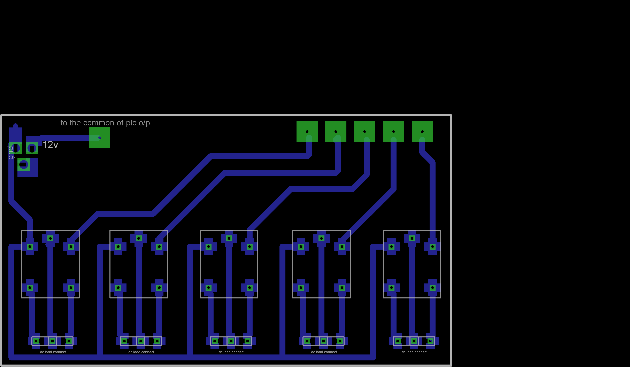

Fig: 3.13

**H-bridge:**

**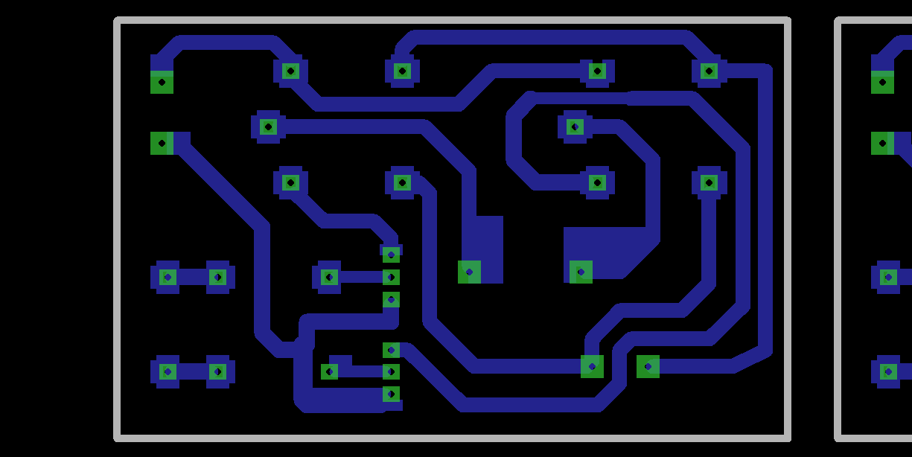**

Fig: 3.14

The project PCBs are made in a computer application called CadSoft Eagle.

This application is worldwide used for making PCBs and Schematics.

**CHAPTER 4 Programming**

****

****

****

**CHAPTER 5 Results And Conclusion**

The improvement of Industrial Control System condition is largely dependent on the modern ways of Industrial management and control. Advanced Control signal controllers and control systems contribute to the improvement of the Industrial Control system problems. The intelligent of the Industrial control system introduced in this project with powerful functions and hardware interface. Good Quality social benefits has been made through the application of the PLC and SCADA Industrial controller in practice, and the application result shows that the PLC and SCADA based Industrial Control system will improve.

**5.1 Future enhancement**

This system can be easily updated. We can add more sensors without effecting the previously installed sensors and their programming. We can also use HMI on the machine itself. So that we get much powerful control over the system.